**FUZZY LOGIC CONTROL SYSTEM IN WASHING MACHINE**

Mayank Gupta

Bharati Vidyapeeth College of Engineering, Paschim Vihar, New Delhi, India

**Abstract**

The paper discusses about the application of fuzzy logic control systems in the application of the washing machines, this paper highlights their benefits in increasing performance and enhancing user experience. Fuzzy logic helps washers to adapt settings based on many variables like type of cloth, dirtiness of cloth, type of dirt and many more variables, which will help to increase the efficiency of the cleaning and at the same time conserving resources like electricity, water, detergent etc. [1] Overall, fuzzy logic helps in advancement of washing machine technology, with superior cleaning results and sustainable living.[2]

**Keywords-** Fuzzy Logic, Washing Machine, control system, sustainability, performance

**Introduction**

In today's modern world, washing machine are one of the indispensable home-appliances and is widely used, washing machine is important because it helps to save a lot amount of water as compare to physical washing of clothes, constant improving of the washing machines by increasing the automation and decreasing human involvement is required to increase the efficiency of the functioning of the washing machines, The paper describes the application of neural based fuzzy that can be used to get a suitable washing time for different cloths.[3]

**Problem Definition**

When one uses washing machine, then manually it select the washing time and also it requires constant monitoring based on the type of dirt, the quantity of the cloths, type of detergent, dirtiness of the cloth one selects the amount of detergent/water and time to wash cloth, but the manual process is time consuming and at the same time not effective, in this paper we address this problem using fuzzy logic [4] this fuzzy logic controlled washing machine will give correct washing time based on the input parameters and the rules defined.[14]

**Problems Details**

The fuzzy system is designed in the four steps first one is fuzzification of inputs which means converting crisp inputs taken by the user into fuzzy inputs, membership functions are created to represent each crisp. Second step is to evaluate the process, in the third steps it involves aggregation of rule outputs and in the last step defuzzification is done which means converting the fuzzy inputs to the crisp outputs so that user will be able to know the time to wash the cloths [5].

The problem in this paper has been solved using only three variables. The input parameter are Degree of dirt, Type of dirt, Type of cloth and the output parameter is in terms of time are very low, low, medium, high, very high.

The input parameters are discussed in details below-

1. Degree of Dirt: Degree of dirt is directly proportional to the washing time of cloths, if the degree of cloth dirtiness is high then it would take much more time and if the degree of cloth dirtiness is less than it would take less time to wash, in this model the degree of dirt has been classified into three membership functions which are Less dirty, dirty, very dirty.
2. Type of cloth: It is mainly based on the material used in the cloth which changes the washing time based on cloth material in this model four types of cloth material is there which are cotton, silk, woolen, jeans.
3. Type of dirt: Type of dirt also determine the amount of time to wash the cloths like a greasy dirt will take more time to wash as compare to a non-greasy dirt, in this model type of dirt is classified into three types which are greasy, non-greasy and mix.

There are many other factors which determine the washing time of the cloths, however in this paper all other factors are considered constant. [6]

**Designing the Fuzzy Logic Controller**

Mamdani-style fuzzy inference system is used to take input from the user and produce the best suitable output.[7]

**Membership Function of Input Parameters**

1. Degree of Dirt - Amount of dirt is the deciding factor for washing time, it is assumed that the degree of dirtiness ranges from 0 to 10 with degree of dirtiness increasing from 0 to 10. Three membership functions are defined less dirty [0 0 4.167], dirty [2.04 5 8], very dirty [5.939 10 10]
2. Type of cloth - cloths are classified into cotton, silk, woolen and jeans and hence four membership functions are used cotton [1.85 3.5 5.2], silk [0 0 3.029], woolen [4.21 6.1 8.05], jeans [7 10 10]
3. Type of dirt – Maximum time to wash a cloth is considered as 60 minutes, type of dirt is classified into greasy [0 0 4], non-greasy [2.679 5.17 7.61] and mix [6.257 10 10], so three membership functions are used with parameters.

Figure1. Membership Function of Type of Cloth

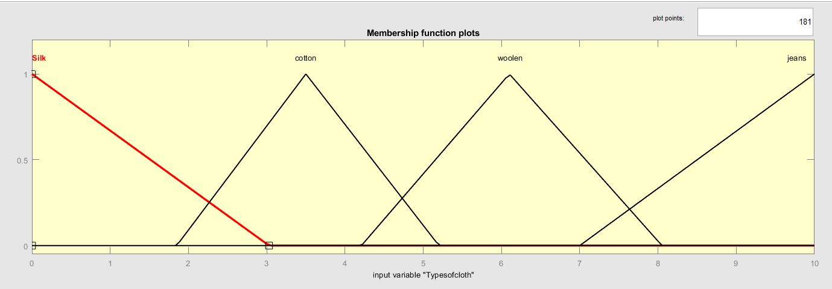

Figure2. Membership Function of Type of Dirt

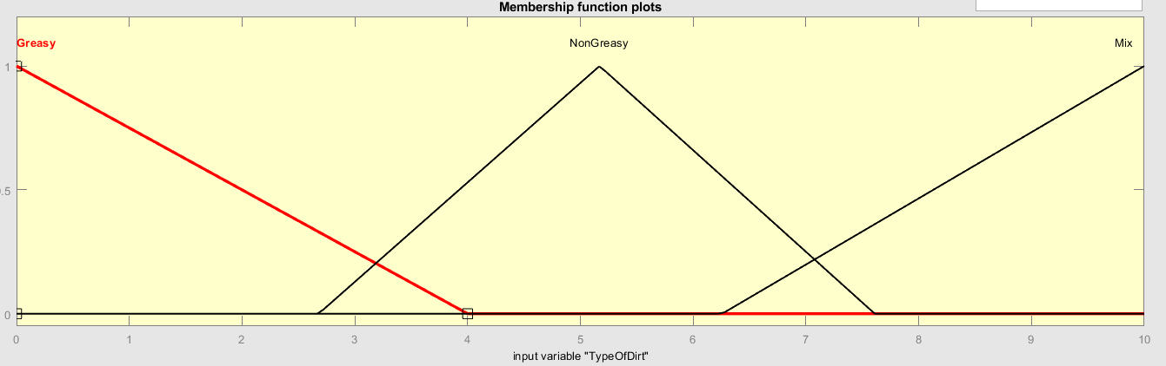

Figure3. Membership Function of Degree of Dirt

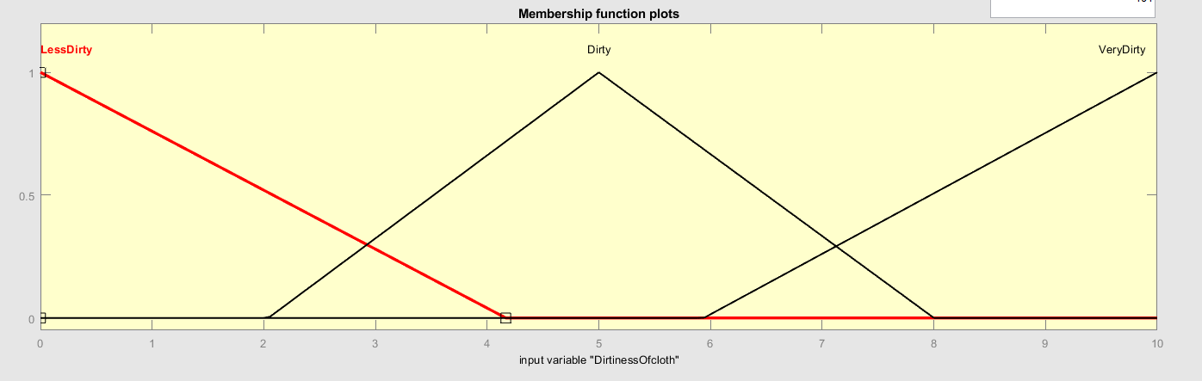

**Membership Function of Output Parameters**

Wash time- Five membership functions are defined for the wash time between range of 0-60 minutes- very low [0 7.147 16], low [8.44 17.6 26.3], medium [19.96 30 40.5], high [33.65 45 54], very high [47 54 60].

Figure3. Membership Function of Washing time

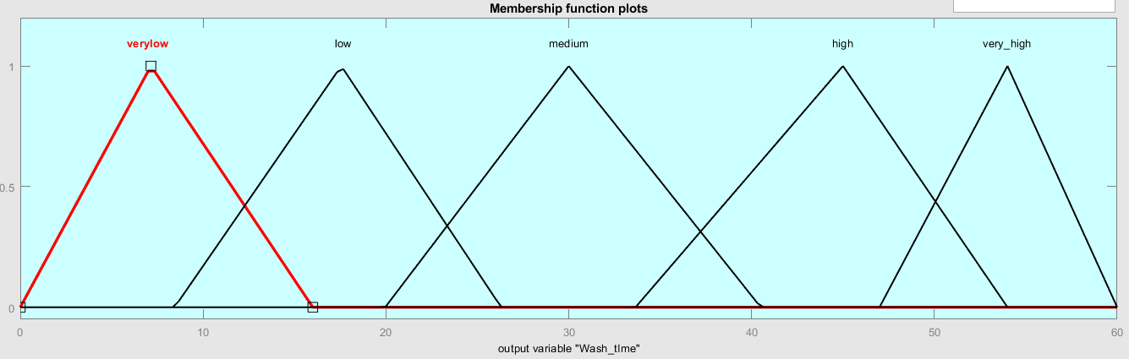

**Control Rules**

Rules for the fuzzy design of the washing machine to derive output are mentioned below in the figures (4.a & 4.b).

Figure4.a Rule Editor from Toolbox/MATLAB.

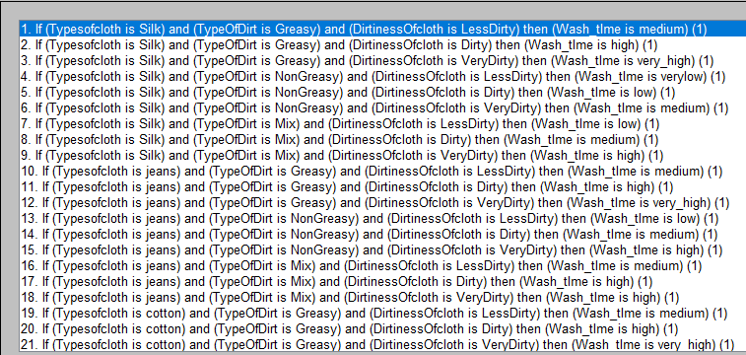

Figure4.b Rule Editor from Toolbox/MATLAB.

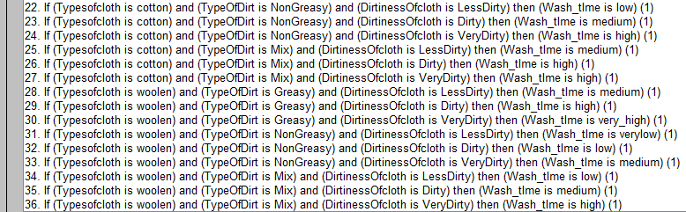

**Fuzzification of Input Parameters**

Sensors obtain the crisp values which is then provided to control system model and which will further converted to input in fuzzy form [8].

**Implication**

Implication means weightage of each parameter to determine the output value so parameter have higher weightage and some parameter have lower weightage to determine output, In this paper we take normalized for less complexity.

**Defuzzification**

The output is in fuzzy and it is to be converted into crisp form so this conversion process is called defuzzification there are many defuzzification methods, in this paper, we used Centroid method which is widely used and most common. [9]

**Result Toolbox/MATLAB**

The established control rules are pointed up in 3D graphs. The relationship between input and output parameters is shown in figures (5.a & 5.b) below.[10]

Figure5.a Rule Viewer from Fuzzy Logic Toolbox/ MATLAB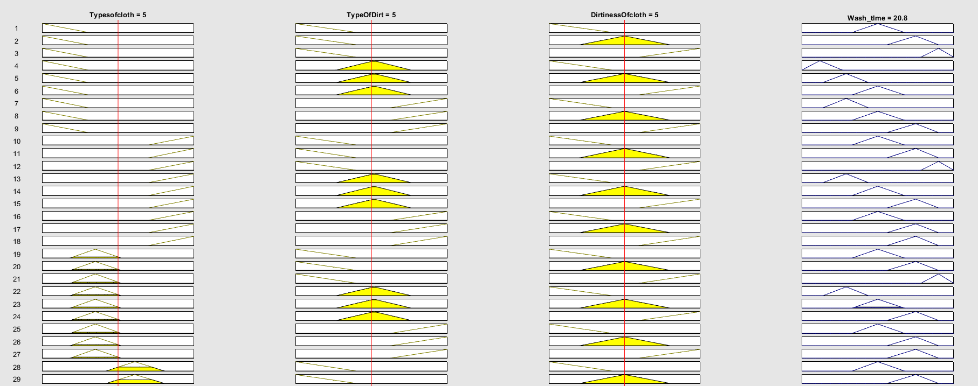

Figure5.b Rule Editor from Toolbox/MATLAB.

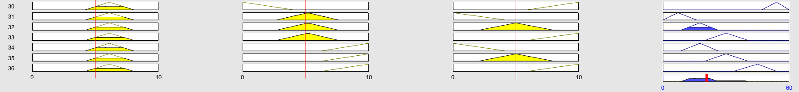

**Surface Viewer**

Fuzzy inference system have been created using MATLAB's fuzzy logic toolbox, [11] The surface response relationship between the input and output parameter are shown in figures (6.a ,6.b & 6.c)

Figure 6.a Surface Viewer from Fuzzy Logic Toolbox

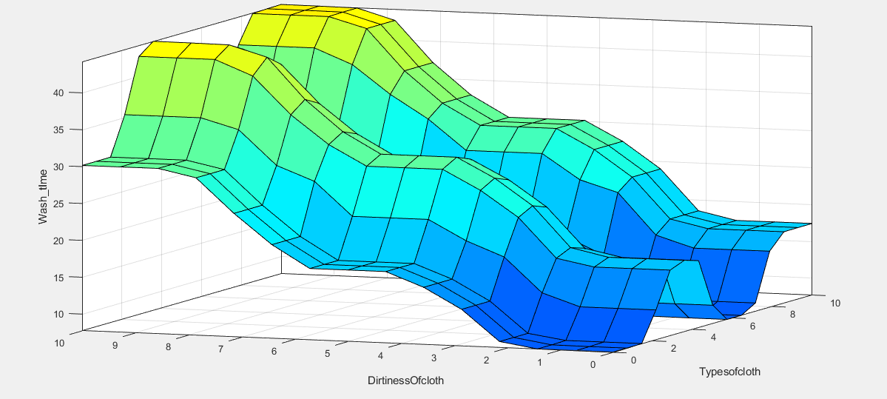

Figure 6.b Surface Viewer from Fuzzy Logic Toolbox

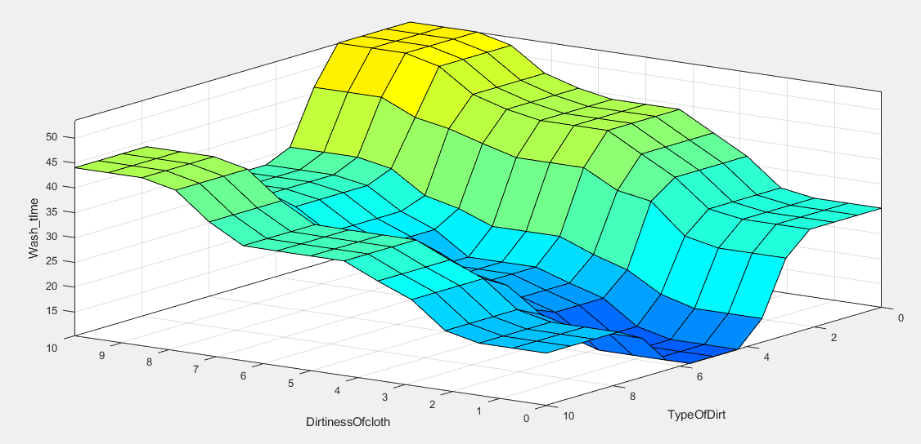

Figure 6.c Surface Viewer from Fuzzy Logic Toolbox

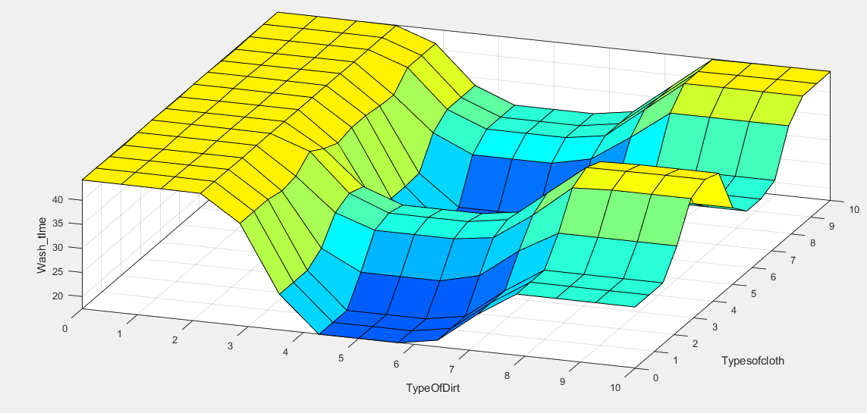

**Results**

To illustrate the working, let us take an example where the input parameters are

Type of cloths (1-10)- 9.5 (Jeans)

Type of Dirt (1-10)- 2 (Greasy)

Dirtiness of cloths (1-10)- 8 (Very Dirty)

Then the output parameter is, Wash Time (0-60)- 53.6056 (Very High)

**Conclusion**

This paper will serve as a valuable resource for improving the efficiency and automation of the washing machines it will help to reduce the wastage of electricity and water also, automatic washing machine has high productivity and performance, implementing the neural based fuzzy logic the efficiency of the washing machines can be further increased with new algorithms and different parameters.[12][13]

**Declaration of Conflicting Interests**

The author declared no potential conflicts of interest with respect to the research, authorship and/or publication of this article.

**Funding**

The author received no financial support for the research, authorship and/or publication of this article.

# **References**

1. Lee L. W., 2007, Application of fuzzy logic control in washing machine, DOI: 10.1109/TASE.2007.909648
2. Zhang S. & Tan Y., 2004, Fuzzy logic control for washing machines, Page No. 742-748
3. Smith J., 2015, Advanced control systems in washing machines: A comparative analysis, Page No. 120-135
4. Chen H. & Wang Q., 2018, Intelligent washing machine control system based on fuzzy logic and neural networks, DOI: 10.1007&42835-018-0019-5
5. Kim S. & Park J., 2019, Development of fuzzy logic control system for washing machine vibration reduction, Page No. 5839-5846
6. Gupta S. & Singh R., 2017, Adaptive fuzzy logic control for washing machines: A comparative study, Page No. 7891-7897
7. Chen L. & Li C., 2016, Fuzzy logic control system design for washing machine energy optimization, DOI: 10.1007/s12053-015-9378-5
8. Patel D. & Desai K., 2022, Real-time implementation of fuzzy logic control system in washing machines, Page No. 256-269
9. Wang X. & Li Y., 2014, Design and implementation of a fuzzy logic control system for washing machines, DOI: 10.3233/1FS-141185
10. Ishaan A., 2021, FUZZY LOGIC CONTROL SYSTEM IN SMART WASHING MACHINE, Page No. 56-67
11. Johnson M., 2019, Optimization of washing machine performance using fuzzy logic control,DOI: 10.1016/j.jclepro.2019.118090
12. Tanaka K. & Sugeno M., 1985, Fuzzy control of washing machines, DOI: 10.1109/TFUZZ.1985.246609
13. Wang H. & Zhang L., 2016, Design and implementation of fuzzy logic control system for washing machine water usage, Page No. 987-995
14. Park S. & Kim H., 2020, Application of fuzzy logic in smart washing machines: A case study, DOI: 10.1109/JlOT.2020.2998288