**FORMULATION AND EVALUATION OF A HYDROGEL PREPARED BY USING METHANOLIC EXTRACT OF *PROCRIS* *REPENS* AND *SARGASSUM DUPLICATUM***

SARANYA S MOHAN*1 , CELESTIN BABOO R.V.2 , SIRAJUDHEEN M.K.3

1M Pharm student, Jamia Salafiya Pharmacy College Pulikkal, Malappuram District, Kerala, India.673637

2Professor and Head, Department of Pharmacognosy, Jamia Salafiya Pharmacy College Pulikkal, Malappuram District, Kerala, India.673637

3Principal, Jamia Salafiya Pharmacy College Pulikkal, Malappuram District, Kerala, India.673637

**ABSTRACT**

This review paper describes the formulation and evaluation of a hydrogel prepared by using the methanolic extract of *Procris repens* and *Sargassum duplicatum. Procris repens* (Lour.) B.J.Conn & Hadiah commonly known as watermelon begonia or sisik nagais a species of flowering plant in the *Urticaceae* family. It is mainly found in tropical regions of Southeast Asia, including Malaysia, Philippines and India. It is often seen in humid environments with well-draining soil. The name *Procris repens* derives from its genus name *Procris*, which is rooted in Greek mythology, referring to a tragic figure associated with themes of love and jealousy. The species name “*repens*” comes from Latin, meaning “creeping” or “spreading”, which describes the plant’s growth habit as it spreads along the ground.

*Sargassum duplicatum* is a species of brown macroalgae belonging to the family *Sargassaceae*. It is primarily found in the warm coastal waters of the western Atlantic, including the Gulf of Mexico and Caribbean Sea. Also found in Rameswaram, Tamil nadu. Bioactive compounds present in *Sargassum duplicatum* includes Phenols, Flavonoids, Polysaccharides: Laminaran (SdL), Fucoidan (SdF), Alginate, Fucoxanthin (carotenoid), Dietary fiber and fatty acids. *Sargassum duplicatum* is used in traditional medicine for wound healing and as an ovicidal agent against mosquito eggs. It helps in bioremediation, used as fertilizer, food, cosmetics, wound healing, anticancer, tyrosinase inhibition. *Sargassum duplicatum* plays an important role in immune boosting by enhanced immunity and resistance to *Vibrio alginolyticus* infection. This review paper discusses in detail study of formulation and evaluation of hydrogel. Here medicated hydrogel of methanolic extract was prepared at various concentrations. After formulation it was evaluated for various physicochemical parameters and in-vitro wound healing activity by scratch assay method was conducted. Results shows that the hydrogel have wound healing activity and it is physically stable.

**KEYWORDS:** *Procris repens***,**hydrogel, Evaluation, Formulation, *Sargassum duplicatum.*

# INTRODUCTION

Formulation studies typically refer to the process of designing, optimizing and testing the composition of a product, often in fields like pharmaceuticals, cosmetics or food.[1] These studies are essential for ensuring that the final product meets the desired specifications in terms of stability, efficacy, safety and other relevant factors.[2] The formulation process involves selecting suitable ingredients, determining their proportions, and evaluating various parameters such as pH, viscosity, and compatibility to achieve the desired product characteristics. It often involves a combination of experimentation, analysis and iterative refinement to develop a formulation that meets the required standards.[3]

Formulation studies focus on creating drug preparations that are both stable and patient-friendly. The skin, the body's largest organ, acts as a protective barrier, shielding the internal environment from external factors. It plays essential roles such as moisturizing, regulating temperature, sensing and defending against pathogens. However, long-term exposure to external elements can stress the skin leading to damage. When skin integrity is compromised, like in wounds, it increases the risk of diseases. Wounds cause discomfort and pain and severe cases can lead to disability. Depending on the healing duration, wounds are classified as acute or chronic. Acute wounds, such as surgical incisions or bites, usually heal within 8 to 12 weeks through natural processes. Chronic wounds, however, do not heal within this time frame, often due to untreated trauma or underlying conditions like diabetes. These wounds are harder to treat, as they involve prolonged inflammation and insufficient healing, leading to higher healthcare costs.

Managing wounds, especially chronic ones, involves a complex process with different phases. Proper wound care helps prevent infections and speeds up healing. Hydrogels have gained attention for their wound-healing properties. Hydrogels are three-dimensional, cross-linked networks composed of water-soluble polymers that form a semi-occlusive layer on the skin, allowing for controlled drug release. Their high water content and porous structure make them flexible, closely mimicking the properties of natural tissue. Hydrogels consist of a solid, water-insoluble polymer matrix and an interstitial fluid, primarily water, which allows them to absorb and retain large amounts of fluids. This combination gives hydrogels excellent biocompatibility and the ability to facilitate the timed release of drugs or growth factors. Their biphasic nature—comprising at least 10% by weight or volume of a porous solid and permeable fluid—enables efficient transport and exchange of substances, making them particularly useful in biomedical applications. Hydrogel’s flexible properties, including ease of modification and their capacity to release therapeutic agents in a controlled manner, make them a valuable tool for promoting wound healing and drug delivery. These three-dimensional polymer networks can be physically or chemically crosslinked, making them either reversible or permanent. Hydrogels are hydrophilic, allowing them to remain flexible and resemble living tissue. They can also serve as delivery systems for drugs, proteins, or cells. Recently, multifunctional hydrogels have been developed to provide multiple benefits in wound healing. Overall, hydrogels are valuable materials in medical applications due to their tissue-like properties, water retention, and ability to deliver targeted treatments. Research continues to explore their potential in healthcare advancements.

**MATERIALS AND METHODS**

**Procedure**

Herbal medicated hydrogels were formulated using methanolic extracts from *Procris repens* leaves and the whole *Sargassum duplicatum* plant, mixed at various concentrations with a hydrogel base. Following formulation, the hydrogels were assessed for their physicochemical properties and wound healing activity.

**Formulation of herbal medicated hydrogel**

**Table 1: Ingredients for the formulation of Aqua Phyto Heal Gel ( 20g )**

|  |  |  |  |  |
| --- | --- | --- | --- | --- |
| Name of ingredients | 5% | 10 % | 15 % | |
| *Procris repens* extract | 0.5 g | 1 g | 1.5 g | |
| *Sargassum duplicatum* extract | 0.5 g | 1 g | 1.5 g | |
| Propylene glycol 400 | 8 ml | 8 ml | 8 ml | |
| Carbopol 940 | 0.8 g | 0.8 g | 0.8 g | |
| Methyl paraben | 0.1 g | 0.1 g | 0.1 g | |
| Propyl paraben | 0.5 g | 0.5 g | 0.5 g | |
| Triethanolamine | 0.5 ml | 0.5 ml | 0.5 ml | |
| Water | 9 ml | 7.1 ml | 6.1 ml | |
| Perfume | Q S | Q S | | Q S |

**Procedure for the formulation of herbal medicated hydrogel**

**Procedure**

* Preparation of Extract Solution: Measure the required amount of distilled water in a beaker. Add the plant extract to the water and heat the mixture until it reaches a gentle boil to ensure the extract dissolves thoroughly. Let it cool down.
* Preparation of Gel base: While stirring at 1200 rpm with a mechanical stirrer gradually add Carbopol 940 to the solution ensuring it disperses uniformly.
* Addition of Propylene Glycol: Slowly add Propylene glycol 400 to the mixture while stirring. This acts as a humectant and helps maintain moisture in the gel.
* Addition of Preservatives: Gradually incorporate methyl and propyl paraben into the mixture. These preservatives help maintain the stability of the formulation and prevent microbial growth.
* pH Adjustment: Adjust the pH to a near-neutral range (6.8-7.0) using Triethanolamine (TEA). Add TEA slowly and stir gently until a clear gel forms.
* Final Dilution and Fragrance Addition: Once the pH is adjusted, add the remaining distilled water to achieve the desired final volume. Mix well to ensure homogeneity.
* Add a few drops of fragrance, if desired to enhance the scent of the formulation.
* Preparation of different concentrations: Prepare gels with various extract concentrations, such as 5%, 10% and 15% by adjusting the amount of plant extract accordingly.
* Packaging: Transfer the final gel formulation into collapsible tubes for easy application and storage.
* Evaluation of physicochemical parameters and wound healing properties: Once the formulation is complete proceed with an evaluation of its physicochemical parameters and wound healing properties.

**Evaluation of Herbal Medicated Hydrogel**

The quality of the herbal hydrogel is assessed based on various physicochemical parameters, including color, odor, pH, spreadability, extrudability, consistency, diffusion study, solubility, washability and stability under different temperature conditions.

**Presence of foreign particles/grittiness**

The hydrogel was visually inspected against a blank background to identify any foreign particles or grittiness.

**Colour, odour, consistency**

Physical properties such as color, odor, smoothness and greasiness were examined through visual assessment.

**Washability**  
A small amount of hydrogel was applied to the skin and its ease of removal with water was tested.

**Solubility**  
The solubility of the hydrogel was tested in boiling water, alcohol, ether and chloroform. It should ideally be soluble in 9 parts of water, 17 parts of boiling water and miscible with alcohol, ether, chloroform and volatile oils.

**pH**

The pH was measured using a digital pH meter. A solution was prepared by mixing 0.5 g of the hydrogel with 100 mL of rectified spirit and allowing it to sit for 2 hours. The pH was measured three times and the average value was recorded.

**Spreadability**

To measure spreadability, 1 g of the hydrogel was placed between two glass slides. A 500 g weight was applied to achieve a uniform thickness. The slides were separated by adding weight until the upper slide began to move. The time taken for this separation was noted and spreadability was calculated by following formula

**S=M×L/T**

where S is spreadability (gcm/sec), M is the weight applied, L is the slide length (cm) and T is the time taken for separation (sec). Shorter separation time indicates better spreadability.

**Extrudability**  
Approximately 10 g of the hydrogel was placed in a standard collapsible tube, sealed and the force needed to extrude a 0.5 cm ribbon of gel within 10 seconds was measured.

**Stability study**

The hydrogel's physical stability was tested over four weeks at various temperatures: 5 ± 3°C (refrigerator), 25 ± 2°C (room temperature) and 37°C (for accelerated stability testing). Observations were made on the effects of temperature, humidity, and time on the hydrogel's physical properties.

**Viscosity**  
Viscosity was measured using a Brookfield Viscometer II with spindle S-64 at 20 rpm, held at 25°C. Each sample was measured in triplicate, and the average was recorded.

**Drug release studies**

The drug release profile of the hydrogel was assessed using a Franz diffusion cell. The hydrogel was placed on an egg membrane between the donor and receptor compartments of the cell. The test was carried out in a phosphate buffer (50 mL) with pH 7.4 at a constant temperature of 37°C with continuous stirring. Samples (2 mL) were collected at intervals, and an equal volume of phosphate buffer was added back. Using a UV spectrophotometer at a 270 nm wavelength, the cumulative percentage of drug release was calculated by comparing the sample with a blank phosphate buffer solution at pH 6.8.

**In-vitro wound healing activity of various hydrogels of *Procris repens* and *S. duplicatum* extract byScratch wound healing assay**

Cell line maintenance: The cell line was procured from the National Centre for Cell Sciences (NCCS), Pune, India. The cells were cultured in Dulbecco’s Modified Eagles Medium (DMEM-Himedia), supplemented with 10% heat inactivated Fetal Bovine Serum (FBS) and 1% antibiotic cocktail containing Penicillin (100U/ml), Streptomycin (0.1 mg/ml), and Amphotericin B (0.25µg/ml). The cell containing TC flasks (25cm2) were incubated at 37OC at 5% CO2 environment with humidity in a cell culture incubator (Galaxy® 170 Eppendorf, Germany).

Cell line used: L929 – Mouse fibroblast cell line (Normal cell line)

Preliminary procedure: The cells (0.3*106 cells/well) were seeded on 6 well plates and allowed to acclimatize to the culture conditions such as 37 °C and 5% CO2 environment in the incubator for

24 h. The test samples were filter sterilized using 0.2 µm Millipore syringe filter. The sample was added to the wells containing cultured cells of at least 80% confluency in different concentrations (25, 50, and 100 µg/mL). Untreated wells were kept as control. Positive control was treated with 0.01nM concentration.

Scratch wound healing assay procedure

(i) Scrape the cell monolayer in a straight line to create a ‘‘scratch’’ with a 200µL pipette tip. Remove the debris and smoothen the edge of the scratch by washing the cells once with 1 ml of the growth medium and then replace with 2 ml of fresh medium.

Critical step: It is important to create scratches of approximately similar size in the assessed cells and control cells to minimize any possible variation caused by the difference in the width of the scratches.

(ii) To obtain the same field during the image acquisition, create markings to be used as reference points close to the scratch. The reference points can be made by etching the well plate lightly with a razor blade on the outer bottom of the dish or with an ultrafine tip marker. After the reference points are made, place the dish under a phase-contrast microscope and leave the reference mark outside the capture image field but within the eye-piece field of view. Acquire the first image of the scratch.

(iii) Place the well plate in a tissue culture incubator at 37 0C. Photomicrographs were taken for varying durations (0 hour, 12 hours, 24 hours and 36 hours). The time frame for incubation should be determined empirically for the particular cell type used. The well plates can be taken out of the incubator to be examined periodically and then returned to resume incubation.

Critical step: Choose a time frame of incubation that allows the cells under the fastest migrating condition to just achieve the complete closure of the scratch.

(iv) After the incubation period, place the dish under a phase-contrast microscope, match the reference point, align the photographed region acquired in Step (ii) and acquire a second image. Likewise images should be taken till the complete closure of the wound.

Cell Migration rate and Average wound area: In order to evaluate the migration rate, the images were analyzed using “ImageJ”software, USA, and percentage of the closed area was measured and compared with the value obtained at 0 h. An increase in the percentage of the closed area indicated the migration of cells. This in turn indicates the efficacy of wound healing.

**RESULT AND DISCUSSION**

Formulation of herbal medicated hydrogels of methanolic extract of *Procris repens* and *Sargassum duplicatum* at various concentrations.

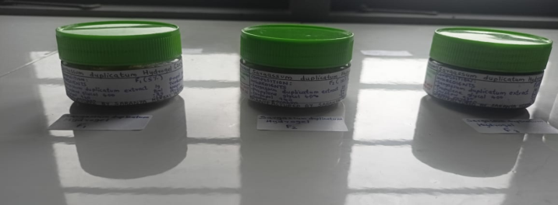

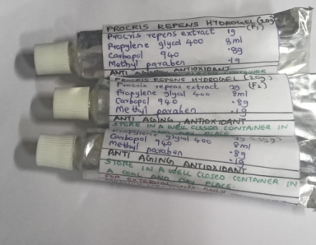 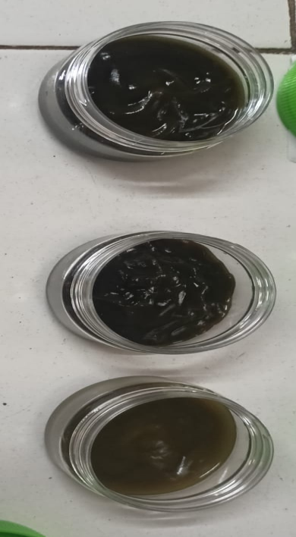

**Fig no.1: Medicated hydrogels of *Procris repens* and *Sargassum duplicatum***

**Label**

|  |
| --- |
| **HERBAL HYDROGEL ( 20 g)** |
| COMPOSITION:  *Procris repens* extract : 0.5 g  *Sargassum duplicatum* extract :0.5 g Propyl paraben : 0.5 g  Propylene glycol 400 : 8 ml Triethanolamine : 0.5 ml  Carbopol 940 : 0.8 g Water : 7.1 ml  Methyl paraben : 0.1 g Perfume : Q.S |
| CATEGORY : Antiseptic, wound healing |
| STORE IN A WELL CLOSED CONTAINER IN A COOL AND DRY PLACE. |
| FOR EXTERNAL USE ONLY.  KEEP OUT OF REACH OF CHILDREN |
| MFG LIC NO : 11026 MFG DATE : 23/5/24  BATCH NO : XY 3005 EXP DATE : 23/5/25 |
| MANUFACTURED BY SARANYA HERBAL PVT LTD |

**Evaluation of herbal medicated hydrogels of methanolic extracts of *Procris repens*  and *Sargassum duplicatum* at various concentrations**

## Table no.2: Evaluation of Physicochemical parameters

|  |  |  |  |
| --- | --- | --- | --- |
| **Parameters** | **Observation** | | |
| **Hydrogels of methanolic extract of *Procris repens and Sargassum duplicatum*** | | |
| **5 % hydrogel** | **10 % hydrogel** | **15 % hydrogel** |
| Colour | Pale green | Light green | Dark green |
| Odour | Characteristic odour for all | | |
| Consistency | Smooth, homogenous, non-greasy | | |
| Foreign  Particles | Free from foreign particles and grittiness | | |
| PH | 7.22 ± 0.02 | 7.16 ± 0.01 | 7.0 ± 0.002 |
| Good for skin pH | | |
| Extrudability | 17.2 gm, Good | 16.32 gm, Good | 16.11 gm, Good |
| Solubility | Soluble in water-ethanol | | |
| Viscosity | 28092 ± 0.01 cps | 28923 ± 0.001cps | 32645 ± 0.002cps |
| Washability | Good | | |

Values are expressed in mean ± SEM, n = 3

**Table no.3: Spreadability of medicated hydrogels of *Procris repens* and *Sargassum duplicatum***

|  |  |  |  |  |
| --- | --- | --- | --- | --- |
| **SAMPLE** | **Weight tide to the upper**  **slide (gm)** | **Length of slide (cm)** | **Time taken to separate the**  **slides (sec)** | **Spreadability (g cm/sec)** |
| 5 % Hydrogel | 50 | 6 | 10 | 30 ± 0.03 |
| 10 % Hydrogel | 50 | 6 | 14.7 | 20.4 ± 0.0001 |
| 15 % Hydrogel | 50 | 6 | 17 | 17.64 ± 0.005 |

Values are expressed in mean ± SEM, n = 3

5 %, 10 %, 15 % hydrogel**s** were found to be easily spreadable.

**Table no 4 : Stability studies of hydrogels of methanolic extract of *Procris repens* and *Sargassum duplicatum* at 5°C, 25°C,37°C**

|  |  |  |  |  |
| --- | --- | --- | --- | --- |
| **Parameters** | **Monitoring phases** | **Hydrogels of methanolic extract of *P. repens and S. duplicatum*** | | |
| **5 %**  **hydrogel** | **10 %**  **hydrogel** | **15 %**  **Hydrogel** |
| **5oC, 25oC, 37oC** | | |
| Appearance | Initial | Pale green,  smooth, non- greasy | Light green,  smooth, non- greasy | Dark green, smooth, non- greasy |
|  | Final | Pale green, smooth, non-  greasy | Light green, smooth, non-  greasy | Dark green, smooth, non- greasy |
| PH | Initial | 7.22 | 7.16 | 7.0 |
| Final | 7.22 | 7.16 | 7.0 |
| Viscosity | Initial | 28092 ±  0.01cps | 28923 ±  0.001cps | 32645 ± 0.002 cps |
| Final | 28092 ± 0.01  cps | 28923 ± 0.001  cps | 32645 ± 0.002 cps |

Values are expressed in mean ± SEM, n = 3

All the hydrogels were found to be stable

**Drug release studies**

* The formulations 5% to 15% were subjected to *in-vitro* drug release studies.
* It showed that phosphate buffer at pH 7.4 releases about 87.4% of a drug release in 5 hours from the formulation.
* In 15% formulation, the drug release was higher using pH 7.4 phosphate buffer solution.

**Table no. 5: Drug release studies of 5%, 10% and 15% of formulated hydrogel**

|  |  |  |  |  |  |  |  |  |
| --- | --- | --- | --- | --- | --- | --- | --- | --- |
| **Time**  **(min)** | **Cumulative% drug release** | | | **Log %drug release** | | | **Sq time** | **Log time** |
| F1 | F2 | F3 | F1 | F2 | F3 |
| 0 | 0 | 0 | 0 | 0 | 0 | 0 | 0 | 0 |
| 30 | 9.8 | 11 | 10 | 0.99 | 1.04 | 1 | 5.477 | 1.4771 |
| 60 | 17.6 | 15.4 | 19.9 | 1.24 | 1.18 | 1.2988 | 7.745 | 1.7781 |
| 90 | 26.8 | 25.2 | 28.7 | 1.42 | 1.40 | 1.4578 | 9.486 | 1.9542 |
| 120 | 35.1 | 34.2 | 36.2 | 1.54 | 1.53 | 1.5587 | 10.954 | 2.0791 |
| 150 | 44.2 | 41.3 | 47.4 | 1.64 | 1.61 | 1.6757 | 12.247 | 2.176 |
| 180 | 57.4 | 52.2 | 58.8 | 1.75 | 1.71 | 1.7693 | 13.416 | 2.2552 |
| 210 | 63.8 | 59.8 | 67.6 | 1.80 | 1.77 | 1.8299 | 14.491 | 2.3222 |
| 240 | 75.9 | 64.3 | 76.3 | 1.88 | 1.80 | 1.8825 | 15.491 | 2.3802 |
| 270 | 81.1 | 72.8 | 85.3 | 1.90 | 1.86 | 1.9309 | 16.431 | 2.4313 |
| 300 | 84.2 | 81.1 | 87.4 | 1.92 | 1.90 | 1.9430 | 17.320 | 2.4771 |

**Graph no.1: In vitro drug release studies of 5%, 10% and 15% formulated hydrogel.**

## Antiseptic activity of various hydrogels of methanolic extract of *Procris repens* and *Sargassum duplicatum* by Agar cup plate method

## a.Anti bacterial activity by Agar cup plate method

## Table no.6: Antibacterial activity of formulated hydrogel

|  |  |
| --- | --- |
| **Sample mg/ml** | **Zone of inhibition**  **(mm in diameter)**  ***S.aureus*** |
| Streptomycin  (+CN) | 36 ± 0.24 |
| Negative  Control  (-CN) | NA |
| Hydrogel (15%) | 20 ± 0.11 |

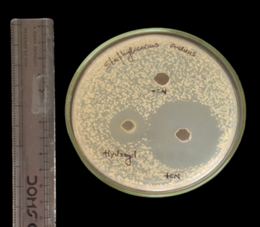

**Fig 2:Antibacterial activity of hydrogel against Staphyloccus aureus**

**b.Antifungal activity by Agar cup plate method**

**Table no.7: Antifungal activity of formulated hydrogel**

|  |  |
| --- | --- |
| **Sample mg/ml** | **Zone of inhibition**  **(mm in diameter)**  ***Candida albicans*** |
| Clotrimazole (+CN) | 32 ± 0.14 |
| Negative control (-CN) | NA |
| Hydrogel (15%) | 25 ± 0.02 |

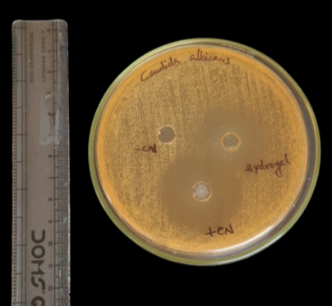

**Fig 3: Antifungal activity of hydrogel against *Candida albicans***

## In vitro wound healing activity of 15% hydrogels of methanolic extract of *Procris repens* and *Sargassum duplicatum* compared with the wound healing hydrogel available in the market by Scratch assay method

Standard hydrogel (Silverex heal gel )

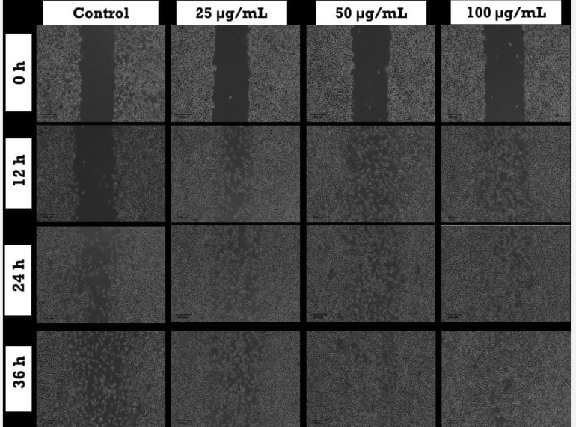

**Fig 4:Wound healing activity of Standard hydrogel ( Silverex heal gel )**

* The standard hydrogel was found to elicit significant wound healing efficacy as evidenced from the representative photomicrographs.
* The wound healing efficiency was found to be in a concentration and time dependant manner.
* The maximum efficacy was elicited by the concentration 100 µg/mL at the time duration of 36 hours.

**Average wound area**

|  |  |  |  |  |
| --- | --- | --- | --- | --- |
| **Sample**  **Concentration** | **Average Wound area (Arbitrary units)** | | | |
| **0 hours** | **12 hours** | **24 hours** | **36 hours** |
| Control | 61.4 | 56.5 | 38.5 | 24.2 |
| Standard  25 µg/mL | 59.3 | 28.0 | 26.4 | 9.9 |
| 50 µg/mL | 62.0 | 17.2 | 13.7 | 1.8 |
| 100 µg/mL | 64.6 | 13.8 | 3.2 | 0.5 |

**Table no.8: Average wound area of Standard hydrogel at different concentration**

**Graphical representation**

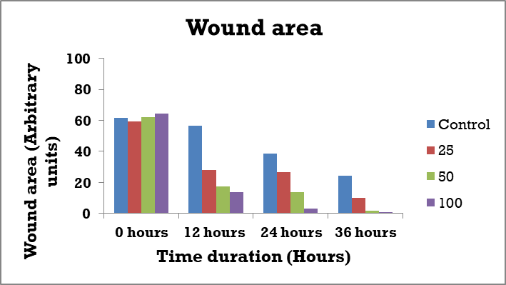

**Graph no.2: Wound area of standard hydrogel at different time period**

Significant reduction of wound area in a concentration or time dependent manner was observed. The maximum efficacy was displayed by 100 µg/mL treated cells.

**Cell migration rate**

**Table no. 9: Cell migration rate of Standard hydrogel at different concentration**

|  |  |  |  |  |
| --- | --- | --- | --- | --- |
| **Sample**  **Concentration** | **Cell Migration Rate (%)** | | | |
| **0 hours** | **12 hours** | **24 hours** | **36 hours** |
| Control | 0.0 | 8.1 | 37.3 | 60.6 |
| Standard  25 µg/mL | 0.0 | 52.8 | 55.4 | 83.3 |
| 50 µg/mL | 0.0 | 72.3 | 77.9 | 97.1 |
| 100 µg/mL | 0.0 | 78.6 | 95.1 | 99.2 |

**Graphical representation**

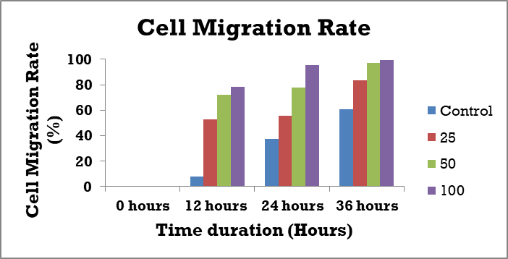

**Graph no.3: Cell migration rate of Standard hydrogel at different time period**

Cell migration was found to be enhanced in sample treated cells compared to control indicating the cell migration capacity of normal cells due to sample treatment.

**Wound healing activity of formulated hydrogel**

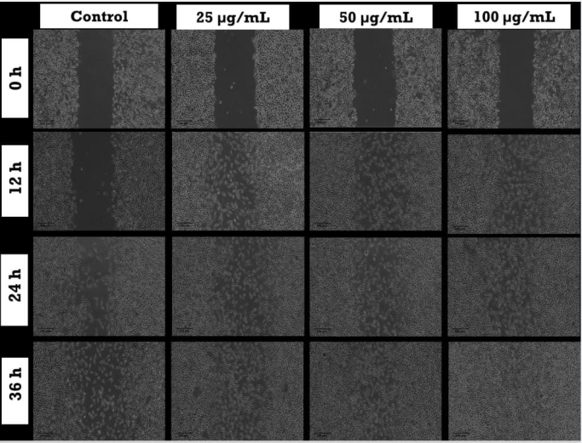

**Fig.5: Wound healing activity of formulated hydrogel**

The formulated hydrogelwas found to elicit significant wound healing efficacy as evidenced from the representative photomicrographs. The wound healing efficiency was found to be in a concentration and time dependant manner. The maximum efficacy was elicited by the concentration 100 µg/mL at the time duration of 36 hours. This is an indication that the sample can be effectively developed therapeutically as a wound healing agent.

**Average wound area**

**Table no.10: Average wound area of formulated hydrogel**

|  |  |  |  |  |
| --- | --- | --- | --- | --- |
| **Sample**  **Concentration** | **Average Wound area (Arbitrary units)** | | | |
| **0 hours** | **12 hours** | **24 hours** | **36 hours** |
| Control | 61.4 | 56.5 | 38.5 | 24.2 |
| Formulated hydrogel  25 µg/mL | 67.1 | 43.4 | 28.1 | 19.3 |
| 50 µg/mL | 64.8 | 35.6 | 17.2 | 8.6 |
| 100 µg/mL | 63.7 | 27.6 | 9.7 | 3.1 |

**Graphical Representation**

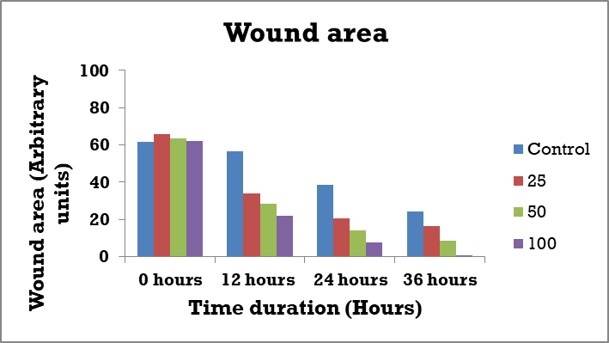

**Graph no.4: Wound area of formulated hydrogel at different time period**

Significant reduction of wound area in a concentration or time dependent manner was observed. The maximum efficacy was displayed by 100 µg/mL treated cells.

**Cell Migration Rate**

|  |  |  |  |  |
| --- | --- | --- | --- | --- |
| **Sample**  **Concentration** | **Cell Migration Rate (%)** | | | |
| **0 hours** | **12 hours** | **24 hours** | **36 hours** |
| Control | 0.0 | 8.1 | 37.3 | 60.6 |
| Formulated hydrogel  25 µg/mL | 0.0 | 35.32 | 58.12 | 71.23 |
| 50 µg/mL | 0.0 | 45.06 | 73.45 | 86.72 |
| 100 µg/mL | 0.0 | 56.67 | 84.77 | 95.13 |

**Table no.48: Cell migration rate of formulated hydrogel**

**Graphical Representation**

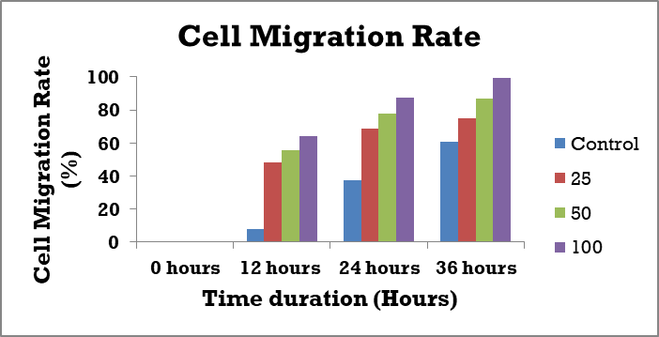

**Graph no. 11: Cell migration rate of formulated hydrogel at different time period**

Cell migration was found to be enhanced in sample treated cells compared to control indicating the cell migration capacity of normal cells due to sample treatment.

**CONCLUSION**

In the present investigation, Selected *Procris repens* plant belonging to terrestrial and *Sargassum duplicatum* seaweed from marine source. This review gives information about the formulation and evaluation hydrogel by using methanolic extract of selected plants. *Procris repens* (Lour.) B.J.Conn & Hadiah commonly known as watermelon begonia or sisik nagais a species of flowering plant in the *Urticaceae* family. Traditionally, *Procris repens* is used in Chinese medicine to treat allergic dermatitis, hepatitis and icterus. *Sargassum duplicatum* is used in traditional medicine as antidiabetic agent, anticoagulant, anti hypertensive and as an ovicidal agent against mosquito eggs, coastal communities historically used seaweeds as a source of fertilizer, food and fodder. Medicated hydrogel of methanolic extract was prepared at various concentrations. After formulation it was evaluated for various physicochemical parameters and in-vitro wound healing activity by protein denaturation inhibition method was conducted. Results shows that the hydrogel have wound healing activity and it is physically stable. The goal of this study was to formulate a herbal hydrogel that doesn't cause side effects or adverse reactions. namely F1 to F3, were formulated. On various parameters like pH, viscosity, and stability, the assessments of all formulations (F1 to F3) were performed. All three formulations showed good consistency, appearance, pH, and simple removal. The formulations secure to use for skin applications. These studies indicate the hydrogel is more stable and healthy.

**ACKNOWLEDGEMENT**

The authors are acknowledging The Chairman and Managing Trustee Sri. Mohammed Siddique K M, Jamia Salafiya Pharmacy College Pulikkal, Malappuram, Kerala, for providing all the support.

**REFERENCES**

**1.** Kokate C K, Purohit A P, Gokhale S B. Pharmacognosy. 50th edition. Pune: Nirali Prakashan; 2014. P. 1.1.

**2.**Aisyah Tri Septiana, Ari Asnani. Antioxidant activity of *Sargassum duplicatum* seaweed extract.Jurnal Teknologi Pertanian.2013;14(2):79-86.

3.Barry J. Conn, Julisasi T. Hadiah. Precursor to flora account of Procris (*Urticaceae)* in Peninsular Malaysia. Garden’s Bulletin (Singapore) 63.2011;155-162.

4.Carla Marrassini, Ignacio Peralta,Claudia Anesini. Comparative study of the polyphenol content-related anti-inflammatory and antioxidant activities of two *Urera aurantiaca* specimens from different geographical areas. Chinese medicine.2018;13-22.

5.Daniela Aros-Mualin, Carmela Rosaria Guadagno, Daniele Silvestro, Michael Kessler. Light, rather than circadian rhythm, regulates gas exchange in ferns and lycophytes. Plant physiology.2023;191(3):1634-1647.

6.Duong Thu Trang, Nguyen Hai Dang. Screening for Vietnamese plant extracts with potential benefit for anti osteoclastogenesis.Vietnam journal of science and technology. 2021; 59 (4):507-517.

7.Fitri Handajani, Sulistiana Prabowo.*Sargassum duplicatum* extract reduced arthritis severity score and periarticular tissue matrix metalloproteinase-1(Mmp-1) expression in Ajuvan arthritis exposed to cold stressor. Systematic reviews in pharmacy.2020;11(6):302-307.

8.Fitria Nikmatul Husna, Muhammed Farrah syadzha, Raden joko kuncoroningrat susilo, Suhailah hayaza, Arif nur Muhammad ansori, Mochammad amin alamsjah, Muhamad nur ghoyatul amin, Pugar arga Christina wulandari, Pratiwi pudjistuti and Khalijah awing. Topical administration effect of *Sargassum duplicatum* and Garcinia mangostana extracts combination on open wound healing process in diabetic mice. Scientifica.2022;11(9):1-7.

9.Roza V.Usoltseva, Stanislav D. Anastyuk, Natalia M.Shevchenko, Valerii V.Surits, Artem S.Silchenko, Vldimir V.Isakov, Tatiana N.Zvyagintseva, Pham Duc Thih, SS vetlana P.Ermakova.Polysaccharides from brown algae *Sargassum duplicatum*: the structure and anticancer activity invitro. Carbohydrate polymers.2017;175:547-556.

10.Subramanian D, Thilagavathy A. Cytotaxonomical studies of South Indian Urticaceae. Cytologia,1988;53(4):671-678.

11.Su-Tuen Yeh, Chiu-Sha Lee, Jiann-Chu Chen.Administration of hot-water extract of brown seaweed *Sargassum duplicatum* via immersion and injection enhances the immune resistance of white shrimp *Litopenaeus vannamei*.Fish and Shellfish Immunology.2006;20(3):332-345.

12.Yinggang Luo,Yan Liu,Huayi Qi,Guolin Zhang.A new glucoceramide from the watermelon begonia, *Pellonia repens*. Chinese academy of sciences.2004; Lipids 39(10)

13.The amount of total phenols in the plant tissues was estimated by the method proposed by Mallick and Singh (1980).

14.Meda, C. E. Lamien, M. Romito, J. Millogo, and O. G. Nacoulma, “Determination of the total phenolic, flavonoid and proline contents in Burkina Fasan honey, as well as their radical scavenging activity,” *Food Chemistry*, vol. 91, no. 3, pp. 571–577,2005.

15.Lee Wei Har, IntanSafinar Ismail. Antioxidant activity, total phenolics and total flavonoids of Syzygiumpolyanthum (Wight) Walp leaves. Int J Med Arom Plants. 2012; 2(2): 219-228.

16. FazelShamsa, HamidrezaMonsef, RouhollahGhamooshi, MohammadrezaVerdian-rizi. Spectrophotometric determination of total alkaloids in some Iranian medicinal plants. Thai J Pharm Sci. 2008; 32: 17-20.

17. Quantitative estimation of total phenolic, flavonoids, tannin and chlorophyll content of leaves of Strobilanthes Kunthiana (Neelakurinji) KC CI, G Indira - Journal of Medicinal Plants Studies 2016; 4(4): 282-2.

18. Chen, Y.F., Yang, C.H., Chang, M.S., Ciou, Y.P. and Huang, Y.C., 2010. Foam properties and detergent abilities of the saponins from Camellia oleifera. International Journal of Molecular Sciences, 11(11), pp.4417-4425.

19. Solich P, Sedliakova V, Karlicek R. Spectrophotometric determination of cardiac glycosides by flow-injection analysis. Anal ChimActa. 1992; 269(2): 199-203.

20.Tofighi, Z., A. Hadjiakhoondi, and N. Yassa. "Determination of cardiac glycosides and total phenols in different generations of Securigerasecuridaca suspension culture." Research Journal of Pharmacognosy 3.2 (2016): 23-31.

21. Zak, B., dickenman RC, White, eG, Burnetth., and Cherney, pJ. (1954). rapid estimation of free and total cholesterol. Am. J. Clin.path. 24:1307.

22.Musa, W. J., Situmeang, B., & Sianturi, J. (2019). Anti-cholesterol triterpenoid acids from Saurauia vulcani Korth.(Actinidiaceae). *International journal of food properties*, *22*(1), 1439-1444.