**AUTONOMOUS VEHICLE CONTROL, PART V: CAR SIDESLIP ANGLE CONTROL USING P-D, I-FIRST ORDER COMPENSATORS AND PD-PI, 2DOF-2 CONTROLLERS COMPARED WITH A PID CONTROLLER**

**Galal Ali Hassaan**

Emeritus Professor, Department of Mechanical Design and Production, Faculty of Engineering, Cairo University, Cairo, Egypt

**ABSTRACT**

This research paper investigates the control of an autonomous car sideslip angle using two compensators and two controllers from the second generation of compensators and controllers presented by the author since 2014. The proposed compensators and controllers are tuned for the best possible performance of the control system incorporating them and the time-based specifications of the control system are outlined. The step time response of the control system using the proposed compensators/controllers is compared with that of a PID controller tuned in a previous work in one of the references. A graphical and quantitative comparison of the step time response and the time-based characteristics is performed to assess the selection of the best compensator/controller suitable for the control of the car sideslip angle.

**Keywords:** Autonomous vehicle control, sideslip angle control, P-D compensator, I-first order compensator, PD-PI controller, 2DOF controller.

1. **INTRODUCTION**

The sideslip angle of road-vehicles is an important variable affecting the stability and safety of the vehicle during the steering process. Its control helps in achieving smooth driving and save maneuvering without accidents. This paper is the fifth in a series aiming at controlling autonomous vehicles. It aims at proposing a number of control compensators and controllers from the second generation presented by the author since 2014. First of all we take an idea about some of the research work about this important subject conducted during the last 23 years.

Kim and You (2001) presented an estimation method for sideslip angle through using an unknown disturbance observation technique for four wheels passenger cars. They transformed the vehicle dynamics into a linear state-space model considering the external disturbances. They verified the estimated sideslip angle using numerical simulation [1]. Vilaplana, Mason, Leith and Leithead (2003) presented a steering controller to enable four-wheel vehicles to display predefined steering characteristics. The controller commanded front and rear steering angle for tracking reference steering yaw rate and sideslip angle signals. They designed the controller to reject disturbances in yaw rate and sideslip [2]. Caroux, Lamy, Basset and Gissinger (2007) investigated a low cost solution for the problem of using very expensive sensors for sideslip angle measurement. They used two different observers: a bicycle observer and another observer based on roll dynamics. They conducted experimental characterization on a specific test bench and compared the different sideslip angle measurement solutions with real tests on a laboratory experimental car [3]. Kim and Ryu (2011) stated that ‘the detection of sliding and skidding is especially critical in emerging situations’. They proposed a method for slideslip angle estimation considering severe longitudinal velocity variation over a short period of time during which the vehicle may lose stability due to sliding or spinning. They used an extended Kalman filter based on a kinematic model. Simulation evaluations and on-road tests showed that their proposed estimation could accurately predict the sideslip angle [4].

Chen and Wang (2013) proposed an estimation method for establishing the vehicle sideslip angle. They estimated the longitudinal ground friction force using a PID observer and the lateral ground friction force for each wheel. Their method was specially proposed for large tire slip angles and lateral friction forces [5]. Li, Du and Zhang (2015) proposed various control strategies to improve vehicle handling and stability performance. They developed an innovative sideslip angle estimation method for an omni-vehicle with in-wheel steering motors to construct a sideslip angle controller and to determine the friction limit criterion. They developed also an optimal steering and driving actuator distribution and control to improve the response of the yaw rate and sideslip angle [6]. Zhang and Zhao (2018) studied the yaw rate and sideslip angle of a vehicle through a PID control algorithm and the genetic optimization PID control algorithm. They claimed that the overshoot was significantly reduced improving the stability of the vehicle during steering [7]. Tang et al. (2020) proposed a path tracking control method designed using a kinematic model predictive control (MPC) to handle the disturbance on road curvature, PID feedback control of yaw rate to reject uncertainties and modeling error and sideslip angle compensator to correct the kinematic model prediction. Their proposed controller performance covered steady-state and transient responses and robustness. They concluded that the proposed controller significantly improved the performance of path tracking [8].

Sawaqed and Rabba (2022) proposed a concurrent yaw rate, sideslip angle and longitudinal velocity direct yaw moment control strategy. They developed three control schemes: fuzzy controllers, optimized PID controllers and fuzzy controllers for yaw rate and sideslip angle with PID controller for the longitudinal velocity. They concluded that the proposed fuzzy controllers reduced the consumed energy by 10 % and decreased both yaw rate and sideslip angle deviation [9]. Li et al. (2023) presented a state observer derived from the extended Kalman filter to estimate the vehicle sideslip angle. They established the transfer function between sideslip angle-steering torque and sideslip angle-steering angle. They validated their proposed method through simulation showing good reliability and effectiveness [10]. Tufano et al. (2024) proposed a strategy based on integrating multiple model (IMM) filters. They developed two IMM algorithms based on the extended Kalman filter and unscented Kalman filter. They evaluated the effectiveness of the proposed methods using a Monte Carlo analysis using an accurate 15-DOF vehicle model and tested the IMM based estimation strategy using two realistic driving scenarios [11].

1. **CONTROLLED CAR SIDESLIP ANGLE**

Zainal, Rahiman and Baharom investigated the control of yaw rate and sideslip angle of a vehicle using a PID controller for double lane changing [12]. They presented two models for the sideslip angle at vehicle speeds of 40 and 90 km/h, Gp40(s) and Gp90(s) as follows:

Gp40(s) = (31.2s+369.3) / (s2+20s+117) (1)

And Gp90(s) = 29.4s+137.6) / (s2+8.9s+45.6) (2)

To understand the need of this process to control, its dynamics will be investigated through the plotting of its time response to a unit step input using the MATLAB command ‘*step*’ [13] which is given in Fig.1 showing also a sideslip angle limit of 4 degrees [14].

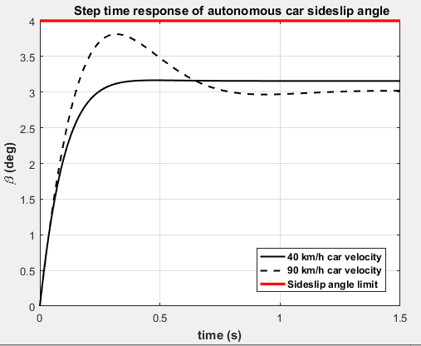

**Figure 1:** Unit step time response of car sideslip angle.

COMMENTS:

The sideslip angle as a car-process to be controlled has the transient and steady-state characteristics:

* Maximum overshoot: 0.305 % for 40 km/h and 26.235 % for 90 km/h velocity.
* Settling time: 0.294 s for 40 km/h and 0.7025 s for 90 km/h velocity.
* Steady-state error of -2.1564 deg for 40 km/h and -2.0205 deg for 90 km/h velocity.
* Severe bad dynamics is practice at the high velocity of 90 km/h which represents a real challenge for any proposed compensator/controller.

1. **CONTROLLING THE SIDESLIP ANGLE USING A P-D COMPENSATOR**

The P-D compensator was used by the author as one of the second generation control compensators presented by him since 2014. He used a P-D compensator to control a highly oscillating second-order-like process [15], car longitudinal velocity [16] and car yaw rate [17]. The block diagram of the control system comprising a P-D compensator to control the car sideslip angle is shown in Fig.2 [15]. It has a proportional control mode in the feedforward path [of Gc1(s) transfer function] and a derivative control mode in the feedback path [of Gc2(s) transfer function] of the single-loop block diagram of Fig.2. Both elements have the transfer functions:

Gc1(s) = Kpc , Gc2(s) = Kds (3)

Where Kpc and Kd are the gain parameters of the compensator.

The compensator parameters are tuned as follows:

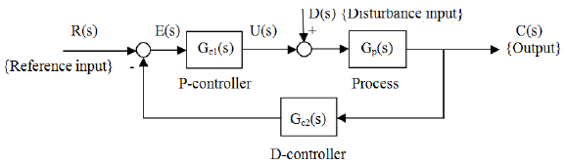

**Figure 2:** P-D compensator controlling sideslip angle [15].

* The transfer function of the closed-loop control system is derived from the block diagram using Eq.2 for the sideslip angle with car speed of 90 km/h (since it has the worst dynamics) and Eq.3 for the compensator.
* This transfer function will reveal a non-zero steady-state error because of the nature of the derivative control action. A constraint is set here to attain a zero steady-state error using the derived closed-loop transfer function. This step yields the proportional gain of the P-D compensator having:

Kpc = 0.331395 (4)

* Few trials for the derivative compensator gain Kd produced reasonable step time response with good characteristics. The selected gain Kd has the value:

Kd = 0.40 (5)

* The unit step time response of the control system using the P-D compensator is obtained using the transfer function derived from the block diagram in Fig.2 and the compensator gain parameters in Eqs.4 and 5 and shown in Fig.3.

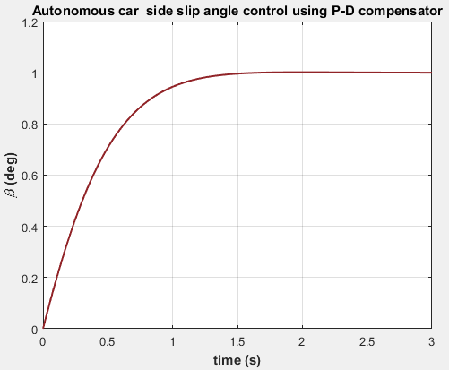

**Figure 3:** Unit step time response of car sideslip angle using a P-D compensator.

COMMENTS:

The sideslip angle controlled by a P-D compensator has the transient and steady-state characteristics for 90 km/h car velocity:

* Maximum overshoot: 0.165 %
* Settling time: 1.232 s
* Steady-state error: -0.00028 deg

1. **CONTROLLING THE SIDESLIP ANGLE USING AN I-FIRST ORDER COMPENSATOR**

The I-first order compensator was introduced by the author as one of the second generation control compensators presented by him since 2014. He used this compensator as one of four proposed compensators to control the longitudinal velocity of an autonomous car [16]. The block diagram of the control system comprising an I-first order compensator to control the car sideslip angle is shown in Fig.4 [16]. It has an integral control mode of transfer function Gc1(s) in cascade with a first-order control mode of transfer function Gc2(s) in the feedforward path of the single-loop block diagram of the control system. Both elements have the transfer functions:

Gc1(s) = Ki/s , Gc2(s) = (1+Tzs)/(1+Tps) (6)

Where Ki , Tz and Tp are the gain parameters of the compensator.

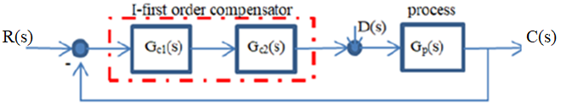

**Figure 4:** I-first order compensator controlling sideslip angle [16].

The I-first order compensator is tuned as follows:

* The transfer function of the closed-loop control system is derived from the block diagram of Fig.4 using Eq.2 for the sideslip angle with car speed of 90 km/ and Eq.6 for the compensator.
* A performance index is assigned to be minimized as function of the control system error. This is selected as the ITAE performance index [18].
* The MATLAB optimization toolbox is used to minimize the ITAE performance index and tune the compensator parameters [19]. The tuning results are as follows:

Ki = 2.146100 ; Tz = 0.078983 s ; Tp = 0.0136583 (7)

The unit step time response of the control system for car sideslip angle control using the I-first order compensator is shown in Fig.5 as generated by the MATLAB ‘step’ command [13].

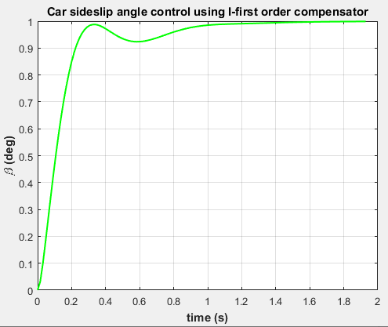

**Figure 5:** Unit step time response of car sideslip angle using a I-first order compensator.

COMMENTS:

The sideslip angle controlled by an I-first order compensator has the transient and steady-state characteristics for 90 km/h car velocity:

* Maximum overshoot: zero
* Settling time: 0.933 s
* Steady-state error: 0.0011 deg

1. **CONTROLLING THE SIDESLIP ANGLE USING A PD-PI CONTROLLER**

The author introduced the PD-PI controller within a series of controllers proposed for the second generation of PID controllers and used to effectively control difficult processes since 2014. He applied the PD-PI controller to control various processes and compared their effectiveness with that of controllers from the first generation of PID controllers [20] to [43]. The PD-PI controller is composed of a PD control mode cascaded with a PI control mode in the feedforward path of a single-loop block diagram of the control system just after the error detector. The PD-PI controller has the transfer functions GPD(s) and GPI(s) given by:

GPD(s) = Kpc1+Kds and GPI(s) = Kpc2+(Ki/s) (8)

Where Kpc1, Kd, Kpc2 and Ki are the four gain parameters of the PD-PI controller.

* The four gain parameters of the PD-PI controller are tuned first manually using some trial values for the controller gain parameters and checking the time-based characteristics of the control system. It was found that the PD-PI controller does not need optimization algorithms to tune its gain parameters. One of the excellent set of gain parameters tried is as follows:

Kpc1 = 70 ; Kd = 0.001 ; Kpc2 = 2 ; Ki = 0.2 (9)

* The unit step time response of the control system for the sideslip angle using the proposed PD-PI controller using its gain parameters in Eq.9 is shown in Fig.6.

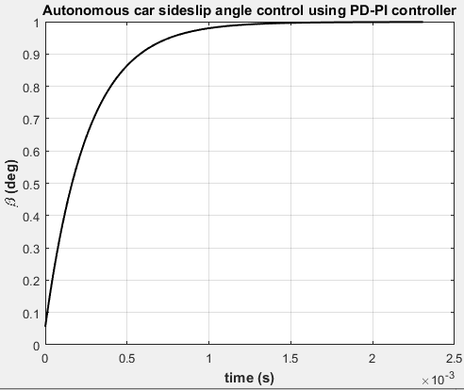

**Figure 6:** Unit step time response of car sideslip angle using a PD-PI controller.

COMMENTS:

The sideslip angle controlled by a PD-PI controller has the transient and steady-state characteristics for 90 km/h car velocity:

* Maximum overshoot: zero
* Settling time: 1.0035 ms
* Steady-state error: zero

1. **CONTROLLING THE SIDESLIP ANGLE USING A 2DOF-2 CONTROLLER**

The author introduced the 2DOF controller within a series of controllers proposed for the second generation of PID controllers and used to effectively control difficult processes since 2014. He applied various structures for the 2DOF controller to control various processes and compared their effectiveness with that of controllers from the first generation of PID controllers [25], [27]-[29] and [31]-[46]. The 2DOF controller structure proposed here is composed of a feedforward PI control mode of Gff(s) transfer function and a feedback PID control mode of Gc(s) transfer function located as shown in Fig.7 [47].

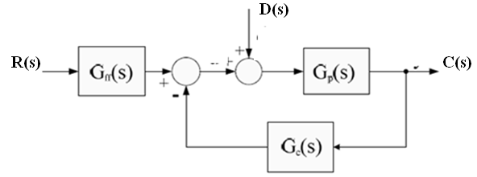

**Figure 7:** 2DOF-2 controller controlling sideslip angle [47].

The 2DOF-2 controller has the transfer functions Gff(s) and Gc(s) given by:

Gff(s) = Kpc1 + (Kis) and Gc(s) = Kpc2 + (Ki/s) + Kds (10)

Where Kpc1, Ki, Kpc2 and Kd are the four gain parameters of the 2DOF-2 controller.

* The transfer function of the control system comprising the 2DOF-2 controller and the sideslip angle process is derived using the block diagram in Fig.6.
* The 2DOF-2 controller is tuned following the same optimization procedure used with the I-first order compensator and PD-PI controller. The tuning results are as follows:

Kpc1 = 0.2863592 ; Ki = 5.1279155 ; Kpc2 = 0.3653716 ; Kd = -0.0049780 (11)

* The unit step time response of the car sideslip angle for reference input tracking is shown in Fig.7 as generated by the ‘step’ command of MATLAB [13] using the transfer function of the control system and the 2DOF-2 gain parameters in Eq.11.

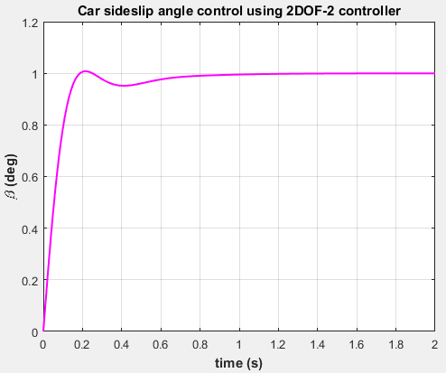

**Figure 8:** Unit step time response of car sideslip angle using a 2DOF-2 controller.

COMMENTS:

The sideslip angle controlled by a 2DOF-2 controller has the transient and steady-state characteristics for 90 km/h car velocity:

* Maximum overshoot: 1.444 %
* Settling time: 0.630 s
* Steady-state error: 0.0001 deg

1. **CONTROLLING THE SIDESLIP ANGLE USING A PID CONTROLLER**

* The PID controller is used here for sake of comparison purposes between controllers from the second generation of PID controllers and those from the first generation.
* Zainal, Rahiman and Baharom [12] tuned PID controllers to control the sideslip angle of a vehicle modeled at velocity of 40 and 90 km/h. Their PID tuned parameters for a 90 km/h velocity were [12]:

Kpc = 0.57 , Ki = 7 , Kd = 0.01 (12)

* The unit step time response of the controlled sideslip angle for reference input tracking using the control system transfer function using PID controller and the controller parameters in Eq.12 is generated using the ‘step’ command of MATLAB [13] and given in Fig.9.

COMMENTS:

The sideslip angle controlled by a PID controller has the transient and steady-state characteristics for 90 km/h car velocity:

* Maximum overshoot: 4.501 %
* Settling time: 0.576 s
* Steady-state error: zero

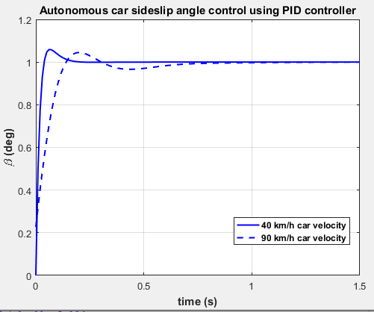

**Figure 9:** Unit step time response of car sideslip angle using a PID controller for 40 and 90 km/h car velocity.

1. **COMPARISON OF PROPOSED COMPENSATORS/CONTROLLERS WITH A PID CONTROLLER**

The time response of the control system using P-D, I-first order compensators and PD-PI, 2DOF, PID controllers is compared graphically in Fig.10 for reference input tracking of 3.5 deg step magnitude showing a 4 deg limit for the sideslip angle.

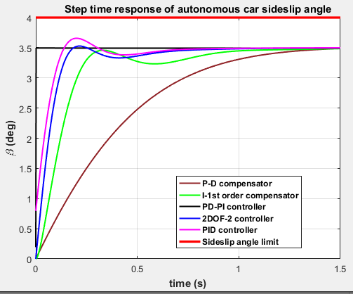

**Figure 10:** Comparison of the step time response of car sideslip angle at 90 km/h car velocity.

A quantitative comparison for the time-based characteristics of the step time response of the control systems proposed for the control of car sideslip angle is presented in Table 1.

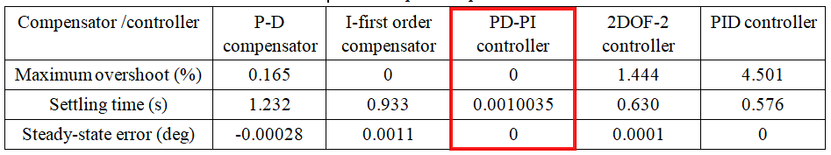**Table 1.** Quantitative characteristics comparison for sideslip angle control.

1. **CONCLUSION**

* The paper investigated the control of the sideslip angle of a car using some compensators and controllers from the second generation of compensators and PID controllers.
* Two tuning techniques for compensator/controller tuning were applied: achieving specific performance measures and using the MATLAB optimization toolbox.
* The performance of the proposed compensators/controllers were compared with that of using a PID controller from the first generation of PID controllers presented and tuned in one of the paper references.
* The P-D compensator succeeded to control the sideslip angle providing 0.165 % maximum overshoot compared with 4.501 % for the PID controller and a steady-state error less than 0.0003 deg.
* The I-first order compensator succeeded to control the sideslip angle providing zero maximum overshoot compared with 4.501 % for the PID controller and a steady-state error less than 0.0012 deg.
* The PD-PI controller succeeded to control the sideslip angle providing zero maximum overshoot compared with 4.501 % for the PID controller and a settling time less than 1 ms compared with 0.576 s for the PID controller.
* The 2DOF-2 controller succeeded to control the sideslip angle providing 1.444 % maximum overshoot compared with 4.501 % for the PID controller and a steady-state error of 0.0001 deg.
* Based on the above comparison of the time based characteristics of the proposed compensators/controllers, the PD-PI controller was choses as the best controller/compensator to control the sideslip angle of the car.

1. **REFERENCES**
2. H. Kim and S. You, “Estimation of vehicle sideslip angle for four-wheel steering passenger cars,” Transactions on Control, Automation and Systems Engineering, Vol. 3, Issue 2, 2001, pp. 72-76.
3. M. Vilaplana, O. Mason, D. Leith and W. Leithead, “Control of yaw rate and sideslip in 4-wheel steering cars with actuator constraints,” European Summer School on Multi-Agent Control, 2003, pp. 201-222.
4. J. Caroux, C. Lamy, M. Basset and G. Gissinger, “Sideslip angle measurement, experimental characterization and evaluation of three different principles,” IFAC Proceedings Volumes, Vol. 40, Issue 15, 2007, pp. 505-510.
5. H. Kim and J. Ryu, “Sideslip angle estimation considering short-duration longitudinal velocity variation,” International Journal of Automotive Technology, Vol. 12, Issue. 4, 2011, pp. 545-553.
6. Y. Chen and J. Wang, “robust sideslip angle estimation for over-actuated electric vehicle: A linear parameter varying system approach”, Proceedings of the ASME Dynamic Systems and Control, Vol. 3, Issue 9, 2013, 9 pages.
7. B. Li, H. Du, W. Li and Y. Zhang, “Sideslip angle estimation based on lateral dynamics model for omni-directional vehicles with optimal steering angle and traction/brake torque distribution,” Mechatronics, Vol. 30, 2015, pp. 348-362.
8. R. Zhang and B. Zhao, “Simulation research on PID control of automotive stability based on genetic algorithm optimization,” Open Access Library Journal, Vol.5, 2018, 8 pages.
9. L. Tang, et al., “An improved kinematic model predictive control for high speed path tracking of autonomous vehicles,” IEEE Access, Vol.8, 2020, pp. 51400-51413.
10. L. Sawaqed and I. Rabba, “Fuzzy yaw rate and sideslip angle direct yaw moment control for student electric racing vehicle with independent motors,” World Electric Vehicle Journal, Vol. 13, Issue 109, 2022, 12 pages.
11. Y. Li et al., “Estimation of intelligent commercial vehicle sideslip angle based on steering torque,” Applied Sciences, Vol. 13, Issue 7974, 2023, 15 pages.
12. F. Tufano, et al., “Vehicle sideslip angle estimation under critical road conditions via nonlinear Kalman filter-based state-dependent interacting multiple model approach,” Control Engineering Practice, Vol.146, 2024, 17 pages.
13. Z. Zainal, W. Rahiman and M. Baharom, “Yaw rate and sideslip angle control using PID controller for double lane changing,”, Journal of Telecommunication, Electronics and Computer Engineering, Vol. 9, 2017, pp. 99-103.
14. Mathworks, “Step response of dynamic system”, https://www.mathworks.com/help/control/ref/dynamicsystem.step.html , 2024.
15. M. Abe and W. Manning, “Tire mechanics”, in “Vehicle handling dynamics”, 2009, https://www.sciencedirect.com/topics/engineering/sideslip-angle
16. G. A. Hassaan, “Tuning of a novel P-D compensator to control a highly oscillating second-order-like process,” International journal of Emerging Engineering Research and Technology, Vol.10, Issue 1, 2022, pp. 1-7.
17. G. A. Hassaan, “Autonomous vehicle control, Part I: Car longitudinal velocity control using P-D, I-first order and notch compensators compared with a PID controller,” International journal of Research Publication and Reviews, Vol.5, Issue 9, 2024, pp. 224-344.
18. G. A. Hassaan, “Autonomous vehicle control, Part IV: Car yaw rate control using P-D, I-second order compensators and PD-PI, 2DOF-2 controllers compared with a PID controller,” World journal of Engineering Research and Technology, 2024, Accepted for publication.
19. A. Shuaib and M. Ahmed, “Robust PID control system design using ITAE performance index (DC motor control),” International journal of Innovative Research in Science, Engineering and Technology, Vol3, Issue 8, 2014, pp. 15060—15067.
20. M. Ancaw, “Practical optimization with MATLAB,” Cambridge Scholars Publishing, 2019.
21. G. A. Hassaan, “Tuning of PD-PI controller used with first-order delayed process”, International Journal of Engineering Research and Technology, vol.3, issue 4, pp.51-55, 2014.
22. G. A. Hassaan, “Tuning of PD-PI controller used with a highly oscillating second-order process”, International Journal of Science and Technology Research, vol.3, issue 7, 2014, pp.145-147.
23. G. A. Hassaan, “Tuning of PD-PI controller used with an integrating plus time delay process”, International Journal of Scientific & Technical Research, vol. 3, issue 9, 2014, pp. 309-313.
24. G. A. Hassaan, “Controller tuning for disturbance rejection associated with delayed double integrator process, Part I: PD-PI controller”, International Journal of Computer Techniques, vol.2, issue 3, 2015, pp.110-115.
25. G. A. Hassaan, “Tuning of PD-PI controller used with a third-order process”, International Journal of Application or Innovation in Engineering Management, vol.9, issue 8, 2020, pp.6-12.
26. G. A. Hassaan, “Control of a boost-glide rocket engine using PD-PI, PI-PD and 2DOF controllers”, International Journal of Research Publication and Reviews, vol.4, issue 11, 2023, pp.913-923.
27. G. A. Hassaan, “Control of rocket pitch angle using PD-PI controller, feedback first-order compensator and I-PD compensator”, International Journal of Computer Techniques, vol.11, issue 1, 2024, 8 pages.
28. G. A. Hassaan, “Liquefied natural gas tank pressure control using PID, PD-PI, PI-PD and 2DOF controllers”, World Journal of Engineering Science and Technology, Vol.10, Issue 2, 2024, pp.18-33.
29. G. A. Hassaan, “Control of boiler temperature using PID, PD-PI and 2DOF controllers”, International Journal of Research Publication and Reviews, Vol.5, Issue 1, 2024, pp.5054-5064.
30. G. A. Hassaan, “Control of Boiler-drum water level using PID, PD-PI, PI-PD and 2DOF controllers”, International Journal of Engineering and Techniques, Vol.10, Issue 1, 2024, 10 pages.
31. G. A. Hassaan, “Tuning of PD-PI and PI-PD controllers to control the internal humidity of a greenhouse”, International Journal of Engineering and Techniques, Vol.9, Issue 4, 2023, 9 pages.
32. G. A. Hassaan, “Tuning of controllers for reference input tracking of coupled-dual liquid tanks”, World Journal of Engineering Science and Technology, vol.8, issue 2, 2022, pp.86-101.
33. G. A. Hassaan, “Tuning of controllers for reference input tracking of a BLDC motor”, International Journal of Progressive Research in Engineering, Management and Science, Vol.2, Issue 4, 2022, pp.5-14.
34. G. A. Hassaan, “Furnace control using I-PD, PD-PI and 2DOF controllers compared with fuzzy-neural controller”, International Journal of Computer Techniques, Vol.11, Issue 2, 2024, 10 pages.
35. G. A. Hassaan, “Control of an electro-hydraulic drive using PD-PI, PI-PD and 2DOF-2 controllers compared with a PID controller”, International Journal of Engineering and Techniques, Vol.10, Issue 2, 2024, 10 pages.
36. G. A. Hassaan, “Thermoplastics injection molding machine control, Part II: Barrel temperature control using PD-PI, PI-PD and 2DOF-2 controllers compared with ANN-PI controller”, International Journal of Engineering and Techniques, Vol.10, Issue 3, 2024, pp.6-15.
37. G. A. Hassaan, “Thermoplastics injection molding machine control, Part IV: Mold packing pressure control using I-PD, PD-PI, PI-PD and 2DOF-2 controllers compared with an adaptive IMC controller”, World Journal of Engineering Research and Technology, Vol.10, Issue 6, 2024, pp.94-114.
38. G. A. Hassaan, “Thermoplastics injection molding machine control, part V:Ram velocity control using I-PD, PD-PI, PI-PD and 2DOF-3 controllers compared with improved PID controller”, International Journal of Computer Techniques, vol.11, issue 3, 2024, pp.42-52.
39. G. A. Hassaan, “Thermoplastics injection molding machine control, part VI: Full-electric injection molding machine control using PD-PI, PI-PD and 2DOF-4 controllers compared with a PI controller”, International Journal of Engineering and Techniques, vol.10, issue 3, 2024, pp.157-166.
40. G. A. Hassaan, “Power turbines control, part I: Al-Jazari turbine control using I-PD, PD-PI, 2DOF-3 and PI-PD controllers compared with a PI controller”, International Journal of Research Publication and Reviews, Vol.5, Issue 7, 2024, pp.175-186.
41. G. A. Hassaan, “Power turbines control, part II: Banu Musa axial turbine power control using PD-PI, PI-PD and 2DOF-3 controllers compared with a PI controller”, International Journal of Engineering and Techniques, vol.10, issue 4, 2024, pp.86-97.
42. G. A. Hassaan, “Power turbines control, part III: Wind turbine speed control using PD-PI, PI-PD and 2DOF-3 controllers compared with a PI controller”, International Journal of Computer Techniques, vol.11, issue 4, 2024, pp.11-21.
43. G. A. Hassaan, “Power turbines control, part IV: Steam turbine speed control using 2/2 second-order, I-PD compensators and PD-PI, 2DOF-3 controllers compared with a PI controller”, World Journal of Engineering Research and Technology, Vol.10, Issue 9, 2024, pp.112-132.
44. G. A. Hassaan, “Autonomous vehicle control, part II: Car steering angle control using PD-PI, PI-PD and 2DOF-3 controllers compared with a PID controller”, International Journal of Engineering and Techniques, Vol.10, Issue 5,2024, pp.1-12.
45. G. A. Hassaan, “Tuning of a 2DOF PI-PID controller for use with second-order-like process”, International Journal of Computer Techniques, Vol.5, Issue 5, 2018, pp.67-73.
46. G. A. Hassaan, “Liquefied natural gas tank level control using PD-PI, I-PD and 2DOF controllers compared with PID control”, World Journal of Engineering Research and Technology, Vol.10, Issue 1, 2024, pp.13-24.
47. G. A. Hassaan, “Thermoplastics injection molding machine control, Part III: Cavity gate pressure control using I-PD, PD-PI, 2DOF-2 controllers and I-P compensator compared with PID controller”, International Journal of Research Publication and Reviews, Vol.5, Issue 5, 2024, pp.4387-4398.
48. G. A. Hassaan, “Thermoplastics injection molding machine control, Part V: Ram velocity control using I-PD, PD-PI, PI-PD and 2DOF-3 controllers compared with improved PID controller”, International Journal of Computer Techniques, Vol.11, Issue 3, 2024, pp.42-52.

**BIOGRAPHY**

***GALAL ALI HASSAAN***

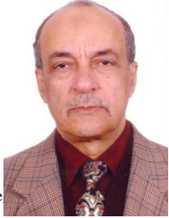

* Emeritus Professor of System Dynamics and Automatic Control.
* Has got his B.Sc. and M.Sc. from Cairo University in 1970 and 1974.
* Has got his Ph.D. in 1979 from Bradford University, UK under the supervision of Late Prof. John Parnaby.
* Now with the Faculty of Engineering, Cairo University, EGYPT.
* Research on Automatic Control, Mechanical Vibrations, Mechanism Synthesis and History of Mechanical Engineering.
* Published more than 340 research papers in international journals and conferences.
* Author of books on Experimental Systems Control, Experimental Vibrations and Evolution of Mechanical Engineering.
* Member of the Editorial Board of some engineering and computer technology international journals.
* Reviewer in some international journals.
* Scholars interested in the authors publications can visit:

**http://scholar.cu.edu.eg/galal**