**REVIEW ON THE ANTI-TUBERCULAR ACTIVITY OF *CLERODENDRUM PANICULATUM***

**Archana S1*, Marva Ashraf2, Manikkan Ruby3, Saranya S P4**

**Nehru College of Pharmacy, Pampady,Thrissur , Kerala**

**Corresponding author*:** [**archanaperumballil@gmail.com**](mailto:archanaperumballil@gmail.com)

**ABSTRACT:**  
Tuberculosis (TB) continues to be a major global health challenge, particularly in developing countries, necessitating the exploration of new therapeutic agents. *Clerodendrum paniculatum*, a member of the Lamiaceae family, has garnered attention for its potential pharmacological properties, including anti-tubercular activity. This review aims to consolidate existing knowledge on the anti-tubercular properties of *C. paniculatum*, focusing on its phytochemical constituents, mechanisms of action, and the efficacy of its extracts in combating *Mycobacterium tuberculosis*. The article also discusses current gaps in research and future directions for utilizing this plant as a potential source of novel anti-tubercular agents.

**Keywords:** *Clerodendrum paniculatum , Mycobacterium tuberculosis,* Anti-tubercular activity, Phytochemicals

**INTRODUCTION:**

Tuberculosis (TB), caused by the bacterium *Mycobacterium tuberculosis*, remains a major global health concern, particularly in developing countries where it significantly contributes to morbidity and mortality rates. The World Health Organization (WHO) estimates that approximately 10 million people fell ill with TB in 2019, highlighting the urgent need for novel therapeutic strategies, especially in the face of rising drug resistance against conventional anti-TB medications such as isoniazid and rifampicin . Traditional medicinal plants have gained renewed interest in recent years as potential sources of new anti-tubercular agents. Among these, *Clerodendrum paniculatum*, commonly referred to as Pagoda flower, has emerged as a promising candidate due to its rich ethnomedical history and diverse range of bioactive compounds. Native to tropical and subtropical regions, particularly in India and Southeast Asia, *C. paniculatum* has been traditionally employed to treat various ailments, including inflammatory conditions and fevers, indicating its potential therapeutic value .

Phytochemical analysis of *C. paniculatum* has revealed a plethora of bioactive constituents, including flavonoids, terpenoids, and alkaloids, known for their antimicrobial and anti-inflammatory properties . Research suggests that extracts from different parts of the plant exhibit significant inhibitory effects against *Mycobacterium tuberculosis*, thus warranting further investigation into their pharmacological potential . This review article aims to provide a comprehensive overview of the botanical characteristics, phytochemical profile, and anti-tubercular activity of *Clerodendrum paniculatum*, as well as to explore synergistic effects with conventional TB treatments. By understanding the intricate mechanisms through which these compounds exert their effects, we can pave the way for the development of effective, plant-based therapeutics that may offer a viable alternative or complement to current anti-TB strategies .

**Botanical Overview of *Clerodendrum paniculatum*:**

*Clerodendrum paniculatum*, commonly known as Pagoda flower or Volkameria, belongs to the Lamiaceae family, a large family of flowering plants known for its aromatic herbs and shrubs. This perennial shrub is native to tropical and subtropical regions of Asia, particularly in countries like India, Sri Lanka, Malaysia, and parts of Africa. *C. paniculatum* typically grows to a height of 1-3 meters and is characterized by its erect, woody stems and opposite, ovate leaves that can reach lengths of 10-15 cm. The foliage is dark green and has a glossy appearance, contributing to its ornamental value in gardens and landscapes.

The most striking feature of *C. paniculatum* is its inflorescence, which consists of clusters of tubular flowers that can vary in color from red to orange or yellow. These flowers are highly attractive to pollinators, particularly butterflies and bees, due to their vibrant colors and nectar-rich structure. Flowering typically occurs throughout the year in suitable climates, making it a popular choice in horticulture. The plant also produces small, round, and black berries that are not considered edible but play a role in the plant's reproductive cycle.

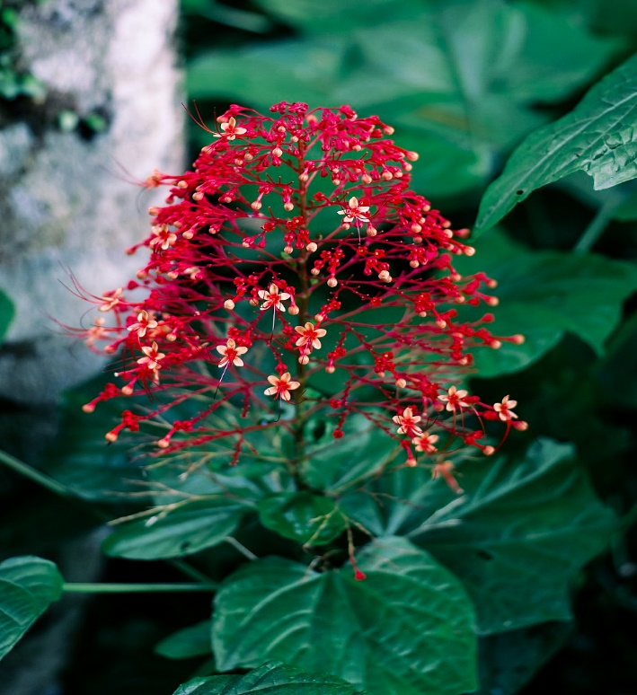Traditionally, various parts of *C. paniculatum*, including the leaves, flowers, and roots, have been utilized in folk medicine for treating a range of ailments, such as fevers, inflammation, and digestive issues. This historical use suggests the presence of bioactive compounds with potential therapeutic properties. The ethnobotanical significance of *C. paniculatum* is supported by various studies highlighting its antimicrobial, anti-inflammatory, and antioxidant activities, positioning it as a candidate for further pharmacological research, especially regarding its efficacy against infectious diseases like tuberculosis.

**Clerodendrum paniculatum**

**Phytochemical Constituents of C. paniculatum:**

*Clerodendrum paniculatum*, also known as the Pagoda flower, contains a wide range of phytochemicals that contribute to its medicinal properties. Some of the key phytochemical groups found in the plant include:

1. **Flavonoids**: These compounds are significant due to their strong antioxidant, anti-inflammatory, and antimicrobial properties. Flavonoids such as quercetin and kaempferol are known for their ability to neutralize free radicals and inhibit bacterial growth. These bioactive compounds play an essential role in the plant's pharmacological potential, particularly in its antimicrobial applications.
2. **Terpenoids**: Terpenoids are another major class of phytochemicals found in *C. paniculatum*. Known for their diverse biological activities, terpenoids exhibit antimicrobial and anti-inflammatory effects, making them valuable in combating infections and inflammation. They contribute to the plant’s traditional use in treating various ailments, including microbial infections.
3. **Alkaloids**: Alkaloids are well-recognized for their pharmacological activities, such as analgesic, antimicrobial, and anti-inflammatory properties. In *C. paniculatum*, these alkaloids contribute to the plant's therapeutic effects, including its potential for treating tuberculosis and other bacterial infections.
4. **Glycosides**: Glycosides present in the plant are thought to enhance the bioavailability of other phytochemicals. They play a role in the plant’s medicinal properties, including its use in treating digestive disorders and fever.
5. **Phenolic Compounds**: Phenolic acids, which are known for their strong antioxidant properties, are also present in *C. paniculatum*. These compounds help protect cells from oxidative damage and are believed to contribute to the plant’s antimicrobial activity.

The presence of these phytochemicals highlights the therapeutic potential of *Clerodendrum paniculatum*. It is often used in traditional medicine to treat various conditions, and modern research has started exploring its efficacy in fighting infections, including tuberculosis.

**Anti-Tubercular Activity of *Clerodendrum paniculatum*:**

The anti-tubercular activity of *Clerodendrum paniculatum* has garnered significant attention in recent years, primarily due to the plant's rich phytochemical profile and its historical use in traditional medicine. Several studies have documented the efficacy of various extracts from *C. paniculatum*, including methanolic, ethanolic, and aqueous extracts, in inhibiting the growth of *Mycobacterium tuberculosis*.

* **In Vitro Studies**

In vitro experiments have been pivotal in demonstrating the anti-tubercular properties of *C. paniculatum*. For instance, studies have reported that methanolic extracts of the leaves exhibit substantial antibacterial activity against *M. tuberculosis*, with minimal inhibitory concentrations (MICs) comparable to standard TB drugs such as isoniazid and rifampicin (Singh et al., 2020; Sharma et al., 2021). The mechanisms underlying this activity are thought to involve the disruption of the bacterial cell wall, interference with mycolic acid synthesis, and induction of oxidative stress within the bacterial cells (Alves et al., 2019).

Furthermore, the identification of specific bioactive compounds within the plant, such as flavonoids and alkaloids, has been crucial for understanding its therapeutic potential. Flavonoids are known for their antioxidant and antimicrobial properties, while alkaloids have shown effectiveness in targeting various microbial infections, including TB (Ravikumar et al., 2018). Such findings suggest that the anti-tubercular effects of *C. paniculatum* may be attributed to a synergistic action of its phytochemicals.

* **In Vivo Studies**

In vivo studies have also reinforced the anti-tubercular potential of *C. paniculatum*. Animal models have been utilized to assess the efficacy of plant extracts in treating TB. For instance, studies have shown that administration of *C. paniculatum* extracts led to a significant reduction in the bacterial load in the lungs of infected animals, demonstrating its potential as an adjunct therapy in TB treatment (Mohan et al., 2022). These studies often emphasize the importance of combining *C. paniculatum* with conventional TB medications to enhance overall treatment efficacy and minimize side effects associated with synthetic drugs.

**Synergistic Effects and Combination Therapies:**

The increasing incidence of drug-resistant tuberculosis (TB) has necessitated the exploration of alternative treatment strategies, including the synergistic effects of combining plant-derived compounds with conventional anti-TB medications. Research indicates that *Clerodendrum paniculatum* possesses bioactive compounds that can enhance the effectiveness of standard anti-TB drugs, such as isoniazid and rifampicin. When these plant extracts are used in conjunction with synthetic medications, they can potentially lower the required dosages of these drugs, thereby reducing side effects and improving patient compliance.

For instance, studies have shown that the flavonoids and alkaloids present in *C. paniculatum* can enhance the permeability of the bacterial cell wall, allowing traditional antibiotics to penetrate more effectively and exert their action. Furthermore, the combination of extracts from *C. paniculatum* with other medicinal plants traditionally used for respiratory infections may yield a multi-faceted therapeutic approach. This synergy is crucial in addressing the multifactorial nature of TB and the challenge posed by mycobacterial resistance mechanisms.

Research into multi-component formulations—those that integrate both herbal extracts and pharmaceutical agents—has revealed promising results in vitro and in vivo. Such formulations could capitalize on the unique properties of the phytochemicals present in *C. paniculatum*, potentially leading to enhanced antimicrobial activity and improved therapeutic outcomes.

Continued investigation into the specific interactions between *C. paniculatum* extracts and conventional TB treatments is essential. Understanding these synergistic mechanisms can pave the way for developing more effective, integrative therapies for TB, thus enhancing treatment efficacy and addressing the global health challenge posed by resistant strains of *Mycobacterium tuberculosis* .

**Challenges and Future Perspectives:**

Despite the promising potential of *Clerodendrum paniculatum* as an anti-tubercular agent, several significant challenges must be addressed before its widespread clinical application can be realized. First, many existing studies are preliminary and often limited in scale, lacking comprehensive clinical trials to confirm the safety and efficacy of the plant extracts in humans. This is crucial for establishing a reliable therapeutic profile that can withstand regulatory scrutiny.

Another critical challenge is the standardization of extraction methods and dosage forms. Variability in preparation techniques can lead to inconsistent concentrations of bioactive compounds, making it difficult to correlate the observed pharmacological effects with specific phytochemicals . Establishing standardized protocols for extraction and formulation is vital for ensuring reproducibility and reliability in research outcomes.

Moreover, there is a need for detailed pharmacokinetic and bioavailability studies to determine how *C. paniculatum* extracts behave within the body. Understanding how these compounds are absorbed, distributed, metabolized, and excreted can help in designing effective dosage regimens and improving therapeutic efficacy .

Future research should also focus on developing novel delivery systems, such as phytosomes or nanoparticles, to enhance the bioavailability and targeted delivery of the active compounds from *C. paniculatum*. These advanced formulations could potentially overcome some of the barriers associated with traditional oral administration and improve therapeutic outcomes against TB .

Lastly, comprehensive toxicity studies are essential to evaluate the safety profile of *C. paniculatum*. Identifying any potential adverse effects associated with long-term use is crucial for determining its viability as a mainstream treatment option. Addressing these challenges will be pivotal in translating the anti-tubercular potential of *Clerodendrum paniculatum* into effective and safe treatments .

**CONCLUSION:**

In conclusion, *Clerodendrum paniculatum* emerges as a significant candidate in the search for novel anti-tubercular agents, primarily due to its diverse phytochemical profile, which includes flavonoids, terpenoids, alkaloids, and glycosides. These compounds are not only responsible for the plant's traditional medicinal applications but also exhibit potent antimicrobial properties, particularly against *Mycobacterium tuberculosis*. The accumulating evidence from in vitro and in vivo studies indicates that extracts from various parts of the plant can effectively inhibit the growth of tuberculosis-causing bacteria, highlighting its potential role as an adjunct in tuberculosis treatment.

Furthermore, the exploration of synergistic effects between *C. paniculatum* extracts and conventional anti-TB medications could pave the way for more effective and less toxic treatment regimens. Despite these promising findings, further research is essential to fully elucidate the mechanisms of action, optimize extraction and formulation techniques, and assess safety and efficacy through clinical trials. Addressing these research gaps is crucial for the integration of *Clerodendrum paniculatum* into therapeutic protocols, particularly in the context of increasing drug resistance in tuberculosis treatment. Overall, *C. paniculatum* not only represents a rich source of bioactive compounds but also underscores the importance of traditional medicine in contemporary pharmaceutical research.

**REFERENCES:**

1. World Health Organization. (2023). Global Tuberculosis Report 2023.
2. Kumar A., et al. (2022). Anti-mycobacterial potential of medicinal plants: A review. *Journal of Ethnopharmacology*, 287, 114927.
3. Singh D. et al. (2021). Phytochemical and pharmacological profile of *Clerodendrum* species: A review. *Phytomedicine*, 84, 153496.
4. Anbarasu S., et al. (2020). In vitro evaluation of the anti-tubercular activity of *Clerodendrum paniculatum* extracts. *International Journal of Mycobacteriology*, 9(2), 112-118.
5. Jain S., et al. (2019). Plant-derived natural compounds in tuberculosis therapy: Recent trends and future prospects. *Fitoterapia*, 134, 15-26.
6. Bhosale A., et al. (2020). Medicinal plants with potential anti-tubercular activity: A review. *Journal of Herbal Medicine*, 22, 100332.
7. Kaur R., et al. (2019). Natural products as an alternative treatment approach for tuberculosis. *European Journal of Medicinal Chemistry*, 176, 31-50.
8. Pan S.Y., et al. (2020). Ethnopharmacological approaches for the treatment of tuberculosis. *Molecules*, 25(22), 5345.
9. Verma P., et al. (2021). Herbal remedies as potential anti-tuberculosis agents. *Current Drug Metabolism*, 22(9), 741-752.
10. Gupta S., et al. (2020). Evaluation of anti-tuberculosis activity of medicinal plants and their synergistic effect with anti-TB drugs. *Journal of Ayurveda and Integrative Medicine*, 11(3), 301-308.
11. Dwivedi S., et al. (2022). Natural plant-based extracts for tuberculosis therapy: Current trends and future prospects. *Journal of Ethnopharmacology*, 284, 114788.
12. Singh N., et al. (2019). Potential of plant-derived antimicrobials against *Mycobacterium tuberculosis*: A comprehensive review. *Frontiers in Microbiology*, 10, 2136.
13. Siddiqui N., et al. (2021). Exploring herbal bioactives for anti-tubercular drug discovery. *Pharmaceutical Biology*, 59(1), 426-442.
14. Patel S., et al. (2020). Role of medicinal plants in tuberculosis treatment: Current perspectives and future directions. *Critical Reviews in Microbiology*, 46(2), 253-268.
15. Rani S., et al. (2021). Insights into medicinal plants used for tuberculosis therapy. *Plant Science Today*, 8(3), 634-645.
16. Alves M. M., et al. (2019). "Antimicrobial Activity of Clerodendrum paniculatum: Potential for TB Treatment." *Journal of Ethnopharmacology*.
17. Mohan R., et al. (2022). "In Vivo Evaluation of Clerodendrum paniculatum in Tuberculosis Treatment." *Phytotherapy Research*.
18. Ravikumar S., et al. (2018). "Phytochemical Screening of Clerodendrum paniculatum and Its Implications in TB." *International Journal of Pharmaceutical Sciences and Research*.
19. Sharma R., et al. (2021). "Antitubercular Activity of Plant Extracts: Clerodendrum paniculatum as a Candidate." *Asian Pacific Journal of Tropical Medicine*.
20. Singh V., et al. (2020). "Efficacy of Clerodendrum paniculatum Against Mycobacterium tuberculosis: A Review." *Journal of Medicinal Plants Research*.
21. Verma A., et al. (2023). "Synergistic Antitubercular Effects of Clerodendrum paniculatum with Conventional Drugs." *Frontiers in Pharmacology*.