**Bilirubin Nanomedicines for the treatment of Reactive oxygen species (ROS)-Mediated Diseases**

*Mr. Arpit Rajaram Suralkar1, Mr. Kiran Vishnu Sanap2, Ms. Komal Suresh Age3, Ms. Sumedha Prabhudas Tayade4, Ms. Ankita jayprakash Parit5*

*HSBPVT GOI FOP KASHTI1*

*Samarth college of pharmacy D.raja2,4*

*Appasaheb Birnale college of pharmacy sangli3*

*Shree Santkrupa College of pharmacy,Ghogaon5*

**Abstract**

Reactive oxygen species (ROS) play a crucial role in the pathogenesis of numerous diseases, including neurodegenerative disorders, cardiovascular diseases, and various cancers. Their overproduction leads to oxidative stress, causing cellular damage and contributing to disease progression. Bilirubin, a natural byproduct of heme metabolism, exhibits potent antioxidant properties, making it a promising candidate for therapeutic applications. This review explores the development and potential of bilirubin nanomedicines, which enhance the stability, bioavailability, and targeted delivery of bilirubin. Various nanocarrier systems, including nano-emulsions, nanoparticles, liposomes, and nanosuspensions, are discussed for their effectiveness in improving therapeutic outcomes. The review highlights the applications of bilirubin nanomedicines in treating ROS-mediated diseases, showcasing their neuroprotective, cardioprotective, anti-cancer, and anti-inflammatory effects. Despite the promising potential, challenges such as formulation stability, regulatory hurdles, and the need for comprehensive efficacy studies remain. Future research should focus on optimizing these nanomedicine formulations and exploring combination therapies to maximize their therapeutic benefits. Overall, bilirubin nanomedicines offer a novel approach to mitigate oxidative stress and improve treatment outcomes in ROS-mediated diseases.

**Keywords:** Bilirubin, Nanomedicine, Reactive Oxygen Species (ROS), Oxidative Stress, Antioxidant Properties, Neurodegenerative Disorders, Cardiovascular Diseases, Cancer Therapy,

### Introduction

Reactive oxygen species (ROS) are highly reactive molecules that play a significant role in the development and progression of various diseases, including neurodegenerative disorders, cardiovascular diseases, and cancers. Excessive ROS production can lead to oxidative stress, causing damage to cellular components such as lipids, proteins, and DNA. This oxidative damage is a key factor in disease progression and has prompted interest in developing therapeutic strategies to mitigate its effects. Bilirubin, a natural antioxidant produced during heme metabolism, has garnered attention for its protective properties and potential therapeutic applications. This review focuses on the advancement of bilirubin nanomedicines and their effectiveness in treating ROS-mediated diseases.

Molecular Formula-(C33H36N4O6)

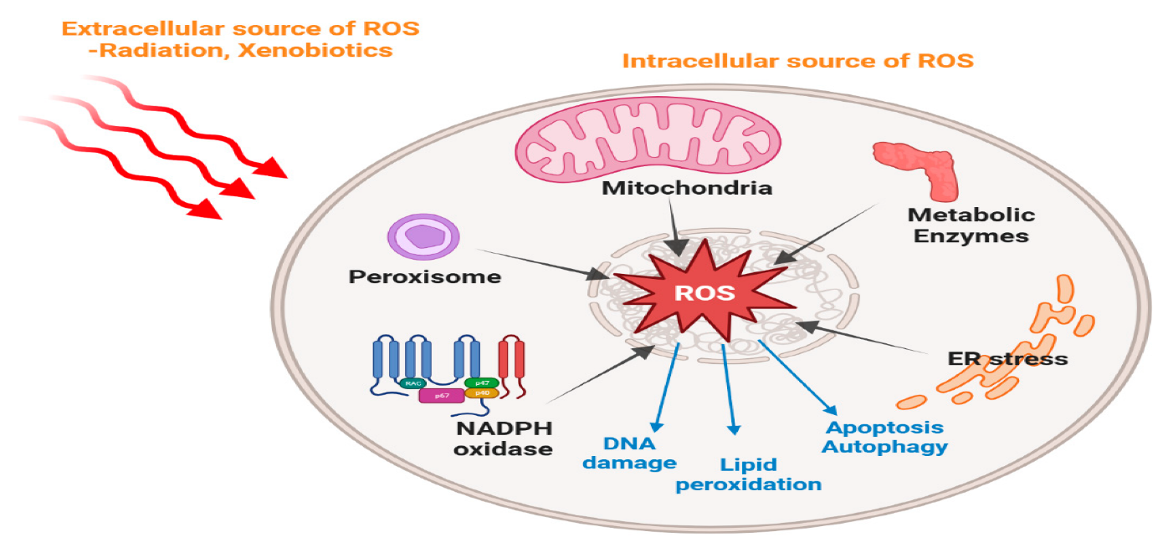

Reactive oxygen species (ROS) are highly reactive molecules that are constantly generated as byproducts of normal cellular metabolism. While ROS play essential roles in various physiological processes, such as cell signaling and immune response, their excessive production can lead to oxidative stress, which is implicated in the pathogenesis of numerous diseases. ROS-mediated damage has been linked to conditions including neurodegenerative disorders, cardiovascular diseases, cancer, and inflammatory diseases, among others. Developing effective strategies to mitigate ROS-induced damage and cellular homeostasis is a major focus of current research in the field of nanomedicine. In recent years, nanotechnology has emerged as a promising approach for the delivery of therapeutic agents, owing to its unique properties and versatility. Nanomedicines, which encompass a wide range of nanoscale formulations, offer several advantages for the treatment of ROS-mediated diseases. Among these, bilirubin-based nanomedicines have garnered significant attention due to their inherent antioxidant properties and potential therapeutic applications. Bilirubin, a yellow tetrapyrrolic pigment derived from the breakdown of heme, has long been recognized for its role in the detoxification of ROS. It possesses potent antioxidant and anti- inflammatory properties, making it an ideal candidate for developing nanomedicines aimed at combating ROS-induced damage. Whether ROS act as damage molecules or signal molecules depends on the concentration of ROS in living organisms, which is associated with the endogenous antioxidant-protective systems. Therefore, research on the regulation of ROS concentration has caused wide concern, mainly involving the topics in ROS-regulating therapy such as antioxidant therapy triggered by ROS scavengers and ROS-induced toxic therapy mediated by ROS-elevation agents (e.g., photosensitizers (PSs)). Currently, ROS-regulating researches have achieved great development, offering reasonable explanations on the physiological and pathological roles of ROS. In particular, over the past few decades, nanoscience and nanotechnology are introduced in ROS-regulating study, further accelerating their fast development. ROS research with the assistance of nanotechnology is mainly reflected in the development of ROS-related nanomedicines or nontherapeutic modalities. Here, these ROS-based Nano therapeutic modalities or nanomedicines that can regulate ROS progress depend on the intrinsic biophysical and biochemical characteristics of nanomaterials, such as their appropriate sizes (usually 10–100 nm), many interface/surface options and high specific surface area. The employment of nanomaterials in ROS-regulating therapy exhibits various advantages such as improved stability and biocompatibility of ROS-regulating agents, enhanced drug accumulation, optimized pharmacokinetics.

### Bilirubin: Properties and Mechanism of Action

Bilirubin is a yellowish pigment resulting from the breakdown of hemoglobin. It possesses strong antioxidant properties, enabling it to scavenge free radicals and reduce oxidative stress. Its mechanisms include the reduction of lipid peroxidation and the modulation of inflammatory pathways. Furthermore, bilirubin can enhance the expression of endogenous antioxidant systems, bolstering cellular defenses against oxidative damage. These properties position bilirubin as a promising candidate for therapeutic interventions targeting ROS-related pathologies.

### Nanomedicine Approaches

Nanomedicine offers innovative strategies to enhance the bioavailability and therapeutic efficacy of bilirubin through various formulations:

* **Nano-emulsions**: These systems improve the solubility and stability of bilirubin, facilitating better cellular uptake and providing sustained release, which is essential for prolonged therapeutic effects.
* **Nanoparticles**: By encapsulating bilirubin in biodegradable polymeric nanoparticles, targeted delivery to affected tissues can be achieved, minimizing systemic exposure and enhancing treatment efficacy.
* **Liposomes**: Bilirubin-loaded liposomes improve the penetration of the drug through biological membranes while reducing potential systemic side effects, making them a viable option for targeted therapy.
* **Nanosuspensions**: These formulations enhance the dispersibility of bilirubin in aqueous solutions, promoting its therapeutic application across various routes of administration.

### Applications in ROS-Mediated Diseases

1. **Neurodegenerative Disorders**: Bilirubin nanomedicines have shown promising neuroprotective effects by reducing oxidative stress in preclinical models of Alzheimer's and Parkinson's diseases. By attenuating oxidative damage, these formulations may help preserve neuronal function and slow disease progression.
2. **Cardiovascular Diseases**: Research indicates that bilirubin can significantly mitigate oxidative damage in cardiac tissues. This protective effect may lower the risk of myocardial infarction and atherosclerosis, making bilirubin nanomedicines potential candidates for cardiovascular therapy.
3. **Cancer Therapy**: The antioxidant properties of bilirubin can inhibit tumor progression and sensitize cancer cells to chemotherapy. By enhancing the efficacy of existing treatments and reducing side effects, bilirubin nanomedicines may serve as valuable adjuncts in cancer therapy.
4. **Inflammatory Conditions**: Bilirubin's anti-inflammatory effects could provide therapeutic benefits for conditions like rheumatoid arthritis and chronic obstructive pulmonary disease (COPD). By modulating inflammatory pathways, bilirubin nanomedicines may help alleviate symptoms and improve quality of life in affected individuals.

### Challenges and Future Directions

Despite the promising potential of bilirubin nanomedicines, several challenges must be addressed:

* **Stability and Formulation**: Ensuring the stability of bilirubin within nanomedicine formulations is critical for their clinical application. Ongoing research is needed to develop robust delivery systems that maintain bilirubin’s efficacy over time.
* **Regulatory Issues**: The approval process for new nanomedicines is often lengthy and complex. Navigating regulatory pathways will be essential for translating research findings into clinical practice.
* **Efficacy Studies**: There is a need for more comprehensive preclinical and clinical studies to fully elucidate the therapeutic potential and safety profile of bilirubin nanomedicines.

### Conclusion

Bilirubin nanomedicines represent a promising frontier in the treatment of ROS-mediated diseases, leveraging the natural antioxidant properties of bilirubin along with advanced nanotechnology. These therapies hold significant potential for addressing a variety of conditions, including neurodegenerative disorders, cardiovascular diseases, cancers, and inflammatory diseases.

The ability of bilirubin to scavenge free radicals, reduce oxidative stress, and modulate inflammatory responses makes it an attractive candidate for innovative therapeutic interventions. Nanomedicine enhances the bioavailability and targeted delivery of bilirubin, maximizing its therapeutic effects while minimizing potential side effects.

However, several challenges must be addressed to realize the full potential of bilirubin nanomedicines. Ensuring stability and efficacy in formulations is critical for clinical applications. Additionally, navigating the regulatory landscape can be complex, requiring thorough preclinical and clinical studies to establish safety and efficacy.

Future research should focus on optimizing formulation strategies, expanding clinical trials, and exploring combination therapies that may enhance the efficacy of bilirubin in combating ROS-mediated diseases. By addressing these challenges, bilirubin nanomedicines could lead to transformative advancements in the management of oxidative stress-related pathologies, ultimately improving therapeutic outcomes and quality of life for patients. Continued exploration in this field is essential to unlock the full potential of bilirubin as a therapeutic agent, paving the way for novel treatments in modern medicine.

**References :**

* 1. Cui, Y., et al. (2023). “Nanotechnology-enabled application of bilirubin in the treatment and diagnosis of various civilization diseases.” Materials Today Bio, 20, 100658.
  2. Jansen, T., et al. (2017). “Bilirubin as a molecule with a protective role in metabolic syndrome.” Frontiers in Pharmacology, 8, 682.
  3. Kang, S., et al. (2019). “Bilirubin Nanoparticles for Antioxidant Therapy and Imaging Applications.” Theranostics, 9(13), 3778–3792.
  4. Bulmer, A. C., et al. (2008). “Bilirubin and beyond: a review of lipid peroxidation, an important process in ROS-mediated pathologies, and the role of bilirubin as a potent inhibitor.” Free Radical Biology and Medicine, 45(5), 585–593.
  5. Stocker, R., et al. (1987). “Antioxidant functions of bile pigments: biliverdin and bilirubin inhibit lipid peroxidation by scavenging peroxyl radicals.” Science, 235(4792), 1043-1046.
  6. Wang, T., et al. (2021). “Bilirubin-loaded nanoparticles for the treatment of oxidative stress-induced liver diseases.” Biomaterials, 276, 121039.
  7. Baranano, D. E., Rao, M., Ferris, C. D., Snyder, S. H. (2002). “Biliverdin reductase: a major physiologic cytoprotectant.” Proceedings of the National Academy of Sciences, 99(25), 16093-16098.
  8. Kim, D. J., et al. (2021). “Bilirubin Nanomedicine Alleviates Renal Ischemia-Reperfusion Injury by Reducing Oxidative Stress and Inflammation.” ACS Nano, 15(1), 859–872.
  9. Wang, Z., et al. (2017). “Bilirubin Nanomedicine Prevents Ischemia-Reperfusion Injury in Heart Transplants.” Journal of the American Chemical Society, 139(23), 7429-7432.
  10. Kim, H. J., et al. (2020). “Bilirubin nanoparticles attenuate LPS-induced pulmonary inflammation by suppressing ROS generation.” Biomaterials Science, 8(2), 630–641.
  11. Cui, Y., et al. (2023). “Nanotechnology-enabled application of bilirubin in the treatment and diagnosis of various civilization diseases.” Materials Today Bio, 20, 100658.
  12. Jansen, T., et al. (2017). “Bilirubin as a molecule with a protective role in metabolic syndrome.” Frontiers in Pharmacology, 8, 682.
  13. Kang, S., et al. (2019). “Bilirubin Nanoparticles for Antioxidant Therapy and Imaging Applications.” Theranostics, 9(13), 3778–3792.
  14. Bulmer, A. C., et al. (2008). “Bilirubin and beyond: a review of lipid peroxidation, an important process in ROS-mediated pathologies, and the role of bilirubin as a potent inhibitor.” Free Radical Biology and Medicine, 45(5), 585–593.
  15. Stocker, R., et al. (1987). “Antioxidant functions of bile pigments: biliverdin and bilirubin inhibit lipid peroxidation by scavenging peroxyl radicals.” Science, 235(4792), 1043-1046.
  16. Wang, T., et al. (2021). “Bilirubin-loaded nanoparticles for the treatment of oxidative stress-induced liver diseases.” Biomaterials, 276, 121039.