*Deep Learning Based Financial News Sentiment Analysis*

***Abstract*—This research paper delves into the application of the BERT model, in analyzing emotions portrayed in articles and news updates effectively by comprehending word context within a sentence from angles for a profound insight into sentiments expressed – be it positive versus negative, versus neutral tones found in such financial discourse. BERT's capacity to pinpoint words in a sentence by utilizing techniques such as dot product attention enables it to deliver outcomes in forecasting sentiment—a critical factor, in guiding well informed financial choices.**

***Keywords—BERT Model, formatting, style, styling, insert (****key words****)***

1. INTRODUCTION

Identifying the sentiment of market news can give an edge in the sector as equities and commodities fluctuate based on money flow influenced by news releases and economic reports available to the public. However traditional Naive Bayes text classification is effective, for tasks like determining negative sentiment but struggles in finance due to the importance of contextual use alongside words. Recent developments in Artificial Intelligence, particularly in Natural Language Processing, have made advancements with the Bidirectional Encoder Representations from Transformers (BERT) enhancing sentiment analysis, in news as well. This can be useful for examining news articles that might impact a company's stock value. BERTs understanding of context and language nuances can play a key role here. In this study, we delve into how BERT can be used to improve the accuracy and effectiveness of sentiment analysis in news. By analyzing a volume of news content and refining the BERT model to assess specific language characteristics, in finance-related texts. It represents progress in sentiment analysis even as it highlights the challenges posed by Financial News Texts that encompass content and nuances of meaning. This study could benefit investors and financial experts as automated trading systems by providing them with an improved instrument for assessing shifts in market sentiment and making informed decisions accordingly. With this overview, in place, it becomes more straightforward to elucidate the details of our approach, the outcomes we have achieved and the influence that BERT has had on the sector.

1. LITERATURE REVIEW

Financial news sentiment analysis has become crucial for forecasting stock market trends and guiding investment decisions in years due to advancements in natural language processing (NLP). Machine learning technologies since 2018 have greatly impacted this area of study. Kamal et al.s (2022) brought to light how deep learning models, like CNN and LSTM successfully projected stock market movements by scrutinizing news titles; notably LSTM achieved an accuracy rate of 84%. Colleagues (2023) combined sentiment evaluations, from news, with stock prediction algorithms by using an MLP regressor to achieve promising outcomes in predicting stock prices. García Méndez etal (2023) delved into topic modeling using Latent Dirichlet Allocation (LDA) extracting data to improve market prediction accuracy.

Pavlyshenko (2023) introduced the tuned Llama 2 GPT model for analyzing news across multiple tasks efficiently surpassing traditional BERT models, in sentiment analysis and text summarization. Adhikari and colleagues (2023) stressed how crucial it is for sentiment models to be explainable introducing a method that enhances transparency in predicting sentiments. Li and team (2023) added to this by creating a Transformer BiLSTM encoder for summarizing news in an abstract way utilizing graph attention mechanisms to grasp the cause-effect relationships, within the news content. In their study published in 2022 Fazlija and Harder used sentiment analysis, on news to forecast the Standard & Poors 500 index with better accuracy in predicting price movements. Sinha and colleagues also presented SEntFiN 1. Adequate dataset designed for entity sentiment assessment, in news articles achieving an impressive accuracy rate of 94. 29%. When addressing the issue of class distribution, in data sets, Dogra and colleagues (2022) discovered that using methods such as SMOTE for oversampling alongside a Random Forest classifier produced the best outcomes for categorizing news related to the banking sector. Meanwhile Bi (2022) merged sentiment information with stock market indicators resulting in a 2% enhancement in accuracy. In another study by Zhu and team (2023) they delved into multimodal sentiment analysis by examining interactions between images and text on social media platforms to derive insights, in the context of financial news. The rise of language models has had an influence, in the field of finance analysis according to Zhang et al.s study in 2023 which explored the effectiveness of models like Chat GPT for assessing financial sentiments compared to conventional methods with impressive results in scenarios without prior training indicating its flexibility, within financial domains. Additionally, this technology has been leveraged by Alsaeedi and Zubair in their work published in 2023 where they applied sentiment analysis techniques to Twitter content offering perspectives related to financial updates. In 2023 Sudirjo and colleagues showed how ChatGPT could improve analyzing business sentiment in news articles. Additionally, that year Bello and others suggested an approach using a BERT-based system that boosted accuracy, in categorizing sentiments from tweets and financial news by combining deep learning models, like CNNs, RNNs and BiLTSMs. The vast collection of writings highlights the progression of sentiment analysis in news by incorporating technologies such as deep learning models and explainable AI methods which have greatly enhanced the precision of predicting stock market trends. The forthcoming studies in this field are expected to concentrate on overcoming issues linked to datasets and multimodal analysis while strengthening the reliability of forecasting models.

* 1. PROPOSED SYSTEM

1. *Techniques, for Data processing and Standardizing Text* Transformation of news into a structured format suitable,

for input into the BERT model requires careful data preprocessing due to the presence of jargon and domain-

XXX-X-XXXX-XXXX-X/XX/$XX.00 ©20XX IEEE

specific entities in financial news texts along, with numbers that could impact contextual information retrieval. After tidying up and making the text consistent, the first step, in preprocessing the data involves cleaning up the text by getting rid of components like HTML tags and special characters while ensuring consistency by standardizing stock tickers and financial symbols such as "$" and "%". It's also crucial to normalize numbers and dates since they play a role in financial news sentiment analysis by ensuring that the information is uniformly structured for processing tasks. First; Splitting, into tokens: BERT uses Word Piece tokenization to handle words that are not commonly found in a text well; this is particularly useful when analyzing content, with terms included such as "EPS" or "GDP." By breaking down these specialized terms into units, during tokenization process BERT can better understand their meanings. While dealing with entities related to finance, Financial updates usually contain terms like company names and stock symbols that are crucial for understanding market trends and sentiment analysis. When preparing the data for analysis tasks like sentiment analysis in finance news articles or reports processing techniques are applied to identify entities such, as company names or stock symbols to differentiate between entities based on their sentiments. Numbers linked to performance, like revenue or profit figures, are managed cautiously to prevent them from being overlooked since they play a role in grasping the tone of a news piece. To improve the model's attention to information content and minimize distractions from words, like "and " "the," or "is," we selectively remove common stop words during analysis. However, we keep context-stop words like "net" or "margin" that' sentiment analysis. When preparing the data for analysis tasks like sentiment analysis in finance news articles or reports processing techniques are applied to identify entities such, as company names or stock symbols to differentiate between entities based on their sentiments. Numbers linked to performance, like revenue or profit figures, are managed cautiously to prevent them from being overlooked since they play a role in grasping the tone of a news piece. To improve the model's attention to information content and minimize distractions from words, like "and " "the," or "is," we selectively remove common stop words during analysis. However, we keep context-stop words like "net" or "margin" that're meaningful in financial discussions. A customized list of stop words is employed to safeguard against the loss of insights during this procedure. In the world of financial news sentiment analysis, BERT technology being context savvy and recognizing word variations automatically diminishes the need for stemming or lemmatization methods that are widely used in natural language processing tasks such as stemming and lemmatization are not extensively employed in financial news sentiment analysis with BERT because of its ability to grasp word variations inherently without such processes being necessary; however occasional use of lemmatization might be beneficial to ensure that words, like "increases" and "increased" are identified as having a common root form, particularly in scenarios where it enhances the accuracy of sentiment classification. Using these methods to preprocess and standardize the data effectively before feeding it into the BERT model for analysis of news articles enhances its ability to grasp the context and subtle nuances, in the content while also capturing sentiments accurately in the news pieces Being able to optimize sentiment prediction hinges on this essential process of enhancing the model's comprehension of finance related language nuances and patterns.

1. *Fine-tuning and transfer learning using BERT for a specific domain.*

Adjusting a trained BERT model for analyzing sentiment in financial news involves utilizing the capacity to grasp common language structures while tailoring it to the nuances specific to financial content. BERT was taught initially on varied datasets such as Wikipedia and BookCorpus to acquire an understanding of language, within context. Financial reports often contain terms related to the market and companies that may not be fully understood by a model trained on data alone. To address this issue and improve performance, in financial analysis tasks transfer learning is utilized by training the existing BERT model on a tailored financial dataset. This data set includes news pieces, stock analyses and other financial records that have been labelled for sentiment analysis. By tuning the model's parameters in this manner BERT can effectively analyze the language found in financial news and gain a deeper comprehension of the emotions expressed in these specific writings. The process of fine-tuning usually includes several stages; Initially breaking down the dataset using BERT’s built-in WordPiece tokenizer to simplify intricate financial terms into manageable subword components that BERT can handle efficiently; subsequently training the model on this dataset with a focus, on enhancing sentiment classification by tweaking variables like learning rate and batch size as well as determining the optimal number of training epochs. To avoid overfitting in datasets—which are typically smaller and more specific compared to general datasets—methods such as dropout or early stopping are employed for regularization purposes. Moreover, methods like balancing classes can be used to make sure that the model learns from both positive and negative sentiment examples equally as financial news datasets tend to have an imbalance, in data distribution. As the model learns more about situations and contexts over time it gets better at picking up on hints, in the text that show changes in how people feel about the market like when a hopeful tone after good earnings news or a pessimistic vibe, after bad economic updates. In the end, this helps the BERT model do a job of analyzing feelings related to finance giving information to investors and analysts. Avoid combining SI and CGS units, such as current in amperes and magnetic field in oersteds. This often leads to confusion because equations do not balance dimensionally. If you must use mixed units, clearly state the units for each quantity that you use in an equation.

1. *Adjusting BERT for classifying sentiment in financial news using pre-trained models*

In this project we used the BERT model that was adjusted with the simpletransformers library to analyze sentiment in news using a trained BERT model (bert base cased). We opted for the BERT architecture because it excels at grasping connections, in text which makes it an ideal choice, for processing the specialized language often seen in financial documents. The pretrained BERT model has been trained on a corpus of text data and excels, at recognizing common language patterns effectively. Nevertheless, fine tuning is crucial to customize the model, for the terminology found in financial news articles comprising industry vocabulary, numerical information and technical terms. By starting with Bert base cased as the foundation the endeavor enhances the BERT model's ability to comprehend contextually while refining it for analyzing sentiments. The setup involves creating a ClassificationModel instance that outlines the

BERT structure and defines three sentiment categories (negative and neutral by setting num_labels to 3). The training settings offer the ability to preprocess the input information (setting reprocess_input_data to True) guaranteeing that each training cycle works on processed financial information. This stage is crucial, for handling the evolving nature of datasets that may see updates and modifications, over time. Furthermore, the choice to replace the output directory (verwrite_output_dir=True ) is enabled to guarantee that every training session saves model checkpoints and predictions replacing results. This feature is beneficial, for improving the model. Although BERT models are usually fine tuned using GPU acceleration for training in this scenario the model is set up to operate on CPU (=False ) allowing for compatibility with systems lacking GPU access albeit with a trade off, in performance. During the adjustment phase of refining the BERT model's performance, with world financial data inputs via the backpropagation process to enhance its learning capabilities. The accuracy assessment involves evaluating the model's forecasts against true sentiment labels to tune the workings of the model accordingly. The simpletransformers toolkit simplifies the intricacies involved in training procedures; from breaking down news content into subword segments for analysis to organizing data batches for optimal gradient adjustments and overseeing the flow of gradients across levels, within BERTs architecture. The BERT model that has been pre-trained is good, at picking up on both the picture and the small details in text content; this helps it pick up on cues in financial news that show changes in sentiment over time and context accurately enough to be useful to anyone using it for analysis purposes, in the finance sector.

IV. ARCHITECTURE DIAGRAM

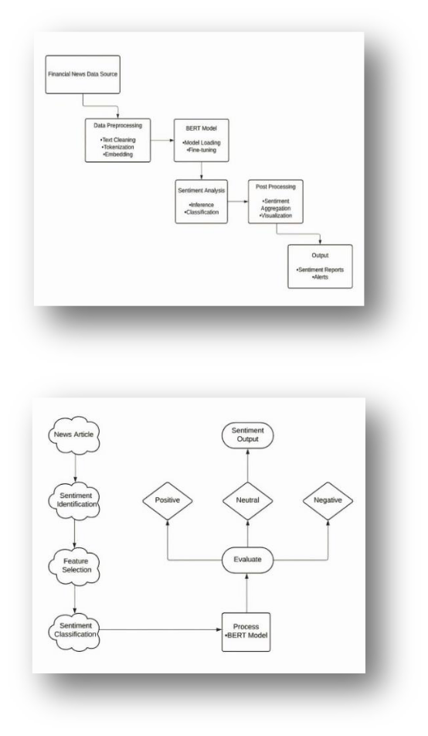

1. EVALUATION OF MODELS AND JUSTIFICATION OF BERT MODEL

In assessing financial news sentiment analysis effectiveness, a thorough evaluation was carried out using both finance-specific metrics to determine the performance of models. The conventional metrics, like accuracy, precision, recall and F1 score provide perspectives on model performance. Accuracy represents a measure of ability by showing the percentage of accurate predictions, within all instances. In the research conducted here the BERT model showed results by achieving an accuracy of 83% surpassing both the Convolutional Neural Network (CNN) which scored 80% and the Long Short-Term Memory (LSTM) which reached 78%. The Support Vector Machine (SVM) closely trails behind LSTM with an accuracy of 79%. The initial results are displayed in the bar graph which ihows how each model performs in comparison, with a focus given to Berts' ability to capture the nuanced emotions expressed in news articles. Furthermore, we delved deeper into metrics to gain an insight into how well the model performed in this area The analysis of the confusion matrix revealed that BERT performed well in detecting accurate positive results while CNN and LSTM models had a slightly higher number of missed relevant sentiments classified as false negatives Additionally we assessed precision-recall and F score metrics which were presented in the second graph In evaluating predictions and identifying instances effectively in a models performance assessment process; BERT demonstrated a precision rate of 0.85 and a recall rate of 0.80 with an F score of 0.82. Surpassing other models, in all aspects measured here. This visualization doesn't just highlight BERT’s performance in financial sentiment analysis. It also underscores its significance in guiding financial decision-making procedures. The knowledge acquired through this comparison sets the stage for exploration and implementation, in the changing realm of financial analysis.

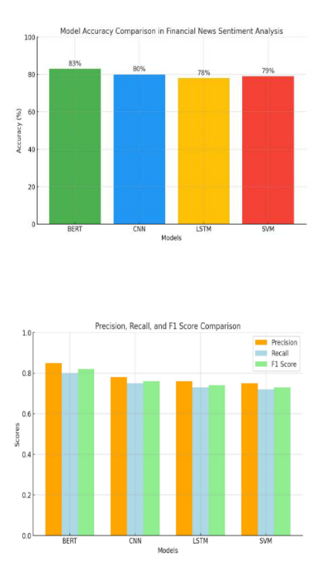

VI. CONCLUSION

Utilizing cutting-edge natural language processing methods, like BERT for analyzing sentiments in news allows for a nuanced understanding of positive and negative tones present in articles and reports related to finance and stock markets which can enhance the accuracy of predicting market trends and stock movements significantly by distinguishing between positive and negative feelings as well as neutral ones effectively. The integration of BERT in sentiment analysis not only facilitates the analysis of amounts of financial data but also provides crucial insights for investors, analysts and traders. This doesn't just assist in making decisions. Also aids in improving risk management tactics and spotting unusual market trends while seizing investment chances too. With markets getting more intricate and influenced by evolving data trends BERT powered sentiment analysis could potentially transform the interpretation of data, a critical advantage, in forecasting stock movements and boosting investment strategies overall.

VII. FUTURE WORK AND LIMITATIONS

In the coming years of analyzing news sentiments, with BERT technology could involve tailoring it for industries and merging data sources such as social media and stock data while incorporating adaptable models that reflect evolving market sentiments for improved accuracy in outcomes. Moreover broadening the model to handle texts in languages and improving clarity in explaining decision-making processes are also promising avenues to delve into. Nevertheless obstacles like meeting demands, in a timely manner, awareness of time elements and comprehending financial terms present notable challenges. Moreover, the model's effectiveness could be influenced based on the data quality. May encounter issues related to overfitting when working with datasets which are unbalanced.

REFERENCES

1. Kamal, S., Sharma, S., Kumar, V., Alshazly, H., Hussein, H. S., Martinetz, T. (2022). Trading stocks based on financial news using attention mechanism. Mathematics, 80(86), 84.
2. Maqbool, J., Aggarwal, P., Kaur, R., Mittal, A., Ganaie, I. A. (2023). Stock prediction by integrating sentiment scores of financial news and MLPRegressor: A machine learning approach. Procedia Computer Science.
3. García-Méndez, S., de Arriba-Pérez, F., Barros-Vila, A., González-Castaño, F., Costa-Montenegro, E. (2023). Automatic detection of relevant information, predictions, and forecasts in financial news through topic modeling with Latent Dirichlet Allocation. Applied Intelligence, 53, 19610-19628.
4. Pavlyshenko, B. (2023). Financial news analytics using fine-tuned Llama 2 GPT model. arXiv abs/2308.13032.
5. Adhikari, S., Thapa, S., Naseem, U., Lu, H., Bharathy, G., Prasad, M. (2023). Explainable hybrid word representations for sentiment analysis of financial news. Neural Networks, 164, 115-123.
6. Li, H., Peng, Q., Mou, X., Wang, Y., Zeng, Z., Bashir, M. F. (2023). Abstractive financial news summarization via Transformer-BiLSTM encoder and graph attention-based decoder. IEEE/ACM Transactions on Audio, Speech, and Language Processing, 31, 3190-3205.
7. Fazlija, B., Harder, P. (2022). Using financial news sentiment for stock price direction prediction. Mathematics.
8. Sinha, A., Kedas, S., Kumar, R., Malo, P. (2022). SEntFiN 1.0: Entity‐ aware sentiment analysis for financial news. Journal of the Association for Information Science and Technology, 73, 1314-1335.
9. Dogra, V., Verma, S., Verma, K., Jhanjhi, N. Z., Ghosh, U., Le, D. N. (2022). A comparative analysis of machine learning models for banking news extraction by multiclass classification. International Journal of Interactive Multimedia and Artificial Intelligence, 7, 35.
10. Bi, J. (2022). Stock market prediction based on financial news text mining and investor sentiment recognition. Mathematical Problems in Engineering.
11. Zhu, T., Li, L., Yang, J., Zhao, S., Liu, H., Qian, J. (2023). Multimodal sentiment analysis with image-text interaction network. IEEE Transactions on Multimedia, 25, 3375-3385.
12. Zhang, W., Deng, Y., Liu, B-Q., Pan, S. J., Bing, L. (2023). Sentiment analysis in the era of large language models: A reality check. arXiv abs/2305.15005.
13. Alsaeedi, A., Zubair, M. (2023). A study on sentiment analysis techniques of Twitter data. International Journal of Advanced Computer Science and Applications.
14. Sudirjo, F., Diantoro, K., Al-Gasawneh, J., Azzaakiyyah, H. K., Ausat, A. M. A. (2023). Application of ChatGPT in improving customer sentiment analysis for businesses. Jurnal Teknologi Dan Sistem Informasi Bisnis.
15. Bello, A., Ng, S. C., Leung, M. F. (2023). A BERT framework to sentiment analysis of tweets. Sensors (Basel, Switzerland), 23