**A REVIEW ON THERAPEUTIC USES & IT'S PHARMACOLOGICAL ACTIVITIES OF GARLIC HERBAL PLANT**

**Randive Anurag .S., Waghmare K.P, Dr.Gaffar Sayyad, Dr.Sanjay Garje. College of Pharmaceutical Science and Research Center, Kada – 414202.**

1. **Abstract:**

Garlic is one of the constituent, which have carry out on deplete the hazard of antineoplastic. contain garlic in the diet helps for the improvement of the healthiness. Medicinal effects of the garlic were known since 5,000 years. Recently, studies were carried out to known melanoma , but also on these blood system and immune response. Purpose of the each component of the garlic were considered to know precisely, which component has got advantageous effect. So this analysis has been achive to know about the component, purpose of each component, operating principal, and advantageous effects of the garlic (1).

**KEY WORD : Garlic allium sativum L, Nutrition,Dibetise Mellitus, Antineoplastic Agents, Blood Pressure lowering agent, traditional uses of garlic, Bioactive agents, Toxicology, Chemical agents, Antiallergic & allergic agents.**

1. **Introduction**

Garlic is one of the comestible plants which has originated involvement a lot of interest throughout human history as a medicinal cure . A broad range of microbes including bacterium, fungi, amoeba and pathogen have been shown to be sensitive to smashed garlic formulation. Moreover, garlic has been reported to lowering blood lipids and to have antineoplastic effects. Chemical investigation of garlic cloves have revealed an extraordinary absorption of sulfur-including composition (1–3%).examination of steam distillations of smashed garlic cloves carried out over a century ago display a variety of allyl sulfides. However, it was not until 1944 that Cabalitto and his colleagues  isolated and found the component answerable for the exceptional bactericidal activity of fine garlic cloves. The compound through out to be an ventilated sulfur compound which they termed allicin, from the Latin name of the garlic plant, *Allium sativum.* Pure allicin is a unstable component that is less miscible in sedimentary solutions and which has the typical odor of novel crushed garlic . Final proof of the synthetic structure of allicin came in 1947, when it was displayed that allicin could be synthetically by mild oxidisation of daily disulfide . The debate on the introduce of allicin in smashed cloves versus its non appearance in odourless intact cloves was determined after Stoll and Seeback  isolated, determined, and synthesized an oxygenated sulfur amino acid that is present in high amount in garlic cloves and which they named alliin . Alliin was found to be the stable pioneers that is converted to allicin by the work of an enzyme termed allinase which is also present in the cloves . Only one compound of alliin ((+)-S-allyl-L-cysteine-sulfoxide) was determine to be present, which in itself had no bactericidal activity. The quantity of alliin and allicin present in different strains of garlic were studied by various investigators. significant variations have been reported, ranging from 2.8 to 7.7 mg/gram determined in Romanian red .The conversion of alliin into the morphologically active allicin molecule upon smashed of a garlic clove is extremely fast, being complete in within a seconds. The enzyme respond for the lysis is alliinase, or alliin-lyase ., a pyrodixal 5-phosphate-charge glycoprotein including of two subunits . Alliinase is present in unusually large quantity in garlic cloves: at least 10% of the total protein content (10 mg/g fresh weight). The genetic coding for the enzyme has been doubled, and upon translation, determine to contain of 448 amino acids with a protein compound mass of 51.45 kDa and simultaneously with a polysaccharide content of 5.5–6%, gives 55 000 kDa . Alliinase has 10 cysteine balance , all of them in S-S bridges, and their reduces, or the elimination of the pyridoxal molecule factor, renders the enzyme inert. demonstration of a reunify allinase has been accomplish in the baculo virus system, and although protein yields were imposing, the synthetic activity was very less due to difficulties with folding of the protein (Mirelman et al*.,* unpublished results). Moreover, in the clove, alliinase is create closely dependent with a lactin . The site of linkage of the carbohydrate moieties of alliinase has been detected at Asp 146 . important similarity has been reported between the garlic and onion alliinases , although alliin was not found in the latter species .Garlic cloves stated are odorless until smashed. Cross-section studies have that the substrate alliin and the enzyme alliinase are located in seperate section. This distinctive alignment suggests that it is designed as a prospective defense mechanism against bacterium parasite of the soil. appropriation of the cloves by saprophyte and other soil pathogens begins by destroying the membrane which encloses the section that contain the enzyme and the substrate. This causes the inter linkage between alliin and alliinase that fastly produces allicin and which in turn inactivates the attack. The reactive allicin compounds formed have a very less half-life, as they react with many of the surrounding proteins, containing the alliinase enzyme, making it into a quasi-suicidal enzyme. This very efficient organization ensures that the clove defense mechanism is only activated in a very small location and for a less period of time, whereas the rest of the alliin and allinase remain conserve in their respective sections and are available for interchange in case of succeeding microorganism attacks. Moreover, since immense generation of allicin could also be poisonous for the plant tissues and enzymes, its very limited production and less-lived reactivity, which is inadequate to the area where the microbial attack takes place, reduce any embryonic self-damage to the plan (2).

1. **Image of Garlic**(3)

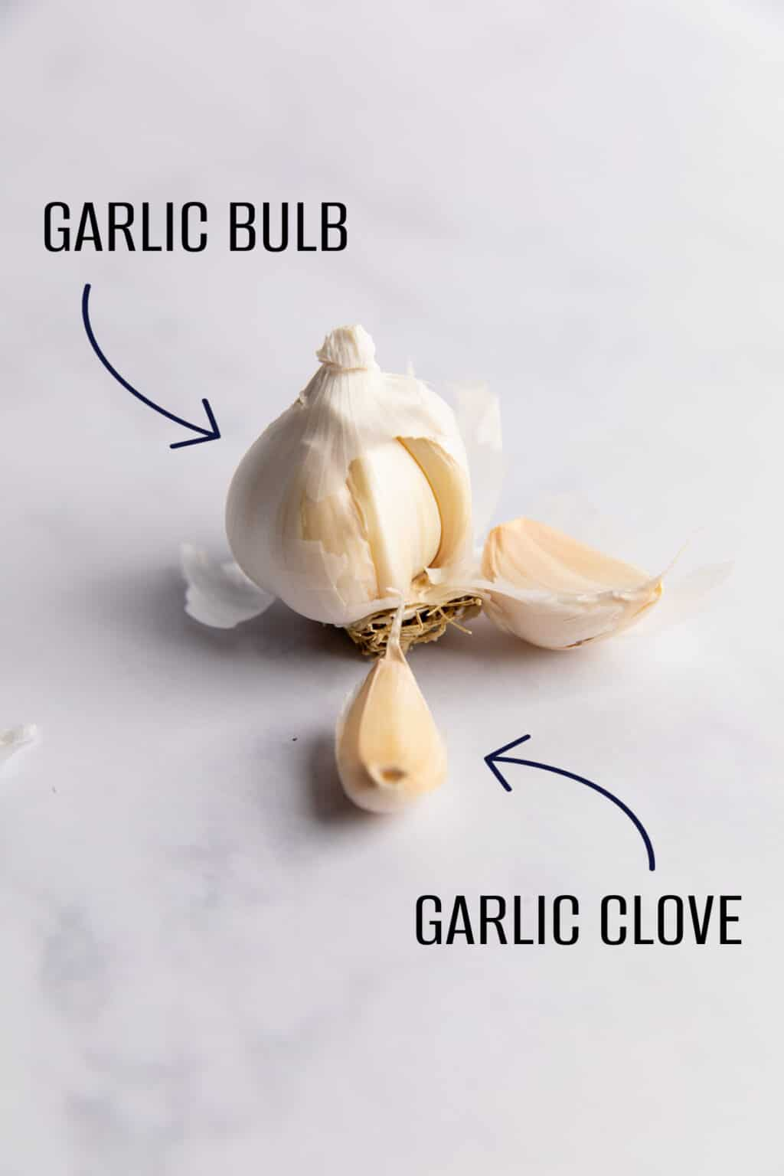

[**https://houseofyumm.com/wp-content/uploads/2023/02/garlic-clove-1-1024x1536.jpg**](https://houseofyumm.com/wp-content/uploads/2023/02/garlic-clove-1-1024x1536.jpg)(3)

1. **Scientific Classification of Garlic**

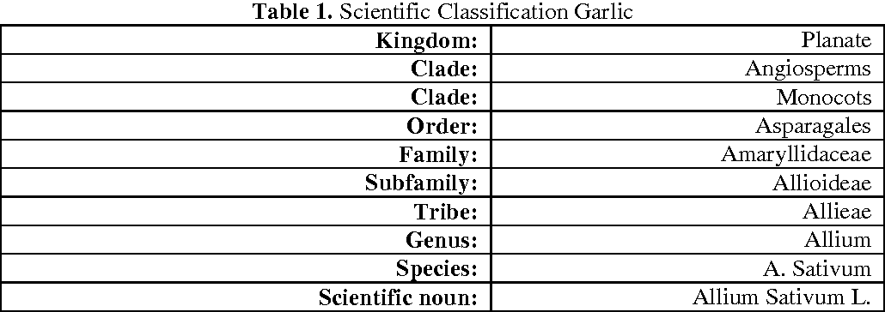

[**https://d3i71xaburhd42.cloudfront.net/fc09895103e5a6d85a60a57b2de34c7d24c1ada5/2-Figure1-1.png**](https://d3i71xaburhd42.cloudfront.net/fc09895103e5a6d85a60a57b2de34c7d24c1ada5/2-Figure1-1.png)(4)

**5.Nutritional Composition of Garlic 100 gr**

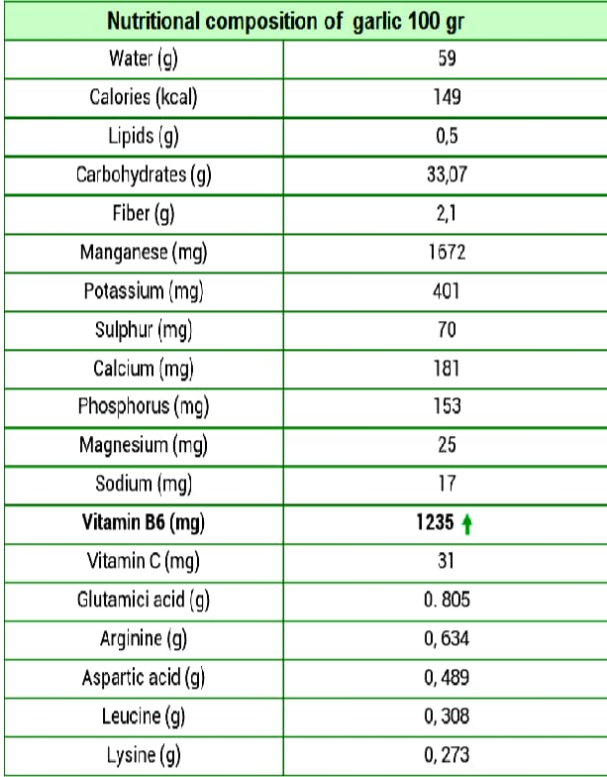

[**https://d3i71xaburhd42.cloudfront.net/fc09895103e5a6d85a60a57b2de34c7d24c1ada5/3-Table2-1.png**](https://d3i71xaburhd42.cloudfront.net/fc09895103e5a6d85a60a57b2de34c7d24c1ada5/3-Table2-1.png) **(5)**

### 6. TRADITIONAL USES OF GARLIC

Garlic is one of the most significant bulb vegetables that has a piquant flavor and mostly used all over the world as a spice and flavoring agent. The organic sulfur components like allicin and DADS are the main components dependable for its sharpness effects and spicy aroma. Garlic is well-known to be used in food formulation, especially dried foods for warehouse and some types of soup and it can be applied in both fresh and dried states .Ancient time, garlic and its related component have been stated to have various morphological activities consisting antineoplastic, antioxidant , hypoglycemic, reno protective, anti- coronary-artery disease, bactericidal, antimycotic agent , and high blood pressure activities . furthermore, garlic has been used in ancient drug to treat dyspepsia, respiring and urinary tract infections and coronary heart disease and it displayed healthful, febrifuge, relaxing, stimulant and water pills (6).

## 7. BIOACTIVE AGENT

Organosulfur components, triterpene glycosides , synthetic agent components and carbohydrates are among the most ordinary bioactive chemicals found in garlic .Onions are richer in protocatechuic acid than garlic, which has a large concentration of quercetin which is resolute by high-performance liquid chromatography (HPLC). Garlic bulb is stated to have total flavonoid (36.1 mg kg–1 FW), phytochemicals components (12.64–22.66 mg/1 g garlic acid), oxidation inhibitor activity (9.92–40.41 mol Trolox/g) estimated using the DPPH(α, α-diphenyl -β-picrylhydrazyl) technique. Organosulfur compounds and their derived products are mostly responsible for the bioactive properties of garlic, with diallyl sodium thiosulfateHypo (allicin) having the major present. Other major organosulfur constituents are dialyl sulfide (DAS), diallyl disulfide (DADS), diallyl trisulfide (DATS), E-ajoene, Z-ajoene, S-allyl-cysteine (SAC), and S-allyl-cysteine sulfoxide (alliin) . various sulfur compounds detect in garlic (7).

**8. Diabetes mellitus**

Although investigational studies illustrated a clear low sugar effect of garlic, the effect of garlic on human blood glucose is still contentious . Many studies found that garlic can lowering blood glucose level in diabetic animals. Garlic was effective in reduce of blood glucose in streptozotocin - as well as alloxan-induced diabetes mellitus in rats and mice . Small term advantage of garlic on Hyperlipidemia in diabetic patients were shown . Garlic significantly reduced serum total cholesterol and LDL cholesterol and moderately raised HDL cholesterol as compared with placebo in diabetic patients . S-allyl cysteine, a morphological component derived from garlic, restored elevated function in diabetic rats by preventing reactive oxygen species formation through regulation of NADPH oxidase subunit expression .Metformin and Garlic therapy in diabetic patients for 12 weeks lowering rapid blood glucose (FBG), but the percentage of change in FBG was more considerable with metformin increase with garlic than with metformin alone . incurable feeding of garlic extracts displayed importance reduce in blood glucose level. However, some other studies displayed no change of blood glucose level after that in human. Therefore, the role of garlic in diabetic patients needs to be further investigated . The advantageous effect of garlic on diabetes mellitus is mainly allocate to the appearance of evaporative sulfur compounds, such as alliin allicin, diallyl bisulfide , diallyl trisulfide, diallyl sulfide, S-allyl cysteine, ajoene, and allyl mercaptan. Garlic extracts have been reported to be effective in decrease insulin resistance (8).

**9. ANTINEOPLASTIC AGENT**

Tumorigenesis using a mouse skin model initiated by 7, 12-dimethyl benz (a) paranaphthalene  (DMBA) and advance by tetra decanoylphorbol  acetate (PMA).82,83 In addition to its activity as a potent tumor booster, PMA is known to excite thrombocyte growth and alprostadil synthesis.84 Since onion and garlic have been known to in prohibit thrombocyte accumulation and alprostadil synthesis,85−87 Belman sought to decide if the oils of these plants might have an effect on tumor boost syndicated with PMA.83 DMBA applicable to the shaven back of Ha/ICR mice and advance three times a week by PMA considerably

|  |
| --- |
|  |
|  |

Decreased the incidence and massiveness of skin tumors in a dose susceptible manner. In a more recent study, Belman et al., 88 found that  (4,5,9-trithiadodeca-1,6,11-triene-9-oxide) from garlic and propenyl sulfide from onion inhibited PMA promotion. other model was studied by Sadhana et al.89 who used garlic oil topically during the observance phase of BP-caused skin neoplasm in Swiss albino mice and reported a inhibit of tumor occurrence and mean number of tumors in those that advanced tumors. Various mode of action of topical or local application have been hypothetical, consisting, in addition to the modification of poisonous metabolism, suppression of cell division, antioxidant agents , suppression of lipoxygenase, and cycloxygenase.90 Wargovich and Goldberg91 reviewed the effect of a sulfide and a bisulfide compound of garlic on various chemical mutagen. They used a nuclear curiosity assay to determine the irregularity of mice [mesothelium](https://www.synonym.com/synonyms/mesothelium). They found that nuclear damage of mice colon cells induced by DMH, a metabolically activated tumour, was moderately inhibited by DADS and markedly inhibited by DAS. DAS did not, however, prohibit the direct acting tumor, N-methyl N - nitrosoguanidine (MNNG) and N-nitrosomethylurea (9).

**10**:  **BLOOD PRESSURE LOWERING AGENT**

A common definition of high blood pressure is a systolic blood pressure (SBP) of 140 mm Hg or higher or a diastolic blood pressure (DBP) of 90 mm Hg or higher or both, prohibition and proper management of high blood pressure reduces the incidence of related disease and infant death rate . A descending shift of 3 mm Hg in SBP reduces the infant death rate from stroke by 8% and from golf stroke heart disease by 5% (Joint National Committee, 1993). Life style modification are definitive therapy for some and adjunctive therapy for all persons with high blood pressure (Joint National Committee, 1997). Diets that are large in fresh fruits, vegetables and less-fat dairy products; have been displayed to decrease high blood pressure . High expenditure of garlic is affiliated with less incidence of high blood pressure in community. Based on current information, garlic powder formulations are considered for proposal as addition in the therapy of high blood pressure patients (10).

**11. TOXICOLOGY OF A.SATIVUM**

Studies conducted and found that the LD50 of the bulb by oral and hypodermal route to rats of both sexes was larger than 30 mL/kg. The watery extract from the bulb induced in vitro oxytocic or ecbolic agent on the pregnant female mouse’s uterus. moreover, the bulb extract (2g/kg) conducted in rats five times a week for six months found no poisonous effects. superficially, poultices with large concentrations of bulb extract can cause external body of skin and antigen activity. The latter has been checked with the internal administration of the watery extract orally in rats and sensitive humans. Correspondingly, the oral bulb can exasperate the renal system in people with particular sensitivity. A dose of 350 mg/ person (both sexes from 30 to 62 years old) administered two a day did not provide poisonous appearances. No information demonstrate the safety of its medicinal herb use in children, pregnancy, or breast feeding. In another study, it was display that the ethyl alcohol extract is not toxin in S. typhimurium. The LD50 of mouse allicin is 60 mg/kg IV and 120 mg/kg SC; the LD50 of the oil is 50-78 mg/kg IV; the LD50 of neoalicin is 70 mg/kg IV and 600 mg/kg orally. Oral administration is not carcinogenic by testing the immune staining in the bone marrow and inducing changes in sister chromatids in spermatogonia. Due to extended ancient use, daily ingestion does not pose any health risk (11).

**12. CHEMICAL AGENTS OF GARLIC**

A. sativum are reported to consist hundreds of phytonutrient including sulfur-consist components such as ajoenes (E-ajoene, Z-ajoene), thiosulfinates (allicin), vinyldithiins (2-vinyl-(4H) -1,3-dithiin, 3-vinyl-(4H)-1,2-dithiin), sulfides (diallyl bisulfide (DADS), diallyl trisulfide (DATS)) and another that assumed 82% of the whole garlic sulfur constituent. Alliin, the main cysteine sulfoxide is transmutation to allicin by allinase enzyme after cutting off the garlic and broken down the chlorenchyma [31]. S-propyl-cysteine-sulfoxide (PCSO), allicin and S-methyl cysteine-sulfoxide (MCSO) are the main odoriferous constituents of freshly milled garlic conductor [31]. PCSO can formed more than fifty digestion count on water constituent and temperature as well as cysteine sulfoxide lyase enzyme that can act on the combination of MCSO, PCSO, and alliin to formed other compounds, such as allyl methane nutritious 2020, 12, 872 3 of 21alkane thiosulfinicmethane sulfonylsulfanyl, and ever according thiosulfinates (R-S-S-R0 ), by which R and R0 are allyl, propyl, and methyls groups . List and structures of some of the sulfur-consisting components  seclusion and solitude from Garlic. combination  chemical formula Structure Alliin C6H11NO3S Allicin C6H10OS2 E-Ajoene C9H14OS3 Z-Ajoene C9H14OS3 2-Vinyl-4H-1,3-dithiin C6H8S2 Diallyl sulfide (DAS) C6H10S Diallyl disulfide (DADS) C6H10S2 Diallyl trisulfide (DATS) C6H10S3 Allyl methyl sulfide (AMS) C4H8S S-alk(en)yl-l-cysteine sulfoxides are the tributary metabolites occurred from cysteine which acquire in the plants of Allium genus . A. sativum preparations includes of various organosulphur components,  N-acetyl-L-cysteine (NAC),  S-2-propenyl-L-cysteine (SAC) , S-2-propenyl-L-cysteine cysteine (SAMC), which are originate from alliin . Notably, SAC has antioxidant Non-steroidal anti-inflammatory drugs, arrange redox, active, inhibiting apoptosis, and signaling capability, while SAMC shows an antineoplastic activity through provide the malignant neoplastic disease cells reproduction . Allicin (allyl thiosulfinate), is a sulfuric  acid  Methyl thiono benzoate  and its pharmacokinetics effect is assigned to its antioxidant activity as well as its interact with thiol-consisting proteins . In the  allyl thiosulfinate. Organic synthesis, cysteine is transferred to allyl thiosulfinate that is decompose by the allinase enzyme . This enzyme composite of Vitamin B6, Orthophosphate which splits 3-(Allyl sulfinyl)alanine and formed Hydrogen nitride R-717 R717 (refrigerant) Amidogen Hydrogen amine, 2-oxopropanoic acid, and  S-alkyl sulfenic acid that are rapidly reactive and volatile at ambient temperature, where twice components were mixed to form allyl thiosulfinate (12).

### 13. ANTIALLERGIC & ALLERGIC AGENTS

An averse to, dyspathetic reaction include the production of gamma globulin E (IgE) and incendiary mediators by immune cells. Kyo et al. obtained that AGE possesses antihistaminic characteristics. In a rat granulocytes line, RBL-2H3, these creator induced H-2 receptor antagonists release with blinatumomab pathogen, and after AGE administration, this important prohibited the antibody -unchangebal allergic release. In addition, in a mouse model, orally administered (o.a.) AGE importantly reduced the index of immune gamma globulin IgE- intermediate superficial level of skin reaction. Zare et al. investigated the effect of mesothelium parenteral route of AGE on an found histaminic-airway irritation murine model and observed that AGE therapy caused a important reduce in the hallmark criteria of allergic-airway inflammation .On the other hand, dietetic garlic lectins have been displayed to carried out allergic from mast cells and basophils as a found their interaction with cell-surface IgE molecules [[52](https://www.ncbi.nlm.nih.gov/pmc/articles/PMC4417560/#B28)]. Recently, Clement et al. isolated three immune system modulator proteins (QR-1, QR-2, and QR-3) from crude A.Sativum. In humans, skin prick test (SPT) using QR-1 and QR-2 on atopic eczema and non atopic subjects disclose that ~26% (in the case of QR-2) of atopic subjects evidence a beneficial reaction, compared with adverse reactions in the case of Atopic dermatitis (normal) subjects. QR-2 induced allergy release from white blood cell to a much high degree in the case of allergic eczema composed with non atopics . conclusion noted the proclivity of garlic lectins to unspecific activate mast cells and basophils in neuro dermatitis as a conclusion of the large concentration of IgE in these patients (13).

### 14. Antiplatelet Effect

Garlic has been shown to inhibit platelet aggregation in both in vitro and in activity and thromboxane A2 production, resulting in antiplatelet action(14 ). (vivo experiments. Garlic′s antithrombotic impact is investigated in situ by modifying fibrinolytic activity through enhanced plasminogen activation and inhibition of thrombin production [15].

### 15. Reduces Stress

In hyperglycemic rats, aged garlic extract prevents adrenal hypertrophy, hyperglycemia, and elevations in corticosterone produced by immobilization stress [16].

### 16. Sickle Cell Anemia

### The generation of dense cells can be inhibited by aged garlic extract (AGE) and other AGE constituents such fructosyl arginine and S-allylcysteine (SAC), which are known to have antioxidant properties. On the other hand, antioxidant activity has been proven, much like with many other garlic components. The growth of dense cells was 50% decreased by the combination of aged garlic extract (4.0 mg/ml) and other beneficial nutrients, including lipoic acid, vitamin E, coenzyme Q10, black and green tea extracts, Pycnogenol, and carotene (17). Bad breath, body odor, nausea, vomiting, gas, weight loss, face flushing, tachycardia, confusion, insomnia, and allergic reactions are among the undesirable side effects of garlic consumption. Despite producing very little juice, the entire tuber is powerful and can be used as an emetic in small(18)

### 17. Antioxidant Activity

Antioxidant enzymes were activated in the presence of diallyl sulfide (DAS), diallyl disulfide (DADS), s-ethylcysteine (SEC), and n-acetylcysteine (NAC) to protect against lipid-related oxidation. Antioxidants, which are abundant in garlic, help to eliminate free radical particles that deteriorate DNA and cell membranes and speed up aging. Antioxidants, such as those found in garlic, help fend off free radicals, which can harm DNA and cell membranes and hasten aging (19,20)

**Reference:**

1. **Indian Journal of Cancer. 60(1):1-3, Jan-Mar 2023.**
2. [**Microbes and Infection**](https://www.sciencedirect.com/journal/microbes-and-infection)[**Volume 1, Issue 2**](https://www.sciencedirect.com/journal/microbes-and-infection/vol/1/issue/2)**, February 1999, Pages 125-129.**
3. [**https://houseofyumm.com/wp-content/uploads/2023/02/garlic-clove-1-1024x1536.jpg**](https://houseofyumm.com/wp-content/uploads/2023/02/garlic-clove-1-1024x1536.jpg)
4. [**https://d3i71xaburhd42.cloudfront.net/fc09895103e5a6d85a60a57b2de34c7d24c1ada5/2-Figure1-1.png**](https://d3i71xaburhd42.cloudfront.net/fc09895103e5a6d85a60a57b2de34c7d24c1ada5/2-Figure1-1.png)
5. [**https://d3i71xaburhd42.cloudfront.net/fc09895103e5a6d85a60a57b2de34c7d24c1ada5/3-Table2-1.png**](https://d3i71xaburhd42.cloudfront.net/fc09895103e5a6d85a60a57b2de34c7d24c1ada5/3-Table2-1.png)
6. [**Nutrients.**](https://www.ncbi.nlm.nih.gov/pmc/articles/PMC7146530/)**2020 Mar; 12(3): 872.**
7. **Nutrition Journal**
8. [**Avicenna J Phytomed.**](https://www.ncbi.nlm.nih.gov/pmc/articles/PMC4103721/)**2014 Jan-Feb; 4(1): 1–14.**
9. **Critical Reviews in Food Science and Nutrition, 44:479–488 (2004**
10. [**https://www.frontiersin.org/journals/nutrition**](https://www.frontiersin.org/journals/nutrition)
11. **Ars Pharmaceutics E-ISSN: 2340-9894 ISSN: 0004-2927** [**https://revistaseug.ugr.es/index.php/ars**](https://revistaseug.ugr.es/index.php/ars)
12. **Ntrients (Journal) MDPI**
13. **Journal Of Immunology Reserch**

**14 Chakraborty D. and Majumder A., Garlic (Lahsun)–an immunity booster against SARS-CoV- 2, *Biotica Research Today*. (2020) 2, no. 8, 755–757.**

**15**  **Fukao H., Hideki Y., and Yoh Ichi T., Antithrombotic effects of odorless garlic powder both in vitro and in vivo, *Bioscience Biotechnology and Biochemistry*. (2007) 71, no. 1, 84–90,**

**16**  **Singh R. and Singh K., Garlic: a spice with wide medicinal actions, *Journal of Pharmacognosy and Phytochemistry*. (2019) 8, no. 1, 1349–1355**.

**17** **Ohnishi S. T. and Ohnishi T., In vitro effects of aged garlic extract and other nutritional supplements on sickle erythrocytes, *Journal of Nutrition*. (2001) 131, no. 3, 1085S–1092S,**[**https://doi.org/10.1093/jn/131.3.1085s**](https://doi.org/10.1093/jn/131.3.1085s)**.**

**18 riedman T., Shalom A., and Westreich M., Self-inflicted garlic burns: our experience and literature review, *International Journal of Dermatology*. (2006) 45, no. 10, 1161–1163,**[**https://doi.org/10.1111/j.1365-4632.2006.02860.x**](https://doi.org/10.1111/j.1365-4632.2006.02860.x)**, 2-s2.0-3374984**

**19.**  **Capasso A., Antioxidant action and therapeutic efficacy of allium sativum L, *Molecules*. (2013) 18, no. 1, 690–700,**[**https://doi.org/10.3390/molecules18010690**](https://doi.org/10.3390/molecules18010690)**, 2-s2.0-84872835124.**

**20. Ajayi G. O., Adeniyi T. T., and Babayemi D. O., Hepatoprotective and some haematological effects of Allium sativum and vitamin C in lead-exposed wistar rats, *International Journal of Medicine and Medical Sciences*. (2009) 1, no. 3, 064–067.**