**Mr Gaykhe Mahesh ,Miss Ghorpade Poonam,Miss Andhale Varsha ,Dr Sayyad Gaffar ,Dr Garje Sanjay.**

**Shri Amolak Jain Vidya Prasarak Mandal’s / College of pharmaceutical science and research centre kada beed 414202**

**A review :Herb used in anti fungal**

Abstract:

There is a need to find ways to cure the many new diseases that are emerging as a result of the expanding human population. Different kinds of new pharmaceuticals have been produced scientifically, but the key issue now ”s that these drugs may have a variety of negative effects on the body and may gradually harm human organs. As a result, the scientist turned to herbal remedies to treat the condition; as a result, the essay is centered around cucumbers, which are naturally occurring fruits that have a wide range of significant components and significant pharmacological effects. For this reason, research and reviews on cucumbers are crucial. Because the article might make it easier to look into the characteristics of cucumbers. Because of its many benefits, including antacid, carminative, hepatoprotective, wound-healing, ulcer-healing, antifungal, and antioxidant qualities, cucumbers are very.The fruit known as papaya (Carica papaya Linn.), which is a member of the Caricaceae family, is highly valued for its nutritional and therapeutic properties worldwide. Since ancient times, people have used the parts of the papaya plant for medical purposes. In this article, we reviewed the pharmacological and therapeutic uses of papaya and highlighted its many attributes as a multifaceted plant. Papaya plants have been the subject of extensive research because of their antibacterial, anti-inflammatory, antioxidant, and anti-malarial qualities, which have demonstrated tremendous therapeutic promise.

Introduction:

As one of the most popular and significant Caricaceae species in terms of commerce, papayas (Carica papaya Linn.) are grown in tropical climates on a large scale. The flowering plant species in question is indigenous to India, Malaysia, Indonesia, the Philippines, Sri Lanka, and Oman. Commercial papaya cultivation has taken place in a number of Asian nations. Papayas are also grown as garden plants in various tropical nations. Papaya is rich in a variety of phytochemicals, such as polysaccharides, enzymes, minerals, vitamins, glycosides, alkaloids, saponins, and sterols. The plant can grow up to 20 meters tall and is easily identified by its weak, flexible stem that is typically unbranched and produces a huge amount of white latex. It also has a terminal cluster of enormous, long-stalked leaves that crowds the stem.

Literature Survey:

The terms C. papaya, taxonomy and morphology of the Carica papaya plant, phytoconstituents of the papaya plant, nutritional value of the Carica papaya, medicinal and pharmacological properties of the papaya, antioxidant activity, anticancer activity, anti-inflammatory activity, antimalarial activity, and anti-diabetic effects of the Carica papaya were used to conduct a literature review on Google Scholar.

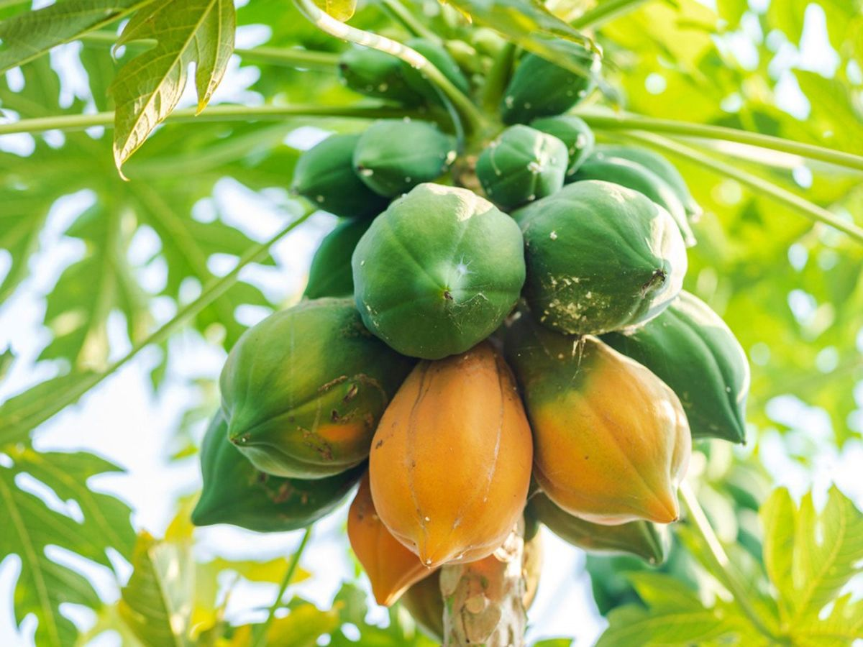

Botanical Classification:

The science of finding, classifying, characterizing, and naming plants is known as plant taxonomy. These plants’ leaves, which resemble those of the common fig (Ficus carica), led Linnaeus to name the genus Carica. The common name is originated from the Taino word papáia, which underwent slight alterations in Spanish to become papaya, the word that is most commonly used worldwide. In Australia and certain Caribbean countries, the fruit is referred to as papaw or pawpaw.

Morphology:

The papaya is a polygamous species that reaches a maximum length of 10 meters. With a diameter of roughly 20 to 28 inches, the broad, oval-shaped leaves are joined to thin branches that are arranged spirally one above the other. It’s challenging to tell apart hermaphrodite, male, and female papaya plants. When any part of the plant is cut, a white latex discharge occurs.[1] The Carica papaya flower has five light-colored, pale petals that are white. It comes in two different forms: the male and female flowers are fused together with the petals, and the female flower has an ovary at the base. The petals are loosely connected to each other at the base.

Enzymes: bioactive moieties in papaya:

Papaya contains a variety of physiologically active moieties. Papaya latex is known to contain strong lipase activity. It contains glycyl endopeptidase, cysteine proteinases, serine proteinase inhibitor, glutaminyl cyclase caricain, class II chitinase, papain, and chymopapain, among other cysteine endopeptidases.

Nutritional Value:

Papaya is rich dense nutritional food as good for health, the amount of calories acquired by consuming Papaya is way more than that from other fruits, the nutrients obtained from Papaya coincide with that the medicinal values obtained from it. The major portion of Papaya constitutes carbohydrates and specially invert easily digestible sugars. Apart from carbohydrates, it also contains proteins and negligible amounts of fats and cholesterol. The ripened fruit of Papaya when consumed can escalate high energy in our body.

The fruit comprises several vitamins, minerals, flavonoids, saponins, and more, The Papaya fruit can be utilized to hinder the problems related to Diabetic Mellitus and the fermented Papaya fruit acts as a nutrient food as it is rich in antioxidants. The seeds of Papaya are black, which is edible, and are spicy to taste when consumed.[3] Papaya roots demonstrate abortifacient action and act as a generative toxin to cure piles; they also show antibacterial and antifungal activity and purgative effect. Fresh roots are administered orally with sugarcane alcohol for alleviating rheumatism.

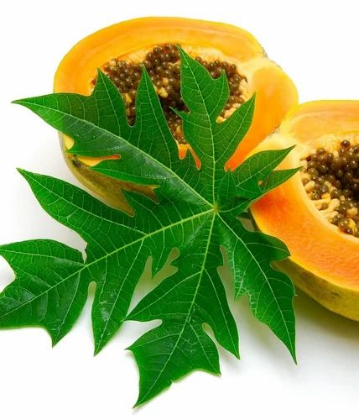

**Fig 1 Papaya leaves**

**Medicinal Uses of Different Parts :**

**Latex:**

It is used as Anthelmintic, relieves dyspepsia, cure diarrhoea, pain of burns and topical use, bleeding haemorrhoids, stomachic, whooping cough. Fruits: Ripe fruits can be used as stomachic, digestive, carminative, diuretic, dysentery and chronic diarrhea, expectorant, sedative and tonic relieves obesity, bleeding piles, wounds of the urinary tract, ringworm and skindisease psoriasis. Unripe fruits are used as diuretic, laxative, dried fruit reduces enlarge spleen and liver, used in snake bite to remove poison, abortificient and anti implantation activity, anti bacterial activity.

**Seeds:**

Carminative, emmenagogue, vermifuge, abortificient, counterirritant, as paste in ringworm disease, psoriasis, antifertility agent in males.

**Root:**

Abortificient, diuretic, is checking irregular bleeding from uterus and anti fungal activity, piles.

**Leaves:**

Young leaves used as vegetables, jaundice, urinary complains, urinary tract infection and gonorrhea, dressing wounds, anti bacterial activity, vermifuge in colic, fever, beriberi, abortion, asthma.

**Flowers:**

Emmengogue, jaundice, febrifuge and pectoral properties. Stem bark: Jaundice, antifungal activity, antihelmantic activity.

* Plant profile :

1. Papaya:

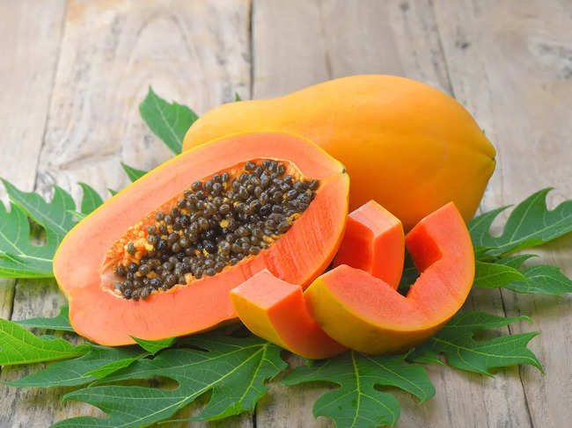

**Fig 2 papaya fruit**

**Synonyms** : papaw,or pawpaw

**Biological source** : The papaya or carica papaya is tropical evergreen tree that is native America .

**Family** : caricaceae

* **Chemical constituent** :

Alkaloids ,glycoside , tannin, flavonide,

* **uses ;**
* anticancer
* support gut health
* reach in vitamin c
* recude inflamation
* anti fungal

1. **Aloe Vera :**

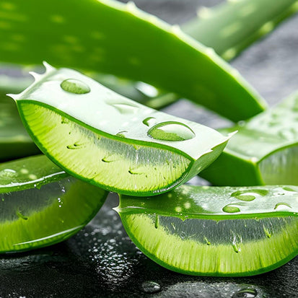

**Fig 3 Aloe vera   
Synonyms: Aloe barbedbensis**

**Biological source : Aloe is dried juice collected by incision from the bases of leaves of various species of aloe .**

**Family : Asphodelaceae ,[Liliaceae ]**

**Chemical constituent :**

* **Amini acid**
* **Sugar**
* **Vitamin**
* **Steroid**
* **Minerals**
* **Salicylic acid**
* **Uses :**
* **Anti fungal**
* **Anti inflammation**
* **Anti anging**
* **Treats acne**
* **Soonthes sunburn**
* **Treat dry skin**

**Conclusion :** Papayas are, in fact, a traditional natural remedy. It is widely recognised for its medicinal and nutritional qualities. It has been utilised as a nutraceutical in ethnomedicine to cure and prevent a variety of illnesses, including cancer. In addition, it has historically been used as an appetite stimulant, menstrual pain reliever, acne medication, meat tenderiser, and contraceptive. The results of this examination unequivocally indicate that the papaya plant's components have potent anti-cancer, anti-dengue, anti-trichochramal, and anti-trichomonal effects. Breast milk was utilised to treat and prevent nipple discomfort and fissures in twelve different studies. Breast milk proved to be both safe and effective in various investigations. Nipple fissure prevention is crucial. One crucial component in preventing and lessening nipple pain and injury is using proper nursing technique. It should be mentioned that instruction in proper nursing technique was provided to both the intervention and control groups in every study. The primary determinant of women's choice to utilise herbs during

Refrence:

* Adebiyi A, Prasad RN, Adaikan PG. Is it true that consuming papaya (Carica papaya) during pregnancy is unsafe? Using a rat model, a prevalent belief in various parts of Asia is evaluated scientifically.2002;88:199–203;
* Br J Nutr. Adaikan PG, Adebiyi A. Jejunal contractions are modulated by a papaya L. seed extract from Carica. Phytother Res.,19:628–632, 2005. The following names are Adjanohoun JE, Aboubakar N, Dramane K, Ebot ME, Ekpere JA, Enoworock EG, Focho D, Gbile ZO, Kamanyi A, Kamsu K J, Keita A, Mbenkum T, Mbi CN, Mbiele AC, Mbome JC, Muberu NK, Nancy WL, Kongmeneck B, Satabie B, Sowora A, Tamze V, and Wirmum CK.
* The contribution of traditional medicine and pharmacopoeia to ethnobotanical and floristic studies in Cameroon. Organisation of African Unity, Addis Ababa, Ethiopia, 1996. Abdullah NR, Afzan A, Halim SZ,
* Rahmani A and Aldebasi Y, Potential Role OfCarica Papaya and their Active constituents in the Prevention and Treatment of Diseases, Published in International Journal of Pharmacy and Pharmaceutical Sciences, 2016; 8(1): 11-15.
* Anuar NS, Zahari SS, Taib IA, Rahman MT. Effect of green and ripe Carica papaya epicarp extract on wound healing and during pregnancy. Food Chem, 2008; 46: 2384-9
* . The Wealth of India - A dictionary Indian raw materials and industrial products: Raw material series, Ca-Ci publications and information directorate, CSIR, 1992; 3: 276-293.
* Indian Materia Medica by K M Nadkarni, 1st Edn by A. K. Nadkarni, Popular PrakashanPvt. Ltd. Bombay, 1954; 273-277.
* Khor ES, Wong NK. Potential antioxidant and cytotoxic properties of secondary metabolite extracts from carica papaya fruits and sood. Int J Pharm Pharm Sci, 2014; 6: 220.
* Amaru LU, Azikiwe CCA. Njoku CJ, Osula FN, Nwosu PJC, Ajugwo AO, Enye JC.
* Orhue PO, Momoh ARM. Antibacterial activities of different solvent extracts of carica papaya fruit parts on some gram positive and gram negative organisms. Int J Herbs Pharmacol Res, 2013; 2: 42- 7.
* Arvind G, Bhowmik D, Duraivel S, Harish G. Traditionaland medicinal uses of Carica papaya, J Med Car Pap, 2013; 1(1): 2320-3862.
* Yogiraj V, Goyal PK and Vyas B, Carica Papaya Lin: An overview, Published in International Journal of Herbal Medicine, 2014; 2(5): 1-8.
* Khor ES, Wong NK. Potential antioxidant and cytotoxic properties of secondary metabolite extracts from carica papaya fruits and sood. Int J Pharm Pharm Sci, 2014; 6: 220.
* Tona L, Kambu K, Ngimbi N, Cimanga K, Vlietinck AJ. Antiamoebic and phytochemical screening of some Congolese medicinal plants. Journal of Ethnopharmacology. 1998; 61(1): 57-65.