Power Quality Enhancement in Distribution Networks Using Active Power Filters in Simulink

Aakash Choudhary
Dept. of electrical &electronic Engg,
HIET shahpur
choudharyaakash733@gmail.com
Chirag Thakur
Dept. of electrical &electronic Engg,
HIET shahpur
tchirag104@gmail.com

Tanuja Saini
Dept. of electrical &electronic Engg,
HIET shahpur
sainitanuja28@gmail.com

Abstract— This paper explores the simulation of power quality disturbances using MATLAB/SIMULINK, focusing on line-faults, capacitor bank energization, and lightning impulses. The line fault model analyzes different fault types and their effects on voltage sags. The capacitor bank model examines oscillatory transients from switching operations, revealing the influence of capacitor size on transient behavior. Additionally, the lightning impulse model replicates standard 1.2/50 μs waveforms, demonstrating the transient effects of lightning strikes. These simulations provide insights into electrical system responses to disturbances, aiding in the development of effective power quality management and protection strategies.
Keywords— Power Quality, Line Faults, Voltage Sag, Capacitor Bank Energization, Oscillatory Transients, Lightning ImpulseIntroduction
Power quality (PQ) is a vital factor in the performance and reliability of modern power systems. The increasing integration of complex loads and distributed energy resources has made power quality disturbances a growing concern in both transmission and distribution systems. These disturbances, including voltage sags, harmonic distortions, and transient overvoltages, can have detrimental effects on sensitive industrial and residential equipment, leading to operational disruptions, financial losses, and reduced equipment lifespan [1]. Common causes of such disturbances include line faults, lightning strikes, and capacitor bank switching, each contributing uniquely to PQ degradation.
Line faults, such as single-line-to-ground (SLG), double-line-to-ground (DLG), and three-phase faults, are the most frequent causes of voltage sags and interruptions in distribution systems. These faults can cause significant voltage drops that may result in power interruptions and equipment damage [2]. Lightning strikes, which induce transient overvoltages, can also lead to insulation breakdowns and long-term degradation of power system components if not properly mitigated [3]. Capacitor banks, which are commonly used for voltage regulation and reactive power compensation, may introduce switching transients, causing voltage spikes and oscillations, especially in systems with a high level of harmonic distortion [4].

different types of faults
In power systems, different types of faults can occur due to various disturbances or failures, and these faults lead to power quality issues such as voltage sags, interruptions, and transients. Faults are categorized based on the number of phases involved and their connection to the ground. The most common fault types are single-line-to-ground (SLG), line-to-line (L-L), double-line-to-ground (DLG), and three-phase faults. Below is an explanation of each fault type, along with IEEE paper references.

Single-Line-to-Ground (SLG) Fault
An SLG fault occurs when one phase of a three-phase system is shorted to the ground. It is the most common type of fault, constituting around 70-80% of all faults in power systems [5]. This fault results in a voltage sag on the faulted phase, while the other two phases may experience either slight changes in voltage or remain unaffected, depending on the system grounding.
Impact: SLG faults cause unbalanced voltage conditions, leading to potential damage to three-phase equipment, especially motors. Protective relays are typically used to detect and clear these faults.

Line-to-Line (L-L) Fault
A line-to-line fault occurs when two phases make contact, either directly or through a conducting medium, bypassing the neutral or ground. These faults are less common than SLG faults but still represent a significant cause of voltage sags and system disturbances. L-L faults cause a significant reduction in the voltages of the two faulted phases, with the third phase typically remaining unaffected [6].
Impact: L-L faults can lead to large currents in the faulted phases, which may result in insulation damage, heating, and mechanical stress on electrical equipment.

Double-Line-to-Ground (DLG) Fault
A DLG fault involves two phases contacting the ground. This type of fault creates severe unbalanced voltage conditions in the system and is more destructive than SLG and L-L faults. Voltage sags occur on the two faulted phases, while the third phase may experience voltage swells [7]. These faults can introduce high fault currents, which can damage transformers, circuit breakers, and other power system components if not cleared promptly.
Impact: DLG faults pose a risk of damaging equipment due to high fault current and unbalanced voltages. They also contribute to high neutral currents in grounded systems.

simulation result
- Line Fault Model
The line fault model developed in MATLAB/SIMULINK simulates voltage sags caused by different types of line faults, such as single-line-to-ground (SLG), double-line-to-ground (DLG), line-to-line (L-L), three-phase faults, and multistage faults. The system comprises an 11 kV, 30 MVA, 50 Hz three-phase source, feeding power through an 11 kV/0.4 kV, 1 MVA delta/wye transformer to a 10 kW resistive and 100 VAR inductive load. Instantaneous and RMS voltage measurements are taken at the 11 kV and 0.4 kV buses.
Two fault blocks are implemented at the 11 kV bus to simulate different fault conditions. A 0.4-second simulation time is set using the ode23tb solver to capture the fault's impact. For instance, during a line-to-line fault between phase A and phase B, voltage sags occur with different magnitudes due to fault resistance. The transformer’s delta/wye configuration alters the fault’s characteristics as the disturbance propagates downstream. Slight voltage swells on the unfaulted phase at the 0.4 kV bus occur due to the absence of a ground connection in L-L faults [8].
Circuit Diagram:
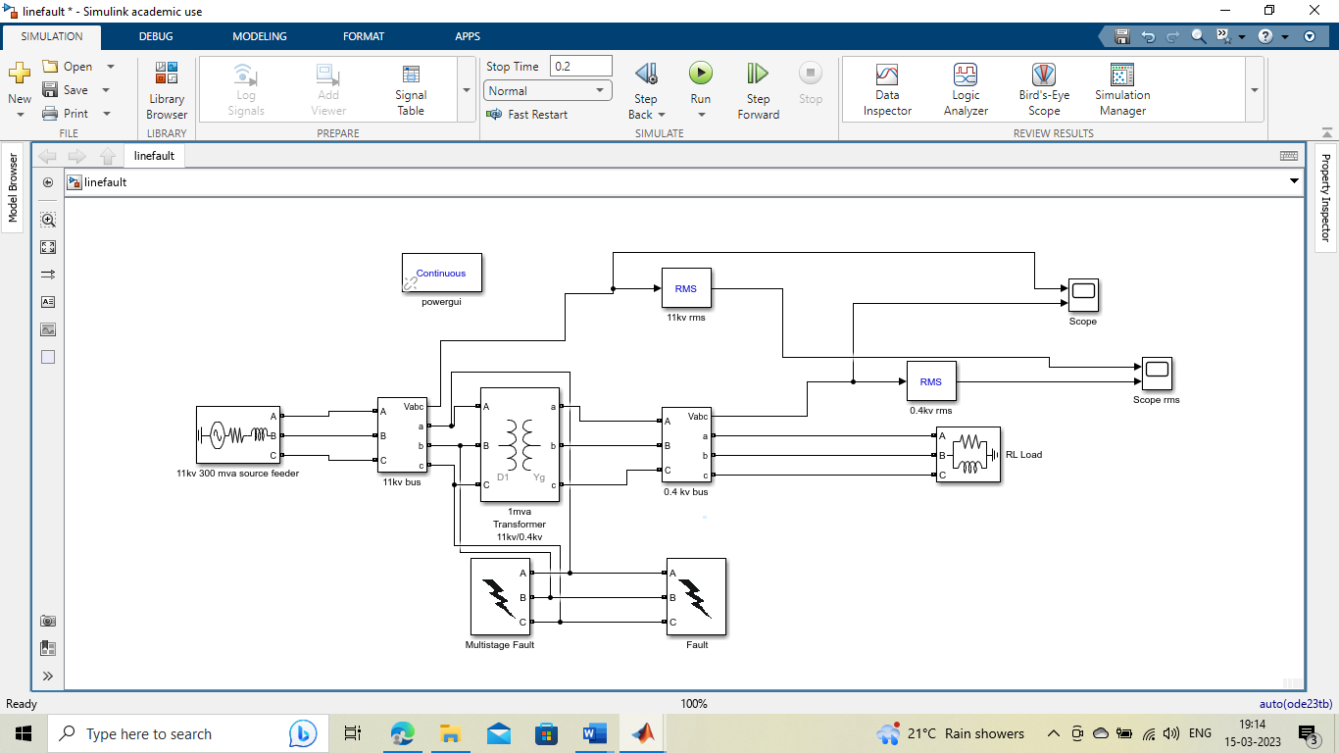
Figure 1 Line Fault Model
Output Waveform:
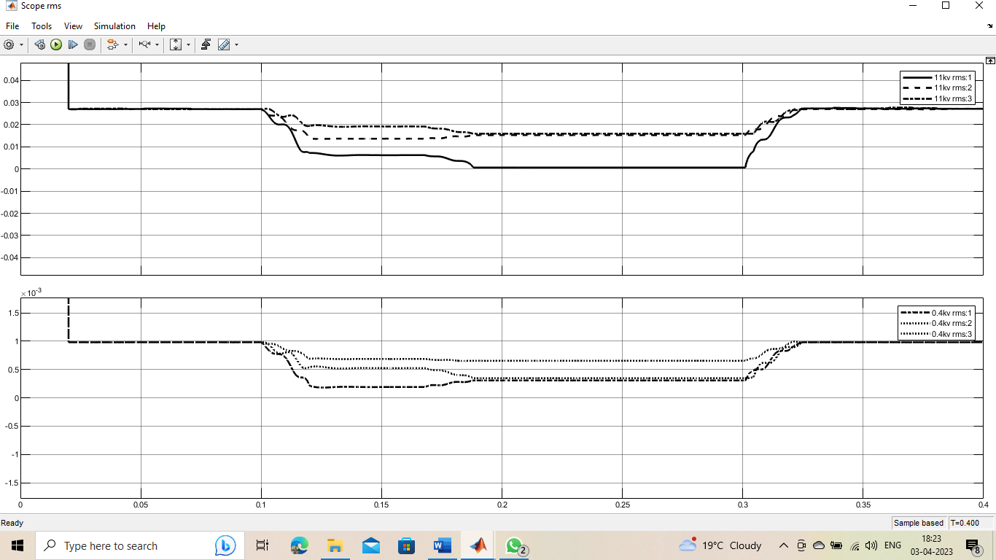
Figure 2 Voltage sag and swell in RMS waveform
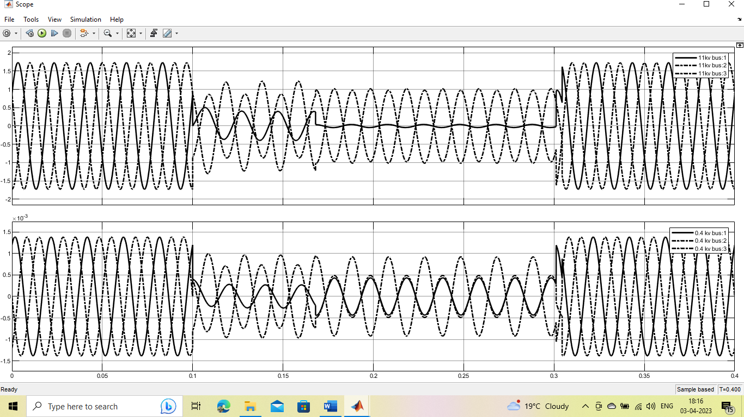
Figure 3 Voltage sag and swell caused by line-to-line fault at 11 kV line
- Capacitor Bank Energizing Model
The capacitor bank energizing model, developed in MATLAB/SIMULINK, simulates oscillatory voltage transients caused by capacitor switching for power factor correction. The system consists of an 11 kV, 30 MVA, 50 Hz three-phase source feeding through an 11 kV/0.4 kV, 1 MVA delta/wye transformer to a 100-kW resistive and 100 KVAR inductive load. Instantaneous waveforms are measured at both the 11 kV and 0.4 kV buses.
Capacitor banks, with capacities of 100 KVAR at the 11 kV bus and 40 KVAR at the 0.4 kV bus, are switched on using a three-phase breaker. When the capacitor bank is energized, voltage transients are generated, particularly noticeable at the 0.4 kV and 11 kV buses. The model shows that the transient magnitude decreases as it propagates upstream due to the strong source at the 11 kV bus. The frequency of the oscillatory transient is inversely related to the size of the capacitor bank: larger banks produce lower frequency transients. The transient's settling time is influenced by the resistive load; a larger load results in faster damping of the oscillations [9].
Circuit Diagram:
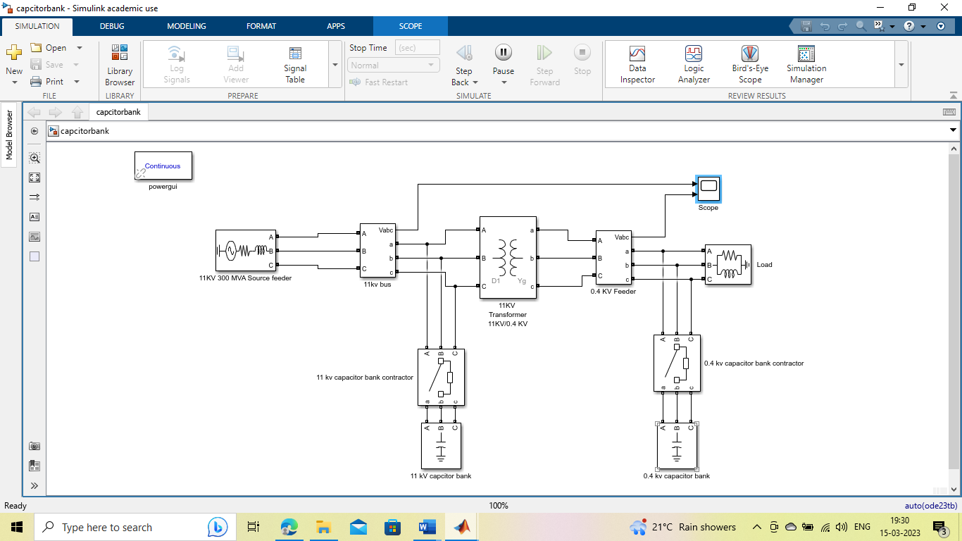
Figure 4 Capacitor bank energizing model
Output Waveform:
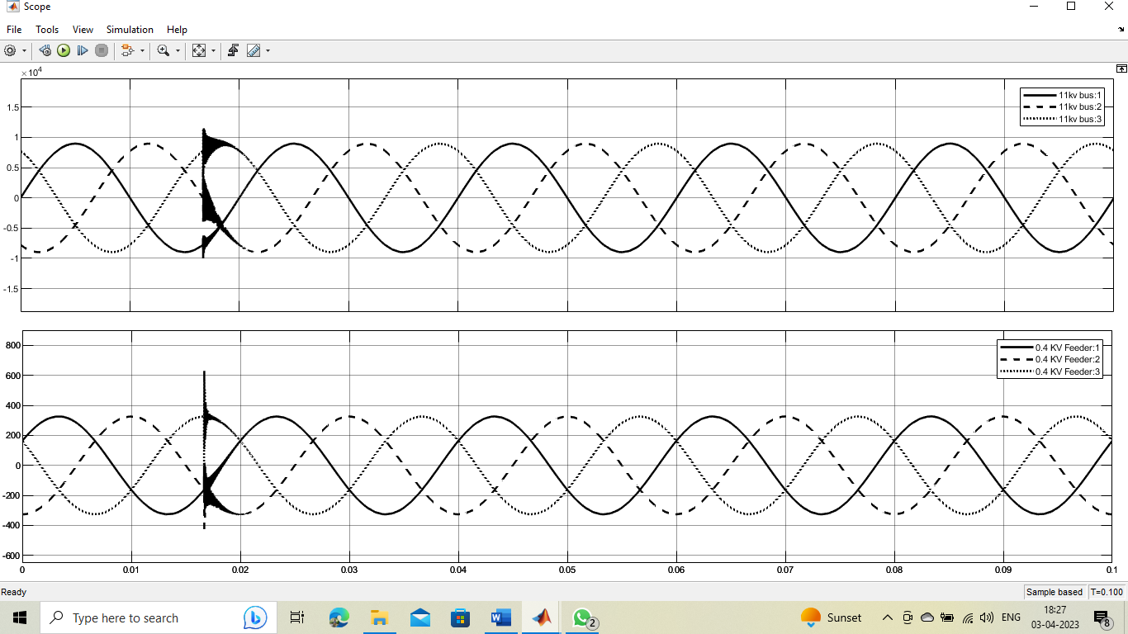
Figure 5 Output waveform of Capacitor bank energizing model
- Lightning impulse model:
The lightning impulse model developed in MATLAB/SIMULINK simulates impulsive transients caused by lightning strikes near transmission lines. The model uses a 0.4 kV, 1 MVA, 50 Hz three-phase source supplying power to a 10-kW resistive and 10 KVAR inductive load. Measurement scopes are placed at the 0.4 kV bus to capture instantaneous waveforms. A lightning block, which includes a controlled voltage source with resistive and inductive networks, is connected to the feeder line to simulate the lightning-induced transient[10].
V(t)=Ae^{-a(t-t1)}.u(t-t₁)----------------(1)
Circuit Diagram:
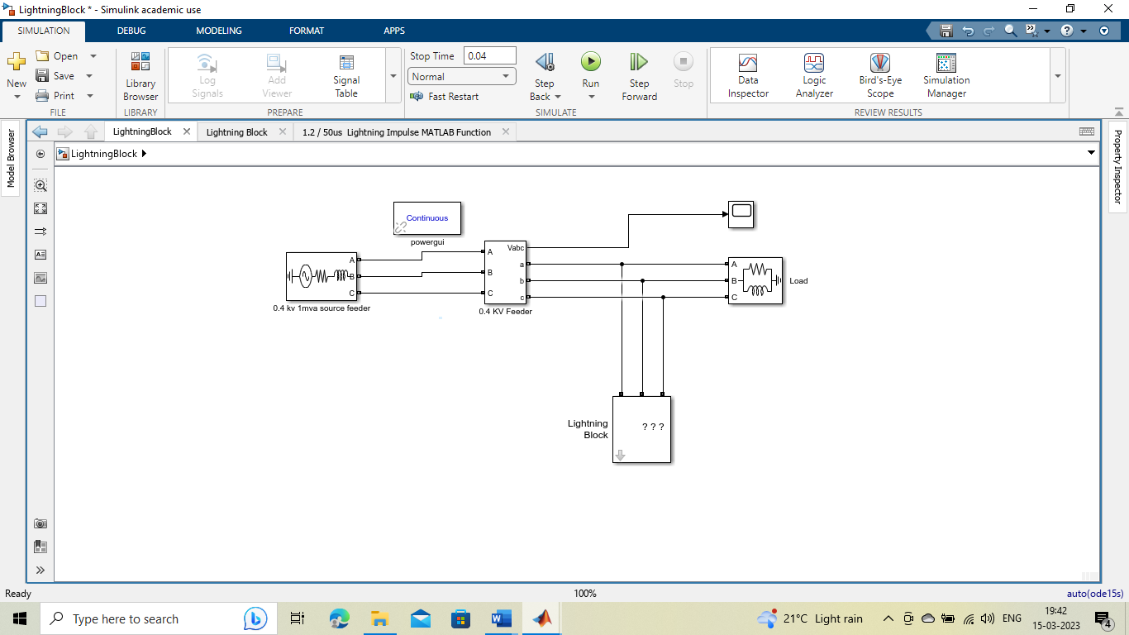
Figure 6 Lightning impulse model
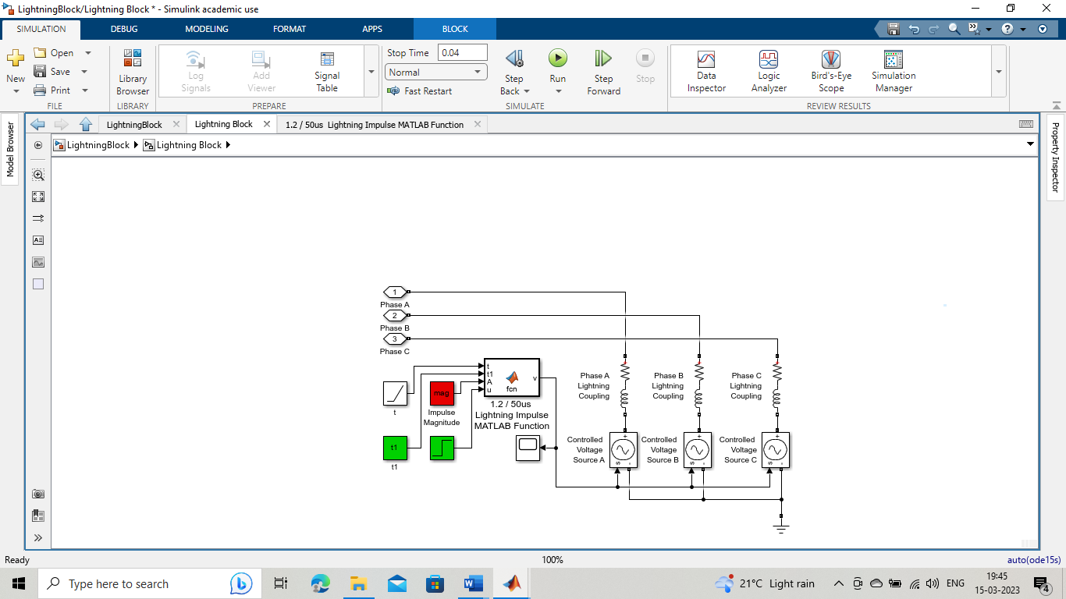
Figure 7 Lightning Block

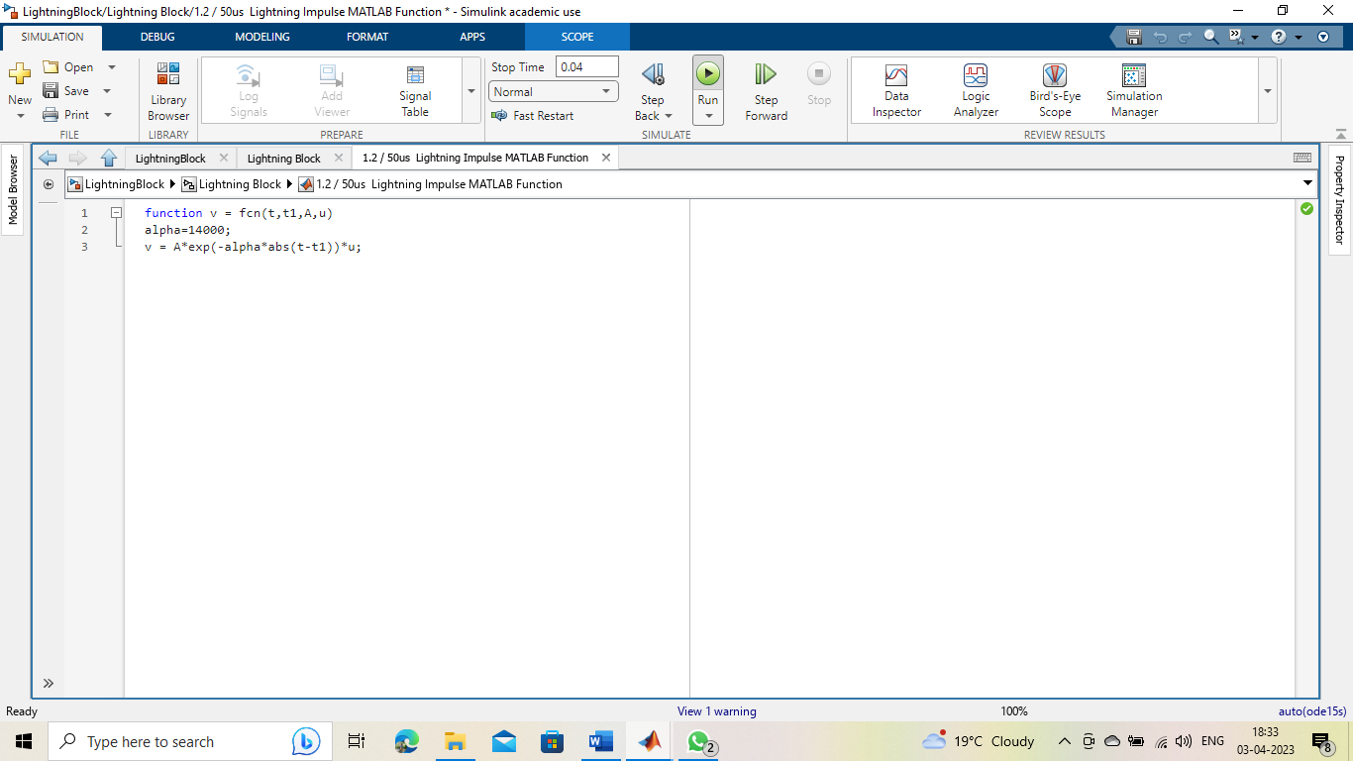
Figure 8 Lightning impulse MATLAB function
Output Waveform:
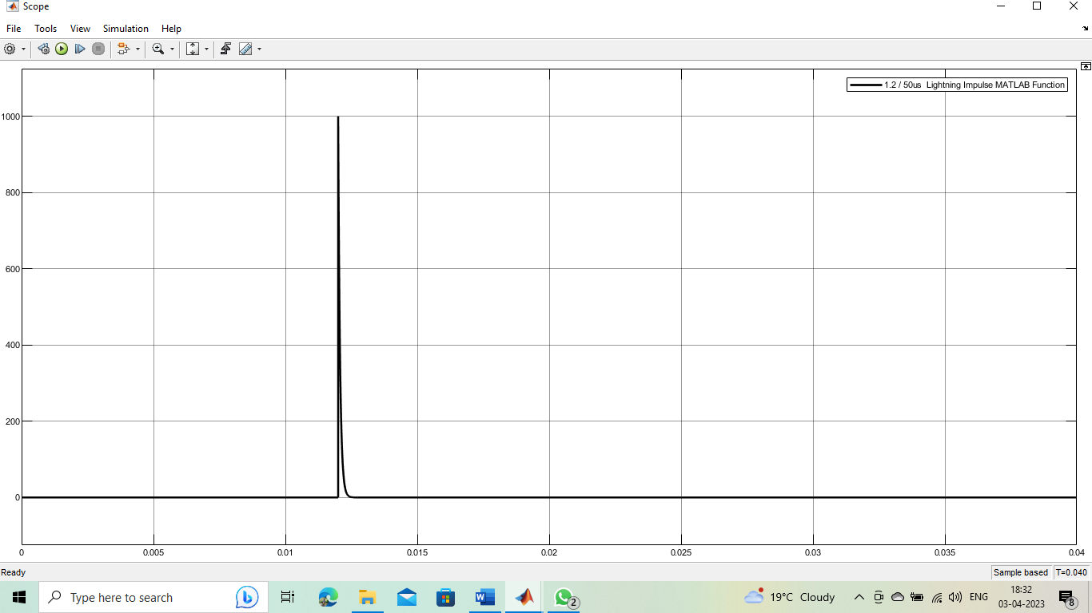
Figure 9 Lightning impulsive waveform

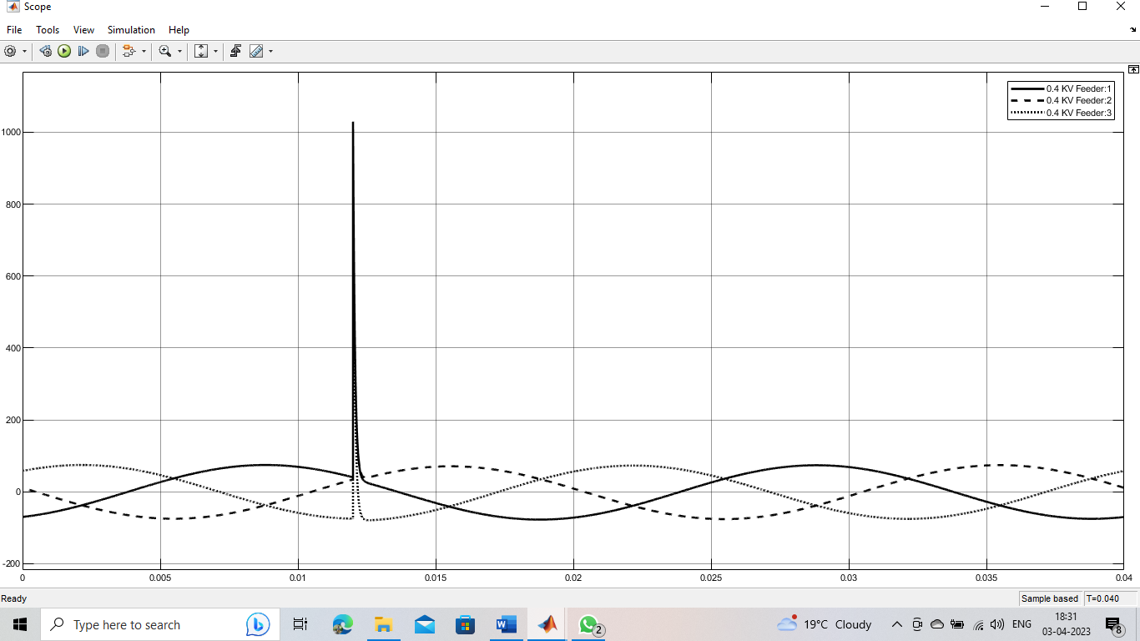
Figure 10 Impulse transient caused by lightning near 0.4kV transmission line

Conclusion
This paper presented simulations of key power quality disturbances using MATLAB/SIMULINK, including line faults, capacitor bank energization, and lightning impulses. Each model demonstrated the transient behaviours these disturbances cause in a power system. The line fault model showed various fault types and their resulting voltage sags, emphasizing how fault impedance and transformer configurations affect sag characteristics. The capacitor bank energization model highlighted the oscillatory transients from switching operations, with results indicating that larger capacitor banks reduce transient frequencies but increase damping time. The lightning impulse model accurately replicated standard 1.2/50 μs waveforms, demonstrating the transient effects of lightning strikes on transmission lines.These simulations provide useful insights into the behavior of power systems under disturbances, helping improve protection strategies and power quality management.

References
- M. Bollen, "Understanding Power Quality Problems: Voltage Sags and Interruptions," IEEE Press, 2000.
- M. H. J. Bollen and I. Y. H. Gu, "Signal Processing of Power Quality Disturbances," IEEE Press, 2006.
- R. C. Dugan, M. F. McGranaghan, S. Santoso, and H. W. Beaty, "Electrical Power Systems Quality," 3rd ed., McGraw-Hill, 2012.
- T. Greenwood, "Electrical Transients in Power Systems," 2nd ed., Wiley, 1991.
- H. J. Altuve, R. C. Thompson, "Fundamentals and Advancements of Single-Line-to-Ground Fault Protection," IEEE Transactions on Power Delivery, 2009.
- S. J. Ranade, "Simulation and Analysis of Line-to-Line Faults in Distribution Networks," IEEE Power Engineering Review, 2011.
- R. H. Brown, "Analysis of Double-Line-to-Ground Faults in Industrial Power Systems," IEEE Transactions on Industry Applications, 2007.
- R. C. Dugan, M. F. McGranaghan, S. Santoso, and H. W. Beaty, "Electrical Power Systems Quality," 3rd ed., McGraw-Hill, 2012.
- R. C. Dugan, M. F. McGranaghan, S. Santoso, and H. W. Beaty, "Electrical Power Systems Quality," 3rd ed., McGraw-Hill, 2012.
- IEEE Std 1159.1-2009, "IEEE Guide for Power Quality Monitoring," IEEE, 2009.

