**Research on Cement with Metakaolin with Robo sand**

*G. Manjunath, **K. Venkata Krishna (Ph.D)

*Post Graduate student, Anantalakshmi Institute of technology and sciences, Anantapur, A.P, India

**Assistant Professor, Anantalakshmi Institute of technology and sciences, Anantapur, A.P, India

**ABSTRACT**

Concrete is a composite material made from cement, water, and fine aggregate and coarse aggregate. But present researchers are in interest of finding new concrete by using different alternative materials or products produced from industries which are harmful to environment. An attempt has been made in the present investigation to evaluate the compressive strength and split tensile strength and flexural strength properties by replacing cement partially with Metakaolin and the perfect substitute for river sand is Robo-sand. River sand is one of the basic ingredients in manufacture of concrete. River sand has become expensive and scarce. Therefore, finding substitutes for the river sand is the objective. The crusher dust is known as Robo-sand can be used as alternative material to the river sand. Robo-sand possess similar properties as that of river sand, hence accepted as a building material. Some percentage of cement is replaced by met kaolin and some percentage of fine aggregate is replaced by Robo-sand. In this project, experimental study was carried out on M-35 grade of concrete. In this concrete mix sand was replaced by Robo sand by a constant percentage and cement was replaced by Metakaolin in various percentages such as 5%, 10%, 15% and 20%. By changing the percentage replacement of material, strength equal to the conventional concrete, optimum percentage of Cement or fine aggregate can be found. Due to the scarcity of fine aggregate and high cost of cement partial replacement of material has been take place. In this study compressive strength, tensile strength and flexural strength are evaluated. In this project we replace the Metakaolin to the cement for obtaining the optimum value. Optimum value of met kaolin is considered as the 15%. Now keeping the metakaolin percentage constant and partial replacement of fine aggregate by Robo sand with increasing percentage has been experimented. The compressive test on concrete cubes, tensile test on cylinders and flexure test on beams is taken into account. The curing at 7days, 28days of cubes, cylinders and beams is considered.

**Keywords**: Robo Sand, Metakaolin, Compressive strength, Split tensile strength, Flexural strength.

**Introduction:**

Concrete is probably the most extensively used construction material in the world. It is an artificial material in which the aggregates are bonded together by the cement when mixed with water. With the advancement of technology and increased field of application of concrete and mortars, the strength, workability, durability and other characteristics of the ordinary concrete can be made suitable for any situation. For this, definite proportions of cement, water, fine aggregate, coarse aggregate, mineral admixtures and chemical admixtures are required.

A fresh concrete is a concrete in the relatively fluid state and readily to be molded but the shape of the fresh concrete would slowly change if the mould was immediately removed. The fresh concrete mixed would kept all the grains of the sand and gravel encased and held in place where it is called homogeneous. The quality and characteristic of the finish product normally influence by the degree of the plasticity and significant changes in the mix properties of the fresh concrete. Hardened concrete is the end product for any concrete design. The most important properties of the hardened concrete are its strength, stress-strain characteristic, shrinkage and creep deformation, permeability and durability. The concrete strength is the greater significance because it is related to the structure of the hardened cement paste and given the overall picture for the quality of the concrete. The strength of the hardened concrete at a given age and under a given curing.

**Materials:**

**Metakaolin**

Metakaolin is brought from Astro chemicals, Chennai having specific gravity of 2.5 is used in replacement of cement. Metakaolin is a chemical phase that forms upon thermal treatment of kaolinite. Kaolinite’s chemical composition is Al2O3:2SiO2. 2H2O and as a result of thermal treatment in the range of 400oC to 500oC, the water is driven away to form an amorphous alumino silicate called metakaolin. Metakaolin is white in colour and acts as a pozzolanic material. The reactivity of the Metakaolin may also be affected by grinding to a finer particle size.

## **Robo Sand**

Robo sand is sand manufactured in the stone quarries. It is a substitute for the river sand used in construction. Robo Sand is collected from “Donabanda quary” crushing unit. It was initially dry in condition when collected and was sieved by IS 4.75 mm. It has shape of particles as Cubical Particle. The specific gravity of ROBO Sand is 2.68, Fineness modulus is 3.34. Grading Confirming to Zone-II.

Robo sand is an ideal substitute to river sand. It is manufactured just the way nature has done for over a million of years. Its numerous advantages over river sand have made it a favorite and must-to-use with quality conscious builders. Robo sand is created by a Rock-Hit-Rock crushing technique using state of art plant & machinery with world class technology.

#### Mixing of Concrete

The mixing of concrete is essential for the production of uniform concrete the mixing should be make sure that the concrete becomes homogeneous, uniform and consistency. Mixing of concrete is done according to I.S: 516-1959. Mixing of the concrete is done using a pan mixer. The ingredients cement, fine aggregates, coarse aggregates and water are introduced into the pan mixer. Initially dry cement and fine aggregates were mixed to which coarse aggregates were added and thoroughly mixed.

#### Slump Cone Test

Slump test is the most commonly used method of measuring consistency of concrete which can be employed either in laboratory or at site of work. It is not suitable method for very wet or dry concrete. It does not measure all factors contributing to workability, nor is it always representative of the place ability of the concrete. However, it is used conveniently as a control test and gives an indication of the uniformity of concrete from batch to batch.

#### Compaction factor test

#### Compacting factor of fresh concrete is done to determine the workability of fresh concrete by compacting factor test as per IS: 1199 – 1959. The apparatus used is Compacting factor apparatus this test is adopted to determine workability of concrete where nominal size of aggregate does not exceed 40 mm. It is based on the definition, that workability is that property of concrete, which determines the amount of work required to produce full compaction. The test consists essentially of applying a standard amount of work to standard quantity of concrete and measuring the resulting compaction. The compaction factor is defined as the ratio of the weight of partially compacted concrete to the weight of fully compacted concrete. It shall be stated to the nearest second decimal place.

**Cube Compressive strength**

Compressive test was done confirming to IS: 516-1959. All the concrete specimens were tested in a Universal Testing Machine (UTM) of capacity 200 tones. Concrete cubes of size 150 mm x 150 mm x 150 mm were tested. Crushing strength of concrete was determined by applying load at the rate of 140 kg/sq. cm/minute till the specimens failed. The maximum load applied to the specimens was recorded dividing the failure load by area of the specimens, ultimate compressive strength.

#### Split Tensile Strength

Split Tensile Strength test was done confirming to IS: 516-1959. All the concrete specimens were tested in a Universal Testing Machine (UTM) of capacity 200 tones. Concrete cubes of size 150 mm x 300 mm ht. were tested for split tensile strength of concrete was determined by applying load at the rate of 140 kg/sq. cm/minute till the specimens failed. The cylinder specimens of concrete was placed horizontal, so that its axis is horizontal between the plates of the testing machine. Narrow strips of the packing material i.e. ply wood was placed between the plates and the cylinder, to receive the compressive stress.

**Results and Discussion**

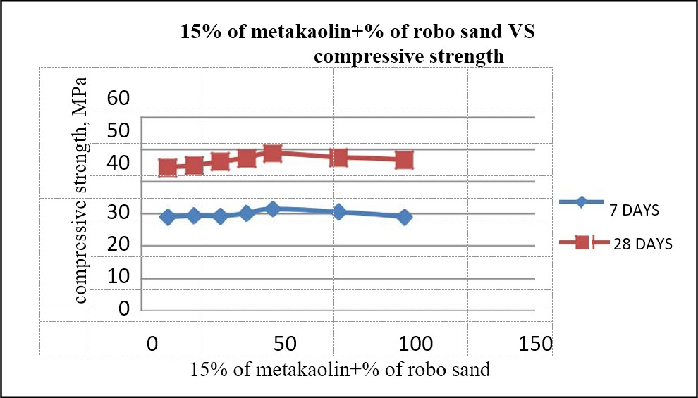

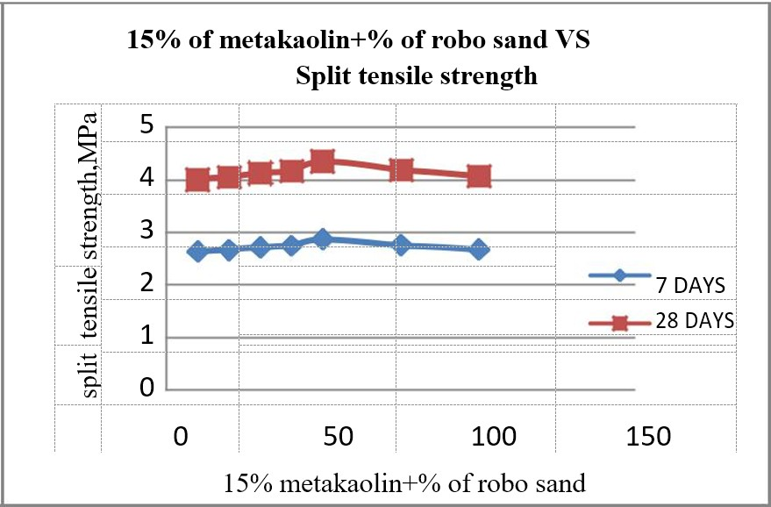**Compressive strength Of Metakaolin & Robo sand for 7 & 28 days**

**Split Tensile Strength of Metakaolin & Robo Sand for 7& 28 Days**

## Conclusions

* The concrete mixture with 15% metakaolin has the highest compressive strength (47.51Mpa), flexural strength (4.29Mpa) and split tensile strength (4.26Mpa) performance at all ages.
* Partial replacement of cement by Metakaolin increases workability of fresh concrete; therefore, use of super plasticizers is not substantial.
* The concrete mixture with 15% Metakaolin and 50% Robo and has the highest compressive strength (48.78Mpa), flexural strength (4.37Mpa) and split tensile strength (4.35Mpa) performance at all ages.
* The effect of acid on metakaolin and Robo sand concrete decreases the resultant values very slightly.
* In durability the strength loss is higher in H2SO4 than in HCL.
* The compressive strength of concrete with Robo sand is marginally higher (7% - 11%) when compared to the concrete with river sand.

**References**

* Beulah M. Asst Professor, Prahallada M. C. Professor., “Effect Of Replacement Of Cement By Metakalion On The Properties Of High Performance Concrete Subjected To Hydrochloric Acid Attack” International Journal of Engineering Research and Applications (IJERA) ISSN: 2248-9622 [www.ijera.com](http://www.ijera.com/) Vol. 2, Issue 6, November- December 2012, pp.033- 038.
* P. Jaishankarand VayugundlachenchuEswara Rao., **“**Experimental study on Strength of Concrete by using Metakaolin and M-Sand” International Journal of ChemTech Research CODEN (USA): IJCRGG, ISSN: 0974-4290, ISSN(Online):2455-9555 Vol.9, No.05 pp 446-452, 2016.
* A.V.S.Sai. Kumar, Krishna Rao B., “A Study on Strength of Concrete with Partial Replacement Of Cement With Quarry Dust And Metakaolin”, International Journal of Innovative Research in Science, Engineering and Technology (An ISO 3297: 2007 Certified Organization) Vol. 3, Issue 3, March 2014.
* Aiswarya S, Prince Arulraj G, Dilip C., “A REVIEW ON USE OF METAKAOLIN IN CONCRETE”, IRACST – Engineering Science and Technology: An International Journal (ESTIJ), ISSN: 2250-3498, Vol.3, No.3, June 2013
* Er. Amritpal K aurEr.Rajwinder Singh Bansal., “Strength and Duriabilty Properties of Concrete with Partial Replacement of Cement with Metakaolin and Marble Dust”, International Journal of Engineering Research & Technology (IJERT) ISSN: 2278-0181 IJERTV4IS070881 [www.ijert.org(](http://www.ijert.org/) This work is licensed under a Creative Commons Attribution 4.0 International License.) Vol. 4 Issue 07, July-2015.
* Disha Singh, Mohd. Afaque Khan, Abhishek Kumar., “Review on the study of compressive strength of concrete using marble dust as partial replacement of cement”, International Research Journal of Engineering and Technology (IRJET) e-ISSN: 2395 -0056 Volume: 03 Issue: 03 | Mar-2016.
* J.M. Khatib, E.M. Negim and E. Gjonbalaj., “High Volume Metakaolin as Cement Replacement in Mortar”, World Journal of Chemistry 7 (1): 07-10, 2012 ISSN 1817-3128 © IDOSI Publications, 2012 DOI: 10.5829/idosi.wjc.2012.7.1.251.
* Ilangovan, R., N. Mahendran, and K. Nagamani, “Strength and durability properties of concrete containing quarry rock dust as fine aggregate”, ARPN Journal of Engineering and Applied Sciences, vol. 3, pp 20-26, May 2008.
* Kou, S.C. and C.S. Poon, “Properties of concrete prepared with crushed fine stone, furnace bottom ash and fine recycled aggregate as fine aggregates”, Construction and Building Materials, vol. 23, pp. 2877–2886, 2009.
* Celik, T. and K. Marar, “Effects of crushed stone dust on some properties of concrete”, Cement and Concrete Research, vol. 26, pp. 1121-1130, July 1996.
* Wild, S., J.M. Khatib, and A. Jones, “Relative strength, pozzolanic activity and cement hydration in super plasticized metakaolin concrete”, Cement and Concrete Research, vol. 26, pp. 1537-1544, Oct. 1996.
* Curcio, F., B.A. DeAngelis, and S. Pagliolico, “Metakaolin as a pozzolanic micro filler for high performance mortars”, Cement and Concrete Research, vol. 28, pp. 803–809, June 1998.
* Poon, C. S., L. Lama, S.C. Kou, Y.L. Wong, and R. Wong, “Rate of pozzolanic reaction of metakaolin in high performance cement paste”, Cement and Concrete Research, vol. 31 pp. 1301–1306, 2001.
* Manu vijay,” Experimental study of concrete strength by replacing baggase ash by marble dust”, May 2015, pp.
* S.K. Jain, P.G. Patil, and N. J. Thakor (2011) Engineering properties of laterite stone scrap Blocks, Agricultural Engineering International: CIGR Journal. Vol.13, No.3, No.1738.