**A Review on Avartani (Helicteres isora)**

**Mr. Tushar D Janjire Mr. KiranWaghmare Dr. Garje Sanjay Dr.Sayyed Gaffar**

**SAJVPM’S College Of Pharmaceutical Science And Research Centre, Kada (Beed), Maharashtra, India.**

**Abstract:**

Helicteres isora, a woody shrub with upright branches that belongs to the Sterculiaceae family, is known in Ayurveda as Avartani. In addition to being widely used in traditional medicine, this plant's roots and fruits have been shown to have antibacterial, anticancer, hepatoprotective, antinociceptive, antioxidant, hypolipidemic, and antidiabetic properties. Methods: Powder microscopical, transverse section, macroscopy, and pharmacognostical investigations were conducted. Hydroalcoholic extracts of fruit and root were used for the initial phytochemical screening. These extracts were then further screened for assays such as glucose adsorption capacity, the influence of extracts on in vitro glucose diffusion, and glucose absorption by yeast cells. Results: Cellular characteristics such as spiral vessels, rosette, elongated sclereids, pitted vessels, prismatic crystals in roots and stellatetrichomes, and lignified stone cells in fruits have been identified as diagnostic features in pharmacognostical research. More research is needed on this medicine to analyze the pharmacological activities of this medicament. The historical review, colloquial names, synonyms, ayurvedic qualities, cultivation and harvesting, research projects, and medicinal applications of avarotaki are all covered in this review article.

**Introduction:**

Because of their safety, effectiveness, and lack of side effects, herbal medications are commonly utilized in the twenty-first century. Plants are being employed for both illness prevention and relief, with differing degrees of success. Eighty percent of the world's population gets their medical care from conventional medicine, according to the WHO.  
A widespread plant in India, Cassia auriculata is a member of the Caesalpiniaceae (Fabaceae) family and is used extensively in Ayurvedic medicine as a tonic and treatment for diabetes. Tanner's cassia, or Cassia auriculata Linn, is also referred to as "Vilayati Tarvad" in Marathi. It has been stated that the plant has hypoglycemic, antibacterial, and microbicidal properties. The shrub is highly recognized for its lovely yellow bloom which utilized for the treatment of skin problems and body odor. It is widely distributed throughout India, mostly in arid deciduous woods that reach elevations of 1500 meters on the slopes of hills. It is said to encompass more than 30,000 acres of Travancore woods.[1,2] It is utilized in Indian traditional medicine and has been shown in studies to have anti-inflammatory, hypolipidemic, and antidiabetic properties.[3] Its fruit powder is intended to relieve stomach gas and gripping pain.[4] The fruit chloroform extract exhibited antimicrobial efficacy against Aspergillus niger, Escherichia coli, Candida albicans, and Staphylococcus aureus.[5] Fruit acetone extract has been shown to have antimicrobial properties. The ethanolic extract from roots showed hepatoprotective properties.[17] An ethanolic fruit extract possesses strong antihyperlipidemic properties.[18] According to several Ayurvedic formulations, including Ayaskrti, Dadhika ghrata, Mahapanchagarya ghrata, Sudarshana churna, Candana Balakasad taila, Prameha Mihira taila, Gandharva churna, and Sidha Praneswar‑rasa, the fruit and root are considered to have multiple therapeutic qualities.

**CLASSICAL REVIEW OF AVARTAKI :**

The word meaning of Avartaki is that which improves the complexion or glow of the body. Avartaki – Avarta ev kayti prakashate | 3 And another meaning of Avarta is one which borne repeatedly .

**Vedic period and Samhita period:**

- In Vedas and Samhita there is no mention of Avartaki

**Samgraha period :**

First time Acharya Vagbhata the author of Asthang hridaya mentioned Avartaki.

**Nighantu kala :**

Dhanwantari Nighantu was written in 11th cent. All the drugs in this Nighantu are described in 11 Vargas. Synonym, property and action etc of Avartaki are described in Guduchyadi varga. Madanapala Nighantu was written in 14th cent. And its subjects are divided under 13 Vargas. Here Avartaki is described in Abhyadi varga. In the same century Kaiyadeva Nighantu or Pathapathya Nighantu was formed. It is divided into 8 Vargas. This Nighantu also describes the properties of Avartaki in Aoushadhi varga. Raja Nighantu (Abhidhanachudamani) divided in 23 Vargas. Here the introduction, properties of Avartaki fall in the Guduchyadi varga.

**PROBABLE INTERPRETATION OF SYNONYMS:**

Interpretation of some important synonyms according to their derivations is given below Aavrtaki - Which increase the complexion or glow of the body or which born repeatedly. Aahulyam – Which spread on the ground. Charmaranga, Charmaranjankarini, Ranagkara - Which used to stained the leather Mahatali, Mahadajalini, Marutali, Mahajalinlka - The herb which spread like a net on the earth Pitkala, Pitpushpa, Pitkalika, Pitkla, Pitkalikyukta- Flowers are yellow in colour Raktapuspi, Raktapushpika - Flowers are red in colour.

TAXONOMY :

Systemic position

Kingdom - Plantae

Subkingdom - Tracheobionta

Super division - Spermatophyta

Division - Magnoliophyta

Class - Magnoliopsida

Sub-class - Rosidae

Order - Fabales

Family - Fabaceae

Genus - Cassia

Species – auriculata

**DISTRUBUTION AND HABITAT**

The shrub occurs on roadside, wastelands, and railway embankments. It is plentiful in the drier districts of Andhra Pradesh, Karnataka, and Tamilnadu found in the dry zones of Southern, Western and central India extending up to Rajasthan in the North; also cultivated in some parts of Punjab, Haryana, Uttar Pradesh and West Bengal and often planted in garden for ornament and as hedges.

**Materials and Methods**

**Plant authentication:**

Fresh roots, fruits of H. isora were collected from the place Suryapet, Telangana state, India. The plant material was authenticated by comparing with voucher specimen‑GPRCP/SV/2000 present in the Department of Pharmacognosy, G. Pulla Reddy College of Pharmacy, Hyderabad, India.

**Macroscopy :**

The roots, fruits of H. isora were examined in daylight and also by dissecting microscope for various macroscopical characters. The color, odor, taste, shape, fracture, surface, apex, external markings of roots, fruits were observed.

**Anatomical studies:**

A thin transverse section of root, fruit of H. isora was taken and treated with chloral hydrate reagent. The cleared sections were mounted in glycerin. The sections were also treated with phloroglucinol reagent to study the lignified tissues such as xylem and sclerenchyma. The presence of starch was identified by irrigating the section with dilute iodine solution.

**Powder microscopy:**

The root and fruit powders were treated separately in chloral hydrate reagent and small quantity of test sample was taken onto a microscopic slide. Two drops of phloroglucinol reagent were added and a cover slip was placed above the sample. Photomicrographs of the different cellular structures in macerated samples were taken with various magnifications by a digital camera attached to trinocular microscopic unit. For conventional observations, ×10 magnification, for micro‑observations ×40 magnification was employed for the study of cellular structures.

**Extraction:**

The collected roots and fruits were shade dried and weighed. The 350 g of plant materials were pulverized and passed through the sieve number‑60. The dried powder material was extracted with 2 l of 70% aqueous ethyl alcohol by cold maceration for 7 days. The solution was f iltered and the extract was concentrated under reduced pressure to yield dried aqueous ethyl alcohol extract of roots and fruits.

**Phytochemical screening:**

Phytochemical screening was performed according to the standard procedures. H. isora root, fruit hydroalcoholic extracts were diluted with respective solvents and a little quantity of test sample was subjected to chemical reagents for the detection of different phytoconstituents such as phenols, flavonoids, alkaloids, and glycosides.

**In vitro evaluation of hypoglycemic activity :**

**Glucose adsorption capacity:**

**To 25 ml of various concentrations of glucose solutions (5, 10, 20, 50, and 100 mM) 250 mg of root, fruit hydroalcoholic extracts were added separately and mixed properly. Then incubate the mixture on a shaker water bath at 37°C for 6 h. After 6 h of incubation, centrifuge the mixture for 20 min at 4000 rpm. The glucose content in the supernatant was determined using Glucose Oxidase‑Peroxidase kit.**

**Glucose diffusion studies :**

Fill the acceptor compartment of Franz diffusion cell with water up to the brim. To 25 ml of glucose solution (20 mM) test extracts (1%) were added. Place a dialysis membrane between acceptor and donor compartment of the Franz diffusion cell. The prepared mixture is placed in the donor compartment. The whole apparatus which is assembled with all this should be placed on a magnetic stirrer which is to be maintained at 37°C for 3 h. At different time intervals, withdraw the samples from the acceptor compartment through the sampling port, at 30, 60, 90, 120, and 180 min. Finally, determine the glucose content in each sample. A control was performed simultaneously without extract.

**Glucose uptake by yeast cells :**

One milliliters of H. isora root, fruit extracts (1–5 mg/ml) were mixed with 1 ml of glucose solution, incubated at 37°C for 10 min. The reaction was started by adding 100 µl of 10% v/v yeast suspension, mixed by vortexing and further incubated at 37°C for 1 h. After incubation, the mixture is centrifuged at 2000 rpm for 5 min. Then the supernatant was collected and determined the glucose content. A control was performed simultaneously without extract.

**Results :**

**Macroscopy :**

**Root:**

Dried‑cut pieces of roots are cylindrical, elongated, somewhat twisted, having wiry rootlets. The root bark is rusty‑brown, inner root is cream color. Surface is rough, shows the presence of cracks, longitudinal striations, and wrinkles. Fracture of root is short in bark and fibrous in wood.

**Fruit:**

The fruits are linear, very hard, rough surface, 5–7 cm long, 0.6–1.0 cm diameter, with 5 spirally twisted, compactly arranged carpels twisted together in the form of a screw, tapering at the both ends, grayish brown in color, and beaked and cylindrical shape. Individual carpels are in spiral shape with two uniform folding’s and contain seeds. Seeds are dark brown to black, 2–2.5 mm in length, four‑angled with two wide flat surfaces slightly centrally depressed, small elevation lying at one pointed end is the hilum. Figures 1 and 2 represent the macroscopic features of root and fruit.

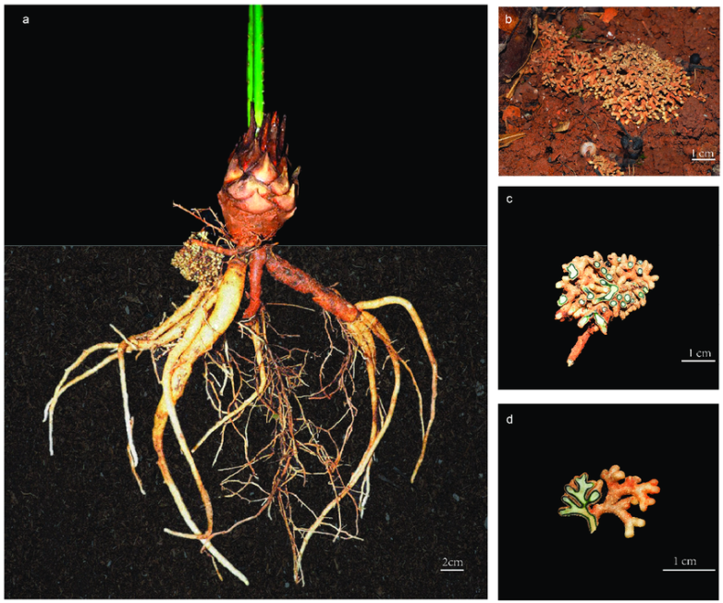

**Morphology of Helectreous isora roots**

Anatomical characters :

**Roots:**

The transverse section of root shows 12–16 layers of closely packed narrow tangentially elongated thincollenchymatous cortical cells have wavy walls that are low in tannin and starch granules. The walls of the cortex are less wavy or straight in the lower rows and more wavy in the upper rows. Although cork is nearly invisible, thick-walled polygonal cork cells are visible in a few areas. The phloem area is made up of many big, ovoid-shaped .The contents of thin-walled parenchymatous cells are abundant starch granules. Phloem fibers with thick walls that are lignified are found in clusters. There aren't many crystals in the shape of rosettes. The xylem region is made up of many small, narrow, ovoid-shaped, thin-walled xylem parenchymatous cells that are filled with cells. There is a bundle of xylem fibers that have been lignified. There are several long, thin lumens filled with sclereids and a small number of prismatic calcium oxalate crystals. Medullary rays that have been aligned are bi-to multiseriate displays the transverse analysis results.

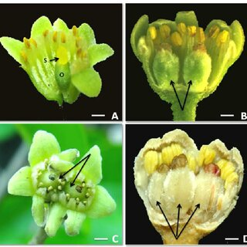

**Morphology of Helectreous isora fruit (a) Complete fruit; (b) Fruit Carpels**

Fruits:

The transverse section of carpels shows thick‑walled cuticle containing epicarp with numerous stellate trichomes with large lumen and few glandular trichomes. Mesocarp is composed of numerous thick‑walled sclerenchymatous cells. Endocarp is wide composed of highly thick‑walled stone cells in several horizontal rows, thick‑walled fibers. The transverse section of seed shows rectangular cells of testa filled with tannin content, a layer of transparent elongated palisade cells, followed by wide endosperm containing thin‑walled parenchymatous cells, filled with oil globules, and aleurone grains. Figure 4 shows the results of transverse section of fruit.

**Powder microscopy:**

**Root:**

Powder is light brownish cream color, with no specific odor and bitter taste. It shows diagnostic microscopic characteristics such as thick‑walled polygonal cells of cork, rectangular cells of cortex cells containing tannin matter, thin‑walled parenchymatous cells with cell contents, lignified pitted vessels; long sclereids with narrow lumen, simple starch grains, numerous rosette, prismatic calcium oxalate crystals, long phloem fibers, and group of lignified quadrangular stone cells. Figure 5 shows the results of powder microscopy of root.

Discussion:

Using several in vitro models, the current study assessed the pharmacognostical, phytochemical, and hypoglycemic potential of the roots and fruits of H. isora (Sterculiaceae). The transverse section of the young root of H. isora reveals parenchymatous cells full of starch grains, prism- and rosette-shaped crystals, and collenchymatous cortical cells with few starch grains and tannin contents.   
Similarly, fresh fruit has an endocarp made up of many horizontal rows of extremely thick-walled stone cells and thick-walled fibers, and an epicarp with many stellate trichomes and few glandular trichomes. Prismmatic calcium oxalate crystals, lignified quadrangular stone cells, long sclereids, simple starch grains, and lignified pitted capillaries were all observed in H. isora root powder microscopy. Comparably, fruit powder has revealed palisade cells, lengthy spiral vessels, lignified stellarate trichomes, and a collection of stone cells of various sizes and forms.   
Phenols, flavonoids, proteins, and other compounds were found in the H. isora root and fruit hydroalcoholic extracts during the initial phytochemical screening (test tube reactions).

**HABIT AND GENERAL FEATURE:**

A fast growing, profusely branched, tall evergreen shrub, generally 1.2- 3 m height, sometimes reaching up to height of 6 m.

**EXTERNAL MORPHOLOGY:**

**Leaves :**

Leaves nearly sessile, approximate 3-4 inch long rachis grooved, pubisient, furnished with a single linear gland between the leaflets of each pair, stipules broad, leafy persistent, their inner bases with filiform points.

**Inflorescence :**

Inflorescence Racemes axillary, nearly as long as the leaves, many flowered approximated toward the end of the branches.

**Flower :**

Flowers large, yellowish about an inch long, shortly pubescent, pedicels forming long peduncled shortly glabrous pubescent bracted few flowers raceme in the axis of the leaves, bracts leafy, ovate to obovate, lanceolate, acuminate, 3-4 inch long, long persistent, calyx glabrous or nearly so, the sepals cilioate, petals-obovate, rounded, shortly clawed, nearly an inch long, filament, overy shortly appressed pubescent, stamens 10

**Fruits :**

Pods pale brown, oblong, 5.5 cm x 1.2-1.8 cm linear oblong at the base in a short stalk, terminating in a long filiform style, very flat, shorthly and rather thinly pubescent.

**Seeds :**

Dark brown in colour compressed, tapering towards the base. 6-12 seed per pod.

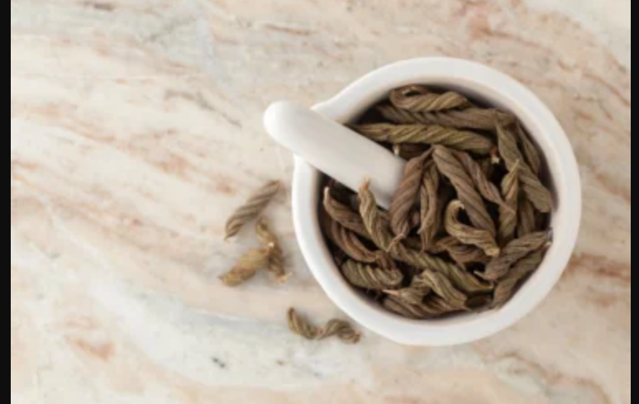

**Inflorescence**

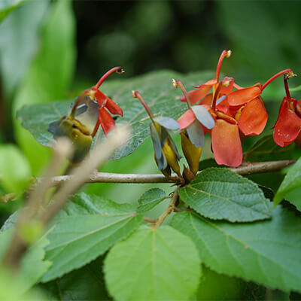

Habit

**THERAPEUTIC USES:**

The only classical reference to Avartaki that is described in Asthang Hridaya is Avartaki Ghrutha 32. prepared by this plant's root. This should be eaten at a day's interval, and then a mess of kodrava and raw kanjika should be eaten. Goiter, leprosy, and lecoderma were all treated by this. It also improves memory and intelligence.   
  
Flowers and flower buds can be used as pessaries to control an excessive menstrual flow, and they are also a great treatment for diabetes.   
  
a drink made from a leaf infusion that is cooling. Because of its strong astringency, the bark is a useful alternative to tannic acid. It serves as a substitute as well.

Decorticated seeds with their testas and kernels are finely powdered and blown into the eyes, or the powder mixed with coconut or gingelly oil is applied to sore eyes. Decorticated seeds are valued for local applications to purulent opthalmia or conjunctivitis, known as "Country sore eye." Additionally, seeds are used for chylous urine and diabetes.

**CONTROVERSIES :**

Controversies in the identification of some drugs arise, since Acharya had used synonyms which may indicate more than one drug with different botanical identity. Interpretation of synonyms and identification by various commentators also create confusion about the exact identity of the drug. In traditional literature like Atharva Veda and classical texts we can find the mention of “Vishanika” whose synonyms given in Nighantus as Aavrtaki. Different synonyms have given by different authors for Vishanika as follow.

According to the text above Vishanika has been used as potent medicinal drug from Vedic period to Samhita period. But the critics of the classical text have given various synonyms for this drug. Acharya Chakrapanidatta says it as Avartani. In the reference of Cha.su.1/78 while mentioning mulini dravya given the meaning of Vishanika as Avartani. Acharya Dalhana in the critical analysis of Susrutha Samhitas at two places has mentioned it as “Meshashringi” and “Avartani” for Vishanika.

After a thorough understanding of the classics it is realised that Vishanika is not similar to “Avartaki”. This is some other drug or synonyms of some plants. Because Acharya Charaka in Sutrasthana first adhyaya telling about sodasa Moolini dravyas has mentioned Vishanika. Where he has told that Vishanika have purgative property. Similarly Acharya Susrutha also agrees with Acharya Charaka justifying his view. He states that Vishanika has purgative action. Raja Nighantu has told this drug has Antidiarrihoeal properties and it is also observed in patients that Avartaki has pacificatory action on the peristaltic movements of the intestine. So it is clear that Vishanika the synonyms used in classical text is not Avartaki which is mentioned in Nighantus.

**CONCLUSION:**

From above literature it is concluded that Cassia auriculata Linn. is responsible for the various therapeutic potentials especially in diabeties. It contains a number of phytoconstituents and amino acids. More research is needed to isolate the constituents responsible for the biological actions. There are very less clinical trial done on Avartaki. The literatures showed that the plant is very safe and effective for medicinal uses. So from this review of literature, it was concluded that the plant is having high medicinal value. The H. isora root and fruit pharmacognostical tests, which included macroscopic, powder microscopic, and anatomical investigations, produced a fingerprint profile for this plant that is helpful for accurate authentication and preventing adulteration from other species. Hydroalcoholic extracts of H. isora fruit and root shown considerable anti-hyperglycemic action at varying doses in all three investigated methods. H. isora root extract outperformed fruit extracts in every model that was examined.   
The use of root extract increased the amount of glucose that yeast cells were able to absorb; the highest uptake values were found at 5 mg/ml, or 56.64%. Similarly, at 180 minutes, root extract displayed a higher GDRI (P ≤ 0.05) value of 120.8. These investigations revealed that the root and fruit extracts of H. isora may have an anti-diabetic mode of action.

**Reference:**

1. (Review on ethnobotany, phytochemistry, and pharmacological properties of Cassia auriculata Salma B, Muthukumar SP, Avinasha S, Manjula SN Pharm Pharmacol Int J. 2020; 8(2):106‒111. )
2. J. O. Voigt; Hortus suburbanns calcuttensis; A catalogue of the plants; International book Distributors; Deharadun page No. 250
3. Wealth of India vol -3. A dictionary of Indian raw materials and industrial products page no 335
4. Chitravadivu, C & Manian, S & Kalaichelvi, K. (2009). Quantitative Analysis of Some Selected Medicinal Plants, India. Journal of Scientific Research. 4.
5. L Pari, M Latha Effect of Cassia Auriculata Flowers on Blood Sugar Levels, Serum and Tissue Lipids in Streptozotocin Diabetic Rats Singapore Med J 2002 Vol 43(12) : 617-621
6. Puranik AS, Halade G, Kumar S, Mogre R, Apte K, Vaidya AD, Patwardhan B. Cassia auriculata: Aspects of Safety Pharmacology and Drug Interaction. Evid Based Complement Alternat Med. 2011; 2011:915240. doi: 10. 1093/ecam/nep237. Epub 2011 May 3. PMID: 21785642; PMCID: PMC3137796.
7. S. A. Gaikwad, Asha Kale, Kavita Mundhe, N. R. Deshpande, J. P. Salvekar Detection of Amino Acids Present in the Leaves of Cassia auriculata L. International Journal of PharmTech Research CODEN (USA): IJPRIF ISSN : 0974-4304
8. Murugan P. Taner’s Cassia (Cassia auriculata L) extract prevents hemoglobin glycation tail tendon collagen properties in experimental diabetic rats. Journal of cell and tissue research. 2010; 10 (1): 2109-2114.
9. Pharmacopia indica – A History of the principal drug of vegetable origin met with in British India – Vol-1
10. Ahmed F, Sairam S, Urooj A. In vitro hypoglycemic effects of selected dietary fiber sources. J Food Sci Technol 2011;48:285‑9. 35. Madhava Reddy B, Satyavati D, Reddy YS, Dayanand Reddy G, Venkatesh S. Effect of Helicteres isora root extracts on glucose induced hyperglycemic rats. Fitoterapia 2004;75:364‑7.
11. Chau CF, Chen CH, Lin CY. Insoluble fiber‑rich fractions derived from Averrhoa carambola: Hypoglycemic effects determined by in vitro methods. LWT Food Sci Technol 2004;37:331‑5.
12. Satake T, Kamiya K, Saiki Y, Hama T, Fujimoto Y, Kitanaka S, et al. Studies on the constituents of fruits of Helicteres isora L. Chem Pharm Bull 1999;47:1444‑7.
13. Gaikwad MS, Dhasade VV. Review on phytochemicals and pharmacological profile of Helicteres isora Linn. Curr Pharm
14. Kumar TM, Violet Christy AM, Ramya RC, Malaisamy M, Sivaraj C, Arjun P, et al. Antioxidant and anticancer activity of Helicteres isora dried fruit solvent extracts. J Acad Indus Res 2012;1:148‑52.
15. Zareen N, Venkatesh S, Bolleddu R, Dayanand RG, Ramesh M. Antidiabetic effect of helicteres isora root in streptozotocin induced diabetic rats. Austin J Endocrinol Diabetes 2019;6:1067.