**Review in Fluid Dynamics in Biomedical Devices**

Sahil kumar1

*1 Mr.Rahul choudhary*

*2 Mr.Deepak Badhan*

*1Department of Mechanical Engineering, Himachal Institute of Engineering and Technology Shahpur, ,* [sahilkumar393560@gmail.com](mailto:sahilkumar393560@gmail.com) 2

|  |
| --- |
|  |
|  |

Abstract

Fluid dynamics plays a critical role in the design and functionality of various biomedical devices, ranging from cardiovascular implants to drug delivery systems. This abstract provides an overview of key principles and applications of fluid dynamics within this field. The behavior of fluids in biomedical devices is influenced by factors such as viscosity, shear stress, and flow patterns, which are essential in understanding how these devices interact with biological tissues. For instance, in cardiovascular devices like stents and artificial heart valves, the optimization of fluid flow can minimize turbulence and thrombosis, thereby enhancing patient outcomes. Moreover, advancements in micro fluidics have enabled the development of portable diagnostic devices that utilize fluid dynamics principles to analyze biological samples with high precision. This innovation is transforming point-of-care testing and personalized medicine. Moreover, advancements in micro fluidics have enabled the development of portable diagnostic devices that utilize fluid dynamics principles to analyze biological samples with high precision. This innovation is transforming point-of-care testing and personalized medicine. n summary, the integration of fluid dynamics in the development of biomedical devices not only enhances their performance but also addresses critical challenges in patient care. Ongoing research in this area promises to lead to more effective and safer medical technologies, ultimately improving health outcomes.

*Key words:* • **Fluid Mechanics**, **Hemodynamic**, **Computational Fluid Dynamics (CFD)**

*Introduction*

Significant advances in the computer-based simulation are growing rapidly in accordance with its importance use and rapid acceptance for various applications. Computational Fluid Dynamics (CFD) is one of the widely adopted methodologies of computer-based simulation which defined as a branch of fluid dynamic that uses numerical solutions of the governing equations for simulating real fluid flows [1].The applications of CFD received tremendous attention and widely adopted for solving complex problems in various modern engineering fields including electronics packaging, chemical engineering, turbines, external and internal environmental architectural design, marine and environmental engineering, metrology, hydrology and biomedical engineering [2,3]. CFD is becoming a key component in developing updated designs and optimization through computational simulations. However, the recent CFD is still emerging in biomedical application due to the complexity of human anatomy and human body fluid behavior. Nevertheless, it is becoming more accessible and practicable by virtue of the advent of digital computer with high performance hardware and software[2]. Since the importance of knowledge of body fluids and system components are expected to perform and bio-fluid physiology study has been growing over the last several years, the advancement of biomedical practices and technology has been stimulated. The biomedical research with the aid of CFD software is still emerging which incorporated the physiology and path physiology of cardiovascular system and respiratory system through simulation. Various researches of simulation and clinical results had been studied, particularly the analyses of blood flow and nasal airflow. In most researches, the blood flow analysis studied the circulation of blood of ventricle function, coronary artery and heart valves. Meanwhile, the nasal airflow analysis studied the basic airflow in human nose, drug delivery improvement and virtual surgery.

**1. RESEARCHES OF BIOMEDICAL IN CFD APPLICATIONS**

CFD plays an important role by offering chances for simulation prior to undertaking real commitment to develop medical interventions in the correct direction and to execute any medical design alteration[7]. The researches of biomedical CFD applications received tremendous attention in the past few years due to the importance of computational medical simulations of circulatory functions. The biomedical CFD applications for cardiovascular and respiratory systems are discussed in the subsequent sub-section.

**I. Cardiovascular Devices**

CFD is extensively used to study blood flow dynamics in cardiovascular devices such as stents, heart valves, and vascular grafts. Research focuses on. Cardiovascular is pertaining to the heart disease which is the major cause of death around the world[8]. Heart valve disease is the common disease which causes by the narrowing of aortic valve or leaking of blood flow on the valve leaflet. Recent study, Basri et al. [5]studied the hemodynamic properties of the effect different valve opening for 45˚, 62.5˚ and fully opening by using the combination of magnetic resonance imaging (MRI) and CFD simulation. The authors investigated the hemodynamic properties in terms of pressure, velocity and wall shear stress to determine blood behaviour of severed aortic stenosis. The result shows the significant decrease of blood pressure on the small valve opening, which caused the obstruction of blood ejection due to narrowing of valve. Hence, the study found that the lower leaflet opening shown detrimental effect on blood flow and induced higher stress on the leaflets. Besides that, Basri et al. [9]compared the normal aortic valve (fully open) and stenosed aortic valve (62.5˚ opening) through the study of hemodynamic properties. The authors used CFD simulation on a 3D aortic valve which imported from MRI data scan. The study observed an increased velocity by 13.7% and a reduced of 2.9% in the mass of blood entering at the aortic branches of stenosed aortic valve compared to normal aortic valve. Thus, the study proved a significant reduction of blood supply to provide blood to head, neck and arm of human body.

1. **Flow Patterns:** Understanding how blood flows through these devices to minimize turbulence and reduce the risk of thrombosis.
2. **Design Optimization:** Using simulations to test various geometries and materials, leading to improved device performance and biocompatibility.
3. **Patient-Specific Modeling:** Creating personalized simulations based on patient- specific anatomical data to predict how devices will perform in real-world scenarios.

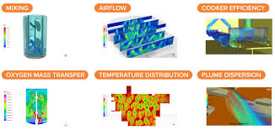

**Fig 1.1 computational fluid dynamics Diagram**

**II. Drug Delivery Systems**

CFD is employed to enhance the efficacy and efficiency of drug delivery mechanisms. According to Lee[7], all the details of flow-related information and overall performance assessments of CFD are classified into three main facets, namely pre-processor, solver (processor) and post-processor.

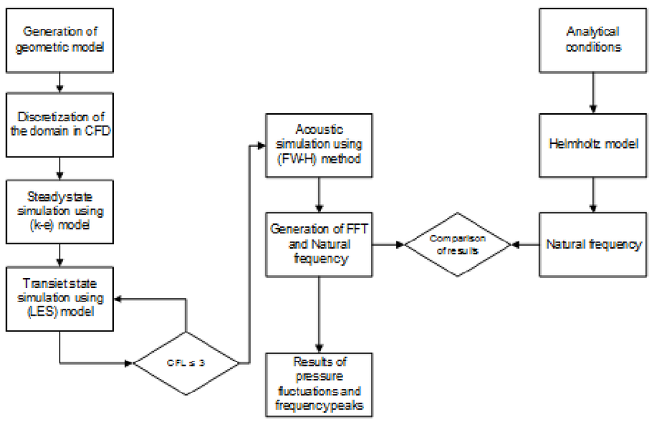

**Fig 1.2 Steps of CFD model construction**

1. **Micro fluidic Devices:** Research in micro fluidics uses CFD to optimize fluid flow for precise control over drug dosing and release rates.

**(B) Targeted Therapy:** Simulations help in designing systems that ensure drugs reach specific tissues or tumors, maximizing therapeutic effects while minimizing side effects.

**III. Respiratory Devices**

In devices like inhalers and ventilators, CFD helps in analyzing airflow patterns. The pre-processor is the input of modeling element that includes problem thinking, discretisation (meshing) and generation of a computational model. The solver is the processing element, where it involves numerical solution methods by virtue of governing equations and algebraic solution. The post-processor is the output element where the computational results are visualized by achieving an acceptable convergence of the equations of state that had been solved for each cell.

1. **Inhalation Efficiency:** Studying the dispersion of aerosolized drugs in the respiratory tract to enhance delivery efficiency.
2. **Ventilation Strategies:** Simulating airflow in artificial lungs to improve patient outcomes in critical care settings.

**IV. Bioengineering and Tissue Engineering**

CFD plays a role in the design of bioreactors and tissue scaffolds:

1. **Nutrient Transport:** Analyzing fluid flow in tissue engineering applications to ensure that cells receive adequate nutrients and oxygen.
2. **Mechanical Stimulation:** Simulating fluid dynamics to assess how mechanical forces from flowing fluids can influence cell behavior and tissue development.

**V. Diagnostic Devices**

CFD aids in the development of diagnostic tools:

1. **Point-of-Care Testing:** Researching fluid flow in devices that analyze biological samples, ensuring rapid and accurate diagnostics.
2. **Imaging Techniques:** Improving the understanding of how blood flow impacts imaging modalities such as MRI and ultrasound.

**VI. Orthopedic Applications**

CFD is utilized in studies involving joint fluid dynamics:

1. **Synovial Fluid Movement:** Analyzing how synovial fluid circulates in joints to understand its role in joint health and diseases like arthritis.
2. **Prosthetic Design:** Optimizing the flow characteristics around orthopedic implants to improve functionality and reduce wear.

**2. MERITS AND LIMITATIONS OF BIOMEDICAL APPLICATIONS IN CFD**

CFD has received increasing interest from mathematical curiosity to become an important technique to study complex physiological flows pattern and demonstrating their potential especially in cardiovascular and respiratory systems. To date, CFD has been adopted by medical researchers to facilitate in predicting the characteristic of circulatory blood flow inside the human body and airflow in human nasal breathing. Hence, it offer benefits such as lower the chances of post-operatives complications, facilitate in developing better surgical treatment, high efficiency with less destructive medical equipment and convey a good understanding of biological procedures [7]. From theoretical point of view, CFD provides benefits by concentrating on the construction and solution of governing equations and the study of numerous approximations to these equations. Meanwhile, the experimental and numerical approaches highlighted the merit of CFD as an alternative cost-effective means of simulating real fluid flow, particularly involving human body systems. Hence, it provides detailed visual and comprehensive information when comparing the fluid dynamics of analytical and experimental approaches.

**3. FUTURE OF CFD MECHANICAL ENGINEERING**

Rapid developing of an outstanding major computational modelling and technological challenges, which directed towards the evolution of CFD has recognised by regulatory authorities. Excellent creative models and the development of novel applications for simulating complex fluid mechanics challenges in regards to human anatomy of cardiovascular and respiratory systems are now being progressively applied with the ability of CFD simulation programs. Therefore, it is important to demonstrate the effectiveness of simulations results relative to invasive measurement through observational trials, particularly in multicentre clinical studies. Clearly, that these methods will direct towards high potential to change clinical practice that benefits to patients, health providers and clinicians.

**4. Conclusion**

The application of CFD in biomedical research is continuously evolving, providing critical insights that drive innovation in medical device design and therapy. As computational capabilities improve and data integration advances, the potential for personalized medicine and optimized healthcare solutions expands, positioning CFD as a cornerstone of future biomedical engineering developments.

**REFERENCES**

[1] Abdulnaser Sayma, Computational fluid dynamics, 1st editio, Ventus Publishing ApS, 2009

[2] H.K. Versteeg, W. Malalasekera, An Introduction to Computational Fluid Dynamics - The Finite Volume Method,

Fluid Flow Handbook. McGraw-Hill …. (1995)

[3] J. Tu, G. Yeoh, C. Liu, Computational Fluid Dynamics. A practical approach, 1st editio, Oxford, 2008

[4] P.D. Morris, A. Narracott, H. Von Tengg-kobligk, D. Alejandro, S. Soto, S. Hsiao, et al., Computational fl uid

dynamics modelling in cardiovascular medicine Correspondence to, (2015)

[5] A.A. Basri, M. Zubair, A.F.A. Aziz, R.M. Ali, M. Tamagawa, K.A. Ahmad, Computational Fluid Dynamics Study of

the Aortic Valve Opening on Hemodynamics Characteristics, in: 2014 IEEE Conf. Biomed. Eng. Sci. 8 - 10

December 2014

[6] S. Zachow, A. Steinmann, T. Hildebrandt, W. Heppt, Understanding nasal airflow via CFD simulation and visualization, (2007)

[7] B.-K. Lee, Computational fluid dynamics in cardiovascular disease., Korean Circ. J. 41 (2011)

[8] J. C., M. Abnurajan, Design of Patient Specific Prosthetic Aortic Valve and to Study its Computational Fluid Dynamics, 3rd Int. Conf. Electron. Comput. Technol. 3 (2011)

[9] A.A. Basri, M. Zubair, A.F.A. Aziz, R.M. Ali, M. Tamagawa, K.A. Ahmad, The effect of Aortic Stenosis on the Hemodynamic flow properties using Computational Fluid Dynamics, in: Proc. Int. Conf. Comput.