**Study of Extraction of Bio-Oil from Leucaena**

**leucocephala Seeds for antidandruff hair oil**

*NILESH PURANE , MS.VAISHNAVI KATKAR , DR, GAFFAR SAYYED ,*

*DR, SANJAY GARJE.*

**Abstract**:

The world is suffered by global warming, and tree plantation is proposed as a cost-effective solution. Leucaena leucocephala is highlighted for its high CO2 absorption and growth rates. This tropical tree can thrive in wastelands and offers multiple benefits, such as its leaves for fodder and its wood for fuel. In India, it covers 100,000 hectares, yielding 12,000 metric tons of biomass annually and a 30% oil yield from its seeds. This oil has a calorific value that can replace fossil fuels. Current research explores a new method for producing bio-oil from the seeds of Leucaena leucocephala.

**Keyword:**

Anti Dandruff hair oil, Natural hair care scalp health, LeucaenaLeucocephala

**Introduction**:

In India, Subabul wood (Leucaena leucocephala) is utilized for both fodder and paper pulp production, making India unique in this use. Approximately 100,000 hectares are planted with this species, which thrives in temperatures of 25 to 30°C and requires annual rainfall between 650 and 3,000 mm. Its optimal growth occurs in sub-humid to humid climates with dry seasons lasting up to 6 or 7 months, specifically in regions 15 to 25 degrees north or south of the equator. Subabul yields about 5-10 tons of dry biomass and 40-50 tons of fresh woody biomass per hectare annually. Farmers can earn around Rs.60,000 per hectare from fodder alone, with additional income from wood sales, totaling about Rs.1.4 lakh per hectare per year. Leucaena leucocephala is a member of the Leguminoceae family and is one of the fastest-growing legumes. Leucaena leucocephala is an important crop in India, especially in drought-prone and semi-arid regions, due to its utility in providing timber, fuel, and fodder. It offers nutritious forage for livestock, enhancing milk production in various climates. The plant aids in soil improvement and erosion control, produces seeds that can be roasted as a coffee substitute, and provides an edible gum used in sauces. Its roots and bark have medicinal properties, and the plant is capable of rapid regrowth after damage. The seeds are dispersed by animals and have adaptations for wind and water movement. Leucaena leucocephala is widely cultivated for forage, firewood, and medicine.

soil conservation and improvement, tannin and dye. It is also planted as a windbreaker, an ornamental plant in the

garden and as an urban shade tree. It is also planted to provide shade for plantation crops. The finely divided leaves

of some cultivars may contain mimosene, an amino acid that may be harmful if consumed in large quantity. Young

3leaves, pods, and flower buds are edible and usually eaten raw, steamed or mixed in soups or with

rice. The plant is

self-fertile and can fix nitrogen. It is an excellent firewood species with a specific gravity of 0.45-0.55 and a high

calorific value of 19 MJ/kg. The wood burns steadily with little smoke, sparks and produces less than 1% ash. The

tree makes excellent charcoal with a heating value of 29 MJ/kg and good recovery values (25-30%).

The tree Leucaena leucocephala and its seeds have various applications. It serves as a natural coagulant for chromium removal, with an effective dosage range of 400-600 mg/L resulting in notable reductions in suspended solids, turbidity, COD, BOD, and chromium. The seed powder can also be utilized for removing synthetic dyes from textiles. Additionally, it may help reduce methane emissions in tropical environments. Activated carbons can be obtained from the tree through specific chemical and physical processes. The seed gum functions as a binder in tablets, and polysaccharides from the seeds exhibit potential cancer prevention and anti-proliferative properties. Furthermore, the seed extract has antihelmintic and antidiabetic effects, along with broad antibacterial activity. The seed oil has recent applications in engineering, particularly in bio membrane modeling for drug and xenobiotic lipophilicity determination.The plant is noted for its properties as a worm repellent, and its dried seeds.

Dandruff is a common scalp condition characterized by excessive flaking of skin cells. It can lead to itching, irritation, and even hair loss. Traditional dandruff treatments often contain harsh chemicals that can damage hair and scalp. Therefore, there is a growing interest in natural alternatives for dandruff management.

Leucaena leucocephala, a fast-growing tree species, has been explored for various applications, including biofuel production. This study investigates the potential of extracting bio-oil from L. leucocephala seeds and evaluating its efficacy as an antidandruff hair oil.

**Objectives:**

1. Extraction of Bio-Oil: To develop a suitable method for extracting bio-oil from L. leucocephala seeds.
2. Chemical Characterization: To analyze the chemical composition of the extracted bio-oil, including fatty acid profile and antioxidant content.
3. In Vitro Anti-Dandruff Activity: To assess the in vitro anti-fungal activity of the bio-oil against Malassezia furfur, a common fungus associated with dandruff.
4. In Vi**Fa**cacy: To evaluate the efficacy of the bio-oil as an antidandruff hair oil in individuals with dandruff.

* **Classfication:**

**Kingdom: Plantae,**

**Order: Fabales,**

Benefits : The oil from Leucaena leucocephala seeds, also called the lead tree or subabool, is believed to have multiple benefits, one of which is treating dandruff.

|  |
| --- |
| **Effects of Leucaena leucocephala seeds** |
| Hair loss | Mimosine in the seeds can cause hair loss in humans and animals. |
| Toxicity | Mimosine can be toxic to humans and animals if ingested in high concentrations |

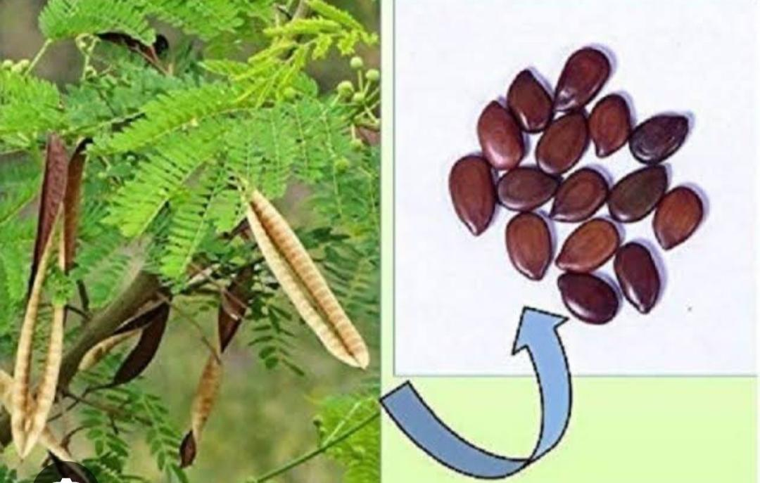

**Fig: *Leucaena leucocephala's seeds***

* **Family: Fabaceae**
* **Subfamily: Mimosoideae**
* **tribe : Mimoseae,**
* **Genus: Leucaena.**
* **Species : L leucocephala**
* **Synonyms: acacia glauca**
* **Biological Name: Leucaena leucocephala ( Lam)**
* Habitat :

Leucaena lecocephala is a tropical plant that thrives in warm temperatures ranging from 25 to 30 degrees Celsius and does not tolerate cold well, leading to reduced growth in cooler winter months. While shading negatively impacts its growth, leucaena can handle moderate light reduction compared to other tree legumes. It grows best in subhumid or humid climates with annual rainfall between 650 mm and 3000 mm, and can withstand dry seasons lasting up to 4 to 6 months. However, it does not fare well in soils with low pH (below 5.5) or deficient in potassium and calcium.: Leucaena lecocephala is a tropical plant that thrives in warm temperatures ranging from 25 to 30 degrees Celsius and does not tolerate cold well, leading to reduced growth in cooler winter months. While shading negatively impacts its growth, leucaena can handle moderate light reduction compared to other tree legumes. It grows best in subhumid or humid climates with annual rainfall between 650 mm and 3000 mm, and can withstand dry seasons lasting up to 4 to 6 months. However, it does not fare well in soils with low pH (below 5.5) or deficient in potassium and calcium.

Evaluation of microbial compound:

The seed oil analysis revealed microbial contaminants in the laboratory. These microbes were identified using microscopic methods based on their morphological characteristics.

* Uses :1: leucocephala has various medicinal properties, including treatment for stomach diseases and uses in contraception and abortion.

2: The seed gum serves as a binder in tablet formulations. Mimosine, an amino acid from the seeds, exhibits anticancer properties and inhibits hair growth.

3: Polysaccharides from the seeds show significant cancer chemo-preventive and anti-proliferative effects.

4:Other studies indicate the seeds have activities as a central nervous system depressant, anthelmintic, and antidiabetic.

5: Mimosine, an amino acid present in certain plants, can lead to hair loss in some animals and humans.

* Physical properties of seeds of Leucaena leucocephala :

1 : they are ovoid in shape with a sphericity of 52.14%. Their average dimensions are 8.84 mm in length, 5.17 mm in width, and 2.02 mm in thickness.

2 : Each seed weighs approximately 0.07 g and has an apparent density of 0.81 g/cm3 anreal density of 0.68 g/cm3, with a porosity of 15.64%.

3 : The seeds are green in color and contain around 5.44% oil, which is rich in unsaturated fatty acids such as linoleic and oleic fatty .

* **The various methods of extraction**

**Including**

**1;microwave-assisted extraction**

**2: Soxhlet extraction**

**3: supercritical fluid extraction**

**4:pulsed electric field extraction,**

**5: enzyme-assisted extraction**

**6: ultrasound-assisted extractio**

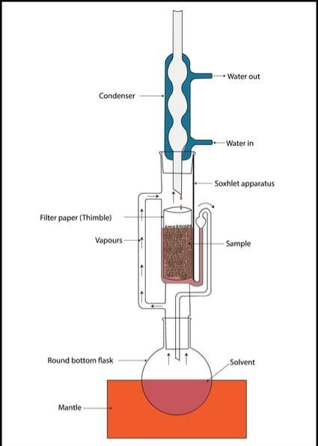1

**Fig: soxhlet extraction apparatus**

\***Conclusion:**

This study showed that L. leucocephala seed oil has good quality and a pleasant smell. It is rich in linoleic acid, an ω-6 PUFA that helps maintain the structure of the skin’s outer layer, preventing water loss. Additionally, the oil has a high level of tocopherols, which can prevent cell damage by neutralizing free radicals.

Leucaena leucocephala seed oil is recognized as a valuable resource with various potential applications across different industries. It is suitable for biodiesel production due to its favorable fatty acid profile, making it a renewable alternative to fossil fuels. The oil also exhibits medicinal properties, including antibacterial, antidiabetic, and anthelmintic activities, suggesting therapeutic uses. Additionally, it has industrial applications in biomembrane modeling and as a corrosion inhibitor for metals. Key advantages include a high oil yield, a beneficial composition with a substantial amount of oleic acid, and the ability to be sustainably cultivated due to the species’ fast-growing and adaptable nature. Overall, this seed oil represents a promising opportunity for sustainable resource utilization and innovation.

**Reference:**

V .D. Samarth, S.R. Sinkar, U. Pandya, and U.P. Dhuldhaj phytonormal effect on the vitro callus induction of tinospora cordifolia Willd miars cell biotechnology and cellular biology 2019

Devaranavadgi S.B., Murthy B.G., Desai S.A. and

Yelashetty S., Preliminary evaluation of subabul genotypes

for psylid tolerance, Cur. Res., 25, 64-65 (1996)

2. Devaranavadgi S.B., Guggari A.K., Kalaghatagi S.B., Wali

S.Y. and Nadagoudar S.B., Suitable Leucaena genotypes

for shallow black soils of northern dry zone of Karnataka,

Annals of Arid Zone, 38(1), 45-48 (1999)

3. Pathak P.S and Patil B.D., Leucaena Research at the

IGFRI. In: Leucaena research in the Asian – Pacific

Region. Proc. Workshop, Singapore, Nov. 23-26, NFTA &

IDRC (1982)

4. Safavi S.M., Farshadfar M.D., Kahrizi and Safavi S.A.,

Genetic variability of some morphological traits in Poplar

Clones, American Journal of Scientific Research, 13, 113-

117 (2011)

5. Wright S. Correlation and causation, J. Agric. Res., 20,

557-585 (1921)

6. Lewis A., Pande K.K., Salil K. Tewari, Gahalain S.S. and

Pankaj Sah, Genetic Variability for different traits in the

Indian Bamboo, New York, Science Journal, 3(6), 27-31

(2010)

7. Chaturvedi O.P. and Pandey N., Correlation and Path

Analysis Studies between Biomass and Other Characters in

Bombax ceiba L., Silvae Genetica, 53(5–6), 269-271

(2005)

8. Burley J. and Wood P.J., A manual on species and

provenance research with particular reference to the

tropics, Tropical Forestry Papers, 10, 34-61 (1978)

9. Singh R.B. and Gupta M.P., Multivariate analysis of

divergence in upland cotton, Indian Journal of Genetics,

28, 151-157 (1968)

10. Ashok Kumar and Paramathma M., Correlation and path

coefficient studies in Casuarina equisetifolia L. Johnson,

Indian Forester, 131(1), 47-55 (2005)

11. Dhillon R.S., Bisla S.S., Arya S. and Hooda M.S., Genetic

variation, heritability and correlations for growth

parameters in Azadirachta indica. A. Juss, Ann. For.,

11(2), 215-221 (2003)

12. Kumaran K., Nesamani K. and Govinda Rao M., Correlation

and Path coefficient studies in Simaruba gl

13. N H Abd Razak et al, “Coagulant from Leucaena leucocephala for Chromium Removal”, in IOP Conference

Series: Materials Science and Engineering 358(2018).

14. Jayanthy, V. et al., “Phytoremediation of dye contaminated soil by Leucaena leucocephala (subabul) seed and

growth assessment of Vigna radiata in the remediated soil”, Saudi Journal of Biological Sciences (2014).

15. Mushtaq Ahmad, Mir Ajab Khan, Muhammad Zafar and Shazia Sultana, “Biodiesel from Non Edible Oil

Seeds: a Renewable Source of Bioenergy, Economic Effects of Biofuel Production”, Dr. Marco Aurelio Dos

Santos Bernardes (Ed.), (2011), ISBN: 978-953-307-178-7.

16. A. B. Chhetri, M. S. Tango, S. M. Budge, and K. C. Watts, “Non-Edible Plant Oils as New Sources for

Biodiesel Production”, (pp. 169–180, 2008).

17. O. S. Stamenkovi, V. B. Veljkovi, and I. B. Bankovi, “Biodiesel production from non-edible plant oils”,

(Volume 16, pp. 3621–3647, 2012).

18. M. I. Hakimi, Khalilullah, F. Goembira and Z. Ilham, “Engine – Compatible Biodiesel from Leucaena

leucocephala seed oil”, Journal of the society of Automotive Engineers Malaysia, (Volume 1, Issue 2, pp. 86-

93,May 2017).

19. Abdul Majeed Khan and Sher Ali, “Production of Biodiesel and Bioethanol from the Legumes of Leucaena