Successful management of primary periodontal lesion with secondary endodontic involvement: A case report

**ABSTRACT:**

Simring & Goldberg initially documented the connection between periodontal and pulpal diseases in 1964 **[1].** The periodontium connects with the dental pulp via several pathways, such as dentinal tubules, the apical foramen, as well as lateral and accessory canals. These pathways facilitate the transmission of pathological agents between the pulp and periodontium, leading to the formation of endo-perio lesions **[2]**. A 39-year-old female patient presented with dental mobility and a fistula adjacent to the left mandibular molar. The patient had no previous dental treatment and was in good systemic health. Clinical intraoral examination of tooth 37 revealed a non-carious tooth with fissure infiltration and supragingival plaque. The tooth did not respond to sensitivity tests and was positive for percussion testing. Periodontal examination showed deep periodontal pockets on the vestibular and palatal surfaces (more than 5 mm) with mobility degree 2. Radiographic examination revealed widening of the periodontal ligament space, a clearly visible periapical lesion, furcation involvement, and horizontal bone loss. Endodontic treatment was performed over two visits under rubber dam isolation, spanning two weeks, with inter-visit calcium hydroxide as an intra-canal medication. The canal was obturated, and access restoration was completed with glass ionomer cement and resin composite at the third visit. Concurrent periodontal debridement was also performed. The article aims to illustrate the effective handling of a primary periodontal lesion accompanied by secondary endodontic involvement, as demonstrated by our successful case report of a second mandibular molar treated with Phase I endodontic and periodontal therapy. Despite the initially guarded prognosis, treatment resulted in resolution of the fistula and reduced tooth mobility.

**Keywords:** Periodontology, Endodontology, Combined Lesion, Perio-Endo Lesion

**INTRODUCTION**

For many years, there has been a dilemma regarding the interrelationship between endodontic and periodontal disease. According to data, pulpal and periodontal diseases account for over 50% of tooth mortality. At times, patients may present with conditions where both lesions are concurrently present on the same tooth. This leads to confusion for clinicians in formulating a diagnosis and determining which condition should take precedence **[2]**. The diagnostic criteria used to distinguish diseases originating from pulp necrosis or attachment loss are not always specific enough to determine the disease's etiology. Understanding the anatomy and structures of the affected tooth and their role in propagating the lesion in a certain direction—whether primary endodontic or periodontal—is crucial in comprehending this complex disease. Occasionally, both lesions occur simultaneously, termed combined periodontal-endodontic lesions, requiring clinicians to identify the causal factor of the established lesion and the infection route for appropriate treatment planning **[3].** In some cases, tissue destruction may have already begun, with one condition potentially exacerbating the other later. Therefore, accurate diagnosis and treatment planning are critical in cases of periodontal-endodontic lesions **[4]**. Hiatt (1977) suggested that such lesions be considered of endodontic origin for treatment planning purposes, as endodontic therapy alone may resolve the lesion **[5]**. However, resolution depends heavily on the primary source and chronicity of the lesion; treatment may ultimately involve both endodontic and periodontal approaches, as noted by Benenati et al. (1981). **[6]** Establishing a correct diagnosis begins with recording clinical history, followed by clinical examination of the affected tooth and surrounding area through visual inspection. Clinical tests are essential for accurate diagnosis and differentiation between endodontic and periodontal diseases. Palpation assesses mucosal sensitivity over the root surface and apical region for infection and inflammation, often associated with both endodontic and periodontal lesions. Percussion of the involved tooth provides insight into the area of inflammation, with lateral percussion potentially indicating pulpal involvement and vertical percussion suggesting possible periodontal involvement. Tooth mobility evaluation suggests periodontal involvement due to the destruction of supporting structures such as the periodontal ligament, cementum, and alveolar bone, leading to abnormal tooth mobility. **[7]**. Extraoral and intraoral tissues are examined for anomalies or disease. In fact, a single test is generally insufficient for a conclusive diagnosis. Concerning radiographic examination of the lesion, it is crucial for determining the involved tissue type—pulpal, periodontal, or both **[3]**. Classification of the lesion also plays a pivotal role in treatment planning; hence, various authors have classified endo-perio lesions over the years in diverse ways **[8]**. The initial classification of endo-perio lesions was proposed by Oliet and Pollock in 1968 **[9]** and since then, numerous classifications have been suggested. This case report discusses the management of an endo-perio case involving primary periodontal lesion with secondary endodontic involvement, benefiting from both endodontic treatment and periodontal intervention.

**CASE REPORT**

A 39-year-old female patient present at CCTD Ibno-Rochd in the Conservative Dentistry and Endodontics Department, referred by the Periodontology Service. Her chief complaint is the appearance of a fistula in the left mandibular region. She also reports dental mobility. The patient is in good general health with no history of dental treatment. Intraoral clinical examination reveals that the left mandibular second molar (tooth 37) shows no detectable caries; only a developmental groove infiltration is visible occlusally without probe catch, with presence of supra-gingival plaque, and a fistulous tract associate with tooth 37. The tooth does not respond to sensitivity tests and shows positive percussion test results. Periodontal examination shows deep periodontal pockets in the vestibular and palatal regions (more than 5 mm) and grade 2 mobility, with bleeding on probing. Radiographic examination reveals horizontal bone resorption, confirming generalized chronic periodontitis. Retro-alveolar radiography of the affected tooth shows mesial and distal interdental horizontal bone loss of tooth 37, furcation involvement is also detected. Desmodontal widening and a visible periapical lesion are observed, and a radiograph with gutta-percha cone in place at the fistula confirms an endodontic origin of the infectious focus. A diagnosis of primary periodontal lesion with secondary endodontic involvement related to tooth 37, with a fistula, is established according to the classification proposed by Simon et al., 1972 **[10],** based on clinical and radiographic examination. According to Rotstein et al., 2004, The lesion should be initially addressed with endodontic treatment in conjunction with Phase I periodontal therapy, which includes scaling and root planing. **[11].** A treatment plan is formulated and divided into different phases. Endodontic treatment is performed on tooth 37. The first session involves access cavity preparation. After canal cleaning and disinfection, temporary intracanal medication with calcium hydroxide is placed. The second session includes biomechanical preparation of the canal using stainless steel files and the ProTaper system up to F2 file with abundant irrigation of 2.5% sodium hypochlorite. Following biomechanical preparation, canals is dried using absorbent paper points and obturated with corresponding ProTaper gutta-percha cones using cold lateral compaction and root canal sealer; temporary coronal restoration is placed. The patient returns for evaluation after 15 days, showing fistula healing observed post-endodontic treatment with a noticeable decrease in size. During the third session, cleaning of the access cavity involves removal of debris and residual obturation cement. A layer of GIC is applied at the cavity floor, followed by incremental application of composite until complete restoration of coronal morphology to ensure optimal sealing and effective tooth restoration. The patient also underwent concurrent periodontal therapy including scaling and root planing, correction of brushing after 3 and 6 months shows complete disappearance of the fistula, reduced tooth mobility, remarkable bone healing and regeneration, as well as resolution of desmodontal widening and radiographic apical reaction. The patient is advised to maintain good oral hygiene and entering a reassessment and maintenance phase for ongoing periodontal monitoring.

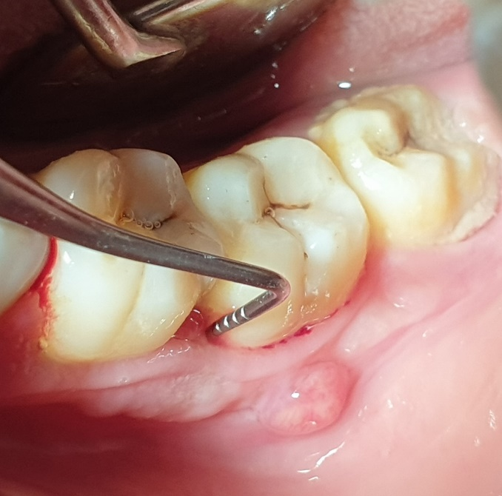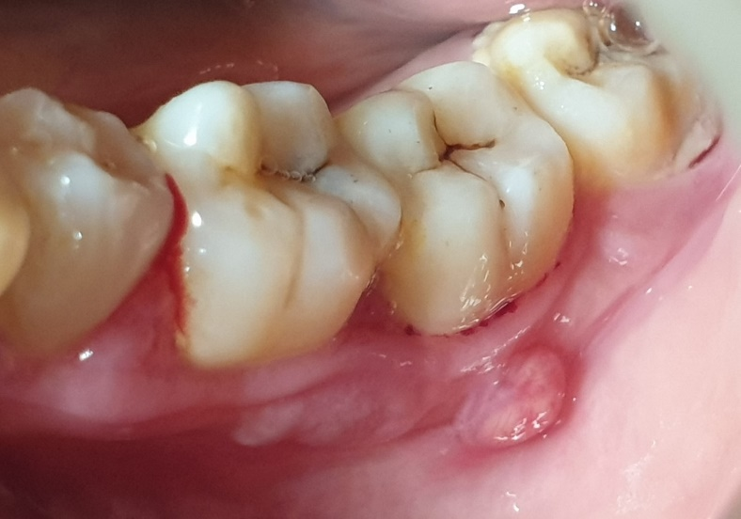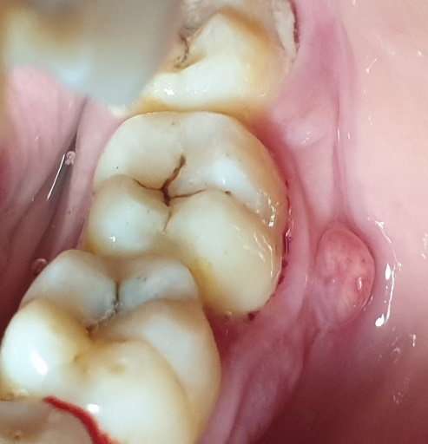

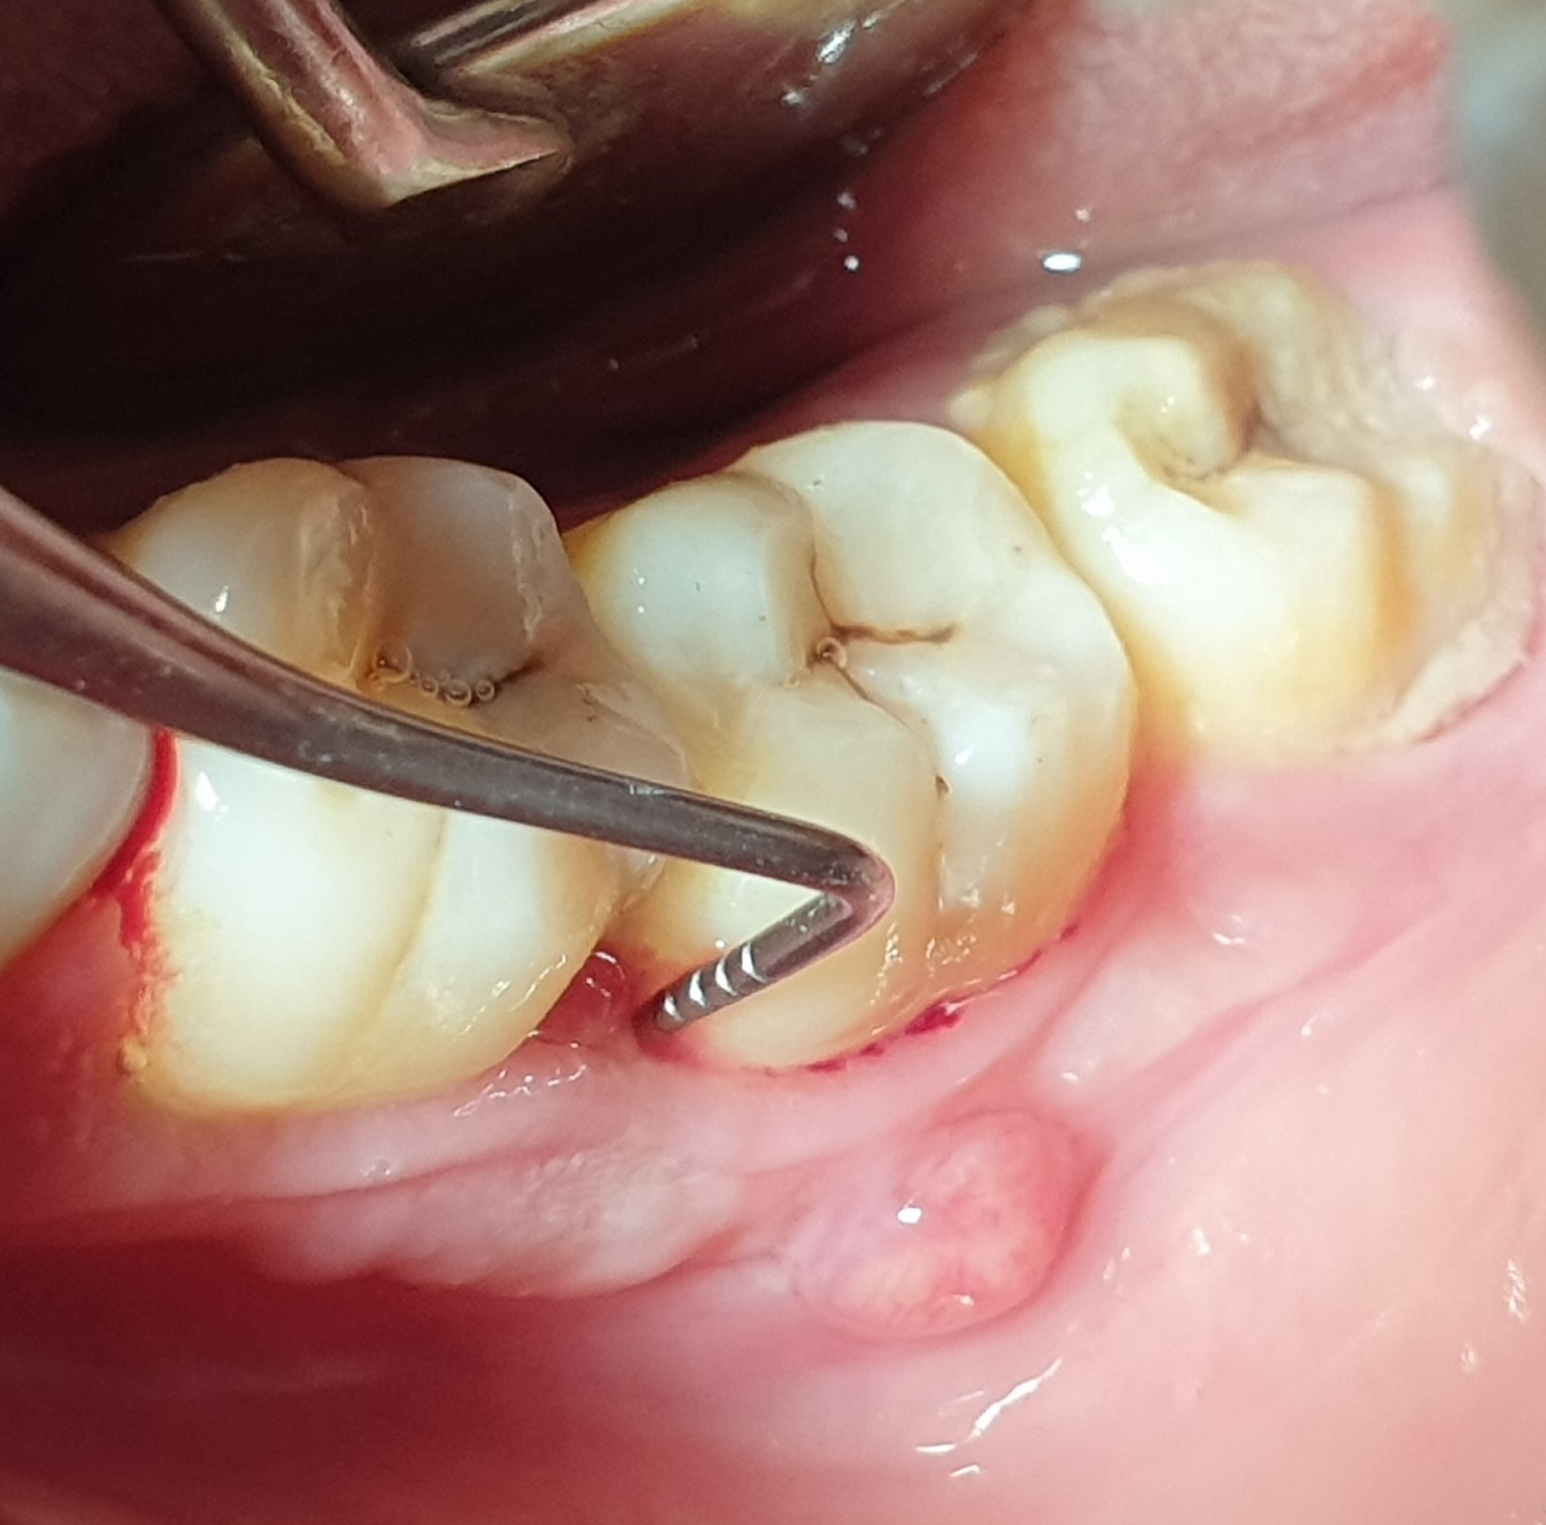

|  |  |  |  |  |
| --- | --- | --- | --- | --- |
| **FIG1:** Vestibular view of the fistulated tooth |  | **FIG2:** Occlusal View + presence of fissure infiltration |  | **FIG3:** Pre-operative periodontal probing showing more than 5 mm. |

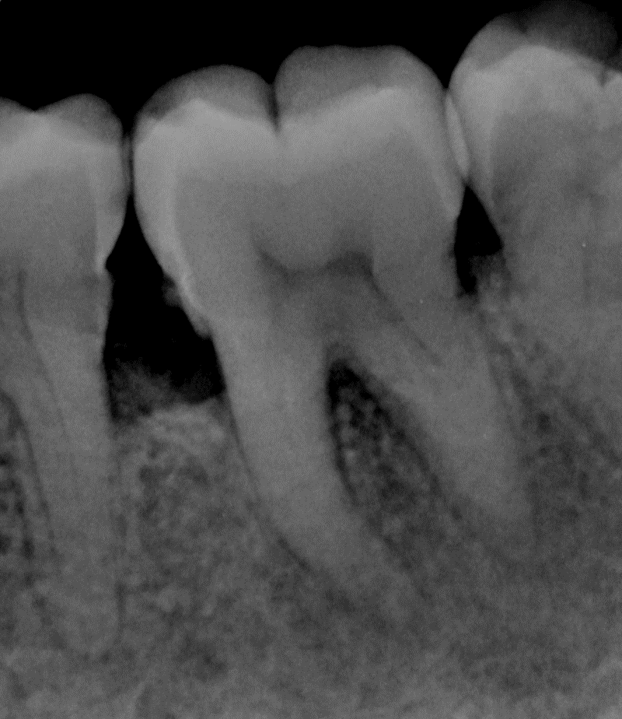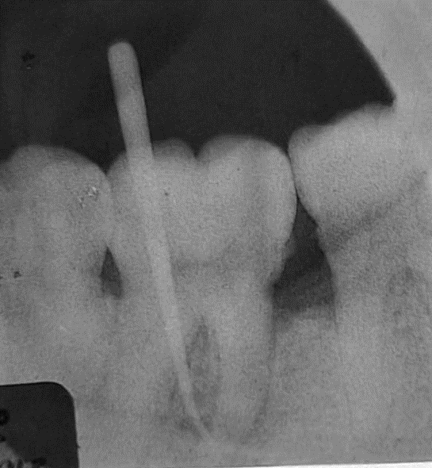

|  |
| --- |
| **FIG5:** Retro-alveolar radiograph with a gutta-percha cone in place at the fistula confirming an endodontic origin. |

|  |
| --- |
| **FIG4:** Pre-operative Retro-alveolar radiograph showing bone lysis, widening of the periodontal ligament, and pulpal reaction |

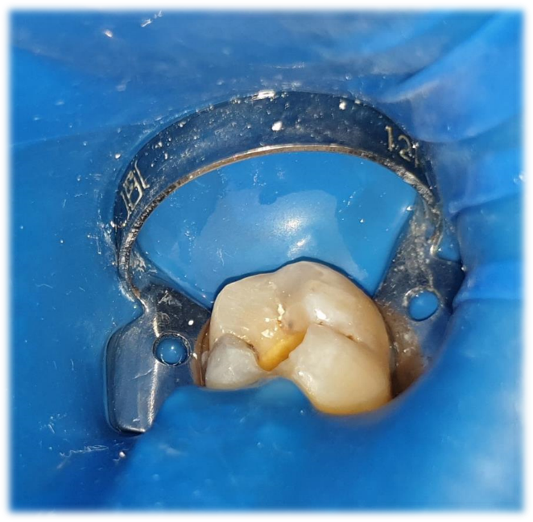

|  |
| --- |
| **FIG6**: 1st session: Placement of the rubber dam; preparation of the access cavity; application of calcium hydroxide |

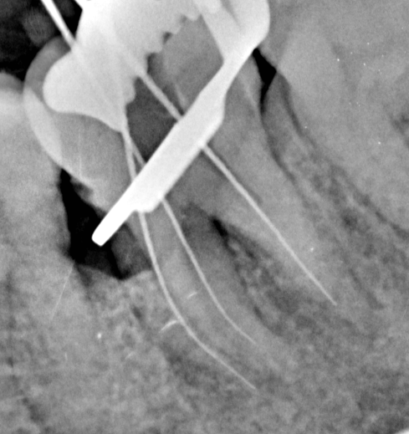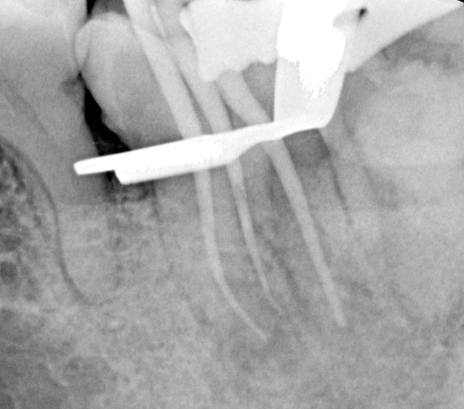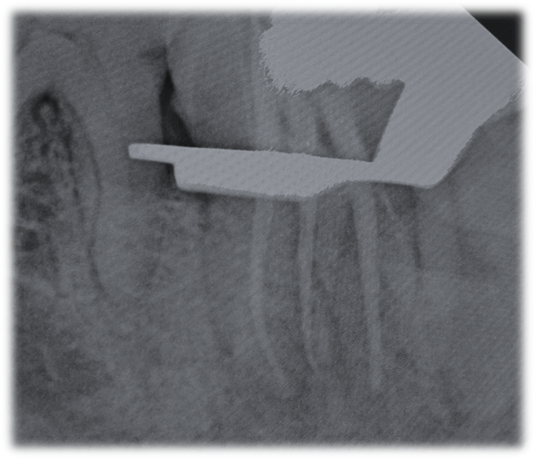

|  |  |  |  |  |
| --- | --- | --- | --- | --- |
| **FIG7:** Second Session: Endodontic treatment, Radiograph with file in place. |  | **FIG8:** Second Session: Endodontic treatment, Radiograph with gutta-percha cone in place. |  | **FIG9:** Second Session: Endodontic treatment, Radiograph showing obturation of three root canals. |

|  |
| --- |
| **FIG10:** Healing of the fistula 15 days after completion of the endodontic treatment. |

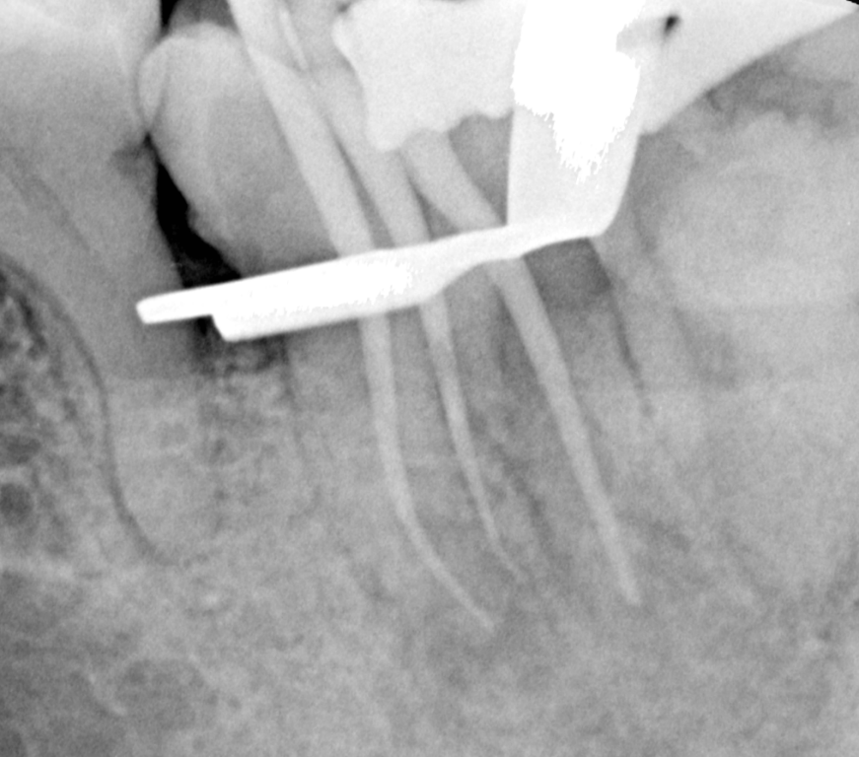

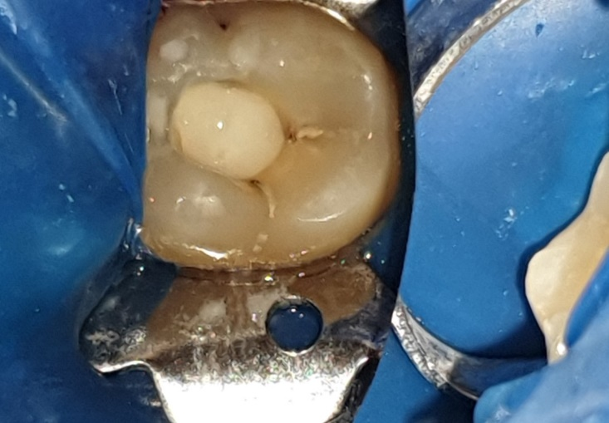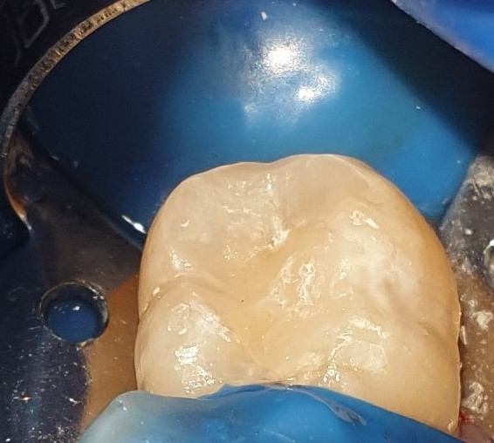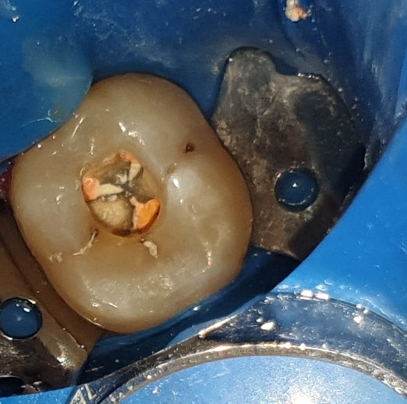

|  |  |  |  |  |
| --- | --- | --- | --- | --- |
| **FIG11:** 3rd Session:  Cleaning of the access cavity. |  | **FIG12:** 3rd Session: Coronal restoration; Placement of Glass ionomer cement (GIC) |  | **FIG13:** 3rd Session: Coronal restoration; Placement of Composite |

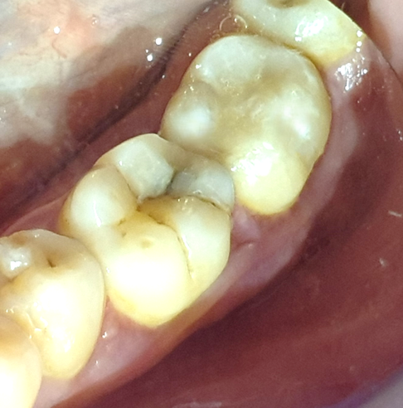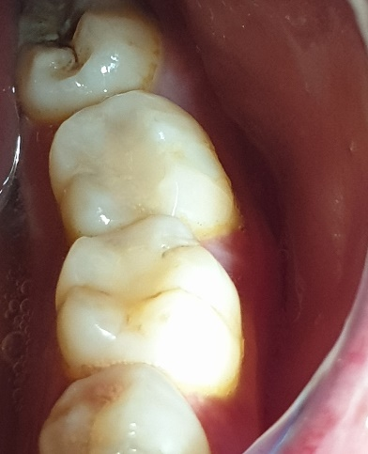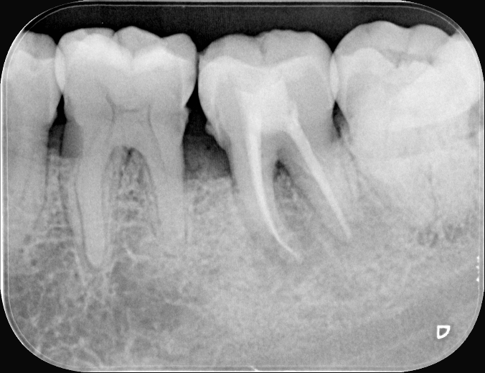

|  |
| --- |
| **FIG15:** After 6 months: Clinical and radiological follow-up shows beginning of healing and bone regeneration |

|  |
| --- |
| **FIG14:** After 3 months: Complete disappearance of the fistula |

**DISCUSSION**

Periodontal tissues and pulp tissues have a common embryonic origin from the mesoderm, developing respectively from the dental papilla and dental sac. The unique interrelationship between these tissues has been a subject of controversy and speculation since Simring and Goldberg's study in 1964 **[1]**. An endo-periodontal lesion occurs when a pulpal lesion communicates with the periodontium through apical foramens, lateral canals, or furcation. Harrington and Steiner **[12]** defined this condition as involving destruction of periodontal attachment to the root apex or lateral canal, necessitating both endodontic and periodontal therapies.

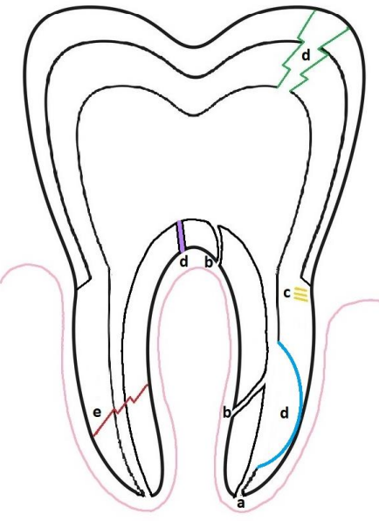

**FIGURE A: Sources of communication between the pulp and periodontium.**

**a) Apical Foramen b) Lateral Canals c) Dentinal tubules d) Perforations e) Fractures [13]**.

The sequelae of endodontic involvement and periodontal disease include increased periodontal probing depths, localized gingival inflammation or swelling, bleeding upon probing, suppuration, fistula formation, percussion sensitivity, increased tooth mobility, angular bone loss, and pain **[13]**.Classifying endo-periodontal lesions poses a challenge for clinicians because the disease remains asymptomatic and only manifests during acute exacerbations. These exacerbations may stem from pulpal involvement, presenting as periapical abscesses, or from periodontal involvement, characterized by periodontal abscesses or aching, throbbing pain typical of periodontal pockets **[14]**. According to Simon et al. (1972), endo-periodontal lesions can be classified as primary endodontic, primary endodontic with secondary periodontal involvement, primary periodontal, or primary periodontal with secondary endodontic involvement—such as in our case—where periodontal disease progresses along the root surface and creates a communication zone with the pulp. This typically occurs when periodontal disease advances to the apical foramen but can also happen through other channels connecting to the pulp like deep infiltration. These lesions share characteristics with primary endodontic lesions with secondary periodontal involvement and are differentiated based on which pathological process occurs first, and finally the last lesion is True Combined Lesion, its diagnosis can be given when the two separate processes have started independent of each other but happen to coalesce.

|  |  |  |  |  |
| --- | --- | --- | --- | --- |
| Diagnosis | Origin | Radiographic Appearance | Restoration Status of tooth | Clinical Indicators |
| Primary Periodontal Lesion with Secondary Endodontic Involvement | Periodontium | The lesion is identical to a primary periodontal lesion, but typically extends the radiolucent area to the apical region. | Absence of caries | -Negative result on sensitivity testing.  -Wider pocket, with or without suppuration.  -More generalized pockets.  -Tooth mobility. |

**Table 1: Summary of the clinical features of the Primary Periodontal Lesion with Secondary Endodontic Involvement presented in our case**

The 2017 World Workshop on Periodontology introduced a classification dividing the lesion into two categories based on its cause **[14]**: infections originating from endodontic and/or periodontal sources, and factors related to trauma and/or iatrogenic influences. Endo-periodontal lesions caused by infections can arise from carious lesions affecting the pulp and subsequently involving the periodontium, or from periodontal destruction affecting the root canal as a secondary effect, or both simultaneously. Otherwise, lesions triggered by trauma or iatrogenic factors may result from root/chamber/furcation perforations, root fractures or cracks, external root resorption, or pulp necrosis spreading through the periodontal tissues. Accurate diagnosis by clinicians is crucial for planning effective treatment and subsequent care **[15]**. Management typically begins with root canal therapy, with initial periodontal intervention rarely necessary. However, when a periodontal abscess complicates the clinical situation with pain and discomfort, incision and drainage may be necessary to relieve acute symptoms **[16]**. Most cases of endo-periodontal lesions resolve with a positive outlook, often showing reduced periapical radiolucency during follow-up. For primary periodontal and combined lesions, surgical intervention in periodontics frequently becomes essential for ensuring successful outcomes and the overall prognosis of the affected tooth or teeth **[16]**. Procedures such as flap surgery, open flap debridement, removal of residual calculus and altered cementum, and elimination of granulation tissue aim to reduce inflammation in the affected area and promote the restoration of healthy tissue, potentially supporting tissue regeneration efforts **[17]**. In our case, surgery was unnecessary, and the outlook was positive. Precise diagnosis is crucial to ensure appropriate treatment addresses the patient's symptoms effectively **[18]**. An incorrect diagnosis from a well-intentioned clinician can still strain the clinician-patient relationship, potentially leading to a reluctance for future consultations, prompting complaints, or negatively impacting the patient’s long-term health. **[18,19].**

As summary, differential diagnosis of endo-periodontal lesions involves distinguishing between various conditions that can affect both the pulp and the periodontium **[20]**. Key considerations include:

**Primary Endodontic Lesions:** These originate within the pulp and may lead to periapical pathosis, such as periapical abscesses or cysts.

**Primary Periodontal Lesions:** These arise from periodontal tissues and can manifest as gingivitis, periodontitis, or periodontal abscesses.

**True Combined Endo-Periodontal Lesions:** These involve interactions between the pulp and periodontium, where pathology in one affects the other. This can include lesions where periodontal disease extends to affect the pulp or vice versa.

Accurate differential diagnosis is crucial to determine the appropriate treatment plan and ensure optimal management of endo-periodontal lesions. This typically involves a comprehensive clinical examination as primordial tests like sensitivity tests, periodontal probing, radiographic evaluation, and sometimes additional microbiological analysis is required. **[21]**.

**Here is the Table 2: summarizing the different tests and characteristics of endo-periodontal lesions for differential diagnosis:**

These details help differentiate between the various types of lesions affecting both dental pulp and periodontal tissues, guiding towards accurate diagnosis and appropriate treatment **[22]**.

Top of Form

Bottom of Form

**CONCLUSION**

The management of endo-perio lesions is a complex undertaking that demands thorough diagnosis and systematic treatment planning. Effective management improves the prognosis of affected teeth. Achieving this outcome hinges on meticulous case selection, detailed history-taking, comprehensive clinical examination, precise sensitivity testing and periodontal probing leading to accurate diagnosis. Adherence to established protocols ensures streamlined management, addressing both pulpal and periodontal aspects with diligent follow-up. Therefore, an interdisciplinary approach proves invaluable in successfully managing endo-perio lesions.

**REFERENCES**

1. Simring M GM. The pulpal pocket approach: Retrograde periodontitis. J Periodontol. 1964; 35:22–48. Available from: DOI:[10.1902/JOP.1964.35.1.22](https://doi.org/10.1902/JOP.1964.35.1.22)
2. Kanagasingam S, Perry ES, Sonde N. Endodontic‐Periodontal Infections. In: Perry ES, Patel S, Kanagasingam S, Hamer S, editors. Pitt Ford’s Problem‐Based Learning in Endodontology [Internet]. 1st ed. Wiley; 2024 [cited 2024 Jul 11]. p. 68–81. Available from: <https://onlinelibrary.wiley.com/doi/10.1002/9781119565987.ch1.8>
3. Sonde N, Edwards M. Perio-Endo Lesions: A Guide to Diagnosis and Clinical Management. Prim Dent J. 2020 Dec;9(4):45–51. Available from: <https://doi.org/10.1177/2050168420963305>
4. Cucolo FCC, Bonvalente MC, Barroso EM, Toledo BECD, Camargo GADCG, Souza AAE, et al. Endo-perio lesions prevalence in non-molar and molar teeth: a pilot study. Rev odontol UNESP. 2021;50: e20210037. Available from: <https://doi.org/10.1590/1807-2577.03721>
5. Hiatt WH. Pulpal Periodontal Disease. Journal of Periodontology. 1977 Sep;48(9):598–609. Available from: DOI: [10.1902/jop.1977.48.9.598](https://doi.org/10.1902/jop.1977.48.9.598)
6. Benenati FW, Roane JB, Waldrop TC. The perio-pulpal connection: an analysis of the periodontic-endodontic lesion. Gen Dent. 1981;29(6):515–20. Available from: PMID: 6948750
7. Dhull KS, Dutta B, Verma RK, Bagchi A, Mahapatra N, Samir P. A Correlation between Clinical Classification of Dental Pulp and Periapical Diseases with its Patho Physiology and Pain Pathway. International Journal of Clinical Pediatric Dentistry. 2023 Sep 11;16(4):639–44. doi: [10.5005/jp-journals-10005-2636](https://doi.org/10.5005%2Fjp-journals-10005-2636)
8. Hany Mohamed Aly Ahmed. Different perspectives in understanding the pulp and periodntal intercommunications with a new proposed classification for endo-perio lesions. Endo Engl. 2012;6(2):87–104.
9. Oliet S, Pollock S. Classification and treatment of endo-perio involved teeth. Bull Phila Cty Dent Soc. 1968 Nov;34(2):12–6. Available from: PMID: 5246112
10. Simon JHS, Glick DH, Frank AL. The Relationship of Endodontic‐Periodontic Lesions. Journal of Periodontology. 1972 Apr;43(4):202–8. Available from: DOI: [10.1902/jop.1972.43.4.202](https://doi.org/10.1902/jop.1972.43.4.202)
11. Rotstein I, Simon JHS. Diagnosis, prognosis and decision‐making in the treatment of combined periodontal‐endodontic lesions. Periodontology 2000. 2004 Feb;34(1):165–203. Available from: doi: 10.1046/j.0906-6713.2003.003431. x.
12. Harrington GW, Steiner DR. Periodontal-endodontic considerations. In: RE Walton, M Torabinejad, eds. *Principles and Practice of Endodontics*, 3rd edn. Philadelphia: W.B. Saunders, 2002: 466–484.
13. Chua HS, Saw ZK, Mohd-Said S. Implementing the 2017 EFP/AAP Periodontal Disease Classification in The Diagnosis and Management of Endo-Periodontal Lesions: A Case Report. cakradonya dental j. 2024 Jun 29;16(1):17–23. Available from: DOI: <https://doi.org/10.24815/cdj.v16i1.36416>
14. Caton JG, Armitage G, Berglundh T, Chapple ILC, Jepsen S, Kornman KS, et al. A new classification scheme for periodontal and peri‐implant diseases and conditions – Introduction and key changes from the 1999 classification. J Clinic Periodontology [Internet]. 2018 Jun [cited 2024 Jul 11];45(S20). Available from: <https://onlinelibrary.wiley.com/doi/10.1111/jcpe.12935>
15. Alshawwa H, Wang JF, Liu M, Sun SF. Successful management of a tooth with endodontic-periodontal lesion: A case report. WJCC. 2020 Oct 26;8(20):5049–56. Available from: doi: [10.12998/wjcc. v8.i20.5049](https://doi.org/10.12998%2Fwjcc.v8.i20.5049)
16. Sandini Trentin M, Gomes Dallepiane F, Serraglio Figueiredo P, Becker AL, Leocovick S, Duque TM, et al. Management of Endo-Perio lesion in a Tooth with an Unfavorable Prognosis: a Clinical Case Report with an 18-Month Follow-Up. Odovtos - Int J Dent Sc. 2024 May 6;48–56. Available from: <https://doi.org/10.15517/ijds.2024.59825>
17. Chandak M, Chaudhari P, Jidewar N, Sarangi S, Ikhar A, Dass A, et al. Successful Management of a Tooth with an Endodontic-Periodontal Lesion Using a Bone Graft. Cureus [Internet]. 2024 Apr 23 [cited 2024 Jul 11]; Available from: doi: [10.7759/cureus.58828](https://doi.org/10.7759%2Fcureus.58828)
18. ElBanna M. CASE REPORT, NON-SURGICAL MANAGEMENT OF AN ENDO-PERIO LESION. Egyptian Dental Journal. 2024 Apr 1;70(2):1987–96. Available from: doi: [10.21608/EDJ.2024.260644.2865](https://doi.org/10.21608/edj.2024.260644.2865)
19. Cucolo FCC, Bonvalente MC, Barroso EM, Toledo BECD, Camargo GADCG, Souza AAE, et al. Endo-perio lesions prevalence in non-molar and molar teeth: a pilot study. Rev odontol UNESP. 2021;50: e20210037. Available from:<https://doi.org/10.1590/1807-2577.03721>
20. Rovai EDS, Matos FDS, Kerbauy WD, Cardoso FGDR, Martinho FC, Oliveira LDD, et al. Microbial Profile and Endotoxin Levels in Primary Periodontal Lesions with Secondary Endodontic Involvement. Braz Dent J. 2019 Jul;30(4):356–62. Available from: <https://doi.org/10.1590/0103-6440201902471>
21. Dwiyanti S. A Multi-Disciplinary Approach in the Management of Endo-Perio Lesions: A 4-year Follow-Up Case Report. Scribante A, editor. Case Reports in Dentistry. 2023 Jan 23; 2023:1–9. Available from: <https://doi.org/10.1155/2023/3024231>

## **M. ELFAROUKI*, N. KHLIL*, I. BENKIRANE**, J. KISSA* «**[Les lésions endo-parodontales vraies, démarche diagnostique et thérapeutique : A propos d’un cas](https://www.lecourrierdudentiste.com/cas-clinique/les-lesions-endo-parodontales-vraies-demarche-diagnostique-et-therapeutique-a-propos-dun-cas.html) » : Service de parodontologie, Service d’odontologie conservatrice, CHU de Casablanca. Faculté de médecine dentaire de Casablanca – Maroc Université Hassan II. Le Courrier du dentiste : Affichages : 41590, Publication : 17 novembre 2011