**A REVIEW OF DIFFERENT HERBS USED IN PREPARATION OF HERBAL SHAMPOO.**

**MR.SUNNY RASAYALI, MS.SNEHAL LAD, DR.GAFFAR SAYYED, DR. SANJAY GARJE.**

**\*1,2,3,4 Shri Amolak Jain Vidhya Prasarak Mandal’s, College Of Pharmaceutical Science And Research Center, Kada, Beed, Ms, India.414202.**

**Email id –** [**sunnyr772@gmail.com**](mailto:sunnyr772@gmail.com)

**________________________________________________________________**

**ABSTRACT :** The primary goal of this study is to make and assess a herbal shampoo and identify its physiochemical function, with a focus on the product's quality, safety, and efficacy. Herbal shampoo is a natural hair care product that is used to clean oil, grime, and dandruff while encouraging hair growth, thickness, and darkening. Additionally, it gives hair shine, smoothness, and softness. A variety of medications are utilized in the pre-mixture of cosmetic shampoo. Various side effects, including hair loss, excessive scaling, itching, pain, nausea, and headaches, are reported with these medications. Thus, an experiment is conducted to create a herbal shampoo that has no negative effects. The current study's objective is to create and assess a herbal anti-dandruff shampoo that contains

**KEYWORDS :** Cosmetic, Herbal shampoo, aloe Vera, dandruff, Hibiscus rosa-sinesis, Acasia concinna, sapindus mukorossi, Azadirachta indica and Glyccerrhiza glabra.

**INTRODUCTION:**

In our daily lives, herbal shampoo is arguably the most popular cosmetic product used to clean our hair and scalp. Herbal shampoos are cosmetic formulations that use traditional ayurvedic herbs to cleanse hair and scalp in a similar manner to conventional shampoos. They are utilized to get rid of things like oils, dandruff, and pollution from the environment. Shampoo is a kind of cosmetic concoction made of plant-based ingredients. a substitute for the commercially available synthetic shampoo. The significance of the herbal shampoo lies in the fact that consumers now favor herbal over chemical goods due to their proven benefits. shampoos are most likely applied as makeup. Shampoos are a viscous mixture of detergents with appropriate additions, preservatives, and active chemicals that are mostly used as beautifying agents (3). This benign, long-term ailment manifests when the scalp becomes greasy or dry, resulting in white fragments of dead skin that show up in the hair or on the shoulders. Most commonly, people associate it with anything that causes a flaky scalp. (7) Good shampoos should almost immediately "atel" generate copious amounts of foam, regardless of the kind of water used or the type of dirt or fat that needs to be cleaned.

**Defination of Herbal shampoo:**

Shampoos are most likely used for cosmetic purposes. It is a hair care product that we use on a daily basis to clean our hair and scalp. Shampoos are sticky detergent solutions with appropriate additions, preservatives, and active ingredients that are most commonly used as beautifying agents. Typically, damp hair is treated with it, massaged into the hair, and then washed with water. The goal of utilizing herbal shampoo is to get rid of makeup-related debris from hair without removing a lot of sebum.   
There are a lot of artificial shampoos on the market right now, both medicated and non-medicated, but natural shampoos are safer, more in demand, and have no negative side effects.

IDEAL PROPERTIES OF HERBAL SHAMPOO:

It should effectively and completely remove dust or soil, excessive sebum or other fatty Substances and loose corneal cells from the hair. It should produce a good amount of foam to satisfy the psychological requirements of the user.

USE OF INGREDIENTS:

Soap Nut Extract:

Stops Hair fall

Prevents Dandruff. 1. Natural and gentle: Soap nut extract is free from harsh chemicals, making it suitable for sensitive scalps and hair.

2. Cleansing: Saponins effectively clean the hair and scalp without stripping natural oils.

3. Antifungal and antibacterial: Properties help control scalp infections and dandruff.

4. Environmentally friendly: Biodegradable and free from synthetic additives.

5. pH balanced: Soap nut extract has a pH level close to the natural pH of hair, reducing irritation.

6. Nourishing: Rich in antioxidants, vitamins, and minerals that promote healthy hair growth.

FIG.2 **SOAPT NUT EXTRACT**

1.Amla Extract: Strengthen the scalp and Hair. Stimulate Hair Growth.Prevent or treat dandruff and dry scalp.Improve overall appearance of Hairs. 1. romotes hair growth: Rich in vitamins, minerals, and antioxidants that stimulate hair growth.

2. Reduces dandruff and itchiness: Anti-inflammatory properties soothe scalp irritations.

3. Enhances shine and texture: Vitamin C content improves hair elasticity and luster.

4. Protects from damage: Antioxidants shield hair from environmental stressors and damage.

5. Natural conditioner: Amla's moisturizing properties leave hair soft and manageable.

6. Gray hair prevention: Believed to reduce graying due to its antioxidant properties.

7. Scalp health: Antifungal and antibacterial properties prevent infections.

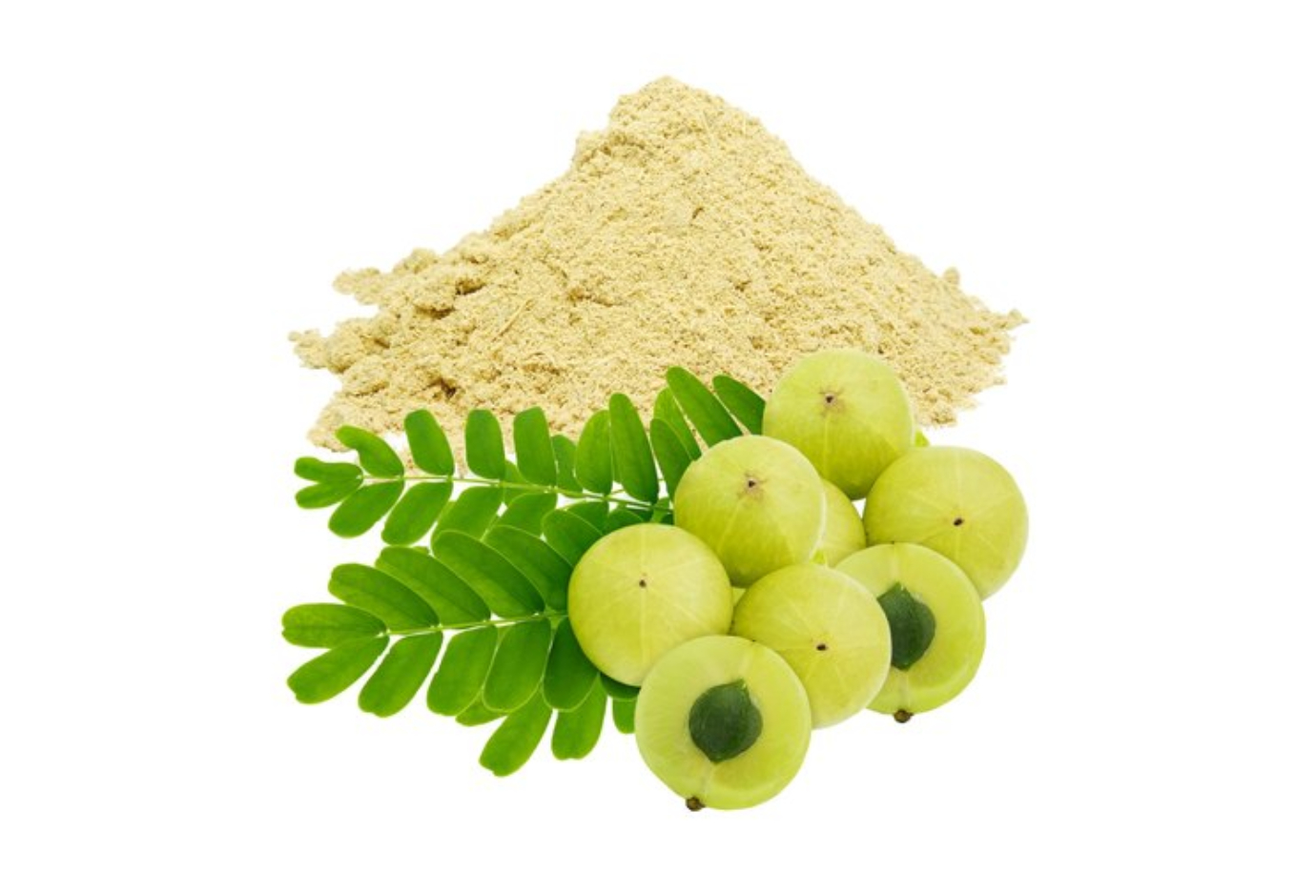

**FIG.3 AMLA EXTRACT**

**Shikakai Extract:**

Prevents Grays.Add more shine to the HairsCrubs Hair Loss. Shikakai extract, derived from the fruit of the Acacia concinna tree, is a popular ingredient in natural hair care products, particularly in ayurvedic and traditional Indian medicine. Here's a rundown on Shikakai extract:

Benefits for hair:

1. Promotes hair growth: Stimulates hair follicles, improving growth rate and density.

2. Strengthens hair: Rich in vitamins, minerals, and antioxidants, reducing breakage and split ends.

3. Detangles and conditions: Shikakai's surfactant properties gently cleanse and moisturize.

4. Scalp health: Anti-inflammatory and antifungal properties soothe irritations, reducing dandruff and itchiness.

5. Natural shampoo alternative: Shikakai extract can be used as a gentle, sulfate-free cleanser.

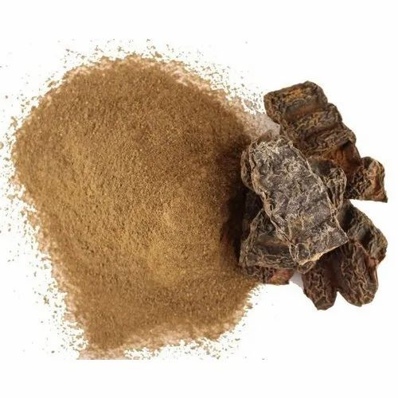

FIG 4 :Shikakai Extract:

**Aloe vera -**

Strengthens.

Calms an itchy scalp.

Deeps Cleans Oily hairs.

Smooth natural curls.

Reduce frizzing.

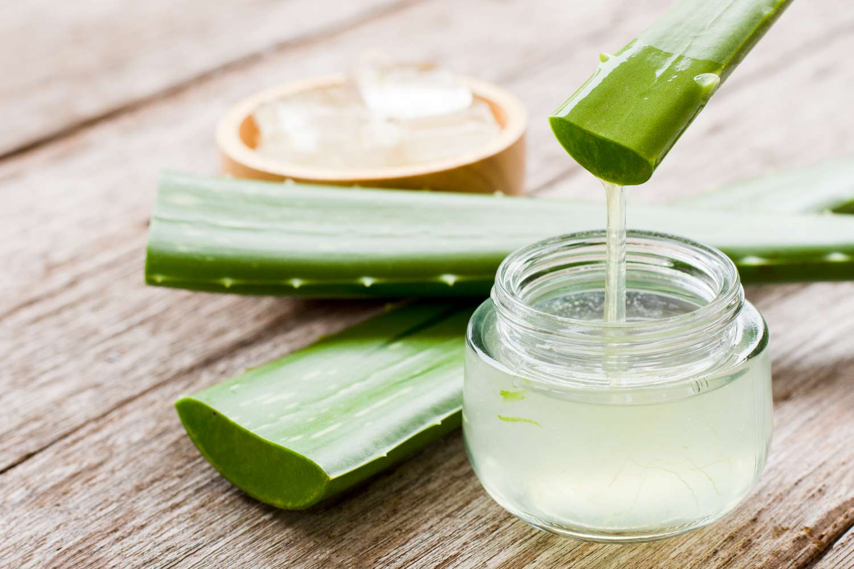

FIG 5: ALOEVRA EXTRACT

ROSE OIL :

It repairs hair damage

Improves Growth of hairs

Reduces the dandruff

Gives fragrance to the shampoo

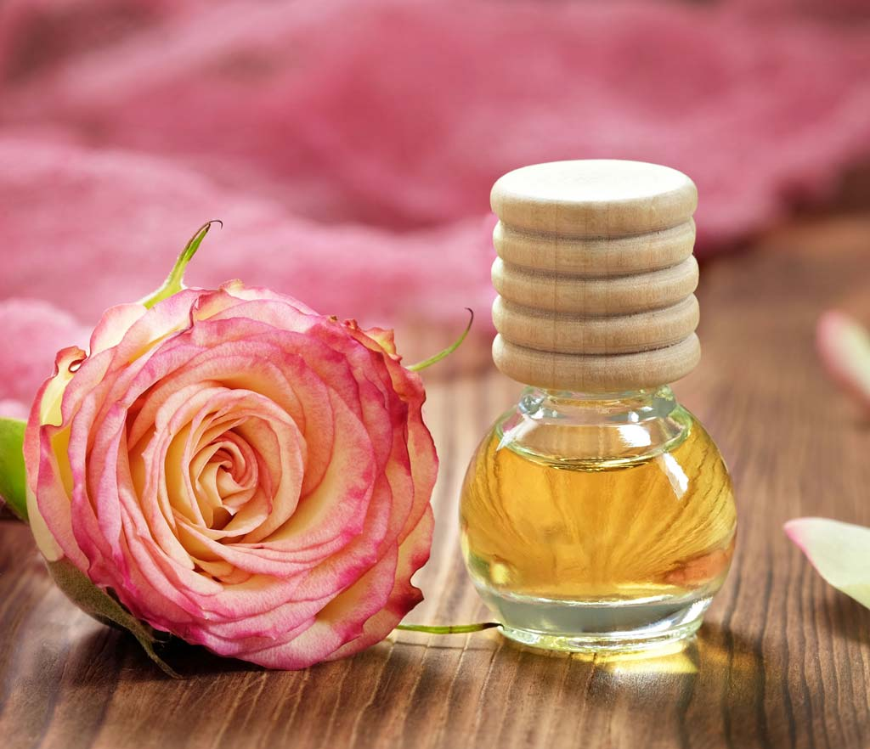

FIG 6.ROSE OIL

**Senna Extract:**

Strong Hairs

Great Conditioner

Combats Hair Loss

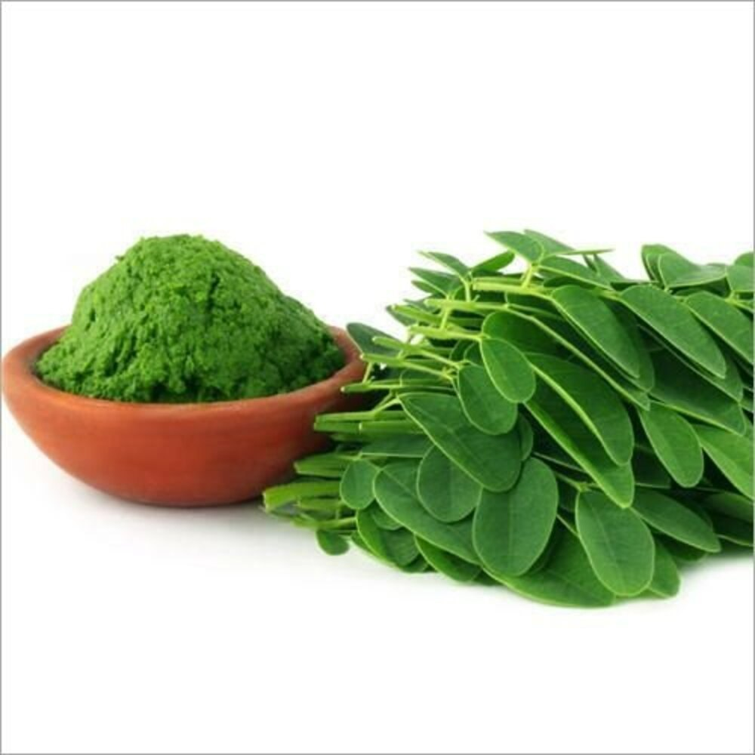

FIG 7.SENNA EXTRACT

**Types of shampoo:**

Powder Shampoo

Liquid Shampoo

Lotion Shampoo

Cream Shampoo Jelly Shampoo.

Aerosol Shampoo Specialized Shampoo

Conditioning Shampoo

Anti‐ dandruff Shampoo

Traditional shampoo

Herbal shampoo

Solid shampoo

1.**Traditional Shampoo** : The most common hair care cosmetic product is the shampoo. Arora et al. reported that can be described, primarily, as a cosmetic preparation, packed in a form convenient for Use, generally applied for cleaning hair and scalp from dirt, residues of previously applied hair Styling products and environmental pollutants.

**2.Herbal Shampoo** :interestingly, there is a large number of plants having beneficial effects on hair and being commonly used in shampoos for their content of vitamins, amino acids, sugars, glycosides phyto-hormones, bioflavonoids, fruit acids and essential oils useful protocols for the artificial soiling of hair, various cleaning processes and the analysis of the lipids remaining on the hair by gas chromatography

|  |  |
| --- | --- |
| **Ingredients** | **Medicinal uses** |
| Neem | Antibacterial agent |
| Soap nut extract | Foaming agent |
| Amla extract | Antidandruff agent |
| Shikakai extract | Detergent |
| Hibiscus | Conditioning agent |
| Bhringraj extract | Hair growth |
| Aloe vera | Moisturizing agent |
| Gelatin | Gelling agent |
| Lemon juice | Antimicrobial |

**ADVANTAGES OF SHAMPOO:**

● Cleansing properties

● Improving hair hygiene.

● Treating scalp conditions

● Treatment for dry scalp

● Treatment for hair loss.

● Treatment for greasing or oily hair.

● Relieves itch and irritation

● Repairs damaged hair.

● Shampoo keeps hair silky or smooth.

**Disadvantages of shampoo :** Herbal drug have slower effect as co pare to allopathic dosages forms.

It requires ion term therapy. They are difficult to hide test and order some time.

Composition of shampoo:

Principal surfactant

Secondary surfactant

Antidandruff agents

Conditioning agents

**CONCLUSION**:

The main purpose behind this formulation was to develop a stable and effective shampoo by including all types of additives which are added in this formulation. By using herbal natural extracts we can reduce the side effects of shampoo. Herbal shampoo is more safer than synthetic shampoo. The PH of the shampoo was adjusted to 5, to retain mantle of scalp which is acidic. Shiny hair having a smooth texture and clean-cut end is generally perceived to be Healthy. Use of Conditioning agents (synthetic) reduces the protein or hair loss. To Provide the effective conditioning effects, the present study involves the Use of shikakai amla, and other plant extracts instead of synthetic. There is a strong need to change the consumer perception of a good shampoo and the onus lies with formulators.

REFERENCE :

Maurya, Shashikant Maury, Piyush Yadav, Manoj Kumar Yadav, Suraj Maurya,Satyam JayaswalDepartment of pharmacy Prasad Institute Of Technology, Jaunpur, Uttar Pradesh (India)A REVIEW ARTICLE ON: HERBAL SHAMPOO2021 JETIR May 2021, Volume 8

)Mrs.K.Sravanthi N.Kavitha, K.Sowmya, S. Naazneen , U.Vaishnavi, CH.AnilSt.Pauls college of pharmacy,Turkayamjal,Rangareddy District,Telangana,5015A Review on Formulation and Evaluation of Herbal AntiDandruff ShampooVolume 6, Issue 3 May – June 2021

Suchita Gokhale1, Ashwini H. Pawshe2 , Srushti P. Patil2, Raj M. Pitambare and Priyam S. Pawar2 1EXTRACTION, FORMULATION AND EVALUATION OF MORINGA HERBAL SHAMPOOISSN: 2320-5407

Mr. Barde Gaurav ., Prof. Mali Shubhangi International Journal of Research Publication and Reviews, Vol 3, Issue 6, pp 74-81, June 2022

Suyog Sunil Bhagwat Dr. N. J. Paulbudhe College of Pharmacy, FORMULATION AND EVALUATION OF HERBAL SHAMPOO 2020 IJCRT | Volume 8, Issue 9 September 2020

Jennifer Gubitosa Vito Rizzi , Paola Fini and Pinalysa Cosma Hair Care Cosmetics: From Traditional Shampoo to Solid Clay and Herbal Shampoo, A Review31 January 2019; Accepted: 14 February 2019; Published: 19 February 2019

Prof. Shital V. Sirsat, Prof. Nikita M. Rathi, Shubham P. Thakare, Mayur S. Sapkal, Amol G. ChavareFormulation and Characterization of Herbal Shampoo Volume 7, Issue 4 April 2022