**To Increase The Sustainability Of EV Charging Stations By Implementing Solar Panels: A Review.**

**Aishwarya Jagtap1, Saujanya Hale1, Priti Shendkar1, Rutuja Chinuke1,**

**Dr. Omprakash Rajankar 2\***

1Department of Electronics and Telecommunication Engineering, Dhole Patil College of Engineering, Savitribai Phule Pune University, Pune, Maharashtra, India.

2Principal, Dhole Patil College of Engineering, Savitribai Phule Pune University, Pune, Maharashtra, India.

Mail addresses of Authors:

aishwaryajagtap134@gmail.com

saujanyahale@gmail.com

pshendkar99@gmail.com

chinukerutuja4@gmail.com

dromprakashrajankar@dpcoepune.edu.in*

**ABSTRACT**

The surge in electric vehicle (EV) adoption has sparked a critical need for widespread charging infrastructure, but the dependency on non-renewable energy sources for powering these stations risks undercutting the very environmental benefits that Electric Vehicles are meant to provide. This paper presents a forward-thinking solution: the integration of solar energy into EV charging stations as a primary power source, transforming these stations into sustainable, self-sufficient units.

Harnessing solar power not only reduces dependence on conventional electricity grids but also reduces operational costs and drastically cuts carbon emissions. By optimizing key variables—such as geographic location, solar panel efficiency, advanced energy storage systems, and smart grid connectivity—solar-powered charging stations can offer reliable, round-the-clock service while making a significant contribution to a cleaner environment.

This innovative approach not only fortifies the resilience and sustainability of EV charging infrastructure but also paves the way for the broader adoption of renewable technologies in both urban and rural landscapes. This paper explores how solar-powered EV charging can become the cornerstone of a green, sustainable transportation.

Keywords— Solar power, electric vehicles, battery charging station, solar panels.

1.INTRODUCTION

The combination of EV charging and Solar power is very important to reduce our dependency on fossil fuels. Even though there are many sources of electricity still it is important that we power the electric vehicles by renewable energy sources in order to create a sustainable solution for addressing global issues. Grid-connected photo-voltaic (PV) arrays offer continuous electricity supply for EV charging fulfilling daily energy demands and provides more photovoltaic generation during peak solar hours. As the world is moving towards sustainable transportation, electric vehicles (EVs) are acting as a great solution for reducing pollution through zero emission and beat the climate changes. However, the infrastructure supporting EVs, particularly charging stations, often rely on traditional energy sources such as diesel generators. This dependency affects the environmental benefits of electric vehicles in a negative manner and also causes air pollution to some extent. The implementation of solar panels into EV charging station infrastructures present a transformative opportunity to overcome this problem. Solar energy is a clean and renewable resource that can be used to reduce the carbon footprints associated with EV charging system. With sunlight, solar-powered charging stations can operate independently without the use of fossil fuels, thus offering a sustainable alternative that aligns with global efforts for transition towards greener energy solutions.

This presentation will dive into insights about implementing solar panels at EV charging stations, examining their potential to increase energy efficiency, promoting environmental sustainability along with reducing the operational costs. As more people choose electric vehicles (EVs) to reduce pollution and save on fuel costs, the need for charging stations is a high demand. However, many traditional charging stations still rely on diesel generators for power. This is a problem because using diesel contributes to air pollution and greenhouse gas emissions, which ultimately harm our environment. To address this issue, we can use solar panels to power EV charging stations.1,3

**2.Current Scenario**

As we see India is stepping towards a sustainable development. The current scenario shows growing of solar energy and it’s contribution in the expanding EV market, managed by government resources, technological advancements and increasing private sectorinvestment.This current scenario of solar based charging stations is mainly focused on reducing dependency on fossil fuels for power generation and decreasing carbon emissions. As the world is moving forward towards clean energy solutions, some solar power countries like India, are also focusing to make advancements into solar system for EV charging stations. In India cities like Jaipur, and Kashmir are working on integrating solar energy into EV charging systems. Advancements in solar technology, such as bifacial and high-efficiency panels, have improved energy capture and reduced the space required for installations. The use of battery storage solutions allows for the management of solar energy, ensuring consistent availability for EV charging even when sunlight is limited .The initial investment for establishing a solar-powered charging stations is high. However, the operational costs are significantly lower due to usage of solar energy, making charging more affordable for users. Government grants, subsidies, and green loans are available to encourage investment in solar charging infrastructure.2

**2.1 Kashmir city**

The state Jammu and Kashmir is situated near great Himalayan Mountains in the north side of India. There, Kashmir Valley is the most urbanized region among Jammu, Kashmir Valley and Ladakh .It has following four seasons: Summer (March–May) having a maximum temperature of 30 to 31 ◦C; Rainy (June–September), with a minimum temperature (9 to 15 ◦C) and high temperature of 30 ◦C; Winter (November–February), with a temperature as low as sub-zero to high of 15 ◦C; Autumn (October–November) with temperature9–20◦C.  
The monthly average of solar GHI is 5.32kWh/m2 a day with maximum of 7.43kWh/m2 per day (month of may) and minimum of 3.36kWh/m2 in a day(month of december).2

**2.2 Jaipur city**

Jaipur, which is the capital city of the State of Rajasthan which is the largest state consisting of almost 10.4% geo-graphical area of India. It has a huge solar energy which makes it ideal to capture solar rays sufficient for generating large amount of electricity . Jaipur has almost 300–325 sunny days in a year and receives 6–7 kWh/m2 solar radiation/day and is second highest in the world to record this. Here the average temperature is between 35 ◦C to 40 ◦C and in summer it is mostly above 45 ◦C. Currently Rajasthan holds a potential of 10000 MW of solar energy. The highest and lowest solar GHI are 6.46 kWh/m2/day (in month of May) and 4.00 kWh/m2/day (in month of August) respectively with a monthly average of 5.26 kWh/ m2/day in Jaipur. 2

**3. Role Of Solar Panels Towards Sustainable** **Development**

Solar panels play a crucial role in promoting sustainability by powering electric vehicle (EV) charging stations. These stations are powered by solar energy which helps to reduce our dependency on fossil fuels and reduce harmful emissions. Solar panels generate clean electricity during the day, which can be used to charge electric vehicles. The extra energy can be stored in batteries or can be sold back to the grid, further reducing wastage of energy. This setup helps to lower down the carbon footprints of charging vehicles, making transportation more environment friendly.2

The photovoltaic cells contribute to sustainability by providing clean energy to power electric vehicle (EV) charging stations. They generate electricity from sunlight, reducing the dependency on fossil fuels like coal or gas, which produce harmful emissions. Making use of solar energy to charge electric vehicles, carbon emissions can be reduced significantly, helping to protect the environment.

Additionally, solar-powered stations can store extra energy in batteries, which ensures a continuous supply of electricity even when the sun is not shining​. This makes solar-powered charging stations an eco-friendly and reliable solution for the future.3

**4. Components Used**

In the build up of a well planned solar charging station a number of components plays an essential role.These components as shown in the Figure 1 make sure that the ideal generation and management of clean energy of EV charging station is carried out.

1. Solar Panel-The solar panel works as a charging module for EV charging station using solar energy.Photovoltaic cells convert sunlight into electric power that can be used to charge a charging station.4
2. Charge Controller-A solar charge controller acts as a regulator for a solar battery stopping it from overcharging and overheating.Batteries are rated for a specific voltage capacity and increasing this voltage can cause permanent battery damage and loss.4
3. Solar Tracker-The use of solar tracker systems rises the amount of solar energy accepted by the solar collector and enhance the energy output of the electricity produced. The solar tracker will rise up the output of solar panels.4
4. Inverter-Inverters combine the solar inverter and electric vehicle chargers that can be charged directly from solar panels.Combining the charger with solar inverter is bright solution that terminates the need for a distinct EV chargers as well as extra wiring and possible electrical upgrades.4
5. Dc charger- batteries uses direct current for charging. A DC charger is outside module that changes AC main power into DC power for charging an electric vehicle. It works simultaneously with the solar panel when attached to charging station and charges the battery.4

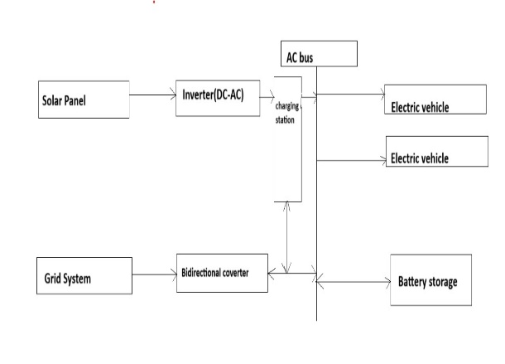

**Figure 1: Block diagram of solar charging station**

**5.Working**

The solar panels generate DC electricity when the sunlight fall on them. This generated power energy is passed through a high step-up boost DC/DC converter, which increases the voltage to the approximate level. To make sure that the solar panels work at their maximum structured, the system makes use of MPPT (Maximum Power Point Tracking) control, which continuously adjusts the operating conditions of the panels to increase the energy output. The boosted DC power is then supplied to the DC microgrid, which acts like a centralized hub for distributing the generated power. Then the part of the DC is converted to AC using a DC/AC inverter to supply AC loads, like household appliances, through an AC microgrid. Before reaching the AC loads, the power passes through a filter (LC or LCL) to check if the electricity is of good quality and have minimum harmonic distortion.

To manage surplus energy and provide power at the time of low solar generation, like in nighttime or in cloudy conditions, the system is equipped with a battery bank. The battery used for storage is connected to the DC microgrid via a bidirectional DC-DC converter, which controls the charging and discharging. The bidirectional nature of the converter allows for flexibility when there is large amount of power from the solar panels, the battery stores the power and when there is a shortage it discharges the stored power back to the system. The charge control mechanism ensures that the battery operates within the safe range to prevent overcharging by extending the battery's life and maintaining system stability. In addition to manage the local loads and battery storage, the system is also designed to charge electric vehicles (EVs). 2

The technical-economic parameters are described by given equation. The output of the solar panel5

PPV = YPVfPV GT GT,STC [1 + P(Tc Tc,STC)]

The peak of battery power charge is calculated by equation : 5

Pbatt cmax,mcc = NbattImaxVnom

1000

The net present cost (NPC) is the current cost of installation of system and operation of the system during the project lifetime. The aim of this optimization process is to reduce the Net present cost with given equation:5

NPC = TAC* (1+i)n -1]/[i* (1+i)n]

where: TAC: is the total annualized cost, i: the annual real interest rate (%),

n: the number of years (systems lifetime)

The cost of energy (COE) is written as the average cost per kWh of electricity generated by the hybrid power system. The equation for the COE is as follows:5

COE = TAC/Euseful

where: TAC is the total annual cost of the system, Euseful is useful production electricity per year (kWh/year).

The capacity of the solar system is derived by adding the total energy output per performance and then removing the quantified system losses to obtain a net effective capacity:8

Total module energy = Night energy + Daytime energy

100%− loses at night 100% - loses at daytime

By making use of the following formula a result p and correct estimation of the number of solar panels needed to meet the system’s energy demands:8

Total PV = Total module energy

Capacity of solar panel

The calculation for the required number of batteries used is done by dividing the total electrical demand of the system by the power capacity of a battery, thus providing a formula to ascertain the exact quantity of batteries necessary for the system.8

Battery = Total electrical demand

Power capacity of the battery

The COE is a critical metric in evaluating the budget of the system. It is calculated by dividing the system’s total yearly cost by its annual electricity production.8

COE = Total NPC

Total electricity production

As per the Table 1, there are 7-12 panels of power 250-400W per panel needed and approximately each panel generates energy around 1.75-4.8kWh(1unit=1kWh) assuming the sunlight for 7 hours a day.A car needs 10unit of electric power to get fully charged (100%), the power needed to get a car fully charged depends upon efficiencies of batteries used in car, some cars won’t need to charge frequently so those cars needs more cost to get fully charged (0% to 100%). For understanding purpose if we are using 12 panels and each panel generates around 4kWh/day then:12*4kWh=48kWh per day.48kWh power is generated from the system in a day. So if a car takes 10unit to get charged then: 48kWh/10 =4.8 cars 4~5 cars get charged in a day.

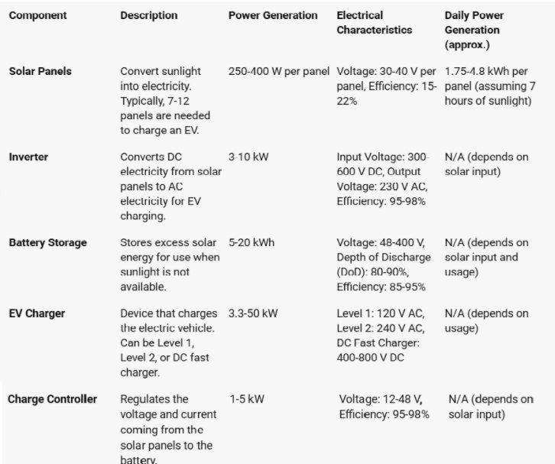

**Table 1: Electrical characteristics4**

In Mumbai the cost of electricity of 1unit is around 15/- so:15*10=150/- needed to charge a car and the amount we get after charging 4 cars will be around 600/- per day. Per month amount we get will be 18000/- (cost may differ in some months). Per year amount we get will be 2,16,000/-. If we talk about scooters a scooter needs 0.6kWh(0.6unit) power to get charged so:48kWh/0.6 =80 scooters. Therefore, if this system only charge scooters then it can charge approximately 80 scooters a day. As discussed the cost of electricity above:15*0.6=9/- needed to charge a scooter and the amount we get after charging 80 scooter will be 720/- per day. Per month amount we get will be 21600/- (cost may differ in some months). Per year amount we get will be 2,59,200/-.

**6. Advantages**

1. Cost Savings: Solar-powered electric vehicle charging stations reduce complete dependency on grid electricity, leading to significant savings for EV owners in terms of cost. By solar energy usage, the cost of charging an EV can be lowered to some extent.5
2. Environmental Benefits: These solar powered charging stations help to reduce greenhouse gas emissions and also lower down the carbon footprint of EVs. Charging electric vehicles with solar energy eliminates the need for fossil fuels consequently contributing to cleaner air and a healthier environment.6
3. Enhanced Charging Efficiency: Research indicates that placing solar panels in an appropriate angle and position in the places where irradiance levels are high, leads to an increase in the output power produced by solar PV systems which leads to more effective EV charging. 7

**7. Future scope**

1. Increased Efficiency of Solar Panels: The study shows that the importance of optimizing solar panel placement for higher energy per unit area. Research and development focuses on the enhancing solar panel technologies to capture more sunlight efficiently, even in partial shading scenarios.​
2. Integration of Energy Storage Systems (ESS): With irregular solar power, finding more energy storage solutions like lithium-ion batteries is critical. In future it could have more innovations in battery technologies to improve efficiency, capacity, and longevity, which makes sure the steady supply of energy for EV charging.​
3. Faster Charging Technologies: The use of DC fast chargers(level3), which offer low-loss, more efficiency and fast charging. Future developments may focus on reducing the charging time for EVs and guarantees compatibility with various types of EVs, possibly through advanced DC-DC converter.
4. Advanced Battery Management Systems (BMS): Managing the charge and discharge cycles of batteries structured is crucial for enhancing system performance. Future research could focus on developing intelligent BMS that better predict and control battery behaviors, increasing the efficiency of both solar and storage systems.
5. Hybrid Charging Systems: Combining solar energy with other renewable sources, such as wind power, could enhance the flexibility of EV charging stations. Hybrid systems would ensure continuous operation, even during periods of low sunlight.
6. Economic and Environmental Impact: As rate of EV adoption grows, combine renewable energy for EV charging could significantly reduce adaptation on fossil fuels and lower greenhouse gas emissions. This greenenergy approach offers a sustainable future for transportation.6

**8. CONCLUSION**

In this review paper, we have explored the basic idea about how the implementation of solar panels in electric vehicle charging station infrastructures can help to generate a clean source of energy which can replace the current fuel powered electric vehicle charging stations and benefit our environment in a positive way.

# **ACKNOWLEDGEMENTS**

We extend our sincere gratitude to the Principal and our project guide, Dr. Omprakash Rajankar, our Department Head, Prof Prachi Deshpande, for their constant support and valuable guidance during the course of our project. We are also grateful to Dr. Bhausaheb Shinde, the project coordinator, for his unwavering encouragement and assistance. Furthermore, we would like to express our appreciation to the entire staff and our fellow classmates who played a significant role in our achievements. Their availability and continuous encouragement have boosted our confidence.

**9. REFERENCES**

1. Singla, P., Boora, S., Singhal, P. et al. Design and simulation of 4 kW solar power-based hybrid EV charging station. Sci Rep 14, 7336 (2024). <https://doi.org/10.1038/s41598-024-56833-5>
2. Himabindu N., Santoshkumar Hampannavar, Deepa B., Swapna M.,Analysis of microgrid integrated Photovoltaic (PV) Powered Electric Vehicle Charging Stations (EVCS) under different solar irradiation conditions in India: A way towards sustainable development and growth,
3. Energy.Reports,Volume7,2021,Pages8534-8547,ISSN23524847,https://doi.org/10.1016/j.egyr.2021.10.103.(<https://www.sciencedirect.com/science/article/pii/S2352484721011227>).
4. Chamola, Vinay & Sikdar, Biplab. (2015). Solar Powered Cellular Base Stations: Current Scenario, Issues and Proposed Solutions. IEEE Communications Magazine. 54. 10.1109/MCOM.2016.7470944.
5. Prakash, Thangalakshmi & K. Dr, Sivasami & Khan, Saad. (2023). DESIGN AND IMPLEMENTATION OF SOLAR CHARGING STATION FOR ELECTRIC VEHICLES. 7. 1-18.
6. Alrubaie, A.J.; Salem, M.; Yahya, K.; Mohamed, M.; Kamarol, M. AComprehensive Review of Electric Vehicle Charging Stations with Solar Photovoltaic System Considering Market, Technical Requirements, Network Implications, and Future Challenges. Sustainability 2023, 15, 8122. https://doi.org/ 10.3390/su15108122.
7. Umair M, Hidayat NM, Sukri Ahmad A, Nik Ali NH, Mawardi MIM, Abdullah E (2024) A renewable approach to electric vehicle charging through solar energy storage. PLoS ONE 19(2): e0297376. https://doi.org/10.1371/journal. pone.0297376
8. Sagar, Gumpa & kiran, Ganji & Eswari, Bondada & Rao, Guruvu & Jayaram, Bairi & Sayamma, Paturi. (2024). A comprehensive review of solar charging stations. International Journal of Research Publication and Reviews. 5. 5278-5283. 10.55248/gengpi.5.0324.0826.
9. S. D. Prasetyo, F. J. Regannanta1, M. S. Mauludin, and Z. Arifin, “Economic feasibility of solar-powered electric vehicle charging stations: A case study in Ngawi, Indonesia,” Mechatron. Intell Transp. Syst., vol. 2, no. 4, pp. 201–210, 2023. https://doi.org/10.56578/mits020402.