**Detail Review on Formulation and Evaluation of Herbal Arthritis Oil (Joint Pain Relief) Using Mustard Oil.**

# Siddheshwar Sandesh*1, Miss. Mahadik Maya*2, Dr.Garje Sanjay*3, Dr.Sayyad Gaffar*4 *

# 1,2,3,4 Shri Amolak Jain Vidhya Prasarak Mandal’s, College Of Pharmaceutical Science And Research Center, Kada, Beed, Ms, India.414202.

­________________________________________________________________________

# ABSTRACT:-

Rheumatoid arthritis (RA) is a long-term autoimmune disorder that primarily affects joints. It typically results in warm, swollen, and painful joints.it affect large population osteoarthritis and (OA) and rheumatoid arthritis (RA) are two major form of arthritis. Traditional medicinal systems have long advocated the use of natural oils for pain relief.

Because herbal formulations include analgesic and anti-inflammatory qualities, they have long been used to treat joint pain and arthritis. Because of its warming and penetrating properties, mustard oil is frequently utilized in these compositions. The creation of a herbal arthritis oil using mustard oil and particular excipients like clove, camphor, peppermint, and garlic is the main topic of this review, which also emphasizes how well these ingredients work together to relieve joint pain. The study examines the development of these formulations, examines the scientific justification for their usage, and provides clinical data in favour of their application.

**KEYWORD:-** Arthritis , Herbal medicine , joint pain relief, mustard oil, anti-inflammatory, pain management , herbal extract ,traditional medicine , safety and efficacy ,quality control , patient outcome ,herbal formulation , oil infusion method .

**INTRODUCTION:-**

Millions of individuals worldwide suffer from the crippling disease known as arthritis, which causes pain, swelling, and stiffness in the joints.Rheumatoid arthritis, gout, and osteoarthritisare common forms that frequently impair mobility and quality of life. There is growing interest in natural, less intrusive arthritis treatments as the world's population ages. Herbal oils, especially those derived from mustard oil, have been used for ages to treat arthritis in ancient medical systems such as Ayurveda. Strong herbal elements like clove, camphor, peppermint, and garlic combined with mustard oil make an effective treatment for relieving joint pain. This review examines the use of these excipients in the formulation of arthritis oils based on mustard oil and discusses their respective and combined effects on pain relief and inflammation reduction. The combinatorial word "arthritis" was created by fusing Greek and Latin. "Arthron" means "joint" in Greek and "specifies inflammation" in Latin. As a result, arthritis is typically thought of as a condition brought on by inflamed joints. It is not a single disease per se; rather, it is a group of medical issues from which 300,000 children in the US alone suffer. If appropriate treatment is not given in a timely manner, the disease may render a person permanently disabled. Worldwide, it causes significant financial hardship due to lost wages and rising prescription costs. There are currently a number of therapy options available just to manage the illness; nevertheless, a quick solution has not yet been discovered. It's important to grasp the workings of a bone joint in order to properly comprehend the condition.

Arthritis is most common in the following areas of the body **:**

**-Hands**

**-Feet**

**-Knees**

**-Hips**

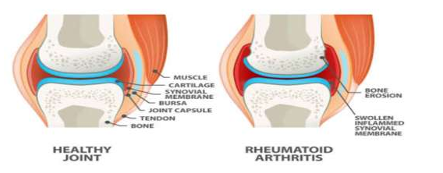

1. **Mustard Oil As A Base for Herbal Arthritis Oil –**

One simple technique to use mustard seeds to alleviate joint pain is to apply warm mustard seed oil to your swollen, arthritic joints. Use long, light strokes to massage the oil without applying too much pressure to enhance blood circulation. Another common component of mustard oil is alpha-linoleic acid (ALA), a type of omega-3 fatty acid that may help lessen inflammation and pain associated with illnesses like rheumatoid arthritis.

.

**Composition of Mustard Oil**

The active ingredients of mustard oil, which is made from the seeds of the mustard plant (Brassica nigra, Brassica juncea), include oleic acid, alpha-linolenic acid, and allyl isothiocyanate. Strong anti-inflammatory and anti-irritating qualities are possessed by these ingredients. Mustard oil's warming properties aid in reducing joint stiffness and enhancing blood flow to the afflicted areas.

**Synonyms**: Vegetable oil

**Biological source:** Mustard oil obtained from natural seed of Brassica nigra Koch or Brassica juncea L. czern

**Chemical constituents:** Mustard oil ha about 60% monounsaturated fatty acid (42% erucic acid & 12% oleic acid ), it has about 21% polyunsaturated fats.

**Uses:**

Mustard oil use as a –

* Dental analgesic
* Carminatives
* Stimulants
* Aromatic

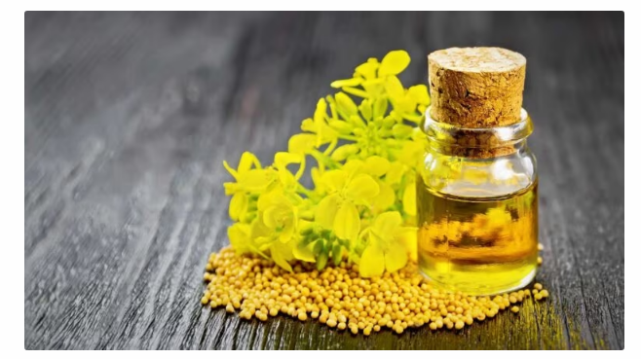

**Therapeutic Properties:**

**Anti-inflammatory:** It is generally known that mustard oil reduces inflammation, which makes it a useful foundation for arthritic oils.

**Analgesic:** By stimulating nerve endings, mustard oil creates a warming sensation that reduces pain.

**Circulation Improvement**: Better circulation in the joints can make them less painful and help them heal faster. This is warming oil that helps blood flow and reduces inflammation.

**Benefits:** It can help loosen up stiff muscles and joints and bring more blood to the area.

**Herbal Excipients in Mustard Oil-Based Arthritis Formulations:**

In addition to mustard oil, specific herbal excipients like clove, camphor, peppermint, and garlic play a significant role in enhancing the therapeutic properties of the formulation. These ingredients have their own anti-inflammatory, analgesic, and circulatory benefits.

1. **Clove (Syzygium aromaticum)**

Eugenol, a substance with potent analgesic and anti-inflammatory qualities, is found in clove oil. It relieves joint pain right away by acting as a natural anesthetic. Clove oil’s antioxidant qualities also lessen oxidative stress, which raises the risk of joint inflammation.

Cloves contain many compounds known for their anti-inflammatory properties, with eugenol being the most important. It’s been shown to reduce your body's inflammatory response, which can lower your risk of health issues such as arthritis and help manage symptoms.

**Mechanism**: Eugenol inhibits pro-inflammatory enzymes like COX-2, reducing pain and swelling .inhibition of prostaglandin synthesis through both cyclooxygenase and lipoxygenase pathways

**Synergistic Effect**: When combined with mustard oil, clove oil enhances the warming sensation and analgesic effects, providing deeper penetration into the affected joint tissues.

**Synonyms**: -Eugenia cariophylata

**Biological source: -** Cloves consist of dried flower buds of Eugenia caryophyllus, (Family: Myrtaceae).

**Chemical constituents**: Clove oil contain about 15 to 20 % of volatile oil, 10% to 13% of tannis, resins, chromosomes and eugenic. The volatile oil of the drug contain eugenol 89% and 5 to 15% eugenol acetate and beta- cairofileno.

**Uses**

* Relieves muscular pain.
* Promotes faster healing.
* Reduce irritability.

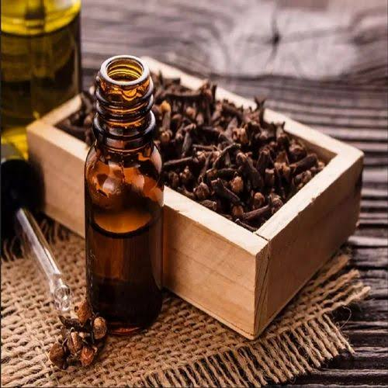

1. **Camphor (Cinnamomum camphora)**

In contrast to mustard oil's warming properties, camphor has a natural cooling impact that acts as an anti-inflammatory and counter-irritant. This warming-cooling mix works wonders to relieve inflammation and soreness in the joints.

**Mechanism:** Camphor stimulates nerve endings, creating a numbing effect that reduces pain perception. It stimulates and desensitizes sensory nerves by activating heat-sensitive TRP vanilloid subtype 1 (TRPV1) and TRPV3 receptors.

**Synergistic Effect:** The formulation is appropriate for both acute and chronic pain management since the combination of mustard oil and camphor helps to balance the warming and cooling effects.

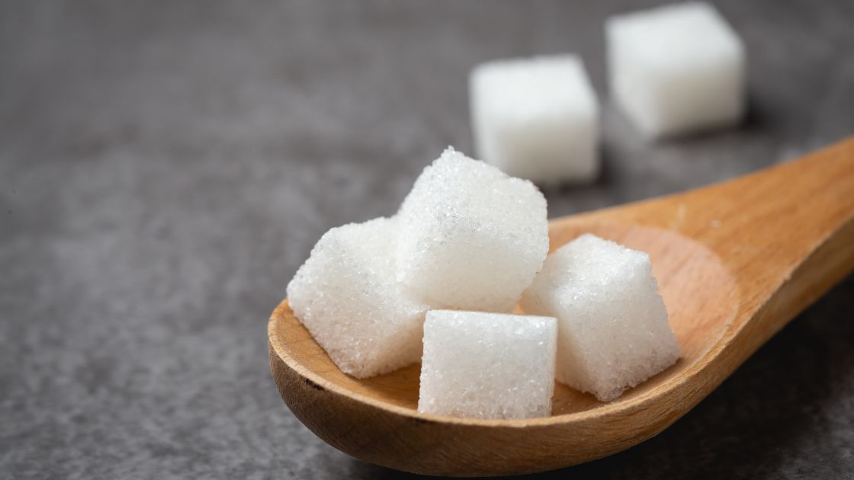

1. **Peppermint (Mentha piperita):**

Menthol, a substance found in large amounts in peppermint oil, has a cooling and analgesic effect. When administered topically, it reduces inflammation, eases discomfort, and enhances circulation. Additionally, menthol possesses anti-spasmodic qualities, which make it perfect for easing arthritic muscular spasms.

**Mechanism**: Menthol activates cold-sensitive receptors, producing a cooling sensation that helps in pain relief. Peppermint oil may help relieve joint pain because it has analgesic and anesthetic properties, and its menthol content can create a cooling effect that numbs pain

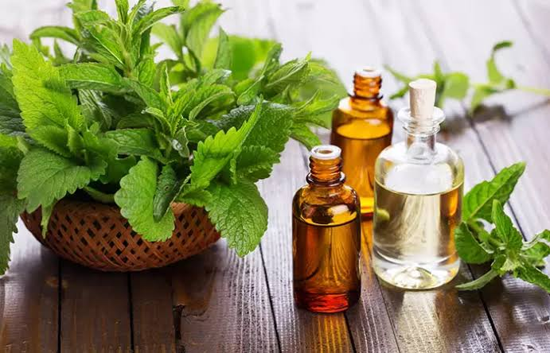**Synergistic Effect**: Because peppermint oil instantly cools down after mustard oil does, it balances out the warming effect of mustard oil and improves the formulation's effectiveness for joint discomfort.

1. **Garlic (Allium sativum)**

Because of its antibacterial, antioxidant, and anti-inflammatory qualities, garlic has long been used. Garlic's primary active ingredient, allicin, has been demonstrated to lower inflammation and slow the development of arthritis.

.

**Mechanism**: Garlic suppresses inflammatory cytokines like TNF-α and IL-6, which are associated with arthritis pain. Garlic may help with joint pain because it has anti-inflammatory properties and can reduce the effects of pro-inflammatory cytokines

**Synergistic Effect**: Garlic strengthens the anti-inflammatory qualities of mustard oil, which offers both temporary and long-term pain relief.

.

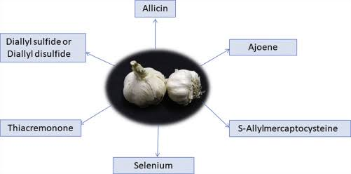

* **Formulation Techniques-**

1. Maceration
2. Hot infusion
3. Steam distillation

* **Traditional Use**

Mustard oil combined with common herbs like ginger and turmeric was used to treat arthritis in traditional medicine systems like Ayurveda and Unani. But stronger herbs like clove, camphor, peppermint, and garlic have been added over time to improve the effectiveness of these mixtures.

* **Modern Advances-**Comprehending herbal pharmacology more thoroughly has led to the development of increasingly intricate formulations. These days, a variety of synergistic herbs and essential oils are combined in mustard oil-based arthritic oils to offer focused relief from arthritis symptoms..
* **Clinical Studies -** Several clinical trials have shown the effectiveness of herbal oils comprising clove, camphor, peppermint, and garlic. For example, a study on the topical application of camphor and clove oil in a mustard oil basis revealed significant decreases in joint pain and inflammation in osteoarthritis patients.
* **Effectiveness -**

|  |  |
| --- | --- |
| 1.Mustard Oil | Anti-inflammatory and improves circulation. |
| 2. Peppermint Oil | Provides a cooling, soothing effect |
| 3.Camphor | Acts as a mild analgesic and increases blood flow. |
| 4.Garlic | Anti-inflammatory properties. |
| 5.Clove | Contains eugenol, which has pain-relieving properties |

* **Stability**: Herbal oils are prone to oxidation. Incorporating natural antioxidants such as vitamin E can help preserve the quality and shelf life of the formulation.
* **Standardization**: Achieving consistent concentrations of active ingredients in each batch remains a challenge. Advances in chromatography and other analytical techniques are being used to ensure standardization.
* **Regulatory Issues:** Regulatory bodies are now enforcing stricter guidelines for the commercialization of herbal products, ensuring safety, efficacy, and quality.
* **Future Prospects -**

The future of mustard oil-based herbal arthritis formulations lies in modern scientific advances, such as:

1. **Nanotechnology**: This could enhance the bioavailability of the active herbal ingredients, leading to improved efficacy.
2. **Synergistic Blends**: The continued exploration of optimal ratios of clove, camphor, peppermint, garlic, and mustard oil will lead to more effective formulations.
3. **Clinical Validation:** Large-scale, placebo-controlled clinical trials are needed to further validate the efficacy of these formulations.

* **Conclusion –**

Strong herbs like clove, camphor, peppermint, and garlic combined with mustard oil provide an effective natural treatment for arthritis and joint discomfort. Each component contributes uniquely to the analgesic, circulatory, and anti-inflammatory effects. Thanks to recent advancements in science, these formulas have evolved and may soon provide arthritis sufferers with safe, natural, and effective relief. This combination has the potential to be very helpful in treating joint pain due to its anti-inflammatory, analgesic, and circulation-enhancing properties. However, as each person responds differently, it could be helpful to consult a healthcare provider for specific advice, especially if there are any underlying medical conditions or ongoing therapies to consider.

.

* **Reference -**

1. Research journal of pharmacognocy & phytochemistry
2. S. Kaul and S. Dwivedi, Indigeneous Ayurvedic Knowledge of Some Species in the Treatment of Human Disease and Disorders, Int. J. Pharm. Life Sci., 1(1), 44-49 (2010).
3. International Education and Research Journal
4. International Journal of Nursing Education

1. The book of pharmacognocy and phytochemistry by kokate sir
2. Arthritis Foundation. Arthritis by the Numbers, Book of Trusted Facts and Figures; v2; 4100.17.10445, 2018.
3. Shayan Senthelal, et.al.Arthritis Published by National Library of Medicine, National for Biotechnology Information June 20, 2023.
4. Imam Haq, et al. “Osteoarthritis” Published by Article in Postgraduate Medical Journal 01/79-377-381
5. International journal of pharmaceutical science Formulation And Evaluation Of Fast Guard Joint Pain Relief Herbal Patches
6. Akhihiro Sudo et.al; Prevalence and risk factors for knee osteoarthritis in elderly Japanese men and women; Journal of orthopaedic science.13:413, 2008
7. Jinks C, Jordan K, Croft P. Measuring the population impact of knee pain and disability with the Western Ontario and McMaster Universities Osteoarthritis Index (WOMAC) Pain. 2002
8. Manohar RP, Pushpan R, Rohini S. “Mustard and its Uses in Ayurveda” International Journal of Traditional Knowledge. 2008-9
9. Research journal of pharmacy and technology, Enhanced anti-arthritic effect of mustard oil in Nanoemulgel Formulation: A comparative clinical study by Jayprakash. S. Suryawanshi, Shivaji. P. Gawade