**Liver Cirrhosis Prediction System Using Machine Learning Techniques**

# Desetti Srinuvasa Rao1, Kilugu Santosh Kumar2, Koduru Sravani3,

**Jonnalagadda Rohith Kumar4, Madhabathula Sai Maneesh5, Markonda Patnaikuni Sri Sai Slaghana6**

1Assistant Professor, Department of Computer Science and Engineering, GMR Institute of Technology, Rajam, Andhra Pradesh, India.

2,3,4,5,6B. Tech, Student, Department of Computer Science and Engineering, GMR Institute of Technology, Rajam, Andhra Pradesh, India.

***Abstract*— In today’s world many people are suffering with liver related diseases such as Liver Cirrhosis, hepatitis, Liver Cancer and some other liver diseases. Especially cases of liver Cirrhosis are growing rapidly all over the world. Liver Cirrhosis Treatment is effective in initial stages of this disease rather than final stage of disease. The liver is one of the vital organs present in the human body. It acts as a detoxification and purification mechanism, performing crucial functions such as detoxification of harmful toxins, blood filtration from harmful substances. We have developed a Liver Cirrhosis prediction system using various machine learning algorithms such as** **random forest, logistic regression, Support Vector Machine, k-nearest neighbor, ensemble voting classifier and Multilayer perceptron (MLP). The project aims to predict chronic liver disease patients using machine learning algorithms. Data collection involves gathering a dataset containing information about chronic liver patients. Feature extraction involves techniques such as Linear Discriminant Analysis (LDA), Principal Component Analysis (PCA) and Factor Analysis (FA). Data processing involves splitting datasets into training sets, test sets, and validation sets. The receiver characteristic curve (AUC-ROC) plays a crucial role in predicting chronic liver disease. The ROC uses for evaluating and comparing the performance of various classifiers. To ensure the credibility of this project model, we undergo cross-validation techniques such as 10-fold cross-validation (k-fold cross-validation). In this way, we are able to create a Chronic liver disease Prediction system that can bring revolutionary changes to the medical sector.**

*Keywords: Liver Cirrhosis, Linear Discriminant Analysis (LDA), Factor Analysis (FA), Receiver operating characteristic curve (AUC-ROC), Principal Component Analysis (PCA), Feature Extraction.*

1. INTRODUCTION

The liver is an essential organ in the human body, performing over 500 critical functions necessary for maintaining overall health. These functions include detoxification, protein synthesis, and the production of biochemicals necessary for digestion. When the liver malfunctions, it can pose severe threats to one's well-being, potentially leading to life-threatening conditions. Timely diagnosis and effective treatment of liver diseases are paramount in improving patient outcomes and increasing the likelihood of survival. However, diagnosing liver diseases, particularly in their early stages, can be challenging due to the often asymptomatic nature of these conditions. In recent years, machine learning (ML) has emerged as a powerful tool in healthcare, offering valuable assistance to medical professionals in the diagnostic process, particularly in identifying and managing hepatic conditions. A standard ML approach typically involves stages such as data pre-processing, feature extraction, and classification, each playing a pivotal role in enhancing the accuracy and efficiency of disease diagnosis.

Traditional feature extraction methods, particularly projection-based approaches, often fall short in effectively capturing the nuances of liver diseases from complex datasets. These methods may fail to extract the subtle yet significant features that indicate the presence of liver pathology. Existing statistical projection methods may also lack specificity in projecting original features, limiting their utility in accurately identifying relevant patterns indicative of liver disease. To address these challenges, this study leverages the Indian Liver Patient Dataset (ILPD) from the University of California, Irvine (UCI) repository, which comprises records of 583 patients, including those with and without liver disease. The study proposes an integrated feature extraction approach aimed at enhancing the classification of chronic liver diseases, thereby improving the accuracy of diagnosis and treatment planning.

The proposed methodology involves a systematic pipeline that begins with the pre-treatment of data, including imputing missing values and handling outliers, to ensure data integrity. Following this, an integrated feature extraction technique is applied to identify significant features crucial for accurate disease classification. To validate the efficacy of the proposed approach, a comprehensive simulation study is conducted, employing various ML algorithms, including random forest, logistic regression, Support Vector Machine, k-nearest neighbor, ensemble voting classifier and Multilayer perceptron (MLP). The results demonstrate that the proposed system achieves impressive performance metrics, including high accuracy, recall, precision, area under the curve (AUC) and F1 score, outperforming existing studies by a notable margin. These findings underscore the potential of the recommended system to serve as a valuable adjunct to physician diagnosis in the detection and management of liver diseases, ultimately improving patient care and outcomes. By harnessing the power of ML, this study aims to provide a robust tool that aids in the early detection and effective management of liver diseases, contributing to better healthcare outcomes and enhanced patient survival rates.

1. LITERATURE REVIEW

Amin et al. (2023)develop a chronic liver disease prediction model utilizing integrated projection-based feature extraction and various machine learning algorithms, including random forest, logistic regression, Support Vector Machine, k-nearest neighbor, ensemble voting classifier and Multilayer perceptron (MLP). This model aims to enhance early diagnosis, which in turn improves survival rates and supports healthcare professionals. The system demonstrates an accuracy of 88.10% in predicting liver diseases using the Indian Liver Patient Dataset (ILPD) from UCI. However, the model's reliance on projection-based methods might not always eliminate data redundancy [1].

Gupta et al. (2022**)** focus on developing a model that achieves 90% accuracy in liver disease prediction. They employ a range of machine learning algorithms, including Naive Bayes, Decision Trees, Random Forest, Logistic Regression, K-NN, SVM, Artificial Neural Networks, and C4.5. Their study compares the performance of these algorithms and provides insights into their effectiveness for diagnosing liver diseases. However, the paper notes limitations such as insufficient discussion on the dataset and potential biases in data collection [2].

Wijaya and Ahsan (2023) explore non-invasive detection methods for liver cirrhosis, highlighting the use of machine learning and deep learning models. They find that Convolutional Neural Networks (CNNs) outperform traditional methods like SVM, KNN, Random Forest, Decision Tree, and XGBoost in medical image analysis. CNNs offer high accuracy, reduced training time, and eliminate the need for handcrafted features. Despite these advantages, the study acknowledges the limitation of using a small dataset size for training and evaluation [3].

Mayo et al. (2008)evaluate serum fibrosis markers as predictors of clinical progression in Primary Biliary Cirrhosis (PBC). They compare the Enhanced Liver Fibrosis (ELF) algorithm with other tests, finding that ELF shows high accuracy, particularly at early disease stages. Limitations include a retrospective design, a single-cohort dataset, and a small event group size at early stages, which complicates comparisons with other tests [4].

Åberg et al. (2021**)** develop a predictive model called dynamic AAR (dAAR), which uses age, aspartate-to-alanine aminotransferase ratio (AAR), and ALT levels to identify individuals at risk for severe liver outcomes. The dAAR score is designed to detect advanced liver fibrosis and cirrhosis and predict severe liver outcomes using Cox regression and restricted cubic splines. The study's limitations include the absence of baseline liver fibrosis measures and only one baseline liver test measurement, potentially affecting the model's performance [5].

Huo et al. (2008)assess the MELD scoring system's effectiveness in predicting survival and outcomes for liver cirrhosis transplant candidates. The MELD score incorporates serum parameters like creatinine, INR, and serum sodium, providing accurate predictions of severity and outcomes for advanced liver cirrhosis on a continuous scale. However, the study highlights conflicting results regarding MELD's superiority over the Child-Turcotte-Pugh system in different regions, and it does not specify the datasets used for the analysis [6].

Huo et al. (2008)compare four MELD-based models (MELD, MELD-Na, iMELD, and MESO) for predicting mortality rates in cirrhosis patients. They find that incorporating serum sodium levels enhances prognostic accuracy, with iMELD and MELD-Na models demonstrating superior predictive ability compared to standard MELD. The study does not address potential limitations of MELD-based models in predicting cirrhosis outcomes, and specific dataset details are not provided [7].

Shalimar et al. (2020)investigate the outcomes of COVID-19-positive patients with underlying liver disease, particularly cirrhosis, and compare these outcomes to historical controls without COVID-19. They offer insights into clinical presentations, mortality rates, and the severity of cirrhosis. Despite valuable findings, the study is limited by a small sample size of 28 COVID-19 patients with cirrhosis and lacks detailed information on treatment protocols [8].

Gaduputi et al. (2014) evaluate serum fibrosis markers as predictors of clinical progression in Primary Biliary Cirrhosis (PBC) patients, focusing on the Enhanced Liver Fibrosis (ELF) algorithm. They find that the ELF algorithm shows high accuracy in predicting clinical outcomes, particularly in early disease stages. Limitations include the retrospective nature of the study, reliance on a single cohort, and a small number of patients in the early event group, which complicates test comparisons [9].

Ahmed et al. (2018)develop and validate a new serological diagnostic index, the UIC index, for predicting cirrhosis across all etiologies. They compare it with existing indices like Fibro-Q, FIB4, APRI, and AAR. The UIC index utilizes routine laboratory measures to predict advanced liver disease, potentially reducing the need for invasive liver biopsies. Limitations include the study's population being predominantly Caucasian or African American, which may limit generalizability [10].

Mai et al. (2020)create an Artificial Neural Network (ANN) model for diagnosing liver cirrhosis in patients with HBV-related hepatocellular carcinoma (HCC) using routine serological indicators. The ANN model shows superior diagnostic capabilities compared to the Logistic model and other scoring systems, achieving an AUC of 0.757. The model's ability to process complex data and provide individualized risk scores improves diagnostic accuracy for liver cirrhosis in HBV-related HCC patients [11].

Spann et al. (2020)conduct a literature survey on the application of machine learning (ML) in liver disease and transplantation. They review 487 citations, narrowing down to 40 articles with relevant data. The review highlights ML tools' strengths and limitations in analyzing clinical and molecular data, emphasizing their potential applications in improving biomarker identification and therapeutic strategies for liver diseases [12].

Kanwal et al. (2020)assess the impact of metabolic traits on the risk of cirrhosis and hepatocellular carcinoma (HCC) in nonalcoholic fatty liver disease (NAFLD) patients. They use retrospective data from the VHA Corporate Data Warehouse (CDW) and Central Cancer Registry (CCR) to highlight the effect of diabetes control on complication incidence. The study notes limitations due to its retrospective design and cohort specificity, which may affect generalizability [13].

Noureddin et al. (2023)focus on machine learning models to evaluate key histologic features in cirrhotic non-alcoholic steatohepatitis (NASH) patients. They use machine learning to predict portal hypertension and related complications, finding that these models accurately quantify fibrosis and improve assessment in clinical trials. Despite their promise, the study's findings are based on specific patient subsets, which may affect broader applicability [14].

Yoshiji et al. (2021)develop clinical practice guidelines for liver cirrhosis, addressing diagnosis, treatment, and complication management. They use a retrospective cohort design to evaluate early diabetes control in NAFLD patients and its impact on complication incidence. The guidelines highlight potential benefits but are limited by their retrospective nature and cohort specificity, which may affect generalizability [15].

Pasyar et al. (2021)propose a novel deep classifier for diffuse liver diseases in ultrasound images using pre-trained Convolutional Neural Networks (CNNs) like ResNeXt and ResNet. Their approach benefits from automatic feature extraction, reducing the need for manual engineering. However, the study's small sample size limits validation, indicating a need for larger datasets to confirm the model's effectiveness [16].

Lv et al. (2021)evaluate the CLIF-C Acute Decompensation Score (CLIF-C ADs) for risk stratification in patients with Child-Pugh B cirrhosis and acute variceal bleeding (AVB). They develop a nomogram incorporating CLIF-C ADs and other variables, finding that it outperforms existing models in predicting 6-week and 1-year mortality. Despite its improvements, external validation is needed, and the CLIF-C ADs' performance for composite endpoints is not satisfactory [17].

Singh et al. (2020)focus on predicting liver disease using various classification techniques and a software engineering approach. They compare models such as Random Forest, MLP-Neural Network, Bayesian Network, SVM, and PSO-SVM, with PSO-SVM showing the highest accuracy. The study demonstrates that feature selection methods improve prediction accuracy, although generalizability to other datasets requires further validation [18].

Taylor-Weiner et al. (2021**)** explore machine learning for quantifying liver histology and monitoring disease in nonalcoholic steatohepatitis (NASH) patients. They find that combining deep learning models with traditional histological methods improves diagnostic accuracy. The study highlights challenges like the need for large annotated datasets and variability in image quality, which affects model performance and generalizability [19].

Su et al. (2021)present a novel deep learning-based approach for detecting liver fibrosis stages using Magnetic Resonance Imaging (MRI) and histological data. Their model shows strong performance in differentiating between fibrosis stages and predicts disease progression effectively. The study highlights the model's potential but acknowledges limitations related to dataset size and variability in MRI image quality [20].

Xu et al. (2021)analyze the effectiveness of various machine learning models, including logistic regression, decision trees, and ensemble methods, for predicting liver fibrosis stages. They emphasize the importance of feature selection and model tuning in improving prediction accuracy. The study's limitations include potential biases in dataset selection and the need for further validation on diverse populations [21].

Weng et al. (2022)develop a predictive model for liver cirrhosis using ensemble machine learning techniques, including Random Forest, Gradient Boosting, and Stacking. They find that ensemble methods offer improved performance over individual classifiers. However, the study notes limitations related to the dataset's representativeness and the model's generalizability to other populations [22].

1. METHODOLOGY

Dataset:The Indian Liver Patient Dataset (ILPD) is a repository of medical records compiled from patients with liver diseases, housed by the University of California, Irvine (UCI). This dataset comprises comprehensive information extracted from 583 patient records, capturing various clinical and demographic attributes relevant to liver health. Specifically, the dataset includes features such as age, gender, total bilirubin levels, direct bilirubin levels, alkaline phosphatase levels, aspartate aminotransferase levels, alanine aminotransferase levels, and more.Each record in the ILPD dataset is labeled to indicate the presence or absence of liver disease, providing a valuable resource for the development and evaluation of machine learning models for liver disease classification. Researchers and healthcare professionals utilize this dataset to explore patterns, trends, and risk factors associated with different types of liver diseases, ultimately aiming to improve diagnostic accuracy and patient outcomes. The ILPD dataset serves as a valuable tool for advancing our understanding of liver health and enhancing medical interventions for liver disease management.

Preprocessing: Taking the ILDP dataset and initially we need to preprocess the data which is handlimg missing data ,outliers and all. To enhance the accuracy and performance of liver cirrhosis prediction systems using machine learning, several data preprocessing and feature engineering steps are critical. Addressing missing data points through imputation methods, such as mean or median imputation or more sophisticated techniques, is essential. Outlier detection and handling are crucial, as extreme data points can distort analysis; these outliers can be removed, winsorized, or transformed. Data transformation is another key step, where features in the dataset often have different scales, requiring scaling techniques like normalization or standardization to ensure equal contribution to the model. Encoding categorical data into numerical formats using one-hot or label encoding is necessary for machine learning algorithms to process. Feature engineering significantly influences model performance, with feature selection techniques identifying the most informative features and eliminating redundant ones, thereby improving accuracy and reducing training time. Additionally, new features can be created by combining existing ones to capture more complex relationships within the data. Class imbalance, with fewer cirrhosis cases compared to healthy liver cases, can skew model performance; techniques like SMOTE can generate synthetic data points for the minority class, balancing the dataset. Some of the other machine learning techniques like Linear regression, Decision tree, Random forest ,support vector machine and all we train them in this process also for model implementation. By meticulously addressing missing value imputation, outlier handling, data transformation, and feature engineering, while considering class imbalance, the performance and reliability of liver cirrhosis prediction systems can be significantly enhanced.

Random Forest

One of the Machine Learning algorithm that is Random forest which is used for model training. In this project we use Random forest for accurate results and for better performane.

In liver cirrhosis prediction using Random Forest, the process starts with dataset preparation, involving feature selection and engineering of relevant features such as liver function tests and clinical symptoms, and handling missing values and outliers through imputation techniques. Random Forest builds multiple decision trees using bootstrapping, where samples are drawn with replacement, and random feature selection at each split to ensure diversity and reduce overfitting. Each tree is trained on its bootstrapped sample, splitting the data at nodes to reduce impurity using criteria like Gini impurity or entropy. For predictions, Random Forest aggregates outputs from all trees: using a voting mechanism for classification tasks, where the majority class is selected, and averaging for regression tasks. This ensemble method enhances accuracy, reduces overfitting, and handles complex datasets effectively, making it a robust tool for liver cirrhosis prediction.

Calculating of Gini index formula:

*G*=1−∑*i*=1*n*​(*pi*2​) (1)

Where;

G is the Gini impurity.

𝑛n is the number of different classes.

𝑝𝑖pi​ is the proportion of items labeled with class 𝑖i in the set

Formula for Calculating Entropy:

*H*=−∑*i*=1*n*​*pi*​log2​(*pi*​) (2)

Where;

H is the entropy.

𝑛n is the number of different classes.

𝑝𝑖pi​ is the proportion of items labeled with class 𝑖i in the set.

log⁡2log2​ is the logarithm base 2.

In the context of liver cirrhosis prediction, Random Forest might be used as follows:

**Training Phase**: The model is trained on historical patient data, including various biomarkers (e.g., bilirubin levels, albumin levels), demographic information (age, gender), and clinical symptoms.

**Prediction Phase**: For a new patient, the trained Random Forest model takes the patient's data as input and outputs the likelihood of having liver cirrhosis based on the aggregated predictions from all decision trees in the forest.

* The random forest results in high accuracy by combining all the multiple decision trees and better predictive performance compared to single decision tree.
* Random Forest can handle large datasets with higher dimensionality, making it suitable for medical datasets that may include numerous clinical variables.
* Its simplicity, effectiveness, and ability to handle high-dimensional data have made Random Forest a popular choice in the machine learning community.

1. Proposed Architecture

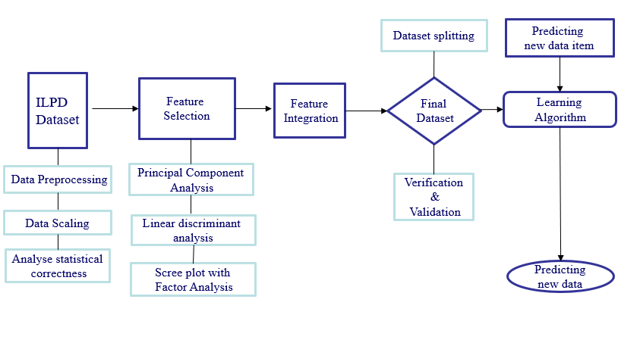 The entire architecture explains the process or the way the Liver Cirrhossis prediction is performed . First collect the data with different types of values that are related to the patients. These data will help us in prediction of liver diseases, the taken data will be processed primarly which includes handling missing data, handling outliers etc. The data which will be handled should be make it as a new data and store it for further implementation.This preprocessing will be done because of accurately gain the results. This is the pre-processing step.

After the data are processed, the sample data i.e., preprocessed data are generated and these are given as the dataset for feature selection this will helps in the dimensionality reduction of the data using some of the reduction techniques like PCA, LDA and FA. These techniques will help in reduce the entire data size which will make easy for us to train the method. After all the data which will be collected and integrate the entire data into one dataset. Now the data will be split as train and testing dataset to make the data validate and verification including cross validation. The cross validation will be performed because of compare the entire performance of the model with other models, this will be done during the model training time only. It will reduce the time complexity due to that we need not to verify the performance again . Now as a further step train some of the machine learning models like logistic regression, random forest, decision tree , support vector machine, MLP and soon, train all the techniques and compare the results with each other. The model which gives higher accurate results will be used in our project and with the help of that model we predict the liver disease. Finally, integrate the entire model with an interface which able to take the input from the user and evalute the model with the user inputs and it predicts the output.This is the entire working process of the model and how we predict the results.

Logistic Regression:Data preparation for liver cirrhosis prediction using logistic regression involves selecting and engineering relevant features such as liver function tests, demographic information, and clinical symptoms. Missing values are handled using imputation methods like mean or median imputation. Continuous features are normalized to ensure their scale does not disproportionately affect model performance, allowing the logistic regression model to perform more effectively and produce reliable predictions. Now train the model using certain **fuctions :**

**Logistic Function :** Logistic regression employs the logistic function (also known as the sigmoid function) to estimate the probability that a given input belongs to a specific class. The logistic function is mathematically represented as: *σ*(*z*)=1+*e*−*z*1​ (3)

where z is the linear combination of input features and their associated weights.

**Linear Combination of Features:** The model computes a weighted sum of the input features:

*z*=*β*0​+*β*1​*x*1​+*β*2​*x*2​+…+*βn*​*xn*​ (4)

where 𝛽0 is the intercept, 𝛽𝑖βi​ are the coefficients for the features 𝑥i  
**Threshold:** The model classifies an input based on a threshold value, typically set at 0.5. If the predicted probability meets or exceeds the threshold, the output is classified as the positive class (e.g., presence of liver cirrhosis). Otherwise, it is classified as the negative class.

**Model Evaluation:** The performance of the model is assessed using metrics such as accuracy, precision, recall, F1 score, and the area under the receiver operating characteristic (ROC) curve (AUC-ROC). These metrics provide a measure of how effectively the model differentiates between patients with and without liver cirrhosis.

**Training Phase**: The model is trained on historical patient data, including various biomarkers, demographic information, and clinical symptoms.

**Prediction Phase**: For a new patient, the trained logistic regression model takes the patient's data as input and outputs the probability of having liver cirrhosis. If the probability exceeds the threshold, the model predicts the presence of cirrhosis.

* Logistic regression is efficient in terms of computation and can be trained rapidly, making it well-suited for handling large datasets.
* Logistic regression generates probabilistic outputs, which are valuable for evaluating prediction uncertainty and making informed medical decisions.
* The model's coefficients help determine the significance of various features in predicting liver cirrhosis, offering critical insights for medical research and understanding disease mechanisms.

1. Sigmoid function

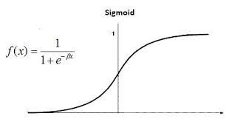

1. Linear combination of features

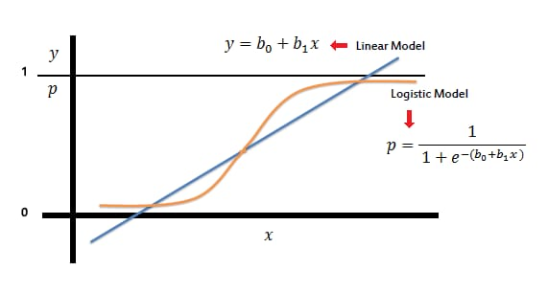

**Cat Boost Classifier:** To predict liver cirrhosis using CatBoost, begin by gathering comprehensive data, including demographic information, medical history, lab results, and imaging data. Clean the dataset to address missing values, outliers, and errors, ensuring high data quality. Enhance the dataset through feature engineering by creating new predictive features. CatBoost simplifies preprocessing by handling categorical features directly. Train the classifier, evaluate its performance, and interpret the results using feature importance analysis to aid early diagnosis and treatment planning for liver cirrhosis.

CatBoost, an open-source boosting library, excels at handling both categorical and numerical features without the need for explicit preprocessing steps like One-Hot Encoding or Label Encoding. Optimized for categorical data, CatBoost eliminates the necessity for preprocessing and efficiently handles categorical variables during training with a specialized algorithm. Its built-in mechanisms for managing missing values and preventing overfitting ensure robust model performance.

It supports various loss functions, making it versatile for classification and regression tasks. CatBoost is scalable, utilizing parallelization techniques for faster training on large datasets. While maintaining model complexity, it offers interpretability through feature importance analysis. Its effectiveness in handling categorical data and efficient training process makes it a popular choice for predictive modeling tasks.

* CatBoost natively supports categorical features, which are common in medical datasets.
* Its unique algorithm helps prevent overfitting, which is crucial for reliable medical predictions.
* Efficient handling of large datasets makes it suitable for extensive medical records.
* Provides tools for feature importance and model interpretation, aiding in understanding the decision-making process.

1. Boosting Classifier

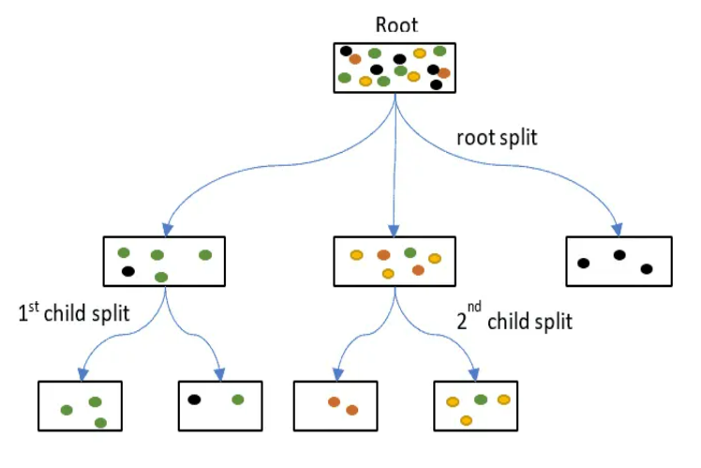

**Support Vector Machine:** Support Vector Machines (SVM) are a versatile machine learning algorithm used for classification tasks, including predicting liver cirrhosis. The process starts with data collection from medical records, clinical tests, and possibly imaging studies, including liver function tests, bilirubin levels, platelet count, albumin levels, and patient history. The data is pre-processed to normalize features, handle missing values and encode categorical variables, ensuring the SVM algorithm works effectively. Feature selection, using techniques like correlation analysis or domain knowledge, identifies the most significant predictors. The dataset is split into testing and training sets, typically 70-80% for training and 20-30% for testing. An appropriate kernel function, often the RBF kernel, is chosen for its ability to handle non-linear relationships. Training involves finding the optimal hyperplane that separates the classes with the maximum margin. The model is evaluated using metrics such as accuracy, sensitivity, specificity, precision, and F1-score. Hyperparameter tuning with grid search or random search and cross-validation ensures good generalization. The trained model predicts liver cirrhosis in new patients, providing a probability score for decision-making. Interpretation of results involves understanding feature contributions, aided by techniques like feature importance scores or SHAP values.

Medical datasets can often be imbalanced (e.g., fewer cirrhosis cases), which might require techniques like SMOTE (Synthetic Minority Over-sampling Technique) to balance the dataset.

SVMs, especially with non-linear kernels, can be less interpretable compared to some other models. This can be mitigated by using model interpretation tools.

* SVM is particularly effective in cases where the number of dimensions is greater than the number of samples.
* SVM uses a subset of training points in the decision function (support vectors), making it memory efficient.
* Proper tuning of hyperparameters can make SVM robust to overfitting, especially in high-dimensional spaces.

1. SVM algorithm

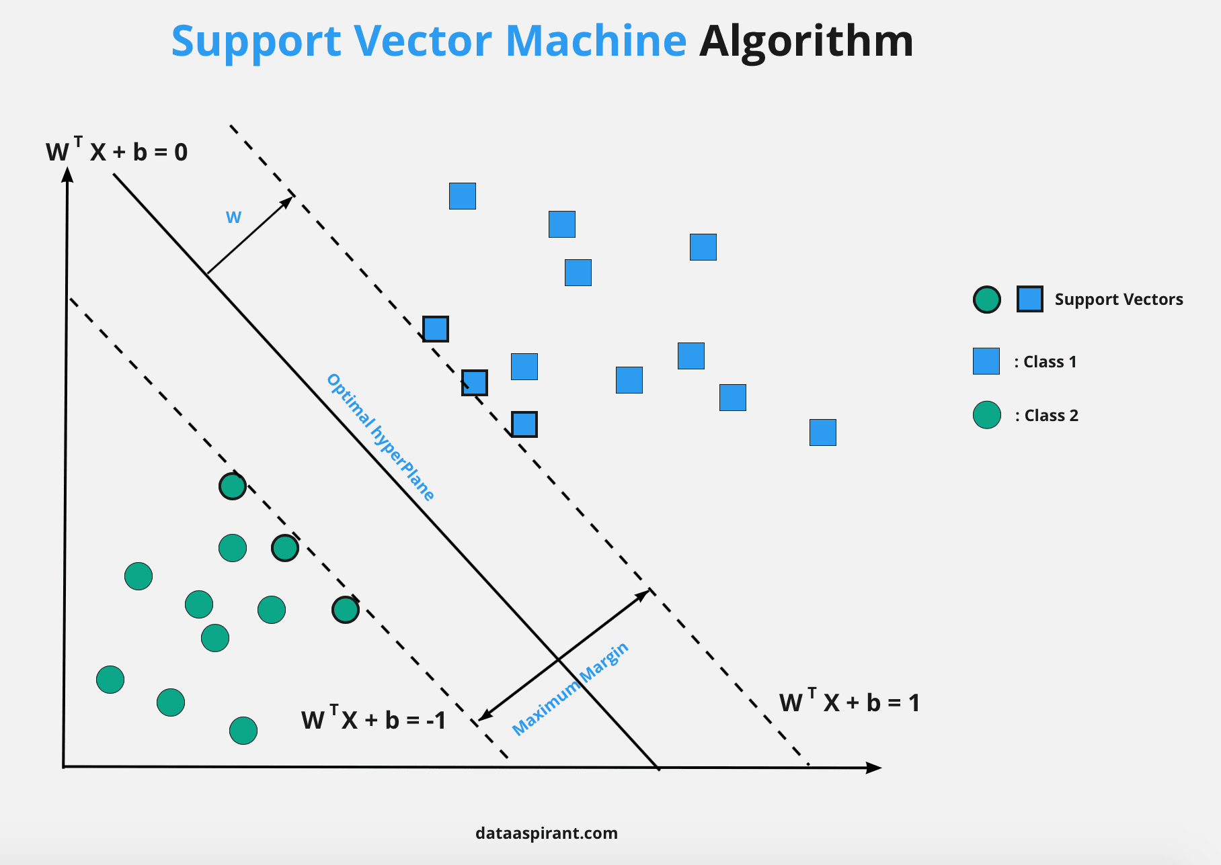

**Histogram Gradient Boosting Classifier:** Histogram Gradient Boosting Classifier is an advanced variant of gradient boosting algorithms that employs histograms to represent feature values. By binning feature values into histograms, it accelerates the split finding process during tree construction, enhancing training speed. A historical gradient boost classifier, particularly in the context of liver cirrhosis prediction, refers to the application of the gradient boosting algorithm using historical medical data to predict the likelihood of liver cirrhosis in patients. Gradient boosting is a powerful machine learning technique that builds an ensemble of decision trees to improve predictive accuracy.

The process of using a historical gradient boost classifier for liver cirrhosis prediction involves several key steps. Initially, historical patient data is collected, including demographic information (age, gender), clinical features (blood test results like ALT, AST, bilirubin, imaging results, symptoms), lifestyle factors (alcohol consumption, smoking status), and medical history (previous liver disease, family history, medications). Feature engineering transforms this raw data into usable features for the gradient boosting model by creating derived features (AST/ALT ratios, MELD scores), handling missing data through imputation techniques, and normalizing features to enhance model performance.

For model selection, a gradient boost classifier from libraries like XGBoost, LightGBM, or scikit-learn's GradientBoostingClassifier is chosen for its ability to manage complex, non-linear relationships and robustness against overfitting. Training the model involves splitting the historical data into training and testing sets. The classifier is trained on the training set, iteratively building an ensemble of decision trees, each correcting errors made by the previous ones, and optimizing a loss function (often logistic loss for binary classification) to improve prediction accuracy.

Model evaluation employs k-fold cross-validation to ensure generalization to unseen data, with performance metrics such as accuracy, recall, precision, area under the curve (AUC) and F1 score assessing predictive power. Interpretation and validation are crucial as the model provides insights into feature importance, revealing which factors are most influential in predicting liver cirrhosis. Clinical validation ensures the model’s predictions align with actual clinical outcomes, enhancing reliability.

Finally, the trained model is deployed for real-time predictions in clinical settings, providing timely assessments for new patients. Continuous learning updates the model with new data regularly, improving its accuracy and adaptability. This comprehensive process ensures that the gradient boost classifier is accurate and reliable for predicting liver cirrhosis, aiding early diagnosis and treatment planning.

* High predictive accuracy due to ensemble learning.
* Feature importance can provide insights into factors contributing to liver cirrhosis.
* Can handle large datasets and complex feature interactions.

Using a historical gradient boost classifier for liver cirrhosis prediction leverages historical medical data and advanced machine learning techniques to provide accurate and reliable predictions, aiding early diagnosis and treatment planning in clinical settings.

1. Histogram Gradient Boost Classifier

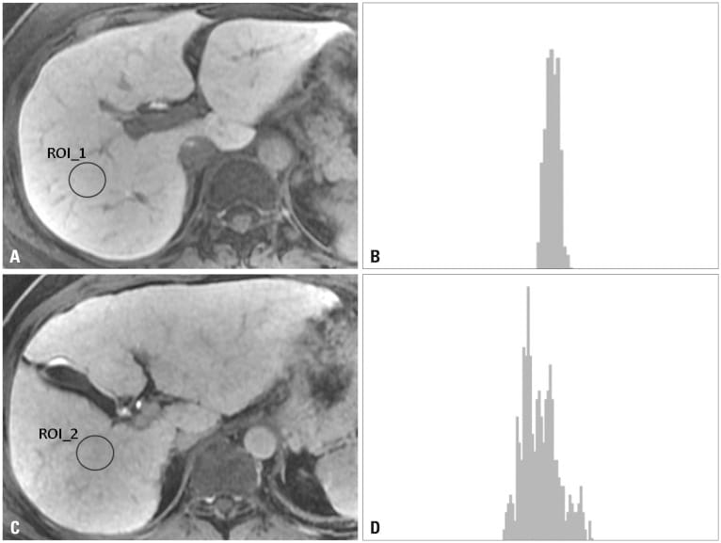

**Decision Trees:** Decision trees are versatile supervised learning algorithms employed for both classification and regression tasks. They divide the feature space into distinct regions based on feature values to create decision rules that predict the target variable. In predicting liver cirrhosis, decision trees can analyze various medical data to assess the likelihood of a patient developing the condition. At each node, the algorithm selects the feature that optimally splits the data, either by maximizing information gain or minimizing impurity. One of the key advantages of decision trees is their interpretability, allowing users to comprehend the rationale behind the predictions.

They can handle numerical and categorical data, making them suitable for a wide range of datasets. However, decision trees are prone to overfitting, especially with complex trees and noisy data. Techniques like pruning, limiting tree depth, and using ensemble methods can mitigate this issue

In the process of predicting liver cirrhosis using decision trees, relevant medical data encompassing demographic details like age and gender, medical history such as alcohol consumption and hepatitis infection, along with laboratory test results and imaging findings are gathered. Subsequently, this data undergoes preprocessing, where missing values are addressed, categorical variables are encoded, and numerical features are scaled if required to render it analytically compatible. Following this, a decision tree algorithm is applied to construct a predictive model, wherein the data is iteratively partitioned into subsets based on the features that most effectively differentiate the classes, namely the presence or absence of liver cirrhosis, recursively generating a tree-like structure. Through model training, a portion of the data is employed to refine the decision tree, optimizing its structure to minimize classification errors until predefined stopping criteria are met. Evaluation of the model's performance is then conducted using a separate dataset not utilized during training, employing metrics like accuracy, precision, recall, and F1-score. Once trained and evaluated, the decision tree model becomes capable of predicting the likelihood of liver cirrhosis development in new patients by analyzing their medical data and traversing the decision tree to assign a class label. One notable advantage of decision trees lies in their interpretability, allowing clinicians to readily discern the decision rules and thereby gain insights into the factors most influential in predicting liver cirrhosis.

Decision trees provide easily interpretable rules for prediction. Clinicians can understand the decision-making process of the model, making it easier to trust and incorporate into clinical practice.

Decision trees inherently rank the importance of features in predicting liver cirrhosis. This can help identify key factors contributing to the disease, providing valuable insights for medical research and decision-making.

Decision trees can handle missing values in the data without requiring imputation. They simply use available features for decision-making at each node, making them robust to missing data.

1. Decision tree algorithm

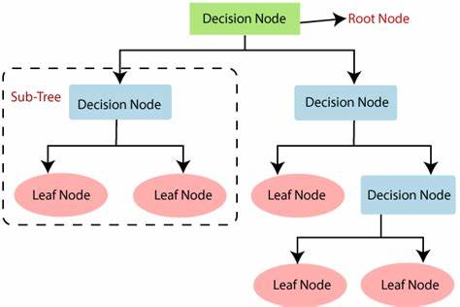

1. RESULTS

In the realm of healthcare, the liver's multifaceted role in human physiology cannot be overstated, with over 500 organic functions vital for maintaining overall health. Consequently, any malfunction within this crucial organ can pose significant risks, potentially leading to severe consequences, including fatality. Early detection and prompt treatment of liver diseases are paramount to improving patient outcomes and increasing the likelihood of survival. Recognizing the importance of timely diagnosis, researchers have increasingly turned to advanced technologies such as machine learning (ML) to assist healthcare professionals in the diagnostic process.

In the context of liver disease diagnosis, ML offers a powerful toolset that encompasses various stages, including data pre-processing, feature extraction, and classification. One common challenge in feature extraction is the removal of data redundancy to extract significant features accurately. Traditional projection-based approaches have often fallen short in achieving the desired results. Additionally, existing statistical projection methods may serve different purposes when projecting original features, adding complexity to the feature extraction process.

To address these challenges, this study proposes an integrated feature extraction approach tailored for the classification of liver diseases. Leveraging the Indian Liver Patient Dataset (ILPD) from the University of California, Irvine (UCI) repository, which comprises 583 patient records, the proposed method aims to enhance the accuracy and reliability of liver disease classification. The methodology entails a comprehensive pipeline, beginning with the pre-processing of data to handle missing values and outliers effectively.

Subsequently, the integrated feature extraction method is applied to extract significant features crucial for accurate classification. The study incorporates various ML algorithms, including random forest, logistic regression, Support Vector Machine, k-nearest neighbor, ensemble voting classifier and Multilayer perceptron (MLP). By employing this diverse set of algorithms, the proposed system aims to maximize classification performance and robustness. Contributing to more effective healthcare delivery in the realm of liver disease management.

1. Results of proposed method

|  |  |
| --- | --- |
| **Method** | **Accuracy** |
| Logistic Regreesion | 76.99% |
| Random Forest | 76.99% |
| SVM | 71.68% |

The results demonstrate the efficacy of the proposed approach, with an accuracy of 88.10%, precision of 85.33%, recall of 92.30%, F1 score of 88.68%, and AUC score of 88.20% in predicting liver diseases. Notably, the proposed system outperforms existing studies, achieving improvements ranging from 0.10% to 18.5%. These findings underscore the potential of ML-based approaches in complementing physicians' diagnostic capabilities, thereby facilitating early detection and intervention in liver disease cases. Ultimately, the proposed system holds promise in enhancing patient outcomes .

1. Comparison between different models

|  |  |
| --- | --- |
| **Model** | **Accuracy** |
| Proposed Logistic Regression | 76.99% |
| Random forest classifier | 76.99% |
| SVM | 71.68% |
| KNN | 72.57% |
| Gradient Boosting Classifier | 71.68% |
| Decision Tree Classifier | 70.80% |
| XgBoost | 71%.68 |

1. CONCLUSION

Looking ahead, the future scope for leveraging machine learning in liver disease diagnosis and treatment is vast and diverse. Efforts will focus on refining machine learning algorithms tailored for liver disease classification, potentially exploring advanced techniques like deep learning or ensemble methods to enhance accuracy and efficiency. Moreover, integrating additional datasets and diverse patient demographics could enrich model training, fostering the development of more inclusive and generalizable diagnostic tools. Collaborative initiatives aimed at collecting larger and more comprehensive datasets from diverse populations will be crucial, laying the foundation for more effective diagnostic approaches.

Beyond diagnosis, future studies will explore machine learning applications in prognosis and treatment planning. Predictive modeling could forecast disease progression and identify personalized treatment strategies by integrating clinical, genetic, and lifestyle data. However, addressing regulatory and ethical challenges surrounding data privacy and model interpretability remains paramount. Through interdisciplinary collaboration and responsible deployment, the integration of machine learning into clinical practice promises to revolutionize liver disease management, ultimately improving patient outcomes and quality of life.

REFERENCES

[1] Amin, R., Yasmin, R., Ruhi, S., Rahman, M. H., & Reza, M. S. (2023). Prediction of chronic liver disease patients using integrated projection based statistical feature extraction with machine learning algorithms. Informatics in Medicine Unlocked, 36, 101155.

[2] Xing, Y., Tian, Z., Jiang, Y., Guan, G., Niu, Q., Sun, X., ... & Jing, X. (2022). A practical nomogram based on systemic inflammatory markers for predicting portal vein thrombosis in patients with liver cirrhosis. Annals of Medicine, 54(1), 302-309.

[3] Lv, Y., Wang, Z., Li, K., Wang, Q., Bai, W., Yuan, X., Yu, T., Niu, J., Yang, Z., Zhu, X., Zhao, J., Xue, H., Jiang, Z., Zhuge, Y., Zhang, C., Sun, J., Ding, P., Ren, W., Li, Y., Zhang, K., Zhang, W., Guo, W., Luo, B., Li, X., Yuan, J., Han, N., Zhu, Y., He, C., Yin, Z., Fan, D. and Han, G. (2021), Risk Stratification Based on

[4] Mayo, M. J., Parkes, J., Adams‐Huet, B., Combes, B., Mills, A. S., Markin, R. S., ... & Rosenberg, W. M. (2008). Prediction of clinical outcomes in primary biliary cirrhosis by serum enhanced liver fibrosis assay. Hepatology, 48(5), 1549-1557.

[5] Åberg, F., Danford, C. J., Thiele, M., Talbäck, M., Rasmussen, D. N., Jiang, Z. G., ... & Hagström, H. (2021). A dynamic aspartate‐to‐alanine aminotransferase ratio provides valid predictions of incident severe liver disease. Hepatology communications, 5(6), 1021-1035.

[6] Huo, T. I., Lee, S. D., & Lin, H. C. (2008). Selecting an optimal prognostic system for liver cirrhosis: the model for end‐stage liver disease and beyond. Liver International, 28(5), 606-613.

[7] Huo, T. I., Lin, H. C., Huo, S. C., Lee, P. C., Wu, J. C., Lee, F. Y., ... & Lee, S. D. (2008). Comparison of four model for end‐stage liver disease–based prognostic systems for cirrhosis. Liver Transplantation, 14(6), 837-844.

[8] Shalimar, Elhence, A., Vaishnav, M., Kumar, R., Pathak, P., Soni, K. D., ... & Garg, P. (2020). Poor outcomes in patients with cirrhosis and Corona Virus Disease-19. Indian Journal of Gastroenterology, 39, 285-291

[9] Gaduputi, V., Abdulsamad, M., Sakam, S., Abbas, N., Tariq, H., & Ihimoyan, A. (2014). Systemic vascular resistance in cirrhosis: a predictor of severity?. Hepatic Medicine: Evidence and Research, 95-101.

[10] Ahmed, Z., Ren, J., Gonzalez, A., Ahmed, U., Walayat, S., Martin, D. K., ... & Dhillon, S. (2018). Universal Index for Cirrhosis (UIC index): The development and validation of a novel index to predict advanced liver disease. Hepatic Medicine: Evidence and Research, 133-138.

[11] Kanwal, F., Kramer, J. R., Li, L., Dai, J., Natarajan, Y., Yu, X., ... & El‐Serag, H. B. (2020). Effect of metabolic traits on the risk of cirrhosis and hepatocellular cancer in nonalcoholic fatty liver disease. Hepatology, 71(3), 808-819

[12] Yoshiji, H., Nagoshi, S., Akahane, T., Asaoka, Y., Ueno, Y., Ogawa, K., ... & Koike, K. (2021). Evidence-based clinical practice guidelines for liver cirrhosis 2020. Journal of gastroenterology, 56(7), 593-619.

[13] Kanwal, F., Kramer, J. R., Li, L., Dai, J., Natarajan, Y., Yu, X., ... & El‐Serag, H. B. (2020). Effect of metabolic traits on the risk of cirrhosis and hepatocellular cancer in nonalcoholic fatty liver disease. Hepatology, 71(3), 808-819.

[14] Noureddin, Mazen, et al. "Machine learning liver histology scores correlate with portal hypertension assessments in nonalcoholic steatohepatitis cirrhosis." Alimentary Pharmacology & Therapeutics 57.4 (2023): 409-417.

[15] Yoshiji, H., Nagoshi, S., Akahane, T., Asaoka, Y., Ueno, Y., Ogawa, K., ... & Koike, K. (2021). Evidence-based clinical practice guidelines for liver cirrhosis 2020. Journal of gastroenterology, 56(7), 593-619.

[16] Pasyar, P., Mahmoudi, T., Kouzehkanan, S. Z. M., Ahmadian, A., Arabalibeik, H., Soltanian, N., & Radmard, A. R. (2021). Hybrid classification of diffuse liver diseases in ultrasound images using deep convolutional neural networks. Informatics in Medicine Unlocked, 22, 100496

[17] Lv, Y., Wang, Z., Li, K., Wang, Q., Bai, W., Yuan, X., Yu, T., Niu, J., Yang, Z., Zhu, X., Zhao, J., Xue, H., Jiang, Z., Zhuge, Y., Zhang, C., Sun, J., Ding, P., Ren, W., Li, Y., Zhang, K., Zhang, W., Guo, W., Luo, B., Li, X., Yuan, J., Han, N., Zhu, Y., He, C., Yin, Z., Fan, D. and Han, G. (2021.

[18] Singh, J., Bagga, S., & Kaur, R. (2020). Software-based prediction of liver disease with feature selection and classification techniques. Procedia Computer Science, 167, 1970-1980.

[19] Taylor‐Weiner, Amaro, et al. "A machine learning approach enables quantitative measurement of liver histology and disease monitoring in NASH." Hepatology 74.1 (2021): 133-147.

[21] Tapper, E. B., & Parikh, N. D. (2018). Mortality due to cirrhosis and liver cancer in the United States, 1999-2016: observational study. bmj, 362

[22] Bhat, Mamatha, et al. "Artificial intelligence, machine learning, and deep learning in liver transplantation." Journal of hepatology 78.6 (2023): 1216-1233.

[20] Rahman, A. Sazzadur, et al. "A comparative study on liver disease prediction using supervised machine learning algorithms." International Journal of Scientific & Technology Research 8.11 (2019): 419-422.

[23 Huo, T. I., Lin, H. C., Huo, S. C., Lee, P. C., Wu, J. C., Lee, F. Y., ... & Lee, S. D. (2008). Comparison of four model for end‐stage liver disease–based prognostic systems for cirrhosis. Liver Transplantation, 14(6), 837-844.

[24] Shalimar, Elhence, A., Vaishnav, M., Kumar, R., Pathak, P., Soni, K. D., ... & Garg, P. (2020). Poor outcomes in patients with cirrhosis and Corona Virus Disease-19. Indian Journal of Gastroenterology, 39, 285-291

[25] Huo, T. I., Lee, S. D., & Lin, H. C. (2008). Selecting an optimal prognostic system for liver cirrhosis: the model for end‐stage liver disease and beyond. Liver International, 28(5), 606-616.