**ASSESSING THE CONTRIBUTION OF SUPPLY CHAIN MANAGEMENT TO ORGANIZATIONAL PERFORMANCE IMPROVEMENT**

Imran Khan A1 Dr. Mohan Lal Dhaka2

1Research Scholar 2 Research Guide

Department of Management

NIILM University, Kaithal (Haryana)

**Abstract:**

Effective supply chain management (SCM) has emerged as a potentially valuable strategy for enhancing organizational performance and securing a competitive advantage in an era where competition is increasingly confined to supply chains rather than between organizations. Five dimensions of SCM practice strategic supplier partnership, customer relationship, level of information sharing, quality of information sharing, and postponement are conceptualized and developed in this study, which also examines the connections between SCM practices, organizational performance, and competitive advantage. An increased degree of SCM implementation may result in enhanced organizational performance and a heightened competitive advantage. Additionally, competitive advantage can positively and directly affect the performance of an organization.

**Keywords:** Cost reduction, Inventory optimization, Customer satisfaction.

**Introduction:**

In the 1990s, as markets became more global and competition increased, so did the difficulties associated with delivering a product or service to the appropriate location at the appropriate time while minimizing expenses. Organizations started to understand that merely increasing internal efficiencies is insufficient; rather, they must ensure that their entire supply chain is competitive. A comprehension and implementation of supply chain management (SCM) have evolved into critical requirements for maintaining profitability and competitiveness in the global marketplace.   
SCM is defined by the Council for Logistics Management (CLM) as the methodical and strategic synchronization of conventional business operations and strategies across organizations and businesses within the supply chain in order to enhance the supply chain's and organizations' long-term performance. Strategic coordination between trading partners is an element that has been explicitly acknowledged in the definition of SCM. Additionally, the definition elucidates the dual objective of SCM, which is to enhance the performance of both individual organizations and the entire supply chain. Information and material transfers must be seamlessly integrated throughout the supply chain for SCM to function as an effective competitive weapon. There has been a growing interest among academics, consultants, and business administrators in the notion of SCM. In an increasingly congested marketplace, numerous organizations have begun to recognize that SCM is the key to establishing a sustainable competitive advantage for their products and/or services. Diverse academic disciplines—including purchasing and supply management, logistics and transportation, operations management, marketing, organizational theory, and management information systems—have examined the SCM concept from a variety of perspectives. Specific facets or vantage points of SCM have been illuminated by a variety of theories, including industrial organization and transaction cost analysis. competitive strategy, resource-based and resource-dependency theory, and a sociopolitical viewpoint.

Notwithstanding the heightened focus on SCM, the existing body of literature has failed to provide substantial guidance to support the implementation of SCM. The conceptual confusion, interdisciplinary origin, and evolutionary nature of the SCM concept have been identified as contributing factors to this phenomenon. In the literature, there is no generally acknowledged definition of SCM. Two distinct avenues have contributed to the development of the SCM concept: purchasing and supply management, and transportation and logistics management. From the standpoint of purchasing and supply management, SCM is equivalent to the integration of a supply base, which originated from the conventional functions of purchasing and materials. SCM, which is synonymous with integrated logistics systems from the standpoint of transportation and logistics management, concentrates on inventory reduction across and within organizations comprising the supply chain. These two viewpoints ultimately merged to form an integrated SCM that coordinates every activity throughout the supply chain.

The complexity and evolutionary character of SCM are also reflected in SCM research. A significant portion of the existing theoretical and empirical investigations in supply chain management (SCM) are limited to the upstream or downstream sectors, or specific facets and perspectives of SCM. Aspects including supplier involvement, supplier selection, and manufacturing performance; the impact of supplier alliances on the organization; supplier management orientation and supplier/buyer performance; and the significance of supplier relationships in enhancing supplier responsiveness. Consider the connections that exist downstream between manufacturers and retailers. A limited number of recent studies have concurrently examined the upstream and downstream components of the supply chain. Examine supplier evaluation practices and SCM in relation to firm performance; devise a conceptual-level instrument to assess supply chain orientation and SCM; and the literature is replete with case studies of successful SCM implementations. Collectively, these studies exemplify endeavors to examine a wide range of intriguing yet varied facets of SCM practices. Nonetheless, the lack of a comprehensive framework that integrates all supply chain activities (upstream and downstream) and establishes a connection between these activities and organizational performance and competitive advantage undermines the applicability of prior findings on supply chain management.

Consequently, the objective of this research endeavor is to empirically validate a framework that delineates the connections between SCM practices, competitive advantage, and organizational performance. SCM practices encompass the collection of endeavors performed by an entity with the intention of fostering efficient administration of its supply chain. It is suggested that SCM practices comprise a multidimensional concept that encompasses both the upstream and downstream segments of the supply chain. Empirical testing is conducted on operational measures for the constructs, utilizing data obtained from participants of a survey questionnaire. By employing structural equation modeling, the hypothesized relationships are examined. By addressing SCM practices simultaneously from both the upstream and downstream sides of a supply chain, it is anticipated that the current research will enable researchers to examine the antecedents and consequences of SCM practice and aid in the comprehension of the scope and activities associated with SCM. Moreover, this research is anticipated to present empirical evidence of the influence of SCM practices on an organization's performance and competitive advantage, in addition to a validated instrument for measuring SCM practices. Moreover, it is anticipated that this study will facilitate further research in this field and furnish valuable guidance for measuring and implementing SCM practices within an organization.

**Objectives of the study:**

1. Analyze and reflect on the extent to which selected infrastructure megaprojects' SCM practices impact organizational performance.
2. Examine and assess the extent to which selected infrastructure Uber initiatives have a competitive advantage over organizational performance.

**Research framework:**

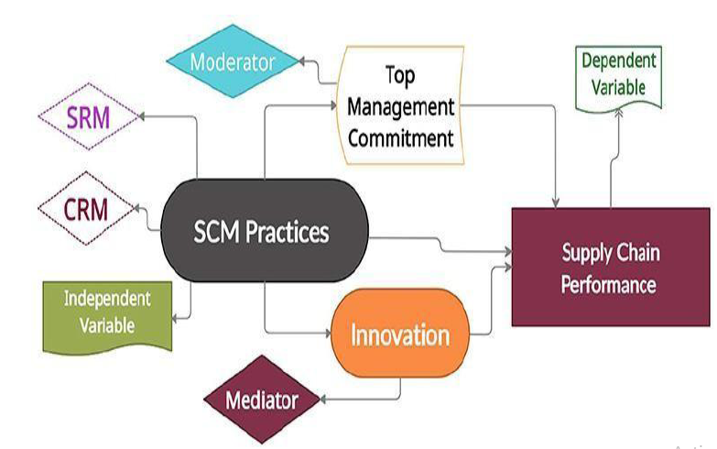

In this investigation, the SCM system depicted in the figure above was developed. The framework indicates that SCM practices will have an impact on hierarchical execution, both explicitly and implicitly via the upper hand. The SCM methodology is defined as a five-dimensional structure. Key provider organization, client relationship, extent of data sharing, nature of sharing of details, and postponement are the five metrics. In the following paragraphs, the evolution of the SCM practice construct is described in detail. The concepts of organizational performance and competitive advantage have been operationalized in the current body of literature. Using literature review assistance, the predicted relationships between SCM activities, competitive advantage, and organizational performance are investigated, and theories concerning these variables are developed.

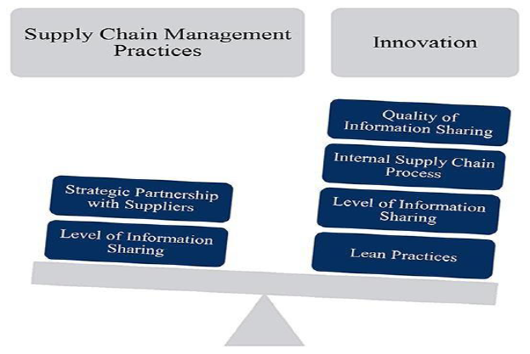

**Figure below represents the theoretical framework of supply chain management practices:**

**Supply chain management and value creation:**

Administration of the Supply Chain and Value Creation SCM Management oversees and directs the activities of businesses from the upstream to the downstream. This pertains to the aspect of management. SCM is primarily concerned with material integration and management. Purchasing, transferring, and regulating across multiple supplier levels and roles from the perspective of the entire system Supply chain management (SCM) has recently shifted its emphasis from production efficiency to customer-driven and cooperation synchronization techniques with the aim of improving the order fulfilment process. It is critical to optimize the overall value produced by supply chains (SCs). Concentrating on a limited portion of the SC's value deters dedication to maximizing chain benefit and reduces the SC's overall profitability. Such a situation hinders the SC from fulfilling its responsibility to deliver value to customers and establish sustainable value for all its stakeholders.

**Appropriate chain rules and participation:**

Over the past three decades or longer, the economic sector has experienced considerable turmoil and instability. The dynamic presence of product components, shifting customer preferences, and globalization of the market, according to Park et al. (2010), have elevated the significance of supply chain performance as a critical determinant of a company's competitive advantage. As a result, numerous businesses have adopted organizational structures such as partnerships, networks, and supply chains, which now support vital organizational entities in a variety of industries. Presently, approaches to SCM are influenced by either the cooperative paradigm or the competitive paradigm. Adam Smith's beliefs underpin the concept of competition, which is predicated on the notion that individuals act to maximize their own benefit. The competitive model is predicated on the notion that inter-firm interdependencies create a zero-sum game environment. This implies that the demise of one actor is exacerbated by the success of another. Businesses can gain a competitive advantage in two ways: first, by assuming a favorable market position; and second, by recognizing and capitalizing on their fundamental capabilities to deliver exceptional products and services. All participants in the supply chain—upstream, midstream, and downstream operations—are permitted and benefit from competition. Several other perspectives that are acknowledged in the field of management studies, such as co-evolution, co-creation, and the responsibilities of producers and consumers, associate value creation with cooperation on a regular basis. hold the view that prioritizing long-term, constructive partnerships and business progress is essential. These studies all agree that SCM techniques influence SC performance, despite the fact that their methodologies differ. Performance, value development, and SCM techniques have been the subject of an abundance of research. As an illustration, the findings demonstrated that knowledge sharing, internal consolidation, and delaying supply chain operations all have substantial and positive effects on the performance and productivity of the supply chain. Elevated levels of supply chain management (SCM) practice may additionally confer a competitive advantage and enhance performance for an organization. Although there is substantial evidence linking supply chain activities with supply chain success, supply chain strategy is a considerably less reliable indicator of SCM performance.

**Organizational performance:**

The degree to which a business attains its financial and market-oriented objectives is a significant determinant of its overall success. SCM's principal short-term objectives are inventory reduction and increased productivity. Long-term objectives for each supply chain participant include increasing market share and revenue, in addition to reducing cycle time.

Financial metrics have been employed to assess the performance of entities in comparison to one another and to monitor their evolution. Supply chain management merely serves as an illustration of how initiatives undertaken by an organization can ultimately lead to enhanced operational effectiveness. A number of previous research studies have assessed an organization's performance by considering financial and market indicators, including return on investment (ROI), market share, profit margin on sales, growth in sales, expansion of market share, and overall competitive position.

**Conclusion:**

This research provides empirical validation for a theoretical framework that delineates the five fundamental constituents of supply chain management (SCM) strategies and elucidates the relationship among SCM strategies, organizational performance, and competitive advantage. It examines three research questions: (1) do organizations that implement SCM practices at a high level experience high levels of organizational success? (2) do organizations that implement SCM practices at a high level also experience high levels of competitive advantage? and (3) do high-performing organizations also exhibit high levels of organizational performance? In order to examine these obstacles, a thorough, precise, and reliable instrument for evaluating SCM processes has been created. Strictly evaluated. This study substantiates the philosophical and prescriptive assertions made in the literature regarding the advantages of SCM methods through the use of empirical data. This study substantiates the philosophical and prescriptive assertions made in the literature regarding the advantages of SCM methods through the use of empirical data. The instrument was assessed using statistical tests, including second-order construct validation, discriminant validity, and convergent validity.

**References:**

1. Child house P, Twill DR. Simplified material flow holds the key to supply chain integration. OMEGA 2003;31(1):17–27.
2. Moberg CR, Cutler BD, Gross A, Speh TW. Identifying antecedents of information exchange within supply chains. International Journal of Physical Distribution and Logistics Management 2002;32(9):755–70.
3. Power DJ, Sohal A, Rahman SU. Critical success factors in agile supply chain management: an empirical study. International Journal of Physical Distribution and Logistics Management 2001;31(4):247–65.
4. Tan KC, Lyman SB, Wisner JD. Supply chain management: a strategic perspective. International Journal of Operations and Production Management 2002;22(6):614–31.
5. Council of Logistics Management. What it’s all about. Oak Brook: CLM, 2000. [6] Feldmann M, Müller S. An incentive scheme for true information providing in supply chains.
6. OMEGA 2003;31(2):63–73.
7. M. Feldmann et al. An incentive scheme for true information providing in supply chains OMEGA (2003)
8. S. Croom et al. Supply chain management analytical framework for critical literature review European Journal of Purchasing and Supply Management (2000).
9. http://www.supply-chain.org/
10. https://www.frontiersin.org/journals/publichealth/articles/10.3389/fpubh.2022.813828/full#h3
11. .https://www.frontiersin.org/journals/publichealth/articles/10.3389/fpubh.2022.813828/full#h3