**Review on Selpercatinib: A Narrative Drug**

**Author :-Ms. Sarika S.Lokhande\***

**Sarikalokhande646@gmail.com**

**College Name :-Loknete Dadapatil Pharate College of Pharmacy.Pune**

**Abstract-**

Rearranged during transfection (RET) alteration promotes oncogenesis in a few cancers. RET mutation positivity is seen in approximately 70% of medullary thyroid cancers, around 30% of differentiated papillary thyroid cancers, and 1-2% of non-smallcell lung cancers (NSCLC). To write this narrative drug review, we searched various websites like the United States Food and Drug Administration, PubMed, Google Scholar, UpToDate, and recently published papers in various international conferences using the search terms “RET,” “RET alteration,” “Retevmo,” “RET inhibitors,” and “selpercatinib.” We shortlisted 31 articles published between January 1980 and January 2024. We discuss the history, mechanism of action, resistance, pharmacodynamics, pharmacokinetics, dosing, toxicity, pivotal trials, and indications of selpercatinib. Selective RET inhibitors like selpercatinib are indicated in the treatment of RET‑altered NSCLC and thyroid cancer.

**Keywords:** Medullary thyroid, non-small-cell lung cancer, papillary thyroid, *RET* inhibitors, *RET* proto‑oncogene, selpercatinib

**Introduction**

As per the Global Cancer Observatory 2020 data, lung cancer ranks second in incidence after breast cancer. There are 2,206,771 (11.4%) new cases of lung cancer and 586,202 (3%) thyroid cancers reported worldwide.[1] In the era of genetic testing and precision medicine, the molecular profile of the tumor helps guide therapeutic decisions. Rearranged during transfection (*RET*) mutations are present in approximately 20-30% of sporadic variants of papillary thyroid carcinoma, 70% of the medullary variant of thyroid cancer, and 1-2% of non-small-cell lung cancer (NSCLC).[2,3]

Approximately 66% of patients with advanced‑stage NSCLC are treated with palliative chemotherapy, which prolongs survival and improves quality of life.[4] Molecular targets in cancer have evolved over the last decade, and the use of tissue‑agonistic therapies for patients has resulted in better survival with drugs that target a particular mutation or alteration.[5] RET is a tyrosine kinase receptor coded by a proto‑oncogene, whose locus is situated on chromosome 10 (10q11.21). Alterations in the *RET* gene, like mutations and fusions, are implicated in lung and thyroid cancers.[2,3] Gene fusions are more common in patients with papillary thyroid cancer, accounting for 20%, while point mutations are more common in patients with the sporadic variant of medullary thyroid cancer.[6] In advanced or metastatic NSCLC and papillary

thyroid cancers, patients who harbor *RET* alterations are often young, never‑smokers with small primary tumors, and carry extensive lymph nodal burden.[7] *RET* positivity in patients with medullary thyroid cancer can be both hereditary and somatic. Hereditary *RET* mutation is seen in multiple endocrine neoplasia type 2, and somatic *RET* mutation is associated with *RET* M918T mutation. Somatic *RET* mutations are associated with a more aggressive clinical

presentation (high tumor and nodal burden) compared to hereditary *RET* mutations in papillary thyroid cancer.[7]

However, patients harboring *RET* mutation and medullary thyroid cancer have a similar disease presentation as those with wild‑type *RET*, except for an early age at presentation.[8]

Advancements in diagnostic approaches like next‑generation sequencing (NGS) in lung cancer have resulted in the identification of a unique subset of *p*atients harboring *RET* mutations*,* constituting 0.6% of the total pool of patients with various cancers tested globally for molecular alterations, who were predominantly women and never‑smokers.[9,10]

Multikinase inhibitors like alectinib, vandetanib, regorafenib, and cabozantinib are known to block the RET receptor; however, they have failed to result in meaningful antitumor activity, given their non-specific target interactions. In recent years, novel small molecules and highly selective RET inhibitors like selpercatinib and pralsetinib have been developed.[11] In this review, we discuss the clinical indications, adverse effects, safety, pharmacodynamics, pharmacokinetics, and the key research trials that have investigated the use of selpercatinib, as well as certain practical aspects concerning drug administration and mitigationm, and management of toxicities.

**Mechanism**

While preparing this drug review, we searched PubMed and Google Scholar from January 1980 to January 2024. Due to the paucity of data, we also searched the United States Food and Drug Administration (US-FDA) database and the UpToDate website. Abstracts published at the annual meetings (2020- 2023) of the American Society of Clinical Oncology and the European Society for Medical Oncology were included. Out of 167 articles, 84 were shortlisted as they included a discussion of *RET* proto‑oncogene and selpercatinib in their abstract and/or title. We excluded 53 articles, as they were either reviews of research data, duplications, or reiteration

of the data presented in the drug manuals or the official FDA label. Finally, we included 31 articles in the drug review. We included only the trials that were completed with published

data in the discussion; we tabulated the upcoming trials that have been registered and those that are currently recruiting.

**MECHANISM OF ACTION**

RET is a receptor tyrosine kinase whose activity is needed for normal renal and neuronal embryonal development. It consists of three structural components: extracellular,

transmembrane, and intracellular.[16‑18] Chromosomal rearrangements in the *RET* locus produce 5’ fusions of dimerizable domains to the 3’ *RET* tyrosine kinase domain,

resulting in products like KIF5B‑RET and CCDC6‑RET, leading to the activation of downstream pathways through autophosphorylation.[19‑21]

Selpercatinib is a selective RET inhibitor with half‑maximal inhibitory concentration (IC50) values ranging from 0.9-67.8 nanomolar (nM) concentration, depending on the specified

genotype like wild‑type *RET* or the various mutated *RET* isoforms.

Molecular studies have shown that selpercatinib directly inhibits RET by causing competitive inhibition at the adenosine triphosphate‑binding site, thus preventing its phosphorylation.[22] At clinically relevant doses, selpercatinib also acts as a multikinase inhibitor, exerting its action on the vascular epithelial growth factors 1 and 2 (VEGFR‑1, VEGFR‑2) and the fibroblast growth factor receptors (FGFR1, FGFR2, FGFR3) as depicted in Figure 2.

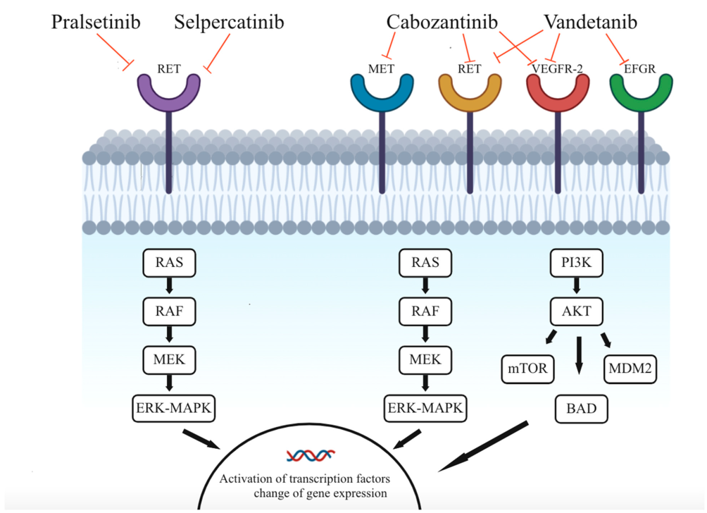

**Figure 2: Mechanism of action of selpercatinib. The mechanisms of action of pralsetinib, selpercatinib, cabozantinib, and vandetanib via inhibition of different receptors and their respective intracellular cascades. (This image was reproduced with permission from the paper by Wang *et al*.[22]). AKT = Protein kinase B, BAD = BCL2‑associated agonist of cell death, EFGR = Epidermal growth factor receptor, ERK = Extracellular regulated kinase, MAPK = Mitogen-activated protein kinase, MDM2 = Mouse double minute 2 homolog, MEK = Mitogen-activated protein kinase kinase‑1, MET = Tyrosine‑protein kinase MET or hepatocyte growth factor receptor, mTOR = Mammalian target of rapamycin, PI3K = Phosphoinositide 3 kinases, RAF = Rapidly accelerated fibrosarcoma, RAS = Rat sarcoma, RET = Rearranged during transfection, VEGFR‑2 = Vascular epithelial growth factor 2**

**MECHANISM OF RESISTANCE**

Mesenchymal-epithelial transition (*MET*) gene amplification has been identified as a cause of both primary and secondary resistance. Upon analyzing a small series of patients with *RET*‑altered tumors that were refractory to selpercatinib, it was hypothesized that existing *MET* amplification caused intrinsic tumor resistance to novel RET‑targeted therapies.[23]

Selpercatinib employs a novel binding mode that occupies both the front and back pockets, involving the active cleft of RET tyrosine kinase.[24] Resistance is acquired by the activation of the non‑gatekeeper mutations that interfere with the target and its corresponding binding site, leading to secondary resistance. RET protein has a solvent front site, where acquired mutations arise, such as G810C and G810S, as a result of prior usage of tyrosine kinase inhibitors. This leads to the substitution of heavy residues at the solvent front, causing difficulty in binding selpercatinib at these sites.[25]

**PHARMACOKINETICS**

The area under the concentration-time curve and maximum clearance (Cmax) of selpercatinib were studied with dose increments from 20-240 mg twice daily. Steady levels were achieved at an average of 7 days following the initiation at all the sequential increment levels from 20-240 mg. The median accumulation ratio was 3.4 when consuming capsules of 160 mg twice a

day orally.[26]

Selpercatinib is majorly metabolized in the liver by the cytochrome p450 family 3A4 (CYP3A4) enzyme mechanism, and the mean bioavailability documented in various studies is 73%.[14] No difference in bioavailability was noted when selpercatinib was taken along with a high‑fat meal versus a normal meal. The volume of distribution was around 191 L and had an apparent clearance of 6 L/h; both volume of distribution and clearance increased with an increase in

body weight.

After a single oral radiolabeled dose of 160 mg in healthy individuals, a significant portion of the drug remained unchanged, 69% was recovered in the feces, and 24% of

radioactivity was found in the urine.[27] broken, crushed, or chewed. No replacement is needed for a missed dose. If vomiting occurs after taking the capsule, do not rechallenge with an extra dose.[28]

**WARNING AND PRECAUTIONS[29]**

1. Serious hepatic adverse events can occur; baseline and frequent monitoring of liver enzymes like aspartate transaminase and alanine transaminase are recommended.

2. Drug‑induced hypertension can occur; it can be controlled with antihypertensive medication and frequent monitoring.

3. Risk of QT interval prolongation (extended interval between the Q and T segments on the electrocardiogram) can occur; therefore, an electrocardiogram, serum electrolyte levels, and thyroid profile should be assessed at baseline and regularly during treatment.

4. Life‑threatening hemorrhagic events can occur; in case of any such events, the drug should be permanently stopped.

5. In case of a hypersensitivity reaction, monitor for fever, rash, joint pains, or muscle sores. If

hypersensitivity is reported, withhold the drug and begin prednisolone (corticosteroids) at a dose of 1 mg/kg.

6. In case of scheduled surgical procedures, discontinue selpercatinib 7 days before the procedure and restart only after adequate wound healing.

7. Caution is advised with a high index of suspicion for tumor lysis syndrome in patients with medullary thyroid cancer when starting selpercatinib; stratify and start prophylaxis as per the tumor burden and other comorbidities and associated risk factors.

8. Growth retardation can occur in children and adolescents, especially with open epiphyses. In case of severe growth issues, interrupt the treatment schedule and restart once the growth has stabilized.

9. During therapy, clinicians should monitor for dry cough and fever. Early evaluation and management are recommended to recognize interstitial lung disease. In case of life‑threatening pneumonitis, stop the drug.

10. May cause hypothyroidism, especially in patients with thyroid cancer. Monitor the thyroid function tests at baseline, and as required. Replacements of thyroid supplements are needed if hypothyroidism is diagnosed during selpercatinib therapy. If the hypothyroid state persists after replacement, discontinue the drug permanently.

**SPECIAL SITUATIONS**

1. **Pregnancy:** Not to be used in pregnant women, given the risk of teratogenicity observed in animal studies.

2. **Lactation:** Not advised for lactating mothers as the drug can be secreted in breast milk for at least 14 days post‑consumption of the last capsule.

3. **Pediatric population:** Dosing should be based on body weight, and parents should be cautioned regarding the possibility of developmental delays.

4. **Geriatric population:** No clinically significant events noted.

**DRUG INTERACTIONS**

Drug interactions are seen with the following concomitantmedications.

1. Antacids, histamine type‑2 receptor blockers, and proton pump inhibitors: They reduce the solubility by increasing the pH.

2. Grapefruit juice, itraconazole, and midazolam inhibit CYP3A4 metabolism of selpercatinib and cannot be given concurrently.

3. Dabigatran (an anticoagulant) results in an increase in the plasma concentration of selpercatinib by interfering with its excretion through P‑glycoprotein.[14]

STORAGE

Can be stored at 20-25ºC, at room temperature.

CLINICAL DATA

Existing data on key clinical trials using selpercatinib are discussed in Table 5.[23-25] Clinical data on ongoing trials have been provided in Table 6.[26-30] There are no clinical data available from India.

CONCLUSION

*RET* alterations are increasingly recognized as driver mutations or alterations in various malignancies. First‑generation selective RET‑targeted agents like selpercatinib result in

exciting outcomes in terms of response rate and duration of response in tumor‑agonistic cohorts. Occurrence of secondary mutations or activation of alternative pathways limit the efficacy. Therefore, a better understanding of the structural mechanisms of resistance may help in designing effective combination therapies to improve the efficiency and durability of selpercatinib therapy. Results of existing studies with long‑term data and real‑world evidence studies will help us to understand and optimally use RET‑targeted agents.

REFERENCES

1. Sung H, Ferlay J, Siegel RL, Laversanne M, Soerjomataram I, Jemal A, *et al.* Global Cancer Statistics 2020: GLOBOCAN estimates of incidence and mortality worldwide for 36 cancers in 185 countries. CA Cancer J Clin 2021;71:209-49.

2. Novello S, Califano R, Reinmuth N, Tamma A, Puri T. RET fusionpositive non-small cell lung cancer: The evolving treatment landscape. Oncologist 2023;28:402-13.

3. Wirth LJ, Sherman E, Robinson B, Solomon B, Kang H, Lorch J, *et al.* Efficacy of selpercatinib in RET-altered thyroid cancers. N Engl J Med2020;383:825-35.

4. Carroll NM, Eisenstein J, Burnett-Hartman AN, Greenlee RT, Honda SA, Neslund-Dudas CM, *et al*. Uptake of novel systemic therapy: Real world patterns among adults with advanced non-small cell lung cancer. Cancer Treat Res Commun 2023;36:100730.

5. Ferrara R, Auger N, Auclin E, Besse B. Clinical and translational implications of RET rearrangements in non-small cell lung cancer. J Thorac Oncol 2018;13:27-45.

6. Koehler VF, Adam P, Fuss CT, Jiang L, Berg E, Frank-Raue K, *et al.* Treatment of RET-positive advanced medullary thyroid cancer withmulti-tyrosine kinase inhibitors—A retrospective multi-center registryanalysis. Cancers (Basel) 2022;14:3405.

7. Wang Z, Tang P, Hua S, Gao J, Zhang B, Wan H, *et al.* Genetic and clinicopathologic characteristics of papillary thyroid carcinoma in the Chinese Population: High BRAF mutation allele frequency, multiple driver gene mutations, and RET fusion may indicate more advanced TN Stage. OncoTargets Ther 2022;15:147-57.

8. Calvo J, Torrealba G, Saenz A, Santamaria C, Morera E, Alvarado S, *et al.* Genetic and clinical features of medullary thyroid carcinoma: The experience of a single center in Costa Rica. J Cancer Epidemiol 2016;2016:9637173.

9. Simarro J, Pérez-Simó G, Mancheño N, Ansotegui E, Muñoz-Núñez CF, Gómez-Codina J, *et al.* Impact of molecular testing using next-generation sequencing in the clinical management of patients with non-small cell lung cancer in a public healthcare hospital. Cancers (Basel)

2023;15:1705.

10. Batra U, Sharma M. Biomarker testing in non-small cell lung carcinoma – More is better: A case series. Cancer Res Stat Treat 2020;3:742-7.

11. Rasalkar AA, Bhatia S, Reddy S, Divijendra N. RET gene fusions/ rearrangements as biomarkers for lung carcinoma. Cancer Res Stat Treat 2021;4:177-9.

12. Takahashi M, Ritz J, Cooper GM. Activation of a novel human transforming gene, ret, by DNA rearrangement. Cell 1985;42:581-8.

13. Goodfellow PJ, Wells SA. RET gene and its implications for cancer. J Natl Cancer Inst 1995;87:1515-23.

14. Food and Drug Administration. Available from:https://www.accessdata. fda.gov/drugsatfda_docs/label/2022/213246s008lbl.pdf. [Last accessed on 2024 Jan 23].

15. Drugs.com. Loxo oncology announces receipt of breakthrough therapy designation from U.S. Food and Drug Administration for LOXO-292 for the treatment of RET fusion-positive thyroid cancer-Drugs.com MedNews. Available from: <https://www.drugs.com/clinical_trials/> loxo-oncology-announces-receipt-breakthrough-therapy-designationu- s-food-administration-loxo-292-17954.html. [Last accessed on 2024 Jan 23].

16. Subbiah V, Yang D, Velcheti V, Drilon A, Meric-Bernstam F. State-ofthe- Art strategies for targeting RET-dependent cancers. J Clin Oncol 2020;38:1209-1.

17. Qian Y, Chai S, Liang Z, Wang Y, Zhou Y, Xu X, *et al*. KIF5B-RET fusion kinase promotes cell growth by multilevel activation of STAT3 in lung cancer. Mol Cancer 2014;13:176.

18. Li AY, McCusker MG, Russo A, Scilla KA, Gittens A, Arensmeyer K, *et al.* RET fusions in solid tumors. Cancer Treat Rev 2019;81:101911.

19. FDA approves selpercatinib for lung and thyroid cancers with RET gene mutations or fusions | FDA. Available from: <https://www.fda.gov/drugs/> resources-information-approved-drugs/fda-approves-selpercatinib-lungand- thyroid-cancers-ret-gene-mutations-or-fusions. [Last accessed on 2024 Jan 23].

20. Solomon BJ, Tan L, Lin JJ, Wong SQ, Hollizeck S, Ebata K, *et al.* RET solvent front mutations mediate acquired resistance to selective RET inhibition in RET-driven malignancies. J Thorac Oncol 2020;15:541-9.

21. Subbiah V, Shen T, Terzyan SS, Liu X, Hu X, Patel KP, *et al.* Structural basis of acquired resistance to selpercatinib and pralsetinib mediated by non-gatekeeper RET mutations. Ann Oncol 2021;32:261-8.

22. Wang LH, Wehland M, Wise PM, Infanger M, Grimm D, Kreissl MC. Cabozantinib, vandetanib, pralsetinib and selpercatinib as treatment for progressed medullary thyroid cancer with a main focus on hypertension as adverse effect. Int J Mol Sci 2023;24:2312.

23. Efficacy | LIBRETTO-001 Trial | Retevmo® (selpercatinib) | HCP. Available from: <https://www.retevmo.com/hcp/efficacy/> libretto-001. [Last accessed on 2024 Jan 23].

24. Wirth LJ, Brose MS, Elisei R, Sherman E. LIBRETTO-531: A phase III study of selpercatinib in multikinase inhibitor-naïve *RET*-mutant medullary thyroid cancer. Future Oncol 2022;18:3143-50.

25. Zhou C, Solomon B, Loong HH, Park K, Perol M, Arriola E, *et al*. First-line selpercatinib or chemotherapy and pembrolizumab in *RET* fusion–positive NSCLC. N Engl J Med 2023;389:1839-50.

26. Morgenstern DA, Mascarenhas L, Campbell M, Ziegler DS, Nysom K, Casanova M, *et al.* Oral selpercatinib in pediatric patients (pts) withadvanced RET-altered solid or primary CNS tumors: Preliminary results from the phase 1/2 LIBRETTO-121 trial. J Clin Oncol 2021;39:10009.

27. ClinicalTrials.gov. Testing the use of targeted treatment for RET positive advanced non-small cell lung cancer. Available from: https://classic.clinicaltrials.gov/ct2/show/NCT05364645. [Last accessed on 2024 Feb 23].

28. Tsuboi M, Goldman JW, Wu YL, Johnson ML, Paz-Ares L, Yang JC, *et al.* LIBRETTO-432, a phase III study of adjuvant selpercatinib or placebo in stage IB-IIIA *RET* fusion-positive non-small-cell lung cancer. from the phase 1/2 LIBRETTO-121 trial. J Clin Oncol 2021;39:10009.

27. ClinicalTrials.gov. Testing the use of targeted treatment for RET positive advanced non-small cell lung cancer. Available from: https:// classic.clinicaltrials.gov/ct2/show/NCT05364645. [Last accessed on 2024 Feb 23].

28. Tsuboi M, Goldman JW, Wu YL, Johnson ML, Paz-Ares L, Yang JC, *et al.* LIBRETTO-432, a phase III study of adjuvant selpercatinib or placebo in stage IB-IIIA *RET* fusion-positive non-small-cell lung cancer.Future Oncol 2022;18:3133-41.

29. Gouda MA, Subbiah V. Precision oncology with selective RET inhibitor selpercatinib in *RET-*rearranged cancers. Ther Adv Med Oncol 2023;15:17588359231177015.

30. IQVIA. Longitudinal access and adjudication data (LAAD). Available from: <https://www.iqvia.com/locations/united-states/library/factsheets/longitudinal-access-and> adjudication-data. [Last accessed on 2023 Feb 23].