**A REVIEW ON: DIFFERENT DRUG USED IN HERBAL OINTMENT**

Ms.Redasni Tanvi,Mr.Tandale Prashant,Dr.Sayyed Gaffar,Dr.Garje Sanjay

# **Abstract :-**

The interest in and utilization of herbal treatments have increased considerably in recent years, even in areas where access to modern medicine is readily available. Various crude Drug Azadirachta Indica (Neem leaves), Curcuma longa (Turmeric), Ocimum sanctum (Tulsi), Emblica officinalis(Amla). Herbal ointments are gaining popularity in both traditional and contemporary practices due to their various therapeutic advantages. This review explores a selection of herbs frequently included in ointment formulations, emphasizing their bioactive constituents and medicinal attributes.Plant produces primary metabolites for their basic survival and secondary metabolites for their ecological, taxonomical and biochemical differentiation and diversity. This study aims to develop and assess a herbal ointment that incorporates extracts of Neem (Azadirachta indica) and Turmeric (Curcuma longa). The ethanolic extracts were obtained through the maceration technique. An ointment base was created, and the herbal ointment was formulated by integrating the extracts into the base using the levigation method. Following the formulation process, an evaluation was conducted.

**Keywords**:-Neem, Turmeric, Tulsi, Maceration,Levigation,Herbal Ointment

**Introduction :**

Herbal plants serve as an exceptional source for both traditional and contemporary medicine, playing a significant role in primary health care systems. The administration of medications through the skin presents a promising approach due to its ease of access, extensive surface area, substantial interaction with the circulatory and lymphatic systems, and the protective qualities of the treatment. In addition to alternative formulations, herbal medicine can also be developed as ointments. These ointments are characterized as viscous semisolid preparations intended for external application on body surfaces, including the skin and mucous membranes.Ointments are applied topically for a variety of Reasons, including as a barrier, antimicrobial, emollient, antipruritic, and kerotolytic, astringents.

**1.*Neem:-***

Synonym-Melia azadirachta

Family-Meliaceae

Neem, scientifically known as Azadirachta indica, is a versatile tree native to the Indian subcontinent. Often referred to as the “village pharmacy,” neem has been utilized for centuries in traditional medicine for its numerous health benefits. Its leaves, bark, seeds, and oil are rich in active compounds such as azadirachtin, nimbidin, and nimbolide, which exhibit antibacterial, antifungal, antiviral, and anti-inflammatory properties.The tree is valued for its leaves,bark, seeds, and oil, which contain compounds. Neem is commonly used in herbal remedies and skin care products.Additionally, neem trees play a significant role in promoting biodiversity and providing habitats for numerous species. They are also recognized for enhancing soil health through their leaf litter, which enriches the soil with essential nutrients.

# **Nutritional Value**

Neem leaves are rich in vitamins and minerals, including:

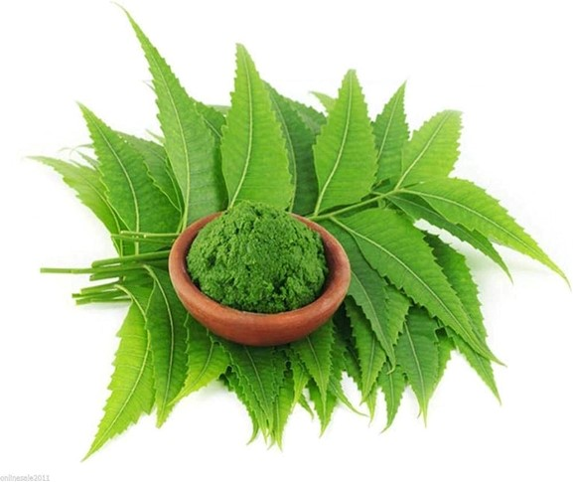

Vitamin C: Boosts immune function and promotes skin health.

Calcium: Essential for bone health.

**Iron**: Important for blood health and energy levels.

**Medicinal Properties:**

Neem leaves and bark possess notable anti-inflammatory, antibacterial, and antiviral characteristics. They are frequently used in the treatment of skin ailments, fevers, and infections.

Oral Health: Traditionally, neem twigs serve as natural toothbrushes. Additionally, neem extract is incorporated into toothpaste and mouthwashes, contributing to dental health by minimizing plaque accumulation and gum disease.

Pesticide Alternative: Neem oil, derived from the seeds, functions as a natural insecticide, effectively targeting a range of pests while remaining safe for beneficial insects, thus making it a favored choice in organic agriculture.

Skin Care: Owing to its antiseptic and hydrating qualities, neem is a prevalent component in soaps, lotions, and creams aimed at addressing acne and various skin disorders.

Blood Purification: Neem is thought to cleanse the blood, promoting overall well-being and assisting in detoxification processes.

Cultural Significance: In Indian culture, neem is revered and often linked to numerous festivals and rituals. Its significance transcends health, symbolizing purity and protection in various communities.

**2..***Turmeric*

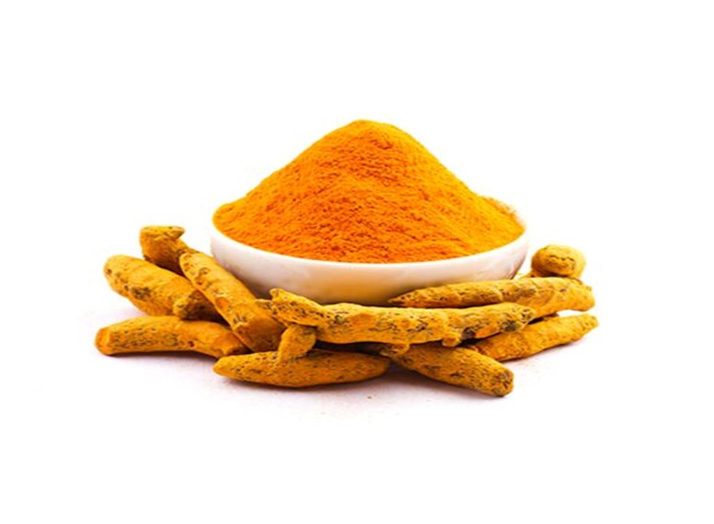

Synonym-Indian saffron

Family-Zingiberaceae

Mechanisms of Action:

Curcumin’s benefits are attributed to its ability to modulate various biological pathways. It influences inflammatory markers like cytokines and enzymes, thereby reducing inflammation. Additionally, it can enhance the production of antioxidants in the body.

# Forms of Turmeric:-

Turmeric can be found in several forms, including:

Fresh Root: Used in cooking or as a health tonic.

Powdered Spice: The most common form for culinary uses.

Supplements: Available in capsules, extracts, and tinctures, often with added black pepper to enhance curcumin absorption.

# Recent Research:-

Recent studies have explored turmeric’s potential role in:

Cancer Prevention: Some research suggests that curcumin may inhibit cancer cell growth and metastasis.

Metabolic Syndrome: Turmeric may help improve insulin sensitivity and reduce blood sugar levels.

Mental Health: There is growing interest in its effects on mood disorders, with some studies indicating it may alleviate symptoms of depression.

# Safety and side effects :-

While turmeric is safe for most people, some may experience:

Gatrointestinal Issues: High doses can cause nausea or diarrhea.

Allergic Reactions: Rare but possible for some individuals.

Drug Interactions: Curcumin can interact with blood thinners, diabetes medications, and drugs that affect liver function.

Cooking: Add turmeric to soups, stews, and rice dishes.

Beverages: Mix it into smoothies or make turmeric tea.

Supplements: Opt for high-quality turmeric supplements if looking for concentrated doses.

# Uses of Turmeric:-

Wide range of uses across culinary, medicinal, and cosmetic f

Culinary Uses

Spice: Commonly used in curries, soups, and rice dishes for flavor and color.

Food Coloring: Added to various foods and beverages for its vibrant yellow hue.

Beverages: Used in teas, smoothies, and golden milk.

Medicinal Uses

Anti-inflammatory: Helps reduce inflammation in conditions like arthritis.

Antioxidant: Protects cells from oxidative stress and damage.

Digestive Aid: Supports digestion and alleviates bloating and gas.

Immune Support: Boosts the immune system and may help fight infections.

Cosmetic Uses

Skin Care: Used in masks and creams for its antibacterial and anti-inflammatory properties; may improve skin tone.

Supplements: Available in capsule form for concentrated curcumin

# *3.TULSI*

Synonym-Holy basil,Tulasi

Family :- Labiatae

Tulsi is also known as holy basil. Leaves of Tulsi are also used in various religious rituals and culinary purpose

Tulsi is a member of ocimumm santum linn and it is well- known in therapeutic benefits.It has roots in Sanskrit and associated with holi basil plantor the godess Tulsi.

Tulsi is known for its numerous health benefits, including antioxidant, anti-inflammatory, and antimicrobial properties. It is commonly used in herbal teas, supplements, and traditional remedies to support overall wellness and boost immunity.

Varieties of Tulsi:-

There are several varieties of tulsi, each with unique properties:-

Ram Tulsi: Known for its sweet flavor and is often used in cooking and teas.

Krishna Tulsi: Characterized by its dark purple leaves, this variety has a more robust flavor and is frequently used in traditional medicine.

Vana Tulsi: Also known as wild tulsi, it grows in natural habitats and is known for its medicinal Uses of Tulsi:-

Stress Relief: It is considered an adaptogen, helping the body adapt to stress and promote mental balance.

Digestive Health: Tulsi can aid digestion, reduce bloating, and alleviate gas.

Respiratory Health: It is commonly used to treat respiratory conditions, such as colds, coughs, and asthma.

Skin Health: Tulsi can be applied topically for acne and skin irritations due to its antimicrobial properties.

Heart Health: It may help lower cholesterol levels and support overall cardiovascular health.

Culinary use:- Tulsi leaves are used in teas, soups, and various dishes for flavor and health benefits.

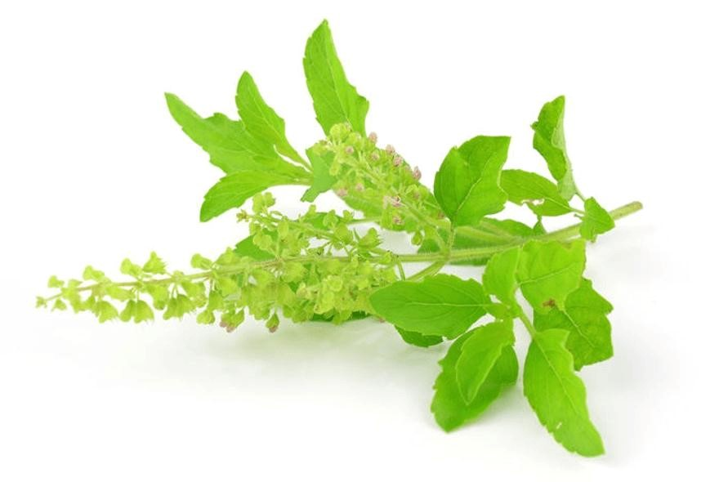

Herbal oinment are natural topical treatments derived from the neem tree, known for its potent medicinal properties. Neem, or Azadirachta indica, has been used in traditional medicine for centuries due to its antibacterial, antifungal, a nd anti-inflammatory effects. These ointments are often utilized to address various skin issues, including acne, eczema, and infections. Rich in antiox idants and essential fatty acids.

## Method of preparation Neem Extract

The leaves were meticulously washed with distilled water and permitted to dry for a duration of ten days. Subsequently, they were blended and transformed into a powder. After ingestion, 350 ml of 90% ethanol was combined with 100 grams of the powder, which was then placed in a percolator. An additional 150 ml of 90% ethanol was added. The mixture was macerated for seven days, with occasional stirring. Following the collection and concentration of the ethanolic extract, a blackish-green residue was produced. This extract was then stored in a cool location within an airtight container.

## Preparation of curcuma longa extract:-

The dried rhizome of Curcuma longa was ground into a powder. The extraction process was identical to that used for neem leaves. The resulting plant extract exhibited a ruby red hue. It was stored in a dark Location, An Air-tight container in a cool environment.

## Procedure For Preparation of herbal ointment :-

1. **Preparation of ointment base** :weighing bees wax and hard paraffin accurately then placed over a water bath in an evaporating container . After melting the hard paraffin were remaining ingredients added and stirred it. To mixing and melting homogeneously by cooling oinment base.
2. Herbal ointment was prepared by weighing Neem and turmeric extract to the ointment bas by levigation method prepare a smooth paste for 2-3 times weight the base gradually incorporating more base until form homogeneous ointment then transferred it into the container



Fig 4. Herbal oinment

Table No.1 Formulation Of Ointment Base

|  |  |  |
| --- | --- | --- |
| Sr. No. | Name of ingredients | Quantity to be taken |
| 1 | Wool Fat | 0.5gm |
| 2 | Cetostearyl alcohol | 0.5gm |
| 3 | Hard Paraffin | 0.5gm |
| 4 | Yellow soft paraffin | 8.5gm |

Table No.2 Formulation of Herbal Ointment

|  |  |  |
| --- | --- | --- |
| Sr No. | Name of Ingredient | Quantity to be taken |
| 1 | Neem extract | 0.06gm |
| 2 | Turmeric extract | 0.06gm |
| 3 | Ointment base | 10gm |

Evaluation parameter of Herbal Ointment:-

1. Colour and Odour:-Visual examination will be assessed to examine the physical characteristics like order and colour
2. Consistency :- smooth and no sign of grettiness will be seen.
3. Non-Irritancy test :- A prepared herbal oinmebt was applied on human skinOutcome will be tracked.
4. Study of physical stability :- four week physical stability test on herbal oinment will be conductedAt various temperature including
5. Solubility:- Soluble with boil water , Miscible with Alcohol ether, chloroform

**Conclusion:**

The development of herbal ointments incorporating extracts of neem, turmeric, and tulsi presents a natural and efficient method for addressing dermatological issues. The synergy of these herbs delivers a wide range of therapeutic benefits**.**Numerous herbs are naturally available, each serving distinct purposes in cream formulations. The current research indicates that herbal creams are highly safe and do not elicit any toxic or adverse reactions when compared to commercially available semisolid products.

## Reference :-

1. Shubhangi. E. Sawant, Monali D. Tajane, Formulation And evaluation of herbal ointment containing Neem And Turmeric extract, Journal of Scientifics and Innovative Research 2016; 5(4): 149-151.
2. Biswas kausik, Chattopadhyay, Ishita, Banerjee K Ranajit and Bandyopadhyay Uday, Biological activities And medicinal properties of Neem (Azadirachta Indica), Current Science, 2002;82(10):1336-1345.

3.Rudra Prasad Giri, Dr. Ajit. K. Gangawane, Dr. Sucheta Giri, Neem the wonder herb: A short review,International Journal of Trend in Scientific Research And Development,

2019;3(3):962-967:l

4.Yamini K. Onesimus T. Preparation and evaluation of Herbal Anti Acne Gel, International Journal of Pharma and Biosciences 2013; 4(2): 956-960.

1. Kokate C.K., Gokhale S.B., Purohit A.P. A textbook of Pharmacognosy, Nirali Prakash an 34th Edi. Sept 2013, 9.117.
2. Turmeric: Pharmacognosy and medicinal uses by Pharma TipsPharmatips.doyouknow.in
3. Pande G. Verma K. Singh M. Evaluation of phytochemical antibacterial and free radical scavenging