**A Deep Study of Vehicular Adhoc Networks**

**Nayan Prajapatia, Dr. Harsh Lohiyab, Sudeesh Chouhanc**

aResearch Scholar, School of Engineering, SSSUTMS, Sehore (M.P.)

bAssociate Professor, School of Engineering, SSSUTMS, Sehore (M.P.)

cAssistant Professor, School of Engineering, SSSUTMS, Sehore (M.P.)

**ABSTRACT**

Vehicular ad hoc networks (VANETs), a subset of mobile ad hoc networks (MANET), holds great potential for the advancement of intelligent transport systems (ITS). VANET enables vehicles to establish a self-organized network without the requirement of a permanent infrastructure. With its potential to enhance road safety and provide real-time traffic updates, as well as other travel conveniences, the VANET has captured the interest of researchers. Though VANET and MANET shares some common characteristics like self-organized network, dynamic topology, ad hoc nature etc., VANET differs from MANET by challenges, application, architecture, power constraint and mobility patterns, so routing protocols used in MANET are not applicable with VANET. Many researchers have proposed a new routing strategy for VANET in recent years. This paper primarily focuses on the different aspects of VANET, including its architecture, unique characteristics, challenges it faces, insights into routing protocols, and simulation models used for its development.

**Keywords:** MANET; Routing Protocols; Power Constraint; Road Side Unit; simulation models.

1. **INTRODUCTION**

In recent years, with the increasing number of vehicles on the road, driving has become difficult and dangerous. The road is saturated, it is difficult to maintain a safe distance and reasonable speed, and drivers are often dissatisfied. While there are no signs of improvement in the short term, government agencies and major automobile companies are working together to develop solutions. One of these developments is a new type of wireless access called Wireless Access in Vehicular Environments (WAVE), designed for vehicle-to-vehicle (V2V) and vehicle-to-vehicle (V2I) communications. VANET uses Dedicated Short-Range Communication (DSRC) IEEE 802.11a, later upgraded to IEEE 802.11p for poor performance. IEEE later standardized everything in the 1609 series called WAVE. This system is used for various vehicle-to-vehicle and vehicle-to-road traffic (RSU) sharing, such as collision avoidance, transportation options, Internet entertainment, etc. When mobile (vehicle) and road units (infrastructure) are combined with WAVE communication equipment, a high-performance Vehicular Ad Hoc Network (VANET) is formed, which is a subset of mobile ad hoc networks (Manet). Most of the features of VANET are inherited from MANET technology and remain unchanged according to the standards of low bandwidth, self-management, personal collaboration, and shared radio. However, the main problem in the operation of VANETs is due to the high speed and uncertainty of the movement of mobile phones (vehicles) on the road (compared to MANETs). This shows that although many routing protocols have been developed in MANETs [2, 3], many routing protocols are not well utilized for VANETs. VANETs are a particularly complex class of MANETs. Therefore, the development of a high-performance system requires the redesign of the MANET architecture to accommodate the rapid change of VANET nodes. This has led to many research challenges to improve the qualification process. Researchers and developers face many challenges. Therefore, many documents and articles try to address these issues. For example, VANET routing protocols and challenges [4], communication and networks [5], routing protocol categories in VANET and the concept behind each policy [6]. Rules, simulation tools.

1. **APPROACHES AND MATERIAL**

**2.1. Architecture of VANET**

In VANET there were mainly two types of communication, V2V (Vehicle to Vehicle) and V2I (Vehicle to Infrastructure), here the infrastructure is mainly in the form of Road Side Unit (RSU). This communication was achieved from WAVE as a wireless medium. The main components are RSU (Road Side Unit), OBU (On Board Unit) and AU (Application Unit). The OBU is usually an equivalent device also known as a user, mounted on the nodes (vehicles) that use the services provided by the RSU. The RSU hosts an application that provides services also known as a provider. In addition to the OBU, a set of sensors are also mounted on the vehicles to collect various data and transmit this data to another vehicle or RSU using WAVE. AU is also mounted on nodes (vehicles) that use a provider-provided application (RSU) with the help of an OBU, for example, the Internet is one kind of service provided by an RSU and used by an AU with the help of an OBU.

**Road Side Unit (RSU)**

The RSU is equipped with a device for short-range communication using IEEE 802.11p radio protocol technology. It is usually located on the side of the road and in other designated places such as intersections, parking spaces. It provided communication range extension and other VANET routing strategies. According to C.C. Communication Consortium, the main functions and procedures associated with RSU are:

1. Extending the communication range of the ad hoc network by redistributing information to other OBUs and sending information to other RSUs for transmission to other OBUs.

2. Operation of a safety application, such as a low bridge warning, accident warning or work zone, using infrastructure-to-vehicle (I2V) communication and acting as a source of information.

3. Providing internet connectivity to OBU.

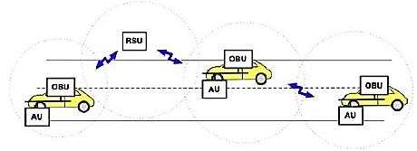

**Figure 1**: Range extension by RSU (C.C. Communication Consortium). [7, 8]

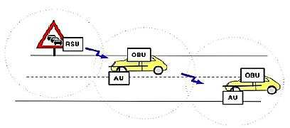

**Figure 2**: RSU work as information source (running safety application) (C.C. Communication Consortium.)[7, 8]

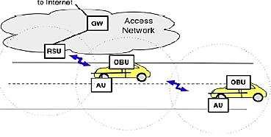

**Figure 3:** RSU extend the range of the ad hoc network by forward the data of OBUs (C.C. Communication Consortium.) [7, 8]

**On Board Unit (OBU)**

According to C.C. Communication Consortium The main function of OBU is reliable message transmission, data security, wireless radio access, ad hoc and location routing, network congestion control [7]. The vehicle-mounted OBU consists of memory, resource command processor (RPC), user interface, IEEE 802.11p short-range communication device for risk applications IEEE 802.11a/b/g/n radio technology is used [ 8] .

**Application Unit (AU)**

The AU can be a dedicated device for safety application or a normal device such as personal digital assistant (PDA) for internet [8]. According to C.C. communication consortium the distinction between the OBU and the AU is logical, The AU communicate with network solely via the OBU which takes responsibility for all mobility and networking functions [7].

**2.2 VANET Characteristics**

Both MANET and VANET have some common characteristic, self-organization, low bandwidth, self- management, no centralization node. But above that VANET has some unique feature that makes it more challenging then MANET, such as frequent disconnected network, highly dynamic, traffic density, mobility pattern of traffic flow etc. Here some of them are discussed.

**1. Highly Dynamic Topology**: The speed and choice of path defines the dynamic topology of VANET. If we assume two vehicle moving away from each other with a speed of 60 mph ( 25m/sec) and if the transmission range is about 250m, then the link between these two vehicles will last for only 5 seconds ( 250m/50ms-1 ). This defines its highly dynamic topology.

**2**. **Predicated mobility**: In MANET mobile nodes are free to move in any direction where as in VANET nodes must follows the particular path so mobility have pattern. Due to road topology and layout vehicles are constrained to follow path. Others things affects the mobility are traffic signals, road signs etc. [9]

**3**. **Power constraint**: Oppose to MANET, VANET have sufficient power supply from car battery, so that is not critical challenge for VANET. So there is no power constraint in VANET routing.

**4. Variable vehicle density**: some roads have high density of traffic and some haven‟t producing variable density of nodes in area. Even traffic lights, road signs, disaster taken placed areas, traffic jams are generating variable vehicle density. And that‟s turn into frequently disconnected network.

**5. Frequently disconnected network**: High dynamic topology and variable vehicle density generate rapid changes in topology which cause in frequently disconnected network. In high density area network disconnection is not a problem but in low density area no forwarding node available so network delay is grown up due to disconnectivity of seamless connection.

**6. Large scale network**: Dense area required large scale network such as highway, city center etc. VANET routing strategies must outperform on large scale network.

**2.3 Scenario**

**MANET and VANET**

A MANET is a wireless network without any fixed topology maintained in real time. Here each node has two roles to perform, as an end system and as a router. For routing Multihop strategy used. VANET, a special case of MANET, has set of unique property. Highways, junctions, traffic lights, avenues restrict movements of nodes. It generates specific mobility patterns opposed to MANET. Vehicles move very faster than nodes in MANET gives shorter connection time between nodes. So network disconnection taken place frequently and route maintenance is harder compared to MANET [10].

**Urban and Highway Environment**

Urban and highways environment scenarios carry different characteristics, so according to that VANET routing strategies developed. In Urban scenario obstacles are more due to city building, vehicle density is high, vehicle speed is low compare to highway, and vehicle density is high. Where as in highway scenario vehicle density is low, vehicle speed is high, obstacle is less, vehicle speed variance is low whereas it is high in urban. Due to these different characteristics highway and urban scenario have different routing strategies. Automatic adoptability of routing strategies according to environment is also a research area, as highway routing strategy less applicable in urban and wise versa. Below table shows scenario comparison for VANET.

**Table 1.** Comparison of environments in VANET

|  |  |  |
| --- | --- | --- |
| **Property** | **Highway** | **Urban** |
| Speed | High | Low |
| Link  connectivity | Maintain | Frequently  disconnect |
| Speed variance | Low | High |
| Vehicle density | Low | High |
| Routing path  options | Few | Many |
| Obstacle | Few | Many |
| Mobility  prediction | Easy | Hard |

**2.4 Challenges in VANET**

**Small effective diameter:** Weak connectivity taken place due to small effective diameter, as nodes moves at high speed with rapid change in topology, resulted into impracticable global topology on VANET. Existing MANET routing protocol not applicable on VANET due to restricted effective diameter [11].

**Signal fading:** signal fading taken place with many obstacles in communication range. High rise buildings, houses, others vehicles etc. restricts signals especially in cities create signal fading and affect the efficiency of routing.

**Connectivity:** Maintaining connectivity in rapidly changing topology is biggest challenge in VANET. High dynamic topology leads to frequent fragmentation in networks, and that leads to throughput degradation.

**Security and privacy:** Due to Ad Hoc nature of VANET, it requires more focus on security and privacy. Here security system must be secure and faster as routing must be fast for rapid changing topology. For trustworthy of message, sender information sharing must in VANET. This generates privacy issue. Keeping a reasonable balance between the security and privacy is one of the main challenges in VANET [12].

**2.5 Routing in VANET**

Routing in VANET can be classified under transmission strategies or routing information. Unicast, broadcast, multicast are various transmission strategies. Topology based and position based routing protocols used various routing information, such as position based routing required preinstalled map or route information.

**Transmission strategies based classification**

According to transmission strategies routing can be classified under Unicast, broadcast and multicast. Multicast further partitioned into geocast and cluster based routing protocols.

In **Unicast routing** one to one communication take place using Multihop scheme; where intermediate nodes are used to forward data. This is the widely used class in ad hoc network. For VANET many Unicast routing protocols are proposed; most of the topology based routings are Unicast such as AODV [28], DSR [29], GPSR [19] etc.

In **Broadcast routing** [30] one to all communication take place. Flooding, BROADCOMM, DV-CAST etc. are broadcast protocols. This is most frequently used routing protocol in VANET especially to communicate the safety related message. Simplest of broadcast method is carried by flooding in which each node rebroadcast the message to other nodes. But with larger density of nodes, this causes exponential increase in bandwidth.

In **multicast routing** [30] one too many communication take place. This can be further partitions into geocast and cluster based. In cluster based routing, nodes automatic partitioned into cluster and one cluster head is selected and all outgoing and incoming communication taken place through it. COIN and CBDRP are cluster based routing. In geocast routing, message delivery to other nodes lie within a specific geographic area, like area where accident taken place. Mobicast, ROVER, ZOR (Zone of Relevance) are geocast protocols.

**Table 2.** Transmission strategy based classification

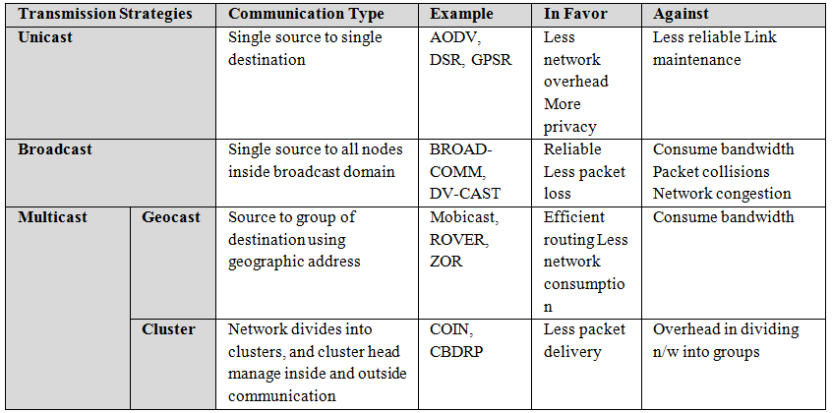

**Routing Information based classification**

This class used link or position information for routing. Topology based routing used links information stored in routing tables for forwarding packet to destination and position based routing used node‟s position for forwarding packets. This position information obtains from GPS.

* **Topology Based Routing Protocols**

Topology based routing protocols use links information that exists in the network to perform packet forwarding. Routing table, maintained at each node, are used to store the link information of all others node in given topology. As the nodes in VANETs are constantly moving, routing table must be maintained frequently.Based on this updation of the routing table, topology based routing protocols can be further partition into Proactive, Reactive and Hybrid.

* **Proactive (Table-Driven)**

Proactive routing maintained the next forwarding hop information in the background regardless of communication requests. For maintaining links information, Proactive routing uses control packets broadcast even though some of paths are never used. Each node maintains such a routing table in the background. The advantage of the proactive routing is that no route discovery requires upon the communication taken place, as it always available on lookup; this is useful for real time application. The main drawback proactive is that it requires maintaining unnecessary link information takes significant bandwidth. Also a propagation delay of links information creates hazards in the routing. As shown in [30], FSR (Fisheye State Routing) propagates link state updates with only immediate neighboring nodes not with whole network, reduces bandwidth consumption. DSDV (Destination Sequence Distance Vector routing) uses shortest path algorithm to implement only one route to destination. OLSR (Optimized Link State Routing protocol) keeps a routing table which contains all possible to network node. OLSR sends updated information to selective node whenever network topology changed, and retransmission of information taken place from receiver node.

* **Reactive (On Demand)**

Reactive Protocols also known as On Demand Routing Protocol reduces network overhead by updating routing table when source node starts a route discovery process. If route to nonexistence destination is required then network flooding is used for finding route and routing table is updated. Here the drawback of proactive routing is overcome by reducing unnecessary link information sharing, but route calculation time upon communication request is increase. As shown in [30], In AODV [28] (Ad hoc on demand Distance Vector), sender node uses broadcast query (RREQ) to find route, upon receiving (RREQ) query intermediate node offers low network overhead, it also flexible to high dynamic topology. Enhancement over AODV is also developed; AOMDV (Ad hoc on demand Multipath Distance Vector) used multipath generation from source to destination, SD- AOMDV used speed and direction factor over AOMDV to enhancing throughput‟s (Dynamic Source Routing Protocol) provide a highly reactive routing process by routing mechanism with an extremely low overhead and fast reaction to the frequent network changes.

* **Hybrid**

Hybrid Protocols used both proactive and reactive routing strategies; it aims to minimize the routing protocol control overhead and reduce the delay of the route discovery process within on demand routing protocols. As shown in [30], ZRP (Zone Routing Protocol) divides the network into zone based on many factors like signal strength, speed etc. Inside the zone proactive routing schema and for outside reactive routing schema is used.

**Table 3. Topology based routing types**

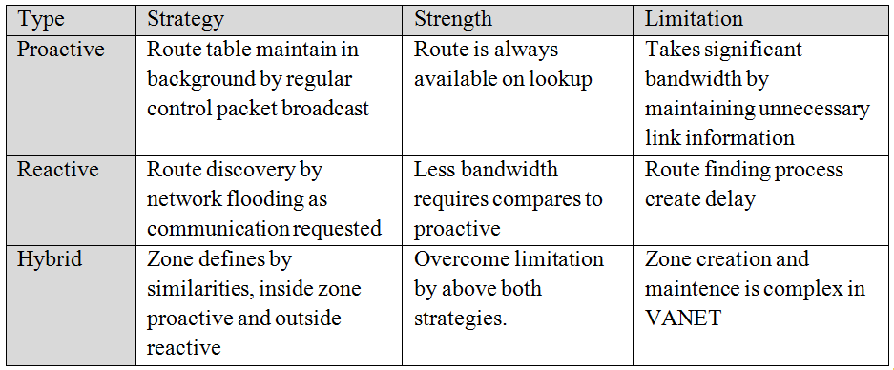

* **Position based routing (Geographic routing)**

Before taking step into position based routing protocols, let us look at forwarding and recovery strategies used in geographic routing.

* **Forwarding strategies**

**Different forwarding strategies**[15] are used in position based routing protocols. Each vehicle maintain information about neighbor nodes, normally that table contain information like geographic position, speed, direction of neighbor. Based on table, source forwards packets to next hop. The forwarding strategies are as follows [12, 13, 14.].

**Greedy forwarding:** Greedy forwarding strategy always forward packet to a node closest to destination. Here source „S‟ forward packet to „A‟, which is closest node to destination „D‟.

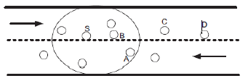

**Figure 4**. Forwarding strategies [15]

Improved greedy forwarding: source node first consults its neighbor table and computes new predicted position of all its neighbors based on direction and velocity and then selects anode which is closest to the destination. „S‟ computes new predicted position of its neighbors and suppose at time t2, vehicle „B‟ over takes the vehicle „A‟, then „S‟ selects „B‟ as its next hop instead of „A‟.[15] Directional greedy forwarding: Directional greedy approach only considers those nodes which are moving towards destination. Thus, it selects vehicle „B‟ as its next hop. Predictive directional greedy forwarding: In this strategy, forwarding node maintains the information of its 2-hop neighbours. Before forwarding the packet, forwarding node consults its neighbour table and computes predicted position of all its neighbours (one- hop and 2-hop neighbours) and then selects a node whose one-hop neighbour is moving towards the destination and is closest to the destination. In this case,

„S‟ selects vehicle „A‟ because its one-hop neighbour „C‟

is moving towards destination „D‟.[15]

* **Recovery Strategies**

Recovery strategies [14] are use when greedy forwarding strategies run into a situation called local maximum, in which the sending vehicle finds itself as a closest vehicle to the destination than all of its neighbours and the destination is not reachable by one hop. But, this does not mean that there is no connectivity to the destination. So recovery strategy is used whenever a local maximum occurs. Most relevant recovery strategies used in position based routing are described below.

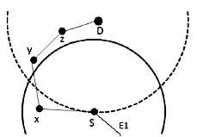

**Figure 5**. Local maximum situation [14]

Right-hand rule to traverse graphs is one of the widely used recovery-mode in position based routing. As shown in fig 2, node „S‟ enter into local maximum situation as closest node to the destination is itself and destination not reachable via one hop connectivity. So forwarding strategy enters into recovery mode. According to right hand rule, if node „S‟ receives the packet from edge E1 then it sends the packet through its next edge counter clock wise about „S‟ here its node „X‟. Whenever, forwarding node is closer to the destination than the node that triggers the recovery strategy, routing jump back into forwarding mode. To use the right hand rule we must have a planar graph by Karp and Kung [16], who use Relative Neighborhood Graph (RNG) computed at each node in order to planarize the graph by removing edges that cross. Since in VANETs the network nodes are constantly moving and at high speeds, this can lead to loops in the right-hand rule approach. Other approach used is the carry-and-forward. As the name suggests, when the local maximum occurs the node carries the packet until an eligible neighbour appears. This approach leads to bigger delays. Instead of using a recovery strategy, some algorithms recalculate the path when the local maximum occur, which can lead to higher delays and to a bigger number of hops. [14]

**Table 4.** Recovery strategies comparison [14]

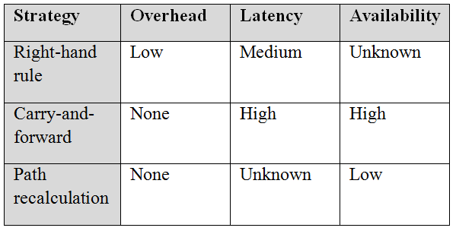

* **Position based routing protocols**

The usage of digital maps, GPS receivers, and a navigation system in modern vehicles inspired the study of position-based routing for vehicular network. Position based protocols assume that GPS device is equipped with vehicle in order to finds its own geographic position. In addition to that Location services also required for obtaining geographical position of destination vehicle. Without the use of location services, becomes very difficult to find destination position. In past, numerous location services have been proposed, for example, grid location service [17] or hierarchical location services [18]. marked as „out of service‟ and recalculation of path

taken place.

* **GPSR (Greedy Perimeter Stateless Routing)**

Greedy Perimeter Stateless Routing [19] used Greedy forwarding strategy, here no path calculation taken place for routing from source to destination. Destination nodes position inserted into packet header and that packet sends to the next hop closer to destination, using greedy strategy. If local maximum occurs then right hand rule is used for recovery strategy.

* **GPCR (Greedy Perimeter Coordinator Routing)** Rather applying greedy forwarding strategy at each forwarding node, GPCR [20] uses restricted greedy strategy when nodes are in street and actual routing decision taken place at junction of streets. Here the packet is forwarded to a node in the junction rather sending it across the junction. GPCR has higher delivery rate than that of GPSR with large average number of hops and slight increase in latency.
* **GSR (Geographic Source Routing)** Geographic Source Routing [21] use Dijkstra”s shortest path algorithm on a map obtains from GPS system. GSR carries out shortest path calculation on each junction and uses greedy forwarding strategy along the path to the next junction until destination is reach. As no real time traffic information is used for path selection of next node may stop at local maximum, then as a recovery it tries to select another vehicle outside that road using greedy forwarding rather than described recovery strategy.
* **A-STAR (Anchor-based Street Traffic Aware Routing)** The Anchor-based Street Traffic Aware routing [22] calculates full path for forwarding packet. Like GSR, it also use dijkstra‟s shortest path algorithm, but uses number of bus line on the road as weight parameter of road for selecting path. Considering the number of bus line on the road, it provides some sort of traffic awareness for better decision making towards path selecting, as better vehicle density lower the chances of local maximum situation. If local maximum occurs them road the destination proposed from Okada is given by [24]:

Dp = Dj/Di Where:

* Dpis the curve metric distance from J to destination
* Di is the curve metric distance from I to destination

And the average vehicle per cell is given by: Navg = Nv/Nc Where:

* Nv is the number of vehicle between I and J
* Nc is the number of cell between I and J

Between junctions an improved greedy forwarding is used, and as recovery mode GyTAR uses carry and forward approach. [14]

* **DGR (Directional Greedy Routing) and PDGR (Predicated Directional Greedy Routing)**

Specifically, when a source vehicle sends a packet to a destination, the routing scheme should be able to efficiently route the packet with few hops and small delay. As the node movement in VANETs is more regular, Reduction in number of hops during routing is achieved in DGR by choosing the node moving toward thedestination using the greedy forwarding strategy. Further enhancement over DGR achieve by predicting the mobility of vehicle. Such predictable mobility information can be derived from the traffic pattern and street layout, this approach is used in PDGR [25] for routing. In both routing carry and forward approach is used as a recovery strategy.

**Table 5 Comparison of Position based routing protocols**

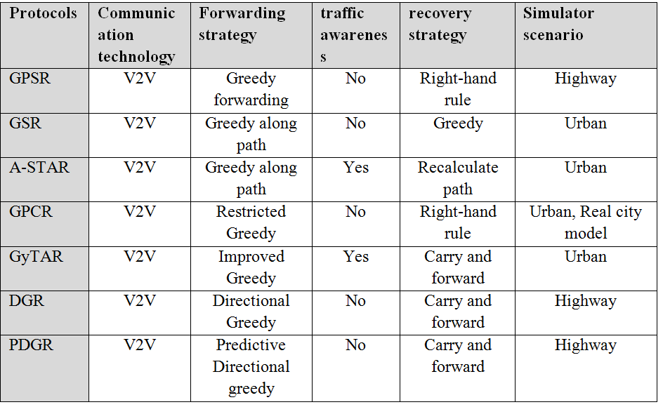

**3. RESULTS AND DISCUSSION**

**VANET Simulation**

In order to apply these routing protocols, the system performance needs to be evaluated. For these reason simulation tools are consider the best means with which to evaluate the performance. As compared to MANET, VANET has many distinct characteristic such as highly dynamic, restricted mobility, traffic regulation. So simulator must provide accurate results with all VANET characteristics. Below are some examples of VANET simulator from [26, 27].

**MOVE (Mobility model generator for Vehicular networks)**

MOVE is a java based application built on SUMO (Simulation of Urban Mobility) with GUI support. MOVE support a good visualization tool and mainly focuses on traffic level feature. MOVE is composed of a Map editor and a Vehicular Movement editor. Map editor is used for create topology for network and vehicular Movement editor generate traffic pattern in topology. MOVE also support random generated graph and user define graph. [26]

**TraNs (Traffic and Network simulator)**

TraNs, a Java based application specially designed for VANET. It integrate SUMO and NS-2 feature with a visualization tool. TraNs Lite, a separate version has been built without NS-2 network simulator supports up to 3000 nodes and can traces from TIGER database ot by using shape files. [27]

**NCTUns (National Chiao Tung University Network Simulator)**

NCTUns is built on C++ programming language with a good GUI support. NCTUns combines the traffic and network simulators in a single module, making a distinct vehicular network environment available. NCTUns can use 802.11a, 802.11b, 802.11g and 802.11 technologies. NCTUns supports other feature like automatic road assignment from SHARPE-format map file; vehicle movement controlled automatically, directional, bidirectional and omnidirectional antenna. [27]

**4. CONCLUSION**

We know that intelligent transportation (ITS) is a necessity in today’s automotive environment because road safety and emergencies are important issues in transportation. In the past few years, many VANET projects and researches have been conducted, many VANET models have been developed. Although more research is needed, many important issues such as improving reliability, network isolation, and latency need to be addressed to achieve the implementation of VANETs. In this paper, we introduced the concepts of VANETs, ​​such as the architecture, characteristics, competition, and teaching principles of VANETs, ​​and different types of operating VANETs. We hope that the information presented in the paper will help other researchers in the future. Finally, some of the challenges that transportation still needs are safety, reliability, popularity of competition strategies, and other services such as internet and entertainment.

**5. REFERENCES**

[1] A. K. Saha and D. B. Johnson, “Modelling mobility for vehicular ad hoc networks,” in Proceedings of ACM International Workshop on Vehicular Ad Hoc Networks, 2004, pp. 91-92.

[2] Mauve, et al. (2001). A survey on position-based routing in mobile ad hoc networks. IEEE Network Magazine, November/December, 30-39.

[3] Mehran, et al. (2004). A review of routing protocols for mobile ad hoc networks. Ad Hoc Networks, 2, 1-22. Doi:10.1016/S1570-8705(03)00043-X.

[4] Li F, Wang Y. Routing in vehicular ad hoc networks: a survey. IEEE Vehicular Technology Magazine 2007; 2(2):12-22.

[5] Hartenstein H, Laberteaux KP. A tutorial survey on vehicular ad hoc networks,Communication Magazine, IEEE 2008;46(6):164-71.

[6] Lin Y, Chen Y, Lee S. Routing in vehicular ad hoc networks: a survey and future perpectives. Journal of Information Science and Engineering 2010; 26(3):913- 32.

[7] C.C. Communication Consortium; IEEE trial-use standard for wireless access in vehicular environments; Olariu and Weigle, 2009.

[8] Al-Sultan S, et al. A comprehensive survey on vehicular Ad Hoc Network and Computer Application (2013) <http://dx.doi.org/10/1016/j.jnca.2013.02.036i>.

[9] Jakubiak J, Koucheryavy Y. State of art and research challenges for vanets. In: consumer communications and networking conference. CCNC 2008. 5th IEEE; 2008. P. 912-6

[10] Dahiya A, Chauhan R. A comparative study of MANET and VANET environment, Journal of Computing 2010; 2(7) ISSN 2151-9617.

[11] Hartenstein H, Laberteaux K. VANET vehicular applications and inter-networking technologies. Wiley Online Library; 2009.

[12] Bernsen J, Manivannan, D. Greedy routing protocols for vehicular ad hoc networks. In: Wireless communications and mobile computing conference, IWCMC „08. International, vol., no., pp. 632–637, 6–8 Aug. 2008.

[13] Cha SH, Min-Woo Ryu MW, Cho KH. A survey of greedy routing protocols for vehicular ad hoc networks. Smart Computing Review 2012.

[14] Fonseca A, Vazao T. Applicability of position-based routing for VANET in highways and urban environment. Journal of Network and Computer Applications JNCA1084-8045 2009.

[15] Sardar Muhammad Bilal, Carlos Jesus Bernardos, Carmen Guerrero; Position-based routing in vehicular networks: A survey; Journal of Network and Computer Applications 36(2013) 685-697.

[16] Karp B, Kung HT. GPSR: greedy perimeter stateless routing for wireless networks. In: MobiCom„00: Proceedings of the 6th annual international conference on mobile computing and networking, ACM, New York, NY, USA; 2000. p. 243–54. <http://dx.doi.org/10.1145/345910.345953>.

[17] Li J, Jannott J, Couto DD, Karger D, Morris R. A scalable location service for geographic ad hoc routing. ACM/IEEEMOBICOM02000 2000:120.130.

[18] Kiess W, Fubler H, Widmer J, Mauve M. Hierarchical location service for mobile ad- hoc networks. ACM SIGMOBILE Mobile Computing and Communications Review (MC2R) 2004;8(4):47–58 October.

[19] Karp B, Kung HT. GPSR: greedy perimeter stateless routing for wireless networks. ACM/IEEE MobiCom 2000.

[20] Lochert C, Mauve M, Fussler H, Hartenstein H. Geographic routing in city scenarios. In: SIGMOBILE mobile computing and communications review, vol. 9. ACM, New York, NY, USA, 2005. p. 69–72, <http://dx.doi.org/http://doi.acm.org/10>. 1145/1055959.1055970.

[21] Lochert C, Hartenstein H, Tian J, Fussler H, Hermann D, Mauve M. A routing strategy for vehicular ad hoc networks in city environments. In: Proceedings of the intelligent vehicles symposium, 2003 IEEE; 2003. p. 156–61, http://dx.doi. org/10.1109/IVS.2003.1212901.

[22] Seet B-C, Liu G, Lee B-S, Foh C-H, Wong K-J, Lee K- K. A-STAR: a mobile ad hoc routing strategy for metropolis vehicular communications. Springer; http://dx.doi. org/10.1007/b97826.

[23] Jerbi M, Senouci S-M, Meraihi R, Ghamri-Doudane Y., An improved vehicular ad hoc routing protocol for city environments. In: ICC; 2007c. p. 3972–9.

[24] Okada H, Takano A, Mase K. A proposal of link metric for next-hop forwarding methods in vehicular ad hoc networks. In: Sixth IEEE Consumer communications and networking conference, 2009. CCNC; 2009. p. 1–5, http://dx.doi.org/ 10.1109/CCNC.2009.4784925.

[25] Jiayu Gong, Cheng-ZhongXu, James Holle. Predictive Directional Greedy Routing in Vehicular Ad hoc Networks, 27th International Conference on Distributed Computing Systems Workshops, IEEE 2007

[26] SheraliZeadally, Ray Hunt, Yuh-Shyan Chen, Angela Irwin, Aamir Hassan, Vehicular ad hoc networks (VANETS): status, results, and challenges, Telecommum Syst, 2010

[27] Al-sultan S, et al. A comprehensive survey on vehicular Ad Hoc network. Journal of Network and Computer Application (2013), http://dx.doi.org/10.1016/j.jnca.2013.02.036i

[28] Perkins, C. E. And Royer, E. M. (1999), “Ad-Hoc On-Demand Distance Vector Routing,” Proc. IEEE WMCSA „99, New Orleans, LA, Feb. 1999 ,pp. 90-100.

[29] Johnson, D. B. And Maltz, D. A. (1996). ”Dynamic Source Routing in Ad Hoc Wireless Networks,” Mobile Computing, T. Imielinski and H. Korth, Eds., Ch. 5, Kluwer, 1996, pp. 153-81.

[30] Marwa Altayeb, Imad Mahgoub, “A Survey of Vehicular Ad hoc Networks Routing Protocols,” ISSR Journals, 2013, Vol. 3, No. 3, pp. 829-846.