**QUALITY EVALUATION OF MONOPILE HIGH STRENGTH CONCRETE IN MARINE BRIDGE FOUNDATION**

Saurav Kumar1, Chaitanya Mishra 2,

1 Student, Department Of Civil Engineering Oriental University, Indore (M.P.)

2 Associate Professor, Department Of Civil Engineering Oriental University, Indore (M.P.)

---------------------------------------------------------------------------------------------------------------------

**Abstract**: Monopile is the most common form of foundation employed under offshore or Marine works. These foundations are subjected to millions of repeated load cycles from the wind and waves of varying magnitude leading to accumulated displacements and changes in soil-pile stiffness. The purpose of this study was to investigate the behavior of Quality Evaluation of Monopile High strength Concrete in Marine bridge foundation.

Monopiles, cylindrical steel structures driven into the seabed or riverbed, have gained prominence as a foundation solution due to their cost-effectiveness, ease of installation, and environmental benefits. This paper explores the design considerations, construction methodologies, challenges, and advancements in utilizing monopiles for such critical infrastructure projects. Through case studies and technical discussions, the paper aims to provide valuable insights for engineers, researchers, and policymakers involved in marine and bridge engineering projects. The investigation was divided into two parts: the first part is studying the long-term behavior through the reduced scale model test, and the second to analyse the short-term behavior using the Finite Element analysis. The findings of three monotonic and seventeen cyclic load tests performed in the laboratory on medium dense sand and dense sand were presented in this thesis. The experimental investigations discussed the effect of asymmetric two-way cyclic loads on the rate of accumulated displacements and changes in soil-pile stiffness. The overall conclusion of this research was that the monopile foundation experiences a higher reversal of accumulated displacement at relatively low load amplitude with an increasing number of cycles. As the monopile was subjected to irrecoverable displacement at the initial cycles and recoverable displacement with an increasing cycles on both serviceability and fatigue loading conditions. Under asymmetric two way cyclic loading with ξc = -1.3, the reversal of accumulated displacement was 49% higher than the symmetric two-way cyclic loading with ξc = -1 at around cycle number N = 2150. It is observed that a more severe problem occurs under asymmetric two-way loading conditions. The non-linear response was observed for both test series, first lateral cyclic secant stiffness increases with a higher rate, and then the rate of increasing got decreased with an increasing number of cycles, but it did not get stabilized. This indicates a gradual increase in soil-monopile system stiffness in each cycle owing to sand densification. The linear regression analysis was also performed to fit the conventional degradation parameter using the minimum number of critical constraints that includes the loading conditions and the flexibility parameter of soil-pile system. In this study, an attempt has been made to examine the influence of embedded length on monopile behavior using finite element analysis. The centrifuge test carried out on a monopile embedded in sandy soil was used to validate the constituent model (Hardening soil model with small-strain stiffness). The numerical studies were performed on a 6m diameter monopile by varying the load amplitude and embedded length ratios (L/D = 4, 5, and 6). The monopile was subjected to two-way symmetric lateral cyclic loading with an amplitude of 30%, 40%, and 50% of the monotonic ultimate capacity of the pile. The difference between the measured displacement of numerical analysis and the centrifuge test varies by 27%. The similar trend irrespective of the values, and the monopile response under cyclic loading was observed from the load displacement curve, which indicates that the measured accumulated displacement increases drastically for the first load cycle. For a given embedded length, the lateral displacement was observed to increase with an increase in load amplitude. Also, the load amplitude was observed to cause a linear increase in the accumulated displacements.

**1.Introduction:** The construction of bridges spanning over waterbodies or in offshore environments poses unique challenges that demand innovative solutions. Among these solutions, monopiles have emerged as a pivotal component, offering a versatile and efficient foundation system for such projects. As our infrastructure needs continue to expand, understanding the capabilities and applications of monopiles becomes increasingly crucial. This paper provides a comprehensive overview of monopiles and delves into their applications in offshore and over waterbodies bridge construction. By examining the design considerations, construction methodologies, challenges, advancements, and case studies, this paper aims to shed light on the significance of monopiles in addressing the complex demands of marine and bridge engineering.

Monopiles, essentially cylindrical steel structures driven into the seabed or riverbed, have gained prominence for their adaptability and cost-effectiveness. Their utilization as foundation solutions offers several advantages, including simplified installation processes, reduced environmental impact, and enhanced structural stability. Understanding the intricacies of monopiles and their integration into bridge construction projects is paramount for ensuring the longevity and resilience of our infrastructure in marine environments. methodologies, challenges, advancements, and case studies, we seek to contribute to the body of knowledge in marine and bridge engineering. By doing so, we hope to facilitate informed decision-making and foster the development of sustainable and resilient infrastructure solutions for the challenges posed by waterbodies and offshore environments. In the subsequent sections, we will delve deeper into the design intricacies of monopiles, explore the various construction methodologies employed, discuss the challenges faced, highlight recent advancements and innovations, present case studies of successful projects, and outline future research directions. Through this comprehensive examination, we aim to provide a holistic understanding of monopiles and their pivotal role in offshore and over waterbodies bridge construction.

# Through this study, we aim to provide engineers, researchers, and policymakers with valuable insights into the effective implementation of monopiles. By exploring the design considerations, construction

Municipal Corporation of greater Mumbai proposed developing a coastal road project (MCRP) from Princess Street flyover to Kandivali junction over about 29km to ease the traffic congestion in Mumbai with recreational spaces.

This project is being implemented in 2 phases namely South and North. The South phase starts at Princess Street flyover and ends at Worli end of Bandra Worli sea link (BWSL).

This phase is divided into 3 packages as mentioned below:

Package 4: Princess Street flyover to Priyadarshini park (CH km 1+970 to CH km 5+900)

Package 1: Priyadarshini park to Baroda palace (CH km 5+900 to CH km 9+720)

Package 2: Baroda palace to Worli end of BWSL (CH km 9+720 to CH km 12+470).

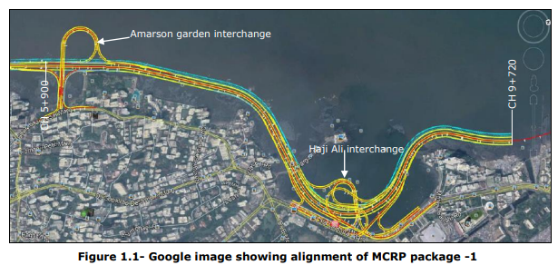

The monopile technique was adopted by the contractor to reduce construction time, and 33 marine modules with monopile foundations were executed in place of group piles.

Two varied sizes of monopiles are executed in the project i.e., 2500mm dia and 3200mm dia and the concrete grade for all the pile is M60.

The reinforcement used for monopile construction corresponds to Fe-550D1.2

1.3 Monopile Foundation:

# A marine monopile is a type of foundation structure used in offshore construction projects, particularly in the offshore wind energy sector and other marine engineering applications. It is essentially a large, cylindrical steel structure that is driven or installed into the seabed or riverbed to support several types of offshore infrastructure, such as wind turbines, offshore platforms, bridges, and marine terminals. Marine monopiles typically consist of a single steel pile, hence the name "monopile," although variations with multiple piles exist. Monopiles are designed to withstand the significant forces exerted by waves, currents, and other environmental factors in offshore and coastal areas. The monopile serves as a sturdy foundation upon which further structures can be built or attached. The installation process of marine monopiles involves specialized equipment such as pile drivers or drilling rigs, depending on the seabed conditions and project requirements. Once installed, the monopile is securely anchored into the seabed, providing stability and support for the superstructure above water. In offshore wind energy projects, marine monopiles are commonly used to support wind turbine towers. The monopile is driven into the seabed, and the wind turbine tower is then mounted onto the top of the monopile, creating a stable foundation for the turbine to operate efficiently even in harsh marine environments. Overall, marine monopiles play a vital role in offshore construction projects, providing a robust and reliable foundation solution for various marine structures, including wind turbines, bridges, platforms, and marine terminals, contributing to the development of offshore infrastructure and renewable energy production.

# SCOPE OF PRESENT STUDY

1. The scope includes 6 test piles and 99 working piles in AGI (Amarsons Garden Interchange), HAI (Haji Ali Interchange), MLB(Main Line Bridge) locations with a diameter of 2500mm and 3200mm. The depth of monopiles varies between 12m to 41m.
2. The monopile design follows the AASTHO and IRC standards (as per the DBR) along with the L-pile analysis and WALLAP software.
3. Amarsons garden interchange monopiles have the shorter shaft length (starts from 4m) due the basaltic rock outcrop with high UCS values whereas Haji Ali interchange has the deepest pile shafts (upto 41m deep) due to marine deposits and clay on seabed levels.

There are 32 monopiles of 2500mm dia in Amarsons garden interchange, 50 monopiles of 2500mm & 3200mm dia in Haji Ali interchange and 17 monopiles of 3200mm dia in Main line bridge.

working scope of Monopile in study:

|  |  |  |  |  |
| --- | --- | --- | --- | --- |
| S.No | Location | ARM | Diameter (mm) | Scope |
| 1 | AGI | 1 | 2500 | 16 |
| 2 | AGI | 2 | 2500 | 16 |
| 3 | HAI | 1 | 2500 | 13 |
| 4 | HAI | 2 | 2500 | 13 |
| 5 | HAI | 2 | 3200 | 10 |
| 6 | HAI | 4 | 3200 | 05 |
| 7 | HAI | 8 | 3200 | 09 |
| 8 | MLB | LHS | 3200 | 09 |
| 9 | MLB | RHS | 3200 | 08 |

**2. Material and methods:**

Selection of material used in concrete mix and their specification

1. Coarse Aggregates

Specification of used coarse aggregates table 3.2.1

|  |  |  |
| --- | --- | --- |
| Particle Size : Sieve Analysis | IS:383-2016/ IS 2386 Part 1-1963 | Table 1000-1 of MORTH (5th Revision) for Mximum nominal size =20mm ( Clause 1.4.1.3 (3) of Sec 3 Volume 5 Construction specification) |
| Flakiness Index & Elongation Index | IS:383-2016/ IS 2386 Part 1-1963 | < 35 % (Flakiness only )As per MoRTH |
| Deleterious Material | IS:383-2016/ IS 2386 Part 2-1963 | Table-2 of IS:383-2016 ( Max. 2% for total constituents) |
| Sp. Gravity | IS:383-2016/ IS 2386 Part 3-1963 Amdt-1(Reaffirm-2016) | Not specified |
| Water Absorption | IS:383-2016/ IS 2386 Part 3-1963 | Not specified |
| Aggregate Crushing Value | IS:383-2016/ IS 2386 Part 4-1963 | < 45% for Concrete work/IS 383-1970 |
| Aggregate Impact Value | IS:383-2016/ IS 2386 Part 4-1963 | < 45% for Concrete work/IS 383-1970 |
| Los-Angeles Abrasion Value | IS:383-2016/ IS 2386 Part 4-1963 | < 50% for Concrete work/IS 383-1971 |
| Soundness | IS:383-2016/ IS 2386 Part 5-1963 | Sodium Sulphate < 12% & Magnesium Sulphate < 18% - IS 383 1970 |
| Alkali Reactivity | IS:383-2016/ IS 2386 Part 7-1963 | Innocuous Aggregates Fig.6 of IS:2386 Part-VII , |
| Petrographic Examination | IS:383-2016/ IS 2386 Part 8-1963 | Identification of Rock as Innocuous as per IS:2386 Part-VIII |
| Chloride & Sulphate Content | BS 812/IS 2720 Part 26/BS EN 1744 | Chloride - Max 0.01% , Sulphate - Max 0.4%(Cl 1.4.2.5 Sec 3 Volume 5) |
| Moisture Content | IS:383-2016/ IS 2386 Part 3-1963 | Actual value |

2. Fine Aggregates

Specification of used fine aggregates

|  |  |  |
| --- | --- | --- |
| Particle Size : Sieve Analysis | IS:383-2016/ IS 2386 Part 1-1963 | Crushed Rock Sand gradation confirming to Table 1000-2 of MORTH (5th Revision ) with permissible limits of max 20% on 150microns Sieve(, Fineness Modulus : between 2.0 to 3.5 |
| Deleterious Materials | IS:383-2016/ IS 2386 Part 2-1963 | Table 2 of IS:383 Max. 2% for total constituents |
| Materials finer than 75micron IS Sieve | IS 383-2016/ IS 2386 Part 1-1963(R2016) | Table 1 of IS:383 Max.15% for Crushed sand |
| Specific Gravity & Water absorption | IS:383-2016/ IS 2386 Part 3-1963 Amdt-1(Reaffirm-2016) | Not specified |
| Soundness | IS:383-2016/ IS 2386 Part 5-1963 | Sodium sulphate < 10% MgSO4<15%/IS 383 1970 |
| Alkali Reactivity | IS:383-2016/ IS 2386 Part 7-1963 | Innocuous Aggregates Fig. 6 of IS:2386 Part VII |
| Chloride & Sulphate Content | BS 812/IS 2720 Part 26/BS EN 1744 | Chloride - Max 0.01% , Sulphate - Max 0.4%(Cl 1.4.2.5 Sec 3 Volume 5) |
| Moisture Content | IS 383-2016/ IS 2386 Part 3-1963(R2016) | Actual value |

3. water

|  |  |  |
| --- | --- | --- |
| To neutralise 100 ml sample of water, using mixed indicator | IS-456-2000(R2016) &  IS-3025 | It should not require more than25 ml of 0.02 normal H2SO4 (IS 456) |
| To neutralize 100 ml sample of water, using phenolphthalein as an indicator, | It should not require more than 5ml 0.02normal NaOH (IS 456) |
| **Total Solid Contents** |  |
| Organic | 200 mg/lit |
| Inorganic | 3000 mg/lit |
| Sulphates (SO4) | 400 mg/lit |
| Chlorides (Cl) | 500 mg/lit |
| Suspended matter | 2000 mg/lit |
| pH | > 6.0 |

4.Cement OPC 53 Grade

4.1 Chemical Properties

|  |  |  |
| --- | --- | --- |
| Loss on ignition | IS:4032-1985(R2019)/ MoRTH (5th Rev) / IS 269 : 2015 | Not more than 4% , IS:269:2015 |
| Insoluble residue | Not more than 5% , IS:269:2015 |
| Alumina Iron Oxide Ratio | Not less than 0.66% , IS:269:2015 |
| Lime Saturation factor | Not more than 1.02% & Not less than 0.8%, IS:269:2015 |
| Magnesia | Not more than 6% , IS:269:2015 |
| Sulphuric Anhydride | Not more than 3.5% , IS:269:2015 |
| Alkalis content ( Na2O) | Max 0.6%, IS:269:2015 |
| Chlorides Content | Max 0.05%, IS:269:2015 |

4.2Physical Properties

|  |  |  |
| --- | --- | --- |
| Normal Consistency | IS:4031-(P1-P14)/IS:269:2015 | Actual Value |
| Initial Setting Time | >30 minute |
| Final Setting time | <600 minute |
| Compressive strength | >27 MPA (3d), >37MPa (7 day) and >53 Mpa (28 days) |
| Fineness by blain air permeability method | >225 sqm/Kg |
| Soundness of Cement | Expansion should not be more than 10mm |

5. Chemical Admixtures

|  |  |  |
| --- | --- | --- |
| Chloride content | IS-9103:1999 (R2018) and IS 6925:1973 (R2018),  MoRTH rev. 5 (clause 2.7.5, Sec. 2, Vol. 5 Construction Specification) | Max 0.2% MoRT&H clause 1012.3.2 |
| Dry Material Content | To be within 3% and 5 % of liquid and solid admixtures respectively of the value stated by the manufacturer ( MoRTH) |
| Ash Content | To be within 1 % of the value stated by the manufacturer  (MoRTH) |
| Relative density | To be within 2% of the value stated by the manufacturer  ( MoRTH) |
| pH | > 6 |

6.Ground Granulated Blast Furnace Slag

|  |  |  |
| --- | --- | --- |
| Manganese oxide | IS-4032-1985(R2019)/ IS:12089-1987(R2018)/ BS 6699 | Max 5.5 %, IS:12089-1987 |
| Magnesium oxide | Max 17 %, IS:12089-1987 |
| Sulphide sulphur | Max 2 %, IS:12089-1987 |
| Ratio (CaO+ MgO+ l/3 Al2O3)/ (SiO,+2/3 Al2O3) | >= 1.0 IS:12089-1987 |
| (CaO+MgO+Al2O3)/ SiO2) | >=-1.0 IS:12089-1987 |
| (CaO + CaS+-l/2 MgO + Al2O3) (SiO2+MnO) | >= 1.5 IS:12089-1987 |
| Insoluble residue | Should not be more than 5% |
| Glass Content | Min 85% |
| Fineness by blain air permeability method | Min 275 m2/kg |
| Moisture content | Max 1 % |
| Chloride content | Max 0.1% |
| Compressive Strength 7 days | Not less than 12 N/mm2 |
| Compressive Strength 28 days | Not less than 32.5 N/mm2 |

1. Microsilica

|  |  |  |
| --- | --- | --- |
| % Retained in 45 Micron | IS-15388-2003 (R2017)/ ASTM C 1240/IS 1727-1967 (R2017) | Max 10% IS-15388-2003 |
| Moisture Content, Percentage by Mass | Max 3 % IS-15388-2003 |
| SiO2 Percentage by Mass | Min 85% IS-15388-2003 |
| Alkalies as Na2O, Percentage by Mass | Max 1.5% IS-15388-2003 |
| Loss on Ignition, Percentage by Mass | Max 4% IS-15388-2003 |
| Compressive Strength N/mm2, 7days ( % of control sample) | Min 85% IS-15388-2003 |
| Specific surface , m2/gm | Min 15 |
| **Particle Size Analysis** |  |
| Bulk Density | As per Manufacturer |
| Particle size (d95) | Less than 11microns |
| Mean particle size (d50) | Not greater than 6 microns |
| Activity Index ( 7days) | 105% Min |

1. corrosion Inhibitor Admixture

|  |  |  |
| --- | --- | --- |
| Chloride content | IS-9103:1999 (R2018) | Within 10 % of the value or within 0.2% whichever is greater as stated by the manufacturer. |
| Dry Material Content | To be within 3% and 5 % of liquid and solid admixtures respectively of the value stated by the manufacturer |
| Ash Content | To be within 5% of the value stated by the manufacturer |
| Relative density | To be within 2% of the value stated by the manufacturer |
| pH | > 6 |
| Specific Gravity | IS 1448 | Min 1 |
| Viscosity | IS 3944-1982 (R2015) | Min 10 second |
| Accelerated Corrosion Test | JIS -Z-1535 ( Japanese Standard) | No spots of Corrossion |
| Active Solid contents | ASTM-1582 | greater than 20% |
| Compressive & Flexural Strength of concrete | ASTM-1582 | 98% of control concrete strength |
| Residue by Oven drying | ASTM-1582 | Negligible |
| Setting Time | ASTM-1582 | No Change than control concrete |
| Effect of chemical admixtures on corrosion of metals | ASTM G 180 |  |

1. Concrete & Concreting

|  |  |  |
| --- | --- | --- |
| Sample of Cube (A sample means as set of 3 Cubes) for 28 days test with additional 3 cubes for 7 days & any additional cubes for early days as per site request | Table 2.7.8 Sec 2 Volume 5 Construction Specification, IS 1199 | Qty. of Concrete (Cum) - No. of samples : (1-5) - 1, (6-15) - 2, (16-30) -3, (31-50) - 5, (51 & above) -4 + One additional for each 50 Cum |
| Workability (Slump) | (IS : 10262-2019, IS : 456-2000(R2016), IRC:21, IS 1199-1959 (R2018) | As stated in Mix Design for specific grade, structural component and method of concreting |
| Temperature of concrete at placing location | IS 1199-1959 (R2018)/ MORTH /Employer's Requirement Volume 5 Section 2 Cl 2.7.9 | Temperature at placement point preferably should not be more than 32 degree Celcious (Between 5°C to 32°C), in no case more than 400 |
| Density of Concrete | IS 516-1959 (R2018) / IS 1199-1959 (R2018)/ MoRTH | Where minimum density of hardened concrete is specified, the mean of any four consecutive samples shall not be less than the specified value and any individual sample result shall not be less than 97.5 per cent of the specified value. |
| Compressive strength of concrete in Trial Mix | IS 516-1959 (R2018) / MoRTH | (i) Mean strength from any group of four consecutive samples should be greater than Target Mean Strength (ii) Individual sample is not less than Target Mean Strength – 3.5 Mpa (iii) Difference between average and max / min = ± 15% ( MoRTH Section 1700) |
| Compressive strength of concrete | IS 516-1959 (R2018) / MoRTH | (i) Mean strength from any group of four consecutive samples should be greater than Characteristic strength (ii) Individual sample is not less than Characteristic str – 3 Mpa (iii) Difference between average and max / min = ± 15% ( MoRTH Section 1700) |
| RCPT | ASTM C1202 | < 1000 Coulombs |
| Water Permeability Test | DIN 1048 Part 5 1991 | < 10mm |
| Chloride migration Coefficient test | NT Build 492 | < 2 x 10 -12 m2/s for all structures except super structures  ( 2 x 10 -12 to 8 x 10 -12  m2/s |
| Initial Surface Absorption Test | BS-1881Part 208 | Max 0.25 ml/M2/sec for all structures except super structures (0.25 to 0.5 ml/m2/sec ) |
| Total Chloride content | Employer's Requirement - Volume 5 Section 2 Cl 2.7.4.2 & 2.7.4.4 | Max 0.1% by weight of cement ( Prestress Structures), 0.2% by wt of cement ( RCC Structures) |
| Total Soluble Sulphate Content (SO3) | Employer's Requirement - Volume 5 Section 2 Cl 2.7.4.2 & 2.7.4.4 | Max 4% |

1. Reinforcement Steel ( Fe 550 D)

|  |  |  |
| --- | --- | --- |
| Carbon | IS - 1786:2008 (R2018) | Max 0.25% |
| Sulphur | Max 0.040% |
| Phosphorus | Max 0.040% |
| Sulphur + Phosphorus | Max 0.075% |
| Ultimate tensile strength | Should not be less than 600N/mm2 |
| 0.2 % proof stress | Min 550 N/mm2 |
| Percentage elongation | Min 14.5% |
| Bend and Rebend | Should pass |
| Mass per meter run (kg) | As per Table 1 of IS 1786 |

1. Rebar Coupler (Fe 550D)

|  |  |  |
| --- | --- | --- |
| Carbon | IS-16172:2014, Employer's Requirement Volume 5, Section 2 Cluase 2.6.6 | 0.40-0.45% |
| Sulphur | 0.70-0.90% |
| Phosphorus | 0.05% max |
| Sulphur | 0.05% max |
| Silicon | 0.10-0.40% |
| Total Slip | 0.1% max |
| Ultimate tensile strength/Static tensile strength | min 125% Strength of Characteristic Strength of corresponding Reinforcement |
| Total Elongation at maximum force | min 3% |

1. Concrete cover blocks

|  |  |  |
| --- | --- | --- |
| Compresive strength | IS 516-1959 (R2018) / MoRTH | Equal to the grade of concrete when used in particuar structure |
| RCPT | ASTM C1202 | < 1000 Coulombs |
| Chloride migration Coefficient test | NT Build 492 | < 2 x 10 -12 m2/s for all structures except super structures ( 2 x 10 -12 to 8 x 10 -12  m2/s |
| Water Permeability Test | DIN 1048 Part 5 1991 | < 10mm |
| Initial Surface Absorption Test | BS-1881Part 208 | Max 0.25 ml/M2/sec for all structures except super structures (0.25 to 0.5 ml/m2/sec ) |
| Total Chloride content | BS-1881 | Max 0.1% by weight of cement ( Prestress Structures), 0.2% to 0.3 % by wt of cement for RCC |
| Total Sulphate Content | BS-1881 | Max 4% |

1. Binding wire (MS ANNEALED WIRE 18 BWG)

|  |  |  |
| --- | --- | --- |
| Diameter | IS: 280 -1978, Employer's Requirement Volume 5 Section 2 Clause 2.6.5 | Should not be less than 1 mm |
| Ultimate tensile strength | 30-50 kg/mm2 |
| Elongation | Not specified |

3. using concrete mix for different part of monopile

|  |  |  |
| --- | --- | --- |
| **Description** | **Cement Content Kg/ per m3** | **GGBS Content Kg/ per m3** |
| Ready Mix Concrete M15 | 140 | 160 |
| Ready Mix Concrete M30 | 230 | 260 |
| Permanent Works (Approved Mix) | | |
| Ready Mix Concrete M15 | 140 | 160 |
| Ready Mix Concrete M30-Jetty Work | 230 | 260 |
| Ready Mix Concrete M45-Civil | 200 | 330 |
| Ready Mix Concrete M45-Pile Cap | 220 | 355 |
| Ready Mix Concrete M45-Permanent Pile | 215 | 350 |
| Ready Mix Concrete M55 Pier | 250 | 320 |
| Ready Mix Concrete M55 Pier Cap | 250 | 320 |

* 1. Concrete mix design for M-60 monopile

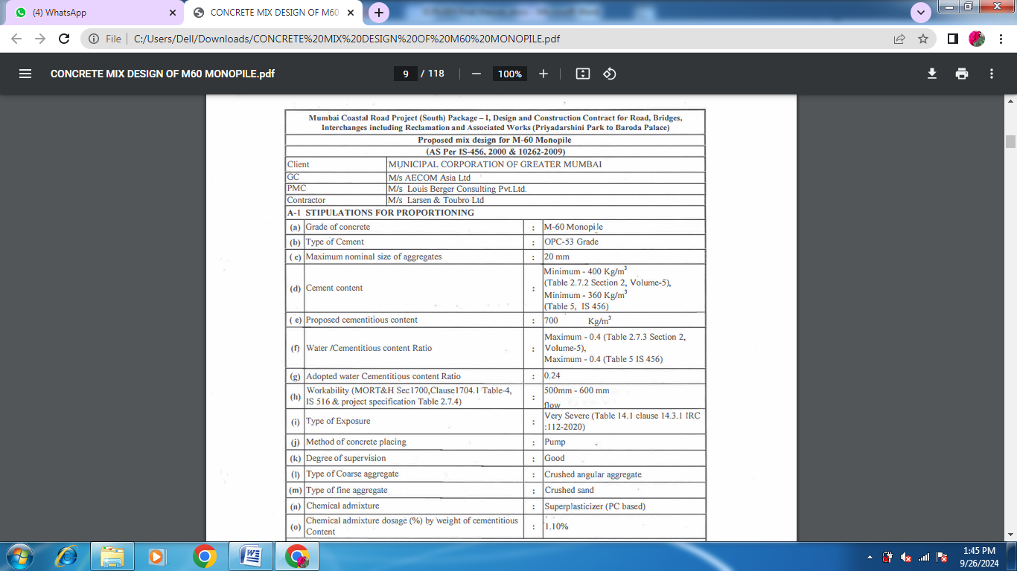

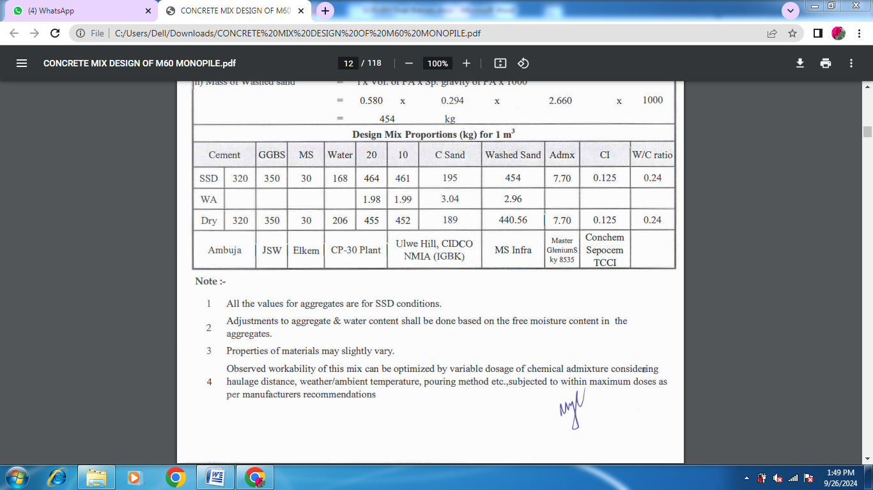

**3.2 Slump Test Result of Different Mix Design**

|  |  |
| --- | --- |
| **Mix** | **Sump mm** |
| M1 | 630 |
| M2 | 620 |
| M3 | 635 |
| M4 | 640 |
| M5 | 630 |

3.3 **composition of mix M60 for monopile**

|  |  |  |
| --- | --- | --- |
| **S.no.** | **Ingredient** | **Quantity kg/cum** |
| 1 | OPC (Type V) | 320 |
| 2 | C Sand (150-400 micron) | 195 |
| 3 | Washed sand | 454 |
| 4 | GGBS | 350 |
| 5 | MS | 30 |
| 6 | Admixture | 7.70 |
| 7 | Water | 168 |
| 8 | 20 mm agg. | 464 |
| 9 | 10 mm agg. | 461 |
| 10 | CI | 0.125 |
|  |  |  |

**4. RESULTS AND DISCUSSION**

**3** **Load test**

**Applied Load and result**

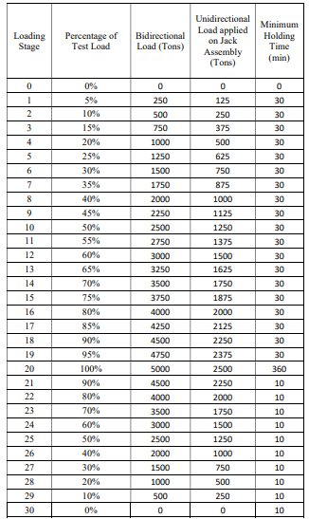

**Total displacement recorded**

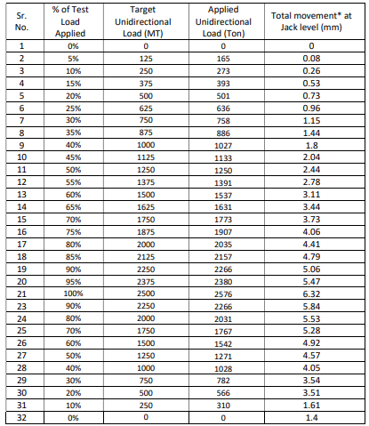

**recorded displacement**

All the three BDSLT (BIDIRECTIONAL STATIC LOAD TEST) test results didn’t show much movement on the monopiles and almost all the load dissipated even before reaching the pile toe. In MPV2, the displacements of bearing plates in either direction are less than 5 mm, so load test was stopped after reaching the maximum unidirectional load of 2576 MT (planned 2500 MT).

Since the observed displacements (in either direction), was less than limiting displacement as explained above, extrapolation of the bidirectional plots is not performed and based on available data points, the equivalent top load plot was developed (see Figure A1).

Based on above test results, it may be concluded that for the given rock embedment length in the similar rock geology, the ultimate pile resistance can be considered as higher than the target test load of 5000 MT Strain gauges at level 1 to 4 showedexceedingly small values of microstrain sensing from the beginning of the test. Since these strain gauges were located within the liner level (placed around pile shaft), the sensed microstrain was exceedingly small and may be ignored. At smaller applied unidirectional test loads, microstrain readings of few levels (i.e., Level 11 strain gauges show lower strain than Level 10 strain gauges. However, beyond it, the microstrain readings were in good agreement with applied load and subsequent load distribution. The individual microstrain readings of all the four units (installed at each level/elevation) are uniform and no significant difference is seen between them.

The last strain gauge level was located at RL (Relative Level) – 23.7 m CD (Chart Datum) (i.e., 0.55 above the pile toe level). Hence, load sensed by the last level strain gauges can be load transferred to the end bearing. In other words, the mobilized end bearing resistance may be representative of the load calculated at the Strain gauge level SG13.

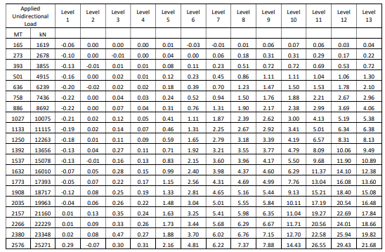

**Load & recorded Displacement**

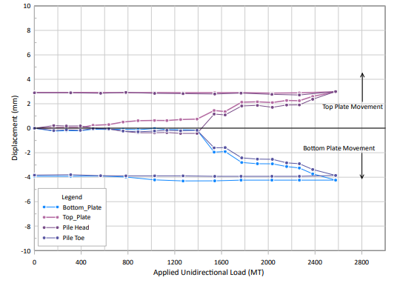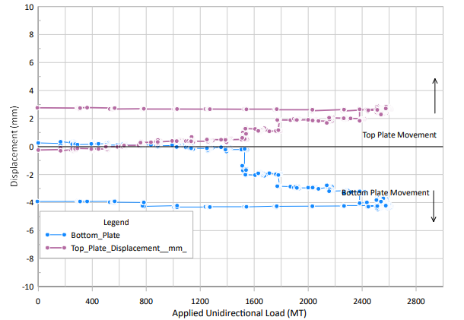

**Load vs Displacement chart**

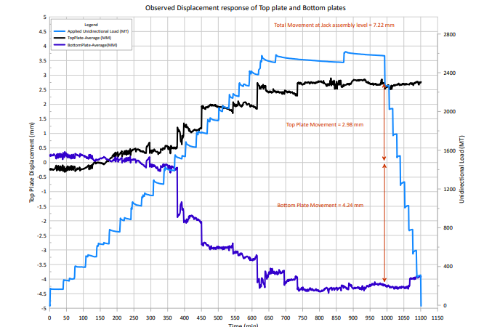

Observed Load-Settlement Response during Test chart

During the maximum applied test load, at final stage, the pile above or below the jack did not experience any significant displacement showing mobilization of considerable shaft resistance. This also shows that pile has considerable balance capacity, and the observed shaft resistance is not ultimate shaft resistance (i.e., upon further loading beyond present test load it may reach to higher value further without crossing limiting displacement).

The end bearing load is derived based on the consideration that the load sensed by level 13 strain gauges will be transferred to the toe load/ End bearing (ignoring the shaft friction contribution below strain gauge level SG13). The end bearing stress is then derived considering the full shaft area contact at the toe. At the ultimate test load, the mobilized end bearing is seen to be 3.17 MPa.

Maximum end bearing load of 1558 MT was seen during ultimate test load (as calculated through strain gauge readings). However, it is imperative to note that with microstrain measurements saw during test, calculated mobilized end bearing resistance are not ultimate end bearing resistance and pile may show significant balance end bearing resistance for higher toe movements.

**4.4 Lateral Load test:**

Three lateral load testing on a test pile of 2500 mm diameter and 3200mm diameter drilled shaft at proposed location in Amarsons, Haji Ali and Main bridge.

The main aim of this load test was to proof-load the test pile to its maximum Lateral test loadof 700 MT todecide the ultimate pile resistance in lateral direction/ capacity and

establish a safe working lateral load on the pile for the proposed construction facilities.

The test pile was a drilled shaftwith a total embedment length below test level of 19.65m

Pile Dimension: 2500 mm

Pile Built- up Level: + 5.899 mCD.

Pile Toe Level (PT): -13.750 mCD

Pile Length (Pile Built-up level to PT): 19.65 m (Specified length below cut off level)

Working Load: 350 MT

Test Load: 700 MT

**4.5 TESTING ON WORKING PILES:**

**4.5.1.CROSS-HOLE SONIC LOGGING:**

CHSL testing follows the ASTM D6760 specifications. All the working piles were tested with Cross-Hole Sonic Logging. Generally, the CHSL tests were carried out 7 days after the date of concreting. Cross hole sonic logging tests conducted at Construction Joint Level +3.750m irrespective of the pile built-up level.

A Cross Hole Analyzer device is connected to one transmitter &one receiver which is lowered in the pile shaft through access/sonic pipes and then pulled at a reasonably constant rate to continuously record the arrival time of pulses between the probes and record the loss of energy during transmission, as the probes are drawn up from the bottom to the top of the pile. This is a quality assurance program to ensure that the pile shaft is formed properly and is of targeted depth.

The probes shall be lowered to the bottom of the piles, brought to the same level and then pulled back. While pulling the probes, the CHA equipment continuously records arrival times versus depth graph. Optionally, data can be collected while lowering the probes from the top. The equipment shows if the probes are not at the same level while pulling or if there is a missing scan in which case the probes shall be adjusted by lowering one of the probes to match each other before the test is continued.

The CSL (Crosshole Sonic Logging) (Cross hole Sonic Logging) procedure inspects the piles’ structural integrity, extent and location of defects, if any. At the receiver probe, pulse arrival time and signal strength are affected by the quality of concrete. Uniform concrete yields consistent first arrival times (FAT) with reasonable pulse wave speed and signal strengths. Non-uniformities such as contamination, soft concrete, and honeycombing, voids, or inclusions show delayed arrival times (FAT) with reduced signal strength. Here, the rating of the integrity considers the increases in “first arrival time” (FAT) and the energy reduction compared to the arrival time or energy in a nearby zone of good concrete. The wave speed obtained is a useful tool to evaluate concrete quality.

Wave speed is best found from the test results from the major diagonals. The wave speed is also affected by the age of concrete, plumb of the holes, reinforcement if any between the holes and hence many times the energy is considered a more important parameter in evaluating the results.

**Table 4.3 .**

|  |  |  |
| --- | --- | --- |
| Classification | FAT Increase compared to  good concrete | Energy reduction compared to good concrete |
| Satisfactory / Good | 0-10% | < 6 dB |
| Minor Defect | 11-20% | < 9 dB |
| Poor/Flaw | 21 to 30% | < 9 to 12 dB |
| Poor/Defect | >31% | > 12 dB |

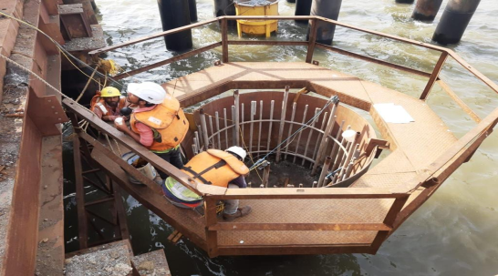 **Fig CHSL testing in offshore monopile.**

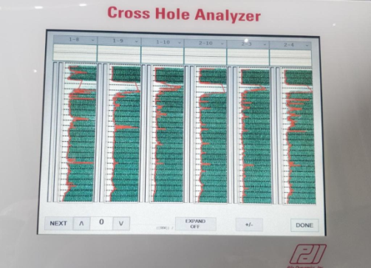 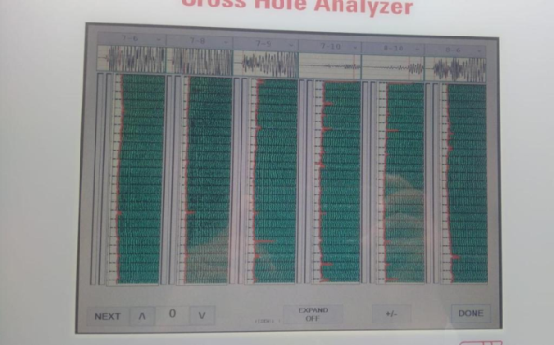 **Fig Field report of CHSL showing some hazy signal**

**4.8 PILE DYNAMIC ANALYSIS (PDA) PDA test setup**

The testing is conducted by impacting the pile with blows of the hammer generally starting with a smaller drop height of 0.5m. This is to ensure the correctness of the data and the setup arrangements. Testing continues by increasing the hammer height by about 0.5m increment till the time the pile set or capacity reaches the required or limiting values.

For each hammer blow, the strain transducers measure strains while accelerations are measured by accelerometers connected on either side of the pile and the settlement/results can be viewed through the monitor with real time readings.

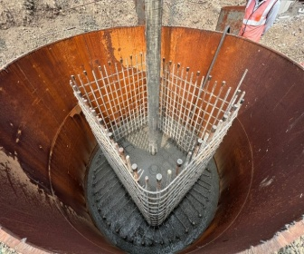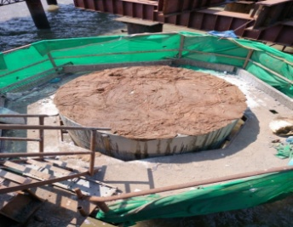 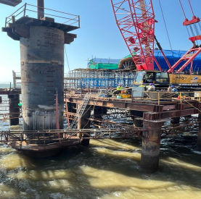 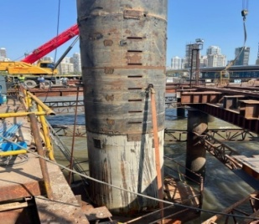

**Fig Pile head concrete pou Prepared pile top for PDA.** PDA test setup (offshore)fig PDA Sensors fixed at the platform level.

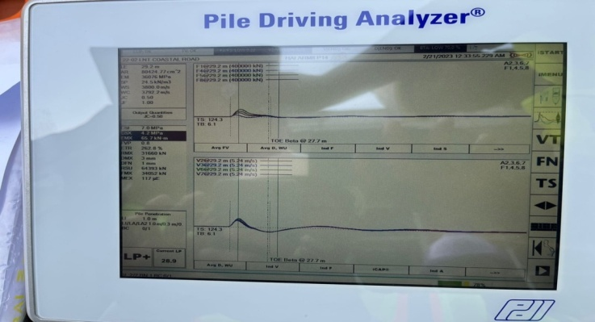 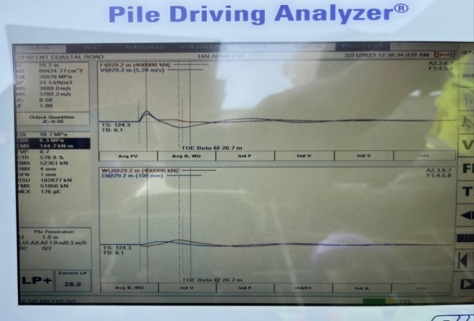

**Results with height of fall 0.5m Results with height of fall 1.0m**.

**4.9.1 Liner driving in AGI:**

Amarsons garden interchange boasts Basaltic bedrock with highly undulated bed formation created difficulties in liner placement and driving. Therefore, outer liners were used to nullify the effect of waves in monopile liner placing (wherever possible).

Extra beams were welded with the support piles to hold the liner in position and within tolerance. The gap between the outer and inner was filled with plug concrete to reduce the wave impact that disturbed the liner position earlier.

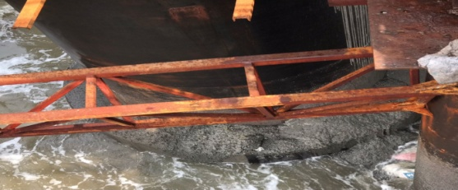

Fig Plug concrete between outer & inner liner to counter the wave impact on liner.

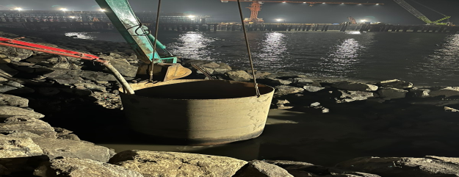

**Fig Plug concrete in the outer liner to get a proper surface for inner liner**.

Another main issue faced in AGI, is the liner tilt while drilling. Also, severe water loss occurred in piles which is countered byadded water input with the help of 2*75HP pumps. Liner tilt during drilling caused the BHA struck inside the borehole which took almost 30 days to retrieve. Several attempts were made to remove the borehole assembly, but everything ended up in vain. Finally, Hydraulic jacks were used to pull out the BHA assembly.

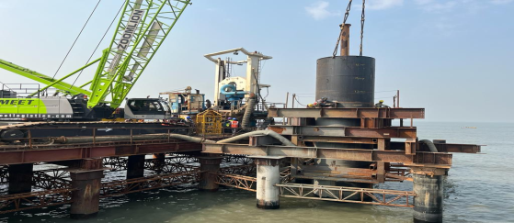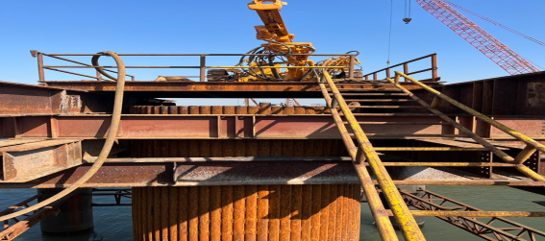

All the above challenges delayed the production rate drastically and almost all the piles in AGI ended up in excess concrete consumption (some piles consumed more than 150% of theoretical concrete consumption). Concrete loss saw at liner tip location almost all the piles. This pattern of concrete loss was inspected with the diver team, and underwater photos revealed a considerable gap between the liner toe and surrounding bedrock. The tremie pipes were kept immersed in the concrete upto 10metres to avoid the choking due to the sudden loss in the concrete level inside the monopile.

To avoid excessive concrete wastage into the sea, sandbags were placed around the pile liner at the bed rock levels. This in turn reduced the amount of concrete loss. Towards the fag end of the monopile construction, concreting was scheduled in hightide time to avoid the excess concrete loss as the wave pressure arrested the concrete loss considerably.

**4.10 Borehole collapse while drilling:**

In haji Ali interchange and Mainline bridge, 3 monopiles were collapsed at the time of drilling. The main reason for such a collapse is the pile liner which was not driven upto the design level.

Once the collapse is confirmed (the drilling levels stayed the same even after drilling for 4-5 hours), the RCD unit along BHA was de-mounted and the pile was then left idle for a couple of days and then Liner driving done upto the possible level. Once the collapse stopped, the pile drilled upto the roe level and concreted.During the drilling of a collapsed pile, the slush from the collapsed zone clogged the outlet pipe of cutting drum (BHA’s part) and then the entire BHA was removed and dismantled into pieces to clear the outlet pipeline.

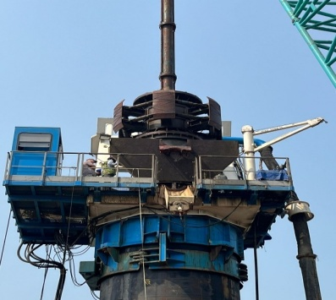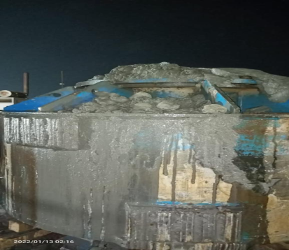

Fig RCD/BHA dismantling from Pile. Fig Slush blocked the drum outlet.

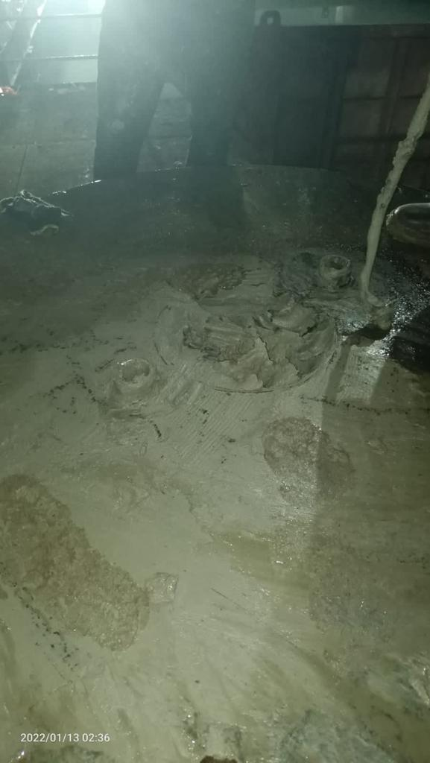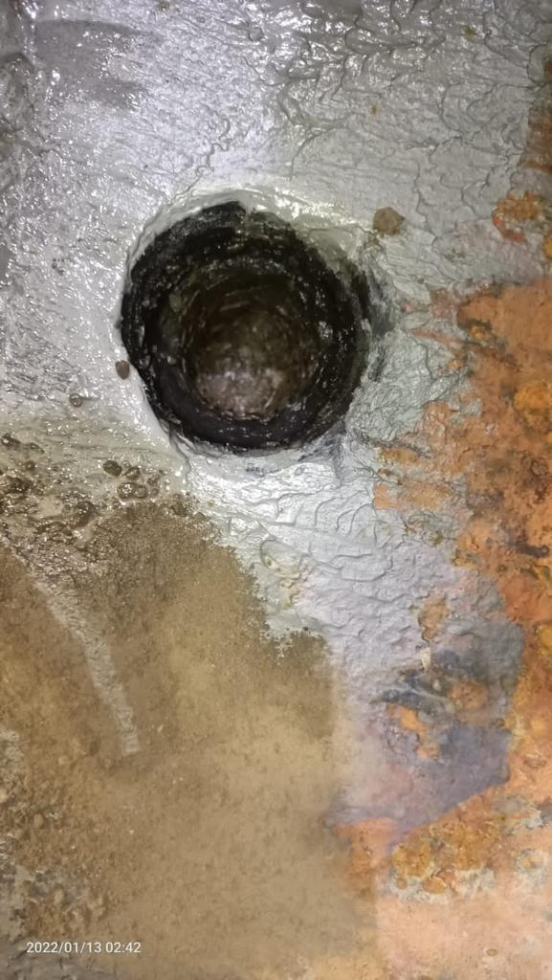

**Fig Clogged Drum outlet fig Outlet pipeline after slush removal.**

**4.11 Anomalies in CHSL test:**

Each monopile was tested for CHSL as per the contract specifications. In the first stages of monopile construction, hazy signals were seen in the longer corridors of sonic tubes, while the adjacent tubes showed satisfactory results and were ruled out as debonding between the Concrete and CHSL tube.

As the same pattern continued in successive tests, concrete coring was done. The cores retrieved from the pile were tested for water permeability and visual examination of cored samples. In some pile core samples, there was a continuous breakage in the cores at the same levels of defects seen in the CHSL report.The piles with such defects are then tested for water permeability and optical televiewer & hydro-jetting. The test results showed the presence of weak concrete/honeycombing in the defect levels of CHSL reports.

Epoxy & Microfine grout was used to fill those piles with defective cores and in some piles 32mm dia rebars were inserted into the core holes and then grouted.

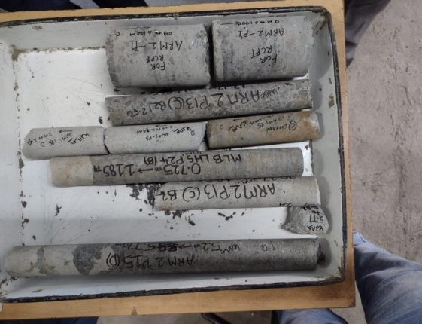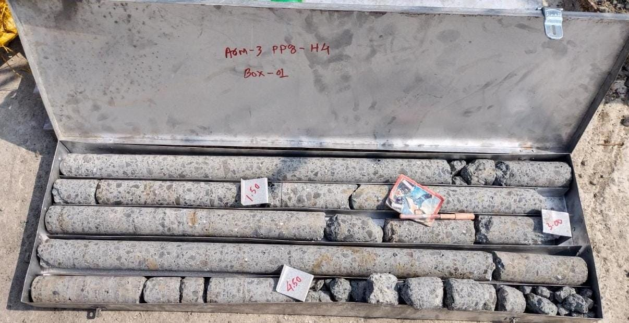

4.12 Cost estimation of the work

Table 4.15 abstract

|  |  |  |  |  |  |
| --- | --- | --- | --- | --- | --- |
| **Sl.No** | **Properties** | **As per Present ITP** | **If revised** | **Qty** | **Cost (Ind. Rup.)** |
| 1 | Deleterious material | 1/Source | 1/3 months | 32 | 14080 |
| 2 | Crushing value | 1/15 days | 1/6 months | 16 | 5600 |
| 3 | Soundness | 1/Source | 1/6 months | 16 | 16000 |
| 4 | Petrographic examaination | 1/Source | 1/Year | 6 |  |
| 5 | Alkali Reactivity | 1/Source | 1/6 months | 16 | 7040 |
| 6 | Chloride & sulphate content | 1/Source | 1/3 months | 32 | 16640 |
| 7 | OPC | 1/Source | 1/6 months | 4 | 7600 |
| 8 | Admixture | 1/Source | 1/3 months | 20 | 37200 |
| 9 | Microsilica | 1/Source | 1/6 months | 4 | 5400 |
| 10 | corrosion inhibitor | 1/Source | 1/6 months | 4 | 15000 |
| 11 | Durability | 1/ 6 months | 1/1000 cum | 200 | 3291000 |
| 12 | Reinforcement steel | 1/1500 MT | 1/500 MT | 40 | 20000 |
| 13 | Strand | 1/Source | 2/Lot | 36 | 90000 |
|  | Total amount of the work is |  |  |  | RS=3525560 |
|  |  |  |  |  |  |

1. CONCLUSIONS

The construction of Monopiles delayed from initial schedule due to various issues like heavy downpour, rough sea and construction & Quality related delays. Executing the monopiles in 3 different locations with a totally different geology is itself a biggest challenge as the drilling rate and method in each loaction varies from another.

The test results of 3 piles with maximum defects in AGI,HAI & MLB shows that the pile is capable of taking the loads from the superstructure as the piles where tested with an impact load approximately 10-15% more than the design load. Many of the delays could have been eliminated if the liner driving was done upto the design level and a proper mix design of the concrete.

Though the construction works posted many challenges, the construction of new piles never stopped which added to the further delay in the schedule.

* It may be possible to achieve optimum performance by positioning a relatively small number of piles in the right place rather than using more heaps or increasing the raft thickness.
* In monopile case, the vertical load reduces the maximum bending torque as well as the lateral defor-mation when subjected to single rod lateral load.
* Safety against a bearing capacity failure, average settlement and different settlement are the quantities to be controlled by monopile foundation.
* Monopile foundations are suitable for the stability of structures and improve performance.

**6 .0 References:**

1. S. Piras, A. Palermo & G. Chiaro “Development of dissipative controlled rocking system for bridge columns supported on monopiles”, University of Canterbury, Christchurch New Zealand Society for Earthquake Engineering, 2021 Annual Conference-Paper 26.
2. Maddela Jyothi Kiran, Gomasa Ramesh and Dr. Annamalai Rangasamy Prakash, “Soil- Structure Interaction study on Group pile over Monopile Foundation”, International Journal for Modern Trends in Science and Technology, Vol. 07, Issue 03, March 2021, pp: 290-294.
3. Kementzetzidis E.; Metrikine, A, Versteijlen, Willem Geert, Pisano, F (2020) “Frequency effects in the dynamic lateral stiffness of monopiles in sand: insight from field Tests and 3D FE modeling”. Geotechnique: International journal of Soil mechanics, 71(9), 812-825.
4. Boominathan Adimoolam and R. Varghese “A study on the effect of pile cap on the vertical impedance of a single pile”,16th Asian Regional Conference on Soil Mechanics and Geotechnical Engineering, Oct-14-18, 2019, Taipei, Taiwan.
5. V. S. Phanikanth, Deepankar Choudhury, and G. Reddy “Behavior of Single Pile in Liquefied Deposits during Earthquakes” International Journal of Geo-mechanics Vol. 13 July/August 2013 pp 454-462.
6. Vanapalli S.K and Taylan Z.N, “Design of Single Piles Using the Mechanics of Unsaturated Soils” International Journal of Geomate, March 2012, Vol 2, (Sl No.3), pp.197-204.
7. Etienne A. Alderlieste, Jelke Dijkstra, A. Frits van Tol, “Experimental investigation into pile diameter effects of laterally loaded mono-piles”30th International Conference on Ocean, Offshore and Arctic Engineering, June 19-24, 2011. Rotterdam, the Netherlands.
8. Jasim M Abbas Zamri Hj Chik Mohd Raihan Taha**,** “Single Pile Simulation and Analysis Subjected to Lateral Load”, International Journal of Geotechnical Engineering, Vol. 13. (2008).
9. Ricardo Dobry, Tarek Abdoun, Thomas D. O’Rourke, and S. H. Goh, “Single piles in Lateral Spreads: Field Bending Moment Evaluation”, International Journal of Geotechnical and Geo-environmental Engineering, Vol. 129 No.10, October 1. 2003, pp.-879-889