**APPLICATION OF HARMONIC POWER FLOW ANALYSIS WITH PROBABILISTIC LOAD VARIATIONS IN DISTRIBUTION SYSTEMS**

**Fatima Muhammad1, D.M. Nazif1, Aminu Umar2, Na’im Garba Yusuf3, Sadiq Umar1, Aliyu Abdulrahman4**

1Department of Elect./Electr. Engineering Technology, Federal Polytechnic Bauchi, P.M.B. 0231, Bauchi, Nigeria; *2Dept. of Mechatronics Engineering Technology, Federal Polytechnic Bauchi, PMB 0231 Bauchi State, Nigeria; 3Dept. of Elect./Electr. Engineering Technology, Federal Polytechnic N’yak, Plateau State, Nigeria; 4Department of Computer Engineering Technology, Federal Polytechnic Bauchi, P.M.B. 0231, Bauchi, Nigeria.*

**ABSTRACT**

*Several kinds of power quality problems can affect the electrical power system. A power quality assessment is required to ensure the precise operation of sensitive equipment. Additionally, it ensures that a power system's needless energy losses are minimized, increasing profitability. One analytical tool used to analyze power quality issues in power systems is power flow. In this work, the basic scenario was implementing harmonic power flow on a single standard distribution system called the Ski-Area network, which consisted of 17 buses. A 5-bus dedicated radial distribution network with a 5 MW linear load and a 2000 HP (1.5 MW) nonlinear 6-pulse converter load was used to study another dedicated feeder. The study utilized "PCFLO" harmonic power flow software to model two networks, converting data into a per unit representation for various power apparatus and equipment. The software was designed with Gauss-Seidal start and Newton Raphson up to 25th harmonic order, considering stochastic load situations. The results showed that the harmonic pattern at bus 12 and feeder 8 had the highest Total harmonic distortion (THDv) and (THDI) at 7% and 147%, respectively, based on the ski area results. The values of THDv and THDI for the 5-bus dedicated distribution network were found to be 45.3% and 7.31% at bus 4, the converter load branch, and bus 5, respectively. The correlation between the simulation and measurement results indicates that they are almost in conformity with the Total Harmonic Distortion (THD) standards of 5% and 20% for voltage and current distortion, respectively, as defined by the Nigerian Electricity Regulatory Commission.*

*Keywords: THDi, THDv, PQ, PCFLO, ATBU*

**1.0 INTRODUCTION**

Electric power quality is a critical concern for both consumers and utilities. Research on power line disturbances, such as voltage sag, harmonic distortion, flicker, notch, spike, and transients, which can cause malfunctions, instabilities, and short lifespans, is becoming more and more relevant. (Ullah et al., 2022). Distribution system planning now requires pre-assessment of harmonic patterns under stochastic load variations for electronic gadgets, identifying anomalous behavior early to prevent system failure and mitigate power quality problems. (Kamel et al., 2019).

Harmonic distortions are caused by nonlinear loads like switch-mode power supplies, VSDs, photocopiers, and UPSs, which transfer harmonics. (Cagri et al., 2020). These loads are common in office buildings and industrial facilities, particularly in computer systems that convert AC electricity into regulated low-voltage DC for internal devices. High-amplitude pulses in non-linear power supplies significantly affect voltage and wave shape harmonic distortion (THD), potentially causing communication problems, overheating, and hardware damage when it contributes significantly to the overall load. (Lamedica et al., 2018).

Periodic voltages and currents have harmonic frequencies that are integer multiples of the frequency of the primary signal, whereas sinusoidal voltages and currents have no harmonic distortion because they only have one frequency. (Yang et al., 2023). Harmonic distortion is the distortion of the signal due to these harmonics. (Gharebaghi et al., 2019). Harmonics are voltage and current types, originating from voltage supply harmonics and influenced by load types like resistive, capacitive, and inductive loads, and can come from the load side or source. (Ruiz-rodriguez et al., 2020).

Harmonic disturbances pose a significant power quality issue, particularly in large-scale harmonic-rich equipment like motor controllers, ICT, and medical devices, affecting efficiency and profitability. (Kharrazi et al., 2020). Distribution system planning now necessitates pre-assessment of harmonic patterns under stochastic load variations to identify anomalous behavior early, thereby preventing system failure.

**2.0 LITERATURE REVIEW**

Stationary and non-stationary disturbances are the main categories of current PQ disturbances. Non-stationary disturbances cause voltage sag, while stationary disturbances cause distortion. Future PQ monitoring is crucial for smart grid networks, including microgrids, renewable energy sources, and market competition. (Hernandez et al., 2020).

Harmonic distortion, caused by higher frequency components in periodic voltages or currents, is the primary cause of power quality issues in electrical systems, leading to low power factor, equipment lifespan, and decreased profit margins. (Xie et al., 2020).

Montoya et al., (2019) highlight the impact of faults in the public utility power grid on renewable energy sources, leading to unpredictable operational conditions. Traditional power systems lack power quality benchmarks, but non-dispatchable and intermittent renewable sources introduce issues. Determining these connections is crucial for preventing transmission losses and instability.

At the stages of generation, transmission, and distribution, waveform distortion happens. While distributed generation (DG) systems generate considerable waveforms due to power electronics devices during transmission and changing loads during distribution, conventional power plants are resistant to waveform distortions. (Zhang et al., 2019).

Research on electric power quality disruptions is influenced by deregulation and concerns about clean power delivery from monopolistic operators. Non-linear loads like distributed generating systems and variable frequency drives are increasingly prevalent in residential, commercial, and industrial power infrastructures. (Che et al., 2020).

Using a Monte Carlo technique, the study examined the impact of DER rating and location on DC or AC distribution feeder voltage. (Amini et al., 2019; Bajaj & Singh, 2021; Kiani-moghaddam et al., 2019). Future microgrids could benefit from the authors' suggested DC/AC radial distribution feeder architecture, which focuses on voltage imbalance, voltage drop, and frequency disturbance in low-voltage hybrid AC/DC radial distribution (Al-jaafreh & Mokryani, 2019; Kazemi-robati & Sepasian, 2019). The study focuses on analyzing the Hosting Capacity of distributed energy resources (DERs) in a network, considering factors like voltage deviation, phase unbalance, thermal overload, power losses, and protection device miscoordination. (Bajaj et al., 2020). Four methods are identified: deterministic, stochastic, optimization-based, and streamlined. The selection depends on the study type and available data.

The detrimental impacts of harmonic pollution are causing increasing concern. System designers need to use precise mathematical models and analytical techniques to avoid this. (Asadi et al., 2021; X. Li et al., 2019). However, the lack of readily available data makes the development of these models difficult. Harmonic analysis is essential for solving problems.

**3.0 MATERIALS AND METHOD**

As long as the distribution system is neither unbalanced nor has significant single-phase harmonic loads, this study employs a balanced harmonic flow methodology using steady-state harmonic modeling and analytical tools.

Large three-phase balanced loads, like ASDs, are typically the ones that cause issues. Distribution capacitors are typically used as three-phase banks, which balance the propagation of harmonics. Single-phase load and load-level phase identification might not be readily available. Injection "rules of thumb" must be applied because the harmonics data for the distorting loads may be of poor quality. Since systems are frequently researched beforehand, not all of the real data are available.

**3.1 Materials**

These include an industrial customer, the SKY distribution network, a personal computer, PCFLO, a Power quality analyzer (FLUKE 435), POWERLOG statistical software for harmonic analysis.

**3.1.1 An industrial customer**

A dedicated 132/11 kV substation transformer was used to build a 5 km 11 kV overhead feeder for an industrial customer. The customer is anticipated to have a 2000 HP (1.5 MW), six-pulse adjustable-speed drive (ASD) and a 5 MW conventional load with a displacement power factor of 0.85 (Z. Li et al., 2020). There is no phase shift because the ASD is connected via a delta-delta transformer. Additionally, 1800kVAr of shunt power factor correction capacitors belong to the customer. The one-line diagram is shown in Figure 1.

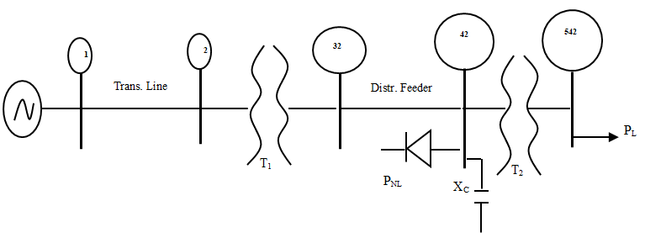

Figure 1: One-Line Diagram of a 5-Bus 132/11 kV Network

**3.1.2 The SKI Distribution Network**

Figure 2 depicts the tourist distribution network in the SKI area. It consists of eight DC-powered ski lifts and a partially meshed underground system with 17 buses. There is roughly a 9 MW overall load. (Seydali et al., 2019). Six-pulse line-commutated ASDs provide soft-start and soft-stop operation for DC motors. As seen in Figure 2, the ideal bus ordering facility in PCFLO defies the standard sequential numbering of network buses.

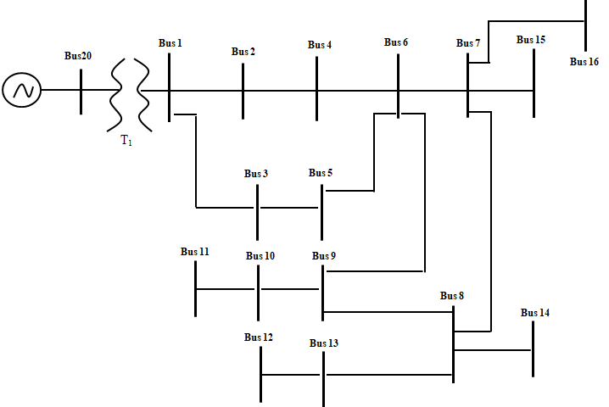

Figure 2: One-Line Diagram of a 17-Bus 13.8/12.5 kV Meshed Ski Network

**3.1.3 Power quality analyzer (FLUKE 435)**

Power distribution systems can be measured extensively by the Fluke 435 power quality analyzer, which measures voltages, current, frequency, dips, harmonics, power & energy, flickers, imbalances, phasors, transients, waveform display, and inrush.

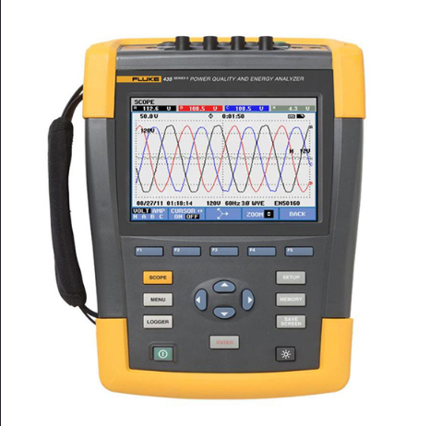

Plate I: Power Quality Analyzer (FLUKE 435)

The Fluke 435 Power Quality Analyzer monitors distribution reticulations with flexible clamps and voltage probes, providing real-time measurement and logging. It can be connected to a computer or laptop, logging data for up to a month and exporting data. The POWERLOG software allows data download from the Fluke 435 experimental rig, which is set up with typical algorithmic handshaking and port communication setup for analysis.(Cho et al., 2019).

**3.2 Methods**

The simulation and analysis of harmonic distortion of the two networks are accomplished according to the flow chart shown in Figure 3.

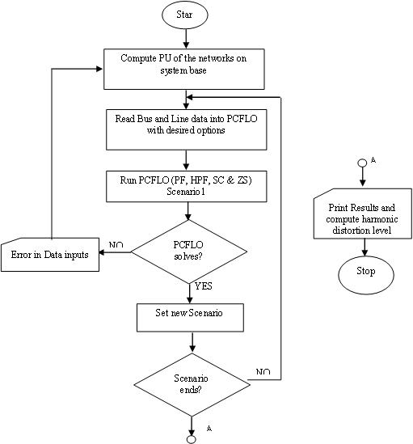

Figure 3: Flow chart to Run PCFLO

**3.2.1.1 Determination of P.U representation of the networks**

The research provided a per-unit representation of networks with a base of 10 MVA and 132 kV, detailing bus numbers, bus type, real power linear load demand, initial voltage specification, non-linear load, displacement power factor, and other parameters.

**3.2.2 Analytical procedures for scenarios studies**

As a primary research goal, the study used statistical indices for harmonic distortion levels to describe non-linear loads as a cumulative distribution function (25%, 50%, 75%, and 95%), which corresponds to stochastic load variation. Equation (1) provides the CDF of a normal distribution for a random variable.

$F_{X}\left(x\right)=P\left(X≤x\right)$…(1)

where:

$F_{X}\left(x\right)=function of X$, $X=real value variable$, $P=Probablity that X will have a value less than or equal to x$ (El-ela et al., 2019).

**4.0 RESULTS**

**4.1 Harmonic Distortion Pattern in Industrial Distribution System**

In the base case scenario, Figures 4 and 5 present the pattern of harmonic distortion in the five-bus industrial network for the current and voltage THD respectively.

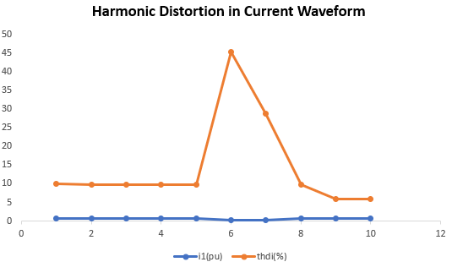

Figure 4: Harmonic Distortion in Current Waveform

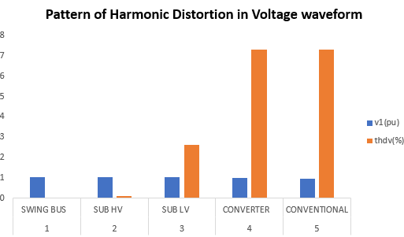

Figure 5: Harmonic Distortion in Voltage waveform

Figure 4 and Figure 5 show that bus 4 to the ground has the highest current THD with a 45.3% distortion level and 7.31% voltage THD at bus 5.

Figures 6 and 7 show the highest distortion levels for current and voltage waveforms in base case histogram plots. In bus 1, the in-feed point is virtually free of harmonic higher-order disturbances, with the 5th and 7th harmonic order at negligible values. In the section with non-linear load, harmonic disturbances are noticeable up to the 25th order, comparable to fundamental current values. The presence of higher-order harmonic quantities leads to high current THD in the network section.

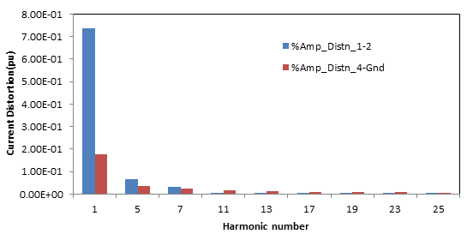

*Figure 6: Comparison of Distortion in Current at In-feed and Highest Distortion Section*

Figure 7 shows that bus 1 in-feed point is almost free of harmonic higher order disturbances in voltage waveform, with the 5th and 7th harmonic order negligible. However, in the section with non-linear load, harmonic disturbances are noticeable up to the 11th order, causing lower voltage THD.

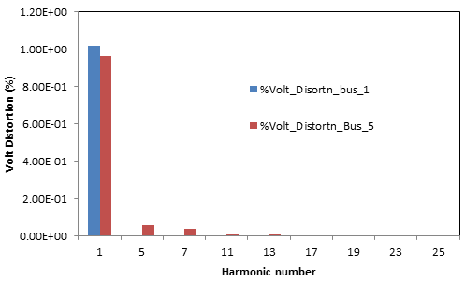

*Figure 7: Comparison of Distortion in Voltage at In-feed and Highest Distortion Section*

Figures 8 and 9 show distortion propagation patterns when a 20% non-linear load increase is applied, with real power at 17.904% and pf at 0.85. The distortion level in the shunt connection remains unchanged at 45.3%, while other areas show a 16.8% increase. The voltage distortion profile slightly increases by 3.72%. The change in distortion is due to non-linear load rise and distortion ripple.

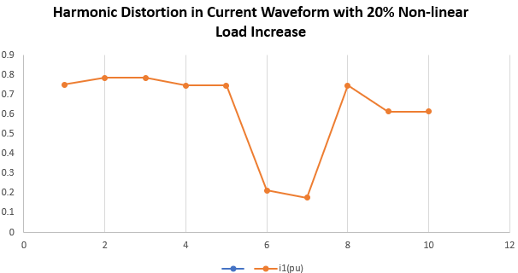

Figure 8: Harmonic Distortion in Current Waveform with 20% Non-linear Load Increase

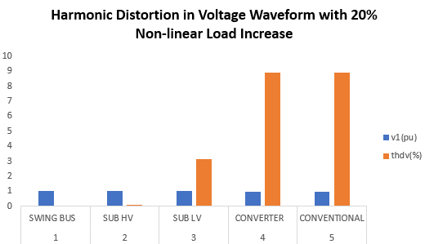

Figure 9: Harmonic Distortion in Voltage Waveform with 20% Non-linear Load Increase

The study assessed the harmonic disturbance level in the network by increasing the non-linear to 40% with a real power of 20.89% at 0.85 p.f. Results showed high distortion levels in neighborhood buses, but current and voltage THD remained at 45.3% and 16.8%, respectively. The summary of the scenarios treated is tabulated in Figure 10.

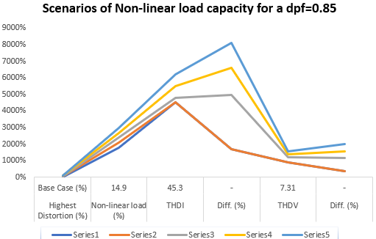

Figure 10: Scenarios of Non-linear load capacity for a $dpf=0.85$

Figure 11-14 shows that mitigating harmonic disturbance with PF corrective devices generally reduces distortion patterns across the network. In-feed substation THD decreases from 9.7% to 8.6%, and 0.09% to 0.1% for volt THD. The highest volt THD decreases significantly to 5.96%. However, the harmonic disturbance pattern worsens as dpf falls below 0.85.

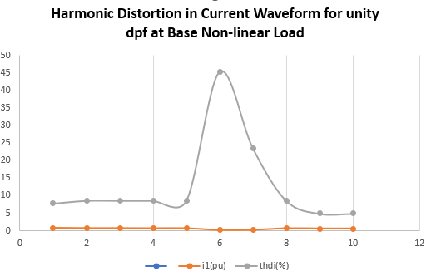

Figure 11: Harmonic Distortion in Current Waveform for unity dpf at Base Non-linear Load

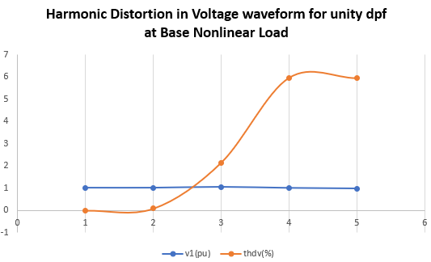

Figure **12**: Harmonic Distortion in Voltage waveform for unity dpf at Base Nonlinear Load

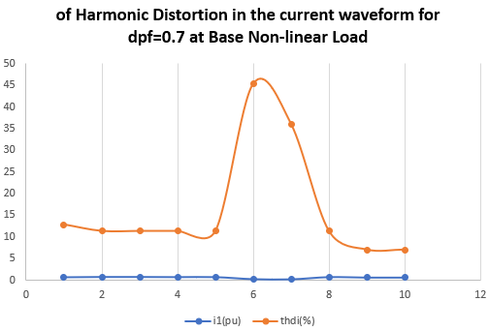

Figure 13: Harmonic Distortion in the current waveform for dpf=0.7 at Base Non-linear Load

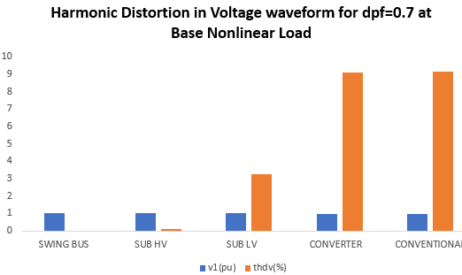

Figure 14: Harmonic Distortion in Voltage waveform for dpf=0.7 at Base Nonlinear Load

Figures 13 and 14 show a significant distortion in the power substation, increasing current THD to 11.3% and volt THD to 0.13%, which aligns with the theoretical concept of a nonlinear inverse relationship between dpf and THD.

**4.2 Harmonic Distortion Pattern in Meshed Distribution System**

The study examines harmonic distortion patterns in a 17-bus meshed network for current and voltage THD. The highest current THD is observed between the substation's in-feed and 15 ski feeders. The distortion is highest in the 17th and 19th orders, while the 23rd and 25th harmonic orders are prominent. The highest current harmonic distortion occurs at the branch between bus 10 and ground, resulting in a current THD of 174.5% for 0.012 pu fundamental current magnitude. The highest voltage THD is obtained at bus 15, with a value of 8.31%.

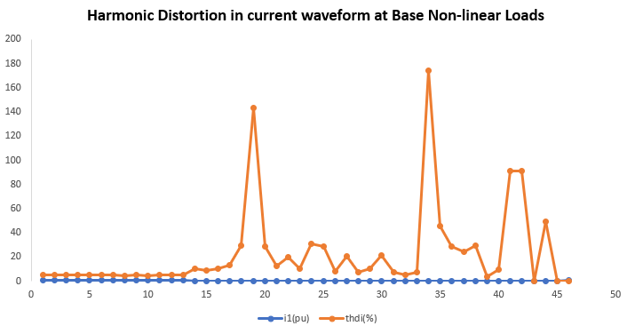

Figure 15: Harmonic Distortion in current waveform at Base Non-linear Loads

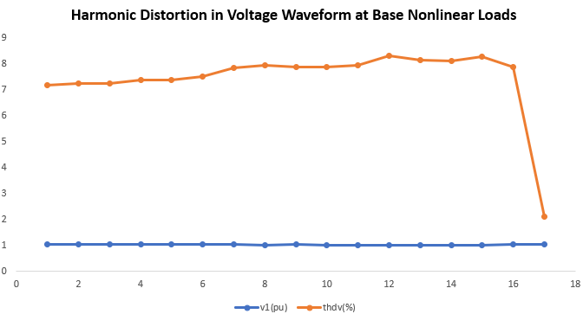

Figure 1**6**: Harmonic Distortion in Voltage Waveform at Base Nonlinear Loads

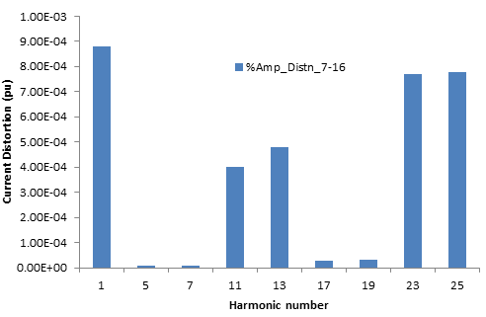

*Figure 17: Comparison of Distortion in Current at Highest Distortion Section*

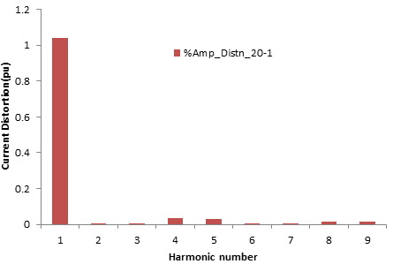

*Figure 18: Distortion in Current at In-feed Section*

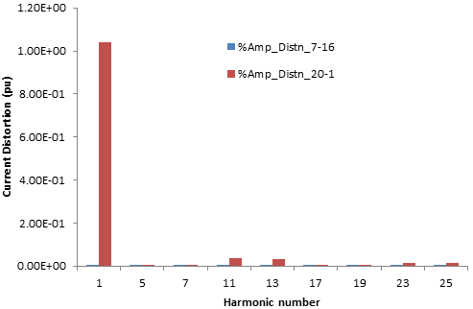

*Figure 19: Super-imposed Distortion in Current at In-feed and next Highest Distortion Section*

Bus 15 is the terminal point from Bus 7 and Bus 16, but the current THD at feeder Bus 7-15 is 29.6% for a fundamental current of 0.11 pu, compared to 143.3% for Bus 16. This is expected due to higher fundamental current which is inversely proportional to THD as in Eqn. (2)

$THD=\frac{K}{I_{1}}$. …(2)

where: $K=\sqrt{\sum_{h=2}^{25}{I_{h}}}$

K is a characteristic of a harmonic source connected at the point.

$$I_{1}=fundamental quantity, in pu.Amp$$

Eqn. (2) determines the value of THD, the fundamental current value in this section, based on the weighted factor K. However, the impact of harmonic disturbance is crucial and a source of concern for modern investigation under prolonged usage.

Figures 19 and 20 demonstrate the relationship between harmonic patterns in the in-feed section and feeder (Bus 11-shunt). Figure 20 shows no harmonic orders missing up to the 25th harmonic order, and the fundamental current is at decade order, resulting in a high current THD value of 174.5%.

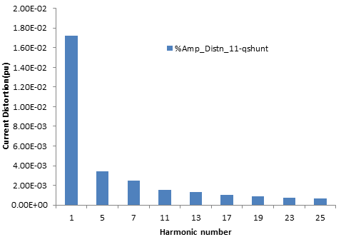

*Figure 20: Comparison of Distortion in Current at Highest Distortion Section*

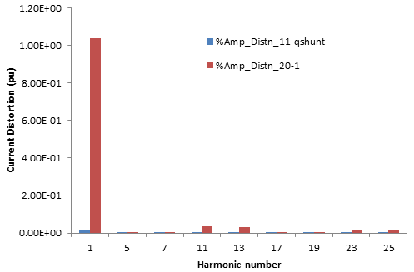

*Figure 21: Super-imposed Distortion in Current at In-feed and Highest Distortion Section*

The data from ATBU power networks shows that distortion levels vary over time, necessitating statistical analysis to determine the extent of harmonic disturbances. The data also reveals that THD values are higher at night than during the morning or evening periods.

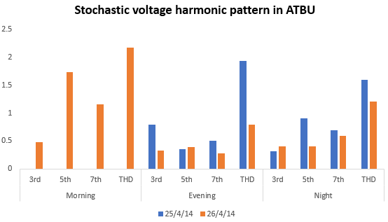

Figure 22: Stochastic voltage harmonic pattern in ATBU

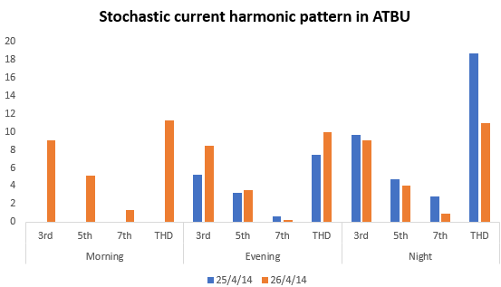

Figure 23: Stochastic Current harmonic pattern in ATBU

**5.0 CONCLUSION**

The harmonic power flow results for a named ski area and 5-bus dedicated distribution feeder have been obtained. For the ski network, the highest Total harmonic distortion (THDv) and (THDI) from the PCFLO were 7% and 147% occurring at bus 12 and feeder 8 respectively. For the 5-bus dedicated distribution network, the (THDv) and (THDI) were obtained as 45.3% and 7.3^% at bus 4, the converter load branch, and bus 5 respectively.

Stochastic harmonic models for two networks show that distortions are more prominent during the night due to low night loading and harmonic loads like TV and energy saving. Simulation results confirm that the HD is inversely proportional to the fundamental current level.

Power factor devices are practical, reliable, and economical methods for harmonic minimization in power systems. In an industrial network with heavily distorted power substations, mitigation of harmonic disturbance with PF corrective devices generally reduces distortion patterns. In the studied case, in-feed substation THD dropped from 9.7% to 8.6% for current THD and 0.09% for volt THD, with the highest volt THD decreasing significantly to 5.96%. However, harmonic disturbance patterns worsen as dpf falls below 0.85.

**6.0 RECOMMENDATIONS**

More practical networks need to be studied. One of the limitations identified was that the quality of harmonics data for the distorting loads may be poor.

More techniques and power quality enhancement with different filter designs in the distribution power systems are required. Attempt to use a practical radial network in the Jos Electricity Distribution Company in PCFLO failed and not accomplished as desired. Thus, foreign networks have been adopted in this research. There is a need to investigate the causes of the failure.

**7.0 REFERENCES**

Al-jaafreh, M. A. A., & Mokryani, G. (2019). Planning and operation of LV distribution networks : a comprehensive review. *IET Energy Systems Integration*, *2*(2122), 1–14. https://doi.org/10.1049/iet-esi.2019.0013

Amini, M., Jalilian, A., Rahimi, M., & Behbahani, P. (2019). Fast network reconfiguration in harmonic polluted distribution network based on developed backward / forward sweep harmonic load flow. *Electric Power Systems Research*, *168*(July 2018), 295–304. https://doi.org/10.1016/j.epsr.2018.12.006

Asadi, M., Shokouhandeh, H., Harikandeh, M. N., Asghari, F., Rahmani, F., Hamzehnia, S. M., Harikandeh, M. N., & Lamouki, H. G. (2021). Optimal Placement and Sizing of Capacitor Banks in Harmonic Polluted Distribution Network. *IEEE Xplore*.

Bajaj, M., & Singh, A. K. (2021). Hosting capacity enhancement of renewable-based distributed generation in harmonically polluted distribution systems using passive harmonic filtering. *Sustainable Energy Technologies and Assessments*, *44*(June 2020), 101030. https://doi.org/10.1016/j.seta.2021.101030

Bajaj, M., Singh, A. K., ALOWAIDI, M., SHARMA, N. K., SHARMA, S. K., & MISHRA, S. (2020). Power Quality Assessment of Distorted Distribution Networks Incorporating Renewable Distributed Generation Systems Based on the Analytic Hierarchy Process. *IEEE Access*, *8*(2020), 145713–145737. https://doi.org/10.1109/ACCESS.2020.3014288

Cagri, I., Karatepe, E., & Boztepe, M. (2020). Electrical Power and Energy Systems Impact of harmonic limits on PV penetration levels in unbalanced distribution networks considering load and irradiance uncertainty. *Electrical Power and Energy Systems*, *118*(December 2019), 105780. https://doi.org/10.1016/j.ijepes.2019.105780

Che, Y., Wang, X., Lv, X., & Hu, Y. (2020). Electrical Power and Energy Systems Probabilistic load flow using improved three-point estimate method. *Electrical Power and Energy Systems*, *117*(August 2019). https://doi.org/10.1016/j.ijepes.2019.105618

Cho, N., Lee, H., Bhat, R., & Heo, K. (2019). Analysis of Harmonic Hosting Capacity of IEEE Std. 519 with IEC 61000-3-6 in Distribution Systems. *2019 IEEE PES GTD Grand International Conference and Exposition Asia (GTD Asia)*, 730–734.

El-ela, A. A. A., El-sehiemy, R. A., Ali, E. S., & Kinawy, A. (2019). Minimization of voltage fluctuation resulted from renewable energy sources uncertainty in distribution systems. *IET Generation, Transmission & Distribution Research*, *13*, 2339–2351. https://doi.org/10.1049/iet-gtd.2018.5136

Gharebaghi, S., Safdarian, A., & Lehtonen, M. (2019). A Linear Model for AC Power Flow Analysis in Distribution Networks. *IEEE Systems Journal*, *PP*, 1–10. https://doi.org/10.1109/JSYST.2019.2921432

Hernandez, J. C., Ruiz-rodriguez, F. J., Jurado, F., & Sanchez-sutil, F. (2020). Tracing harmonic distortion and voltage unbalance in secondary radial distribution networks with photovoltaic uncertainties by an iterative multiphase harmonic load flow. *Electric Power Systems Research*, *185*(April), 106342. https://doi.org/10.1016/j.epsr.2020.106342

Kamel, S., Hamdy, W., Abd-elgwad, S., Carlo, M., Selim, A., & Jurado, F. (2019). Development of Probabilistic Power Flow Algorithm for Radial Distribution Systems with Capacitors Using Analytical Approach. *2019 10th International Renewable Energy Congress (IREC)*, *Irec*, 1–6.

Kazemi-robati, E., & Sepasian, M. S. (2019). Passive harmonic filter planning considering daily load variations and distribution system reconfiguration. *Electric Power Systems Research*, *166*(September 2018), 125–135. https://doi.org/10.1016/j.epsr.2018.09.019

Kharrazi, A., Sreeram, V., & Mishra, Y. (2020). Assessment techniques of the impact of grid-tied rooftop photovoltaic generation on the power quality of low voltage distribution network - A review Point of Common Coupling Point of Estimation Method Reactive Power Impact on Voltage Index Total Harmonic. *Renewable and Sustainable Energy Reviews*, *120*(December 2019), 109643. https://doi.org/10.1016/j.rser.2019.109643

Kiani-moghaddam, M., Shivaie, M., & Weinsier, P. D. (2019). Electrical Power and Energy Systems A techno-economic multi-objective model for hybrid harmonic filter planning considering uncertainty in non-linear loads. *Electrical Power and Energy Systems*, *112*(May), 339–352. https://doi.org/10.1016/j.ijepes.2019.05.013

Lamedica, R., Ruvio, A., Ribeiro, P. F., & Regoli, M. (2018). A Simulink model to assess harmonic distortion in MV/LV distribution networks with time-varying nonlinear loads. *Simulation Modelling Practice and Theory*. https://doi.org/10.1016/j.simpat.2018.10.012

Li, X., Gan, W., & Yan, S. (2019). Optimal Dispatch for Battery Energy Storage Station in Distribution Network Considering Voltage Distribution Improvement and Peak. *Journal of Modern Power Systems and Clean Energy*, *XX*(Xx), 1–9. https://doi.org/10.35833/MPCE.2020.000183

Li, Z., He, Z., Song, Y., Tang, L., & Wang, Y. (2020). Stochastic Assessment of Harmonic Propagation and Amplification in Power Systems Under Uncertainty. *IEEE Transactions on Power Delivery Stochastic*, *8977*(MC), 1–10. https://doi.org/10.1109/TPWRD.2020.3002890

Montoya, F. G., Baños, R., Alcayde, A., & Arrabal-campos, F. M. (2019). Electrical Power and Energy Systems Analysis of power flow under non-sinusoidal conditions in the presence of harmonics and interharmonics using geometric algebra. *Electrical Power and Energy Systems*, *111*(March), 486–492. https://doi.org/10.1016/j.ijepes.2019.04.032

Ruiz-rodriguez, F. J., Hernandez, J. C., & Jurado, F. (2020). Electrical Power and Energy Systems Iterative harmonic load flow by using the point-estimate method and complex affine arithmetic for radial distribution systems with photovoltaic uncertainties. *Electrical Power and Energy Systems*, *118*(December 2019), 105765. https://doi.org/10.1016/j.ijepes.2019.105765

Seydali, M., Abad, S., Ma, J., & Han, X. (2019). Distribution systems hosting capacity assessment: Relaxation and linearization. In *Smart Power Distribution Systems*. Elsevier Inc. https://doi.org/10.1016/B978-0-12-812154-2.00023-7

Ullah, Z., Wang, S., Wu, G., Qazi, H. S., Tostado-véliz, M., Jabbar, M. W., Turky, R. A., & Elkadeem, M. R. (2022). Advanced studies for probabilistic optimal power flow in active distribution networks : A scientometric review. *IET Generation, Transmission &Distribution*, *June*, 3579–3604. https://doi.org/10.1049/gtd2.12555

Xie, X., Sun, Y., Wang, Q., Li, Y., Zhang, Y., & Zhang, L. (2020). A Piecewise Probabilistic Harmonic Model of Aggregate Residential Loads. *IEEE Transactions on Power Delivery 1*, *8977*(c), 1–11. https://doi.org/10.1109/TPWRD.2020.2995081

Yang, C., Sun, Y., Zou, Y., Zheng, F., Liu, S., Zhao, B., Wu, M., & Cui, H. (2023). Optimal Power Flow in Distribution Network : A Review on Problem Formulation and Optimization Methods. *Energies*, *16*(5974), 1–42.

Zhang, J., Xiong, G., Meng, K., Yu, P., Yao, G., & Dong, Z. (2019). Electrical Power and Energy Systems An improved probabilistic load flow simulation method considering correlated stochastic variables. *Electrical Power and Energy Systems*, *111*(January), 260–268. https://doi.org/10.1016/j.ijepes.2019.04.007