**Review On Lozenges**

**Vishal Lakshman Ajabe1* Mr.Akash Kale2* Dr.Sanjay Garje**

**Dr. Gaffar Sayyed**

1) Student, Shri Amolak Jain Vidya Prasarak Mandals College Of Pharmaceutical Science And Research Center Kada 414202 Ashti Beed Maharashtra India.

2) Assistant Professor Shri Amolak Jain Vidya Parasark Mandals College Of Pharmaceutical Science And Research Center Kada 414202 Ashti Beed Maharashtra India.

Corresponding Author Address:- Shri Amolak Jain Vidya Parasark Mandals College Of Pharmaceutical Science And Research Center Kada 414202 Ashti Beed Maharashtra India.

Corresponding Author Mail:- mr.ajabevishal1802@gmail.com

**ABSTRACT:**

Lozenges represent a highly regarded and innovative dosage form within the realm of oral confectionery products. Their utilization dates back to the 20th century, and they continue to be produced commercially. The future of lozenges appears promising as a novel approach for drug delivery, both for localized action and systemic effects within the oral cavity. Defined as solid medicated forms that are flavored and sweetened, lozenges are designed to be sucked and retained in the mouth or pharynx. One of the primary advantages of medicated lozenges is their ability to prolong retention time in the oral cavity, which enhances bioavailability, minimizes gastric irritation, and circumvents first-pass metabolism. Acceptance of lozenges as a dosage form is notably high among both adults and children. The market offers various types of lozenges, including compressed, hard, and soft varieties, with discussions on their preparation methods and the ingredients involved. This review encompasses a comprehensive examination of all aspects related to lozenges, highlighting their applications and summarizing various research studies conducted to date, along with formulation and evaluation parameters, packaging, and practical uses.

**KEYWORDS :-**  Lozenge, Troches

**INTRODUCTION:-**

Lozenges are medicated, flavored preparations designed to be dissolved in the mouth or pharynx, containing one or more active ingredients typically within a sweetened base. they are primarily utilized to alleviate symptoms in the oropharyngeal region, which may arise from local infections, and can also provide systemic effects if the medication is effectively absorbed through the buccal mucosa or ingested. these formulations are particularly beneficial for patients who have difficulty

swallowing solid oral medications, as well as for those requiring a slow release of medication to maintain a consistent concentration in the oral cavity or to soothe the throat tissues with a drug solution. Commonly included in lozenges are analgesics, anesthetics, antimicrobials, antiseptics, antitussives, aromatics, astringents, corticosteroids, decongestants, and demulcents. This list is not exhaustive, as numerous other medications can also be effectively delivered via lozenges. Additionally, lozenges can be formulated with either single or multiple active ingredients, tailored to meet the specific needs of individual patients.

**DEFINATION :-** “Lozenges are solid dosage form containing the flavoring and sweetening agents that are intended to dissolve or disintegrate slowly in the mouth or oral cavity”. They are most often used for localized effect into oral cavity and can also show systemic effect if it is well absorbed in the buccal lining and pharynx.

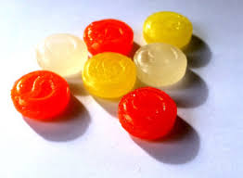

Fig:-Strepsils

**ADVANTAGES:-**

. The formulation is simple to administer for both pediatric and geriatric patients.

It maintains prolonged contact with the oral cavity, ensuring effective delivery.

This dosage form is particularly beneficial for patients who have difficulty swallowing solid forms, offering a more agreeable alternative.

It facilitates both local and systemic effects via the oral cavity and extends the duration of drug action while circumventing first-pass metabolism.

Additionally, it possesses a pleasant taste, which enhances patient compliance.

The preparation process requires minimal equipment and time, and the overall production costs are reduced.

**TYPES OF LOZENGES:**

•         Medicated lozenges.

•         Non-medicated lozenges.

**CLASSIFICATION OF LOZENGES:**

I. **According to its site of action:**

a. Local Effect-

e.g   Antiseptics, Decongestant.

b. Systemic Effect-

e.g   Vitamins, Nicotine.

**II.    According to its texture and composition:**

a. Chewable-

e.g   Vitamins.

b. Hard-

e.g   Lollipops.

c. Soft-

e.g   Bentasil.

d. Compressed-

e.g   Troches.

**A.    CHEWABLE LOZENGES:**

The active ingredients in chewable lozenges are embedded within a caramel base, allowing them to be chewed rather than dissolved in the mouth. These lozenges are formulated using Glycerin, Gelatin, and Water. They are enhanced with fruit flavors and possess a slightly acidic taste, which is deliberately included to mask the unpleasant flavor of glycerin. These lozenges are specifically designed for pediatric use, facilitating the absorption of medication intended for gastrointestinal tract and systemic effects. The Glycerin base utilized in these chewable lozenges is identical to that found in glycerin suppositories or glycerin gelatinized suppositories, comprising 70%

glycerin, 20% gelatin, and 10% purified water

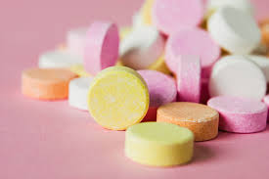

Fig:- Chewable lozenges

**Manufacturing of Chewy or Caramel Based Medicated Lozenges:**

The candy mixture is heated to a temperature range of 95-125℃ and subsequently moved to a planetary or sigma blade mixer. the mixture is permitted to cool down to 120℃. after this, a whipping agent is incorporated while the temperature remains below 105℃. the medicaments are introduced at temperatures between 95-105℃. a colorant is dispersed in a humectant and added to the mixture when it is above 90℃. seeding crystals and flavoring are then incorporated at temperatures below 85℃, followed by the addition of a lubricant at temperatures exceeding 80℃. finally, the candies are shaped using the rope forming technique**.**

**B.    HARD LOZENGES:**

These lozenges consist of a combination of sugar and carbohydrates, typically existing in noncrystalline forms, often in an amorphous or glassy state. They are also referred to as "syrups of sugar." The weight of hard candy lozenges ranges from 1.5 to 4.5 grams, with a moisture content of 0.5 to 1.5%. These lozenges are designed to dissolve directly rather than disintegrate; however, their preparation necessitates high temperatures, which precludes the use of heat-sensitive substances or ingredients. Hard lozenges are commonly employed to alleviate sore throat pain, address various throat infections, and provide relief from irritation by delivering drugs with topical anesthetic or antibiotic properties.

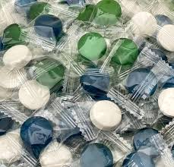

Fig:- Hard lozenges

**Manufacturing of Hard Candy Lozenges:**

The preparation of the candy base involves dissolving a specified amount of sugar in one-third of its weight in water within a candy base cooker. This process continues until the temperature reaches 110℃. Subsequently, corn syrup is incorporated and the mixture is heated until the temperature attains a range of 145-156℃. Once the desired temperature is achieved, the candy mass is removed from the cooker and transferred to a greased container placed on a scale for weight measurement. Following this, colorants or additives in the form of solutions, pastes, or color cubes are introduced. The mass is then moved to a water-jacketed stainless steel cooling table for thorough mixing, during which flavors, medicinal ingredients, and ground salvage are added. The mixture can either be poured into molds or pulled into ribbons as it cools, after which it is cut to the preferred length. The resulting lozenges are then packaged. Historically, cocaine voice tablet lozenges and pastilles were introduced in the late 1800s and were referenced in the Extra Pharmacopoeia of 1888. These lozenges were utilized by singers and public speakers to alleviate vocal huskiness and hoarseness.

**C.   SOFT LOZENGES:**

Soft lozenges are designed for the gradual release of medication in the mouth and are formulated using components such as polyethylene glycol (PEG), chocolate, or an acacia base. Some varieties of soft lozenges also incorporate silica gel within their acacia base, which is the primary ingredient responsible for the desired smoothness and texture. Lozenges that utilize a PEG base tend to soften at elevated temperatures and possess hygroscopic properties; therefore, it is essential to recommend that they be stored in a cool, dry environment.

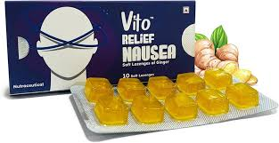

Fig:- Soft lozenges

**Manufacturing of Soft Lozenges:**

The soft texture of these lozenges allows for hand rolling, after which they can be cut into pieces. The warm mixture may also be poured into a plastic mold. It is important to overfill the mold cavity when using PEG, as it contracts upon cooling. This step is unnecessary when working with chocolate, as it does not undergo shrinkage. Tuntarawongsa and Phaechamud developed clotrimazole soft lozenges using the molding method and assessed the factors influencing the physical properties of the lozenge. Their research indicated that increasing the amounts of PEG 1500, xanthan gum, or xylitol resulted in greater hardness of the lozenge. Additionally, they observed that the disintegration time increased with a higher number of active ingredients and greater hardness

**D.COMPRESSED LOZENGES**: Heat-sensitive ingredients cannot be formulated using the same procedures as those employed for soft and hard lozenges. Instead, the compression method, akin to that used for compressed tablets, is applicable for these ingredients. The primary distinction lies in their non-disintegrating nature and slower dissolution profile. The granulation method is utilized in the production of compressed lozenges

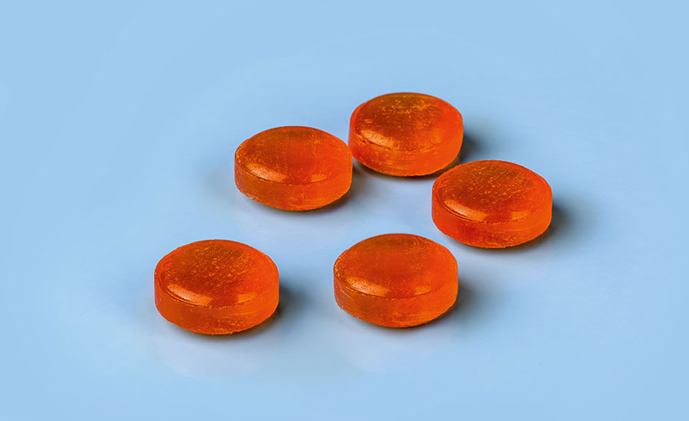

Fig:- Compressed lozenges

**Manufacturing of Compressed Tablet Lozenges:**

### Heat-sensitive ingredients require a different formulation approach compared to the methods used for soft and hard lozenges. The appropriate technique for these ingredients is the compression method, similar to that used for compressed tablets. The key difference is their non-disintegrating characteristics and a slower dissolution rate. The granulation method is employed in the manufacturing of compressed lozenges.

### FORMULATION OF LOZENGES :

**Table no-1:Formulation of lozenges**

|  |  |
| --- | --- |
| **Ingredients** | **Examples** |
| Candy base  a.     Sugar.  b.    Sugar free vehicle.  c.     Fillers. | Lactose, Maltose, Sucrose, Dextrose.  Mannitol, Sorbitol, Polyethylene glycol.  Di-calcium phosphate, Calcium sulphate, Calcium carbonate, Microcrystalline cellulose. |
| `Lubricants | Magnesium stearate, Calcium stearate, Stearic acid, PEG, Vegetable oils, Fats. |
| Binders | Acacia, Corn syrup, Sugar syrup, Gelatin, Polyvinyl pyrrolidone, Tragacanth, Methyl cellulose. |
| Coloring agent | Water soluble and lakolene  dyes, Colors, Orange color paste, Red color cubes etc. |
| Flavoring agent | Menthol, Eucalyptus oil, Spearmint, Cherry flavor, etc. |
| Whipping agent | Milk protein, Egg albumin, gelatin, Xanthan gum, Starch, Pectin, Algin, Carrageenan. |
| Humectant | Glycerin, Propylene glycol, Sorbitol. |

nd thoroughly blended.] 9 The blended mass is subjected to the granulation with sugar or corn syrup and screened through (2-8 mesh size) screen. [This is followed by drying and milling to 10-30 mesh size. Flavour and lubricant are then added prior to compression]

**THERAPEUTIC USES**

1. Anesthetic
2. Analgesic
3. Antifungal
4. Smoking cessation
5. Nausea relief

### EVALUATION OF LOZENGES

### Quality control:-

**Candy base-**These is used to check the various parameters such as- corn syrup, sugar delivery gear, temperature, steam pressure, vaccum of cookers used for candy base.

**Moisture analysis-**

1.       Gravimetric method- 1gm of testing sample is to be placed in vaccum oven at 60-70° for 12- 16 hrs. After specific given period of time, the sample is to be weighed and moisture content is calculated as follows-

Moisture content = Initial weight – Final  weight

2.     Karl fisher titration- A sample calculated so that to contain 10-250 mg water, is taken in titration flask and Karl fisher reagent is used and titrated.

3.     Determination of sugar and corn syrup ratio- These can be done by using “Dextrose equivalent method” which is also termed as “Lane eyvon titration method”.

4.     Percentage of reducing sugar- 3gm of anhydrous dextrose is dissolved in 500 ml of water and 2 drops of methylene Blue is added which is then boiled for 2 min and titrated against 25 ml of fehling solution and the end is yellowish red.

Percentage reducing sugar = (Reducing sugar factors × 100) ÷ (Sample weight / 250

× Volume of sample solution consumed by Fehling’s solution)

#### Physical And Chemical Testing:

Diameter and Thickness - The uniformity of lozenges is contingent upon their diameter, which can be measured using a vernier caliper. The acceptable range for the diameter of lozenges is within ±5% of the standard value.

Hardness - The ability of lozenges to withstand shipping, storage conditions, breakage, transportation, and handling is influenced by their hardness. Therefore, it is essential to assess hardness to determine its threshold capacity, which can be quantified using a Monsanto hardness tester, expressed in kg/cm².

Weight Variation - The weight variation test as per USP involves weighing 20 individual lozenges and calculating the average weight. The weight variation is determined using the formula: Weight Variation = (Average Weight – Initial Weight) ÷ Average Weight Friability - Friability testing is conducted similarly to hardness testing.

This test is performed using a Roche Friabilator, which operates at a specific speed, typically 25 rpm, for a duration of 4 minutes.

In-vitro Drug Release - This assessment, also known as the dissolution test, is performed using a USP-II paddle type dissolution apparatus.

Drug Content - A specified number of lozenges are crushed and dissolved in a designated solvent, with absorbance measured spectrophotometrically. Examples include:

1. Anesthetics – Lidocaine, Benzocaine.

2. Analgesics – Fentanyl, Codeine.

3. Antifungals – Clotrimazole, Miconazole.

4.       Smoking cessation – Nicotine.

5.       Nausea relief – Ondansetron, Promethazine.

#### Microbial Check:

These can be used to recognized or checkout the presence of any bacteria, mold, spores in the raw materials, finished products, machinaries, tunnels, environment of production or storage etc. Laboratories microbial test include the following counts :

Total plate

Total coliform

Yeast and mold

*E.coli*

Staphylococcus

Salmonella

**Stability Testing:-**

**1. Stability Testing of lozenges before packaging-**

Lozenges are carried for stability testing under following conditions-

1-2 months at 60°C.

3-6 months at 45°C.

9-12 months at 37°C.

36-60 months at 25°C and 4°C.

**2. Stability testing of lozenges after packaging-**

Lozenges after final packing is carried for stability testing under following conditions-

25°C at 80%RH for 6-12 months.

37°C at 80%RH for 3 months.

25°C at 70%RH for 6-12 months.

**Application of Lozenges:-**

Lozenges are utilized in the management of both localized and systemic ailments. They can incorporate a range of pharmaceutical agents aimed at alleviating conditions related to oral and throat infections, including oral thrush, sore throat, cough, gingivitis, and pharyngitis, as well as serving as decongestants. Additionally, these formulations have been employed for systemic drug delivery in applications such as smoking cessation and pain management.

**CONCLUSION:**

Lozenges represent a formulation that is both efficient and time-saving. They are particularly well-accepted and preferred for pediatric patients. Medicated lozenges, commonly utilized for treating throat infections and sore throats, serve as an ideal dosage form for children. The advantages of lozenges include enhanced patient compliance, comfort, and effective treatment, characterized by a rapid onset of action. Additionally, they require a lower dosage, reduce the frequency of dosing, and are economically viable. Lozenges play a significant role in the field of pharmacy, having established a prominent position that is likely to be maintained in the future**.**

#### REFERENCE:

1.        Lozenges          and           Pastilles,   Prolonged Medication From Palatable Preparations. Royal Pharmaceutical Society, Information sheet: 4.

2.        Peters D. Medicated Lozenges. In: Lieberman HA, Lachman L, Schwartz JB, editors. Pharmaceutical Dosage Forms: Tablets. 2nd ed. New York: Marcel Dekker, Inc.; 2005. p. 419-577.

3.        Mendes RW, Bhargava H. Lozenges. In: Swarbick J, editor. Encyclopedia of Pharmaceutical Technology. 3rd ed. North California, USA: Informa Healthcare Inc.; 2006. p. 2231-2235.

4.        Batheja P, Thakur R, Michniak B. Basic Biopharmaceutics of Buccal and Sublingual Absorption. In: Touitou E, Barry BW, editors. Enhancement in drug delivery. London, New York: CRC Press, Taylor and Francis Group; 2006. p. 189.

5.        James MD. Medicated Lozenges. Br Med J. 1880; 880.

6.        Allen LV. Troches and Lozenges. Secundum Artem. Current and Practical Compounding Information for the Pharmacist. 4(2).

7.        Lozenges and medication sticks. The Pharmaceutics and compounding Laboratory. UNC ESHEL MAN/school of pharmacy.

8. Maheshwari R., Jain V., Ansari R., Mahajan S.C., joshi G. A Review on lozenges. British Biomedical Bulletin. 2013; 1(1): 35-43.

9. Shinde G., Kadam V., Kapse G.R., Jadhav S.B., Zameeruddin Md., Bharkad B.A:Review on lozenges. “Indo American Journal of Pharmaceutical Research. 2014; 4(1):566-571.

10. Pothu R., Rao Y. Lozenges Formulation and Evaluation. International Journal of Advances in Pharmaceutics. Research. 2014; 5(5):290 – 298.

11. Kaur R., Kaur S. Role of polymers in drug delivery. Journal of Drug Delivery and Therapeutics, 2014; 4(3):32-36. <https://doi.org/10.22270/jddt.v4i3.826>.

12. Pothu, R. and Yamsani, M.R., 2014. Lozenges formulation and evaluation: A review. Ijapr, 1, pp.290-294

13. Mishra, K.K., Tasneem, K., Jain, V. and Mahajan, S.C., 2017. Formulation and evaluation of herbal lozenges. Journal of Drug Delivery and Therapeutics, 7(7), pp.87-90

14. Bhandarkar, A., Alexander, A., Bhatt, A., Sahu, P., Agrawal, P., Banjare, T., Gupta, S., Sahu, H., Diwedi, S.D., Sahu, S.K. and Yadav, P., 2018. Formulation and Evaluation of Ascorbic acid Lozenges for the treatment of Oral Ulcer. Research Journal of Pharmacy and Technology, 11(4), pp.1307-1312

15. Choursiya, S. and Andheriya, D., 2018. Review on lozenges. Journal of Drug Delivery and Therapeutics, 8(6-A), pp.124-128.

16.  James MD. Medicated Lozenges. Br Med J. 1880; 880.

17   Allen LV. Troches and Lozenges. Secundum Artem. Current and Practical Compounding Information for the Pharmacist.

.

18.  Lozenges and medication sticks. The Pharmaceutics and compounding Laboratory. UNC ESHEL MAN/school of pharmacy.

19. Phaemachud T, Tuntarawongsa S. Clotrimazol Soft Lozenges Fabricated with Melting and Mold Technique. Res J Pharm Biol Chem Sci. 2010

20. Developing Treatments with Controlled Drugs. Part One: Cannabis, Coca, and Cocaine. Museum of the Royal Pharmaceutical Society. 2011.

21. Esimone CO, Okoye FBC, Odimegwu DC, Nworu CS, Oleghe PO, Ejogha PW. In vitro Antimicrobial Evaluation of Lozenges Containing Extract of Garlic and Ginger. Int J Health Res. 2010.