**Traffic congestion analysis based on PeMS data: study case California Freeway SR-91E**

**Randy Franstiarajah**

**(Corresponding Author)**

School of Transportation

Southeast University, Nanjing 211189, P. R. China.

finalitezrandy@gmail.com

**Rizka Syahraini**

School of Civil Engineering

Southeast University, Nanjing 211189, P. R. China.

riskasyahrini123@gmail.com

**ABSTRACT**

Traffic congestion which has become a common occurrence with the advancement of society, leading to negative impacts on city dwellers and the economy. The study highlights the importance of a comprehensive and real-time understanding of urban traffic congestion to find an effective way to reduce and control it. The paper discusses recurring bottlenecks on urban freeways caused by stationary traffic and sudden changes in roadway capacity. The study proposes the use of the Performance Measurement System (PeMS) as a tool for conducting operations research, which can provide valuable insights into the patterns and causes of congestion, assisting in the development of congestion reduction and management strategies. The study site is the SR91-E section located in Orange County Area. The PeMS database and built-in applications offer several advantages in understanding system performance and analyzing options. This study presents the result interpretation of freeway analysis by using PeMS and concludes with future work directions. PeMS analysis involves using statistical techniques and modeling to analyze traffic data collected by the PeMS system for a variety of purposes, including bottleneck identification and analysis, which can help transportation agencies make informed decisions about traffic management strategies.

**Keywords:** Traffic Congestion, PeMS analysis, Congestion Reduction, Traffic Management Strategies

**INTRODUCTION**

Congestion has heightened interest in traffic analysis, with the advancement of society traffic congestion has become a common occurrence. Increasing traffic congestion has a negative impact on city dwellers, particularly by causing mental stress and disrupting their daily lives, resulting in higher blood pressure, negative emotions, and a lower frustration tolerance. Congestion has an impact on the economy as well. It raises production costs for businesses by increasing travel time, delivery delays, and fuel costs (Falcocchio et al., 2015). To find an effective way to reduce and control urban traffic congestion and keep the city running smoothly, it is necessary to have a comprehensive and real-time understanding of urban traffic congestion, determine appropriate congestion indexes, and quantitatively evaluate congestion. As a result, urban road networks must be evaluated using appropriate tools. Accurately identifying traffic bottlenecks is critical for calibrating fundamental diagrams and improving congestion mitigation efforts. Significant research efforts have been devoted over the last few decades to investigating various aspects of traffic bottlenecks, such as their characteristics (Daganzo et al., 2005), identification methods (Varaiya et al., 2004), and treatment strategies (Logi et al., 2002). There are recurring bottlenecks on urban freeways that are often caused by stationary traffic, and usually occur at certain locations that experience sudden changes in roadway capacity, for example, on-ramps, off-ramps, and work zones. In contrast, factors cause non-recurrent bottlenecks such as traffic incidents, weather conditions, and special events that cause unexpected reductions in capacity. In spite of the fact that nonrecurring traffic bottlenecks is unpredictable, it is difficult to predict and control their locations and durations. This paper only discusses recurring bottlenecks. Additionally, empirical observations have confirmed that, during peak periods, traffic conditions tend to remain relatively stationary (Jin et al., 2015). Because imperfect metering and excess demand are major causes of congestion, effective ramp-metering and demand diversion strategies can help alleviate it. As a result, many studies on transportation network analysis, operations, control, and management are based on the assumption of recurring bottlenecks, which are common in urban settings.

In this study, we propose PeMS as a tool for conducting operations research. When compared to traditional approaches that are based on limited data due to the high effort and cost involved in field data collection, the PeMS database and built-in applications offer several advantages in understanding system performance and analyzing options. The goal of this project is to conduct a freeway operational analysis using the database of the freeway performance measurement system (PeMS). The use of PeMS increases the utility of data from loop detector surveillance systems, which are frequently archived offline with no processing or analysis. These data can provide valuable insights into the patterns and causes of congestion, assisting in the development of congestion reduction and management strategies.

The paper is organized as follows: Section 2 provides an overview of recent research .Section 3 is concerned with explaining the study site and analysis of bottlenecks of SR91-E section located at Orange County Area.Section 4 is the result interpretation of asssesment of freeway analysis by using PeMs .Finally, the research is concluded with future work directions in the final section

**LITERATURE REVIEW**

Congestion is a major issue in urban areas, resulting in increased travel time, decreased productivity, increased fuel consumption, and negative environmental consequences. Analysis of traffic patterns and data can provide valuable insights for traffic management and planning in order to better understand and mitigate traffic congestion. In order to contextualize the proposed analysis techniques, a critical review of algorithms using loop detector data is provided. Several studies on this topic have been conducted, and the literature review will include relevant research findings from various sources.

Many studies have proposed methods for detecting queues based on real-time traffic flow data. Lin and Daganzo (1997), for example, detected a traffic queue between two neighboring loop detectors by using cumulative differences in occupancy over time. They proposed that significant changes in the cumulative difference in occupancy indicate the occurrence of incidents. Coifman (2000) devised a method for detecting the onset of congestion based on the travel time of individual vehicles. His model detects the onset of congestion whenever link travel time increases dramatically.

TCC method developed by Cassidy and Windover (1995) uses loop detector data to determine bottleneck locations based on the tendency of cumulative vehicle arrival curves at detector stations. It can also analyze the specifics of flow features. Since its inception, the TCC method has gotten a lot of attention. TCC is widely used by researchers to study traffic characteristics at bottlenecks (Bertini et al., 2005). Lawson et al. (1996) proposed a method for measuring vehicle travel time and length distribution in a queue by modifying the inputoutput (or queuing) diagram. Their method can report the maximum queue length as well as the time at which the maximum queue occurs.Furthermore, by combining TCC, the threshold method, and the ASDA-FOTO model, (Li et al., 2010) proposed an automatic deformation accumulation curve method. The results show that it performs better in terms of identifying traffic congestion in terms of high accuracy and effectively reducing the impact of random fluctuations in traffic flow. However, when used to analyze traffic flow characteristics, this method cannot reveal traffic features in greater detail than traditional methods.

Another class of methods is based on the extraction and classification of congestion-related features. (Konstantinos et al., 2011) proposes a system with Spatiotemporal Orientation Analysis as features, motivated by visual dynamics. (Amina et al., 2013) propose a motion vector statistical feature to detect traffic congestion and encode motion information. Another feature proposed is symbolic representation, which combines appearance and motion clues. Although these methods do not use object detection as a preprocessing step, the classification results are dependent on accurate labeling because most algorithms divide congestion (Mahsa et al., 2013).

The purpose of this paper is to improve the efficiency of bottleneck identification. The literature provides insights into critical traffic parameters but is less informative about their in-depth application. This paper adds to the body of knowledge by proposing a PeMs algorithm for loop detector data with different collection cycles. It first determines the occurrence and approximate location of bottlenecks using large cycle data due to its high accuracy in determining the occurrence of bottlenecks. The small-cycle data is then introduced to determine the precise location and duration of the bottleneck.By accurately identifying bottleneck locations and durations, transportation agencies can implement targeted measures such as lane widening, signal timing adjustments, and demand management strategies to mitigate congestion and reduce travel times. The proposed algorithm can also serve as a basis for further research and analysis to improve our understanding of traffic congestion dynamics and develop more effective traffic management strategies.

**DATA COLLECTION & ANALYSIS**

**Study site**

The study area is a State Route 91E (SR 91-E) is a significant east-west state route in California that connects a number of areas of the Greater Los Angeles metropolitan area. It has a total length of 59.1 miles. It officially goes east to Riverside at the intersection with the Pomona (SR 60 west of SR 91) and Moreno Valley (SR 60 and I-215 east of SR 91) freeways from Vermont Avenue[3] in Gardena, just west of the connection with the Harbor Freeway (Interstate 110, I-110).

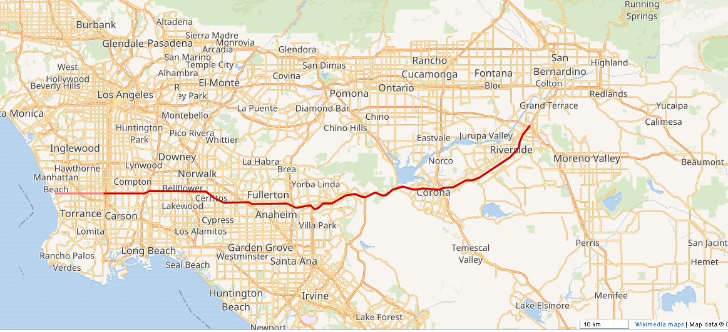

**FIGURE 1 Study site of SR-91E Freeway**

The study site is equipped with loop detectors, and the data from the detectors is stored, processed, and analyzed by the freeway performance measurement system (PeMS). The California PeMS database was queried for five minutes of flow, speed, and occupancy loop detector data. PeMS includes algorithms for calculating system performance measures (vehicle miles and vehicle hours of travel), traveler metrics (delay and travel time along system segments), and travel time reliability measures. Based on detector data, we used the PeMS bottleneck algorithm in conjunction with field observations to identify active off-ramp bottlenecks. The work described in this paper makes use of the historical database maintained by the California Department of Transportation (Caltrans).

Consider a freeway with a series of segments marked and partitioned by a series of successive detectors, as shown in Figure 2. The goal is to estimate segment travel time using real-time loop detector data. Because loop detectors typically report vehicle counts and occupancy, the spot traffic flow speed at detector  at time **can be calculated using the following formula:

 （1）

Where q denotes traffic volume, o occupancy, and g is a factor equal to the sum of effective vehicle length and detector length.Equation (1) states that if two sequential loop detectors are installed on the same link segment, the travel time between two detectors can be simply estimated by averaging the speed obtained from the boundary detectors as follows:

 （2）

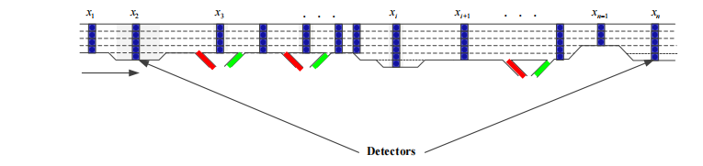

**FIGURE 2 Illustration of detector system along the freeway**

**Overview Performance measurement system (PeMS) for congestion analysis**

Performance Measurement System (PeMS) analysis refers to the process of analyzing data collected through PeMS to evaluate the performance of transportation systems. PeMS is a sophisticated traffic monitoring system that collects real-time traffic data from sensors installed on roadways, and provides valuable insights into traffic flow, congestion, and other traffic-related parameters.

PeMS analysis involves using statistical techniques and modeling to analyze traffic data collected by the PeMS system. This analysis can help transportation agencies to identify traffic patterns, understand the causes of congestion, and make informed decisions about traffic management strategies.PeMS analysis can be used for a variety of purposes, including:

1. Bottleneck Identification and Analysis : Bottleneck identification and analysis using performance Measurement System (PeMS) involves utilizing the data-driven approach provided by PeMS, which is a traffic management and monitoring system to collect, analyze, and interpret traffic data on California highways. PeMS provides real-time and historical traffic data, including traffic flow, speed, and occupancy, which can be used to identify and analyze bottlenecks in the highway system.
2. Bottleneck Discharge Rate : Based on the processed data, the bottleneck segment can be identified as the location where traffic volume exceeds the capacity of the roadway, resulting in congestion. PeMS provides various visualization tools, such as time-space diagrams and speed-flow diagrams, which can help identify the bottleneck location.Once the bottleneck location is identified, the bottleneck discharge rate can be calculated as the rate at which vehicles pass through the bottleneck segment during the congestion period. This can be calculated as the ratio of the number of vehicles that pass through the bottleneck segment during the congestion period to the duration of the congestion period.
3. Bottleneck Impact : Once the bottleneck location is identified, the impacts of the bottleneck on traffic performance measures can be analyzed. This may involve comparing the performance measures, such as travel time, delay, and queue length, before and after the bottleneck location, or comparing the performance measures under different scenarios (e.g., different days, different times of day, different weather conditions) to understand the impacts of various factors on bottleneck performance.
4. Freeway Operational Analysis :Application of PeMS in freeway operational analysis is level of service determination. PeMS provides data on various traffic parameters that can be used to calculate the level of service, which is a measure of the quality of traffic flow on a roadway. This information can be used to assess the performance of a freeway segment and identify areas where improvements may be needed to maintain an acceptable level of service.

Overall, PeMS analysis is an important tool for transportation agencies to monitor and manage traffic flow, and make data-driven decisions to improve the efficiency and safety of our transportation systems.

**RESULT & DISCUSSION**

**Bottleneck Identification and Analysis**

The goal is to identify and assess freeway bottlenecks. One key goal of this analysis is to see if bottleneck capacity can be preserved using spatial analysis. Figures 3(a)–3(d) show the spatial-temporal speed along the SR91-E District 12 freeway on four different days, as well as the spatial-temporal congestion level at each time slot and segment via hot maps. The yellow parts denote a traffic state with high traffic speed and no or low congestion, whereas the dark and blue parts denote a traffic state with low traffic speed and a high level of traffic congestion.

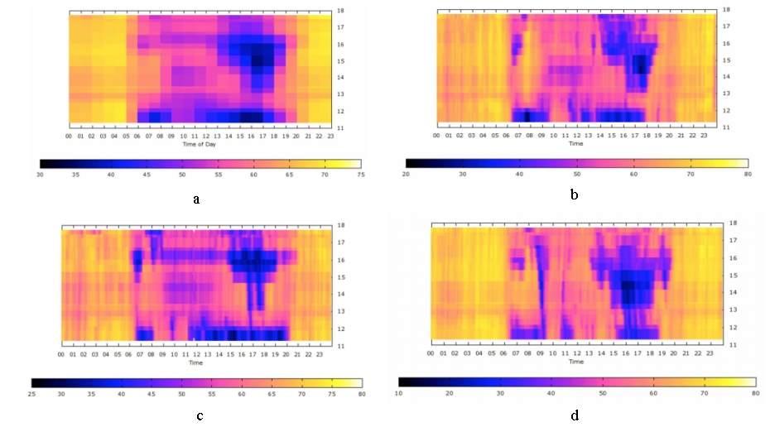

**FIGURE 3 Spatial-temporal speed on different days in 25th - 28th ,March 2019**

**a Spatial-temporal speed on 25th ,March**

**b Spatial-temporal speed on 26th,March**

**c Spatial-temporal speed on 27th,March**

**d Spatial-temporal speed on 28th,March**

Figure 3 shows that the evolution of travel time is significantly influenced by the level of traffic congestion: travel ime increases as the level of congestion increases and decreases as the level of congestion decreases. For example, in Figure 3(d), on March 29th, Bottleneck 1 is located between Postmiles 16 and 17. The bottleneck lasts 6 hours (from 13:00 to 19:00), and the queue is 3.5 miles long (from Postmile 13 to Postmile 16.5). Bottleneck 2 is located between Postmile 11 and Postmile 12.5. It is almost always congested, and the queue is very long. The queue eventually ends between Postmiles 8 and 9, making the total length of the queue approximately 4 miles. During peak hours, the line can be seen all the way to the start of the highway. The contours of weekday Postmile peak hours for an entire week between March 25th and March 29th 2019. We can see from the graphs that the two bottlenecks we identified appear on most days at roughly the same location and duration, indicating that these are recurring congestions. The above analysis shows that traffic state patterns can uniquely identify the congestion area and duration of congestion. Furthermore, similar traffic state patterns can be reflected by multiple detectors along a road due to the propagation and recurrence of congestion. For example, if a detector in the downstream detected a certain level of congestion, detectors in the upper stream may also detect it after it has propagated there.

**Bottleneck Discharge Rate**

The objective of the PeMS (Performance Measurement System) application was to analyze data pertaining to bottleneck discharge rates in a specific area. Figure 4 shows the traffic flows for SR91-E,The analysis of the graph yielded intriguing findings regarding the two identified bottlenecks, Bottleneck 1 and Bottleneck 2.

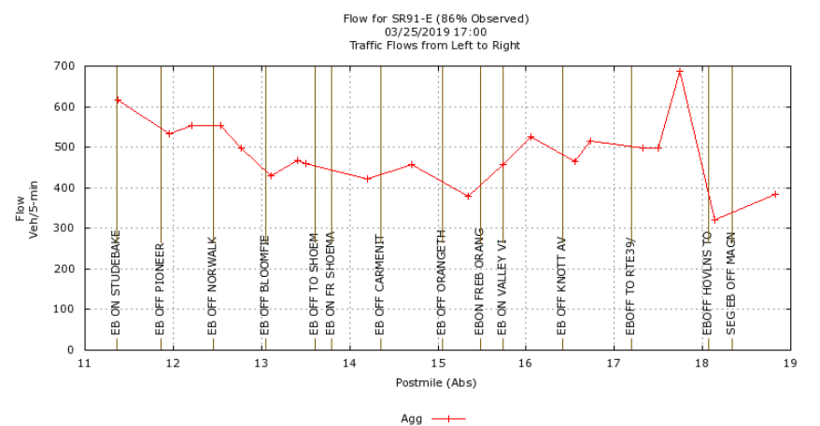**FIGURE 4 Traffic Flow Graphic for SR91-E**

In the case of Bottleneck 2, the analysis revealed that there is no significant discharge flow on the upstream side. The flow rate at Postmile 13, which is slightly higher at 4980 veh/hr, is nearly negligible and comparable to the flow rate at the bottleneck. This suggests that a considerable portion of the discharging flow from Bottleneck 2 may potentially exit the highway through a series of off-ramps located in the vicinity of the bottleneck. Consequently, the remaining discharging flow on the mainline does not exhibit a significant increase compared to the bottleneck flow rate. This speculation indicates that Bottleneck 2 may not have a notable impact on the flow rate downstream of the bottleneck.

On the other hand, for Bottleneck 1, there is a clear increase in the flow rate at Postmile 18 after the bottleneck, with a discharge rate of 8400 veh/hr across four lanes. This indicates that Bottleneck 1 is causing a conspicuous increase in flow rate downstream of the bottleneck, suggesting that it has a significant impact on the flow rate in the studied area.

Overall, these findings provide valuable insights into the flow dynamics and potential bottlenecks in the studied area. It can be inferred that Bottleneck 1 is causing a notable impact on the flow rate downstream, whereas Bottleneck 2 does not seem to have a similar effect. This analysis serves as a foundation for further research in traffic flow management and congestion mitigation strategies in the studied area.

**Bottleneck Impact**

Based on in this study, it is evident that the PeMS system has successfully identified multiple bottlenecks at a finer grain in two specific locations. The analysis of the mobility performance report as shown in the Figure 5 the bottleneck between Postmile 16 and 17 has an average delay of 467.7 veh-hrs per day, while the bottleneck between Postmile 11 and 12.5 has an average delay of 839.6 veh-hrs per day.These significant delays highlight the negative impact of these bottlenecks on the traffic flow, causing long queues that last for several miles and result in consecutive slow-moving highway segments.

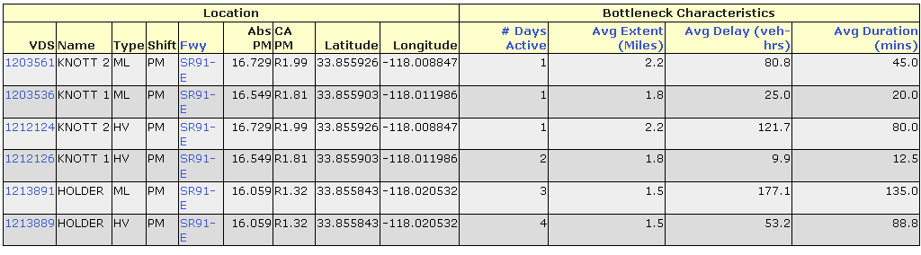

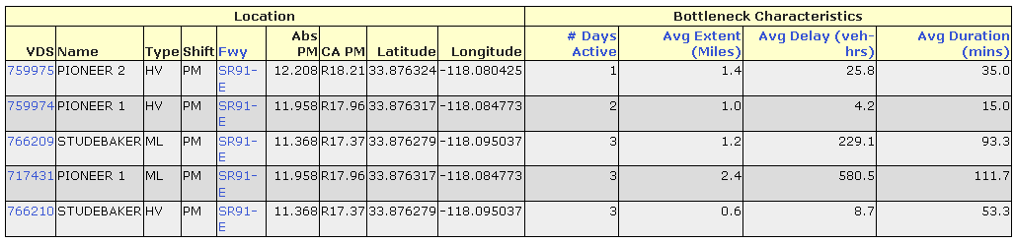

**FIGURE 5 Mobility Performance Report**

These study align with previous sections and studies that have emphasized the adverse effects of bottlenecks on traffic flow. The identified bottlenecks are consistent with the concept of traffic congestion theory, which posits that congestion occurs when demand exceeds the capacity of the roadway, resulting in reduced traffic flow and increased delays .The delays observed in this study indicate that these bottlenecks are significant barriers to smooth traffic flow and have a detrimental impact on overall transportation efficiency.

Furthermore, this study study highlight the need for effective strategies to mitigate the identified bottlenecks and improve traffic flow in the studied locations. Solutions such as road widening, optimizing signal timings, or implementing demand-based pricing strategies could be considered to alleviate the congestion and reduce delays caused by these bottlenecks. These study contribute to the existing body of research on traffic congestion and provide valuable insights for transportation planners and policymakers to address the identified issues and enhance the overall performance of the transportation system.

**Assesment of Freeway Performance**

**Estimating Parameters of Traffic Flow**

In this study, we investigated the macroscopic parameters of traffic flow, namely free flow speed, wave speed, and jam density. These parameters are crucial in understanding the dynamics of traffic flow and predicting traffic patterns. In this section, we present our analysis of the data to determine these parameters.

First, we determined the free flow speed of the study section, which was found to be 70 mph, as shown in the Figure 6.

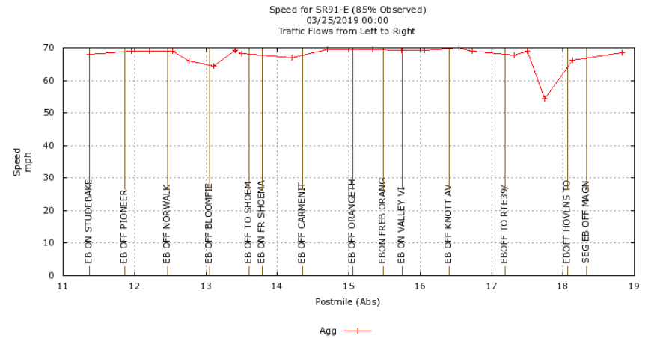

**FIGURE 6 Free Flow Speed Graphic**

We obtained speed and flow data from the PEMS (Performance Measurement System) dataset for the week of 03/25/2019 -- 03/31/2019 at the specific section of interest, as illustrated in the Figure 7. This dataset provided us with the necessary data to estimate the wave speed and jam density of the study section.

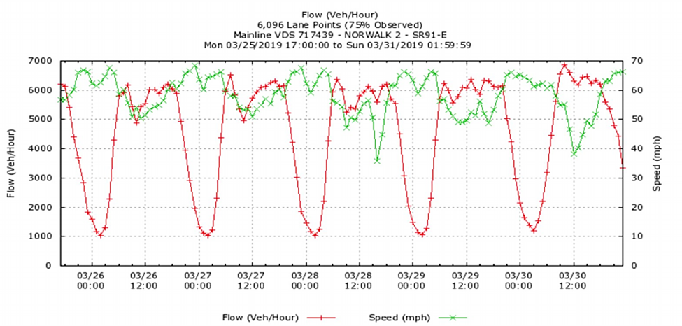

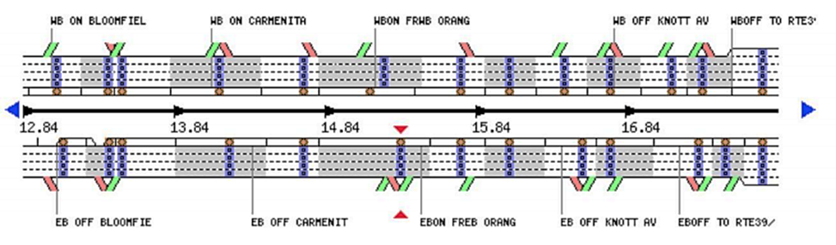

**FIGURE 7 Speed and Flow Graphic for SR91-E**

Our analysis involved processing the data to calculate the wave speed and jam density. The wave speed represents the speed at which traffic congestion propagates upstream, while the jam density represents the maximum traffic density that can be sustained before traffic comes to a complete stop.After calculating density from flow and speed data, we can plot all the flow and density data point at the bottleneck, to get the fundamental (Q-k) diagram.Based on our analysis, Estimating from the diagram above, we can find the maximum flow to be approximately 6000 veh/hour and estimate wave speed 9.1 mile/hour ,indicating the rate at which congestion propagates upstream. Additionally, the jam density was estimated to be 754 vehicles per 4 lane, representing the maximum traffic density that can be sustained before traffic comes to a standstill.

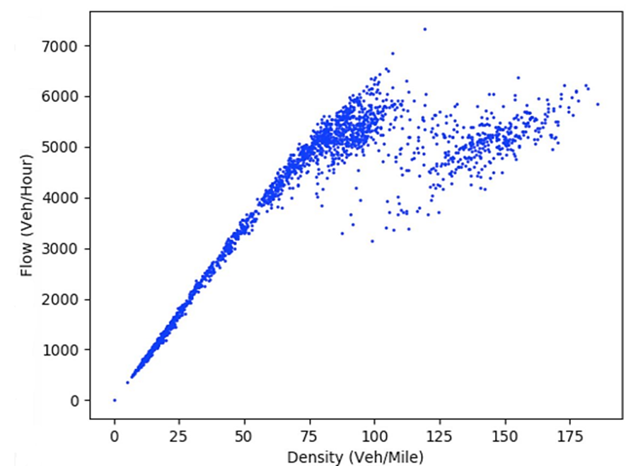

**FIGURE 8 Diagram of Estimated Parameters Traffic Flow**

This study provide important insights into the traffic flow characteristics of the study section. The estimated wave speed and jam density can be used to optimize traffic management strategies, such as ramp metering and variable speed limits, to improve traffic flow efficiency and reduce congestion.

Overall, our analysis of the speed and flow data from the PEMS dataset has provided valuable information on the macroscopic parameters of traffic flow in the study section, enhancing our understanding of traffic dynamics and facilitating the development of effective traffic management strategies. Further research can be conducted to validate and refine these estimates, as well as explore additional factors that may impact traffic flow in the study area.

**Estimating of Travel Times**

The analysis of this study focused on estimating the average travel time and travel time reliability measures within the study corridor. Figure 9 presents the weekday travel time data for the week of 03/25/2019 to 03/29/2019, segregated by individual lanes.Upon examination of the data, several key observations can be made with Averaging all travel times, we estimate that the average travel time of the corridor is 17.77 minutes. There are discernible variations in travel times among different lanes within the study corridor.This suggests that travel times may be influenced by specific lane characteristics, such as the number of lanes available, lane width, and presence of any lane-specific restrictions.

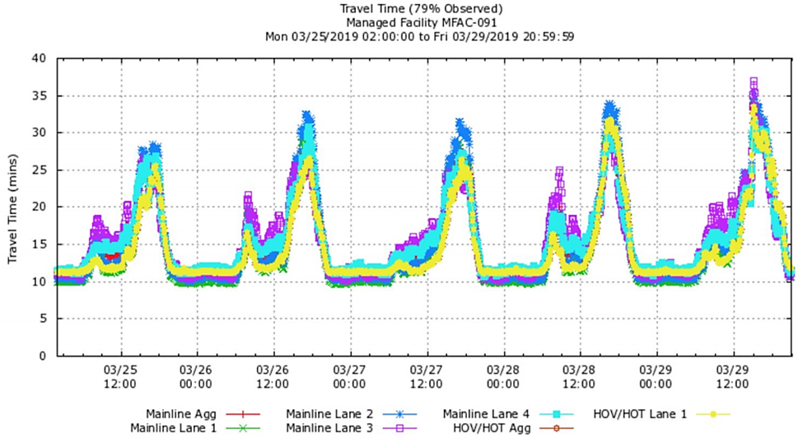

**FIGURE 9 Weekday Travel Time of The Week 03/25/2019-03/29/2019**

The cumulative probability of travel times, as depicted in the Figure 10 showed that at the average travel time of 17.77 minutes, the probability was approximately 70.7 percent. Furthermore, at the 90th percentile, the travel time increased to 29.44 minutes, indicating that congestion was a common occurrence.This study also found that travel time was highly influenced by the occurrence of bottlenecks. As the severity of the bottleneck increased, travel time also increased, as evident in the figures above. Without any bottlenecks, the free-flow travel time was approximately 11 minutes. However, during weekday PM peak hours, travel time typically increased to about 30 minutes, and in some cases, it could go up to 38 minutes. This indicates that traffic congestion during peak hours significantly impacted travel times, leading to delays and increased travel times for commuters.

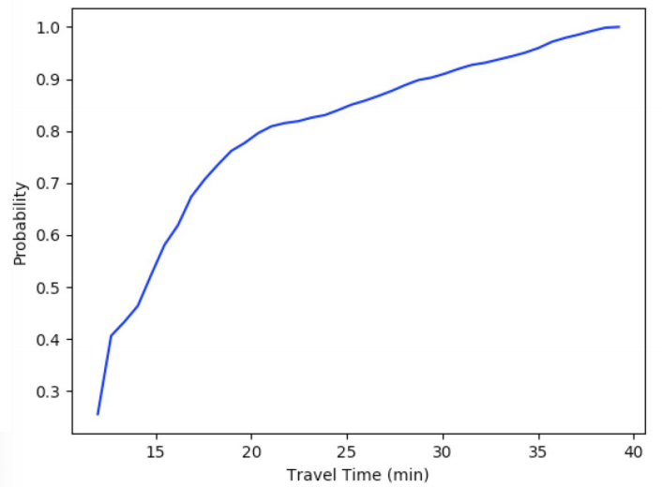

**FIGURE 10 Cumulative Probabilities of Travel Times**

**CONCLUSIONS**

Traffic congestion has become a common occurrence in modern society and has a negative impact on both city dwellers and the economy. To effectively reduce and control urban traffic congestion, it is necessary to have a comprehensive understanding of urban traffic congestion, determine appropriate congestion indexes, and quantitatively evaluate congestion. Recurring bottlenecks are a common cause of congestion in urban settings and there have been significant research efforts devoted to investigating their characteristics, identification methods, and treatment strategies.

The PeMS database and built-in applications have proven to be an essential tool for conducting operations research and identifying traffic patterns, congestion causes, and traffic management strategies. As demonstrated in this study, PeMS analysis can assist transportation agencies in identifying bottleneck locations and assessing their capacity and discharge rates, which can inform policy decisions aimed at enhancing the transportation system's overall performance.

Specifically, the study identified and analyzed two bottleneck locations on the SR91-E freeway in District 12, California, using spatial-temporal analysis. The identified bottlenecks were found to cause significant delays and reduce traffic flow efficiency. The study's findings provide important information for transportation planners and policymakers to address the issues identified and improve the transportation system's overall performance.

Furthermore, the study highlights the need for effective strategies to mitigate bottlenecks, such as road widening, optimizing signal timings, or implementing demand-based pricing strategies. The study contributes to the existing body of research on traffic congestion and provides a foundation for further research on traffic flow management and congestion mitigation strategies in the studied area. Improving traffic flow and reducing congestion is crucial for improving the quality of life for city dwellers and promoting economic growth.

**REFERENCES**

1. Falcocchio, J. C., & Levinson, H. S. (2015). The costs and other consequences of traffic congestion. In Springer Tracts on Transportation and Traffic (pp. 159-182). (Springer Tracts on Transportation and Traffic; Vol. 7). Springer International Publishing. https://doi.org/10.1007/978-3-319-15165-6_13

2. C. F. Daganzo, “A variational formulation of kinematic waves: basic theory and complex boundary conditions,” Transportation Research Part B: Methodological, vol. 39, no. 2, pp. 187–196, 2005.

3. C. Chen, A. Skabardonis, and P. Varaiya, “Systematic identification of freeway bottlenecks,” Transportation Research Record: Journal of the Transportation Research Board, vol. 1867, no. 1, pp. 46–52, 2004.

4. F. Logi and S. G. Ritchie, “A multi-agent architecture for cooperative inter-jurisdictional traffic congestion management,” Transportation Research Part C: Emerging Technologies, vol. 10, no. 5-6, pp. 507–527, 2002.

5. W.-L. Jin, “On the existence of stationary states in general road networks,” Transportation Research Part B: Methodological, vol. 81, pp. 917–929, 2015.

6. Lin W. H. and C. F. Daganzo. A Simple Detection Scheme for Delay-Inducing Freeway Incidents. Transportation Research Part A 31, No 2, 1997, pp. 141-155.

7. Coifman, B. Identifying the Onset of Congestion Rapidly with Existing Traffic Detectors. Presented at the 80th Annual Meeting of Transportation Research Board, Washington, D.C., 2000.

8. M. J. Cassidy and J. R. Windover, “Methodology for assessing dynamics of freeway traffic flow,” Transportation Research Record: Journal of the Transportation Research Board, no. 1484, pp. 73–79, 1995.

1. R. L. Bertini, S. Hansen, and K. Bogenberger, “Empirical analysis of traffic sensor data surrounding a bottleneck on a German autobahn,” Transportation Research Record: Journal of the Transportation Research Board, vol. 1934, pp. 95–107, 2005.
2. H. Li and R. L. Bertini, “Comparison of algorithms for systematic tracking of patterns of traffic congestion on freeways in Portland, Oregon,” Transportation Research Record: Journal of the Transportation Research Board, vol. 2178, no. 1, pp. 101–110, 2010.
3. T. W. Lawson, D. J. Lovell, and C. F. Daganzo, “Using input output diagram to determine spatial and temporal extents of a queue upstream of a bottleneck,” Transportation Research Record: Journal of the Transportation Research Board, vol. 1572, no. 1, pp. 140–147, 1997.
4. Konstantinos G. Derpanis and Richard P. Wildes, “Classification of traffic video based on a spatiotemporal orientation analysis,” in IEEE Workshop on Applications of Computer Vision, 2011, pp. 606–613.
5. Amina Riaz and Shoab A Khan, “Traffic congestion classification using motion vector statistical features,” in International Conference on Machine Vision, 2013, pp. 90671A–90671A.
6. Mahsa Ghasembaglou and Abolfazl Toroghihaghighat, “Symbolic classification of traffic video shots,” Advances in Intelligent Systems and Computing, vol. 225, no. 1, pp. 207–219, 2013.