**Developing road safety management framework at unsignalized intersection: study case three ways in Depok City, Indonesia**

**Randy Franstiarajah**

**(Corresponding Author)**

School of Transportation

Southeast University, Nanjing 211189, P. R. China.

finalitezrandy@gmail.com

**Rizka Syahraini**

School of Civil Engineering

Southeast University, Nanjing 211189, P. R. China.

riskasyahrini123@gmail.com

**Abstract**

This study addresses the road safety issues at an unsignalized intersection in Depok City, Indonesia, with the objective of developing a road safety management framework to mitigate the risks and enhance overall safety. The study identifies the intersection of Jalan Raya Tanah Baru and Jalan Raya Sawangan as a high-risk area due to its unsignalized nature, inadequate signage, absence of pedestrian crossings, and presence of side obstacles. Field observations and analysis reveal crossing conflicts, acceleration behavior, and rear-angle collisions as prevalent accident types. Based on the identified problems, the study proposes several effective solutions, including the installation of traffic control lights, enhanced signage and road markings, the construction of pedestrian crossings, the enforcement of parking regulations, and road safety education. These solutions align with international best practices, comply with local regulations, and consider the specific characteristics of the intersection. Implementing these treatments can significantly enhance intersection safety, reduce accidents, and improve traffic management in Depok City.

**Keywords:** Road safety; Unsignalized intersections; Road safety management framework; Effective Solutions; Field observations

1. **Introduction**

Indonesia, with a population exceeding 260 million, stands as the fourth most populous nation globally. The nation's rapid economic growth has resulted in increased demand for transportation and car ownership. Consequently, road accidents have been on the rise in Indonesia over the past decade. In 2016 alone, a staggering 105,374 cases of traffic accidents were recorded, leading to 25,859 fatalities, 22,939 severe injuries, and 120,913 minor injuries (BPS Indonesia, 2017). Among these incidents, there were 135,883 motorcyclists involved, as motorcycles are the most popular mode of transportation in the country. Remarkably, the number of serious motorcycle crashes surpasses those of other transportation modes (Nielso et al., 2009). Motorcyclists face a fatality risk approximately 30 times higher and serious injuries about 8 times higher compared to other driver groups (Huang and Preston, 2004).

Road accidents pose a significant threat to public safety and are influenced by various factors, including human behavior, vehicle conditions, and external elements such as road conditions. Effective management of road damage plays a crucial role in accident prevention and ensuring the safety of road users. The national road network in Indonesia spans 47,017 km, as reported by the Ministry of Public Works (PUPR) in 2017. It is observed that 51.76% of the road network is in good condition, 38.59% is in moderate condition, and 5.76% and 3.89% are lightly and severely damaged, respectively (Zhong et al., 2011). These statistics highlight the need for effective road management practices to prevent accidents and ensure the safety of road users.

The intersection of Tanah Baru Street and Sawangan Street in Depok City is one of the unsignalized intersections located very close to the center of community activities. Serving as a crucial link between districts in West Java, the traffic conditions at this intersection are consistently busy every day, posing a high potential for traffic crashes.

Human factors have been identified as a significant contributor to road accidents. Driving errors, accounting for 93% of traffic accidents, along with operational deficiencies (34%) and vehicle malfunctions (12%), emphasize the role of human factors in these incidents (Nikzad, 2008). Abrupt stops or lane changes by vehicles can startle other road users, leading to spontaneous reactions and potential conflicts that increase the risk of accidents. Unsignalized intersections, lacking traffic signals or control devices, present a higher risk of non-compliant behavior and accidents. The Indonesian Road Capacity Manual (1997) estimates that unsignalized intersections contribute to approximately 0.60 accidents per million vehicles. These intersections often serve as black spot areas, characterized by a higher frequency of accidents surpassing specified thresholds (DTKS, 2007). In the intersection area as well, the trajectory of vehicles will intersect at one point of conflict; this conflict will inhibit movement and also potentially become the location of a collision (accident). The number of potential conflict points at an intersection depends on the number of crossing legs, the path of the intersection legs, the arrangement of the intersection, and the direction of movement (Nurdjanah, 2018). One such intersection prone to non-compliant behavior and accidents is the Tanah Baru Street-Sawangan Street intersection in Depok City, which serves as a vital link between districts in West Java.

Assessing road safety involves analyzing road accidents, the number of victims, and their associated negative consequences. Safety is considered a product produced through a management system with three levels: institutional management functions, interventions, and outcomes (Bliss, 2004). Achieving road safety outcomes necessitates a multidisciplinary approach within a complex multi-sectoral context (ERSO, 2006). It is crucial to strike a balance between competing interests and adopt a holistic, system-wide approach.

In developing a road safety management framework, this study draws inspiration from the Road Safety Development Index (RSDI) framework, which comprises three main pillars: focusing on road user behavior, the system (including safer vehicles, roads, law enforcement, and management), and the outcome represented by the mortality rate due to accidents (Al-Haji, 2007). Additionally, the Five Pillars of Safety from the 2011–2020 Road Safety Action Decade Program—Road Safety Management, Safer Roads and Mobility, Safer Vehicles, Safer Road Users, and Post-Crash Response—are integrated into the framework.

One significant challenge in road safety management is the lack of public awareness of road safety programs. Addressing this awareness gap is crucial for improving road safety management. The proposed framework suggests adapting the New Zealand Framework Land Transport Safety Authority, which draws inspiration from the European Transport Safety Council, while also considering the specific state and socio-cultural conditions of Depok City.

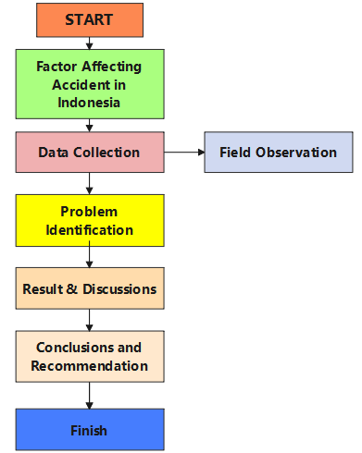Road accidents have been extensively researched worldwide and are recognized as a critical aspect for identifying gaps in traffic management and the broader transportation system (Soehodho, 2017). Therefore, the objective of this study is to develop a road safety management framework that specifically addresses the road safety issues at unsignalized intersections in Depok City, Indonesia. The study aims to evaluate the effectiveness of potential treatments based on the observed safety problems in the study area.

**Fig. 1.** The diagram of the framework.

1. **Factor affecting accidents in Indonesia**

The frequency of accidents in Indonesia has been investigated by analyzing data from the National Transportation Safety Committee of Indonesia (KNKT) report on road accidents and transportation data that spans across a period of 2007 to 2020. The research findings indicate that traffic accidents in Indonesia are influenced by a combination of physical and institutional factors. The study delves into specific aspects pertaining to traffic accidents, with special attention given to unsignalized junctions, as evidenced in Tables 1 and 2.

Table 1. The general characteristics concerning traffic accidents in Indonesia

|  |  |  |
| --- | --- | --- |
| No | Performance of road,traffic and pavement | Detail factors in traffic accidents |
| 1 | Vehicle condition | 1. Inadequate mechanical upkeep. 2. The components of brake life have exceeded the limit. 3. Unroadworthy automobiles. 4. Inadequate crashworthiness of body machine design and specification. |
| 2 | Traffic condition | 1. Freight cars enter the prohibited lanes. 2. Lack of supervision of route licensing. 3. Lack of route limitation to heavy vehicles. 4. High operations of passenger buses. |
| 3 | Vehicle speed | 1. Lack of speed restrictions. 2. Lack of installed speed bumps. 3. Lack of ribbon/rumble strips. |
| 4 | Pedestrian access | 1. Lack of space for pedestrians. 2. Poor designs of pedestrian elevation. 3. Much disturbance on pedestrian access. 4. Many barriers and parking on the street. |
| 5 | Equipment and road lighting | 1. Lack of road lighting in sloping areas. 2. Lack of road lighting in the black spot area. |
| 6 | Road markings and facilities | 1. Lack of appropriate placement of road 2. Lack of markings, especially in sloping areas. 3. Lack of clearness of road marking. 4. Lack of pedestrian marking. 5. Lack of road facility in stating traffic sign such as speed limit, warning, precaution and mirrors. |

Table 2. Regulation and supervision related to traffic accidents

|  |  |  |
| --- | --- | --- |
| No | Soft performances in road and traffic | Detail factors in traffic accidents |
| 1 | Regulation | 1) Lack of understanding traffic law.  2) Lack of socialization of using seat belts.  3) Lack of understanding of road safety and  other regulations.  4) Lack of staff to control black spot areas.  5) Lack of driving licenses.  6) Lack of supervision to the psychological  conditions of road users. |
| 2 | Human resources |

1. **Materials and methods**

3.1 Field observation

The phenomenon of vehicle growth has brought about a new dilemma for the residents of Depok City, namely the extraordinary level of congestion. Congestion and traffic accidents are closely linked due to the increase in vehicle ownership and the significant impact of the number of casualties. Throughout the year 2021, there have been a total of 461 traffic accident cases in Depok City. One of the locations that contributes to accidents in Depok is the unsignalized three-way intersection on Tanah Baru Street and Sawangan Street. This area experiences heavy traffic, especially during working hours, with various vehicles traversing the road, including public transportation, goods vehicles, and private vehicles. Given the increasing number of accidents resulting in significant losses in terms of both human lives and material damage, it is crucial to conduct a study on these accidents. The observation location is the intersection of Jalan Raya Tanah Baru and Jalan Raya Sawangan, which is one of the intersections with alternating high density on each lane during peak hours which show in Fig. 2 and Fig. 3.

Based on the data at the observer's location, the intersection is an unsignalized intersection that does not have traffic control lights. The condition of the signs and road markings at the observation location hardly meets the feasibility criteria because only one no-stop sign was found on Jalan Raya Sawangan 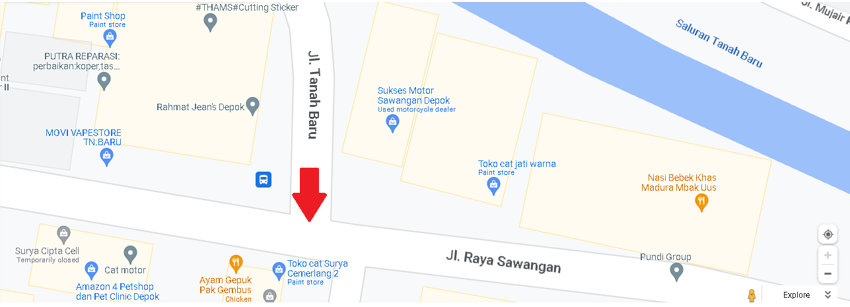heading west. As for road markings at the research location, they are only found on Jalan Raya Sawangan, and there is no zebra crossing that serves to inform motorists that there is a lane for pedestrians to cross

**Fig. 2.** Observed location intersection.

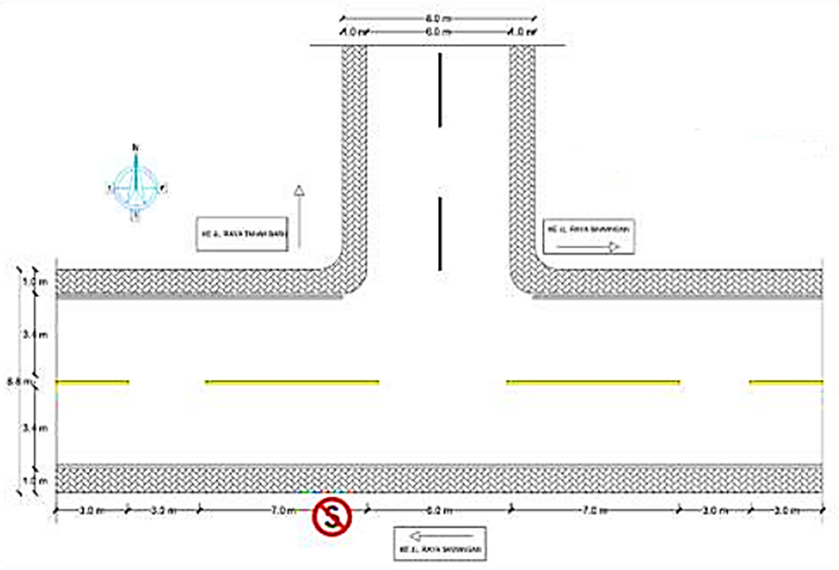**Fig. 3.** Situation map of the studied intersection.

3.2 Problem Identification

Driving is a complex job, so it requires certain abilities and knowledge because, at the same time, the driver has to face the vehicle with his equipment and receive influence from his surroundings. Smoothness and safety depend on the readiness and skill of the driver in running his vehicle. Many accidents are caused by negligence from drivers due to their lack of attention and failure to obey signs and markings along the road they pass (Suhadi, 2018).

Unsignalized intersections are more commonly observed along rural highways and in suburban areas; at these locations, vehicular traffic speeds are high and driver behaviour is more unpredictable due to complex manoeuvre. Also, high-speed vehicles, through as well as turning movement traffic, have severe conflicts at unsignalized intersections, which results in endangering road users' safety The unsignalized nature of the intersection, coupled with inadequate signage and the absence of pedestrian crossings, presents a significant road safety problem. The lack of traffic control lights at the intersection relies heavily on signs and road markings, which are currently in inadequate condition. Insufficient signage, exemplified by the presence of only one no-stop sign on Jalan Raya Sawangan heading west, contributes to confusion and potential conflicts among motorists approaching the intersection from various directions.

The absence of zebra crossings further compounds the safety concerns at the intersection, as pedestrians are left without designated areas to safely cross the road. This absence not only jeopardizes the safety of pedestrians but also contributes to a lack of awareness among motorists, who may not anticipate the presence of pedestrians in the vicinity.

The combination of inadequate signage and the absence of pedestrian crossings increases the risk of accidents at the intersection, particularly during peak hours when there is heavy traffic flow and alternating high density in each lane. Analysis of movement flow indicates that crossing conflicts are the most frequent and vulnerable type of traffic accident at the location. Acceleration behavior during crossings by road users has been identified as a significant factor contributing to these accidents. Rear-angle (RA) collisions are the most prevalent type of collision, resulting from the dominant movement patterns that lead to traffic conflicts at the intersection, where vehicles converge from different directions.

The minor road, which lacks proper priority and attention from major road users, is particularly prone to accidents as vehicles enter this section. Additionally, the presence of numerous side obstacles, including improperly parked vehicles used for passenger and cargo loading, exacerbates the potential for collisions or accidents. These side obstacles impede visibility and disrupt the readiness of road users when navigating the intersection. Moreover, the absence of essential road markings and traffic safety facilities, such as malfunctioning traffic lights, medians, street lighting, and stop lines, further contributes to serious conflicts and traffic accidents at the intersection.

In conclusion, the road safety issues at the intersection of Jalan Raya Tanah Baru and Jalan Raya Sawangan stem from its unsignalized nature, inadequate signage, the absence of pedestrian crossings, and the presence of side obstacles. These factors increase the risk of crossing conflicts, acceleration behavior, and rear-angle collisions. Addressing these concerns through appropriate signage, pedestrian infrastructure, and road safety facilities is crucial to mitigating the risks and ensuring the safety of all road users at the intersection.

1. **Results and discussions**

Road traffic is built on based on three aspects; human, vehicles and road environment, that interrelated each other. Bezerra, B.S. (2019) and Haddon.(1968) have categorized the relation between highway condition and traffic accident. They proposed factors needed considering on cycle traffic accident. Due to the factors on pre-crash are more relevant with technical aspect on sustianble road transport in aspect of planning and implementation, so those are used as a based to analyze cases on traffic accidents. Table 3 showed Haddon’s model.

Road safety management is implemented to optimize the use of road networks and traffic movements in order to ensure security, safety, order, and smooth traffic and road transportation, such as: 1. Traffic control at intersections (see Section 4.1); 2. enhanced traffic sign and road marking (see Section 4.2); 3. construction of pedestrian crossing (see Section 4.3); 4. enforcement of parking regulations (see Section 4.4); 5. road safety education and awareness (see Section 4.5); and 6. regulation and law approach (see Section 4.6) .Based on the road safety problems identified at the intersection of Jalan Raya Tanah Baru and Jalan Raya Sawangan, several possible treatments can be proposed to improve safety and mitigate the risks.

Table 3. The general characteristics concerning traffic accidents in Indonesia

|  |  |  |
| --- | --- | --- |
| Phase | Factors | Detail factors in traffic accidents |
| Pre-crash Crash Preventions | Human | 1. Reduction of risk exposure (reduction of the need to travel, replace of trips by modes, etc).   1. Knowledge of norm and rules. 2. Practical training. 3. Raise people’s awareness aiming to promote the appropriate behavior. 4. Police enforcement. 5. Use of clothing with reflective material by   pedestrians, cyclists, motorcyclist and street workers at night. |
| Vehicles and equipment | 1. Lighting. 2. Proper maintenance. 3. Reflective devices for bicycles, motorcycles,   and heavy vehicles.   1. Speed management. 2. Road worthiness. |
| Road environment | 1. Pedestrian Facilities. 2. Limits. 3. Road geometry. 4. Drainage. 5. Signals. |

4.1 Traffic control at intersection

Implementing signalized traffic control lights at the intersection can effectively manage traffic flow and reduce conflicts between vehicles. This treatment has been proven effective in many intersections worldwide by providing clear right-of-way instructions to motorists and enhancing overall safety.

For conventional unsignalized intersections, it is recommended to enhance sign and pavement markings based on established guidelines and best practices. Figure 4 illustrates a typical enhancement of sign and pavement markings that should be considered for installation. This approach is particularly recommended for intersections with a high or moderate frequency of crashes. Even if it is not feasible to install all the signs due to specific constraints, partial installation of the sign and pavement marking package can still yield a notable improvement in safety levels. These enhancements effectively complement the installation of signalized traffic control lights, further enhancing the overall safety of the intersection (FHWA, 2011).

4.2 Enhanced traffic sign and road marking

Traffic control is a device that functions to limit the movement of vehicles so as to create safe and comfortable traffic for all road users. These devices are divided into two groups, namely road markings and traffic signs. Both function to regulate traffic in relation to smoothing traffic flow (Suhadi, 2018).

Based on the traffic safety issues observed at the intersection, the main cause of conflicts can be attributed to drivers going against the direction of traffic due to the absence of road markings indicating the separation of traffic lanes when passing through the intersection. To mitigate these conflicts, actions can be taken to improve road markings in accordance with Indonesia Ministry of Transportation Regulation No. 34 of 2014 (MOT,2014), including; 1.edge line pavement marking；2.dashed longitudinal line pavement marking; 3.transverse line pavement marking.

Improving the condition and visibility of signs and road markings is crucial to providing clear instructions and guidance to drivers approaching the intersection. This can include adding additional signs indicating right-of-way, lane designations, and pedestrian crossings. Studies have shown that clear and visible signage reduces driver confusion and contributes to safer driving behavior.

4.3 Construction of pedestrian crossing

Enhancing pedestrian safety is of paramount importance in promoting overall road safety. A proven measure to achieve this is the installation of zebra crossings and pedestrian infrastructure at appropriate locations within intersections. These designated crossing areas provide pedestrians with a safer and more structured means to traverse roadways. Installing zebra crossings and pedestrian infrastructure at appropriate locations within the intersection can improve pedestrian safety by providing designated areas for crossing.

Pedestrian crossings have proven effective in reducing accidents involving pedestrians and improving overall road safety. Studies and empirical evidence have consistently demonstrated the effectiveness of pedestrian crossings in reducing accidents and improving road safety. By creating dedicated spaces for pedestrians to cross, drivers are more likely to anticipate and accommodate their presence, mitigating potential conflicts between vehicles and pedestrians. By providing designated areas for crossing, these interventions enhance visibility, promote driver awareness, and reduce the risk of accidents involving pedestrians.

4.4 Enforcement of parking regulations

Stricter enforcement of parking regulations can effectively address the problem of improperly parked vehicles on minor roads. By implementing measures to ensure that vehicles are parked in designated areas and do not obstruct the flow of traffic, visibility and overall safety at the intersection can be significantly improved. This treatment has been proven effective in various locations, as it discourages drivers from parking in unauthorized areas and encourages compliance with parking regulations. It also helps create a more organized and efficient traffic environment, reducing the potential for conflicts and accidents. Considering the high traffic volume and diverse range of vehicles observed at the intersection of Jalan Raya Tanah Baru and Jalan Raya Sawangan, the enforcement of parking regulations is particularly suitable for this case to enhance road safety and mitigate the risks associated with improper parking.

4.5 Road safety education and awarness

The National Highway Traffic Safety Administration (NHTSA) has identified human errors that cause traffic accidents. They included recognition, decision, and performance errors (NHTSA,2015).In Indonesia’s context, it is vital to increase drivers’ knowledge and skills by developing relevant training programs. Such programs include an introduction to theories of on-road recognition, the provision of rules, guidance, a code, psychological assessment, and the enhancement of practical driving. Implementing road safety education and awareness programs is an essential measure to enhance safety at the intersection. By conducting targeted campaigns and educational initiatives, both drivers and pedestrians can be informed about safe behaviors and best practices when navigating the intersection. Emphasizing responsible driving, adherence to traffic rules, and promoting pedestrian safety can significantly contribute to creating a safer road environment. This treatment has been proven effective in various locations, as it helps raise awareness about potential risks and encourages individuals to adopt safe habits. Given the observed heavy traffic and diverse range of vehicles at the intersection of Jalan Raya Tanah Baru and Jalan Raya Sawangan, implementing road safety education and awareness programs is particularly suitable for this case. By increasing knowledge and promoting responsible behaviors, this treatment can contribute to reducing accidents and improving overall road safety.

4.6 Road safety education and awarness

Legislation serves as a powerful tool for promoting effective road safety management and deterring violations of rules and regulations. To ensure road safety and sustainability, numerous regulations and laws have been enacted, as highlighted in Table 4. These legal provisions comprehensively address various aspects aimed at enhancing road safety in Indonesia.

While the established laws and regulations provide a solid foundation, it is essential to integrate technological advancements into their implementation for efficient road safety management. This research paper emphasizes the significance of employing technology to effectively enforce regulations and laws. The Road Safety Management Framework, depicted in Fig. 4, showcases the holistic approach required to manage road safety effectively. By aligning legal measures with technological solutions, the framework aims to optimize road safety outcomes in Indonesia.

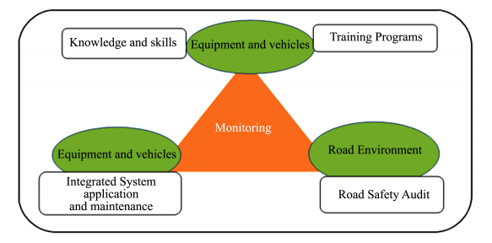**Fig. 4.** The framework of road safety management in Indonesia adapt from Bezerra,B.S (2019) .

Table 3. The general characteristics concerning traffic accidents in Indonesia

|  |  |  |
| --- | --- | --- |
| Type | Aspect | Rules,regulations, and guidelines in Indonesia |
| Established norms and guidelines | The design and layout of road infrastructure | Law No. 38-year 1997,Regarding the geometric aspect of designing road networks connecting cities. |
| Legislation and regulatory standards | Road safety facility | Ministry of Transportation. Law No. 82-year 2018,Regarding the management of traffic flow and ensuring the safety of road users through the use of control tools and measures. |
| Legislation and regulatory standards | Urban planning for pedestrians | Ministry of Public Works, Law No. 26 of 2007,Regarding the methods and guidelines for designing pedestrian-friendly spaces and ensuring efficient pedestrian planning. |
| Established norms and guidelines | The design and construction of road surfaces | Road Pavement Manual. No. 04/SE/Db/2017. |
| Established norms and guidelines | Technical protocols and recommendations for ensuring road safety | Ministry of Public Works No. 02/IN/Db/2012. |
| Legislation and regulatory standards | Vehicle safety measures | Government regulation No. 37-year 2017,Regarding the aspects of ensuring safety in traffic and the transportation of goods and individuals on roads |

The proposed treatments are suitable for the case of the intersection of Jalan Raya Tanah Baru - Jalan Raya Sawangan for several reasons:

1. High Frequency of Conflicts: The observed road safety issues at the intersection, such as conflicts between vehicles and improper parking, indicate a high frequency of safety hazards. The treatments, such as the installation of traffic control lights and enhanced signage, have been proven effective in managing traffic flow, reducing conflicts, and improving overall safety in similar intersections globally. Implementing these treatments can address the specific challenges faced at this intersection.
2. International Best Practices: The recommended treatments, including the installation of traffic control lights, enhancement of signage and road markings, construction of pedestrian crossings, enforcement of parking regulations, and road safety education, align with international best practices and guidelines. These treatments have been successfully implemented in various locations worldwide and have shown positive results in improving road safety and reducing accidents.
3. Local Regulations: The proposed treatments also comply with the Indonesia Ministry of Transportation Regulation No. 34 of 2014, which provides guidelines for road markings and signage. By following these regulations, the treatments ensure that the intersection meets the required standards and promotes safe behaviors among road users.
4. Specific Intersection Characteristics: Considering the heavy traffic volume, diverse vehicle types, and congestion issues observed at the intersection, the proposed treatments are well-suited to address the identified road safety problems. For example, the installation of traffic control lights can effectively manage the flow of vehicles and reduce conflicts in a busy intersection. Similarly, enhancing signage and road markings can provide clear instructions to drivers, reducing confusion and potential accidents. The construction of pedestrian crossings can ensure safe passage for pedestrians, who may face risks due to the absence of designated crossing areas. Additionally, the enforcement of parking regulations and road safety education can address specific issues related to improper parking and raise awareness among road users.
5. By implementing these treatments, the intersection of Jalan Raya Tanah Baru - Jalan Raya Sawangan can benefit from improved road safety, reduced accidents, and enhanced overall traffic management. These treatments have proven effective in similar cases globally, and their suitability for this specific case is based on the identified road safety issues and the unique characteristics of the intersection.
6. **Conclusions**

The T-Intersection of Jalan Raya Tanah Baru and Jalan Raya Sawangan in Depok City, Indonesia, presents significant road safety issues due to its unsignalized nature, inadequate signage, absence of pedestrian crossings, and presence of side obstacles. These factors contribute to crossing conflicts, acceleration behavior, and rear-angle collisions, leading to a high potential for traffic accidents. To mitigate these risks and enhance intersection safety, several effective solutions can be implemented.

The proposed treatments align with international best practices, comply with local regulations, and are suitable for the specific characteristics of the intersection. By implementing these solutions, the intersection of Jalan Raya Tanah Baru and Jalan Raya Sawangan can experience improved road safety, reduced accidents, and enhanced overall traffic management. Selecting the most appropriate treatments requires assessing the road safety issues, considering local conditions and constraints, evaluating effectiveness and feasibility, and prioritizing the treatments that address the most critical problems while being suitable for the specific context.

By addressing the road safety issues at the intersection and implementing these effective solutions, it is possible to create a safer road environment for all users and mitigate the risks associated with traffic accidents. This study provides valuable insights for policymakers, transportation authorities, and urban planners in their efforts to enhance intersection safety and improve the overall transportation system in Depok City, Indonesia.

1. **Acknowledgments**

This reseach project would not have been possible without the assistance of a large number of people. I'd want to take this opportunity to thank everyone who contributed to the success of this project, as well as my fellow students, who advised me in developing my study ideas by sharing their experience. Finally, and most significantly, I'd like to convey my heartfelt gratitude for always being my emotional support and teaching me how to face every problem with intelligence and confidence.

1. **References**
2. Administration, U. S. D. of T. H. (2011). *Intersection Safety: A Manual for Local Rural Road Owners*.September 5.
3. Al-Haji, G. (2007). Road safety development index: Theory, philosophy and practice. Linköping University, Norrköping, Sweden.
4. Bezerra, B.S. (2019) Road Safety and Sustainable Development. In: Leal Filho, W., Wall, T., Azul, A.M., Brandli, L. and Özuyar, P.G., Eds., *Good Health and Well*-*Being*. *Encyclopedia of the UN Sustainable Development Goals*, Springer, Cham, 1-13.
5. Bezerra, B.S. (2019) Road Safety and Sustainable Development. In: Leal Filho, W., Wall, T., Azul, A.M., Brandli, L. and Özuyar, P.G., Eds., *Good Health and Well*-*Being*. *Encyclopedia of the UN Sustainable Development Goals*, Springer, Cham, 1-13.
6. Bliss, T. (2004). Implementing the Recommendations of the World Report on Road Traffic Injury Prevention, Transport Note No. TN-1, World Bank, Washington DC.
7. Central Buerau of Statistics Indonesia 2017. (BPS-Statistics Indonesia).
8. Haddon, J.W. (1968) The Changing Approach to the Epidemiology, Prevention, and Amelioration of Trauma: The Transition to Approaches Etiologically Rather than Descriptively Based*. American Journal of Public Health*, **58**, 1431-1438.
9. Haworth N, Greig K and Nielson A 2009 Comparison of risk taking in moped and motorcycle crashes Transportation research record 2140(1) 182-187.
10. Huang B, and Preston J 2004 A literature review on motorcycle collisions: Final report. Transport Studies Unit (Oxford University).
11. Marsaid, et al. 2013. Factors Associated with the Incidence of Traffic Accidents in Motorcycle Riders in Malang Regency Police Area. Journal of Nursing Science - Volume 1, No. 2, November 2013. Brawijaya University: Malang.
12. Ministry of Transportation, Regulation of the Minister of Transportation Number 13 Year 2014 on Traffic Signs. Republic of Indonesia, 2014.
13. NHTSA (2015) Critical Reasons for Crashes Investigated in the National Motor Vehicle Crash Causation Survey.
14. Nikzad M. *Traffic accidents and damage caused by it, Causes and ways out of them.* Tehran: Applied Research Office of Traffic Police; 2008. Persian.
15. Nurdjanah, N. (2018). INCREASING TRAFFIC PERFORMANCE AT NON SIGNAL INTERSECTION IN TASIKMALAYA REGENCY. l, 1–29.
16. Soehodho S 2017 Public Transportation Development and Traffic Accident Prevention in Indonesia *IATSS Research* **40** (2) 76-80.
17. Suprayoga, G.B., Witte, P. and Spit, T. (2020) Identifying Barriers to Implementing a Sustainability Assessment Tool for Road Project Planning: An Institutional Perspective from Practitioners in Indonesia. *Journal of Environmental Planning and Management*, **63**, 2380-2401.
18. Zhong C, Sisiopiku V, Ksaibati K and Zhong T 2011 Crash prediction on rural roads. *In Proceeding of the 3rd International Conference on Road Safety and Simulation*, Indianapolis, Indiana.