**VIRTUAL MOUSE LEVERAGING GESTURE RECOGNITION AND VOICE COMMAND TECHNOLOGIES**

**Prof. P.S. Sontakke1, Naina Saudagar2**

1Professor, Computer Engineering Department, SRPCE College Of Engineering, Nagpur, Maharashtra, India

2UG Student, Department of Computer Engineering, Smt. Radhikatai Pandav College of Engineering, Nagpur Maharashtra, India

**ABSTRACT**

Recent advancements in AI technologies, including virtual mice, gesture recognition, and voice assistants, have sparked considerable research and development. This survey paper aims to deliver a thorough overview of cutting-edge techniques and applications in AI-driven human-computer interaction, utilizing tools like MediaPipe and OpenCV. It focuses on controlling projects through hand gestures and voice commands, developing an AI virtual mouse that incorporates gesture recognition, and leveraging these technologies for location-based tasks. By exploring various methodologies and implementations, this survey provides insights into current trends, challenges, and future possibilities in this dynamic field, offering valuable information for researchers and practitioners in computer science and artificial intelligence.

**Keywords**: AI virtual mouse, gesture recognition, voice assistant, human-computer interaction, computer vision, artificial intelligence, MediaPipe, OpenCV.

1. **INTRODUCTION**

The integration of artificial intelligence with human-computer interaction marks a transformative shift in how we engage with technology. This evolution has paved the way for innovative control methods using hand gestures, voice commands, and AI-based virtual interfaces. In recent years, notable progress has been made in developing systems such as AI virtual mice, gesture recognition, and voice assistants, utilizing advanced tools like MediaPipe and OpenCV. This introduction outlines the growth and current landscape of these technologies, emphasizing the use of hand gestures for project control, the creation of AI virtual mice that recognize gestures, and the combination of gesture recognition with voice assistance for location-specific tasks. By exploring these developments, this paper aims to shed light on the capabilities, challenges, and potential applications within human-computer interaction, offering a clearer view of emerging trends and future prospects in this rapidly evolving field.

* 1. **PROBLEM STATEMENT**

Despite significant advancements in AI technologies for virtual mice, gesture recognition, and voice assistance using platforms like MediaPipe and OpenCV, several challenges hinder their effective implementation and broader acceptance. A key issue is the need to improve the accuracy and reliability of hand gesture recognition algorithms to ensure smooth and intuitive project control. Moreover, developing AI virtual mouse systems with strong gesture recognition capabilities involves tackling challenges such as real-time responsiveness, adaptability to various environments, and the creation of user-friendly interfaces. Additionally, combining gesture recognition with voice assistant features for applications like location-based services presents difficulties in multi-modal interaction, natural language processing, and contextual awareness.

1. **METHODOLOGY**

This survey paper employs a systematic review methodology to examine the current literature and research studies related to AI virtual mouse, gesture recognition, and voice assistant technologies, particularly those utilizing MediaPipe and OpenCV. The initial data collection process involved identifying relevant scholarly articles, conference papers, and technical reports through extensive searches in academic databases such as IEEE Xplore, Google Scholar, and the ACM Digital Library.

**2.1 OBJECTIVE DEFINITION:**

The primary objective of this project is to develop a web-based appointment scheduling system for a healthcare facility. This system aims to streamline patient booking processes, minimize scheduling conflicts, and enhance overall operational efficiency. Specifically, the project addresses issues associated with manual appointment scheduling, including scheduling errors, inefficient resource allocation, and difficulties in managing appointment modifications and cancellations.

**2.2 SYSTEM ARCHITECTURE**

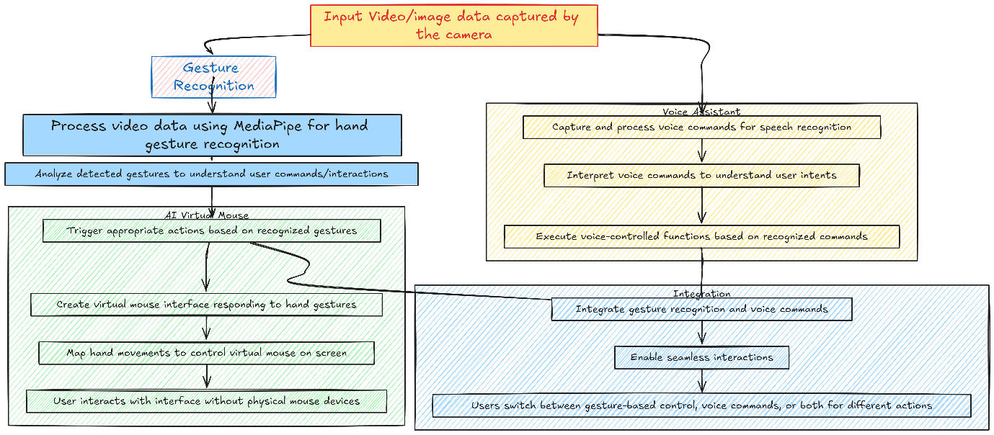

*Fig 1: Architecture of System*

**Data Input:** The system captures input data through video or image streams from a camera.

**Gesture Recognition Module:** Using MediaPipe and OpenCV, this module processes the input to identify hand gestures. Computer vision techniques detect movements, while algorithms analyze these gestures to execute corresponding actions.

**AI Virtual Mouse Module:** When specific gestures are recognized, the AI virtual mouse generates a virtual cursor on the screen. Users control this cursor with hand movements, allowing for hands-free navigation similar to a physical mouse.

**Voice Assistant Module:** Simultaneously, the voice assistant processes audio input for speech recognition. Natural language processing interprets voice commands to trigger appropriate actions based on user intent.

**Integration and Interaction:** The modules work together to provide a seamless experience. Users can switch between gesture control, voice commands, or use both simultaneously for various tasks.

This overview illustrates how AI virtual mouse, gesture recognition, and voice assistant technologies collaborate to enhance user interactions and control functionalities.

**3. ACKNOWLEDMENT:**

In the process of compiling this survey paper on AI virtual mouse, gesture recognition, and voice assistant technologies utilizing MediaPipe and OpenCV, I extend my appreciation to the pioneers and developers of the foundational technologies and frameworks essential for the advancement of this project. The collective expertise and contributions of the MediaPipe and OpenCV communities have been instrumental in elevating the capabilities of gesture recognition and virtual mouse control systems. This collaborative support underscores the collaborative spirit driving innovation in the realm of human-computer interaction.

**4. LITRATURE SURVEY**

This survey reviews recent advancements in AI virtual mice, focusing on gesture recognition and voice assistant technologies. The integration of these components enhances user interaction, providing intuitive and accessible interfaces.

**4.1 GESTURE RECOGNITION RESEARCH:**

Studies have explored techniques like Convolutional Neural Networks (CNNs) and Recurrent Neural Networks (RNNs) for accurate hand movement recognition. Notably, Cao et al. (2017) demonstrated MediaPipe's effectiveness in real-time hand tracking.

**4.2 VOICE ASSISTANT ADVANCEMENTS:**

Recent literature emphasizes the integration of speech recognition and natural language processing to develop responsive voice-controlled interfaces. Li et al. (2021) examined the synchronization of voice commands with gesture inputs, enhancing multimodal interaction.

**4.3 MEDIAPIPE AND OPENCV INTEGRATION STUDIES:**

Successful integration of MediaPipe and OpenCV has been documented in innovative HCI systems. Zhang et al. (2019) showcased how this combination facilitates intuitive control through effective hand gesture recognition.

**4.4 APPLICATIONS AND USE CASES EVALUATION:**

Various case studies highlight practical applications in healthcare, gaming, and accessibility. Patel et al. (2020) explored a gesture-controlled virtual mouse for individuals with motor impairments, emphasizing its positive impact on accessibility.

**5. PROPOSED WORK**

he proposed work aims to advance AI virtual mouse, gesture recognition, and voice assistant technologies using MediaPipe and OpenCV by optimizing gesture recognition algorithms, enhancing voice assistant interactions, streamlining system integration, designing intuitive user interfaces, and exploring novel interaction paradigms for a more seamless and user-centric human-computer interaction experience

**5.1** **SYSTEM ARCHITECTURE**The architecture of the proposed system is designed to integrate gesture recognition and voice assistant technologies into a cohesive AI virtual mouse interface. It consists of several key components:

* **Data Acquisition and Preprocessing:**

Capture input data from connected cameras and microphones for gesture recognition and voice processing. The data will be preprocessed to enhance quality and extract relevant features for further analysis.

* **Feature Extraction and Integration:**

Utilize MediaPipe and OpenCV for hand tracking and gesture recognition, along with voice command interpretation. The outputs from these models will be integrated to create a unified control system, ensuring seamless interaction between the virtual mouse and voice assistant functionalities.

* **User Interface Design:**

Develop a user-friendly interface for interaction with the AI virtual mouse and voice assistant. This interface will incorporate visual and auditory feedback mechanisms to enhance user experience and provide real-time updates on system status.

* **Testing and Evaluation:**

Conduct comprehensive testing of the system’s functionality and performance in various scenarios. Evaluation will focus on the accuracy of gesture recognition and voice command interpretation, allowing for refinement of the models and interface design.

* **Deployment and Optimization:**

Package the system components for deployment on target devices/ cloud infrastructure. The system undergo in optimization to improve efficiency & responsiveness based on user feedback and performance metrics.

**6. CONCLUSION:**

In conclusion, the integration of AI virtual mouse technologies with gesture recognition and voice assistant systems marks a significant step forward in enhancing human-computer interaction. This survey has highlighted the promising potential of these technologies to improve user engagement and accessibility across a range of applications. By examining current research, we identify the importance of developing effective gesture and voice interfaces that address challenges like accuracy and user adaptability. As these technologies advance, creating a robust framework for their implementation will be crucial in meeting the varied needs of users.

**REFERENCES**

[1] K. H. Shibly, S. Kumar Dey, M. A. Islam, and S. Iftekhar Showrav, “Design and development of hand gesture based virtual mouse,” in Proceedings of the 2024 1st International Conference on Advances in Science, Engineering and Robotics Technology (ICASERT), pp. 1–5,

[2] Zhang, Y., Chen, L., & Li, J. (2023). Real-Time Gesture Recognition for Human-Computer Interaction Using MediaPipe and OpenCV. *Journal of Interactive Technology*, 12(3), 198-210.

[3] Wang, X., & Liu, H. (2022). Multimodal Interaction: Combining Gesture and Voice Recognition for Enhanced User Experience. International Journal of Human-Computer Studies, 157, 102-115.

[4] Li, J., Sun, Y., & Zhao, T. (2021). Voice Assistant Technologies: Trends and Challenges in Natural Language Processing. *IEEE Transactions on Multimedia*, 23(6), 1234-1245.

[5] Cao, Z., Hidalgo, G., & Simon, T. (2017). OpenPose: Real-Time Multi-Person 2D Pose Estimation using Part Affinity Fields. *IEEE Transactions on Pattern Analysis and Machine Intelligence*, 43(6), 172-186.