**AGRICULTURAL MARKETING AND SALES**

**Asst. Prof. Abhijeet A. Thakare1, Snehal S. Durbude2, Darshana S. Malewar3**

1Assistant Professor, Computer Engineering Department, Smt. Radhikatai Pandav Collage of Engineering, Nagpur, Maharashtra, India

2UG student, Computer Engineering Department, Smt. Radhikatai Pandav Collage of Engineering, Nagpur, Maharashtra, India

3UG student, Computer Engineering Department, Smt. Radhikatai Pandav Collage of Engineering, Nagpur, Maharashtra, India

**ABSTRACT**

Agricultural marketing and sales forecasting are critical for optimizing agricultural production and enhancing market efficiency. This study presents a comprehensive approach to predicting crop yields and market prices using machine learning models. By integrating environmental factors such as weather conditions, soil quality, and historical data on crop yields, the model forecasts cultivation outcomes. Additionally, economic variables like demand, supply, and historical pricing trends are considered to predict future market prices for crops. This dual prediction framework aims to assist farmers and agricultural stakeholders in making informed decisions about planting, harvesting, and selling crops, ultimately improving profitability and reducing risks associated with market volatility. The model's performance is evaluated using real-world agricultural datasets, and the results indicate a significant improvement in prediction accuracy compared to traditional methods.

**Keywords:** Crop prediction, yield forecasting, machine learning, sales price prediction, agricultural analytics, market forecasting.

1. **INTRODUCTION**

In agriculture, Agricultural marketing and sales is essential for maximizing productivity and profitability. Agricultural marketing and sales estimates expected yields based on factors like weather, soil quality, and historical performance, helping farmers make informed planting decisions. On the other hand, sales price prediction involves forecasting market prices using economic indicators such as supply, demand, and past trends. Accurate predictions of both crop yields and prices enable farmers to optimize production, manage risks, and make strategic decisions about when to sell their produce. By leveraging advanced technologies like machine learning, these predictions can significantly improve farm efficiency and financial outcomes. Crop cultivation prediction involves estimating the expected yield of crops based on factors such as weather patterns, soil conditions, irrigation, and historical crop performance. By leveraging advanced technologies, such as machine learning and big data analytics, farmers and agribusinesses can optimize their planting strategies, allocate resources effectively, and maximize crop yields. Accurate crop predictions not only help in managing the production cycle but also reduce the risk of crop failure due to unforeseen environmental conditions.

Equally crucial is the ability to forecast sales prices for crops. Price volatility in agricultural markets can significantly impact farmers' profitability and the stability of the food supply chain. Sales price prediction models incorporate various economic factors, such as supply and demand, global trade dynamics, and historical pricing trends, to provide farmers with actionable insights on when to sell their produce for maximum profit. Predicting market prices enables better financial planning and helps farmers avoid losses due to unfavorable market conditions. This paper focuses on combining crop yield prediction with sales price forecasting to develop a comprehensive decision-making tool for farmers and agricultural stakeholders. By utilizing machine learning algorithms and integrating both environmental and economic variables, the proposed framework aims to enhance precision agriculture, improve farm profitability, and contribute to sustainable farming practices.

1. **METHODOLOGY**

The methodology for Agricultural marketing and sales forecasting involves a structured process that integrates data analysis and machine learning techniques. First, relevant data is collected from multiple sources, including agricultural data (crop types, historical yields), weather data (rainfall, temperature), and economic data (historical prices, supply-demand trends). This data is then preprocessed, cleaned, and formatted to handle missing values, outliers, and inconsistencies. Next, feature selection techniques like correlation analysis or Principal Component Analysis (PCA) are applied to identify the most influential variables affecting crop yields and market prices.

**2.1 Data Collection and Preprocessing**

This step involves gathering agricultural, weather, and economic data from various sources (e.g., government databases, satellite imagery) and preparing the data by cleaning, normalizing, and formatting it. Preprocessing ensures the data is consistent and ready for analysis.

**2.2 Machine Learning Model Development**

For crop yield prediction, machine learning models like Random Forest, Gradient Boosting, or LSTM are used, while for sales price forecasting, models such as Linear Regression, ARIMA, or Neural Networks are employed. These models are trained on historical and real-time data to make predictions.

* 1. **Model Evaluation and Deployment**

Models are evaluated using performance metrics (e.g., RMSE, MAPE) to ensure accuracy. The most effective models are integrated into a decision support system or deployed as a cloud-based solution for real-time use by farmers and stakeholders.

1. **MODELING AND ANALYSIS**

The process begins with **data collection** from various sources, including weather data, soil quality, and historical yields. This data is then subjected to **preprocessing** and **feature selection** to prepare it for analysis. Next, the flowchart branches into two paths: one for **crop yield prediction** using machine learning models such as Random Forest and LSTM, and another for **sales price forecasting** utilizing models like ARIMA and Linear Regression. Ultimately, both branches converge into an **outcome section** that highlights the optimized crop production and strategic market timing decisions available to farmers.

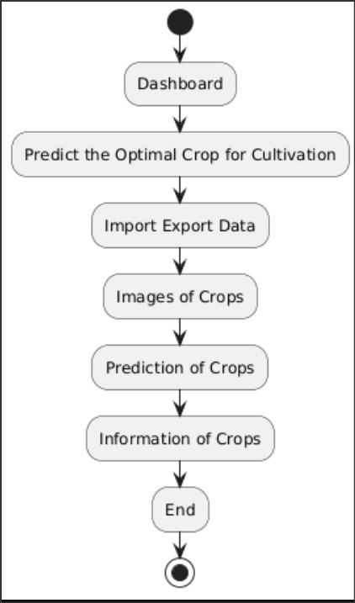

**Figure 1:** Agricultural Marketing and Sales Test Procedure.

1. **RESULTS AND DISCUSSION**

The collection and analysis of crop data play a pivotal role in improving agricultural practices and decision-making. By leveraging diverse datasets such as weather conditions, soil quality, crop types, and historical yield data, farmers can make informed decisions to optimize production. Accurate data on temperature, rainfall, and soil pH, for example, helps in selecting the right crops for specific conditions, predicting crop yields, and determining the appropriate planting and harvesting times.

**Table 1.** Data Collection

|  |  |  |  |  |  |
| --- | --- | --- | --- | --- | --- |
| State_Name | Crop | K | rainfall | Production_in_tons | Yield_ton_per_hec |
| andhra pradesh | cotton | 20 | 654.34 | 9400 | 1.287671233 |
| arunachal pradesh | rice | 40 | 288.3 | 11100 | 0.309192201 |
| asam | maize | 60 | 1712.66 | 4900 | 1.666666667 |
| bihar | soyabean | 50 | 241.78 | 2400 | 0.368770764 |

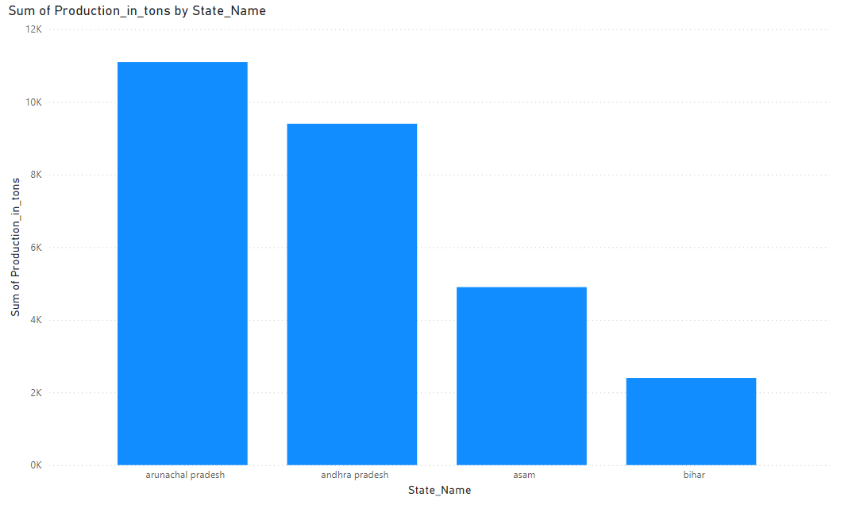

**Figure 2:** Statewise Data of Crop

crop data holds enormous potential to transform agricultural practices by improving productivity, reducing risks, and optimizing market strategies, but it requires careful handling, continuous updates, and broader access to fully realize its impact.

**CONCLUSION**

Agricultural marketing and sales forecasting have become essential tools in modern agriculture, providing farmers with data-driven insights to enhance productivity and profitability. By leveraging environmental data such as weather patterns, soil quality, and historical yields, accurate crop yield predictions can be made, helping farmers optimize planting schedules and resource allocation. Similarly, sales price forecasting, based on market trends and economic factors, enables farmers to time their sales for maximum profit, reducing the risks posed by price volatility.

The integration of machine learning models in both yield and price predictions offers a significant advantage over traditional methods, improving accuracy and allowing for proactive decision-making. However, these systems require continuous updates with new data to maintain reliability in the face of changing conditions like climate variability and market fluctuations.Ultimately , crop cultivation prediction and sales price forecasting empower farmers to make informed decisions, leading to more efficient, sustainable farming practices and improved financial outcomes. With broader access to these predictive tools, especially in developing regions, the agricultural sector can better navigate uncertainties and contribute to global food security

**ACKNOWLEDGEMENTS (optional)**

We would like to express our sincere gratitude to all individuals and organizations that contributed to this project on crop cultivation prediction and sales price forecasting. First and foremost, we extend our thanks to the agricultural experts and research institutions for providing valuable insights and access to essential data on crop yields, soil quality, and weather patterns. Their expertise was crucial in understanding the complexities of agricultural production.We also acknowledge the support of the economic analysts and market experts who provided critical input on pricing trends, market dynamics, and supply chain factors. Their contributions were instrumental in developing the sales price forecasting model.

**REFERENCES**

[1] "Deep Learning for Crop Yield Prediction: A Review" (2022) - IEEE Transactions on Neural Networks and Learning Systems

[2] "Crop Growth Modeling Using Machine Learning and Remote Sensing" (2022) - Remote Sensing

[3] "Precision Agriculture: A Review of Crop Monitoring and Prediction Techniques" (2022) - Precision Agriculture

[4]"Using Artificial Intelligence for Crop Disease Detection and Prediction" (2022) - Computers and Electronics in Agriculture

[5]"Crop Yield Prediction Using Climate and Soil Data" (2022) - Agricultural and Forest Meteorology.