**A Review Paper on Optimization of Process parameters in EDM of heat treated carbon tool steel**

Sumer Singh

College of Technology & Engineering, Udaipur

sumerrock1993@gmail.com

Abstract- Manufacturing with machining contributes to a larger extent in most of the industry as even the formed parts needs finishing by removal of material. The conventional machining processing involving common machine tools is making use of modern technology high production through better tooling and computer numerical control machining. The conventional material can be process with normal tools and machined with ease and little stress on the system. But special alloys, with high hardness and toughness are difficult to be worked on by these machines. Especially heat treated components acquire such a high degree of surface hardness that these are impossible to be cut with the best of tool materials available as on date. To take care of these challenges, modern machining method has be evolved using non-conventional approaches for metal removal, such as Electric discharge machining (EDM). In this work, experiments are carried out to investigate the effect of process parameters on material removal rate of machined workpiece specimens and it is observed that the rate of material removal rate is calculated with high degree of accuracy after the machining process. The experiments are performed on ZNC-250 die-sink electric discharge machine for EDM drilling of carbon tool steel workpiece using copper rod as electrode. Experiments are designed using fractional and full factorial design of experiment (DOE) and experimental runs were conducted for various combinations of process parameters such as current (I), pulse on time (Ton), servo voltage (V) and keeping pulse off time (Toff) as constant. Analysis of variance (ANOVA), and regression techniques were employed to study the performance characteristics at different conditions and levels according to DOE. It is found that the MRR is mainly influenced by current where as other two parameters i.e. pulse on time and servo voltage have lesser effect on material removal rate. The maximum MRR is 16.24 mm³/min. The percentage contribution of the current, pulse on time and servo voltage are found to be 64.29%, 25.78% and 4.04% in fractional DOE approach while in full factorial DOE approach, the percentage contributions are 62.05%, 26.39% and 1.09% respectively. The optimum combination of (I), (Ton) and (V) for maximizing MRR is found as 12A, 60 𝛍s and 4V respectively. The results obtained by this research will be useful for various industries and researchers working in this field.

Keywords: EDM, EDM drilling, Copper, MRR, DOE, ANOVA analysis Introduction

The conventional machining process involving common machine tools is making use of modern technology, high production through better tooling and computer numerical control machining. The raw stocks of different shapes and sizes are worked upon by these tools and machining with ease and little stress on the system. But special alloys, with high hardness and toughness are difficult to be worked on these machines. Especially heat treated components acquire such a high degree of surface hardness that these are impossible to be cut with the best of tool materials available as on date. Carbon steel is most commonly used in manufacturing shear blades and industrial cutters. Out of many uses, one of the most common use of carbon 2 tool steel is in making of industrial cutters. Due to their workability, hardenability, product performance, affordability and other characteristics, carbon steel are the most widely used cold rolled special steel. Carbon tool steel is used in wide range of fields. From hard application including blades, cutting tools, and regular tools; to applications that require elasticity and toughness including regular springs, spiral springs, knitting needles, horns, measuring tapes and washers. This steel is good, economical choice when fair wear resistance is required and corrosion is not a problem. But there are many problems faced in machining this material. Many sheet metal operations cannot be performed due to their hard material properties and heat treatment processes. A common use of carbon tool steel is in the area of cutting of hardwood, plastics, metals etc. For these applications the blades are to be held in other suitable holding devices which need creating holes in the blades at places other than the original cavities. It is not possible to drill the desired holes on these blades with conventional or advanced tool materials because of surface characteristics. The blade possess a very high degree of hardness along with mirror like polish which makes it difficult to work with any type of drill or punch. In recent years, the practice of hard and difficult to machine materials, due to its brilliant technological properties, is extensively used in various sectors in modern manufacturing industries. Due to, its excellent properties and behavior in these applications even more challenging, its transformation and processing is even more challenging. They present problems which limit the accuracy and rising production costs. Consequently, the machining of such material in an efficient manner is a challenge. To take care of these challenges modern machining methods have been evolved, using non-conventional approaches for metal removal which include Electric discharge machining (EDM), Electrochemical machining (ECM), Ultrasonic machining, Water jet machining, Laser beam machining (LBM), etc. Primary characteristics of non-traditional methods are: a) Prototype Production: The EDM process is most widely used by the mould-making tool and die industries, but is becoming a common method of making prototype and 3 production parts, especially in the aerospace, automobile and electronics industries in which production quantities are relatively low. b) Metal disintegration machining: Several manufacturers produce EDM machines for the specific purpose of removing broken tools (drill bits or taps) from work pieces. In this application, the process is termed "metal disintegration machining". c) EDM has become an indispensable process in the modern manufacturing industry. The use of EDM is especially essential for machining difficult-to machine materials (hardened alloy steel, high speed steel, super alloy, cemented carbide) and complex geometry parts for which traditional techniques are not applicable d) It is primarily used for production of subtle cavities in forming tools or polymer injection, prototype parts and other highly specialized products. With the increased capability of EDM controls, new processes use simple-shaped electrodes to 3D EDM complex shapes. Since the tool does not touch the workpiece there are no cutting forces, therefore, very fragile parts can be EDM machined e) X, Y, and Z axis movements allow for the programming of complex profiles using simple electrodes. f) The process is burr-free g) Secondary finishing operation can be neglected New advancement in the field of material science has led to new engineering metallic materials, composite materials and high tech sense of ceramic having good mechanical properties and thermal characteristics as well as electrical conductivity so that they can readily be machined by spark wearing away. Nontraditional machining has grown out of the need to machine these exotic materials. These machining processes are non-conventional in the sense that they do not employ traditional electrodes for metal removal and instead they directly use other forms of energy. The problems of high complexity in shape, size and higher demand for Cartesian product accuracy and surface finish can be solved through non-traditional methods. Currently, non-traditional processes possess virtually unlimited capabilities except for volumetric material removal rates, for which great approaches have been made in the past few years to increase the material removal rates. As material removal rates increases, the price effectiveness of cognitive operation also increases, appealing ever greater uses of nontraditional processes. One of the popular non-conventional process being used 4 extensively in industry in electric discharge machining (EDM) which is primarily an electrical erosion by spark between electrode tool and workpiece. The present work involves the optimization of process parameters in electric discharge machining of heat treated carbon tool steel by varying the parameters. Looking to the need of the studies in the field of the advancement of the manufacturing processes, the objectives of this study are: • To study the effect of machining parameters on material removal rate (MRR) during electric discharge machining. • Optimization of machining parameters for maximum material removal rate (MRR) in EDM machining of heat treated carbon tool steel with electric discharge machining (EDM)

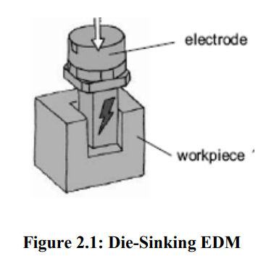

Die-sinking EDM In the die-sinking EDM machining process, two metal parts immersed in the insulating liquid are connected to the current source, which is automatically turned on and off based on the parameters set on the control unit. When the current is turned on, an electrical tension is formed between two metal parts. If two parts are brought together within one fraction of an inch, then the electrical tension is discharged and a spark jumps across the channel. Where it strikes, the metal gets so hot that it melts. The Sinker EDM, also called the Cavity type EDM or Volume EDM, consists of an electrode and work piece immersed in a liquid such as EDM oil, kerosene, deionized water and other dielectric fluid which is an electrical insulator that helps to control the arc discharge. The electrode and work piece are connected to a suitable power supply. The power supply creates an electrical potential between two parts. As the electrode reaches the workpiece, the dielectric breakdown occurs in the fluid, forming a plasma channel, and a small spark jump. Fig 2.1 shows the schematic diagram of Die-Sink EDM.

Effect of Parameters on MRR and SR Material removal determines each machining rate and tool electrode wear. In die sinking EDM, the material removal rate is defined as removed volume per unit time and specifies material removal on work piece. The relative tool wear, defined because the volumetric quantitative relation of material removal on tool electrode over that on work piece, measures the material removal on tool conductor. The ratios of material removal between electrodes depend on a number of the control parameters. Current density has the higher influence on power distribution that determines the quantitative relation of material removal between electrodes. The plasma channel expands throughout discharge duration; the pulse duration is the most significant control parameter affecting the relative material removal rate between the electrodes. The 18 anode has larger material removal with shorter pulse duration while the cathode has larger material removal with longer pulse length. Besides pulse duration, parameters that cause decrease of current density can reduce the material removal of the anode too (Yan et al., 2002).

1 Electric Discharge Machine (EDM) For attaining the objective of the present work through the complete set of experimentation an Electric Discharge Machine, model ZNC-250 (die-sinking type) available in the workshop of the Mechanical Department, CTAE as shown in Fig 3.1 is used. ZNC-250 has the provisions of programming in the Z-vertical axis-control and manually operating X and Y axes. Divyol spark errossion oil-25 (specific gravity= 0.750 @ 29.5℃, Min.) was used as dielectric fluid.

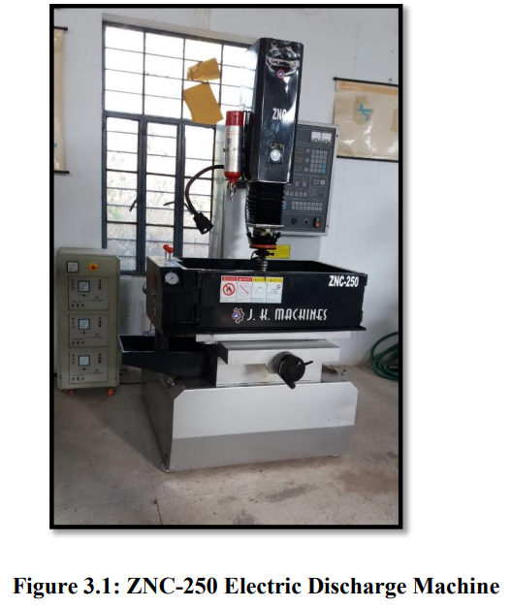

**2. Experimental Procedures**

Before running the experiment, the electrode and work piece are cut according to the required dimensions. The electrode needs to be cut, its diameter same for all workpiece specimens. A lathe machine is used to cut the electrode with desired diameter. For the material removal rate, the die sink EDM machine is used for all work piece specimens with the same diameter of electrode by changing the control parameters. 3.7.1 Experimental steps: The electric discharge machine, model ZNC-250 (die-sinking type) with servohead (constant gap) and positive polarity for electrode (reverse polarity) is used to conduct the experiment. Divyol Seo-25 is used as dielectric fluid. 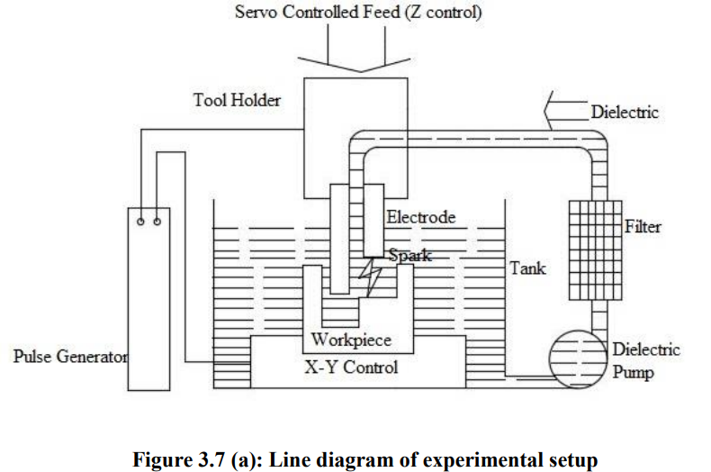

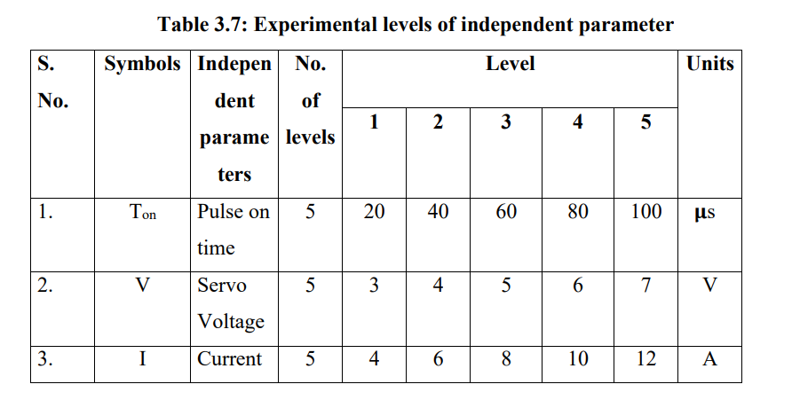

RESULTS AND DISCUSSION In this Chapter, a description is presented about the task of data collection for different machining parameters, namely current, pulse on time and servo voltage according to the proposed setup and methodology and their separate statistical analysis is also presented in this chapter. At last, comparative analysis of combination of parameter values is presented in order to determine the best machining rate. This complete task has been divided into two stages: 1) Full factorial design of experiment 2) Fractional design of experiment Hence, the experiments are performed according to these sets of data levels and the gathered data are used for analysis and formulation of the regression equation to get predicted material removal rate values

**4. Conclusion**

The present investigation is aimed at study on effect of process parameters for obtaining maximum material removal rate during EDM drilling of SK2MCr4 as workpiece with copper electrode by changing the combination of control parameters as current, pulse on time and servo voltage, while keeping pulse off time as constant, and optimizing the machining parameters. The relationship between control parameters and the performance measures are expressed by multiple regression model, i.e., fractional and full factorial design of experiment approach. The results are presented by main effect plots, interaction graphs and percentage contribution graphs. Finally, the following conclusions are drawn for both fractional and full factorial design of experiment. • Material removal rate (MRR) increases linearly with respect to increase in current from 4 A to 12 A. The current value is restricted to 12 A due to safety reasons and occurrence of firing in dielectric fluid. • MRR increases initially with increase in pulse on time from 20 𝛍s to 60 𝛍s, but it decreases later on with further increase in pulse on time from 60 𝛍s to 100 𝛍s. The max MRR of 11.77 mm3 /min is obtained at constant current and voltage of 8 A and 3 V, respectively. • The effects of servo voltage on MRR are having variable trend. The MRR initially increases and then decreases with increase in the servo voltage from 3 V to 7 V. In combination with current and pulse on time, the servo voltage of 3 V is preferable. • Amongst the control parameters, the material removal rate is strongly affected by current, while the pulse on time and servo voltage have lesser effect on material removal rate. • Optimization of machining parameters for maximum material removal rate (MRR) by Taguchi L9 orthogonal design of experiment and ANOVA analysis, the value 85 of maximum material removal is 16.24 mm³/min in combination of parameters values as current, pulse on time, and servo voltage are 12 A, 60 𝛍s and 3 V, respectively. • Material removal rate and control parameter (i.e., Ton and V) have highly nonlinear relationships among them for both fractional and full factorial DOE except for current, which has a linear relationship, while keeping pulse off time as constant. • Taguchi Design is a robust model for optimization when experimental runs are to be kept limited and it does not involve all the parameters combination. Thus, rate of error by this approach was found to be 5.89%, which is lower as compared to full factorial design approach where error was found 10.49%. • The fractional DOE is proven to be a best choice, because it involves all the possible combination of parameter values in a minimum number of run and gives minimum error rate hence shows accuracy of the experimental setup and statistical model and material removal values can be concluded up to close level of accuracy and precision

SUGGESTIONS FOR FUTURE WORK The work has been carried out without any prior experience with EDM drilling processes, thus consisting of rather simplified models. Further studies of the EDM drilling process and industry experience would undoubtedly result in a more detailed EDM drilling model, improving the accuracy of the results. Another potential way to improve the performance with advancement in level of automation, the present vertical movement (z axis) of die-sink EDM machine and the tool arrangement may be changed by rotary movement for better performance of material removal rate. Current work, all of the experiments were carried out at specified levels which were in the scope of this study. For example, instead of using single workpiece material, in future various studies can be performed taking into consideration differing workpiece material and their different shapes and sizes so that their effect can also be analyzed. The problem of tool wear, tool characteristics, tool material, etc. can be taken into consideration in the similar types of studies. In the current study only MRR is found out, also study on the other output parameters for the same workpiece and electrode material can be done. For example, SR, TWR, aspect ratio, etc

References

Banker, K., Prajapati, U., Prajapati, J. and Modi, P. 2014. Parameter optimization of electro discharge machine of AISI 304 steel by using Taguchi method. International Journal of Application or Innovation in Engineering & Management 3: 20-24. Bergaley, A. and Sharma, N. 2013. Optimization of electrical and non-electrical factors in EDM for machining die steel using copper electrode by adopting Taguchi technique. International Journal of Innovative Technology and Exploring Engineering 3: 2278-3075. Berger P.D. and Maurer, R.E. 2001. Experimental Design with Applications in Management, Engineering and the Sciences. Duxbury Press, USA pp. 496. Chakraborty, S., Dey, V. and Ghosh, S.K. 2015. A review on the use of dielectric fluids and their effects in electrical discharge machining characteristics. Precision Engineering 40: 1-6. Chandramouli S., Shrinivas Balraj U. and Eswaraiah K., (2014). Optimization of Electrical Discharge Machining Process Parameters Using Taguchi Method, International Journal of Advanced Mechanical Engineering, 4: 425-434. Choudhary, R., Kumar, H. and Garg, R.K. 2010. Analysis and evaluation of heat affected zones in electric discharge machining of EN-31 die steel. Indian Journal of Engineering and Materials Sciences (IJEMS) 17: 91-98. Dewangan, S.K. 2010. Experimental investigation of machining parameters for EDM using U-shaped electrode of AISI P20 tool steel. M.Tech thesis submitted to National Institute of Technology, Rourkela, Odisha (India). Erden, A., 1983. Effect of materials on the mechanism of electric discharge machining (EDM). Journal of Engineering Materials and Technology 105: 132-138. Ersan A. and Necip B. 2006. Design of Optimization of Cutting Parameters when Turning Hardened AISI 4140 Steel (63 HRC) with Al2 O3 + Ticn Mixed Ceramic Tool. Journal. of Materials and Design 112: 852-858. Fisher R.A. 1925. Statistical Methods for Research Worker. Oliver & Boyd, London. 89 Gaikwad, V. and Jatti, V.S., 2016. Optimization of material removal rate during electrical discharge machining of cryo-treated NiTi alloys using Taguchi’s method. Journal of King Saud University-Engineering Sciences. Ghani J. A., Choudhury I. A. and Hassan H. H. 2004. Application of Taguchi Method in the Optimization of End Milling Parameter. Journal of materials processing technology 145: 84–92. Jeevamalar, J. and Ramabalan, S. 2015. Die sinking EDM process parameters: a review. International Journal of Mechanical Engineering and Robotics Research 4: 315. Joseph R. Davis. 1989. Metals Handbook Desk Edition. ASM