**MISSILE SHIELD RADAR SYSTEM USING ARDUINO**

**Prof. P. B. JAIPURKAR1, Om Shinde2, Tushar Moon3**

1Professor, Computer Engineering Department, SRPCE College Of Engineering, Nagpur, Maharastra, India

2UG Student, Department Of Computer Engineering, Smt. Radhikatai Pandav College Of Engineering, Nagpur Maharastra, India

3UG Student, Department Of Computer Engineering, Smt. Radhikatai Pandav College Of Engineering, Nagpur Maharastra, India

**ABSTRACT**

The aim of our project is to design a missile launcher which is controlled by the signals from a RADAR. The working is based on Arduino Uno, Servo motor, Ultrasonic sensor. The idea is to first code the entire working using our previous knowledge of programming. The code will then be simulated on software and later be interfaced with the hardware or Arduino Uno. The ultrasonic sensor movement is maintained by the servo motor fixed within it. The servo motor is made to revolve through fixed angles; if object is detected then the angle position is sent as the input to the launcher fixed servo motor. The launcher will release the missile fixed within it. This project will play an important role in defense purposes.

**Keywords**: Arduino Uno, Ultrasonic sensor, Servo motor

1. **INTRODUCTION**

RADAR is an object detection system which uses radio waves to determine the range, altitude, direction, or speed of objects. Radar was secretly developed by several nations before and during the World War II. The term RADAR itself, not the actual development, was coined in 1940 by United States Navy as a crony for Radio Detection and ranging. The modern uses of radar are highly diverse, including air traffic control, radar, astronomy, air defence systems, antimissile systems, antimissile systems; marine radars to locate landmarks and other ships; aircraft anti-collision systems; ocean surveillance systems, outer space surveillance. A radar system is the heart of a missile guidance system. Our main aim of developing this project is to make the automated missile launching devices which is highly helpful in defence technology and surveillance in upcoming years. These launching vehicles can be used in army supported with tankers and other vehicles, used in navy by supporting with ships, and used in aircraft by installing it in air-crafts. These launchers will be actuated if there is any interruption in the radar signals.

The term RADAR was coined in 1940 by the United States Navy as an acronym for “RADIO Detection and Ranging.” Radar systems have a wide range of applications. Geologists use radar to map the earth and other planets. Meteorologists use radar to track the storms, hurricanes and tornadoes.

Advancements in Tracking Technology: The foundation of our Autonomous Missile Defense System lies in the integration of an advanced sonar-based object tracking system. Sonar, known for its effectiveness in underwater applications, has been adapted to create a sophisticated tracking mechanism for airborne targets. This system continuously monitors the trajectory of incoming missiles, providing real-time data on their position and movement. The utilization of sonar technology adds a layer of versatility, allowing the system to operate effectively in various environmental conditions, including adverse weather and low-visibility situations.

Ultrasonic Radar Sensors for Enhanced Detection: The system incorporates ultrasonic radar sensors, a choice motivated by their ability to cover substantial detecting distances while remaining effective in both day and night scenarios. These sensors play a pivotal role in the initial detection phase, working in tandem with the sonar-based tracking system. Their capacity to operate in diverse lighting conditions ensures the system's reliability in a range of environments, contributing to the system's adaptability and effectiveness. ved by using DarkNet for feature detection after the convolutional layer.  the results of the application of the proposed models for plant disease detection and diagnosis.

Microcontroller-based Control Unit: The heart of the Autonomous Missile Defense System lies in the Microcontroller-based control unit. Programming in Embedded 'C' language, this control unit acts as the brain orchestrating the entire defense mechanism. Upon receiving data from the tracking system, the control unit processes the information, calculates the optimal response, and issues precise commands to the firing mechanism. This level of automation not only accelerates the response time but also ensures a coordinated and accurate engagement with the incoming threat.

1. **LITERATURE SURVEY**

“The Idea” Army, Navy and the Air Force make use of this technology. The idea of making an ULTRASONIC RADAR came as a part of a study carried out on the working and mechanism of “mini radar”. Hence this time we were able to get a hold of one of the Arduino boards, Arduino UNO. So knowing about the power and vast processing capabilities of the Arduino, we thought of making it big and a day to day application specific module that can be used and configured easily at any place and by anyone. Moreover, in this fast moving world there is an immense need for the tools that can be used for the betterment of the mankind rather than devastating their lives. Hence, from the idea of the self-driving cars came the idea of selfparking cars. The main problem of the people in the world is safety while driving. So, this gave up a solution to that by making use of this project to continuously scan the area for traffic, population etc. After going through some of the papers regarding RADAR implementation using ultrasonic sensor we found that this concept is quite sought everywhere and is a popular concept which is still in progress. These papers had some really innovative ideas for prevention from accidents and driving safer. The techniques that were illustrated were par excellence and can bring about a major change in the field of automobiles. The technologies used were not only efficient and reliable but also economically feasible. This paper deals this deals the major causes of accidents and the simple ways in which they can be prevented. The existing system uses microcontroller and LCD display, we have used Arduino UNO and MATLAB for respective purposes. Our major aim is display the obstacle position as accurately as possible. and as well as protection of the vehicles at the same time to prevent accidents or minor scratches to the vehicles.

D. A. Ghoghre [1], Ahire Dhanshri, Ahire Priyanka, have presented the radar system which is used for only object detection, and can be implemented for surveillance only and not available in defence technology.

Srijan Dubey [2], Supragya Tiwari and Sumit Roy, have performed an object detection system with the help of ultrasonic sensor and published “Implementation of Radar using Ultrasonic Sensor”, this system is used for detecting objects in an open surface and provide alarming system to indicate the interference of objects. This is a surveillance system which can able indicate. Kadam D. B. [3], Patil Yuvr J. B., Chougale Krishna V., Perdeshi Swagat S., have published “Arduino Based Moving Radar System”. This system is based on making a vehicle which is moved automatically by the signals of the ultrasonic sensor, controlled by the Arduino Uno processor and its software commands.

Sanjeev Kumar Verma [4], Sudhir Sing Badhuriya, and Saleem Akhtar, have worked on material analysis and non-destruction technology with the help of ultrasonic sensor and many types of material analyzing tools and different materials. Pamfil Somadiag [5]., He has designed “Air and Ballistic Missile Defense Systems LTC.” This system is used to launch the missile with the help of air through ballistic missile launching vehicle. These systems are designed to provide low cost in defence technology, but it has low efficiency than other system and needs proper maintenance. T. V. Karthikeyan., A. K. Kapoor [6]., Scientists Defence Research and Development laboratory, Hyderabad, have published paper on “Guide Missiles”. They have worked on the team of human controlled and semi-automatic missile launching devices. They tell about computer controlled and automated missile system which is highly actuated by huge power systems, however these systems needs human interface or help while locking the target to be attacked. Bo Zhang [7], Zhou Wang and Tao Wang, Publishedon the topic of “Research on Movement Characteristics of Launching Mechanism of Portable Missile”.

They have studied about the portable mini-missile launching vehicles highly adaptable to the war land. These need alternative power backups to overcome the power scarcity, because these systems needs more power to handle normal or huge sized missile. These devices cannot able to withstand high loads, and needs specially designed missile to work in high efficiency. C. Isik., S. K. Ider., B. Acbar [8]., worked on “Modelling and verification of a missile launcher system.” They have developed a reusable launcher which is highly support the financial wastages in defence testing and other working systems. However, these missile systems after a single usage will be affected highly, and needs more spares and small operating systems for rebuilding the launching tools. It also needs proper housing which is high in cost than normal missile launching tools. Ohtsuka Hirohito [9]., Yagi Kazuhiro, Kishi Kohichi, Nohara Masaru, Sano Naruhisa, Worked on JAXA on “Research on Advanced Solid Rocket Launcher”. These are the world’s best solid rocket launcher. But it is large in size and bulky and high in cost. Whereas this is a complex design.

1. **PROPOSED SYSTEM**

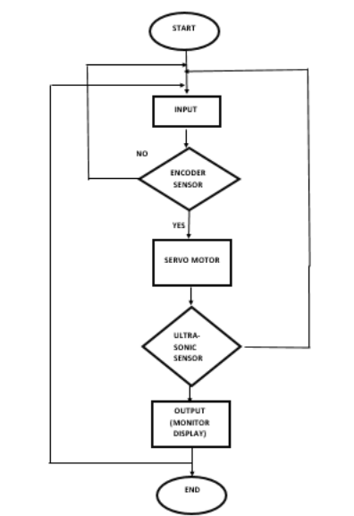Arduino is an open-source project that created microcontroller-based kits for building digital devices and interactive objects that can sense and control physical devices. The project is based on microcontroller board designs, produced by several vendors, using various microcontrollers. These systems provide sets of digital and analog input/output (I/O) pins that can interface to various expansion boards (termed shields) and other circuits. The boards feature serial communication interfaces, including Universal Serial Bus (USB) on some models, for loading programs from personal computers. For programming the microcontrollers, the Arduino project provides an integrated development environment (IDE) based on a programming language named Processing, which also supports the languages C. The projected system uses an ultrasonic module interface to microcontroller of ARDUINO family. An ultrasonic transducer encompasses a transmitter, and the receiver is worn. The transmitted waves had been meditated from the object and acquired by way of the transducer again. the overall time taken for sending the waves to receive it become calculated by way of taking into apprehension the rate of sound. Then the distance is calculated via the program going for walks at the microcontroller and displayed on a liquid crystal displayed (liquid crystal display) display screen interfaced to the microcontroller.

Fig 1**:** Proposed System

**ARDUINO**

The Arduino Uno R3 is a open source microcontroller board based on the ATmega328 chip. This Board has 14 digital input/output pins, 6 analog input pins, Onboard 16 MHz ceramic resonator, Port for USB connection, Onboard DC power jack, An ICSP header and a microcontroller reset button. It contains everything needed to support the microcontroller. Using the board is also very easy, simply connect it to a computer with a USB cable or power it with DC adapter or battery to get started. The recommended range is 5v to 12v for Arduino Uno.

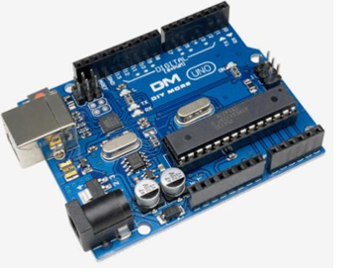

Fig. 2: Arduino

**SOFTWARE**

Software is the important parameter to make the device automation. In proposed implementation we used embedded c programming language and compiler Arduino IDE we used. Here we used Arduino IDE software for programming write up and execution of entire system.

**ULTRASONIC SENSOR**

Ultrasonic sensors emit short, high-frequency sound pulses at regular intervals. These propagate in the air at the velocity of sound. If they strike an object, then they are reflected back as echo signals to the sensor, which itself computes the distance to the target based on the time-span between emitting the signal and receiving the echo. As the distance to an object is determined by measuring the time of flight and not by the intensity of the sound, ultrasonic sensors are excellent at suppressing background interference. Virtually all materials which reflect sound can be detected, regardless of their color. Even transparent materials or thin foils represent no problem for an ultrasonic sensor. Micro sonic ultrasonic sensors are suitable for target distances from 30 mm to 10 m and as they measure the time of flight they can ascertain a measurement with pinpoint accuracy. Some of our sensors can even resolve the signal to an accuracy of less than 0.18 mm. Ultrasonic sensors can see through dust-laden air and ink mists. Even thin deposits on the sensor membrane do not impair its function. Sensors with a blind zone of just 30 mm and an extremely narrow beam spread are finding totally new applications these days: measuring levels in yoghurt pots and test tubes as well as scanning small bottles in the packaging sector - no trouble for our sensors. Even thin wires are reliably detected.

**DC MOTOR**

A dc motor uses electrical energy to produce mechanical energy, very typically through the interaction of magnetic fields and current-carrying conductors. The reverse process, producing electrical energy from mechanical energy, is accomplished by an alternator, generator or dynamo. Many types of electric motors can be run as generators, and vice versa. The input of a DC motor is current/voltage, and its output is torque (speed). The DC motor has two basic parts: the rotating part that is called the armature and the stationary part that includes coils of wire called the field coils. The stationary part is also called the stator. Figure shows a picture of a typical DC motor, Figure shows a picture of a DC armature, and Fig shows a picture of a typical stator. From the picture you can see the armature is made of coils of wire wrapped around the core, and the core has an extended shaft that rotates on bearings. You should also notice that the ends of each coil of wire on the armature are terminated at one end of the armature. The termination points are called the commutator, and this is where the brushes make electrical contact to bring electrical current from the stationary part to the rotating part of the machine.

1. **COMPONANTS**

**A. Arduino Uno**

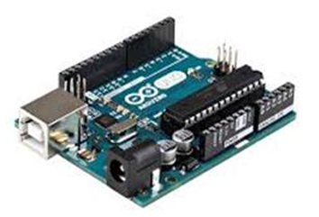

Fig 3: Arduino Uno

Arduino Uno is a physical computing platform that released under open-source license and based on a simple microcontroller board (Fig. 1). Integrated Development Environment (IDE) is devoted for coding the device. In most applications, the Arduino Uno board is used as a controller. Initially, the device requires a direct connection to a computer at the first setting steps. The most important advantage with Arduino is the programs can be directly loaded to the device without requiring any hardware programmer to burn the program. This is done because of the presence of the 0.5KB of Boot loader which allows the program to be burned into the circuit. All we have to do is to download the Arduino software and writing the code.

**B. Ultrasonic Sensor**

HC-SR04 Ultrasonic (US) sensor is a 4 pin module, whose pin names are Vcc, Trigger, Echo and Ground respectively. This sensor is a very popular sensor used in many applications where measuring distance or sensing objects are required. The module has two eyes like projects in the front which forms the Ultrasonic transmitter and Receiver. The sensor works with the simple high school formula that The Ultrasonic transmitter transmits an ultrasonic wave, this wave travels in air and when it gets objected by any material it gets reflected back toward the sensor this reflected wave is observed by the Ultrasonic receiver module.

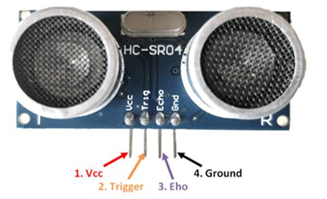

Fig 4:Ultrasonic Sensor.

**C. Servo Motor**

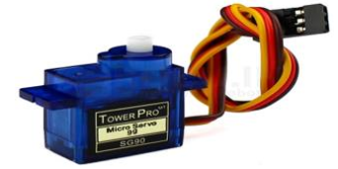

Fig 5:Servo Motor

A servomotor is a rotary actuator or linear actuator that allows for precise control of angular or linear position, velocity and acceleration. It consists of a suitable motor coupled to a sensor for position feedback. It also requires a relatively sophisticated controller, often a dedicated module designed specifically for use with servomotors. Because servo motors use feedback to determine the position of the shaft, you can control that position very precisely. As a result, servo motors are used to control the position of objects, rotate objects, move legs, arms or hands of robots, move sensors etc. with high precision. Servo motors are small in size, and because they have built-in circuitry to control their movement, they can be connected directly to an Arduino. Servo motor consist of Black/Brown ground wire, Red power wire (around 5V), and Yellow or White PWM wire.

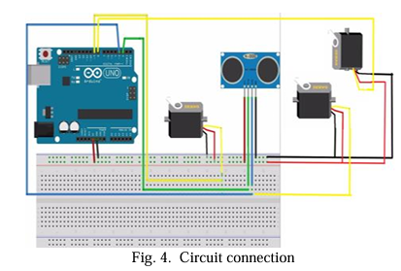

1. **CONCLUSION**

In this paper we have attempted to use ultrasonic sensor for implementation of RADAR and got results that exceeds our presumed expectations. With some enhancements the system can be used for real time purposes.

The project “Missile tracking and auto collision system” is mainly intended to operate design and construct automatic missile detection and destroying system. The system is designed to detect the target (missile) moving in multiple directions. The target destroying system moves automatically in the direction of missile and fires it upon fixing the target. In future we can add GSM to this project is that the status of target properties is not known. This can eliminate by having a GSM module, which gives the status of target. We can also add Ultrasonic module, which is used for obstacle detection with GSM module which gives respective information. By connecting wireless camera to the system, then we can see the outer world from our personal computer only by using GPRS and GPS. We can use this system at so many fields and we can use to handle so many situations

1. **REFERENCES**

[1] Missile detection and destruction robot using detection algorithm Md Kamrul Siam, Shafayet Ahmed, Md Habibur Rahman, Amir Hossain Mollah (2024)

[2] Center for Strategic and International Studies. Terminal High Altitude Area Defense (THAAD). Available online: https://missilethreat.csis.org/system/thaad/#easy-footnote-bottom-11-4113 (accessed on 11 December 2022 ).

[3] American Physical Society Panel on Public Affairs. Ballistic Missile Defense: Threats and Challenges; Technical Report; American Physical Society: Ridge, NY, USA, 2022.

[4] Kadam D. B, Patil Yuvr J. B, Chougale Krishnat V, and Perdeshi Swagat S, “Arduino Based Moving Radar System,” International Journal of Innovative Studies in Sciences and Engineering Technology, vol. 3, no. 4, pp. 23-26, April 2017.

[5] Zhang Bo, Wang Zhuo and Wang, Tao, Research on Movement Characteristics of Launching Mechanism of Portable Missile Launcher. Journal of Physics: Conference Series, vol. 1087, 2018.

[6] Abbay P., Akhilesh S., Amrit P., and Kriti, “A Review on Ultrasonic Radar Sensor for Security system”, Journal of Emerging Technologies and Innovative Research, April 2016.

[7] Mukund Wani, Neha Keswani, Snehal Neel, Smiley Chopade, “Automatic Billing Trolley,” in International Research Journal of Engineering and Technology,” vol. 4, no. 4, pp. 3239-3242, April 2017