**A Probabilistic Machine Learning Model for Sentiment Analysis of Social Media Data**

**Harsh Shriwas1, Prof. Sanmati Jain2**

*Abstract*— Recently, big data and big data analytics have found applications in various fields. The realm of social media and related applications is a significant area of research where Artificial Intelligence has demonstrated remarkable influence. This paper proposes a mechanism for classifying text data into various sentiment categories. This scenario utilizes data in the form of tweets. The raw data has undergone pre-processing before being utilized to train a neural network. A Neural Network is subsequently trained utilizing the data categories, which consist of tweets reflecting the happy, neutral, and sad emotions of Twitter users. The Bayesian Regularization (BR) approach has been employed to train the artificial neural network. This proposed approach attains an accuracy of 98%.

Keywords—Artificial Neural Network (ANN), Text Mining, Bayesian Regularization, Mean Square Error (MSE).

1. **INTRODUCTION**

The advent of data analytics has been enormous and text mining and opinion mining has garnered huge importance because of its broad range of applications in a variety of domains like the social media, analytics of data, business applications etc [1]. Sentiment analysis can be defined as a study that is based on a computational analysis and determination of textual opinions, emotions, behaviour and the attitude exhibited towards any entity. [2] Sentiment analysis tries to find out the attitude or an opinion of the user based user’s textual data. It also aids in making decisions. Sentiment Analysis helps in determining whether the piece of tweet or any piece of writing is positive, negative or neutral [3]-[4]. It analyses the sentiment behind the text of any user, hence it helps companies for product reviews and enhance business prospects [5]. It has got a broad range of applications today, especially in the areas where outcomes are dependent on human sentiments and opinions. It can also be considered as opinion mining [6]. To be able to analyse and implement such tasks, Artificial Intelligence is used. In this context, the concept of data mining is utilized which a knowledge based procedure which is based on extraction of skilled patterns and information [7]-[8]. The extracted data is then used in visualization of applications and creation of real time programs for the process of decision making. The applications can be diverse such as marketing and finance, advertising, opinion polls, social media, product reviews just to name a few. The following diagram illustrates the mechanism [9].

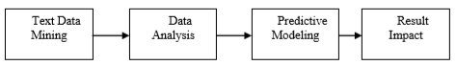

***Fig.1 Text Mining model for sentiment analysis***

While several data sources are available on the internet to be mined, yet a judicious use of web mining is to be done prior to any system design model is to be used [10]-[11]. The critical factor is also the feature selection from the raw data to be included in the analysis of the data as a whole. The unstructured text mining approach is often used and the text is to be replaced with suitable tokens or numerical counterparts prior to training any designed mechanism for the classification of the text data [12]. While data as a whole can consist of more than textual data, hence pre-processing of the data is of topmost priority [13]. The automated classification of sentiment based classification can be leveraged in several applications which need an automated mechanism for sentiment classification [14]-[15]. The major challenge in this section is the proper training of the automated system as the training accuracy would yield high classification accuracy later [16].

1. **CONTEXTUAL ANALYSIS AND DEEP LEARNING**

One of the major challenges in sentiment analysis is the contextual analysis of data. The different aspects are discussed subsequently [17].

**2.1 Contextual Analysis**

It is often difficult to estimate the context in which the statements are made. Words in textual data such as tweets can be used in different contexts leading to completely divergent meanings.

**2.2 Frequency Analysis**

Often words in textual data (for example tweets) are repeated such as

##I feel so so so happy today!!

In this case, the repetition of the word is used to emphasize upon the importance of the word. In other words, it increases to its weight. However, such rules are not explicit and do not follow any regular mathematical formulation because of which it is often difficult to get to the actuality of the tweet [18].

**2.3 Converting textual data into numerically weighted data**

The biggest challenge in using an ANN based classifier is the fact that the any ANN structure with a training algorithm doesn’t work upon textual data directly to find some pattern. It needs to be fed with numerical substitutes. Hence it becomes mandatory to replace the textual information with numerical information so as to facilitate the learning process of the neural network [19].

the machine or artificial intelligence system requires training for the given categories [8]. Subsequently, the neural network model needs to act as an effective classifier. The major challenges here the fact that sentiment relevant data vary significantly in their parameter values due to the fact that the parameters for each building is different and hence it becomes extremely difficult for the designed neural network to find a relation among such highly fluctuating parameters. Generally, the Artificial Neural Networks model’s accuracy depends on the training phase to solve new problems, since the Artificial Neural Networks is an information processing paradigm that learns from its environment to adjust its weights through an iterative process [20].

Deep learning models do have the capability to extract meaning form large and verbose datasets by finding patterns between the inputs and targets. Since neural nets directly process numeric data sets, the processing of data is done prior to training a neural network. The texts are first split into training and testing data samples in the ratio of 70:30 for training and testing. Further, a data vector containing known and commonly repeated spam and ham words is prepared. The SMS spam collection v.1 dataset is used as a dataset for the proposed work. Text normalization is followed by removal of special characters and punctuation marks.

Subsequently the data set structuring and preparation is performed based on the feature selection. The deep learning structure is depicted in figure 2 [21].

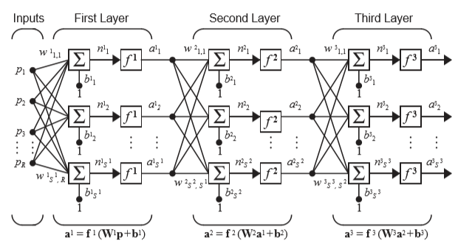

***Fig.2 The deep learning structure***

The deep learning structure is depicted in figure 2 and it is basically a cascade of stacked neural networks.

Multiple hidden layers facilitate the analysis of complex data. The cascading weight updating can be understood as:

$a^{n}=φ_{n}(φ_{n-1}…….φ_{1}\left\{wp+b\right\})$**(1)**

Here,

W is the weight

b is the bias

a is the input to the final nth layer

ɸ is the activation function

The output is given by:

$y=f(\sum_{i=1}^{n}{x_{i}w_{i}+θ})$**(2)**

1. **PROPOSED ALGORITHM**

The proposed approach is mathematically modelled as:

Let the universal set of all data sample be represented by U. Thus any sample of the data class would be a subset of the universal set A given by:

$A ϵ U ∇ U$**(3)**

Here,

A is the data sample set

U is the universal set

The overlapping group classification occurs in case of the data sample belonging to both data categories of A and B with some overlapping attributes [22]. In such cases, the decision has to be made based on a probabilistic approach by the classifier and the classification is prone to errors. The decision becomes more complex with increasing number of attributes termed as features or parameters. The decision in such an overlapping attributed class can be done using the Bayes’ theorem which is invoked by the Probabilistic Neural Network as:

$P \left(\frac{C1}{C2}\right)= \frac{P \left(\frac{c2}{c1}\right).P (C1)}{P (C2)}$**(4)**

Here:

$P \left(\frac{C1}{C2}\right)$ represents the probability of occurrence of C1 given C2 is true

$Prob \left(\frac{N}{M}\right)$ represents the probability of occurrence of C2 given C1 is true

$Prob (C1)$ represents the individual occurrence probability of the event C1

$Prob (C2)$ represents the individual occurrence probability of the event C2

The weight updating strategy for the probabilistic classifier can follow the backpropagation based gradient descent approach given mathematically as:

$W_{n+1}=W_{n}-\left\{{\left(J_{n}^{T}J_{n}+cI\right)}^{-1}\right\}J_{n}^{T}e_{n}$**(5)**

Where, {\displaystyle \mathbf {J} }   
 is weight of nth round or iteration of weight update for the network $W_{n+1}$ 
 is weight of (n+1)st round or iteration of weight update for the network $e_{n}$ 
 represents the error of the nth round or I represents an identity matrix $c$ 
represents the combination co-efficient given by $c=w_{n+1}-w_{n}$, which gives the magnitude of weight change per iteration at any given iteration n $J_{n}$ 
 is the Jacobian matrix given by [23]

$J_{n}=\left(\begin{matrix}\frac{∂^{2}e1}{∂{w1}^{2}} & ⋯ & \frac{∂^{2}en}{∂{w1}^{2}} \\ ⋮ & ⋱ & ⋮ \\ \frac{∂^{2}em}{∂{wn}^{2}} & ⋯ & \frac{∂^{2}em}{∂{wn}^{2}}\end{matrix}\right)$**(6)**

$J_{n}^{T}$ is the transpose of the Jacobian Matrix.

The Jacobian matrix is essentially the second order rate of change of the errors of the network w.r.t. to the weights of the networks[24].

Typically, the classification is done based on the maximum posteriori probability of the data sample given by:

Let there be ‘N’ classes of data sets available in the sample space ‘U’.

The conditional probabilities of N classes for the universal set U is given by:

$P(\frac{A}{U})$**, $P(\frac{B}{U})$, …….. $P(\frac{N}{U})$. (7)**

The maximum magnitude of the probability of a particular class is found as:

$P\left(max\right)=\begin{matrix}P(\frac{A}{U}) \\ P(\frac{B}{U}) \\ \begin{matrix}⋮ \\ \begin{matrix}⋮ \\ ⋮ \\ ⋮\end{matrix} \\ P(\frac{N}{U})\end{matrix}\end{matrix}$**(8)**

The maximum probability decides the class of the new data sample.

The final classification accuracy is computed as:

$Ac=\frac{TP+TN}{TP+TN+FP+FN}$**(9)**

Here.

**TP** represents true positive

**TN** represents true negative

**FP** represents false positive

**FN** represents false negative

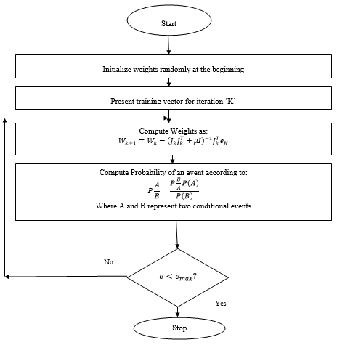

***Fig.3 Flowchart for training***

1. **RESULTS**

The proposed system utilizes the textual data in the form of tweets to be analyzed based on positive, negative and neutral tokens to be represented by -1, 0 and 1 respectively. Subsequently, the number of tokens with polarity is also fed to the neural network as a training parameter.

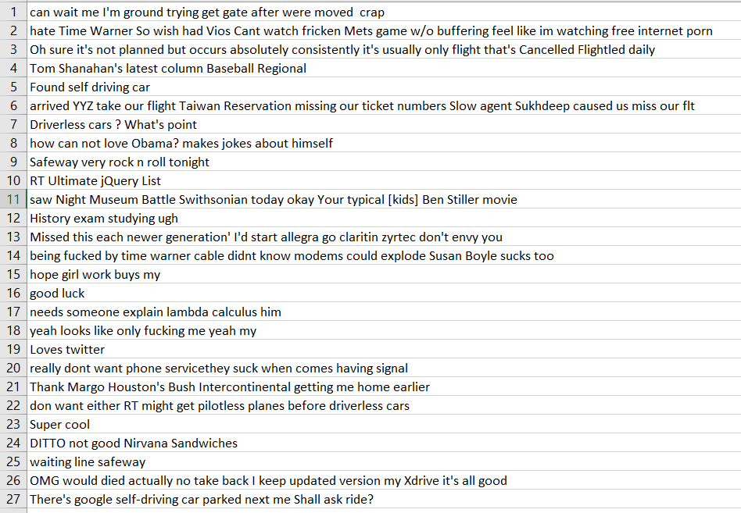

***Fig.4 Sentiment Data***

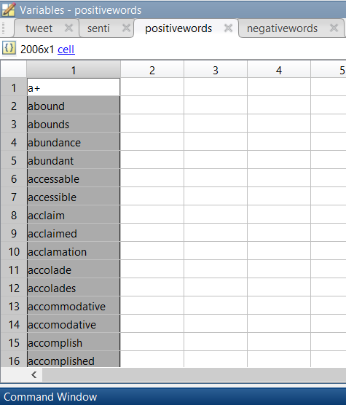

***Fig. 5 Positive Tokens***

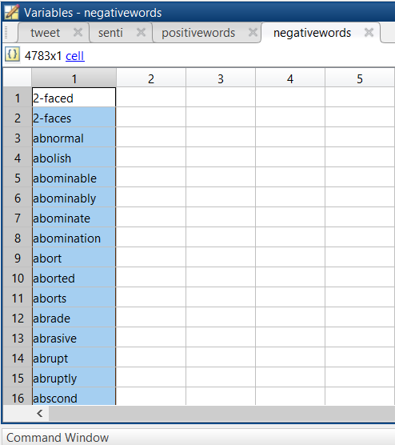

***Fig. 6 Negative Tokens***

The Deep Net with 5 hidden layers is designed. The number of layers in limited to five to reduce the time complexity.

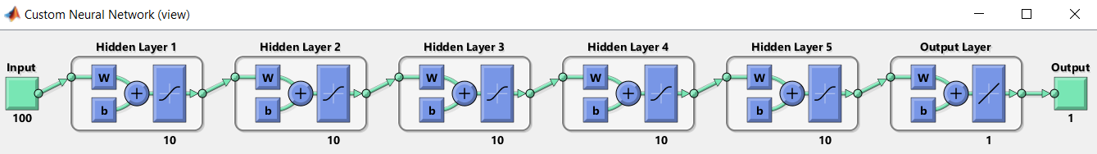

***Fig. 7 Designed Deep Net***

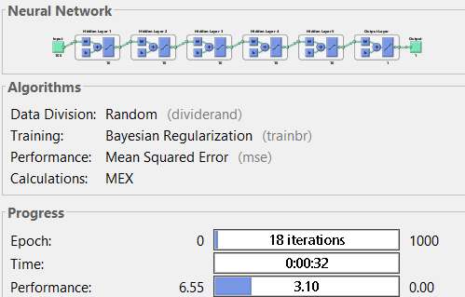

***Fig.8 Deep Net Parameters***

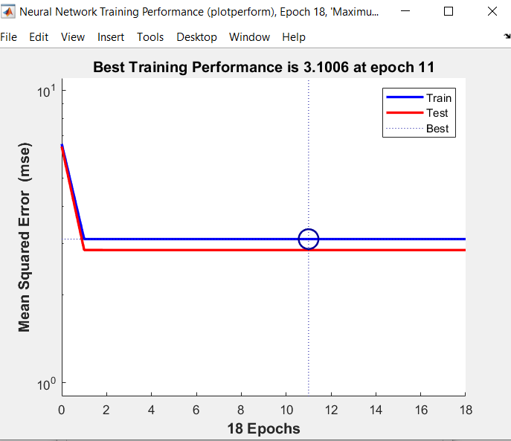

***Fig.9 MSE Variation***

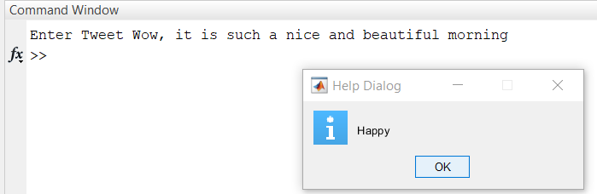

***Fig.9 GUI for classification (happy)***

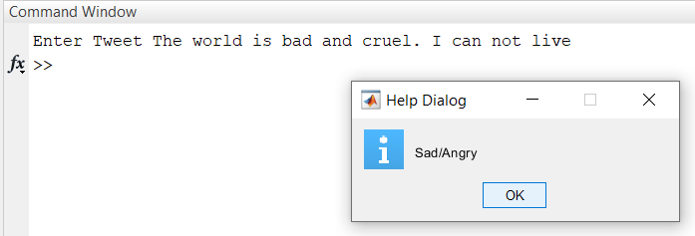

***Fig.9 GUI for classification (sad)***

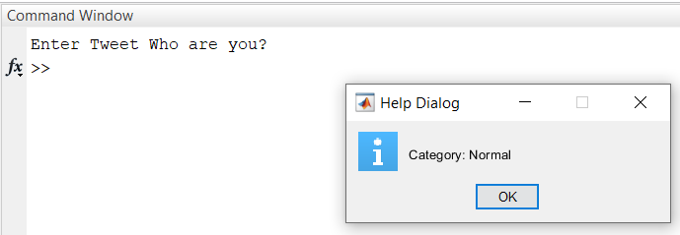

***Fig.9 GUI for classification (neutral/normal)***

The proposed system parameters can be summarized in table 1.

**Table 1. Summary of Results**

|  |  |
| --- | --- |
| **Parameter** | **Value** |
| ML category | Deep Supervised Learning |
| No. of hidden layers | 5 |
| Iterations | 18 |
| Error | 2% |
| Accuracy (Proposed Work) | 98% |
| Accuracy  (Previous Work, [1]) | 91% |

# **CONCLUSION**

**Sentiment analysis has diverse uses in information systems, encompassing the classification of reviews, summarization of reviews, and various real-time applications. There are potential opportunities to implement sentiment analysis in real-time business models. This study concentrates on sentiment analysis through the classification of tweets from social media (Twitter) data. A deep Bayesian network has been utilized for the training and subsequent evaluation of tweets. The Bayesian Regularization (BR) algorithm has been employed, and the resulting outputs exhibit variability due to its probabilistic classification. The suggested technique achieves a classification accuracy of 98%, far surpassing prior methods.**

**REFERENCES**

[1] R. Obiedat et al., "Sentiment Analysis of Customers’ Reviews Using a Hybrid Evolutionary SVM-Based Approach in an Imbalanced Data Distribution," in IEEE Access, 2022, vol. 10, pp. 22260-22273

[2] R. Obiedat et al., "Sentiment Analysis of Customers’ Reviews Using a Hybrid Evolutionary SVM-Based Approach in an Imbalanced Data Distribution," in IEEE Access, vol. 10, pp. 22260-22273.

[3] Z. Desai, K. Anklesaria and H. Balasubramaniam, "Business Intelligence Visualization Using Deep Learning Based Sentiment Analysis on Amazon Review Data," 2021 12th International Conference on Computing Communication and Networking Technologies (ICCCNT), Kharagpur, India, 2021, pp. 1-7.

[4] H. Liu, I. Chatterjee, M. Zhou, X. S. Lu and A. Abusorrah, "Aspect-Based Sentiment Analysis: A Survey of Deep Learning Methods," in IEEE Transactions on Computational Social Systems, vol. 7, no. 6, pp. 1358-1375.

[5] MLB Estrada, RZ Cabada, RO Bustillos, “Opinion mining and emotion recognition applied to learning environments”, Journal of Expert Systems, Elsevier 2022.

[6] R. Wang, D. Zhou, M. Jiang, J. Si and Y. Yang, "A Survey on Opinion Mining: From Stance to Product Aspect," in IEEE Access, vol. 7, pp. 41101-41124, 2019

[7] Lijuan Zheng,Hongwei Wang ,Song Gao,“ Sentimental feature selection for sentiment analysis of Chinese online reviews”, SPRINGER 2018

[8] Jitendra Kumar Rout,Kim-Kwang Raymond Choo,Amiya Kumar Dash,Sambit Bakshi ,Sanjay Kumar Jena,Karen L. Williams,“ A model for sentiment and emotion analysis of unstructured social media text”, SPRINGER 2018

[9] Asha S Manek ,P Deepa Shenoy,M Chandra Mohan,Venugopal K R, “Aspect term extraction for sentiment analysis in large movie reviews using Gini Index feature selection method and SVM classifier”, SPRINGER 2017

[10] Md Rakibul Islam ; Minhaz F. Zibran, , “Leveraging Automated Sentiment Analysis in Software Engineering”, IEEE 2017

[11] Hassan Saif, Yulan He, Miriam Fernandez, Harith Alani, “Contextual Semantics for Sentiment Analysis for Twitter”, Elsevier 2016

[12] Duyu Tang , Furu Wei , Bing Qin ,Nan Yang ,Ting Liu, Ming Zhou,” Sentiment Embeddings with Applications to Sentiment Analysis”, IEEE 2016

[13] Xing Fang ,Justin Zhan,”Sentiment analysis using product review data”,SPRINGER 2015

[14] Basant Agarwal ,Soujanya Poria,Namita Mittal,Alexander Gelbukh,Amir Hussain, “Concept-Level Sentiment Analysis with Dependency-Based Semantic Parsing: A Novel Approach”, SPRINGER 2015

[15] Emitza Guzman ; Walid Maalej,” How Do Users Like This Feature? A Fine Grained Sentiment Analysis of App Reviews”, IEEE 2014

[16] Geetika Gautam ; Divakar Yadav,” Sentiment analysis of twitter data using machine learning approaches and semantic analysis”, IEEE 2014

[17] Erik Cambria , Björn Schuller ,Yunqing Xia ,Catherine Havasi,” New Avenues in Opinion Mining and Sentiment Analysis”,IEEE 2013

[18] Erik Cambria ,Björn Schuller ,Bing Liu ,Haixun Wang ,Catherine Havasi, ” Knowledge-Based Approaches to Concept-Level Sentiment Analysis”, IEEE 2013

[19] Hassan Saif,Yulan He,Harith Alani,” Semantic Sentiment Analysis of Twitter”, SPRINGER 2012

[20] Bing Liu ,Lei Zhang, “A Survey of Opinion Mining and Sentiment Analysis”, SPRINGER 2012

[21] Alena Neviarouskaya , Helmut Prendinger , Mitsuru Ishizuka, “Secure SentiFul: A Lexicon for Sentiment Analysis”, IEEE 2011

[22] Jorge Carrillo de Albornoz, Laura Plaza, Pablo Gervás, Alberto Díaz, “A Joint Model of Feature Mining and Sentiment Analysis for Product Review Ratings”, SPRINGER 2011

[23] Gang Li, Fei Liu, “A clustering-based approach on sentiment analysis”, IEEE 2010

[24] Wei Wang, “Sentiment analysis of online product reviews with Semi-supervised topic sentiment mixture model”, IEEE 2010