**A Deep Neural Network Model for Predicting Crypto Price Trends**

**Anjali Pal1, Prof. Sanmati Jain2**

*Abstract*— Cryptocurrency price prediction is a form of time series forecasting that is exceptionally complex due to the reliance of crypto prices on various financial, socio-economic, and political factors. Furthermore, minor discrepancies in cryptocurrency price forecasts can lead to substantial losses for companies who rely on these predictions for financial analysis and investment decisions. Recently, artificial intelligence and machine learning techniques have been extensively utilized for cryptocurrency price prediction due to their superior accuracy compared to traditional statistical methods. The suggested methodology utilizes a steepest descent-based scaled backpropagation algorithm in conjunction with data preprocessing via discrete wavelet transform (DWT) for cryptocurrency price forecasting. The proposed system demonstrates a reduced mean square percentage error relative to the previously established technique.

Keywords—Crypto price Forecasting, Artificial Neural Network (ANN), Back Propagation, Discrete Wavelet Transform (DWT), Mean Absolute Percentage Error (MAPE).

1. **INTRODUCTION**

With increasing digitization and resource distribution, cryptocurrencies have gain significant importance. This has led to large scale investments in cryptocurrencies such as Bitcoin, Etherium etc [1]. However, crypto prices are extremely random, fluctuating and volatile in nature which makes investments risk prone. Moreover, previous crypto data often exhibits random fluctuations, volatility and deviation from a particular trend, which is often termed as noise [2]. This noisy behavior makes pattern recognition difficult leading to inaccuracies in forecasting results. Hence, it is necessary to filter out the baseline noise from the time series crypto data prior to applying the data to any machine learning or deep learning model for pattern recognition [3]. While crypto trend analysis is a time series regression problem, what makes it extremely complicated is the dependence on several non-numeric parameters such as socio economic conditions, political conditions of a country, political stability, financial crisis and trade wars, global slowdown and public sentiments pertaining to a company etc. This leads to variabilities in the stock trends often exhibiting non-coherent patterns with respect to historical data [4].



**Fig.1 Common Crypto Currencies**

Global events, such as natural disasters, geopolitical tensions, or pandemics, can also impact crypto trends [5]. These events can create uncertainty in the markets and cause investors to become more risk-averse and hence it is essential to note that data trends are inherently variable and can be influenced by a wide range of factors [6]. It's also worth mentioning that past performance does not guarantee future results, so investors should exercise caution when making investment decisions based on historical trends [7].. Cryptocurrency prediction is basically a time series prediction problem. Mathematically:

$P=f(t,v)$**(1)**

Here,

P represents crypto price

f represents a function of

t is the time variable

v are other influencing global variables

The dependence of crypto process over time makes it somewhat predictable under similar other conditions of global influencing variables. However, even the slightest of changes can derail the prediction completely [8].

Statistical techniques are not found to be as accurate as the contemporary artificial intelligence and machine learning based approaches [9]. In this paper, a back propagation based scaled conjugate gradient algorithm is used in conjugation with the discrete wavelet transform (DWT) for forecasting crypto price trends. The evaluation of the proposed approach has been done based on the mean absolute percentage error (MAPE). A comparative MAPE analysis has also been done w.r.t. previously existing techniques [10].

1. **DEEPNETS**

Deep learning has evolved as one of the most effective machine learning techniques which has the capability to handle extremely large and complex datasets [11]. It is training neural networks which have multiple hidden layers as compared to the single hidden layer neural network architectures [12].

The architectural view of a deep neural network is shown in figure 1. In this case, the outputs of each individual hidden layer is fed as the input to the subsequent hidden layer. The weight adaptation however can follow the training rule decided for the neural architecture. There are various configurations of hidden layers which can be the feed forward, recurrent or back propagation etc [13].

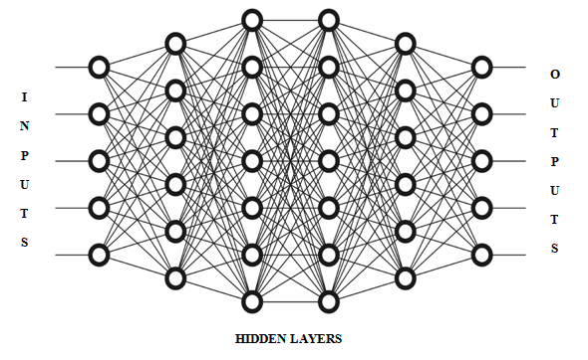

**Fig.2 The Deep Neural Network Architecture**

The figure above depicts the deep neural network architecture with multiple hidden layers. The output of the neural network however follows the following ANN rule:

$Y=f(\sum_{i=1}^{n}{X_{i }. W_{i} + θ_{i})}$**(2) $Y=\sum_{i=1}^{n}{X_{i }. W_{i} + θ_{i}}$ $y=\sum_{i=1}^{n}{x_{i }}.w_{i }$**

Where,

X are the inputs

Y is the output

W are the weights

Ɵ is the bias.

Training of ANN is of major importance before it can be used to predict the outcome of the data inputs.

1. **BACK PROPAGATION**

Back propagation is one of the most effective ways to implement the deep neural networks with the following conditions [14]:

1. Time series behavior of the data
2. Multi-variate data sets
3. Highly uncorrelated nature of input vectors

The essence of the back propagation based approach is the fact that the errors of each iteration is fed as the input to the next iteration. [15]. The error feedback mechanism generally is well suited to time series problems in which the dependent variable is primarily a function of time along with associated variables. Mathematically,

$Y=f(t, V_{1}….V_{n})$**(3)**

Here,

Y is the dependent variable

f stands for a function of

t is the time metric

V are the associated variables

n is the number of variables

The back propagation based approach can be illustrated graphically in figure 2.

In case of back propagation, the weights of a subsequent iteration doesn’t only depend on the conditions of that iteration but also on the weights and errors of the previous iteration mathematically given by [16]:

$W_{k+1}=f(W_{k},e_{k},V)$**(4)**

Here,

$W_{k+1}$ are the weights of a subsequent iteration

$W_{k}$ are the weights of the present iteration

$e_{k}$ is the present iteration error

V is the set of associated variables

In general, back propagation is able to minimize errors faster than feed forward networks, however at the cost of computational complexity at times. However, the trade off between the computational complexity and the performance can be clearly justified for large, complex and uncorrelated datasets for cloud data sets [17].

1. **GRADIENT DESCENT BASED TRAINING**

The gradient descent algorithms (GDAs) generally exhibit:

1. Relatively lesser memory requirement
2. Relatively faster convergence rate

The essence of this approach is the updating of the gradient vector g, in such as way that it reduces the errors with respect to weights in the fastest manner. Mathematically, let the gradient be represented by g and the descent search vector by p, then [18]:

$p_{0}=-g_{0}$**(5)**

Where, {\displaystyle \mathbf {J} }

denotes the gradient given by $\frac{∂e}{∂w}$

The sub-script 0 represents the starting iteration

The negative sign indicates a reduction in the errors w.r.t. weights [15].

The tradeoff between the speed and accuracy is clearly given by the following relations [16]:

$W_{k+1}= W_{k}-αg_{x} , α=\frac{1}{µ}$**(6)**

Here,

$w_{k+1}$ is the weight of the next iteration

$w_{k}$ is the weight of the present iteration

$g_{x}$ is the gradient vector

µ is the step size for weight adjustment in each iteration.

There are several ways to implement the back propagation technique in the neural networks [19]. One consideration however always remains that of the least time and space complexity so as to reduce the amount of computational cost that is associated with the training algorithm. The essence of the scaled conjugate gradient algorithm is the fact that it has very low space and time complexity making it ideally suited to large data sets to be analyzed in real time applications where the time is a constraint. The training rule for the algorithm is given by:

$A_{0}=-g_{0}$**(7)**

A is the initial search vector for steepest gradient search

g is the actual gradient

$w_{k+1}=w_{k}+μ_{k}g_{k}$**(8)**

Here,

$w_{k+1}$ is the weight of the next iteration

$w_{k}$ is the weight of the present iteration

$μ_{k}$ is the combination co-efficient

1. **THE DISCRETE WAVELET TRANSFORM**

The wavelet transform is an effective tool for removal of local disturbances. Crypto prices show extremely random behavior and local disturbances. Hence conventional Fourier methods do not render good results for highly fluctuating data sets. Mathematically, the wavelet transform can be given as [20]

***Z* (*S, P*) = $\int_{-∞}^{∞}{z\left(t \right) (\left(S,P, t\right))dt}$ (9)**

Here,

S denotes the scaling operation

P denotes the shifting operation

t denotes the time variable

Z is the image in transform domain

z is the image in the spatial domain

The major advantage of the wavelet transform is the fact that it is capable of handling fluctuating natured data and also local disturbances. The DWT can be defined as [21]:

**WΦ (Jo, k) = $\frac{1}{\sqrt{M}}\sum_{n}{S\left(n\right).}{Φ(n)}_{jo'k}$ (10)**

The data is divided in the ration of 70:30 for training and testing data set bifurcation.

The final performance metrics computed for system evaluation are:

1) Mean Absolute Percentage Error (MAPE)

$MAPE =\frac{100}{M}\sum_{t=1}^{N}{\frac{E-E_{t}|}{E_{t}}}$**(11)**

Here Et and Et~ stand for the predicted and actual values respectively.

The number of predicted samples is indicated by M.

2) Regression

The extent of similarity between two variables is given by the regression.

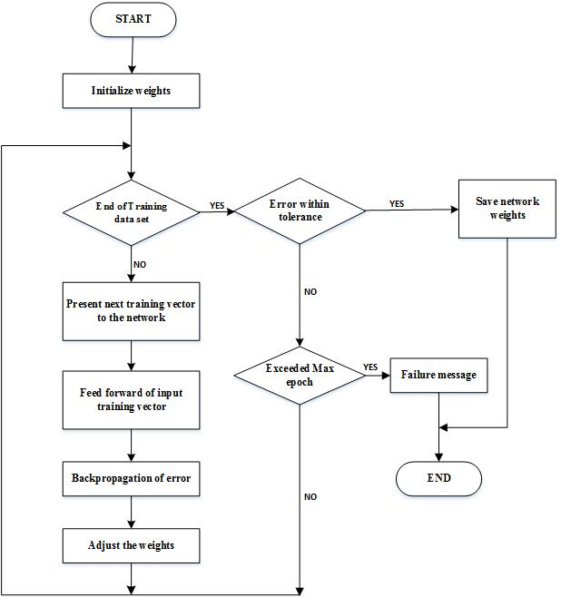

**Fig.3 Flowchart of Back Propagation**

1. **RESULTS**

The results have been evaluated based on the following parameters:

1. (MAPE)
2. Regression
3. MSE w.r.t. the number of epochs

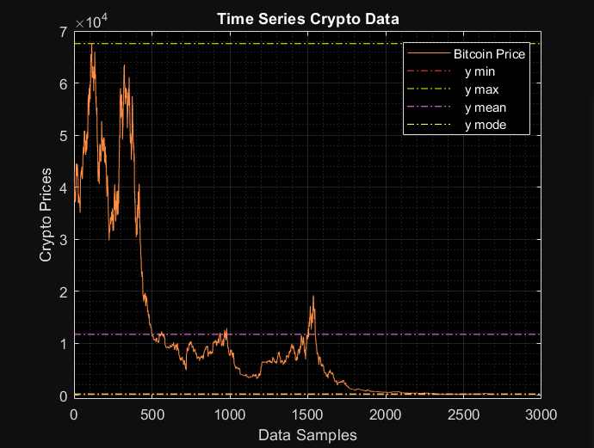

**Fig.4 Original Bitcoin Price**

The figure above depicts variation in Bitcoin price.

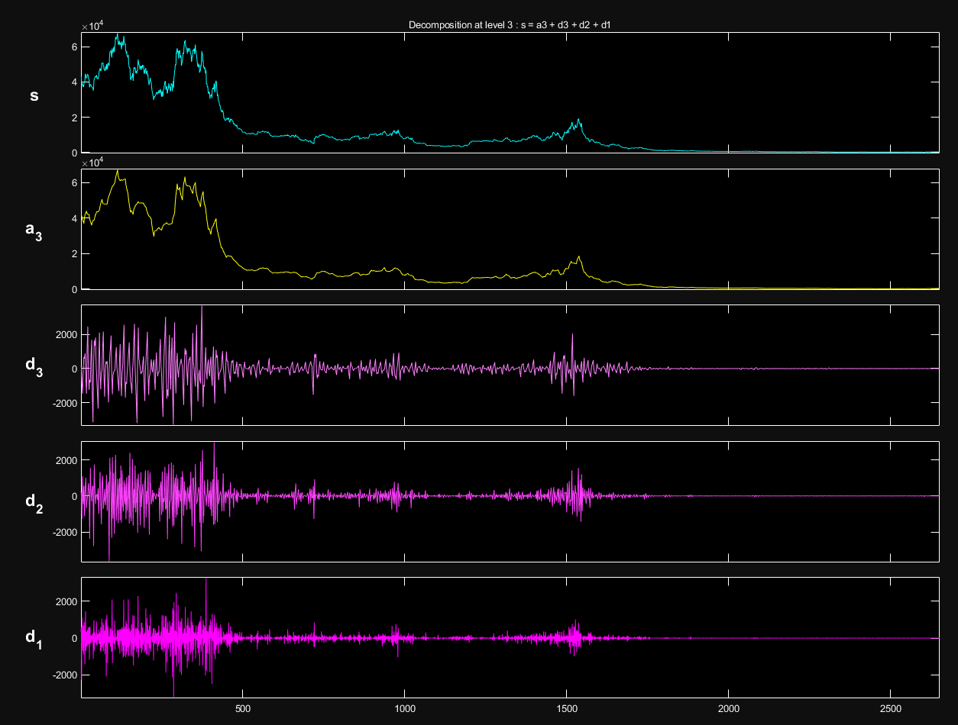

**Fig.5 Symlet Decomposition at Level 3**

The figure above depicts the Symlet decomposition in terms of approximate and detailed co-efficients for the data.

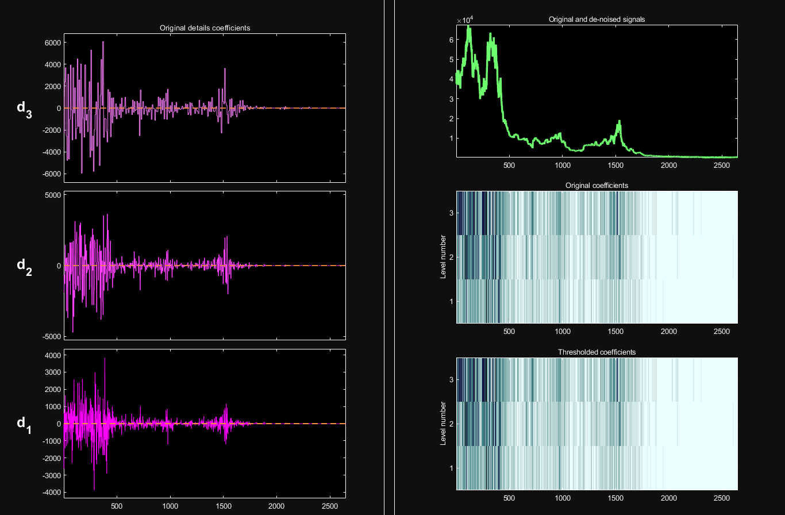

**Fig.6 Denoising data using Symlet**

The figure above depicts the denoising process using Symlet.

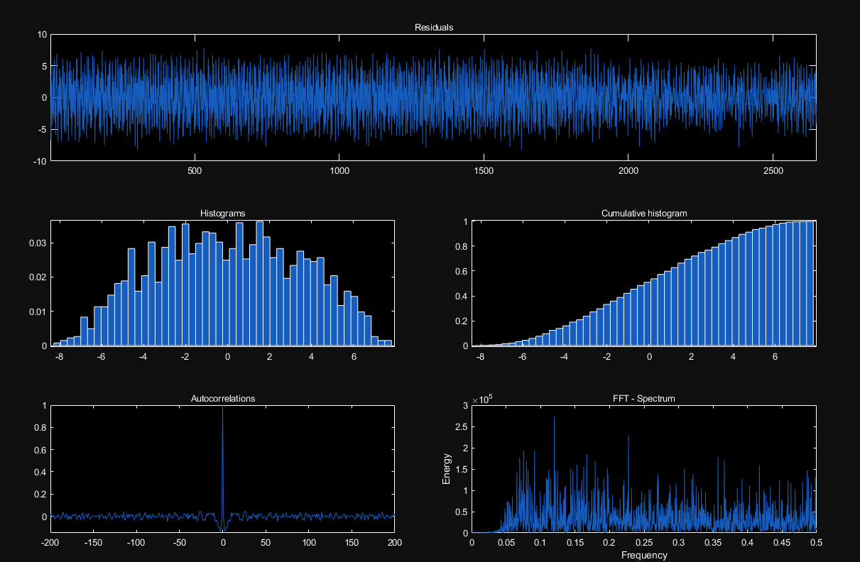

**Fig.7 Multi-Resolution Analysis**

The figure above depicts the multi resolution analysis of noise baseline.

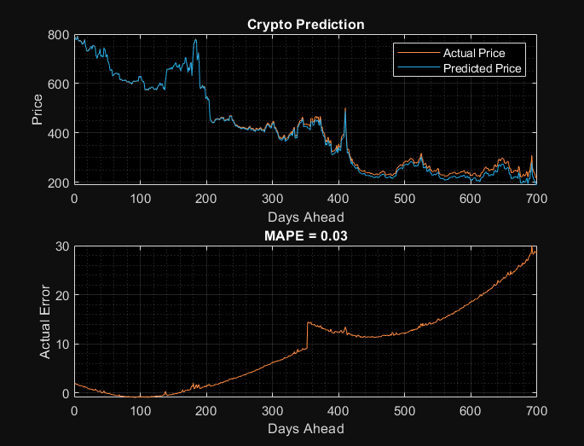

**Fig.8 Predicted and Actual Crypto Behavior**

The figure above depicts the predicted and actual crypto behavior.

From the above figures, it can be concluded that the proposed system attains the following results:

1) Iterations:1000

2) MSE=3.26

3) RMSE=1.8055

4) MAPE of Proposed work=0.03%

5) MAPE of Previous work [1]=0.06%

# **CONCLUSION**

**It can be concluded from previous discussions that crypto price prediction is a category of time series prediction with high sensitivity and dependence on external factors. Hence it is often challenging to attain high levels of accuracy in prediction. In the proposed approach a back propagation based deep neural network model with back propagation. The adaptive gradient descent algorithm (GDA) is used to train the neural network. Data pre-processing is done using the discrete wavelet transform. It has been shown that the proposed work attains a mean absolute percentage error of 0.03% and RMSE of 1.8055. Thus the proposed system is able to achieve low errors and higher accuracy Also the proposed work outperforms previously existing systems in terms of the accuracy for the benchmark datasets used.**

**REFERENCES**

[1] M. Rafi, Q. A. K. Mirza, M. I. Sohail, M. Aliasghar, A. Aziz and S. Hameed, "Enhancing Cryptocurrency Price Forecasting Accuracy: A Feature Selection and Weighting Approach With Bi-Directional LSTM and Trend-Preserving Model Bias Correction," in IEEE Access, vol. 11, pp. 65700-65710, 2023

[2] G. Kim, D. -H. Shin, J. G. Choi and S. Lim, "A Deep Learning-Based Cryptocurrency Price Prediction Model That Uses On-Chain Data," in IEEE Access, vol. 10, pp. 56232-56248, 2022.

[3] Z. Shahbazi and Y. -C. Byun, "Improving the Cryptocurrency Price Prediction Performance Based on Reinforcement Learning," in IEEE Access, vol. 9, pp. 162651-162659, 2021

[4] M. Ertz and É. Boily, ‘‘The rise of the digital economy: Thoughts on blockchain technology and cryptocurrencies for the collaborative economy,’’ Int. J. Innov. Stud., vol. 3, no. 4, pp. 84–93, Dec. 2019.

[5] V. Buterin. (2013). Ethereum White Paper: A Next Generation Smart Contract & Decentralized Application Platform. [Online]. Available: https://github.com/ethereum/wiki/wiki/White-Paper

[6] D. Vujicic, D. Jagodic, and S. Randic, ‘‘Blockchain technology, bitcoin, and ethereum: A brief overview,’’ in Proc. 17th Int. Symp. INFOTEHJAHORINA (INFOTEH), Mar. 2018, pp. 1–6.

[7] M. Mudassir et al., ‘‘Time-series forecasting of Bitcoin prices using highdimensional features: A machine learning approach,’’ Neural Comput. Appl., 2020.

[8] S. Asante Gyamerah, ‘‘Are bitcoins price predictable? Evidence from machine learning techniques using technical indicators,’’ 2019, arXiv:1909.01268.

[9] J.-Z. Huang, W. Huang, and J. Ni, ‘‘Predicting bitcoin returns using highdimensional technical indicators,’’ J. Finance Data Sci., vol. 5, no. 3, pp. 140–155, Sep. 2019.

[10] R. Adcock and N. Gradojevic, ‘‘Non-fundamental, non-parametric bitcoin forecasting,’’ Phys. A, Stat. Mech. Appl., vol. 531, Oct. 2019, Art. no. 121727.

[11] D. Philippas, H. Rjiba, K. Guesmi, and S. Goutte, ‘‘Media attention and bitcoin prices,’’ Finance Res. Lett., vol. 30, pp. 37–43, Sep. 2019.

[12] J. Abraham, D. Higdon, J. Nelson, and J. Ibarra, ‘‘Cryptocurrency price prediction using tweet volumes and sentiment analysis,’’ SMU Data Sci. Rev., vol. 1, no. 3, p. 1, 2018.

[13] D. Shen, A. Urquhart, and P. Wang, ‘‘Does Twitter predict bitcoin?’’ Econ. Lett., vol. 174, pp. 118–122, Jan. 2019.

[14] N. Aslanidis, A. F. Bariviera, and Ó. G. López, ‘‘The link between cryptocurrencies and Google trends attention,’’ Finance Res. Lett., vol. 47, Jun. 2022, Art. no. 102654, doi: 10.1016/j.frl.2021.102654.

[15] Y. B. Kim, J. G. Kim, W. Kim, J. H. Im, T. H. Kim, S. J. Kang, and C. H. Kim, ‘‘Predicting fluctuations in cryptocurrency transactions based on user comments and replies,’’ PLoS ONE, vol. 11, no. 8, Aug. 2016, Art. no. e0161197.

[16] D. Liang, F. Ma and W. Li, "New Gradient-Weighted Adaptive Gradient Methods With Dynamic Constraints," in IEEE Access, 2020, vol. 8, pp. 110929-110942.

[17] X. Huang, J. Guan, B. Zhang, S. Qi, X. Wang and Q. Liao, "Differentially Private Convolutional Neural Networks with Adaptive Gradient Descent," 2019 IEEE Fourth International Conference on Data Science in Cyberspace (DSC), Hangzhou, China, 2019, pp. 642-648.

[18] AC Wilson, R Roelofs, M Stern, “The marginal value of adaptive gradient methods in machine learning”, Proceedings in Advances in Neural Information Processing Systems 30 (NIPS 2017).

[19] Y Xue, Y Wang, J Liang, “A self-adaptive gradient descent search algorithm for fully-connected neural networks”, Neurocomputing, Elsevier 2022. Vol.478, pp. 70-80.

[20] I Khandelwal, R Adhikari, G Verma, “Time series forecasting using hybrid ARIMA and ANN models based on DWT decomposition”, Procedia in Computer Science, vol.48, pp. 173-179.

[21] A Butorova, E Baglaeva, I Subbotina, “Application of the Wavelet Data Transformation for the Time Series Forecasting by the Artificial Neural Network”, Proceedings in New Trends in the Applications of Differential Equations in Sciences, Springer 2022, pp 365–370.