ATM SOFTWARE USING JAVA SWINGS AND OOPS CONCEPTS

# K GARATA SAI MALLIK1, J A PAULSON2,

**1PG student, Department of Computer Science and Engineering, Nalanda Institute of Engineering and Technology, Kantepudi, Sattenapalli, Guntur-522438, AP, India.**

# 2 Associate Professor, Department of Computer Science and Engineering, Nalanda Institute of Engineering and Technology, Kantepudi, Guntur-522438, AP, India.

**ABSTRACT:**This report makes an attempt to grasp the look of an automatic Teller Machine (ATM) system, a tool employed by bank customers to method account transactions. Typically, a user inserts into the ATM a special plastic card that's encoded with data on a magnetic strip. The strip contains Associate in Nursing identification code that's transmitted to the bank's central pc by electronic equipment. to stop unauthorized transactions, a private positive identification (PIN) should even be entered by the user employing a data input device. the pc then permits the ATM to finish the transaction; most machines will dispense money, settle for deposits, transfer funds, and supply data on account balances. Banks have shaped cooperative, nationwide networks in order that a client of 1 bank will use Associate in Nursing ATM of another for money access. Some ATMs also will settle for credit cards for money advances. the primary ATM was put in in 1969 by Chemical Bank at its branch in Rockville Centre, New York. A client employing a coded card was distributed a package containing a collection add of cash.

1. **INTRODUCTION**

An automated teller machine (ATM) or automatic banking machine (ABM) may be a computerized telecommunications device that has the purchasers of a financial organization with access to monetary transactions during a public area while not the necessity for a cashier, human clerk or bank teller. On latest ATMs, the client is known by

inserting a plastic ATM card with a tape or a plastic open-end credit with a chip, that contains a novel card range and a few security info like AN expiration date or CVVC (CVV). Authentication is provided by the client coming into a private number (PIN).

1. **PURPOSE**

Using associate ATM, customers will access their bank accounts so as to form money withdrawals (or mastercard money advances) and check their account balances also as purchase cellular phone paid credit. If the currency being withdrawn from the ATM is completely different from that that the checking account is denominated in (eg: retreating Japanese Yen from a checking account containing USA Dollars), the money are going to be born-again at a wholesale charge per unit. Thus, ATMs usually offer the simplest doable charge per unit for foreign travelers and ar heavily used for this purpose also.

ATMs are proverbial by varied alternative names together with machine-controlled dealing Machine, machine-controlled banking machine, cashpoint (in Britain),money machine, bank machine, machine, topographic point, Bancomat (in varied countries in Europe a Russia), Multibanco (after a registered trade mark, in Portugal), and Any Time cash (in India).

1. **SCOPE**

The main purpose of the ATM division and knowledge service is to produce the

shopper’s money

flexibility, worldwide acceptance and round-the-clock convenience. Bank problems solely VISA Credit Cards, the famed mastercard whole. Cardholders can buy goods/services up to the credit limit and might use the credit facility upon reimbursement. MasterCard may be a safer substitute to money and is that the tonality of payment worldwide. commonplace chartered Bank is that the 1st to introduce the Bangladeshi monetary unit MasterCard. the cardboard is issued primarily to a person’s name and also the specific person will use the cardboard in anyplace in People's Republic of Bangladesh. The enterprise of Premier Bank MasterCard section is to stay the records of all sales and customers’ requests, the knowledge of cardholders and reports them to necessary documents.

1. **SYSTEM ANALYSIS**

The OBS Administration falls wanting dominant the employee’s activities in analyzing his/her strengths and weakness. the choice for appraisal of distribution next project to the worker or to coach him/her to reinforce the talents – wherever lies with correct projection. he's not supplied with the elaborate project info done or to be allotted supported Application / Verticals.Need of additional manual effort.

* It wont to take a lot of time to search out any worker
* Not greatly correct.
* Danger of losing the files in some cases.

1. **REQUIREMENT OF NEW SYSTEM**

The decision in assignment correct skillful hands for the project is a very important issue in OBS Module. The OBS Administrator ought to report with the private holding the skills required for the project assignment. the choice in creating analysis about the employee’s skills may be a prime necessary before booting in. The projected system of

OBS Module is that the right software package to be incorporated into the Automation of OBS software package for serving to the organization wants with relevancy practiced Human Resource.

The projected system provides detail general info concerning the worker at the side of instructional, Certification, ability and Project details. It enhances the OBS Management in adding, viewing and change employees’ details and generates numerous reports concerning employee’s ability and knowledge. Suggestions and Grievances denote by the staff are upheld for taking care of the mandatory steps in forwarding the company’s obligation.

1. **ADVANTAGES**

Very fast and correct.No would like of any further manual effort.No fever of information loss. Just would like a touch data to work the system.Doesn’t need any further hardware device.At last terribly simple to search out the workers.

1. **FEASIBILITY STUDY**

Once the matter is clearly understood, successive step is to conduct feasibleness study, that is high-level capsule version of the entered systems and style method. the target is to see whether or not or not the projected system is possible. The tOBSee tests of feasibleness are allotted.

* Technical feasibleness
* Economical feasibleness
* Operational feasibleness

1. **TECHNICAL FEASIBILITY**

In Technical practicability study, one must check whether or not the projected system are often developed victimisation existing technology or not. it's planned to implement the projected system

victimisation java technology. it's evident that the mandatory hardware and package square measure offered for development and implementation of the projected system. Hence, the answer is technically possible.

1. **ECONOMICAL FEASIBILITY**

As part of this, the costs and benefits associated with the proposed system compared and the project is economically feasible only if tangible or intangible benefits outweigh costs. The system development costs will be significant. So the proposed system is economically feasible.

1. **OPERATIONAL FEASIBILITY**

It is a standard that ensures interoperability without stifling competition and innovation among users, to the benefit of the public both in terms of cost and service quality. The proposed system is acceptable to users. So the proposed system is operationally feasible.

1. **FEASIBILITY STUDY** Requirement Validation examines the specification to confirm that every one system needs are explicit unambiguously; those inconsistencies, errors are detected and corrected and therefore the work merchandise change to the quality.

There area unit several needs from user perspective and brought care whereas planning a system, area unit as follows.Dynamic nature of system. i.e. System modification its operating reckoning on scenario.

Component based mostly definition of system. i.e. System is split into smaller elements which is able to work severally additionally there combined affort is result into output

of system.Flexibility of system. i.e. System ought to work with nice ease with differing types of documents.Flexible info style ought to be done to accommodate data concerning new input. Flexible front-end style in order that it will support practicality of all sorts of input. Back-end shouldn't have an effect on front-end or contrariwise.

All info changes ought to be done by front-end solely.Simplicity ought to be there in system style.User friendliness ought to be achieved.System ought to be simply reparable and adaptive .Design for such system is formed in such some way that connected data is unbroken in same tables.Different data associated with completely different element is keep in numerous tables.

To make the task of data of knowledge of data entry simple varied band boxes and list The info style ought to support the accommodation of recent element information in a very method, specified it should permit to continue the present relationship with alternative the opposite elements and other elements of system. boxes area unit designed in order that user will need to simply choose the values from the given choices.

1. **FUNCTIONS OF SYSTEM Use Case:**

Use case is a description of a set of sequence of actions that a system performs that yields an observable result of value to a particular thing in a model.Graphically, Use Case is rendered as an ellipse with dashed lines, usually including only its name as shown below.

**USE CASE DIAGRAM**

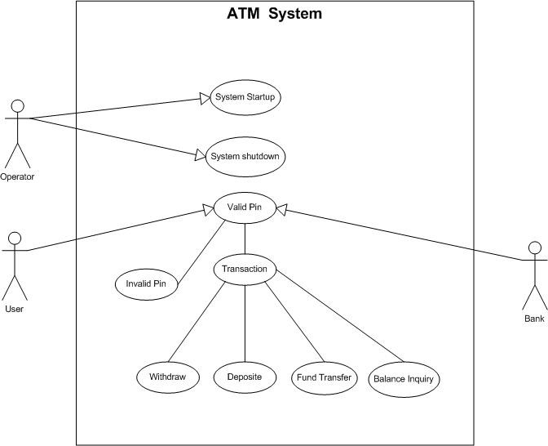

**Fig:1 ATM Software use case diagram**

1. **FLOW CHART OR ACTIVITY DESIGN**
   1. **ACTIVITY DIAGRAM:**

An Activity Diagram is actually a flow chart showing flow of management from activity to activity. they're accustomed model the dynamic aspects of as system. they'll even be accustomed model the flow of AN object because it moves from state to state at

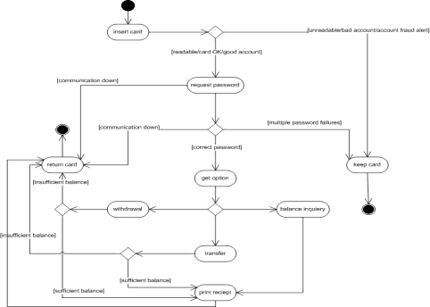

**Fig:2. ATM software Activity Diagram** completely different points within the flow of management.

# Content:

Activity diagrams commonly contain: Fork, Start & End Symbol

* 1. **CLASS/E-R DIAGRAM**

Class diagrams ar the foremost common diagrams found in modeling object-oriented systems. a category diagram shows a collection of categories, interfaces, and collaborations and their relationships.

diagrammatically, a category diagram could be a assortment of vertices and arcs.

**CLASS DIAGRAM:**

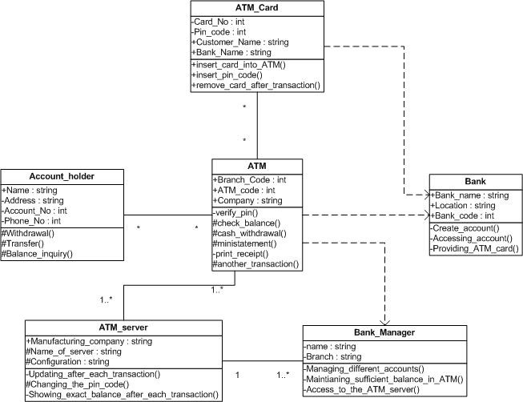

**Fig:3. ATM Software class diagram**

A class Diagram is a graph that represents the relationship between the classes and represents their semantics.

Here ATM works as main class. All other classes are related with this class.

ATM does following operations:

* Verify_pin()
* Check_balance()
* Cash_withdrawal()
* Ministatement()
* Print_receipt()
* Another_transaction()

ATM card related with ATM through many to many relationship. It does following operations:

* Insert_card_into_ATM()
* Insert_Pin_code()
* Remove_card_after_transaction()

Account holder related with ATM through many to many relationship. It performs following operations:

* Withdrawal()
* Transfer()
* Balance_inquiry()

ATM server related with ATM by one or many to one or many relationship. It also performs some task shown as below:

* + Updating_after_each_transaction()
  + Changing_the_pin_code()
  + Showing_exact_balance_after_eac h_transaction()

Bank Manager associated with ATM through one or many to one relationship.

ATM is not related with this class, but dependent on this class. So there is a dependent relationship assigned to them. Bank Manager does following tasks:

* + Managing_different_accounts()
  + Maintaining_sufficient_balance_in

_ATM()

* + Access_to_the_ATM_server()

Here, a class Bank not related to any of the class, but some classes are dependent on these classes which are shown as dependent relationship with it.

Normally this class performs following operations:

* + Create_Account()
  + Accessing_Account()
  + Providing_ATM_card()
  1. **SYSTEM ACTIVITY**

An Interaction diagram shows associate degree interaction, consisting of a group of objects and their relationships, as well as the messages which will be sent among them. Interaction diagrams area unit used for modeling the dynamic aspects of the system.

# INTERACTION DIAGRAM:

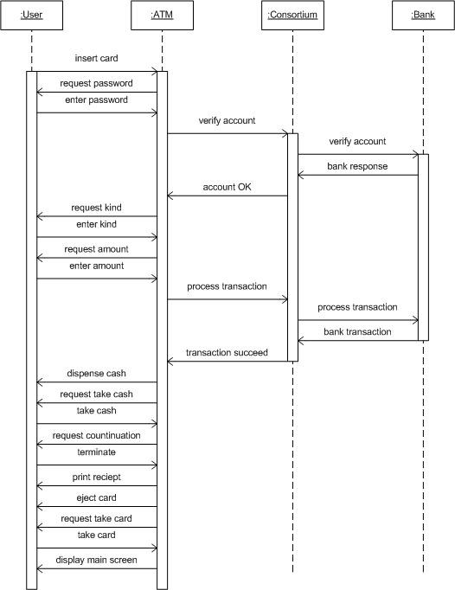

**Fig:4. ATM Software Interaction Diagram**

# DATA DICTIONARY

A Data lexicon may be a Catalogue – a repository of part in a very system. because the name recommend, these parts focus on knowledge and also the method these area unit structured to fulfill the user demand and system desires. In knowledge lexicon we discover list of all the weather area unit knowledge flows, knowledge stores, and method. the info lexicon stores details and outline of those parts.

If anybody needs to understand what percentage characters area unit during a information item, by what alternative names it's documented within the system, or wherever it's utilized in the system, they must be able to realize the solution during a property developed information lexicon.

The Data lexicon is developed throughout information flow analysis and assists the system development in deciding the user demand.

# Importance of Data Dictionary

Analysis use knowledge lexicon for 5 necessary reasons:

* + To manage the detail in massive system.
  + To communicate a standard that means for all system components.
  + To Document the feature of the system.
  + To Facilitates analysis of the main points so as to judge characteristics and confirm wherever system changes ought to be created.
  + To find error and omissions within the system.

# FUNCTIONAL AND BEHAVIORAL MODELLING

* 1. **CONTEXT DIAGRAM**

The top-ranking diagram is usually referred to as a “context diagram”. It contains one method, however it plays a really vital role in learning this system. The context diagram defines the system which will be studied within the sense that it determines the boundaries. something that's not within the method known within the context diagram won't be a part of the system study.

* 1. **DATA FLOW DIAGRAM**

A graphical tool accustomed describe and analyze the instant of information tOBSough a system manual or machine- controlled as well as the method, stores of information, and delays within the system. knowledge Flow Diagrams area unit the central tool and therefore the basis from that different elements area unit developed. The transformation of information from input to output, tOB Sough processes, is also delineate logically and severally of the physical elements related to the system. The DFD is additionally referred to as an information flow graph or a bubble chart.

A graphical tool accustomed describe and analyze the instant of information through a system manual or machine-controlled as well as the method, stores of information, and delays within the system. knowledge Flow Diagrams

area unit the central tool and therefore the basis from that different elements area unit developed. The transformation of information from input to output, through processes, is also delineate logically and severally of the physical elements related to the system. The DFD is additionally referred to as an information flow graph or a bubble chart.

# TYPES OF DATA FLOW DIAGRAMS

Data Flow Diagrams are of two types as follows:

1. Physical DFD
2. Logical DFD
3. **PHYSICAL DFD:**

Structured analysis states that this system ought to be initial perceive properly. The physical DFD is that the model of this system and is employed to make sure that this system has been clearly understood. Physical DFDs shows actual devices, departments, and other people etc., concerned within the current system.

# LOGICAL DFD:

Logical DFDs square measure the model of the planned system. They clearly ought to show the necessities on that the new system ought to be engineered. Later throughout style activity this is often taken because the basis for drawing the system’s structure charts.

# Data Flow Diagram(Level-0):

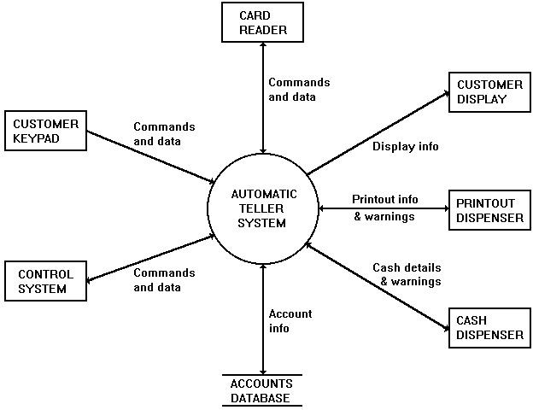

**Fig:5. ATM Software Data Flow Diagram**

This diagram shows the automated Teller System package and therefore the hardware that it interacts with. The arrows show the direction and kind of information flowing between 36 the package and every hardware component.

1. **EXTERNAL ENTITIES: CONTROL SYSTEM:**

This system permits and disables the client interface and receives client requests and system reports. an appropriate system would be a private pc joined to a central system with access to the Accounts information. The client interface (keypad, display, etc) is controlled by enabling and disabling the cardboard Reader, that is that the customer's entry-point to the system. Requests for statements and chequebooks square measure denote to the system. It additionally receives standing reports for low printer-paper and money levels.

# ACCOUNTS DATABASE:

This is a info containing account numbers, balances and alternative account data. information is retrieved from the info once a client requests a balance report or a money withdrawal.The info is updated

when a withdrawal.

# CARD READER:

The Card Reader receives the customer's card and retrieves the PIN and account range hold on on that. This info is transmitted to the code that permits the client computer keyboard and initiates the PIN verification procedure. once business is completed the cardboard Reader is tutored to come the cardboard. If the client enters AN incorrect PIN, a hard and fast range of retries is allowable, once that the cardboard Reader is tutored to confiscate the cardboard.

# CUSTOMER KEYPAD:

The client input device permits a client to enter a identification number, choose choices and enter money values. The input device is barely enabled once a card is detected within the Card Reader.

# CUSTOMER DISPLAY:

The client show presents messages, choices and reports to the client. The show is active in the slightest degree times.

# PRINTOUT DISPENSER:

This provides the client with a written balance or receipt. The output signal Dispenser reports to the system if the paper level is low.

# CASH DISPENSER:

This assembles and delivers money to the client. The dispenser receives data regarding the values and quantities of notes to dispense (1 x $20, 2 x $5, etc). The machine reports to the system if the money levels square measure low.

# Data Flow Diagram(Level-1):

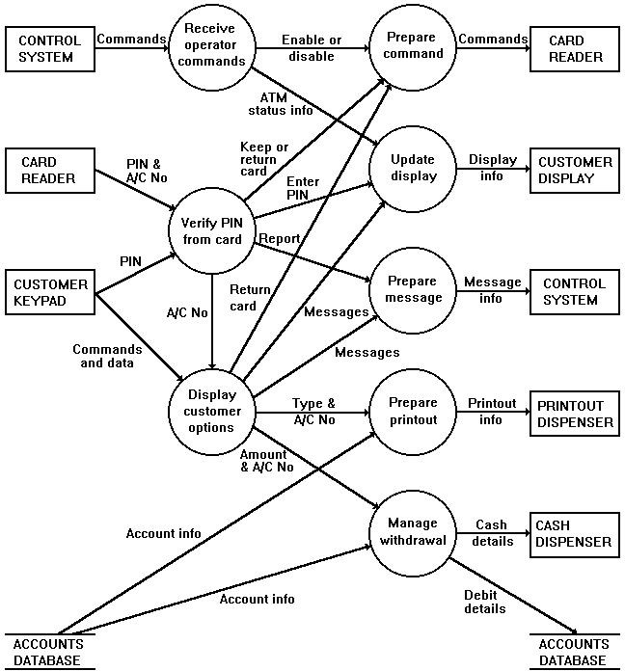

**Fig:6 ATM Process Data Flow Diagram**

This diagram shows information getting into and deed the system. input file is received from the hardware parts on the left. numerous kinds of information square measure processed by totally different components of the software package. Output information is distributed to the weather of hardware on the correct.

1. **DFD LEVEL1 PROCESSES**

# Interact With Operator

This method deals with commands from the system operator. These square measure the commands that modify or disable the client interface by dominant the cardboard Reader. The operator might issue these commands from another ADP system or by employing a activate an impact panel.

# Interact With Customer

This method handles all interactions with the client and operates only if a card is detected within the Card Reader. Input is received at the start from the cardboard Reader and so directly from the client via the client input device. The client receives output from the client show, the output Dispenser and also the machine. client interactions can also involve causation reports to the system. The initial step of all client interactions is to verify the customer's PIN. once this a menu of choices is given on the show that the client selects by

pressing applicable keys on the input device. These choices cause alternative displays and requests for more input. Some choices need account details that square measure retrieved from the Accounts info and should conjointly involve change the info. throughout the ultimate stage of all client interactions the cardboard Reader is tutored to either come or confiscate the cardboard.

# Prepare Command

This process handles communication with the Card Reader hardware. The system requires that the Card Reader is able to receive the following commands.The Card Reader is enabled and disabled by commands from the system operator. A card is returned or retained in response to interactions with the customer.

# Update Display

This method deals with the client monitor. once no card is within the Card Reader, the client show shows general info (such as 'Insert Card'). once a card is detected the show is updated in response to client interactions. If the system is disabled by the system operator, the show is updated to point the system standing.The following is a list of screens which are shown on the Customer Display.

# Prepare Message

This method prepares and transmits messages to the system. These messages are often requests from customers for statements and chequebooks or reports regarding the amount of printer-paper and money.

# Prepare Printout

This method prepares and controls the utilization of the output Dispenser to provide balance reports and receipts. The customer's balance is retrieved from the Accounts info (if required). If the printer-paper level becomes low choices that involve printouts area unit disabled and a warning message is shipped to the system.

# Manage Withdrawal

This method receives requests for withdrawals of specific amounts from a definite account and operates the cash machine. Before continuing, the customer's details within the Accounts info area unit checked. If the request exceeds the customer's balance (or in agreement overdraft) the withdrawal is denied. The system uses a denomination choice algorithmic program supported the notes out there and also the quantity needed. The Accounts info is updated once every withdrawal. If the money level becomes low, choices providing money withdrawals area unit disabled and a warning message is shipped to the system.

1. **LIMITATIONS AND FUTURE ENHANCEMENT**

**Limitation:**

Although I even have tried to feature all the connected options to the current on-line Bus Reservation System however there are some limitation. This system is stand alone system thus knowledge saved throughout completely different methodes area unit keep within the machine during which that process was dead. So there's the matter of distributed info.

**Future Enhancement:**

As mentioned the limitation of this technique, we will implement this as client/server system. thus all the info are going to be hold on within the single machine, and for any purpose all the info are going to be retrieved from this central information. So there'll be no human work need for the worker. Ca

|there'll be only 1 person needed United Nations agency will maintain this central information.

**XV. CONCLUSION**

Back in 1969, Chemical Bank proclaimed that a brand new variety of banking was being launched. With that, customers were given plastic cards designed with a magnetic strip

that would be used with a machine engineered into a wall. Gone were the times of getting to face in line for a teller or not having cash accessible when traditional banking hours. nearly everybody has detected of associated used an ATM machine. curiously, a number of folks feel that ATM machines area unit the most effective issue to happen within the banking world whereas people contemplate them a curse. the most criticism detected concerning ATM machines is that whereas they're convenient, they're big-ticket to

use. However, if we glance at it from a banking perspective, business is business. no matter what we predict of ATM machines, there's little doubt that they need modified the globe and therefore the manner within which we have a tendency to do things. for instance, assume what percentage times we've been out somewhere solely to get we've no money and that we area unit out of checks, ah, however within the corner, there's associate ATM machine. within the blink of a watch, we have a tendency to swipe the cardboard and currently have money accessible. additionally to propulsion cash out, the ATM machine additionally makes it convenient to deposit cash, transfer cash, and check balances. better of all, to use associate ATM machine, we have a tendency to don't got to head to the bank. we'll notice ATM machines at alternative banks, grocery stores, looking malls, along the roadside, palace, airports, in casinos, and even on the South Rim of the Grand Canyon. For this reason, ATM machines area unit extraordinarily helpful!

**REFERENCES**

* G. C. Sacket and C. Y. Metz, "ATM and Multiprotocol Networking," McGraw- Hill, 1996.
* H. Dutton and Peter Lenhard, "Asynchronous Transfer Mode (ATM) Technical Oveview," 2nd Ed., Prentice Hall, 1995.
* B. Dorling, D. Freedman, C. Metz, and J. Burger, "Internetworking over ATM: An Introduction," Prentice Hall, 1996.
* RFC 3134, Terminology for ATM ABR Benchmarking. J. Dunn, C. Martin. June 2001.
* RFC 3116, Methodology for ATM Benchmarking. J. Dunn, C. Martin. June 2001.
  + RFC 3108, Conventions for the use of the Session Description Protocol (SDP) for ATM Bearer Connections. R. Kumar, M. Mostafa. May 2001.
  + RFC 3038, VCID Notification over ATM link for LDP. K. Nagami, Y. Katsube, N. Demizu, H. Esaki, P. Doolan. January 2001.
  + RFC 3035, MPLS using LDP and ATM VC Switching. B. Davie, J. Lawrence, K. McCloghrie, E. Rosen, G. Swallow, Y. Rekhter, P. Doolan. January 2001.
  + RFC 2955, Definitions of Managed Objects for Monitoring and Controlling the Frame Relay/ATM PVC Service Interworking Function. K. Rehbehn, O. Nicklass, G. Mouradian. October 2000.
  + RFC 2844, OSPF over ATM and Proxy- PAR. T. Przygienda, P. Droz, R. Haas. May 2000.
  + RFC 2823, PPP over Simple Data Link (SDL) using SONET/SDH with ATM-like framing. J. Carlson, P. Langner, E. Hernandez-Valencia, J. Manchester. May 2000.
  + RFC 2761, Terminology for ATM Benchmarking. J. Dunn, C. Martin. February 2000.
  + RFC 2684, Multiprotocol Encapsulation over ATM Adaptation Layer 5. D. Grossman, J. Heinanen. September 1999.
  + RFC 2682, Performance Issues in VC- Merge Capable ATM LSRs. I. Widjaja, A. Elwalid. September 1999.
  + RFC 2601, ILMI-Based Server Discovery for ATMARP. M. Davison. June 1999.
  + RFC 2515, Definitions of Managed Objects for ATM Management. K. Tesink, Ed. February 1999.
  + RFC 2514, Definitions of Textual Conventions and OBJECT-IDENTITIES for ATM Management. M. Noto, E. Spiegel, K. Tesink. February 1999.
  + RFC 2512, Accounting Information for ATM Networks. K. McCloghrie, J. Heinanen, W. Greene, A. Prasad. February 1999.
  + RFC 2492, IPv6 over ATM Networks. G. Armitage, P. Schulter, M. Jork. January 1999.
  + RFC 2417, Definitions of Managed Objects for Multicast over UNI 3.0/3.1 based ATM Networks. C. Chung, M. Greene. September 1998.
  + RFC 2383, ST2+ over ATM Protocol Specification - UNI 3.1 Version. M. Suzuki. August 1998.
  + RFC 2382, A Framework for Integrated Services and RSVP over ATM. E.

Crawley, L. Berger, S. Berson, F. Baker,

M. Borden, J. Krawczyk. August 1998.

* RFC 2381, Interoperation of Controlled- Load Service and Guaranteed Service with ATM. M. Garrett, M. Borden. August 1998.
* RFC 2380, RSVP over ATM Implementation Requirements. L. Berger. August 1998.
* RFC 2379, RSVP over ATM Implementation Guidelines. L. Berger. August 1998. (Also BCP0024)
* RFC 2337, Intra-LIS IP multicast among routers over ATM using Sparse Mode PIM. D. Farinacci, D. Meyer, Y. Rekhter. April 1998.
* RFC 2331, ATM Signalling Support for IP over ATM - UNI Signalling 4.0 Update. M. Maher. April 1998.
* RFC 2320, Definitions of Managed Objects for Classical IP and ARP Over ATM Using SMIv2 (IPOA-MIB). M. Greene, J. Luciani, K. White, T. Kuo. April 1998.
* RFC 2269, Using the MARS Model in non-ATM NBMA Networks. G. Armitage. January 1998.
* RFC 2226, IP Broadcast over ATM Networks. T. Smith, G. Armitage. October 1997.
* RFC 2225, Classical IP and ARP over ATM. M. Laubach, J. Halpern. April 1998.
* RFC 2170, Application REQuested IP over ATM (AREQUIPA). W. Almesberger, J. Le Boudec, P. Oechslin. June 1997.