MICROSTRIP PATCH ANTENNA DESIGN FOR ULTRA-WIDE BAND APPLICATIONS

Dr. C. Balamurugan1, Karthika A2, Karthika M3, Kaviya G4, Sri Lakshmi Priya S5, Vaishnavi H6 1Assistant Professor, ECE, 2,3,4,5,6UG Student, ECE,

1,2,3,4,5,6National Engineering College, Kovilpatti, Tamilnadu, India

# KEYWORDS:

Ultra-Wide Band, Microstrip patch antenna, staircase patch

# ABSTRACT:

On account of its distinct features, for low-power wireless transceiver systems, the microstrip patch antenna is most commonly preferred. This research suggests the microstrip patch antenna design for ultra-wideband applications that achieve wideband properties by modifying the radiating element's form from a rectangular to a staircase geometry and boosting the antenna's gain by including several slits in the patch. The proposed antenna has dimensions of 15mm*14.5mm and a staircase-like structure with several slots to support wideband applications. The antenna exhibits resonance in the UWB frequency range having a maximum bandwidth of 7.25 GHz at 5.87 GHz to 8.53 GHz,9.03 GHz to 10.6 GHz, and 11.38 GHz to 14 GHz. The outcomes of the simulations indicate that the proposed antenna is applicable to Ultra- wideband applications.

# Introduction

Any country's natural resource, the radio spectrum, should be used wisely and effectively. The radio spectrum can be classified into several portions of frequency bands such as Low-Frequency spectrum, High-Frequency spectrum, Ultra High-Frequency spectrum, etc… Depending on the frequency range, the radio spectrum may be divided into several sections or bands, and each of these bands has a unique set of properties and applications. The majority of the S band's applications are in mobile satellite communications and weather radar and ship radar systems. Several different technologies, including Bluetooth, Zigbee, Wi-Fi, and others, use the widely used 2.4 GHz industrial, scientific, and medical application band, which is included in this frequency range. NASA uses this radio channel to communicate with both the Space Shuttle and the International Space Station. In the case of an accident, the S-band is used to transmit distress signals and deliver live weather and traffic updates.

Due to its short wavelength, which enables higher-resolution imaging for discrimination and identification of the target, the X-Band is frequently utilized for radar applications, and also it is employed in civil, military, and governmental radar applications. Applications for data communication, localization, identification, radar, and sensing are run in the UWB band of the radio spectrum. In the Ku band, the possibility to employ smaller dish antennas for VSAT applications is made possible by the vast distance between satellites, which enables very high-powered transmissions. It also experiences less interference from the ground. Radars, astronomical observations, and satellite communications all make use of the K band. This frequency band offers short-range, high-resolution, and high-throughput radars.

As it comprises the top portion of the radio spectrum's S band, C band, and X band, UWB has become increasingly important in wireless applications recently. As a result, wireless applications have been considered for antenna design in the UWB spectrum. In order to broadcast and receive radio signals, low-power transceiver devices require antenna that are small, inexpensive, low-power, and compact. All of these criteria are met by microstrip patch antennas.

# Literature Survey

Yahya et al. have devised a method of increasing the Bandwidth of the antenna by adding numerous slots to its ground plane **[1]**. The antenna uses an FR4 substrate. By doing so, the author has increased the Bandwidth to 2.5 GHz. Halim Boutayeb, Tayeb A. Denidni, and others suggested the EBG structure made as a mushroom-like design with a circularly

symmetrical to increase gain **[2]**. Using the proposed concept, the authors have achieved an enhanced gain of 2.9 dB using the new substrate.

Anwer et al designed an antenna by lowering the back lobe, the improvised gain is 5.4 dB, and raised the directivity up to 7.74 dB using a copper-coated second layer of FR-4 **[3]**. Manoj Kumar Garg et al have devised the partial ground antenna **[4]** and found that inserting suitable slots in the patch and ground of the antenna enhances the bandwidth performance and also found that the dimensions of the ground plane and patch can be varied to obtain significant impedance bandwidth. Narinder Sharma, Snehdeep Sandhu, et al have come up with a concept of a Slotted Rectangular Microstrip Patch Antenna **[5].** The authors have used the proposed antenna with a full ground plane that shows multiband characteristics with narrower bandwidth, while the partial ground plane exhibits multiband characteristics with wide-band characteristics.

Al-Gburi et al developed Monopole Antennas Using FSS Single Layer Reflector **[6].** As the antenna's gain increases from 1.65 dB to 7.87 dB, the authors have shown how the FSS's gain capability has improved. The proposed antenna has a maximum gain of 9.68 dB at 9.64 GHz and a 92% overall efficiency. Parchin et al. have demonstrated the improvement of FSS's gain capability, with the UWB antenna's gain increased from 1.65 dB to 7.87 dB **[7].** The antenna's gain is 9.68 dB at 9.64 GHz and its overall efficiency is around 92%. Applying a unique single-layer frequency selective surface (FSS), it is made of 10x10 unit cells. The author has improved the antenna's gain characteristic from 1 to 3 dBi to 6. 5 to 9 dBi.

Patel et al found that band width of a single-layer patch antenna resonates at 1.71% for the upper resonance frequency and 1.68% for the lower resonance frequencies, whereas it increases to 5.28% and 2.77% for two layers **[8]**. Tang et al. have designed planar antenna in order to lower the lower edge of the antenna’s impedance bandwidth and increase gain values above 0 dBi over the full frequency range of UWB, the radiating patch of a monopole elliptical UWB antenna was given an arc-shaped slot **[9]**. Nikolaou et al have designed a super wideband printed monopole antenna **[10]** and to achieve compact size and impedance matching over a broad range of operating frequencies extending from 0.7 to 18.5 GHz, the author combined a geometrically formed monopole and a defective ground plane in the antenna.

An ultra-wideband microstrip patch antenna is developed in the proposed study after the research. This antenna is simulated, and the results are analyzed to figure out if it could be employed in Ultra Wide Band applications.

# Antenna Design:

A microstrip patch antenna using FR4 substrate for UWB application is designed for the center frequency of 7.5GHz. The height of the substrate is taken to be 1.6mm and the dielectric constant is 4.4

Microstrip antenna is designed using a transmission line model with the following design equations,

Width of the rectangular patch antenna is computed from equation (1):

𝑊 = 𝐶

2𝑓𝑟

2

√

𝗌𝑟+1

(1)

Effective dielectric constant ( 𝜖𝑒𝑓𝑓) of the rectangular patch antenna is determined from equation (2):

𝜖𝑒𝑓𝑓 =

𝗀𝑟+1 2

+ 𝗀𝑟 −1

2

(1 + 12

−1

) 2 (2)

𝑊

ℎ

Effective length (𝐿𝑒𝑓𝑓 ) specified at the resonance frequency is determined from equation (3):

𝐿𝑒𝑓𝑓

= 𝑐

2𝑓𝑟 √𝗀𝑒𝑓𝑓

(3)

The extension length of the rectangular patch antenna is computed from equation (4):

ℎ

𝛥𝐿 = ℎ ∗ 0.42

ℎ

(𝗀𝑒𝑓𝑓+ 0.3) (𝑊 +0.264) (𝗀𝑒𝑓𝑓−0.258)( 𝑊+0.8)

(4)

The length of the rectangular patch antenna is calculated from equation (5): L = 𝐿𝑒𝑓𝑓 – 2ΔL (5)

Since a patch is positioned between air and a dielectric medium, the effective dielectric constant must also be taken into consideration. Overall, the proposed design measures 30 x 35 mm. The developed antenna resonates at 7.5 GHz with return loss having less than -10 dB. This antenna consists of a staircase-like patch, which is resonated at (2.86GHz – 3.92GHz) and (5.35 GHz – 12.6 GHz).

The staircase shape patch concept is employed as trial and error for obtaining the desired results. FR4 substrate is preferred since it is an electrical insulator. Its dielectric strength

and strength-to-weight ratio is high. They are lightweight and moist resist and it is mostly available at cheap cost as compared with other substrate materials.

# Results and Discussion

The proposed antenna structure is designed and simulated using the ANSYS HFSS software. Radiation properties like gain, radiation pattern, and efficiency, as well as impedance matching variables like reflection coefficient and voltage standing wave ratio are evaluated to analyse an antenna's performance.

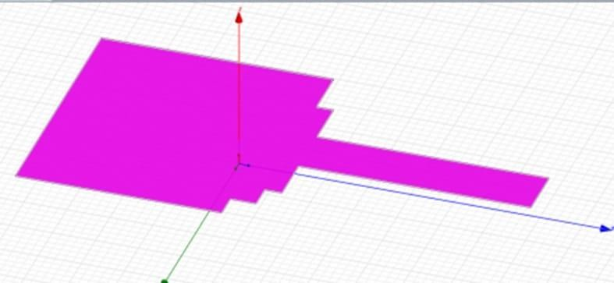

Fig. 1. Structure of radiating patch in the proposed antenna.

# Table 2

Antenna design parameter specifications (mm)

|  |  |
| --- | --- |
| **Parameters** | **Dimensions (in mm)** |
| Length of the patch | 15 |
| width of the patch | 14.5 |
| Length of the substrate | 30 |
| Width of the substrate | 35 |
| The thickness of the substrate | 1.6 |
| Feed length | 13.5 |

|  |  |
| --- | --- |
| Feed width | 3.2 |
| Dielectric constant | 4.4 |
| Length of the ground plane | 30 |
| Width of the ground plane | 12.5 |

# Return Loss:

The simulated antenna's return loss characteristics show how much power is reflected from the antenna due to an impedance mismatch between the antenna and the transmission line.

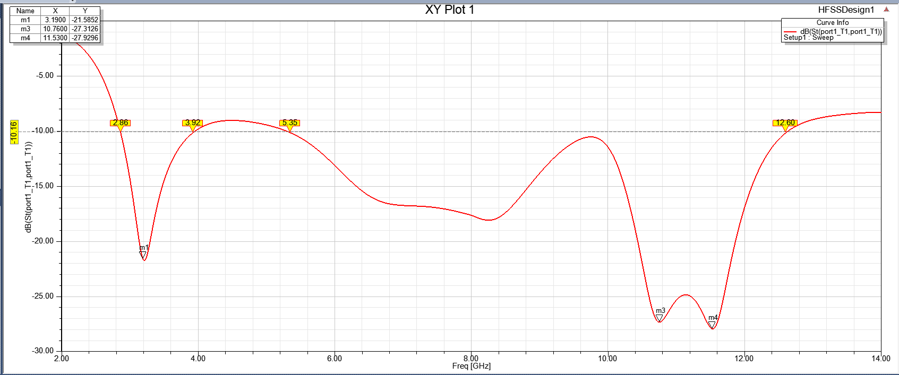

Fig 5. Return loss of the proposed antenna

In the figure 5,it is inferred that the patch antenna has the bandwidth of 35 MHz and 36 MHz, respectively for the frequencies at (5.87-8.53GHz), (9-10.6GHz), and (11.3-14GHz).The designed antenna covers its upper portion of UWB frequency spectrum between 10.6 GHz and

11.3 GHz.

# Radiation Pattern:

Radiation pattern can be defined as the graphical representation of the field or power distribution in the far field region from the antenna. The radiation pattern is shown below. The antenna has good radiation characteristics and achieves a gain of 7.6 dB at 7.5 GHz, according to the figure.

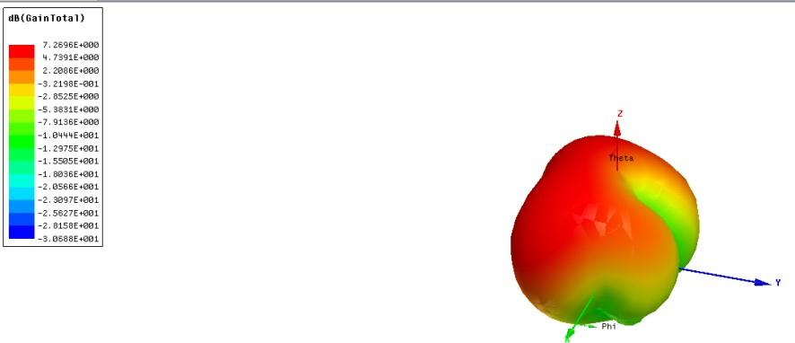

Fig 6. Gain of the proposed antenna

# Antenna Gain

Antenna gain plays a crucial aspect in its radiation properties. The antenna's gain provides information about how well it couples a radio signal into free space. Ultrawide Frequency band is intended for the proposed antenna. The gain's variation with respect to frequency in the proposed band the gain is 7.2dB. The maximum gain is 7.8dB at 7.5GHz, which is its resonant frequency. The proposed antenna significantly increases gain over the whole UWB frequency band.

# Directivity:

Directivity can be defined as the concentration of the antenna’s radiation pattern in a particular direction. If the antenna’s beam is highly focused or concentrated, then the directivity will be higher. The proposed antenna reaches its maximum directivity of 8.9 dB at 7.5GHz, which is its resonance frequency. The proposed antenna achieves a significant degree of directivity over the UWB frequency band.

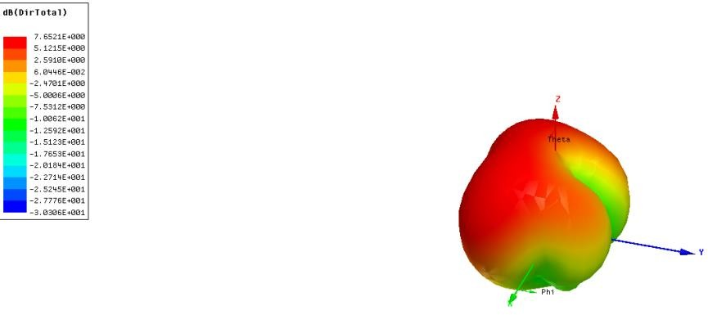

Fig 7. Directivity of the proposed antenna

# Impedance matching

Impedance of the proposed antenna is presented in Fig 8 for the proposed frequency range. Antenna impedance is closer to required impedance of 50 ohm.

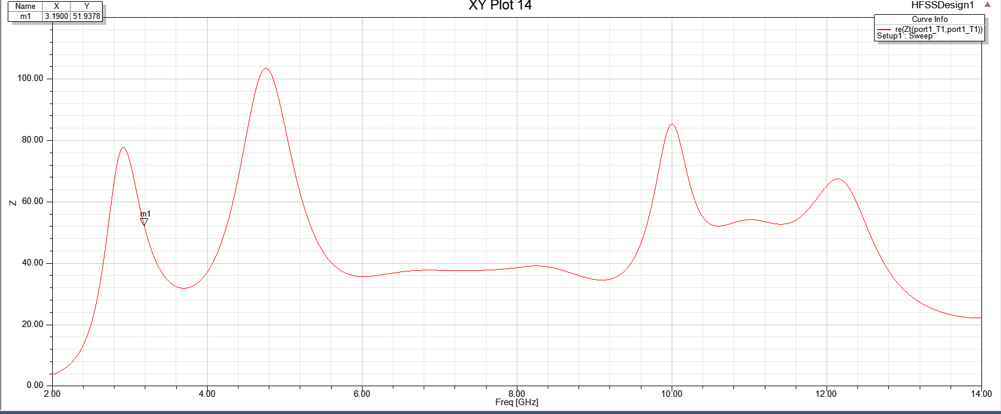

Fig 8. Impedence of the proposed antenna

# VSWR

Voltage Standing Wave Ratio (VSWR) of the proposed antenna is plotted in Fig 9 for interested frequency ranges. Proposed antenna archives the VSWR of average value of 3. Hence it is inferred that proposed antenna can be employed for practical applications.

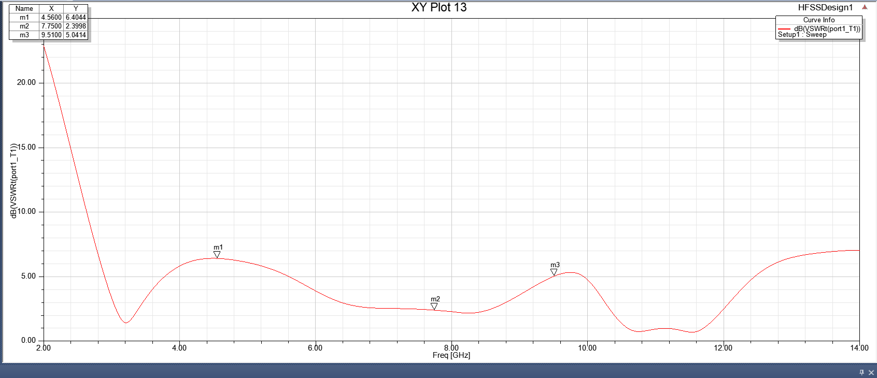

Fig 9. VSWR of the proposed antenna

# CONCLUSION

Huge amounts of data are transmitted wirelessly through UWB over a broad frequency band. A UWB antenna can take the place of several narrow-band antennas, reducing interference from several antennas and freeing up space. Applications for ultra wideband antennas are more common, in part as a result of recent developments in wireless communication and consumer electronics. The ultra-wideband antenna has several distinctive benefits, including greater data rates, minimal power usage, Low cost. Especially when compared to traditional narrow-band antennas, effective at achieving broad bandwidth. The designed antenna consists of a staircase- like patch, and multiple slits in the patch which resonates at the frequencies of (5.87GHz to 8.53GHz), (9.03GHz to 10.6GHz), and (11.38GHz to 14GHz).

# REFERENCES

1. Yahya S. H. Khraisat et al, Increasing Microstrip Patch Antenna Bandwidth by Inserting Ground Slots, Journal of Electromagnetic Analysis and Applications (2018)
2. Halim Boutayeb; Tayeb A Denidni et al, Gain Enhancement of a Microstrip Patch Antenna Using a Cylindrical Electromagnetic Crystal Substrate, IEEE Transactions on Antennas and Propagation DOI: 10.1109/TAP.2007.908818, (2007).
3. Anwer Sabah Mekki, Mohd Nizar Hamidon,Alyani Ismail and Adam R. H. Alhawari et al , Gain Enhancement of a Microstrip Patch Antenna Using a Reflecting Layer, International Journal of Antennas and Propagation (2015).
4. Manoj Kumar Garg et al, Partial Ground Microstrip Patch Antenna for Ultra-wideband Applications (2019).
5. Narinder Sharma, Snehdeep Sandhu et al, A Slotted Rectangular Microstrip Patch Antenna for Wideband Wireless Applications, International Journal of Engineering and Technology , 10.21817/ijet/2017/v9i3/170903095, (2017).
6. Al-Gburi AJA, Ibrahim IBM, Zeain MU, Zakaria Z et al , Compact Size and High Gain of CPW-Fed UWB Strawberry Artistic Shaped Printed Monopole Antennas Using FSS Single Layer Reflector, IEEE, DOI: 10.1109/ACCESS.2020.2995069, (2020).
7. Parchin NO, Abd-Alhameed RA, Shen M et al, Gain Improvement of a UWB Antenna Using a Single-layer FSS, DOI: 10.1109/PIERS-Fall48861.2019.9021920, (2019).
8. Patel JM, Patel SK, Thakkar FN et al, Analysis of W-slot loaded patch antenna for dualband operation,AEU, International journal of electronics and communication DOI:10.1016/j.aeue.2011.04.011, (2011).
9. Tang M-C, Shi T, Ziolkowski RW et al, Planar Ultrawideband Antennas With Improved Realized Gain Performance, IEEE Transactions on Antennas and Propagation, DOI:10.1109/TAP.2015.2503732, (2015).
10. Nikolaou S, Abbasi MAB et al, Design of miniaturized super wideband printed monopole antenna operating from 0.7 to 18.5, (2020).
11. C. Balamurugan, P. Marichamy, R. Harichandran , Performance Comparison

of Microstrip Patch Antenna Usingh‑BN Nanoceramic Substrate and FR4 Substrate, (2021)

1. Balamurugan Chinnagurusamy, Marichamy Perumalsamy, Multiband microstrip patch antenna using copper nanoradiating element for X band and C band applications (2021)
2. Balamurugan Chinnagurusamy, Marichamy Perumalsamy, Arun Samuel Thankamony Sarasam, Design and fabrication of compact triangular multibandmicrostrip patch antenna for C- and X-band applications (2021)