**WEATHER MONITORING SYSTEM USING ARDUINO**

Author Affiliations

|  |  |  |
| --- | --- | --- |
| Suvinraj S  B.E, ECE  National Engineering College, Kovilpatti [1911108@nec.edu.in](mailto:1911108@nec.edu.in) | Rajesh Kumar G  B.E, ECE  National Engineering College, Kovilpatti [1911098@nec.edu.in](mailto:1911098@nec.edu.in) | Manish @Venkatesh S  B.E, ECE  National Engineering College, Kovilpatti  [1911081@nec.edu.in](mailto:1911081@nec.edu.in) |
|  | Dr.C.Lakshmi,M.E.,Ph.D.,  Assistant Professor(SG),  National Engineering College, Kovilpatti  lakshmi-ece[@nec.edu.in](mailto:1911103@nec.edu.in) |  |

**ABSTRACT**

In the agricultural sector, a weather monitoring system was necessary. In the suggested work, simple weather monitoring equipment that runs on an Arduino UNO is used to measure weather parameters. This equipment can detect environmental factors like temperature and humidity. Sensors that detect temperature are used to gauge environmental conditions. The purpose of a weather tracking system is to find, keep track of, and show various weather parameters like temperature and humidity. The system makes use of sensors to identify and track weather factors, and it then transmits the data it has gathered via Bluetooth so that smartphones can access it.

**INTRODUCTION**

The weather monitoring device is primarily used to track environmental variables like temperature, humidity, air pressure, and rainfall. In our everyday lives, weather monitoring is crucial. Without the assistance of a weather forecasting organization, people can directly access the weather data online using a weather reporting system that uses sensors for humidity and rain as well as temperature and other stats. our endeavour. Using a temperature sensor, DHT 11, we can measure temperature and humidity. The measured data can be saved, and the current data can be viewed on our smartphones.

**LITERATURE SURVEY**

SURVEY 1 :-

TITLE: ARDUINO BASED WEATHER FORECASTING STATION

In order to predict the weather on a daily, weekly, or monthly basis, weather forecasting stations use computerised systems. For private use, these systems, which are used by meteorology in our nation, can be both expensive and challenging. For the purpose of eradicating such issues, intelligent weather stations that can be used independently are being created. In this research, a smart weather station has been created to monitor the changing weather throughout the day. Users are provided with approximated weather information after the data from the air station's temperature, humidity, pressure, and rain sensors has been processed using an Arduino-based processor.

SURVEY 2:-

TITLE: ARDUINO POWERED SMART WEATHER MONTORING SYSTEM

In this work, a database device used to generate the provided data is built based on the symbols and a two-dimensional control system is integrated with information acquisition techniques. The main components used to build the device for real-time weather tracking are the sensors. Temperature and humidity can be measured and controlled using a range of sensors. The obtained records

can be displayed internally as virtual output while the output is displayed on the LCD panel. To monitor and manage the area within the specified location, the entire system also occasionally modifies the weather at the designated location. The final result can be shown on the LCD display after accurately determining the temperature and humidity in a specific location.

SURVEY 3 :-

TITLE: REAL TIME STANDALONE DATA ACQUISITION SYSTEM FOR ENVIRONMENTAL DATA

The distribution of environmental info is becoming increasingly important over time. We can identify appropriate locations for agriculture, industry, and other uses with the help of real-time environmental monitoring. To execute the data acquisition strategy and interface both analogue and digital sensors in this paper, an Arduino-UNO microcontroller-based board is used. The dew point has been calculated while concurrently monitoring temperature, humidity, light intensity, and gas concentration. The necessary user interface for the end user is provided by Lab View 2015 technology. It helps with a quick and efficient understanding of the issue. Data from this system is also made available for additional processing and for obtaining the desired outcomes. Monitoring of the living area, industry, and agriculture are all facilitated by the system.Wi-Fi is used for data transmission that is saved in a cloud account in order to operate an independent weather station in a stand-alone configuration. Wherever you are in the globe, you can use this data for a variety of things.

SURVEY 4 :-

TITLE: IOT-BASED DATA LOGGER FOR WEATHER MONITORING USING ARDUINO- BASED WIRELESS SENSOR NETWORKS WITH REMOTE GRAPHICAL APPLICATION AND ALERTS.

Monitoring devices have become a big part of our lives in recent years. To have dynamic and real-time climate statistics for a specific area, we therefore suggest in this paper an automated weather monitoring system. The suggested system is built using embedded systems and internet of things technology. Aside from those components, the system also has wireless technology and electrical gadgets. This system's primary goal is detecting the climate parameters, such as temperature, humidity, and the presence of some gases, using sensors. A remote programme or database can then receive the captured values. The data can then be displayed in the shape of graphics and tables.

**HARDWARE ARCHITECTURE:**

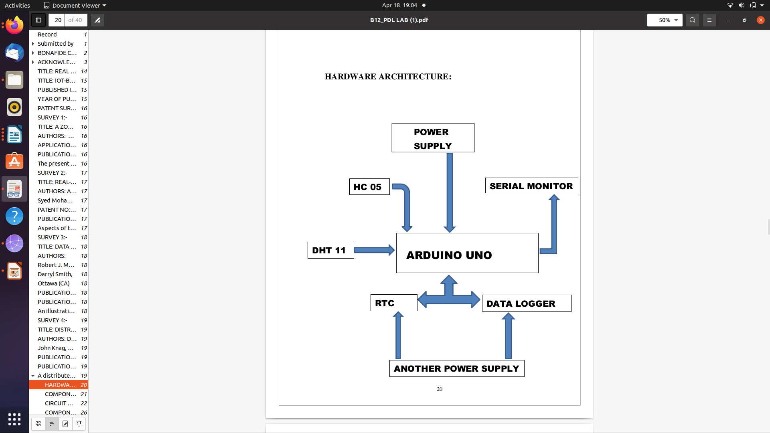

**DESCRIPTON**

The Arduino UNO board has a DHT 11 (which monitors temperature and humidity) sensor connected to an ATMEGA microcontroller. The pin connections were provided, and the Arduino board made the connection. HC-05 will use a serial monitor and smartphones to show the output. (BLUETOOTH MODULE). Continuous monitoring is done of the environment's temperature and humidity. The Arduino software on the PC has been downloaded with the code for the work's execution. Anywhere, at any moment, one can measure the temperature and humidity.

**COMPONENTS USED:**

Arduino UNO

HC – 05 (BLUETOOTH MODULE)

RTC

DATA LOGGER

DHT 11 Sensor

Power Supply 5V and another power supply of 5V – 12V

Serial Monitor

Arduino IDE Software

PLX DAQ

Bread Board

**COMPONENTS DESCRIPTION:**

RTC

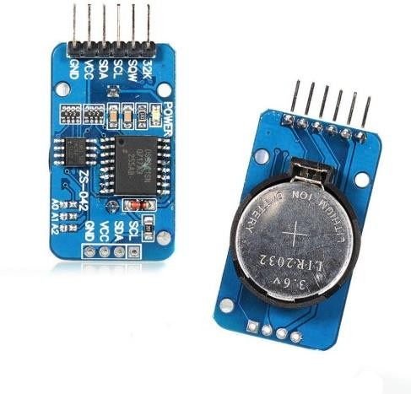

A real-time clock (RTC) is a piece of electronic equipment that tracks the passage of time (typically in the shape of an integrated circuit). RTCs are found in almost every electronic device that requires accurate timekeeping, even though the word is frequently used to describe the components in personal computers, servers, and embedded systems. Real-time clocks are differentiated from standard hardware clocks, which are nothing more than signals that control digital electronics, by the use of the word. and don't measure time in human seconds. It is important to distinguish RTC from real-time processing, which has the same three-letter acronym but has nothing to do with the time of day.RTC modules are essentially TIME and DATE reminiscing devices that are battery-powered and able to function even in the absence of external power. The TIME and DATE remain current as a result. Therefore, whenever we want, we can use the RTC module to get exact TIME and DATE.

**DHT 11 SENSOR:**

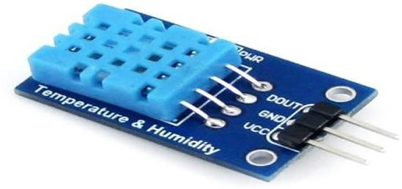

For measuring temperature and humidity, use the inexpensive digital monitor DHT 11. A micro-controller, such as an Arduino, Raspberry Pi, or another, can readily interface with this sensor to measure humidity and temperature in real-time. A monitor for relative humidity is the DHT11. Both a capacitive humidity sensor and a thermistor are used by this sensor to detect the ambient air. The level of atmospheric moisture is measured as humidity. Numerous physical, chemical, and biological processes are impacted by atmospheric humidity. The business expense of the products, employee health, and worker safety can all be impacted by humidity in industrial applications. The amount of moisture contained in the gas, which may be a mixture of nitrogen, argon, water vapor, or another gas, is measured by humidity.Based on the units of measurement, there are two different kinds of humidity sensors. A digital monitor for humidity and temperature is called DHT11.

**ARDUINO UNO:**

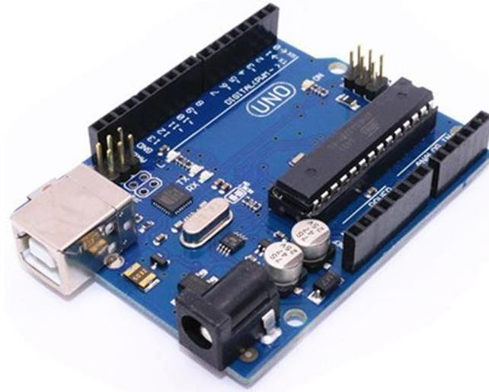

An ATmega328-based microcontroller device is the Arduino Uno.It has 6 analogue inputs, a 16 MHz crystal oscillator, a USB link, a power jack, an ICSP header, and a reset button. It also has 14 digital input/output pins, 6 of which can be used as PWM outputs. It has everything required to enable the microcontroller, to put it simply. To begin, power it with an AC-to-DC adapter, a battery, or a USB cable and attach it to a computer. The Uno is distinct from all In contrast to earlier devices, this one does not use the FTDI USB-to-serial driver. chip. In its place, a USB-to-serial adapter built into the Atmega16U2 is featured.Either an external power source or the USB connection can be used to charge the Arduino Uno. The power source is immediately chosen. Battery power or an AC-to-DC adapter (wall wart) can supply external (non-USB) electricity. Using pin Mode (), digital Write(), and digital Read() methods, the Uno's 14 digital pins can all be used as inputs or outputs. They use 5 volts to work. Each port has a 20–50k ohm internal pull-up resistor and a maximum current capacity of 40 Ma.

**POWER SUPPLY:**

An element that powers at least one electric load is known as a power source. Normally, it changes one form of electrical power into another, but it can also change another form of energy, like sun, mechanical, or chemical energy, into electrical energy. Electricity is supplied to components by a power source. In most cases, the word refers to electronics built into the powered component. An illustration is the conversion of AC current to DC current by computer power supplies, which are typically found at the back of the computer case with at least one fan. An adapter, power brick, or power source are other names for the same device.

HC – 05:

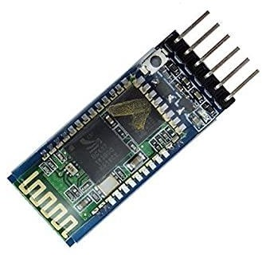

The HC-05 Bluetooth Module is a straightforward Bluetooth SPP (Serial Port Protocol) module created for the establishment of transparent wireless serial connections. Because it communicates serially, interacting with a controller or a PC is simple. With the ability to switch between master and slave modes, the HC-05 Bluetooth module can neither receive nor send data.

**SOFTWARE IMPLEMENTATION:**

The software is made up of a free-running programme that modifies data from the DHT 11 sensor. Written on an Arduino sketch, the programme code is then uploaded to the Arduino Uno development device. The Arduino sketch IDE software is used to create the hex file.

# HARDWARE PROTOTYPE:

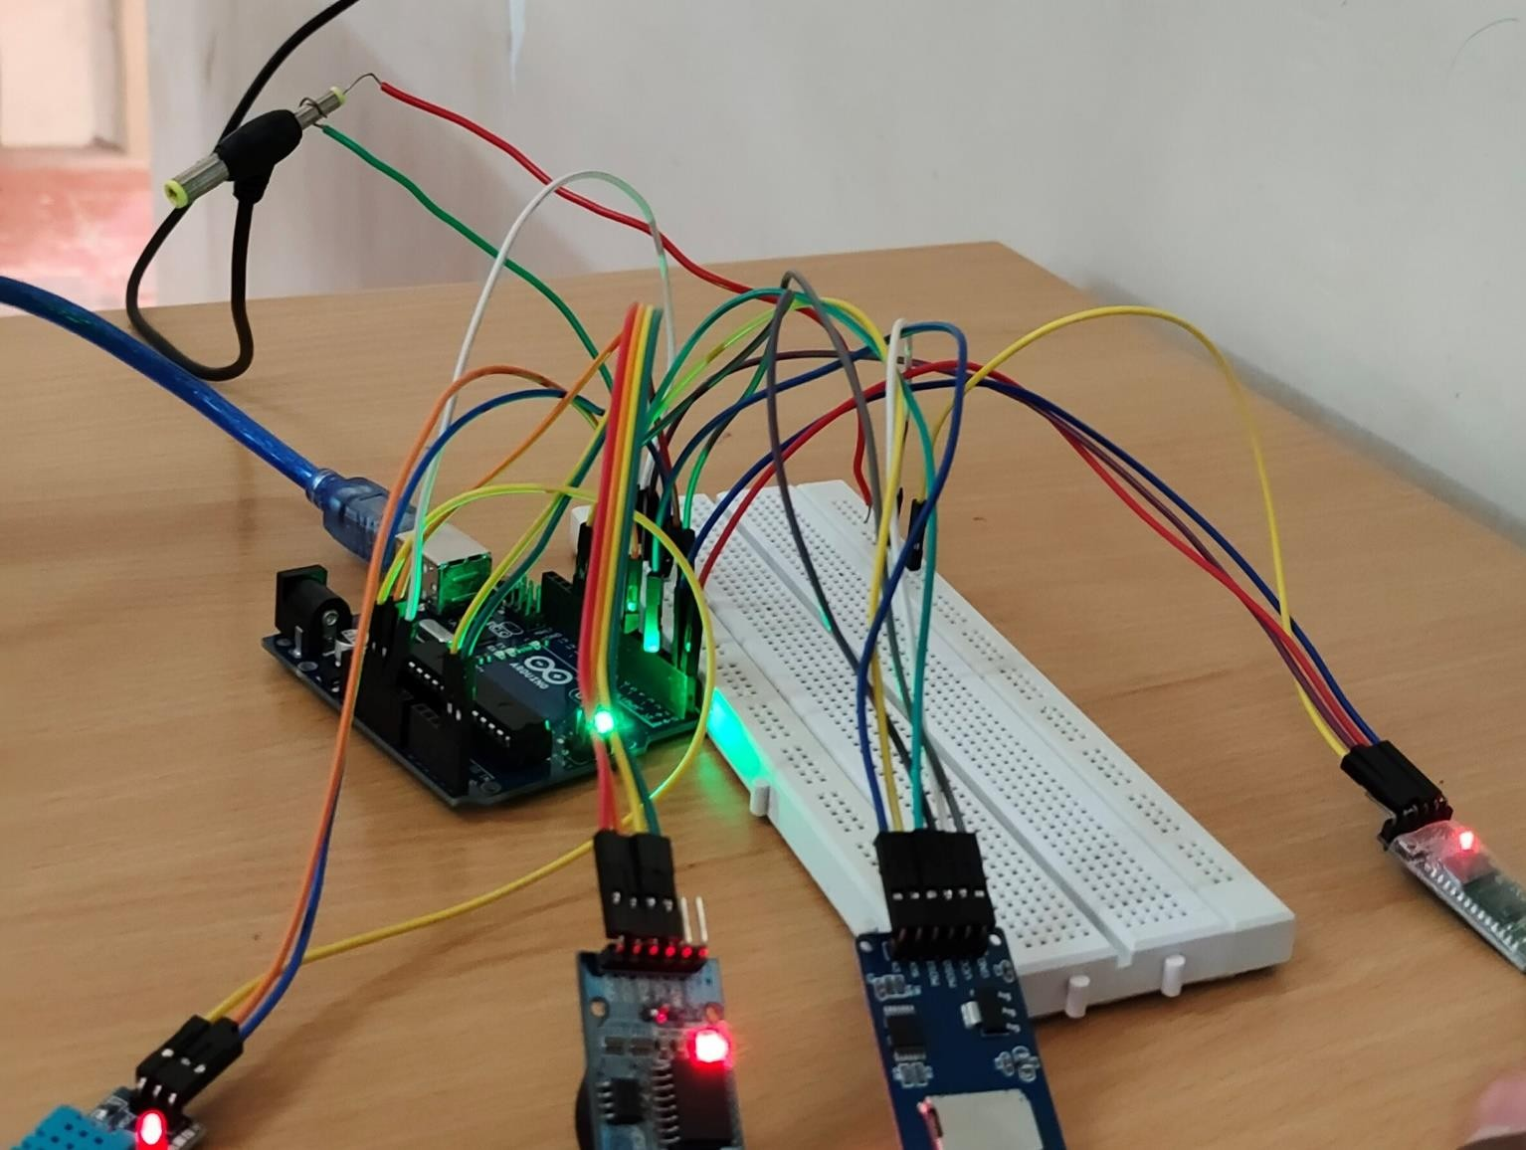

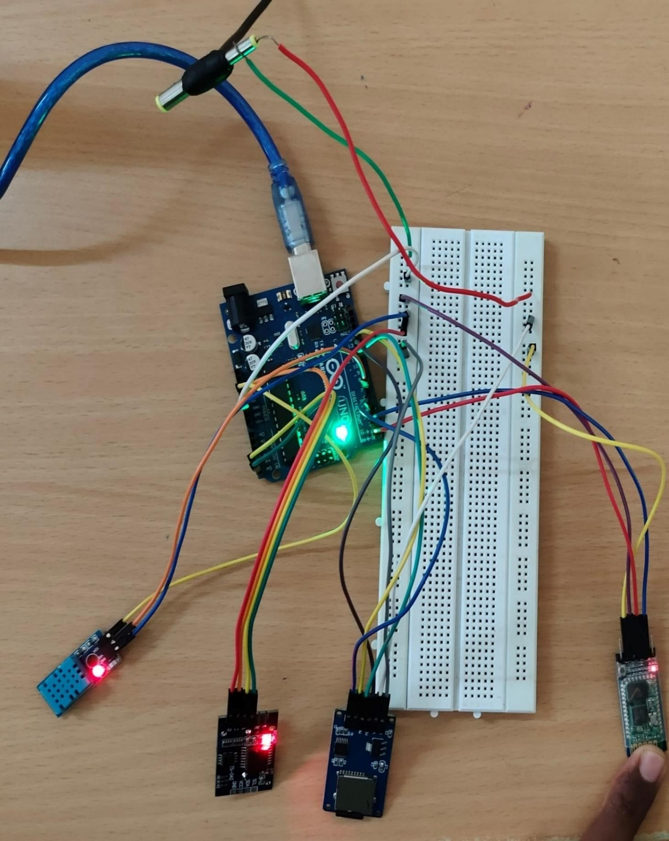

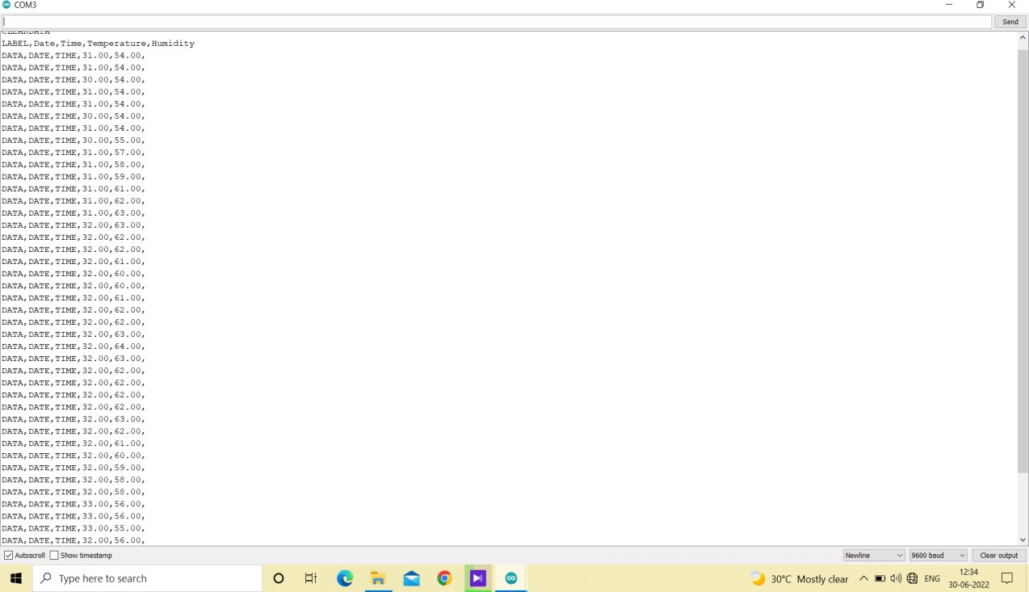

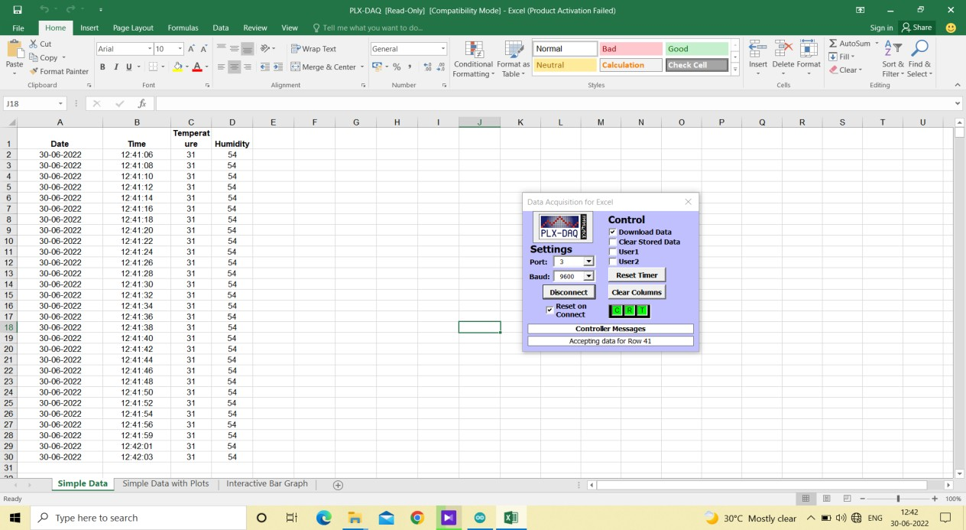

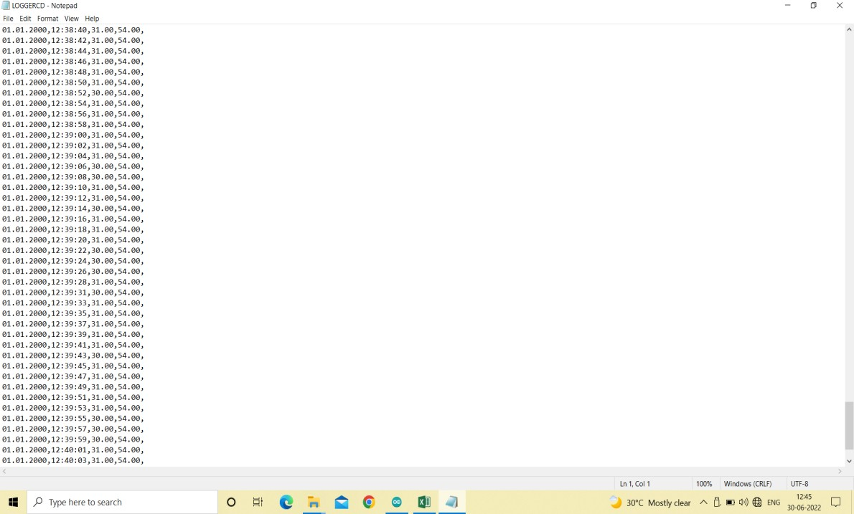

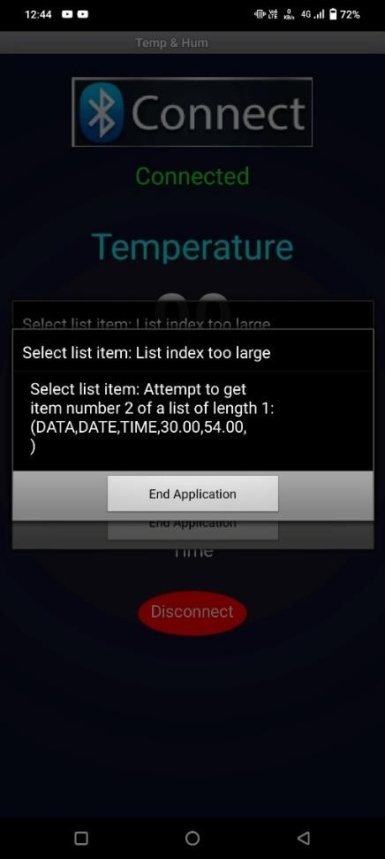

**CONCLUSION:**

The outcome of the proposed system's testing was satisfactory and complied with society's needs for improved weather monitoring. According to experimental findings, the temperature sensor can react rapidly, data can be transmitted over Bluetooth, and the results can be viewed on our smartphones or serial monitors.

# REFERENCES:

[1]prasad, padalkar. an iot based system for real time standalone data acquisition system for environmental data. global conference for advancement in technology, (2021).

[2]dr.c.d. naidu., dr. rajendra prasad somineni real time standalone data acquisition system for environmental data monitoring iacc 2017,(2017)

[3]jesudoss a., sivasangari a., sardar maran and mercy theresa m. iot- based data logger for weather monitoring using arduino-based wireless sensor networks with remote graphical application and alerts. international conference on communication and signal processing.(2020)

[4].[https://create.arduino.cc/projecthub/electropeak/getting-started-](https://create.arduino.cc/projecthub/electropeak/getting-started-with-hc-05-bluetooth-module3-arduino-e0ca81) [with-hc-05-bluetooth-module3-arduino-e0ca81](https://create.arduino.cc/projecthub/electropeak/getting-started-with-hc-05-bluetooth-module3-arduino-e0ca81)

[5].<https://create.arduino.cc/projecthub/the_electro_artist/arduino-temperature-logger-with-sd-card-08e6ed>