IOT-BASED WATER BODIES MONITORING SYSTEM

Jayaram .P.M1 ,Stanly Samuel. M2 , Suresh. V3

1Student, National Engineering College, Kovilpatti, India, Department of ECE, Bachelor of Engineering. 2Student,National Engineering College, Kovilpatti, India, Department of ECE, Bachelor of Engineering. 3 Associate Professor of ECE at the N2ational Engineering College in Kovilpatti, India.

Email : [1911403@nec.edu.in](mailto:1911403@nec.edu.in), [1911406@nec.edu.in](mailto:1911406@nec.edu.in), vsece@nec.edu.in

***Abstract - Water pollution is one of the primary issues with green globalisation. The most difficult method of implementing dirty water is the cost-effective and efficient system of water quality observation. As water utilities face more difficulties, drinking water may become increasingly valuable for all people. These issues are brought on by the large population, scarcity of water supplies, etc. As a result, many techniques are utilised to track the water quality in real time. In order to ensure that the distribution of water is done properly, a novel approach in IoT-Based water quality has been predicted. Real-time water quality monitoring is now feasible because to data collection, processing, and transmission made possible by the growth of wireless device networks and the Internet of Things. Water quality needs to be periodically assessed in order to guarantee a reliable supply. In this project, we demonstrate how to design and construct a low-cost system for Internet of Things (IoT)- based real-time water quality monitoring. To monitor the physical and chemical characteristics of the water, the system uses a range of sensors. You may measure the characteristics of the water, including its temperature, turbidity, and rain sensor. The core controller can process the values that the sensors measure. A core controller option is the Node MCU model. The sensor data may also be seen online via a WI-FI system (ThingSpeak).***

***IoT system, Wi-Fi module, Sensors, temperature, and water level are keywords.***

1. INTRODUCTION

Inventions abound in the twenty-first century, but at the same time, environmental problems such as pollution, global warming, and others are developing. As a result, there is no clean water for human use. Due to factors like global warming, dwindling water supplies, expanding population, etc., real-time monitoring of water quality is difficult nowadays. Therefore, it is necessary to create better methodologies for real-time monitoring of water quality parameters. Turbidity is a term used to describe the quantity of invisible suspended particles in water. The danger of cholera and diarrhoea increases with increasing turbidity. Turbidity levels below zero indicate pure water. A temperature sensor gauges the water's temperature, hot or cold. The manual collection of water samples from various locations is a component of conventional methods of water quality monitoring.

Currently, all humans highly value access to clean drinking water. Water levels in the lakes are getting lower and

lower in recent years. Urbanisation, industry, and population growth are all contributing factors to the deterioration and contamination of drinking water. Better methods of monitoring water quality are therefore required. Testing had to be done manually to determine the water quality. Such methods take more time and are no longer regarded as effective. By focusing on the aforementioned issues, our design develops a low-cost system for real-time water quality monitoring in an IoT environment. Finding a solution for the water monitoring and control system is therefore crucial. IoT is a remedy.

Internet of Things technology has recently been sparked by advancements in computing and electrical technology. The Internet of Things is a network of electronic devices that communicate with one another via a control device. A network of devices known as the Internet of Things (IoT) works together to efficiently support human employment. In order to convey environmental data, it pools computational power.

These gadgets might be sensors, home appliances, embedded systems, or data analysis tools. This concept offers an inexpensive water monitoring device as a remedy for both water wasting and poor water quality. The system makes use of sensors. The water level is determined using an ultrasonic sensor. Other parameters such as water temperature and turbidity can be calculated using various corresponding sensors. This device employs a rain sensor that may immediately communicate information to the user via a buzzer and cloud after detecting the presence of rain. Microcontrollers can process the computed sensor readings and upload them to the internet through the ESP 8266 WiFi module. We may use this approach to analyse how much water is utilised at specific times throughout the day or month. Consumer-owned user terminals can access the alert messages and data generated by the sensors after they have been relayed over the Internet to a cloud server.

The remaining portions of this project are structured as follows: related work and an overview of it; a schematic circuit showing how it operates; findings and a discussion; and a conclusion outlining potential future directions.

1. HARDWARE DESCRIPTION

Fig. 2.1 depicts the hardware components' connection to the node MCU.

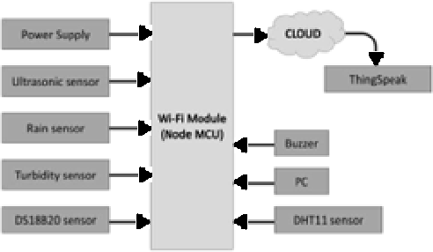

Block diagram of an IoT-based Water Bodies Monitoring System (Fig. 2.1)

1. NODE MCU

Built on the low-cost ESP8266 System-on-a-Chip (SoC), the open-source Node MCU (Node Micro Controller Unit) is a software and hardware development environment. Express if Systems developed and manufactured the ESP8266, which features all the essential parts of a computer, including a CPU, RAM, networking (Wi-Fi), and even a modern operating system and SDK. As a result, it makes a fantastic replacement for all IoT projects and a fantastic choice for all IoT applications.

However, using the ESP8266 as a chip is difficult.

Even basic operations like turning it on or sending a keystroke to the chip's "computer" need the correct cable connections to its pins. Programming must also make use of low-level machine instructions that the chip hardware can interpret. At this degree of integration, it is trivial to use the ESP8266 as an embedded controller in surplus items. It's a major issue for newbies, hackers, or students who want to test it out in their own IoT projects.

1. ULTRASONIC SENSOR

An ultrasonic sensor converts the audio that is reflected while measuring the distance to a target object using ultrasonic sound waves into an electrical signal. Compared to audible noises, which are those that people can hear, ultrasonic waves move more slowly yet go farther. An ultrasonic sensor detects the sound after it has gone to and from the target and is made up mostly of the transmitter (which creates a signal using piezoelectric crystals) and receiver.

The distance between an object and the sensor may be calculated by keeping track of how much time passes between the transmitter's sound emission and the receiver's contact with the sound. The formula used to determine the solution is D = 12 T x, where D stands for length, T for time, and C for the 343 m/s sound speed. Using an ultrasonic sensor as an example, the distance between the two objects would be D = 0.5 x 0.025 x 343 or around 4.2875 metres if the researcher placed the sensor inside a container and waited for the noise to return after 0.025 seconds.

1. DS18B20 TEMPERATURE SENSOR

Data about temperature is produced in the 9–12 bit range by a particular type of temperature sensor, the DS18B20. These figures show the temperature of the object. This sensor's ability to communicate with an internal CPU is made possible by the One-wire bus protocol, which only requires a single data line to connect.

Additionally, since this sensor receives its power directly from the data line, it does not require an external power supply.

The DS18B20 temperature sensor can be utilised in thermosensitive consumer items, thermostatic controls, industrial systems, and thermometers. The temperature is monitored via the DS18B20 temperature sensor, just as a temperature sensor.

This sensor has a sensitivity range of 9 bits to 12 bits, and its power-up resolution is calibrated to the 12-bit standard. The sensor's 2-byte register may be used to store temperature readings before it goes back to being dormant. If the sensor is powered by an external source, it is feasible to add scan time slots after the Convert T command. In reaction to variations in temperature, the sensor will act by supplying and delivering 1.

1. RAIN SENSOR

The rain switch, also known as a rain sensor, is a switching device that is activated by raindrops. There are two different applications for rain sensors. The first is an automatic irrigation system that has a water-saving feature that requires the system to turn off in the event of rain. The second is a device that helps windscreen wipers function automatically while protecting an automobile's interior from the elements.

This board uses the resistance concept and has nickel-coated lines. This sensor module generates a digital output when the moisture threshold is met and enables for the detection of moisture through analogue output pins. Given that it has both an electrical module and a PCB, this module is comparable to the LM393 IC. PCB is utilised in this situation to catch the rain. The operational amplifier can compute when rain forms a parallel resistance channel on a board. This sensor, a resistive dipole, solely displays moisture-dependent resistance. It exhibits higher resistance when it is dry and less resistance when it is wet, for instance.

1. TURBIDITY SENSOR

The turbidity sensors determine how much light is reflected by the water's suspended particles. The concentration of total suspended solids (TSS) increases as water turbidity (cloudiness or haziness) increases. Turbidity sensors are used in a wide range of laboratory experiments, wastewater and effluent measurements, settling pond management tools, sediment transport studies, and river and stream measuring.

The Turbidity Sensor detects particles suspended in water using end-emitting infrared light that is undetectable to the human eye. It then analyses light transmittance and dispersion rate to increase the liquid's turbidity as TSS (Total Suspended Solids) levels rise.

1. DHT11 SENSOR

A composite sensor that generates calibrated digital data for both temperature and humidity is the DHT11 digital temperature and humidity sensor.. The device has great dependability and outstanding long-term stability thanks to the technology of a dedicated digital modules collecting as well as the temperature and humidity sensor technology.

The sensor is coupled to a powerful 8-bit microprocessor and has a resistive sensing of moist components and an NTC temperature measuring device.

Only the VCC, GND, and DATA pins are functional. Contact is established with DHT11 via the DATA line sending start signals, and DHT11 responds with an answer signal. Following receipt of the response signal, the host begins to gather 40-bit humidity data (8- bit integer humidity + 8-bit decimal humidity + 8-bit integer temperature + 8-bit decimal temperature + 8-bit checksum).

1. BUZZER

A buzzer or beeper is an aural signalling device that can be mechanical, electromechanical, or piezoelectric (short for piezoelectric). Buzzers and beepers are frequently used in alarm clocks, timers, trains, and to validate human input such as mouse or keyboard clicks.

The pin configuration of the buzzer is shown below. Positive and negative pins are included on it. This is the positive terminal, which is denoted by the '+' symbol or a lengthier terminal. The negative terminal is represented by the '-' symbol or short terminal and is powered by 6 Volts, whilst the positive terminal is represented by the '+' symbol or long terminal and connects to the GND terminal.

1. RESULTENT DISCUSSION

In the sample functioning model, the Sensors are connected to the Node MCU, which is connected to Thingspeak. The hardware setup of the IoT-based water bodies monitoring

system is shown in Figure 3.1.

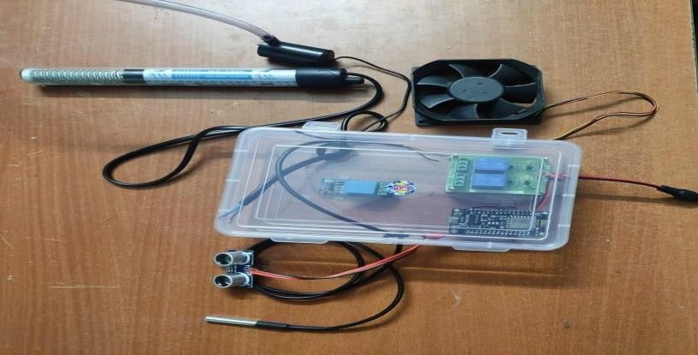

The hardware setup of the IoT-based water bodies monitoring system is shown in Fig.3.1.

1. CONCLUSION

This project's technology is an effective, low- cost IoT solution for monitoring water quality in real-time. The designed system, which has NodeMCU target boards, successfully interfaces with a number of sensors. Real-time development of an effective algorithm for monitoring water quality. Turbidity measurements for groundwater and supply water in Hyderabad Metropolitan City vary from 600 to 2000 NTU. The turbidity of the water, the volume of water in the tank, the temperature, and the humidity of the surrounding air are all tracked using the webserver and a web-based application called ThingSpeak. The ThingSpeak mobile app also allows users to keep track of these measured metrics. The system's performance during testing was suitable for meeting the needs of the needed region for monitoring water quality, level, and quantity as well as rainfall. The results of the experiment demonstrate that the water monitoring sensor can work continuously as well as react promptly to changes in water level and quality caused by rain and other factors.

1. RESULT

The end result displays a graphical depiction of rain detection, quality monitoring, and water level monitoring.

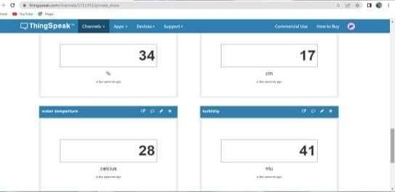

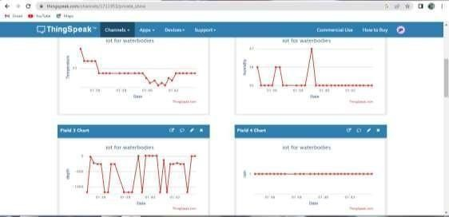

Fig. 5.1 Output in Thingspeak in pc

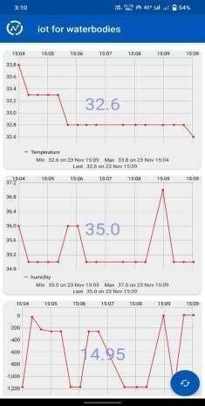

Fig. 5.2: Thingspeak mobile app output

5. REFERENCE

1. Krishna S, Sarath TV, M S Kumaraswamy, Vishnu Nair, “IOTBASED Water Parameter Monitoring System” published in 2020 IEEE 5th International Conference on Communication and Electronics Systems (ICCES).
2. Ajith Jerom B, Manimegalai R, Ilayaraja V, “An IOT- BASED Smart Water Quality Monitoring System using Cloud” published in 2020 International Conference on Emerging Trends in Information Technology and Engineering (IC-ETITE).
3. Ms. Ch. Sowmya, Dr. C.D. Naidu, Dr. Rajendra Prasad Somineni, D. Ramesh Reddy, “Implementation of Wireless Sensor Network for Real Time Overhead Tank Water Quality Monitoring” published in 2017 IEEE 7th International Advance Computing Conference (IACC).
4. Abdullahi Salisu, Hauwa Mohammed Mustafa, Aisha Mustapha, Gasim Hayder, “Applications of IoT and Artificial Intelligence in Water Quality Monitoring and Prediction: A Review” published in 2021 6th International Conference on Inventive Computation Technology (ICICT).
5. Khalid Waleed A. S., Purba Daru Kusuma, Casi Setianingsih, “Monitoring and Classification System of River Water Pollution Conditions with Fuzzy Logic” published in 2019 IEEE International Conference on Industry 4.0, Artificial

Intelligence, and Communications Technology (IAICT).

1. Bansari, Deb Majumder Raktim, Pratihar Dey, Atmadip Majumdar, Arka, “IOT-BASED Water Quality Monitoring Systems in River, Lakes, and Ponds” published in 2021.
2. Badashah, Syed Jahangir; Mishra, Gyanshankar Praphullakumar; Komma, Vijaya Nirmala; Basha, A. M. Mahaboob; Rajaiah, M.; Meena, I.; B., Neeraja; Manikandan, J.; R., Varadaraj K.; Kumar, S. Vijay; Patel, G. C. Manjunath; Lakshmikanthan, Avinash, “An IOTBASED Pollution Management System to Monitor the Pollutants Released into Air or Water Bodies from Industries” published in 2022.
3. Dr. R. Joshua Samuel Raj, Dr. S. Saravanan, Dr. K. M. Sakthivel, Dr. K. P. Sanal Kumar, Dr. S. Geetha, Dr. S. Anu H Nair, Dr. Anil Lamba, Dr. Satinderjeet Singh, Dr. M. Prasad, Dr. S.R.Boselin Prabhu, Ms. Dhanya G S & Dr. A. Jegatheesan, “Internet of Things (IoT) based Intelligent Water Quality Monitoring and Distribution Management System” published in 2020.
4. Malik, Akash Malik, Vishwas Chaudhary, Harivansh Kumar Kumar, Rikshit Kumar, Arun, “IoT Driven ML-based Automated Water Quality Monitoring System for Industrial building” published in 2022.
5. Varsha Lakshmikantha, Anjitha Hiriyannagowda, Akshay Manjunath, Aruna Patted, Jagadeesh Basavaiah, Audre Arlene Anthony, “IOT-BASED Smart Water Quality Monitoring System” published in 2021.
6. PHILMINAQ (Mitigating impact from aquaculture in the Phillippines), 2018. Water Quality Criteria and Standards for Freshwater and Marine Aquaculture, Marine Science Institute, IOP Conf. Series: Materials Science and Engineering 340 (2018) 01201doi:10.1088/1757-899X/340/1/012014.
7. Harun Z., Reda, E. and Zulkifli, R. (2017). Buoyancy effect on atmospheric surface layer: measurements from the East Coast of Malaysia, IOP Conference Series. 33
8. Kutty, M. N. (2017). Site selection for aquaculture: physical features of water, Nigerian Institute for Oceanography and Marine Research, Food and Agriculture Organization of The United Nations. Downloaded on 21 Feb. 2017
9. C. Dupont, P. Cousin, and S. Dupont, "IoT for Aquaculture 4.0 Smart and easy-to-deploy real-time water monitoring with IoT," 2018 Global Internet of Things Summit (GIoTS), Bilbao, Spain, 2018, pp. 1-5, doi: 10.1109/GIOTS.2018.8534581.