**ONE GAZE IS WORTH INFINITE WORDS**

(**STUDY ON COGNITO - ATTENTION BASED NEUROINTEGRAL MODEL**)

**Dr. J Satpathy, Director Research, Neurointegral Scientific Institute, Bogotá, Colombia**

**Dr. Julio César Ramírez Vargas, Director General, Neurointegral Scientific Institute, Bogotá, Colombia**

**Dr. Alfredo Steve Sherrington Rodríguez, Universidad Santo Tomás, Mexico**

**Dr. Amena Allouch, Faculty, Safir School, Beirut Governorate, Lebanon**

**Dr. Arlen LopezArce, Faculty, Universidad Interamericana University, Pueble, Mexico**

**Dr. Irina Valentina Tudor, Faculty of Sciences, University of Craiova, Romania**

**Dr. Kavitha Subramaniam, Head, Business School, ATC, Penang, Malaysia**

**Isaidys Adriana Abanto Silva, Neuropsychologist, Neurointegral Scientific Institute, Bogotá, Colombia**

**Abstract**

*As an* ***introduction****, Brunswick Lens Model of, cognition based neurointegral, decision making was the first attempt (with application of non - determinist, probabilistic processes) towards computational a probabilistic advance to neurointegral decision making (cognito conduct of human beings with cues or indicators / variables) through use of linear regression. The fundamental argument of this replicate is that a restricted set of pointers (use of assortment of indications) can be mapped aligned with a neurointegral decision objective (ultimate neurointegral decisions) all the way through a weighting design.* ***Aim*** *of this paper is to reflect upon heterodoxies and disruption neuromanagement preferred Brunswik - oriented neurointegral decision making process that marks commitment to obdurate intention. The aim is to decipher an interdisciplinary - oriented neurointegral peep into dynamics of challenges in neuromanagement preferred Brunswik - oriented neurointegral decision pathways that establish a parallel connecting risk-oriented pattern with preferred Brunswik - oriented neurointegral decision-making performing as moderator.* ***Scope*** *was to include students in a study to decode the absorption quotient of Students in a classroom with reference to ergonomics and related factors. Study attempts to examine the contrast between unswerving, univocal, realistic arch in a multifaceted process of unambiguous conciliation.* ***Methodology*** *adopted is an eye tracking experiment (with cues or indicators / variables) of students to gauge cognito - ocular indices and attention during discourse of knowledge transaction.* ***Results*** *indicate that Lens Model of Brunswik (1956), descriptive conceptualization of the human decision process, does influence cognition and attention through; information in decision situation, actual decision made and optimal or correct decision which should have been made in that persnickety condition.* ***Recommendations*** *include eye tracking of all Students before commencing a course of Instruction in a Subject / Class.*

**Key Words: Brunswick Lens, Neurointegral Decision, Eye Movement and Cognito - Attention Management**

*(Authors are grateful to Prof Ana Moreira, Institute of Applied Psychology, Lisbon, Portugal*

*for groundwork data analysis)*

**Preamble**

 Brunswik - oriented neurointegral decisions are predictable part of personage behavior with daily life being progression of Brunswik - oriented neurointegral decisions (Belton & Dhami; 2021 and Goldstein & Hogarth; 1997). Idiosyncratically, researchers are engrossed in assumptions, beliefs, habits and strategy to make neurointegral decisions (Belton & Dhami; 2021 and Goldstein & Hogarth; 1997). Any iteration of cognito management as individual attempt would need elucidation of substrates, techniques in addition to unpredictable effect of poignant maneuver in lead cognitive utility operative in neurointegral decision making processes relevant and virtual to biological resources (Belton & Dhami; 2021 and Goldstein & Hogarth; 1997). Brain considers sources of information before neurointegral decision (Belton & Dhami; 2021 and Goldstein & Hogarth; 1997). With dissimilar disciplines progressing in course of typically dissimilar techniques (multisensory input) and considerable advances, query of how we blueprint neurointegral decisions has affianced researchers (Belton & Dhami; 2021 and Goldstein & Hogarth; 1997). This paper investigates neurointegral basis of Brunswik - oriented neurointegral decision inexorableness (‘cloud of Brunswik - oriented neurointegral decision fog’) parameters in cognito management of predictable function (Belton & Dhami; 2021 and Goldstein & Hogarth; 1997). Cognito compound structure advancement to Brunswik - oriented neurointegral decision making, in turn, influence cognito management; perception strappingly entrenched in managerial psychology and cognito science (Belton & Dhami; 2021 and Goldstein & Hogarth; 1997). Amalgamation offers stimulating prospective for fabrication of near - precise models of Brunswik - oriented neurointegral decision making (Belton & Dhami; 2021 and Goldstein & Hogarth; 1997).

No preferred neurointegral decision is a packaging up (Castellan; 1977, Brunswik; 1944 and Satpathy & Washington; 2022). Traditional preferred neurointegral decision models have long preliminary in appreciative (decision ‘drivership’) preferred decision making (Castellan; 1977, Brunswik; 1944 and Satpathy; 2023) These assume that individuals are rational actors who aim to capitalize value through optimal preferred decisions (Castellan; 1977, Brunswik; 1944 and Satpathy; 2023). Since ascent of cognito-sciences in research on complicated anthropoid capital oriented business ‘drivership’ preferred neurointegral decision making, behavioral complicated cognito-anthropoid capital has connected strides in direction of swelling psychosomatic practicality of prototypes and causal suppositions (Castellan; 1977, Brunswik ; 1944 and Satpathy; 2023) This approach has been effectual at spawning inventive exploration schemata in cognito-anthropoid oriented decision ‘drivership’ Brunswik - oriented neurointegral decision dynamics (Gigerenzer; 2011, Castellan; 1977, Brunswik ; 1944 and Satpathy;2023) Within new sod of cognito - oriented business ‘drivership’, these dissimilar stratagem, conscientiously despoiled by those not conversant of its start, and incontrovertibly, those beginning may be omitted, try to find universal idiom and conjecture to better comprehend anthropoid behaviour (Castellan; 1977, Brunswik ; 1944 and Satpathy; 2023).

Rational behaviour, in this perspective, refers to individuals making consistent and logical preferred neurointegral decisions oriented on complete and accurate information (Castellan; 1977, Brunswik; 1944 and Satpathy; 2023) Neo -classical business ‘drivership’ relies on numerical models and equilibrium - oriented frameworks to analyze decision ‘drivership’ phenomenon (Castellan; 1977, Brunswik; 1944 and Satpathy; 2023). It assumes that individuals have perfect information, make preferred Brunswik - oriented neurointegral decisions oriented on well-defined Brunswik - oriented neurointegral decisions, and connect in efficient neurointegral decision interactions (Gigerenzer; 2011 and Castellan; 1977, Brunswik; 1944 and Satpathy; 2023). This approach provides insights into preferred (multisensory key in) Brunswik - oriented neurointegral decision behaviour and has been influential in shaping (decision ‘drivership’) preferred Brunswik - oriented neurointegral decisions (Gigerenzer; 2011 and Castellan; 1977, Brunswik; 1944 and Satpathy; 2023).

**Introduction**

Deliberations on ‘challenges in neuro - management preferred Brunswik - oriented neurointegral decision pathways’ has christened 21st Century as convoluted play turf in decision ‘drivership’ decision dynamics (Satpathy and Gera; 2020 and Satpathy and Mallik; 2020). Over decades, decision ‘drivership’ practices has metamorphosed ushering era of inter - disciplinary practices with ‘anthropoid beings’, as ‘Central Agents’ of neurointegral decision behaviour (Satpathy and Gera; 2020 and Satpathy and Mallik; 2020). Some practices are convoluted but considerable in spite of unsullied neuromanagement preferred Brunswik - oriented neurointegral decision tasks (Satpathy and Gera; 2020 and Satpathy and Mallik; 2020). These lead to espouse determined outlines, operational tools, procedures and multi - dimensional setting (Satpathy and Gera; 2020 and Satpathy and Mallik; 2020). As a final point, decision ‘drivership’ practices are wedded to neurosciences (Satpathy and Gera; 2020 and Satpathy and Mallik; 2020). If VUCA (Vulnerability, Uncertainty, Complicated and Ambiguity) has given cradle to BANI (Brittle, Anxious, Non-linear, and Incomprehensible), it is biddable that time is appropriate for endoscopic peek into challenges in neuro - management preferred Brunswik - oriented neurointegral decision pathways (Satpathy and Gera; 2020 and Satpathy and Mallik; 2020). New siblings; RUPT (Rapid, Unpredictable, Paradoxical, and Tangled) and TUNA (Turbulent, Uncertain, Novel, and Ambiguous) pose challenge (Satpathy and Gera; 2020 and Satpathy and Mallik; 2020). Innovative implications are still unreliably tacit because they have not yet been completely explored. But, it is a ground - breaking idea that is gaining recognition (Cronbach, 1975). The time is ripe to grip package with positive lens in sync with forces of chaotic conditions (Satpathy and Gera; 2020 and Satpathy and Mallik; 2020). Promising turf of neuro-sciences offers conjectural support to this facet (Satpathy and Gera; 2020 and Satpathy and Mallik; 2020).

Investigation on complicated preferred neurointegral decision making has spread from complicated ‘preferred’ neurointegral decision behaviorist attentiveness to ‘cognitive ‘advance that focus on complex neurointegral decision processes (Kowler, Pizlo, Zhu, Erkelens, Steinman, & Collewijn; 1991 and Satpathy, Das, Panda and Gankar; 2020). In neural computational replication, each intricate neurointegral decision for phase of complicated preferred neurointegral decision task is represented by nodule of neural motion (Kowler, Pizlo, Zhu, Erkelens, Steinman, & Collewijn; 1991 and Satpathy, Das, Panda and Gankar; 2020). Complicated preferred choice relate to neural proposition with intensification of shift and convoluted chosen neurointegral decision origin. This is for neural shift to conquer convoluted preferred choice to be concluded (Kowler, Pizlo, Zhu, Erkelens, Steinman, & Collewijn; 1991, Satpathy, Das, Panda and Gankar; 2020). A way to explore computational neurointegral decision making is to scrutinize positioning of Brunswik - oriented neurointegral decision behaviour leading to decision point (Kowler, Pizlo, Zhu, Erkelens, Steinman, & Collewijn; 1991 and Satpathy, Das, Panda and Gankar; 2020). Ocular movements are central measure of complicated neurointegral decision (Kowler, Pizlo, Zhu, Erkelens, Steinman, & Collewijn; 1991 and Satpathy, Das, Panda and Gankar; 2020). Eye movements are indissolubly connected to optical deliberation as both are prime tools for choosing shares of chromatic projection for enriched perceptual and rational processing (Kowler, Pizlo, Zhu, Erkelens, Steinman, & Collewijn; 1991 and Satpathy, Das, Panda and Gankar; 2020).

**Brunswick’s Framework: Scan**

Brunswick pre-dates emergence of neuromanagement (Dhami; 2004, 2005, 2006, 2008 and 2012). This ‘lens’ is an attempt at explaining goal seeking behaviour in absence of rational neurointegral decision etc (Dhami; 2004, 2005, 2006, 2008 & 2012). Brunswik recognized that rational decision (structure-monism, development of albedo -perception, duplicity principle in theory of color perception, experiments on developmental psychology of thinking , perception and quantitative determination) was impossible to use and explain how preferred decisions are being made (Dhami; 2004, 2005, 2006, 2008 & 2012). All these take back to fluid intelligence discussion; whether or not it is defendable? Which is the space that one should be exploring?  Integrating argument and offering reasonable explanation for decision making, in absence of rational processes being used, (Dhami; 2004, 2005, 2006, 2008 and 2012 does not absolve neurointegral decision makers from decisions are still being made (Dhami; 2004, 2005, 2006, 2008 & 2012)  But how? What we do know is that rational neurointegral decision is not being used (Dhami; 2004, 2005, 2006, 2008 & 2012). Hence, hypothesis that could be being offered is by way of an explanation (Dhami; 2004, 2005, 2006, 2008 & 2012). This is what researchers think is going on, and have some logic / long standing empirical evidence for support (Dhami; 2004, 2005, 2006, 2008 & 2012).  That empirical evidence is limited should come as no revelation because behavioral studies are rare (Dhami; 2004, 2005, 2006, 2008 & 2012). So drawing on general conjecture of neurointegral decision making (Dhami; 2004, 2005, 2006, 2008 & 2012), neuromanagement is not just a substance of pragmatism; but inevitability (Dhami; 2004, 2005, 2006, 2008 & 2012).

**Eye Movements**

Investigating eye movements is a gauge based on condition that substantiation of point of reference of complicated neurointegral decision behaviour is replicating computational neurointegral decision for epoch of complicated decision configuration (Kowler, Pizlo, Zhu, Erkelens, Steinman, & Collewijn; 1991, Satpathy, Das, Panda and Gankar; 2020). Role of eye movements, premeditated or spontaneous effect, help in gaining, possessing and tracing visual inducements, for phase of complicated neurointegral decision formation (Kowler, Pizlo, Zhu, Erkelens, Steinman, & Collewijn; 1991 and Satpathy, Das, Panda and Gankar; 2020). Current proof suggests that orientation of eye movement itself may not be an essential constituent (Kowler, Pizlo, Zhu, Erkelens, Steinman, & Collewijn; 1991 and Satpathy, Das, Panda and Gankar; 2020). To a certain extent, it can be a result of intensification in contact to incitement as an influential factor in complicated preferred Brunswik - oriented neurointegral decision formation (Kowler, Pizlo, Zhu, Erkelens, Steinman, & Collewijn; 1991 and Satpathy, Das, Panda and Gankar; 2020).

Origin of neuro - decision ‘drivership’ has been laced with ‘Agents’ of complication (Hammond; 2006 & Satpathy and Sahoo; 2021). Preferred neurointegral decision has always been mired with paradoxes (Hammond; 2006 & Satpathy and Sahoo; 2021). Within framework of neuro - probabilistic functionalism in Brunswik’s Lens decisions framework, anthropoid-centered approaches are order of the Century (Hammond; 2006 & Satpathy and Sahoo; 2021). Innovations and advances in neurointegral decision formation offer array of issues, questions and opportunities for experimentation (Hammond; 2006 & Satpathy and Sahoo; 2021). Whether neurointegral decision (decision ‘drivership’ innovations) is optimal, favorable or advantageous is always subject to ‘Triantaphyllou Effect’ (Reference - Run analysis for performance values of alternatives  requirements for human-computer interface in varying milieu caused by ambiguity and indistinctness; Hammond; 2006 & Satpathy and Sahoo; 2021). Since incursion of neuro - biology research (Triantaphyllou effect) has betrothed stride on path of cumulative mental expediency of models and fundamental assumptions (Hammond; 2006 & Satpathy and Sahoo; 2021). To add credence is neuro - probabilistic functionalism in Brunswik’s Lens - oriented neurointegral decisions (Hammond; 2006 & Satpathy and Sahoo; 2021). This paper recognises ‘neurointegral decision’ (number of preferred Brunswik - oriented neurointegral decisions increases, so does complicatedness of knowing what is best (Hammond; 2006 & Satpathy and Sahoo; 2021). Instead of increasing freedom to have what we want, paradox of preferred Brunswik - oriented neurointegral decision suggests that having too many preferred decisions limits preferred decision; Hammond; 2006 & Satpathy and Sahoo; 2021). This paper explores perspective in anthropoid cognition and quantum formalism to explore possibilities, narrow down solutions and discuss future developments (Hammond; 2006 & Satpathy and Sahoo; 2021).

Traditional decision ‘drivership’ models have limitations when it comes to capturing complicated ties of real-world decision ‘drivership’ neurointegral decision making. This is particularly in unpredictable environments (Hammond; 2006 & Satpathy and Hammond; 2006 & Satpathy; 2022). In practice, individuals frequently face cognitive limitations, imperfect information, and bounded rationality, which deviate from assumptions of rational behaviour (Hammond; 2006 & Satpathy and Hammond; 2006 & Satpathy; 2022 and Hammond; 2006 & Satpathy and Saufi; 2021). Heterodox theories emerge as alternative frameworks that challenge assumptions of rational behaviour and propose ways of perceptive preferred neurointegral decision making (Hammond; 2006 & Satpathy and Hammond; 2006 & Satpathy; 2022). One prominent heretical conjecture is Behavioural Decision ‘drivership’, which explain deviations from rational behaviour (Hammond; 2006 & Satpathy and Hammond; 2006 & Satpathy; 2022). It recognizes that individuals are prone to cognitive biases, heuristics, and emotional influences that affect preferred decision making processes (Hammond; 2006 & Satpathy and Hammond; 2006 & Satpathy; 2022 and Hammond; 2006 & Satpathy and Saufi; 2021).

**Aim and Objective(s)**

*‘Perception, then, emerges as that relatively primitive, partly autonomous, institutionalized, ratio morphic subsystem of cognition which achieves prompt and richly detailed orientation habitually concerning the vitally relevant, mostly distal aspects of the environment on the basis of mutually vicarious, relatively restricted and stereotyped, insufficient evidence in uncertainty-geared interaction and compromise, seemingly following the highest probability for smallness of error at the expense of the highest frequency of precision. That’s a simplification.’*

*….. Frank Rosenblatt*

Rapid pace of technological advancements in digital era has brought forth convergence of transformative forces: digital transformation and artificial intelligence (Castellan; 1977 and Kowler; 2011). There is imperative need to understand issues and challenges research in turf of decision management with center of concentration on preferred neurointegral decision making (Castellan; 1977 and Kowler; 2011). This paper aims to survey concept of flowing perspicacity in perspective of preferred Brunswik - oriented neurointegral decision-making and how unpredictability influences decision ‘drivership’ behaviour (Castellan; 1977 and Kowler; 2011). There is need to unscrambling dynamics of fluid preferred neurointegral decision intelligence in face of unpredictability with heterodoxian neuro - business ‘drivership’ perspective (Castellan; 1977 and Kowler; 2011). Need is to explore relationship between fluid intelligence and decision ‘drivership’ behaviour, unravel underlying ocular processes, provide insight into mechanisms that contribute to decision ‘drivership’ success (Castellan; 1977 and Kowler; 2011). Aim is to reflect upon heterodoxian and disruption Brunswik - oriented neurointegral decision process that mark commitment to obdurate intention (Castellan; 1977 and Kowler; 2011). Aim is to decipher interdisciplinary peep into dynamics of challenges in Brunswik - oriented neurointegral decision pathways (Castellan; 1977 and Kowler; 2011).

Scope examines range, dimensions and predictability of substrates underlying neurointegral decision pathways (Castellan; 1977 and Kowler; 2011). Methodology incorporates attempt to replicate ideology of biology in influence of neurointegral algorithms in shaping decision strategy (Castellan; 1977 and Kowler; 2011). Ocular tracking have been explored towards obtaining deductions in decision ‘drivership’ preferred neurointegral decisions on 03 (three) participants (N = 03). Paper addresses issues in neurointegral decision making signature(s). Objective is to screen ideology of bionetwork in behavioral replicas within neuro - probabilistic functionalism endoscopy in Brunswik - oriented neurointegral decisions (Castellan; 1977 and Kowler; 2011). Purpose is to reject traditional assumptions and evaluate factors and neural - agents that cast stimulus on neurointegral decision (Castellan; 1977 and Kowler; 2011).

**Methodology**

Can apparatuses reflect? Can AI do deep-seated investigation? How does AI pick up the pace of elementary explorations? *‘Neuroleadership is a concept in which neurosciences and organizational practices are linked. Its aim is to improve leadership effectiveness based on a thorough understanding of how the human brain works. Therefore, it addresses the brains of leaders, but also of workers and even consumers. Work activities take on a whole new meaning if you look at them from neurosciences. Neuroleadership focuses on finding new perspectives for aspects such as decision-making, collaboration and teamwork, emotion regulation, problem solving, and change processes. All those activities can be approached differently if interpreted from the knowledge provided by neurosciences. It's important to make it clear that trying to understand the brain, in the framework of work, has nothing to do with trying to manipulate it. What is sought is to create the conditions for everything to work better. Neuroleadership is a scientific-based discipline that focuses not only on the mental processes of the individual but also on how they influence and are influenced by the environment.’ .........* Santiago Vitola.

Cognitive architectures can be useful as a way ‘to explore different aspect of cognition’ (Zhao, Gersch, Schnitzer, Dosher & Kowler; 2012, Brunswik; 1957, Belton and Dhami; 2021 and Bruce & Friedman; 2002). Few neurocognitive models are simple (Zhao, Gersch, Schnitzer, Dosher and Kowler; 2012, Brunswik; 1957 and Belton and Dhami; 2021 and Bruce & Friedman; 2002). Though implemented in spear neurons, it’s not clear how biologically logical they are (Zhao, Gersch, Schnitzer, Dosher and Kowler; 2012, Brunswik; 1957 and Belton & Dhami; 2021 and Bruce & Friedman; 2002). Thalamus-cortical path idea is influential and may in point of fact be basis of a lot (if not all) of cognition (Zhao, Gersch, Schnitzer, Dosher and Kowler; 2012, Brunswik; 1957 and Belton and Dhami; 2021 and Bruce & Friedman; 2002). We relate (Zhao, Gersch, Schnitzer, Dosher and Kowler; 2012) Brunswick’s Lens apparatus to identify pieces of information and data, within realm of probabilistic functionalism, to synchronize various advancements and up-gradations in designing ‘diagram of cues’ oriented on inter - related pointers; eye (Zhao, Gersch, Schnitzer, Dosher and Kowler; 2012, Brunswik; 1957 and Belton and Dhami; 2021 and Bruce & Friedman; 2002, Zhao, Gersch, Schnitzer, Dosher and Kowler; 2012, Brunswik; 1957 and Belton and Dhami; 2021 and Bruce & Friedman; 2002).

Methodology examines challenges which include personified, enacted, entrenched and biological under - defined range, dimensions and predictability of biological substrates underlying cognition processes (Zhao, Gersch, Schnitzer, Dosher and Kowler; 2012, Brunswik; 1957 and Belton and Dhami; 2021 and Bruce & Friedman; 2002). Methodology incorporates review and conceptual framework of turf research in neuro - probabilistic functionalism endoscopy (Zhao, Gersch, Schnitzer, Dosher and Kowler; 2012). Brunswick’s neurointegral decisions tone (Zhao, Gersch, Schnitzer, Dosher and Kowler; 2012, Brunswik; 1957 and Belton and Dhami; 2021 and Bruce & Friedman; 2002 include attempt with empirical part (Zhao, Gersch, Schnitzer, Dosher and Kowler; 2012, Brunswik; 1957 and Belton and Dhami; 2021 and Bruce & Friedman; 2002). As regards methodology, paper draws from ocular tracking experiment with replicative efforts on neurointegral studies (Zhao, Gersch, Schnitzer, Dosher and Kowler; 2012, Brunswik; 1957 and Belton and Dhami; 2021 and Bruce & Friedman; 2002). Methodology is calibrated juxtaposition of conjectural and investigational contributions with spotlight on capability to balance oscillation with reference to eye dynamics (Zhao, Gersch, Schnitzer, Dosher and Kowler; 2012, Brunswik; 1957 and Belton and Dhami; 2021 and Bruce & Friedman; 2002). Tobii hand held eye tracker equipment with software has been used. Experiments were carried out and data obtained at NTNU University, Taipei (Taiwan).

**Experimental Results and Discussion**

(***Please refer to Tables and Graphs / Charts appended at the end of this paper***)

**Cognition** refers to mental processes and activities related to acquiring, processing, storing, and using information. It encompasses wide range of mental functions, including perception, memory, language, problem-solving, and decision-making. In context of this research, cognition involves studying how subjects at perceive, process, and utilize information in academic pursuits. Understanding how subjects perceive, process, and utilize information in academic pursuits involves delving into various aspects of cognition. Here are some key elements to consider when studying these cognitive processes:

Perceptual Processing: Perception is initial step in cognitive processing. Subjects perceive information through senses, primarily sight and hearing. They interpret visual and auditory stimuli from lectures, textbooks, presentations, and other educational materials. Researchers can explore how subjects perceive and make sense of complex visual or auditory information.

Attention Focus: Attention plays crucial role in academic learning. Researchers can investigate how subjects allocate attention when studying, attending lectures, or working on assignments. This includes understanding what factors influence attention, such as interest, motivation, and cognitive load.

Memory Formation: Memory is central to acquisition and utilization of information. Subjects encode information into memory, and later retrieval is essential for successful academic performance. Research can explore how subjects process and store information in short-term and long-term memory, as well as factors that impact memory consolidation and retrieval.

Cognitive Strategies: Subjects employ various cognitive strategies to enhance learning. These strategies can include note-taking, summarization, mnemonic techniques, and concept mapping. Research can investigate which strategies subjects use, how effective they are, and how these strategies evolve as subjects progress in academic careers.

Metacognition: Metacognition refers to thinking about one's thinking. It involves self-awareness and self-regulation of cognitive processes. Research can examine how subjects monitor and evaluate learning, set goals, and adjust strategies accordingly. Metacognitive skills are essential for effective study habits and problem-solving.

Information Integration: In education, subjects often need to integrate information from various sources, such as readings, lectures, and discussions. Research can examine how subjects synthesize information from different courses or disciplines and how they transfer knowledge across contexts.

Motivation and Emotion: Emotional states and motivation can significantly impact cognition. Research can examine how subjects' motivation levels and emotional states, such as stress or anxiety, influence cognitive processes, attention, and information utilization. Understanding these factors help in designing interventions to improve learning outcomes.

Technology and Learning: Consider role of technology in modern education. How do subjects use digital resources, online platforms, and educational technology tools to access, process, and utilize information? Research can examine impact of digital distractions and effectiveness of online learning environments.

Individual Differences: Recognize that individual subjects may have different cognitive styles, abilities, and prior knowledge. Research can examine how these individual differences affect ways subjects perceive, process, and utilize information in their academic pursuits.

Methods for Studying Cognition: To study these aspects of cognition among subjects, researchers typically employ combination of methods, including surveys, experiments, interviews, observations, and cognitive assessments. Collecting both quantitative and qualitative data can provide comprehensive understanding of how subjects engage with academic information. Techniques like eye-tracking, cognitive testing, and neuroimaging can be employed to gather data on how subjects perceive, process, and remember information and how their attention resources are allocated during learning tasks.

Benefits of Understanding Cognition: Ultimately, by gaining insights into how subjects perceive, process, and utilize information, educators and institutions can develop effective teaching strategies, support mechanisms, and curricular designs to enhance subject learning and success.

Key Advantages: Understanding cognition among subjects offers several significant benefits for educators, institutions, and subjects themselves.

Improved Teaching Strategies: By gaining insights into how subjects perceive, process, and utilize information, educators can tailor teaching methods to align with subjects' cognitive processes. This leads to effective instructional strategies, enhanced engagement, and improved learning outcomes.

Personalized Learning: Understanding individual differences in cognition allows to provide personalized learning experiences. By recognizing subjects' strengths and weaknesses, instructors can offer targeted support and adapt content to meet individual needs, fostering inclusive learning environment.

Enhanced Curriculum Design: Cognition research informs curriculum development. Institutions can design courses and programs that align with how subjects learn best, promoting deeper understanding, critical thinking, and knowledge retention.

Efficient Resource Allocation: Institutions can optimize allocation of resources, such as technology, instructional materials, and support services, based on an understanding of how subjects use resources to support cognitive processes.

Identification of At-Risk Subjects: Cognitive research help identify subjects who may be at risk of academic challenges early in education. This allows for timely intervention and support to prevent dropouts or academic underachievement.

Effective Study Skills: By teaching subjects about cognitive processes, metacognition, and effective study strategies, educators empower subjects to become self-regulated learners. This equips them with valuable skills that improve academic performance and overall success.

Reduction in Stress and Anxiety: Understanding how cognitive factors like stress and anxiety affect learning can lead to development of stress-reduction and mental health support programs. Reducing these barriers to learning can have positive impact on subjects' well-being and academic progress.

Enhanced Assessment: An understanding of cognition lead to development of better assessment methods. This includes assessments that align with how subjects learn and demonstrate their knowledge, reducing biases and promoting fair evaluation.

Research-Based Policies: Policymakers can use cognitive research to inform decision-making, leading to evidence-based policies that support subject success and overall effectiveness of education institutions.

Continuous Improvement: Ongoing research into cognition and learning ensures that educational practices remain current and effective. Institutions can adapt to changing subject needs and advances in pedagogical research to continuously improve educational offerings.

Positive Learning Environment: Knowledge of cognition can contribute to the creation of a supportive and engaging learning environment. This can enhance subject motivation, satisfaction, and sense of belonging within institution.

Global Competitiveness: Graduates of institutions that prioritize understanding cognition may possess stronger critical thinking, problem-solving, and adaptability skills, making them competitive in global job market.

Analyzing subjects' gaze patterns, distractions, and note-taking habits during lectures provide valuable insights into attention allocation strategies. Understanding where subjects direct visual attention and how distractions affect their information processing is crucial in this context. Examining multitasking behaviours, the impact of study environments, and subjects' time management strategies during study sessions sheds light on their ability to allocate attention effectively outside of lectures. These factors play a significant role in information processing during self-guided study. Correlating attention allocation patterns with learning outcomes, cognitive load, and retention/recall capabilities allows assessing how attention strategies affect subjects' academic performance and cognitive processes. Individual differences, motivation levels, and cognitive strategies significantly influence how subjects allocate attention during learning. Understanding these factors provides nuanced view of attention allocation. Developing and testing interventions to enhance subjects' attentional allocation during lectures and study sessions is essential. These interventions may include mindfulness techniques, digital detox programs, or guidance on effective note-taking.

In realm of education, cognition, which encompasses wide spectrum of mental processes such as perception, memory, language, problem-solving, and decision-making, constitutes a pivotal element. For academic researchers, cognition entails examination of how subjects within learning institutions perceive, process, and employs information in pursuit of academic endeavours. Understanding intricate dynamics of subjects' information perception, processing, and utilization necessitates a comprehensive exploration of cognitive components, including perceptual processing, attentional focus, memory formation, cognitive strategies, metacognition, information integration, motivation, technology usage, and individual differences. To investigate facets of cognition in education, researchers commonly employ combination of research methods, ranging from surveys and experiments to interviews, observations, and cognitive assessments. This multifaceted approach facilitates collection of both quantitative and qualitative data, further enhanced by specialized techniques like eye-tracking and neuroimaging to gain insights into how subjects perceive, process, and retain information and how they allocate attention during learning tasks.

The significance of understanding cognition extends to various advantages it offers for educators, institutions, and subjects alike. These advantages encompass refinement of teaching strategies, provision of personalized learning experiences, enhancement of curriculum design, optimization of resource allocation, early identification of at-risk subjects, cultivation of effective study skills, reduction of stress and anxiety barriers to learning, development of fair and effective assessment methods, formulation of research-based policies, continuous improvement of educational practices, creation of a positive learning environment, and elevation of graduates' global competitiveness in job market. Moreover, subfields focusing on attention allocation, metacognitive strategies, and comprehensive cognitive process research provide nuanced insights into effective teaching and learning practices that stand to benefit subjects and educational institutions.

Exploring allocation of subject attention and information processing is another critical research area within broader context of understanding cognitive processes in higher education. To comprehensively grasp this domain, researchers employ diverse range of research methods, encompassing surveys, observational studies, and neuroimaging techniques. These methods allow for examination of subjects' attention allocation patterns during lectures and study sessions, shedding light on strategies, distractions, and neurobiological underpinnings of attention. Furthermore, analyzing factors influencing attention allocation, including individual differences, motivation levels, and cognitive strategies, offers nuanced understanding of cognitive facet. The development and testing of interventions, such as mindfulness techniques and digital detox programs, aim to enhance subjects' attentional allocation, both during lectures and self-guided study sessions. Longitudinal studies, tracking changes in attentional behaviours as subjects’ progress through academic programs, provide valuable insights into development of attentional skills. Ethical considerations, especially when employing neuroimaging or collecting sensitive data on subjects' behaviours and attention, are integral to research process. Additionally, by discussing research implications and recommendations, research contributes to improvement of teaching methods and study environments, ultimately enhancing attention allocation and information processing in education.

Metacognitive strategies in higher education present yet another compelling avenue of research. The primary objectives encompass identifying and comprehending metacognitive strategies employed by successful subjects and designing and evaluating instructional interventions to impart strategies and bolster learning outcomes. Achieving these objectives necessitates the recruitment of a diverse sample of high-achieving subjects, employing a combination of qualitative and quantitative data collection methods, including interviews, surveys, and think-aloud protocols. These methods help identify metacognitive strategies such as goal setting, monitoring, self-regulation, time management, and adaptation based on feedback. Quantitative assessments, employing validated scales and questionnaires, gauge level of metacognitive awareness among successful subjects. Development and implementation of targeted metacognition training interventions, coupled with controlled experiments to evaluate effectiveness, constitute essential components of this research. Moreover, data analysis and reflection contribute to refining training programs. By discussing implications and recommendations, research aims to assist educators and institutions in incorporating metacognitive training into higher education curricula, thereby facilitating improved learning outcomes while adhering to ethical considerations throughout all stages of research.

Finally, conducting comprehensive cognitive process research in education necessitates consideration of various key elements. These encompass defining research objectives, questions, and hypotheses clearly, establishing participant selection criteria, adhering to ethical standards, selecting appropriate research methods and designs, determining suitable sampling strategies, developing or selecting relevant data collection instruments, defining and operationalizing cognitive processes and variables of interest, outlining data collection procedures, formulating a robust data analysis plan, identifying and addressing potential confounding variables, considering the research environment's impact, ensuring data validity and reliability, deciding between longitudinal and cross-sectional studies, incorporating mixed methods approach, implementing secure data management practices, upholding ethical standards in participant interactions, interpreting findings within existing literature and theories, assessing generalizability, discussing practical implications for educators, institutions, and policymakers, and planning for research diffusion. By meticulously considering these key elements, researchers can design rigorous studies that contribute to deeper understanding of cognitive processes in higher education.

Conducting longitudinal studies helps track changes in subjects' attentional behaviours and information processing as they progress through academic programs. This long-term perspective offers valuable insights into development of attentional skills. Analyzing collected data using appropriate statistical methods and interpreting findings in the context of existing literature in cognitive psychology and education is crucial for drawing meaningful conclusions. Discussing implications of research findings for educators and institutions, and providing recommendations for improving teaching methods and study environments, contributes to enhancing attention allocation and information processing in education.

The main objective of this research is to identify and understand metacognitive strategies used by successful subjects in higher education. Additionally, it aims to design and evaluate instructional interventions to teach these strategies and enhance learning outcomes. First step has been to trade in data into SPSS Statistics 29 software. Descriptive statistics were then carried out. For comparisons between groups, the t-student test for independent samples, t-student test for paired samples and one-way ANOVA have been used after checking the respective assumptions. The respective non-parametric tests have been used if the assumptions were not met. Pearson's correlations have been used to study the association between the variables. Initially, descriptive statistics were carried out on the variables under study, the results of which are shown in the table.

**Attention** is a complex cognitive process, and its quantification modeling has been a topic of interest in various fields, including psychology, neuroscience, and artificial intelligence. While there isn't a single quantification formula that fully describes attention, there are several quantification models and theories that attempt to capture different aspects of attention. Attention is a critical cognitive process that plays a fundamental role in learning and academic performance. It involves focusing mental resources on specific stimuli or tasks while ignoring distractions. In educational settings, understanding how subjects allocate and manage attention during lectures and study sessions is essential for optimizing learning experiences. This complex and multifaceted research area encompasses various aspects, including selective attention, sustained attention, and divided attention. This paper explores the factors influencing subjects' attention allocation, advantages of effective attention allocation, recommendations for improving attention strategies, and practical applications of understanding subject attention.

Filter Theory: This model suggests that attention acts as filter that selectively processes certain information while ignoring or attenuating other information. It can be represented as a convolution or multiplication of sensory input and attention weights.

Feature Integration Theory: Proposed by Anne Treisman, this suggests that attention helps integrate features of an object (e.g., colour, shape) into coherent perceptual whole. Quantification models here involve feature binding and binding errors.

Resource Allocation Theory: This theory posits that attention is a finite resource that can be distributed among different tasks or sensory inputs. The quantification concept of resource allocation can be modelled using principles from economics, such as utility functions.

Capacity Models: These models describe attention as having limited capacity, often measured in terms of bits of information. Quantification formulations use concepts from information theory to model attention capacity and its allocation.

Neural Network Models: Neural networks, particularly recurrent neural networks (RNNs) and convolution neural networks (CNNs) have been used to model attention mechanisms in brain / eye(s). Attention mechanisms in these models often involve learnable parameters (e.g., attention weights) and can be fine-tuned using gradient-based optimization.

Biophysical Models: These models attempt to describe underlying neural mechanisms of attention, including role of neurotransmitters and neural firing rates. They involve differential equations and computational neuroscience approaches.

Attention Mechanisms in Deep Learning: Attention mechanisms, such as transformer architecture and its variants (e.g., BERT, GPT), have been pivotal in natural language processing and computer vision tasks. These models use quantification formulations for attention mechanisms, including self-attention and cross-attention mechanisms.

Reinforcement Learning with Attention: In reinforcement learning, attention mechanisms are used to model how agents focus on relevant parts of environment (Brunswik Concept) to make decisions. These models involve quantification formulations related to policy optimization and value estimation.

Psychometric Functions: Psychophysicists use quantification functions like sigmoid curves to model how attention affects perception and decision-making in psychophysical experiments.

Bayesian Models: Bayesian frameworks can be used to model probabilistic nature of attention. For example, attention can be seen as process of updating beliefs about environment based on sensory evidence and prior knowledge.

In ***summary***, quantification of attention is a multidisciplinary field encompassing various models and theories. Choice of quantification approach depends on specific aspect of attention being studied and context in which it is applied, whether it's psychology, neuroscience, artificial intelligence, or other fields. These models and theories provide valuable insights into how attention operates in human brain / eye(s) and how it can be implemented in artificial systems to improve performance in various tasks.

Attention Economy Model: This model views attention as finite resource that individuals allocate among various tasks, activities, or information sources.

Neural Network Models: In context of artificial intelligence and deep learning, attention mechanisms have been integrated into neural network architectures.

Statistical Models for Visual Attention: In computer vision, researchers have developed statistical models to simulate human visual attention.

Quantification Psychology: Researchers in quantification psychology have developed quantification models to describe how attention influences perception and decision-making.

Information Theory: Information theory concepts, such as entropy and mutual information, have been applied to study of attention. These concepts help quantify amount of information conveyed by different stimuli and how attention affects processing of information.

Bayesian Models of Attention: Bayesian approaches have been used to model attention in various contexts. Bayesian models consider attention as probabilistic process, where prior beliefs and sensory evidence are combined to estimate probability of attending to different stimuli.

Reinforcement Learning: In context of reinforcement learning, attention mechanisms can be integrated into algorithms to enhance agent's ability to focus on relevant information in environment. This is used in tasks such as image captioning and natural language understanding.

It's important to note down that quantification of attention can vary significantly depending on specific context and application. Researchers from fields such as psychology, neuroscience, computer science, and cognitive science continue to develop and refine quantification models to better understand and simulate attention in various domains. These models are instrumental in advancing understanding of human cognition and in developing applications in artificial intelligence and human-computer interaction.

Factors Influencing Subject Attention: Several factors hinder subjects from effectively allocating attention during lectures.

Environmental Distractions: Environmental factors such as noise, uncomfortable seating, and visual distractions divert subjects' attention away from lecture content (Steele, 2005).

Technological Distractions: The use of digital devices for non-academic purposes during lectures can significantly disrupt attention.

Lack of Engagement: Passive or monotonous lectures lead to disengagement and reduced attention from subjects.

Cognitive Overload: Overwhelming subjects with excessive information lead to cognitive overload and decreased attention.

Lack of Relevance: Subjects disengage if they perceive lecture content as irrelevant to goals.

Physical Discomfort: Physical discomfort, such as fatigue or hunger, diverts attention away from lecture material.

Lack of Interactivity: Lectures that lack opportunities for subject interaction hinder attention.

Stress and Anxiety: High levels of stress or anxiety limit subjects' ability to allocate attention effectively.

Lack of Motivation: Subjects who lack intrinsic motivation struggle to maintain attention.

Cognitive Fatigue: Extended lectures without breaks lead to cognitive fatigue.

Learning Disabilities: Subjects with learning disabilities may struggle to allocate attention effectively.

**Table – 1**

**Mean, Standard Deviation, Minimum Point and Maximum Point : For Gaze Point X and Gaze Point Y**

|  |  |  |
| --- | --- | --- |
|  | Gaze Point X | Gaze Point Y |
| **Mean** | 639 | 441 |
| **Stand Dev** | 220.5812 | 178.0818 |
| **Minimum** | 2 | 200 |
| **Maximum** | 888 | 886 |

**Table – 2**

**Spearman’s Rank Correlation between Gaze Point X and Gaze Point Y**

|  |  |  |  |
| --- | --- | --- | --- |
| **Coefficient (rs):** | 0.034154 | | |
| **N:** | 5629 | | |
| **T Statistic:** | 2.56348 | | |
| **DF:** | 5627 | | |
| **p Value** | 0.010389 | | |
| **Correlation Coefficient between X and Y** | | 0.034154 |

**Table – 3**

**T-test (Gaze point X Vs Gaze point Y)**

|  |  |  |
| --- | --- | --- |
| **t-Test: Paired Two Sample for Means** |  |  |
|  |  |  |
|  | *Gaze Point X* | *Gaze Point Y* |
| **Mean** | 638.7930361 | 440.7571505 |
| **Variance** | 48664.71 | 31718.76635 |
| **Observations** | 5629 | 5629 |
| **Pearson Correlation** | 0.034153725 |  |
| **Hypothesized Mean Difference** | 0 |  |
| **df** | 5628 |  |
| **t Stat** | 53.30275091 |  |
| **P(T<=t) one-tail** | 0 |  |
| **t Critical one-tail** | 1.64512442 |  |
| **P(T<=t) two-tail** | 0 |  |
| **t Critical two-tail** | 1.960385586 |  |

**Table – 4**

**Spearman’s Rank Correlation between Occurrence Duration and Gaze Point Y**

|  |  |  |
| --- | --- | --- |
| **Spearman's between duration and X** |  | |
| **Coefficient (Rs):** | | 0.155688977 |
| **N:** | | 5630 |
| **T Statistic:** | | FALSE |
| **DF:** | | 5628 |
| **p Value** | | 1 |

**Table – 5**

**Spearman’s Rank Correlation between Occurrence Duration and Gaze Point Y**

|  |  |
| --- | --- |
| **Spearman's between duration and Y** |  |
| **Coefficient (Rs):** | 0.252295921 |
| **N:** | 5630 |
| **T Statistic:** | 19.56000293 |
| **DF:** | 5628 |
| **p Value** | 1.76451E-82 |

**Fig - 1**

**Scatter Plot Occurrence Duration and Point X**

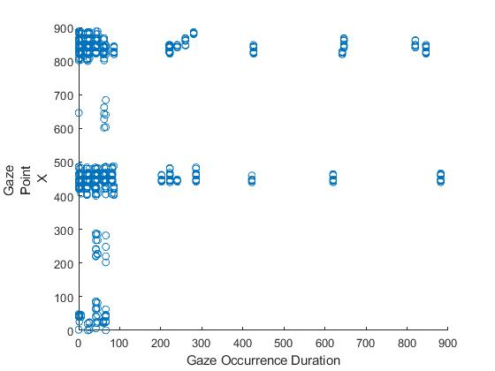

**Fig – 2**

**Scatter Plot Occurrence Duration and Gaze Point Y**

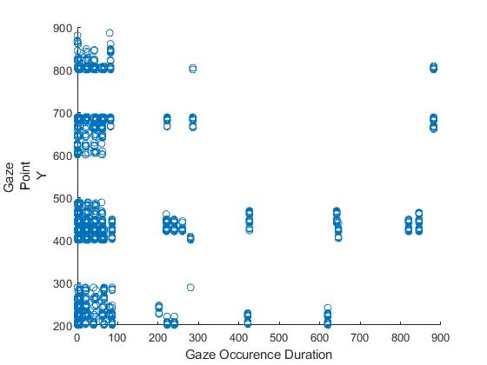

**Table – 6**

**ANOVA Test Between Distance Left And Distance Right**

|  |  |  |  |  |  |  |
| --- | --- | --- | --- | --- | --- | --- |
|  |  |  |  |  |  |  |
| **Summary** |  |  |  |  |  |  |
| *Groups* | *Count* | *Sum* | *Average* | *Variance* |  |  |
| Distance Left | 5596 | 3492817 | 624.1631 | 2.826316 | | |  |  |
| Distance Right | 5596 | 3492817 | 624.1631 | 2.826316 |  |  |
| **ANOVA** |  |  |  |  |  |  |
| *Source of Variation* | *SS* | *df* | *MS* | *F* | *P-value* | *F crit* |
| Between Groups | 2.86E-09 | 1 | 2.86E-09 | 1.01E-09 | 0.999975 | 3.84229 |
| Within Groups | 31626.47 | 11190 | 2.826316 |  |  |  |
|  |  |  |  |  |  |  |
| Total | 31626.47 | 11191 |  |  |  |  |

**∴** Distance between left and right , after calculating the distance between them

mean, SD minimum point and maximum point are calculated as:

|  |  |
| --- | --- |
| Mean | 624.2 |
| SD | 1.681015 |
| minimum | 0 |
| Maximum | 33.94113 |

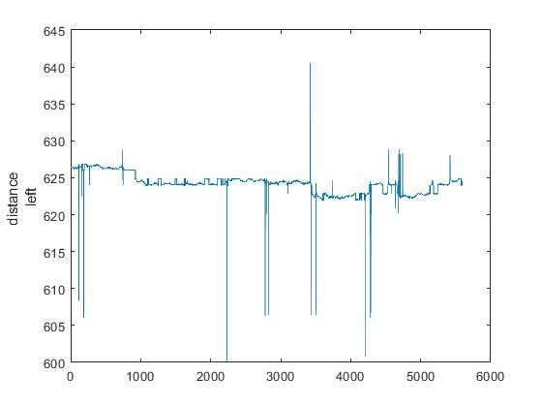

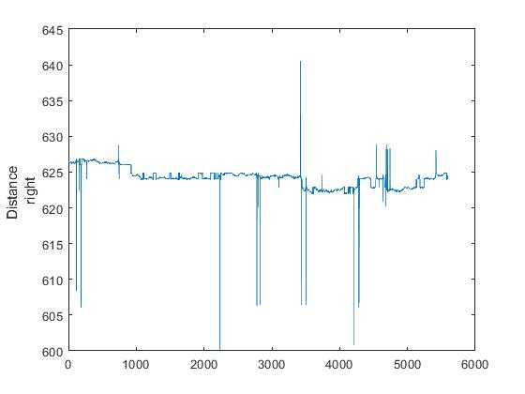

**Table - 7**

**Descriptive Statistics of Variables**

|  |  |  |  |  |  |  |
| --- | --- | --- | --- | --- | --- | --- |
| Sub | Variable | N | Minimum | Maximum | Mean | SD |
| 1 | Recording Time | 203 | 2 | 688 | 371.67 | 204.57 |
| Duration | 203 | 0 | 260 | 154.39 | 114.10 |
| Gaze Point X | 180 | 840 | 888 | 861.41 | 7.67 |
| Gaze Point Y | 180 | 402 | 804 | 456.12 | 77.03 |
| Distance Left | 173 | 608.44 | 626.88 | 626.24 | 1.50 |
| Distance Right | 180 | 0 | 626.88 | 601.89 | 121.42 |
| 2 | RecordingTime | 203 | 0 | 888 | 393.55 | 328.10 |
| Gaze Duration | 203 | 0 | 280 | 106.48 | 125.37 |
| Gaze Point X | 168 | 826 | 888 | 874.86 | 11.38 |
| Gaze Point Y | 168 | 266 | 684 | 410.46 | 55.26 |
| Distance Left | 167 | 606.08 | 626.88 | 626.10 | 3.13 |
| Distance Right | 168 | .00 | 626.88 | 622.37 | 48.40 |
| 3 | Recording Time | 203 | 400 | 2088 | 913.46 | 550.90 |
| Gaze Occurrence Duration | 203 | 22 | 280 | 62.49 | 62.42 |
| Gaze Point X | 203 | 0 | 886 | 618.69 | 378.80 |
| Gaze Point Y | 203 | 288 | 448 | 420.09 | 20.06 |
| Distance Left | 203 | 626.20 | 626.84 | 626.45 | .20 |
| Distance Right | 203 | 626.20 | 626.84 | 626.45 | .20 |
|  | RecordingTime | 609 | 0 | 2088 | 559.56 | 461.85 |
| Gaze Duration | 609 | 0 | 280 | 107.79 | 110.69 |
| Gaze Point X | 551 | 0 | 888 | 776.09 | 259.35 |
| Gaze Point Y | 551 | 266 | 804 | 428.93 | 58.15 |
| Distance Left | 543 | 606.08 | 626.88 | 626.27 | 1.93 |
| Distance Right | 551 | 0 | 626.88 | 617.18 | 75.01 |

As for the Gaze Occurrence Type, the distribution is as follows (Table).

**Table – 8**

**Subject Frequencies**

|  |  |  |  |  |  |  |
| --- | --- | --- | --- | --- | --- | --- |
| **Gaze Occurrence**  **Type** | **Subject 1** | | **Subject 2** | | **Subject 3** | |
| **Frequency** | **%** | **Frequency** | **%** | **Frequency** | **%** |
| Unclas | 44 | 21.7 | 73 | 36.0 | 0 | 0 |
| Saccade | 51 | 25.1 | 23 | 11.3 | 18 | 8.9 |
| Fixation | 108 | 53.2 | 107 | 52.7 | 185 | 91.1 |

The effect of Gaze Occurrence Type on Gaze Occurrence Duration, Gaze Point X and Gaze Point Y was then tested for each Subject. The most appropriate test would have been the One-Way ANOVA parametric test, but as the assumptions of normality and homogeneity of variances were not met, the Kruskal-Wallis non-parametric test was used for Subjects 1 and 2, and the Mann-Whitney non-parametric test for Subject 3.

**Table – 9**

**Effect of Gaze Occurrence Type on Duration**

|  |  |  |  |  |
| --- | --- | --- | --- | --- |
| Subject | Gaze Uccurrence  Type | Test Statistics | p | Mean Rank |
| 1 | Unclas | 179.65*** | < 0.001 | 53.97 |
| Saccade | 42.82 |
| Fixation | 149.50 |
| 2 | Unclas | 125.62*** | < 0.001 | 58.74 |
| Saccade | 44.09 |
| Fixation | 143.96 |
| 3 | Unclas | 7.91*** | < 0.001 | - |
| Saccade | 111.00 |
| Fixation | 9.5 |

Note. * p < 0.05; **p < 0.01; *** p < 0.001

In **Subject 1**, There were statistically significant differences in Gaze Occurrence Duration as function of Gaze Occurrence Type (H (2) = 179.65; p < 0.001; ηH = 0.88). Gaze Occurrence Type of Fixation group differed significantly from Gaze Occurrence Type of Unclas group (Z = 11.63; p < 0.001) and Occurrence Type of Saccade group (Z = 9.89; p < 0.001), showing significantly higher mean rank.

In **Subject 2,** there were statistically significant differences in Gaze Occurrence Duration as a function of Gaze Occurrence Type (H (2) = 125.62; p < 0.001; ηH = 0.62). Gaze Occurrence Type of Fixation group differed significantly from Gaze Occurrence Type of Unclas group (Z = 9.92; p < 0.001) and Occurrence Type of Saccade group (Z = 7.68; p < 0.001), showing significantly higher mean rank.

In **Subject 3**, there were statistically significant differences in Gaze Occurrence Duration as function of Gaze Occurrence Type (Z = 7.91; p < 0.001; r = 0.56). Gaze Occurrence Type of Fixation group differed significantly from the Gaze Occurrence Type of Saccade group, showing a significantly lower mean rank.

**Table – 10**

**Effect of Gaze Occurrence Type on Gaze Point X**

|  |  |  |  |  |
| --- | --- | --- | --- | --- |
| Subject | Gaze  Occurrence Type | Test Statistics | p | Mean Rank |
| 1 | Unclas | 5.67 | 0.059 | 79.29 |
| Saccade | 104.01 |
| Fixation | 86.88 |
| 2 | Unclas | 14.68*** | < 0.001 | 59.79 |
| Saccade | 79.87 |
| Fixation | 94.27 |
| 3 | Unclas | 0.58 | 0.561 | - |
| Saccade | 111.00 |
| Fixation | 9.5 |

Note. * p < 0.05; **p < 0.01; *** p < 0.001

In **Subject 1,** there were no statistically significant differences in Gaze Point X as function of Gaze Occurrence Type (H (2) = 5.67; p = 0.059; ηH = 0.02).

In **Subject 2,** there were statistically significant differences in Gaze Point X as function of Gaze Occurrence Type (H (2) = 14.68; p < 0.001; ηH = 0.08). Gaze Occurrence Type of Fixation group differed significantly from Gaze Occurrence Type of Unclas group (Z = 3.80; p < 0.001), showing significantly higher mean rank(Table).

In **Subject 3,** there were no statistically significant differences in Gaze Point X as function of Gaze Occurrence Type (Z = 0.58; p = 0.561; r = 0.06).

**Table – 11**

**Effect of Gaze Occurrence Type on Gaze Point Y**

|  |  |  |  |  |
| --- | --- | --- | --- | --- |
| Subject | Gaze Occurrence  Type | Test  Statistics | p | MeanRank |
| 1 | Unclas | 32.78*** | < 0.001 | 120.69 |
| Saccade | 116.21 |
| Fixation | 72.49 |
| 2 | Unclas | 9.41** | 0.009 | 105.09 |
| Saccade | 83.93 |
| Fixation | 77.31 |
| 3 | Unclas | 3.72*** | < 0.001 | - |
| Saccade | 53.08 |
| Fixation | 106.76 |

Note. **p < 0.01; *** p < 0.001

In **Subject 1**, there were statistically significant differences in Gaze Point Y as function of Gaze Occurrence Type (H (2) = 32.78; p < 0.001; ηH = 0.17). Gaze Occurrence Type of Fixation group differed significantly from Gaze Occurrence Type of Unclas group (Z = 3.90; p < 0.001) and Occurrence Type of Saccade group (Z = -4.97; p < 0.001), showing significantly lower mean rank.

In **Subject 2**, there were statistically significant differences in Gaze Point Y as function of Gaze Occurrence Type (H (2) = 9.41; p = 0.009; ηH = 0.04). Gaze Occurrence Type of Fixation group differed significantly from Gaze Occurrence Type of Unclas group (Z = -3.07; p = 0.006), showing significantly lower mean rank.

In **Subject 3**, there were statistically significant differences in Gaze Point Y as function of Gaze Occurrence Type (Z = 7.91; p < 0.001; r = 0.56). Gaze Occurrence Type of Fixation group differed significantly from Gaze Occurrence Type of Unclas group, showing significantly higher mean rank.

Next, for all the groups, we tested whether there were statistically significant differences between Gaze Point X and Gaze Point Y, using Student's t-tests for paired samples. Assumption of normality was not tested because samples consist of more than 03 participants, according to Central Limit Theorem, they tend towards normality.

**Table – 12**

**Differences between Gaze Point X and Y**

|  |  |  |  |  |  |  |
| --- | --- | --- | --- | --- | --- | --- |
| Subject | t | p | Gaze Point X | | Gaze Point Y | |
| Mean | SD | Mean | SD |
| 1 | 69.85*** | < 0.001 | 861.41 | 7.67 | 456.12 | 77.03 |
| 2 | 96.54*** | < 0.001 | 874.86 | 11.38 | 410.46 | 55.26 |
| 3 | 7.67*** | < 0.001 | 618.69 | 378.80 | 420.09 | 20.06 |

Note. *** p < 0.001

Statistically significant differences were found between Gaze Point X and Gaze Point Y in :-

Subject 1 (t (180) = 69.85; p < 0.001; d = 5.21),

Subject 2 (t (168) = 96.54; p < 0.001; d = 7.45)

Subject 3 (t (203) = 7.67; p < 0.001; d = 0.54), with Gaze Point X always showing a higher mean than Gaze Point Y

Pearson's correlations were used to test the association between the variables under study.

**Table – 13**

**Association Between Variables Under Study /** (**Subject 1**)

|  |  |  |  |  |  |  |  |  |
| --- | --- | --- | --- | --- | --- | --- | --- | --- |
|  | |  |  |  |  |  |  |  |
| 1. RecordingTime |  | -- |  |  |  |  |  | |  |
| 1. Gaze OccurrenceType |  | -0.61*** | -- |  |  |  |  | |  |
| 1. Gaze OccurrenceDuration |  | -0.78*** | 0.89*** | -- |  |  |  | |  |
| 1. Gaze PointX |  | 0.34*** | 0.02 | -0.05 | -- |  |  | |  |
| 1. Gaze PointY |  | 0.36*** | -0.49*** | -0.49*** | -0.06 | -- |  | |  |
| 1. Distance Left |  | -0.01 | 0.17* | 0.09 | 0.24** | -0.43*** | -- | |  |
| 1. Distance Right |  | -0.18* | 0.35*** | 0.27*** | -0.13 | -0.51*** | 1.00*** | | -- |
|  |  |  |  |  |  |  |  | |  |

Note. * p < 0.05; **p < 0.01; *** p < 0.001

The results indicate that Recording Time is negatively and significantly associated with Gaze Occurrence Type (r = - 0.61; p < 0.001), Gaze Occurrence Duration (r = -0.78; p < 0.001) and Distance Right (r = -0.18; p = 0.017). It was positively and significantly associated with Gaze Point X (r = 0.34; p < 0.001) and Gaze Point Y (r = 0.36; p < 0.001). Gaze Occurrence Type was positively and significantly associated with Gaze Occurrence Duration (r = 0.86; p < 0.001), Distance Left (r = 0.17; p = 0.022) and Distance Right (r = 0.35; p < 0.001). It was negatively and significantly associated with Gaze Point Y (r = -0.47; p < 0.001). Gaze Occurrence Duration is negatively and significantly associated with Gaze Point Y (r = -0.49; p < 0.001) and positively and significantly associated with Distance Right (r = 0.27; p < 0.001). Gaze Point X is positively and significantly associated with Distance Left (r = 0.24; p = 0.002).Gaze Point Y is negatively and significantly associated with Distance Leftt (r = -0.43; p < 0.001) and Distance Right (r = -0.51; p < 0.001).

**Table – 14**

**Association between Variables / (Subject 2)**

|  |  |  |  |  |  |  |  |  |
| --- | --- | --- | --- | --- | --- | --- | --- | --- |
|  |  |  | |  |  | 5 | 6 |  |
| Recording Time |  | -- |  |  |  |  | |  | |  |
| Gaze Occurrence Type |  | -0.41*** | -- |  |  |  | |  | |  |
| Gaze Occurrence Duration |  | -0.29*** | 0.66*** | -- |  |  | |  | |  |
| Gaze Point X |  | -0.22** | 0.32*** | 0.58*** | -- |  | |  | |  |
| Gaze Point Y |  | 0.18* | -0.27*** | -0.19* | -0.56*** | -- | |  | |  |
| Distance Left |  | -0.33*** | 0.25*** | 0.16* | 0.67*** | -0.55*** | | -- | |  |
| Distance Right |  | -0.16* | 0.15 | 0.09 | 0.28*** | -0.39*** | | 1.00*** | | -- |

Note. * p < 0.05; **p < 0.01; *** p < 0.001

The results indicate that Recording Time is negatively and significantly associated with Gaze Occurrence Type (r = -0.41; p < 0.001), Gaze Occurrence Duration (r = -0.29; p < 0.001), Gaze Poin X (r = -0.22; p = 0.004), Gaze Distance Left (r = -0.33; p < 0.001) and Distance Right (r = -0.16; p = 0.040). It was positively and significantly associated with Gaze Point Y (r = 0.18; p = 0.023). Gaze Occurrence Type was positively and significantly associated with Gaze Occurrence Duration (r = 0.66; p < 0.001), Gaze Point X (r = 0.32; p < 0.001) and Distance Left (r = 0.25; p < 0.001). It was negatively and significantly associated with Gaze Point Y (r = -0.27; p < 0.001).

Gaze Occurrence Duration is negatively and significantly associated with Gaze Point Y (r = -0.19; p = 0.016).It was positively and significantly associated with Gaze Point X (r = 0.58; p < 0.001) and Distance Right (r = 0.16; p = 0.035). Gaze Point X is positively and significantly associated with Distance Left (r = 0.67; p < 0.001)and Distance Right (r = 0.28; p < 0.001).It was negatively and significantly associated with Gaze Point Y (r = -0.56; p < 0.001). Gaze Point Y is negatively and significantly associated with Distance Left (r = -0.55; p < 0.001) and Distance Right (r = -0.39; p < 0.001).

**Table – 15**

**Association Between Variables / (Subject 3)**

|  |  |  |  |  |  |  |  |
| --- | --- | --- | --- | --- | --- | --- | --- |
|  | 1 |  |  |  |  |  |  |
| Recording Time |  | -- |  |  |  |  |  |  |
| Gaze OccurrenceType |  | .023* ** | -- |  |  |  |  |  |
| Gaze Occurrence Duration |  | -0.26*** | 0.19** | -- |  |  |  |  |
| Gaze Point X |  | 0.41*** | 0.07 | 0.09 | -- |  |  |  |
| Gaze Point Y |  | 0.65*** | 0.24*** | -0.37*** | 0.51*** | -- |  |  |
| Distance Left |  | -0.59*** | -0.27*** | 0.31*** | -0.74*** | -0.78*** | -- |  |
| Distance Right |  | -0.59*** | -0.27*** | 0.31*** | -0.74*** | -0.78*** | 1.00*** | -- |

Note. * p < 0.05; **p < 0.01; *** p < 0.001

The results indicate that Recording Time is negatively and significantly associated with Gaze Occurrence Duration (r = -0.26; p < 0.001), Distance Left (r = -0.59; p < 0.001) and Distance Right (r = -0.59; p < 0.001). It was positively and significantly associated with Gaze Occurrence Type(r = 0.23; p < 0.001), Gaze Point X (r = 0.41; p < 0.001)and Gaze Point Y (r = 0.65; p < 0.001). Gaze Occurrence Type was positively and significantly associated with Gaze Occurrence Duration (r = 0.19; p = 0.006) andGaze Point Y(r = 0.24; p < 0.001).It was negatively and significantly associated with Distance Left (r = -0.27; p < 0.001) and Distance Right (r = -0.27; p < 0.001). Gaze Occurrence Duration is negatively and significantly associated with Gaze Point Y (r = -0.37; p < 0.001).It was positively and significantly associated with Distance Left(r = 0.31; p < 0.001) and Distance Right (r = 0.31; p < 0.001). Gaze Point X is negatively and significantly associated with Distance Left (r = -0.74; p < 0.001) and Distance Right (r = -0.74; p < 0.001).It was positively and significantly associated with Gaze Point Y (r = 0.51; p < 0.001). Gaze Point Y is negatively and significantly associated with Distance Left (r = -0.78; p < 0.001) and Distance Right (r = -0.78; p < 0.001). The next step was to test whether there were statistically significant differences in the variables under study according to the Subject. To this end, several non-parametric Kruskal-Wallis tests were carried out since the assumptions for the parametric ANOVA One Way test were not verified.

**Table – 16**

**Effect Of Subject On Variables**

|  |  |  |  |  |
| --- | --- | --- | --- | --- |
| **Dependent Variable** | **Subject** | **H** | **p** | **Mean Rank** |
| Recording  Time | 1 | 176.63 | < 0.001 | 230.69 |
| 2 | 245.59 |
| 3 | 438.72 |
| Fixation Index | 1 | 373.88 | < 0.001 | 54.50 |
| 2 | 169.50 |
| 3 | 303.66 |
| Gaze Occurrence  Duration | 1 | 26.47 | < 0.001 | 355.74 |
| 2 | 272.61 |
| 3 | 286.65 |
| Gaze Point X | 1 | 217.60 | < 0.001 | 260.48 |
| 2 | 416.35 |
| 3 | 173.61 |
| Gaze Point Y | 1 | 143.73 | < 0.001 | 375.21 |
| 2 | 171.00 |
| 3 | 274.93 |
| Distance  Left | 1 | 76.46 | < 0.001 | 221.30 |
| 2 | 359.08 |
| 3 | 243.57 |
| Distance  Right | 1 | 79.30 | < 0.001 | 220.56 |
| 2 | 364.92 |
| 3 | 251.57 |

Note. *** p < 0.001

There are statistically significant differences in Recording Time according to Subject (H (2) = 176.63; p < 0.001; ηH = 0.29). Recording Time is significantly higher in Subject 3 than in Subject 1 (Z = -11.91; p < 0.001) and Subject 2(Z = -11.06; p < 0.001). There are statistically significant differences in Fixation Index according to Subject (H (2) = 378.88; p < 0.001; ηH = 0.99). Fixation Index is significantly higher in Subject 3 than in Subject 1 (Z = -19.02; p < 0.001) and Subject 2 (Z = -10.21; p < 0.001).There are statistically significant differences in Gaze Occurrence Duration according to Subject (H (2) = 26.47; p < 0.001; ηH = 0.04). Gaze Occurrence Duration is significantly higher in Subject 1 than in Subject 2(Z = 4.81; p < 0.001) and Subject 3 (Z = 3.99; p < 0.001).There are statistically significant differences in Gaze Point X according to Subject (H (2) = 217.60; p < 0.001; ηH = 0.39). Gaze Point X is significantly higher in Subject 2 than in Subject 1 (Z = 9.16; p < 0.001) and Subject 3 (Z = 14.66; p < 0.001). Gaze Point X was also significantly higher in Subject 1 compared to Subject 3 (Z = 5.35; p < 0.001).There are statistically significant differences in Gaze Point Y according to Subject (H (2) = 143.73; p < 0.001; ηH = 0.26). Gaze Point Y is significantly higher in Subject 1 than in Subject 2(Z = 11.99; p < 0.001) and Subject 3 (Z = 6.17; p < 0.001). Gaze Point Y was also significantly higher in Subject 3 compared to Subject 2 (Z = 6.28; p < 0.001).There are statistically significant differences in Distance Left according to Subject (H (2) = 76.46; p < 0.001; ηH = 0.14). Distance Left is significantly higher in Subject 2 than in Subject 1(Z = 8.11; p < 0.001) and Subject 3 (Z = 7.06; p < 0.001). There are statistically significant differences in Distance Right according to Subject (H (2) = 76.30; p < 0.001; ηH = 0.17). Distance Right is significantly higher in Subject 2 than in Subject 1(Z = 8.47; p < 0.001) and Subject 3 (Z = 6.38; p < 0.001).

Using chi-square test, we also tested whether Subject and Gaze Occurrence Type were independent. The results show that these two variables are not independent (ꭓ2 (4) = 119.95; p < 0.001; V = 0.31). The results are shown in the table.

**Table – 17**

**Subject * Gaze Occurrence Type Cross Tabulation**

|  |  |  |  |  |  |  |
| --- | --- | --- | --- | --- | --- | --- |
|  | | | Gaze Occurrence Type | | | Total |
| Unclas | Saccade | Fixation |
| Sub | 1 | Count | 44 | 51 | 108 | 203 |
| Expected Count | 39.0 | 30.7 | 133.3 | 203.0 |
| % within Gaze  Occurrence Type | 37.6% | 55.4% | 27.0% | 33.3% |
| Adjusted Residual | 1.1 | 4.9 | -4.6 |  |
| 2 | Count | 73 | 23 | 107 | 203 |
| Expected Count | 39.0 | 30.7 | 133.3 | 203.0 |
| % within Gaze  Occurrence Type | 62.4% | 25.0% | 26.8% | 33.3% |
| Adjusted Residual | 7.4 | -1.8 | -4.8 |  |
| 3 | Count | 0 | 18 | 185 | 203 |
| Expected Count | 39.0 | 30.7 | 133.3 | 203.0 |
| % within GazeOccurrenceType | 0.0% | 19.6% | 46.3% | 33.3% |
| Adjusted Residual | -8.5 | -3.0 | 9.4 |  |
| Total | | Count | 117 | 92 | 400 | 609 |
| Expected Count | 117.0 | 92.0 | 400.0 | 609.0 |
| % within Gaze Occurrence  Type | 100.0% | 100.0% | 100.0% | 100.0% |

Finally, the association between the variables under study was tested using Pearson's correlations.

**Table – 18**

**Association Between Variables**

|  |  |  |  |  |  |  |  |  |
| --- | --- | --- | --- | --- | --- | --- | --- | --- |
|  | 1 |  | |  |  |  |  |  |
| Recording Time |  | -- |  |  |  |  |  | |  |
| Gaze Occurrence Type |  | 0.04 | -- |  |  |  |  | |  |
| Gaze Occurrence Duration |  | 0-.41*** | 0.51*** | -- |  |  |  | |  |
| Gaze Point X |  | -0.02 | -0.13** | 0.20*** | -- |  |  | |  |
| Gaze Point Y |  | 0.14*** | -0.33*** | -0.22*** | 0.14** | -- |  | |  |
| Distance Left |  | -0.08 | 0.22*** | 0.10* | -0.06 | -0.42*** | -- | |  |
| Distance Right |  | -0.01 | 0.25*** | 0.12** | -0.04 | -0.48*** | 1.00*** | | -- |

Note. * p < 0.05; **p < 0.01; *** p < 0.001

The results indicate that Recording Time is negatively and significantly associated with Gaze Occurrence Duration (r = -0.41; p < 0.001). It was positively and significantly associated with Gaze Point Y (r = 0.15; p < 0.001). Gaze Occurrence Type was positively and significantly associated with Gaze Occurrence Duration (r = 0.51; p < 0.001), Distance Left (r = 0.22; p < 0.001) and Distance Right (r = 0.25; p < 0.001). It was negatively and significantly associated with Gaze Point X(r = -0.13; p < 0.001) and Gaze Point Y (r = -0.33; p < 0.001). Gaze Occurrence Duration is positively and significantly associated with Gaze Point Y (r = 0.20; p < 0.001), Distance Left (r = 0.10; p = 0.022) and Distance Right (r = 0.12; p = 0.002).It was negatively and significantly associated with Gaze Point Y (r = 0.22; p < 0.001). Gaze Point X is positively and significantly associated with Gaze Point Y (r = 0.14; p < 0.001).Gaze Point Y is negatively and significantly associated with Distance Left (r = -0.42; p < 0.001) and Distance Right (r = -0.48; p < 0.001).

The results show that Time Rel positively and significantly correlates with GTY (r = 0.81; p < 0.01), with YAW GT (r = 0.03; p < 0.05), and with PITCH GT (r = 0.25; p < 0.01). In turn, it is negatively and significantly correlated with the YR AW (r = -0.16; p < 0.01), with the GT Ym m (r = -0.21; p < 0.01), with the Ymm (r = -0.14; p < 0. 01), with PITCH DATA (r = -0.06; p < 0.01), with Gaze GT (r = -0.09; p < 0.01) with AOI_IND (r = -0.09; p < 0.01), with AO I_X (r = -0.08; p < 0.01) and with AO I_Y (r = -0.08; p < 0.01). GTX positively and significantly correlates with GTY (r = 0.26; p < 0.01). It is negatively and significantly correlated with XRAW (r = -0.33; p < 0.01), with XRAW (r = -0.31; p < 0.01), with GT Ym m (r = -0. 37; p < 0.01), with the Xmm (r = -0.21; p < 0.01), with the Ymm (r = -0.31; p < 0.01); with the YAW GT (r = -0.45; p < 0.01), with the YAW DATA (r = -0.17; p < 0. 01), with the PITCH GT (r = -0.26; p < 0.01), with the PITCH DATA (r = -0.21; p < 0.01), with the GAZE GT (r = -0.42; p < 0.01), with the GAZE ANG (r = -0.40; p < 0. 01), with DIFF GZ (r = -0.04; p < 0.05), with AOI_IND (r = -0.11; p < 0.01), with AO I_X (r = -0.09; p < 0.01) and with AO I_Y (r = -0.10; p < 0.01).

GTY is negatively and significantly correlated with XRAW (r = -0.28; p < 0.01), with XRAW (r = -0.33; p < 0.01), with GTXm m (r = -0.13; p < 0. 01), with GT Ym m (r = -0.37; p < 0.01), with Xmm (r = -0.19; p < 0.01), with Ymm (r = -0.34; p < 0.01); with YAW GT (r = -0.24; p < 0.01), with YAW DATA (r = -0. 19; p < 0.01), with the PITCH GT (r = -0.49; p < 0.01), PITCH DATA (r = -0.20; p < 0.01), with the GAZE GT (r = -0.44; p < 0.01), with the GAZE ANG (r = -0.37; p < 0. 01), with the DIFF GZ (r = -0.06; p < 0.01), with the AOI_IND (r = -0.12; p < 0.01), with the AO I_X (r = -0.11; p < 0.01) and with the AO I_Y (r = -0.11; p < 0.01). XR AW is positively and significantly correlated with the XRAW (r = 0.32; p < 0.01), the GTXm m (r = 0.37; p < 0.01), the GT Ym m (r = 0.38; p < 0.01), the Xmm (r = 0.39; p < 0. 01), with Ymm (r = 0.30; p < 0.01), with PITCH GT (r = 0.22; p < 0.01), PITCH DATA (r = 0.21; p < 0.01), with GAZE GT (r = 0.27; p < 0.01), with GAZE ANG (r = 0.38; p < 0.01), with DIFF GZ (r = 0.06; p < 0.01). It is negatively and significantly correlated with YAW GT (r = -0.17; p < 0.01), AOI_IND (r = -0.10; p < 0.01), AO I_X (r = -0.09; p < 0.01) and AO I_Y (r = -0.10; p < 0.01).

The XR AW is positively and significantly correlated with the GTXm m (r = 0.16; p < 0.01), the GT Ym m (r = 0.73; p < 0.01), the Xmm (r = 0.19; p < 0.01), the Ymm (r = 0. 63; p < 0.01); with YAW GT (r = 0.18; p < 0.01), with YAW DATA (r = 0.09; p < 0.01), PITCH DATA (r = 0.28; p < 0.01), with GAZE GT (r = 0.50; p < 0.01), with GAZE ANG (r = 0.38; p < 0.01). It is negatively and significantly correlated with PITCH GT (r = -0.49; p < 0.01), with AOI_IND (r = -0.11; p < 0.01), and with AO I_Y (r = -0.11; p < 0.01). GTXm m is positively and significantly correlated with GT Ym m (r = 0.20; p < 0.01), with Xmm (r = 0.68; p < 0.01), with Ymm (r = 0.14; p < 0.01), with PITCH GT (r = 0. 09; p < 0.01), with PITCH DATA (r = 0.14; p < 0.01), with GAZE GT (r = 0.11; p < 0.01), with GAZE ANG (r = 0.19; p < 0.01), with DIFF GZ (r = 0.03; p < 0.05). It is negatively and significantly correlated with the YAW GT (r = -0.24; p < 0.01), with the YAW DATA (r = -0.04; p < 0.05), with the YAW GT (r = -0.24; p < 0.01) and with the YAW DATA (r = -0.04; p < 0.05).

Xmm m is positively and significantly correlated with Ymm (r = 0.67; p < 0.01), with PITCH GT (r = 0.15; p < 0.01), with PITCH DATA (r = 0.17; p < 0.01), with GAZE GT (r = 0.19; p < 0.01), with GAZE ANG (r = 0.25; p < 0.01), with DIFF GZ (r = 0.04; p < 0.05). It is negatively and significantly correlated with the YAW GT (r = -0.12; p < 0.01), with the AOI_IND (r = -0.07; p < 0.01), with the AO I_X (r = -0.06; p < 0.01) and with the AO I_Y (r = -0.06; p < 0.01). Ymm m is positively and significantly correlated with YAW GT (r = 0.22; p < 0.01), with YAW DATA (r = 0.10; p < 0.01), with PITCH DATA (r = 0.27; p < 0.01), with GAZE GT (r = 0.49; p < 0.01), with GAZE ANG (r = 0.38; p < 0.01), with DIFF GZ (r = 0.06; p < 0.01). It negatively and significantly correlates with PITCH GT (r = -0.06; p < 0.01).

YAW GT is positively and significantly correlated with YAW DATA (r = 0.28; p < 0.01), with PITCH GT (r = 0.27; p < 0. 01), with PITCH DATA (r = 0.14; p < 0.01), with GAZE GT (r = 0.70; p < 0.01), with GAZE ANG (r = 0.34; p < 0.01), with DIFF GZ (r = 0.09; p < 0.01). YAW DATA is positively and significantly correlated with PITCH GT (r = 0.24; p < 0.01), with PITCH DATA (r = 0.07; p < 0.01), with GAZE GT (r = 0.26; p < 0.01), with GAZE ANG (r = 0.18; p < 0.01).

PITCH GT is positively and significantly correlated with GAZE GT (r = 0.23; p < 0.01), with GAZE ANG (r = 0.34; p < 0.01), with DIFF GZ (r = 0.18; p < 0.01). PITCH DATA is positively and significantly correlated with GAZE GT (r = 0.37; p < 0.01) with GAZE ANG (r = 0.27; p < 0.01).GAZE GT is positively and significantly correlated with GAZE ANG (r = 0.58; p < 0.01), with DIFF GZ (r = 0.06; p < 0.01).GAZE ANG positively and significantly correlates with DIFF GZ (r = 0.05; p < 0.01). AOI_IND is positively and significantly correlated with AO I_X (r = 0.64; p < 0.01) and AO I_Y (r = 0.92; p < 0.01). Finally, AO I_X is positively and significantly correlated with AO I_Y (r = 0.63; p < 0.01).

The lesson of complicated preferred Brunswik - oriented neurointegral decision making and predicament solving has attracted concentration (Brunswik; 1957 and Belton and Dhami; 2021 and Bruce and Friedman; 2002). Long-drawn-out researches necessitate (model - oriented experiential) study of behavior and offer locale for basic research on how ill-structured predicament are, and can be, solved (Brunswik; 1957 and Belton and Dhami; 2021 and Bruce and Friedman; 2002). Clinician neuro - complicated preferred Brunswik - oriented neurointegral decision making can be premeditated with great yield using time-honored method of inquisition, especially all the way through concentrated studies (Brunswik; 1957 and Belton and Dhami; 2021 and Bruce and Friedman; 2002). Neuro - neurointegral management propose elucidation all the way through succession of proportions of eye motion at point of obscure preferred Brunswik - oriented neurointegral decision (Brunswik; 1957 and Belton and Dhami; 2021 and Bruce and Friedman; 2002). It affords conceptual and idealistic framework for perceptive and conducting research at Neurointegral Science, Management and Psychology gamut (Brunswik; 1957 and Belton and Dhami; 2021 and Bruce and Friedman; 2002).

# In the realm of higher cognitive perspective(s), cognition, which encompasses a wide spectrum of mental processes such as perception, memory, language, problem solving, and decision-making, constitutes a pivotal element. For academic researchers, cognition entails the examination of how students within higher learning institutions perceive, process, and employs information in the pursuit of their academic endeavours. Understanding the intricate dynamics of students' information perception, processing, and utilization necessitates a comprehensive exploration of cognitive components, including perceptual processing, attentional focus, memory formation, cognitive strategies, metacognition, information integration, motivation, technology usage, and individual differences. To investigate these facets of cognition in higher cognitive perspective(s), researchers commonly employ a combination of research methods, ranging from surveys and experiments to interviews, observations, and cognitive assessments. This multifaceted approach facilitates the collection of both quantitative and qualitative data, further enhanced by specialized techniques like eye tracking and neuroimaging to gain insights into how students perceive, process, and retain information and how they allocate their attention during learning tasks.

The significance of understanding cognition extends to various advantages it offers for educators, institutions, and students alike. These advantages encompass the refinement of teaching strategies, provision of personalized learning experiences, enhancement of curriculum design, optimization of resource allocation, early identification of at-risk students, cultivation of effective study skills, reduction of stress and anxiety barriers to learning, development of fair and effective assessment methods, formulation of research-based policies, continuous improvement of cognitive perspective(s)al practices, creation of positive learning environment, and elevation of global competitiveness in job market. Moreover, subfields focusing on attention allocation, metacognitive strategies, and comprehensive cognitive process research provide nuanced insights into effective teaching and learning practices that stand to benefit both students and cognitive perspective(s) of institutions.

Exploring allocation of student attention and their information processing is another critical research area within the broader context of understanding cognitive processes in higher cognitive perspective(s). To grasp comprehensively this domain, researchers employ diverse range of research methods, encompassing surveys, observational studies, and neuroimaging techniques. These methods allow for examination of students' attention allocation patterns during lectures and study sessions, shedding light on strategies, distractions, and neurobiological underpinnings of attention. Furthermore, analyzing factors influencing attention allocation, including individual differences, motivation levels, and cognitive strategies, offers a nuanced understanding of this cognitive facet. The development and testing of interventions, such as mindfulness techniques and digital detox programs, aim to enhance students' attentional allocation, both during lectures and self-guided study sessions. Longitudinal studies, tracking changes in attentional behaviors as student’s progress through academic programs, provide valuable insights into the development of attentional skills. Ethical considerations, especially when employing neuroimaging or collecting sensitive data on students' behaviours and attention, are integral to research process. Additionally, by discussing research implications and recommendations, this research contributes to the improvement of teaching methods and study environments, ultimately enhancing attention allocation and information processing in cognitive perspective(s).

Metacognitive strategies in higher cognitive perspective(s) present yet another compelling avenue of research. The primary objectives encompass identifying and comprehending the metacognitive strategies employed by successful students, designing, and evaluating instructional interventions to impart these strategies and bolster learning outcomes. Achieving these objectives necessitates the recruitment of a diverse sample of high-achieving students, employing a combination of qualitative and quantitative data collection methods, including interviews, surveys, and think-aloud protocols. These methods help identify metacognitive strategies such as goal setting, monitoring, self-regulation, time management, and adaptation based on feedback. Quantitative assessments, employing validated scales and questionnaires, gauge the level of metacognitive awareness among successful students. The development and implementation of targeted metacognition training interventions, coupled with controlled experiments to evaluate their effectiveness, constitute essential components of this research. Moreover, data analysis and reflection contribute to refining the training programs. By discussing implications and recommendations, this research aims to assist educators and institutions in incorporating metacognitive training into higher cognitive perspective(s) curricula, thereby facilitating improved learning outcomes while adhering to ethical considerations throughout all stages of the research process.

Finally, conducting comprehensive cognitive process research in higher cognitive perspective(s) necessitates the consideration of various key elements. These encompass defining research objectives, questions, and hypotheses clearly, establishing participant selection criteria, adhering to ethical standards, selecting appropriate research methods and designs, determining suitable sampling strategies, developing or selecting relevant data collection instruments, defining and operationalizing cognitive processes and variables of interest, outlining data collection procedures, formulating a robust data analysis plan, identifying and addressing potential confounding variables, considering the research environment's impact, ensuring data validity and reliability, deciding between longitudinal and cross-sectional studies, incorporating a mixed methods approach, implementing secure data management practices, upholding ethical standards in participant interactions, interpreting findings within existing literature and theories, assessing generalizability, discussing practical implications for educators, institutions, and policymakers, and planning for research dissemination through academic journals and conferences. By meticulously considering these key elements, researchers can design rigorous studies that contribute to a deeper understanding of cognitive processes in higher cognitive perspective(s).

Top of Form

Neuro - neurointegral offers;

* Explanation in course of set of data obtained via progression of measurements of eye motion at time of complicated preferred Brunswik - oriented neurointegral decisions (Satpathy, Larsen, Lockhart and Misra ;2023),
* Provides abstract and idealistic scaffold for discerning and conducting neuro - neurointegral research at junction of Neuroscience, Neurointegral and Psychology (Satpathy, Larsen, Lockhart and Misra ;2023),
* Describes customary replica for preferred Brunswik - oriented neurointegral decision process that links and spans Neurobiological, Psychological, and Neurointegral levels of analysis (Satpathy, Larsen, Lockhart and Misra ;2023),
* Applies neuroscience to neurointegral and neo-classical neurointegral, and ties to biological constraints in how we adjudicate preferred Brunswik - oriented neurointegral decisions (Satpathy, Larsen, Lockhart and Misra ;2023),
* An important resource from neurointegral to neuroscience, to progress of inter-disciplinary research (Satpathy, Larsen, Lockhart and Misra ;2023),
* Seen as sub turf of experimental neurointegral, where neuro data is enriched with eye data (Satpathy, Larsen, Lockhart and Misra ;2023),
* proposes to construct eye-oriented models capable of predicting observed behaviour (Satpathy, Larsen, Lockhart and Misra ;2023),
* Shed light on causes of behaviour (and of neuro anomalies) and capable of explaining and predicting complicated preferred Brunswik - oriented neurointegral decisions (Satpathy, Larsen, Lockhart and Misra ;2023),
* Provides information about underlying mechanisms used by the eye for period of preferred Brunswik - oriented neurointegral decision processes, In particular, it shows which eye regions are activated when a complicated preferred Brunswik - oriented neurointegral decision is made and how these regions interact with each other, This knowledge can be used to build a model that represents this particular mechanism (Satpathy, Larsen, Lockhart and Misra ;2023),
* Combining above gives interdisciplinary insight to define fundamentals of neuro - neurointegral complicated preferred Brunswik - oriented neurointegral decision making that has eluded researchers working within each individual turf (Satpathy, Larsen, Lockhart and Misra ;2023 and Kowler; 2011).

Paper reflects relevant findings on typical HP-DM behaviour (Satpathy, Larsen, Lockhart and Misra; 2023 and Kowler; 2011). Results suggest that cognito apparatuses explore ‘business preferred Brunswik - oriented neurointegral decision tectonic shifts(s)’ thinking through biological basis in anthropoid prototyping of economic preferred Brunswik - oriented neurointegral decision making signature(s) (Satpathy, Larsen, Lockhart and Misra; 2023 and Kowler; 2011). With reference to neuro - probabilistic functionalism in Brunswik’s Lens Preferred Brunswik - oriented neurointegral decisions framework, paper reflects relevant findings on typical anthropoid behaviour (Satpathy, Larsen, Lockhart and Misra; 2023 and Kowler; 2011). Study calls into question theories localizable to a specific neural system (Kowler; 2011). Study exhibits key findings, from both the scientific and practitioner perspectives, and explain how neuro apparatuses explore ‘business preferred Brunswik - oriented neurointegral decision tectonic shifts(s)’ (Satpathy, Larsen, Lockhart and Misra; 2023 and Kowler; 2011).

**Recommendations**

Analyzing qualitative data from interviews and think-aloud protocols helps identify metacognitive strategies like goal setting, monitoring, self-regulation, time management, and adaptation based on feedback. Utilizing quantitative data, such as validated scales and questionnaires, assesses the level of metacognitive awareness among successful subjects. Designing targeted interventions and training programs based on identified metacognitive strategies is crucial for teaching these skills effectively. Conducting controlled experiments to test effectiveness of metacognition training and ensuring active engagement with materials is essential. Analysing data from both intervention and control groups helps assess impact of metacognition training on learning outcomes and academic performance. Evaluating impact of metacognition training and reflecting on its challenges and successes aid in refining training program. Discussing implications of findings for educators and institutions and providing recommendations for incorporating metacognitive training into higher education curricula supports improved learning outcomes. Establishing participant selection criteria based on academic programs, demographic backgrounds, or other relevant factors guides study's focus. Selecting suitable sampling strategy and ensuring an adequate sample size is essential for robust findings. Developing secure data management plan ensures data integrity.

Active Learning Strategies: Encourage active learning techniques such as discussions and problem-solving.

Breaks and Intermissions: Incorporate short breaks during longer lectures.

Digital Device Policies: Establish clear policies regarding digital device use.

Structured Note-Taking: Teach effective note-taking strategies.

Engaging Visual Aids: Use visually appealing visuals to supplement lectures.

Clear Organization: Structure lectures with a clear outline.

Engaging Delivery: Use varied delivery methods and enthusiasm.

Active Participation: Encourage subject participation.

Real-World Applications: Relate content to real-world examples.

Multimodal Resources: Incorporate multimedia resources.

Assessment and Feedback: Use formative assessments and provide feedback during lectures.

Mindfulness Practices: Teach mindfulness techniques.

Regular Self-Reflection: Encourage subjects to reflect on their attentional habits.

Provide Lecture Outlines: Distribute lecture outlines in advance.

Encourage Movement: Allow opportunities for brief movement breaks.

Effective Teaching Strategies: Adapt teaching methods to capture and maintain subjects' attention.

Classroom Management: Manage classroom dynamics by recognizing signs of inattention.

Digital Learning Design: Optimize online courses for sustained attention.

Individualized Learning: Tailor instruction to individual attentional needs.

Attentional Support Services: Offer support for attention difficulties.

Feedback and Assessment: Assess attention to encourage engagement.

Pedagogical Innovation: Experiment with new teaching approaches.

Interventions for Attention Difficulties: Provide specialized support for subjects with attention challenges.

Neuroeducation: Design brain / eye(s)-friendly classrooms and teaching methods.

Mindfulness Practices: Teach attention-enhancing techniques.

Teacher Professional Development: Train educators in attention-capturing strategies.

Parental Involvement: Educate parents on supporting their children's attention.

Time Management Skills: Incorporate time management into the curriculum.

Enhanced Learning Environments: Design classrooms with attention in mind.

Development of Study Skills: Offer study skills workshops.

**Conclusion**

Paper raises interesting theoretical and practical levels of analysis significant in business strategy (Kowler; 2011). Research efforts conclude with characteristic schemes and presents directions for future research (Kowler; 2011). Paper concludes with number of propositions that have been generated from theoretical ‘mosaic’ and presents directions for future research (Satpathy, Larsen, Lockhart and Misra; 2023 and Kowler; 2011).

What are the apparatuses that keep gaze stable with either stationary or moving targets? How does motion of cognitive image on retina affect vision? Where do look - and why - when performing complicated task? How can world appear clear and stable despite continual movements of eyes? Cognitive processes driving eye movements for the period of complicated Brunswik - oriented neurointegral decision making are not in any consequential way different from those in similar tasks (Kowler; 2011 and Satpathy, Majumdar, Mallik, Mahapatra, Warrier, Khatun and Okeyo; 2023). Eye movements in complicated preferred Brunswik - oriented neurointegral decision making are partially driven by (complicated) task demands (Kowler; 2011 and Satpathy, Majumdar, Mallik, Mahapatra, Warrier, Khatun and Okeyo; 2023). Eye movements in complicated Brunswik - oriented neurointegral decision making are partially driven by stimulus properties that bias information uptake in favor of visually salient stimuli (Kowler; 2011 and Satpathy, Majumdar, Mallik, Mahapatra, Warrier, Khatun and Okeyo; 2023). Eye movements do not have causal effect on Brunswik - oriented neurointegral decision formation (Kowler; 2011 and Satpathy, Majumdar, Mallik, Mahapatra, Warrier, Khatun and Okeyo; 2023). However, through properties inherent to visual system, such as stimulus-driven concentration, eye movements do lead to down-stream effects on complicated preferred Brunswik - oriented neurointegral decision making (Kowler; 2011 and Satpathy, Majumdar, Mallik, Mahapatra, Warrier, Khatun and Okeyo; 2023).

Complicated Brunswik - oriented neurointegral decision makers optimize eye movements to reduce demand on memory and reduce number of fixations and length of saccades needed to complete complicated preferred Brunswik - oriented neurointegral decision task (Kowler; 2011 and Satpathy, Majumdar, Mallik, Mahapatra, Warrier, Khatun and Okeyo; 2023). Drivers of eye movements in complicated preferred Brunswik - oriented neurointegral decision making change dynamically within tasks (Orquin and Loose; 2013; 2011 and Satpathy, Majumdar, Mallik, Mahapatra, Warrier, Khatun and Okeyo; 2023). Concentration should be paid for performing experimental procedures in order to evaluate usability, accuracy and reliability of eye tracking systems (Kowler; 2011 and Satpathy, Majumdar, Mallik, Mahapatra, Warrier, Khatun and Okeyo; 2023). Any model that aims to describe complicated preferred Brunswik - oriented neurointegral decision making must reflect that visual information play central role in complicated preferred Brunswik - oriented neurointegral decision dynamics (Kowler; 2011 and Satpathy, Majumdar, Mallik, Mahapatra, Warrier, Khatun and Okeyo; 2023).

Neural networks, which are quantification models inspired by structure and function of brain / eye(s), play central role in understanding cognition. These networks consist of interconnected nodes (neurons) that process and transmit information. Quantification techniques can be used to model behaviour of neurons and their connections. Probability theory is fundamental to understanding cognition, as it provides framework for modeling uncertainty and making decisions under uncertainty. Bayesian probability theory is commonly used to model how individuals update beliefs and make decisions based on new information. Information theory is can be used to quantify and analyze information processing in brain / eye(s). Concepts like entropy, mutual information, and coding theory can be applied to understand how information is represented and transmitted in neural systems. Statistical methods can be used to to analyze experimental data in cognitive psychology and neuroscience. Techniques such as regression analysis, analysis of variance (ANOVA), and machine learning algorithms can be employed to extract meaningful patterns from data related to cognitive tasks and brain / eye(s) activity.

Dynamical Systems Theory can be used to study dynamics of cognitive processes over time. It can be applied to model how cognitive systems evolve and change in response to various inputs and conditions. Graph theory can be used to model and analyze connectivity and network properties of brain / eye(s). Graph-based representations are used to study brain / eye(s) networks, including functional and structural connectivity, and to understand how information flows within brain / eye(s). Game theory can be applied to model decision-making in situations involving strategic interactions. It can be used to understand how individuals make choices and interact with others in social and economic contexts.

Optimization techniques can be used to model how brain / eye(s) might optimize various cognitive processes, such as memory retrieval, decision-making, and problem-solving. These models often involve finding optimal solutions to complex problems. Cognitive models, such as cognitive architectures and computational models of specific cognitive processes (e.g., memory, perception), use quantification representations to simulate and explain human cognitive abilities. Cognitive systems are often viewed as complex adaptive systems. Concepts from complex systems theory, such as emergence, self-organization, and criticality, can be used to study dynamics of cognition. Overall, quantification of cognition is a multidisciplinary field that leverages various quantification tools and approaches to gain insights into workings of human mind and brain / eye(s). Researchers in this field can develop quantification models and theories that can explain and predict cognitive processes and behaviours.

**Appendix**

|  |  |  |  |  |  |  |  |  |  |
| --- | --- | --- | --- | --- | --- | --- | --- | --- | --- |
| **Sub** | **Fixation** | **Recording Time** | **Fixation**  **Index** | **Gaze Occurrence**  **Type** | **Gaze**  **Occurrence Duration** | **Gaze**  **Point X** | **Gaze**  **Point Y** | **Distance**  **Left** | **Distance**  **Right** |
| Sub-1 | I-VT Refine | 84 |  | Unclas | 8 | 846 | 424 | 626.4 | 626.4 |
| Sub-1 | I-VT Refine | 88 |  | Unclas | 8 | 846 | 426 | 626.28 | 626.28 |
| Sub-1 | I-VT Refine | 2 |  | Unclas | 8 | 848 | 426 | 626.28 | 626.28 |
| Sub-1 | I-VT Refine | 4 | 0 | Fixation | 260 | 860 | 424 | 626.28 | 626.28 |
| Sub-1 | I-VT Refine | 8 | 0 | Fixation | 260 | 848 | 424 | 626.28 | 626.28 |
| Sub-1 | I-VT Refine | 2 | 0 | Fixation | 260 | 846 | 444 | 626.28 | 626.28 |
| Sub-1 | I-VT Refine | 4 | 0 | Fixation | 260 | 846 | 428 | 626.28 | 626.28 |
| Sub-1 | I-VT Refine | 8 | 0 | Fixation | 260 | 862 | 428 | 626.4 | 626.4 |
| Sub-1 | I-VT Refine | 22 | 0 | Fixation | 260 | 860 | 426 | 626.4 | 626.4 |
| Sub-1 | I-VT Refine | 24 | 0 | Fixation | 260 | 862 | 422 | 626.26 | 626.26 |
| Sub-1 | I-VT Refine | 28 | 0 | Fixation | 260 | 848 | 428 | 626.26 | 626.26 |
| Sub-1 | I-VT Refine | 22 | 0 | Fixation | 260 | 848 | 422 | 626.26 | 626.26 |
| Sub-1 | I-VT Refine | 24 | 0 | Fixation | 260 | 864 | 426 | 626.4 | 626.4 |
| Sub-1 | I-VT Refine | 28 | 0 | Fixation | 260 | 860 | 426 | 626.28 | 626.28 |
| Sub-1 | I-VT Refine | 42 | 0 | Fixation | 260 | 844 | 440 | 626.28 | 626.28 |
| Sub-1 | I-VT Refine | 44 | 0 | Fixation | 260 | 864 | 424 | 626.24 | 626.24 |
| Sub-1 | I-VT Refine | 48 | 0 | Fixation | 260 | 860 | 428 | 626.24 | 626.24 |
| Sub-1 | I-VT Refine | 42 | 0 | Fixation | 260 | 862 | 420 | 626.28 | 626.28 |
| Sub-1 | I-VT Refine | 44 | 0 | Fixation | 260 | 860 | 422 | 626.26 | 626.26 |
| Sub-1 | I-VT Refine | 48 | 0 | Fixation | 260 | 860 | 428 | 626.28 | 626.28 |
| Sub-1 | I-VT Refine | 62 | 0 | Fixation | 260 | 848 | 424 | 626.28 | 626.28 |
| Sub-1 | I-VT Refine | 64 | 0 | Fixation | 260 | 848 | 426 | 626.24 | 626.24 |
| Sub-1 | I-VT Refine | 68 | 0 | Fixation | 260 | 862 | 420 | 626.26 | 626.26 |
| Sub-1 | I-VT Refine | 62 | 0 | Fixation | 260 | 860 | 428 | 626.26 | 626.26 |
| Sub-1 | I-VT Refine | 64 | 0 | Fixation | 260 | 848 | 424 | 626.24 | 626.24 |
| Sub-1 | I-VT Refine | 68 | 0 | Fixation | 260 | 848 | 424 | 626.28 | 626.28 |
| Sub-1 | I-VT Refine | 82 | 0 | Fixation | 260 | 864 | 420 | 626.26 | 626.26 |
| Sub-1 | I-VT Refine | 84 | 0 | Fixation | 260 | 864 | 424 | 626.24 | 626.24 |
| Sub-1 | I-VT Refine | 88 | 0 | Fixation | 260 | 848 | 422 | 626.28 | 626.28 |
| Sub-1 | I-VT Refine | 82 | 0 | Fixation | 260 | 862 | 426 | 626.28 | 626.28 |
| Sub-1 | I-VT Refine | 84 | 0 | Fixation | 260 | 848 | 426 | 626.42 | 626.42 |
| Sub-1 | I-VT Refine | 88 | 0 | Fixation | 260 | 848 | 424 | 626.4 | 626.4 |
| Sub-1 | I-VT Refine | 202 | 0 | Fixation | 260 | 860 | 428 | 626.4 | 626.4 |
| Sub-1 | I-VT Refine | 204 | 0 | Fixation | 260 | 860 | 420 | 626.4 | 626.4 |
| Sub-1 | I-VT Refine | 208 | 0 | Fixation | 260 | 860 | 422 | 626.44 | 626.44 |
| Sub-1 | I-VT Refine | 202 | 0 | Fixation | 260 | 864 | 420 | 626.42 | 626.42 |
| Sub-1 | I-VT Refine | 204 | 0 | Fixation | 260 | 864 | 428 | 626.42 | 626.42 |
| Sub-1 | I-VT Refine | 208 | 0 | Fixation | 260 | 860 | 422 | 626.44 | 626.44 |
| Sub-1 | I-VT Refine | 222 | 0 | Fixation | 260 | 848 | 428 | 626.4 | 626.4 |
| Sub-1 | I-VT Refine | 224 | 0 | Fixation | 260 | 864 | 420 | 626.42 | 626.42 |
| Sub-1 | I-VT Refine | 228 | 0 | Fixation | 260 | 848 | 422 | 626.42 | 626.42 |
| Sub-1 | I-VT Refine | 222 | 0 | Fixation | 260 | 860 | 420 | 626.4 | 626.4 |
| Sub-1 | I-VT Refine | 224 | 0 | Fixation | 260 | 848 | 428 | 626.42 | 626.42 |
| Sub-2 | I-VT Refine | 228 | 0 | Fixation | 260 | 862 | 428 | 626.42 | 626.42 |
| Sub-2 | I-VT Refine | 242 | 0 | Fixation | 260 | 844 | 422 | 626.42 | 626.42 |
| Sub-2 | I-VT Refine | 244 | 0 | Fixation | 260 | 862 | 428 | 626.42 | 626.42 |
| Sub-2 | I-VT Refine | 248 | 0 | Fixation | 260 | 848 | 422 | 626.42 | 626.42 |
| Sub-2 | I-VT Refine | 242 | 0 | Fixation | 260 | 864 | 428 | 626.4 | 626.4 |
| Sub-2 | I-VT Refine | 244 | 0 | Fixation | 260 | 864 | 440 | 626.26 | 626.26 |
| Sub-2 | I-VT Refine | 248 | 0 | Fixation | 260 | 860 | 424 | 626.2 | 626.2 |
| Sub-2 | I-VT Refine | 262 | 0 | Fixation | 260 | 866 | 426 | 626.22 | 626.22 |
| Sub-2 | I-VT Refine | 264 | 0 | Fixation | 260 | 860 | 428 | 626.2 | 626.2 |
| Sub-2 | I-VT Refine | 268 | 0 | Fixation | 260 | 868 | 424 | 626.28 | 626.28 |
| Sub-2 | I-VT Refine | 262 | 0 | Fixation | 260 | 868 | 424 | 626.28 | 626.28 |
| Sub-2 | I-VT Refine | 264 | 0 | Fixation | 260 | 868 | 426 | 626.2 | 626.2 |
| Sub-2 | I-VT Refine | 268 | 0 | Fixation | 260 | 860 | 428 | 626.2 | 626.2 |
| Sub-2 | I-VT Refine | 282 | 0 | Fixation | 260 | 862 | 422 | 626.22 | 626.22 |
| Sub-2 | I-VT Refine | 284 | 0 | Fixation | 260 | 864 | 428 | 626.22 | 626.22 |
| Sub-2 | I-VT Refine | 288 | 0 | Fixation | 260 | 862 | 428 | 626.26 | 626.26 |
| Sub-2 | I-VT Refine | 282 | 0 | Fixation | 260 | 868 | 428 | 626.26 | 626.26 |
| Sub-2 | I-VT Refine | 284 | 0 | Fixation | 260 | 860 | 428 | 626.24 | 626.24 |
| Sub-2 | I-VT Refine | 288 | 0 | Fixation | 260 | 862 | 420 | 626.24 | 626.24 |
| Sub-2 | I-VT Refine | 202 | 0 | Fixation | 260 | 864 | 420 | 626.26 | 626.26 |
| Sub-2 | I-VT Refine | 204 | 0 | Fixation | 260 | 862 | 428 | 626.26 | 626.26 |
| Sub-2 | I-VT Refine | 208 | 0 | Fixation | 260 | 860 | 422 | 626.26 | 626.26 |
| Sub-2 | I-VT Refine | 202 | 0 | Fixation | 260 | 866 | 422 | 626.28 | 626.28 |
| Sub-2 | I-VT Refine | 204 | 0 | Fixation | 260 | 868 | 422 | 626.4 | 626.4 |
| Sub-2 | I-VT Refine | 208 | 0 | Fixation | 260 | 868 | 422 | 626.28 | 626.28 |
| Sub-2 | I-VT Refine | 222 | 0 | Fixation | 260 | 868 | 422 | 626.4 | 626.4 |
| Sub-2 | I-VT Refine | 224 | 0 | Fixation | 260 | 868 | 440 | 626.28 | 626.28 |
| Sub-2 | I-VT Refine | 228 | 0 | Fixation | 260 | 868 | 422 | 626.42 | 626.42 |
| Sub-2 | I-VT Refine | 222 | 0 | Fixation | 260 | 866 | 440 | 626.4 | 626.40 |
| Sub-2 | I-VT Refine | 224 | 0 | Fixation | 260 | 868 | 424 | 626.44 | 626.44 |
| Sub-2 | I-VT Refine | 228 | 0 | Fixation | 260 | 866 | 424 | 626.4 | 626.40 |
| Sub-2 | I-VT Refine | 242 | 0 | Fixation | 260 | 860 | 420 | 626.42 | 626.42 |
| Sub-2 | I-VT Refine | 244 | 0 | Fixation | 260 | 860 | 422 | 626.46 | 626.46 |
| Sub-2 | I-VT Refine | 248 | 0 | Fixation | 260 | 860 | 420 | 626.42 | 626.42 |
| Sub-2 | I-VT Refine | 242 | 0 | Fixation | 260 | 868 | 428 | 626.42 | 626.42 |
| Sub-2 | I-VT Refine | 244 | 0 | Fixation | 260 | 868 | 420 | 626.28 | 626.28 |
| Sub-2 | I-VT Refine | 248 | 0 | Fixation | 260 | 860 | 426 | 626.42 | 626.42 |
| Sub-2 | I-VT Refine | 262 | 0 | Fixation | 260 | 860 | 420 | 626.42 | 626.42 |
| Sub-2 | I-VT Refine | 264 | 0 | Fixation | 260 | 860 | 428 | 626.42 | 626.42 |
| Sub-2 | I-VT Refine | 268 | 0 | Fixation | 260 | 860 | 428 | 626.28 | 626.28 |
| Sub-2 | I-VT Refine | 262 | 0 | Fixation | 260 | 868 | 422 | 626.28 | 626.28 |
| Sub-2 | I-VT Refine | 264 | 0 | Fixation | 260 | 860 | 422 | 626.26 | 626.26 |
| Sub-2 | I-VT Refine | 268 | 0 | Fixation | 260 | 860 | 422 | 626.28 | 626.28 |
| Sub-2 | I-VT Refine | 282 | 0 | Fixation | 260 | 860 | 422 | 626.26 | 626.26 |
| Sub-2 | I-VT Refine | 284 | 0 | Fixation | 260 | 868 | 428 | 626.26 | 626.26 |
| Sub-2 | I-VT Refine | 288 | 0 | Fixation | 260 | 868 | 420 | 626.26 | 626.26 |
| Sub-2 | I-VT Refine | 282 | 0 | Fixation | 260 | 868 | 422 | 626.22 | 626.22 |
| Sub-3 | I-VT Refine | 284 | 0 | Fixation | 260 | 868 | 426 | 626.24 | 626.24 |
| Sub-3 | I-VT Refine | 288 | 0 | Fixation | 260 | 866 | 420 | 626.24 | 626.24 |
| Sub-3 | I-VT Refine | 402 | 0 | Fixation | 260 | 868 | 428 | 626.24 | 626.24 |
| Sub-3 | I-VT Refine | 404 | 0 | Fixation | 260 | 864 | 424 | 626.2 | 626.2 |
| Sub-3 | I-VT Refine | 408 | 0 | Fixation | 260 | 860 | 420 | 626.24 | 626.24 |
| Sub-3 | I-VT Refine | 402 | 0 | Fixation | 260 | 866 | 422 | 626.2 | 626.2 |
| Sub-3 | I-VT Refine | 404 | 0 | Fixation | 260 | 860 | 426 | 626.28 | 626.28 |
| Sub-3 | I-VT Refine | 408 | 0 | Fixation | 260 | 866 | 422 | 626.22 | 626.22 |
| Sub-3 | I-VT Refine | 422 | 0 | Fixation | 260 | 866 | 440 | 626.24 | 626.24 |
| Sub-3 | I-VT Refine | 424 | 0 | Fixation | 260 | 866 | 420 | 626.24 | 626.24 |
| Sub-3 | I-VT Refine | 428 | 0 | Fixation | 260 | 864 | 426 | 626.22 | 626.22 |
| Sub-3 | I-VT Refine | 422 | 0 | Fixation | 260 | 868 | 422 | 626.26 | 626.26 |
| Sub-3 | I-VT Refine | 424 | 0 | Fixation | 260 | 866 | 428 | 626.28 | 626.28 |
| Sub-3 | I-VT Refine | 428 | 0 | Fixation | 260 | 868 | 424 | 626.28 | 626.28 |
| Sub-3 | I-VT Refine | 442 | 0 | Fixation | 260 | 866 | 426 | 626.42 | 626.42 |
| Sub-3 | I-VT Refine | 444 | 0 | Fixation | 260 | 868 | 424 | 626.46 | 626.46 |
| Sub-3 | I-VT Refine | 448 | 0 | Fixation | 260 | 868 | 420 | 626.42 | 626.42 |
| Sub-3 | I-VT Refine | 442 | 0 | Fixation | 260 | 862 | 424 | 626.48 | 626.48 |
| Sub-3 | I-VT Refine | 444 | 0 | Fixation | 260 | 868 | 428 | 626.6 | 626.6 |
| Sub-3 | I-VT Refine | 448 | 0 | Fixation | 260 | 860 | 422 | 626.62 | 626.62 |
| Sub-3 | I-VT Refine | 462 | 0 | Fixation | 260 | 866 | 426 | 626.6 | 626.6 |
| Sub-3 | I-VT Refine | 464 |  | Saccade | 6 | 864 | 444 | 626.64 | 626.64 |
| Sub-3 | I-VT Refine | 468 |  | Saccade | 6 | 868 | 422 | 626.66 | 626.66 |
| Sub-3 | I-VT Refine | 462 |  | Saccade | 6 | 862 | 428 | 626.8 | 626.8 |
| Sub-3 | I-VT Refine | 464 |  | Saccade | 6 | 866 | 484 | 626.86 | 626.86 |
| Sub-3 | I-VT Refine | 468 |  | Saccade | 6 | 844 | 486 | 626.86 | 626.86 |
| Sub-3 | I-VT Refine | 482 |  | Unclas | 0 | 848 | 688 | 608.44 | 608.44 |
| Sub-3 | I-VT Refine | 484 |  | Unclas | 0 | 862 | 648 |  | 0 |
| Sub-3 | I-VT Refine | 468 |  | Unclas | 0 | 862 | 680 |  | 0 |
| Sub-3 | I-VT Refine | 462 |  | Unclas | 0 | 846 | 804 | 620.24 | 620.24 |
| Sub-3 | I-VT Refine | 464 |  | Unclas | 0 | 848 | 622 | 626.68 | 626.68 |
| Sub-3 | I-VT Refine | 468 |  | Saccade | 46 | 866 | 604 | 626.66 | 626.66 |
| Sub-3 | I-VT Refine | 482 |  | Saccade | 46 | 868 | 662 | 626.62 | 626.62 |
| Sub-3 | I-VT Refine | 484 |  | Saccade | 46 | 866 | 642 | 626.68 | 626.68 |
| Sub-3 | I-VT Refine | 488 |  | Saccade | 46 | 868 | 608 | 626.64 | 626.64 |
| Sub-3 | I-VT Refine | 482 |  | Saccade | 46 | 860 | 482 | 626.64 | 626.64 |
| Sub-3 | I-VT Refine | 484 |  | Saccade | 46 | 868 | 446 | 626.6 | 626.6 |
| Sub-3 | I-VT Refine | 488 |  | Saccade | 46 | 860 | 420 | 626.48 | 626.48 |
| Sub-3 | I-VT Refine | 4 | 2 | Fixation | 26 | 862 | 404 | 626.86 | 626.86 |
| Sub-3 | I-VT Refine | 8 | 2 | Fixation | 26 | 862 | 402 | 626.84 | 626.84 |
| Sub-3 | I-VT Refine | 20 | 2 | Fixation | 26 | 864 | 404 | 626.82 | 626.82 |
| Sub-3 | I-VT Refine | 24 | 2 | Fixation | 26 | 864 | 400 | 626.84 | 626.84 |
| Sub-3 | I-VT Refine | 28 | 2 | Fixation | 26 | 864 | 402 | 626.84 | 626.84 |
| Sub-3 | I-VT Refine | 20 | 2 | Fixation | 26 | 862 | 402 | 626.86 | 626.86 |
| Sub-3 | I-VT Refine | 24 | 2 | Fixation | 26 | 866 | 402 | 626.88 | 626.88 |
| Sub-3 | I-VT Refine | 28 | 2 | Fixation | 26 | 866 | 404 | 626.86 | 626.86 |
| Sub-3 | I-VT Refine | 40 | 2 | Fixation | 26 | 864 | 408 | 626.88 | 626.88 |

**Appendix**

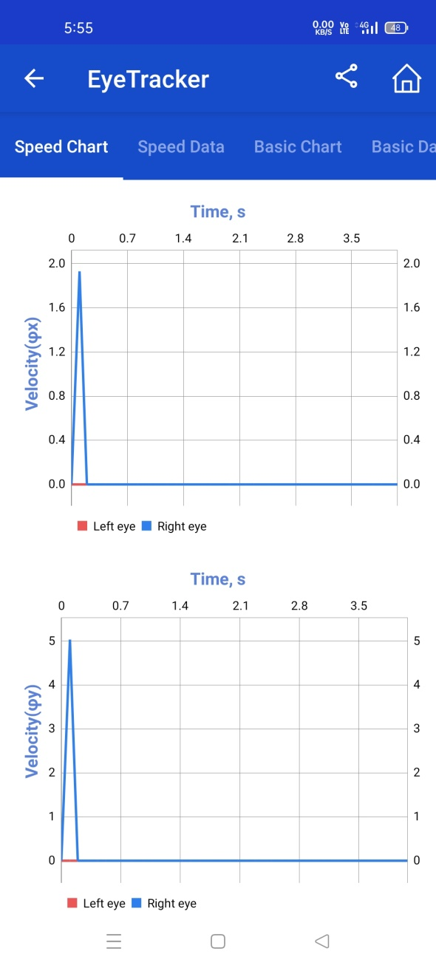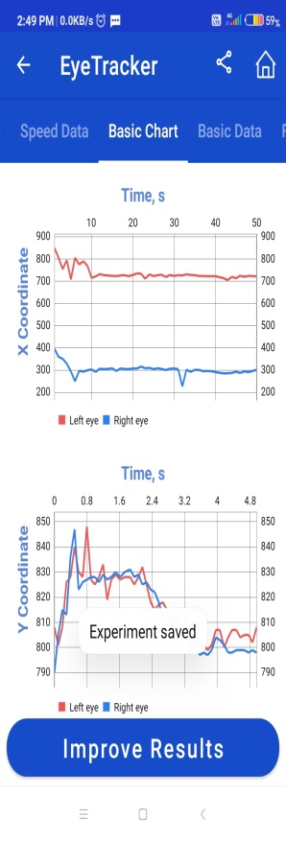

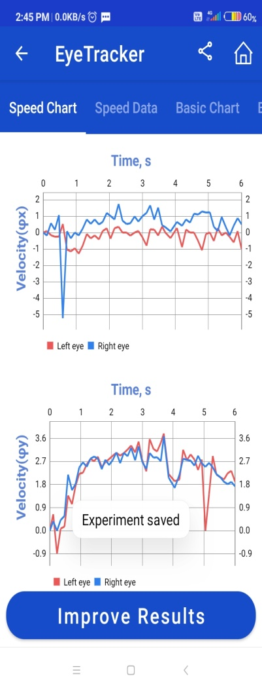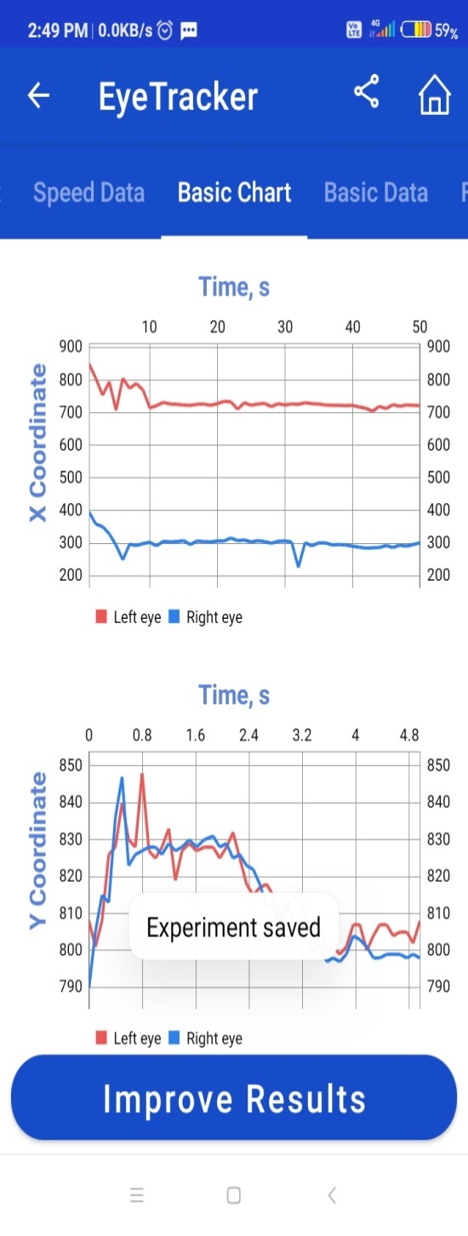

**\**

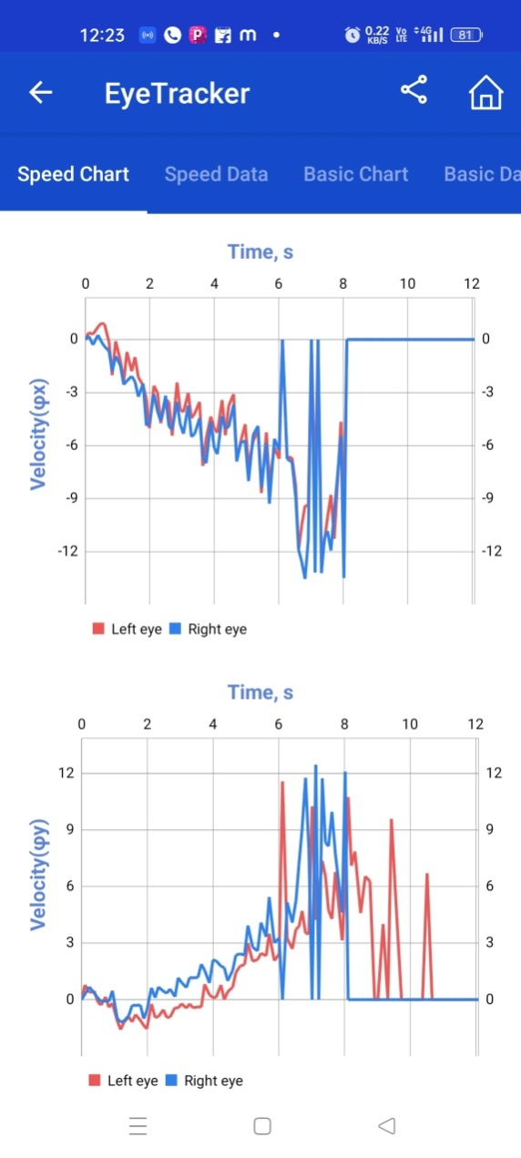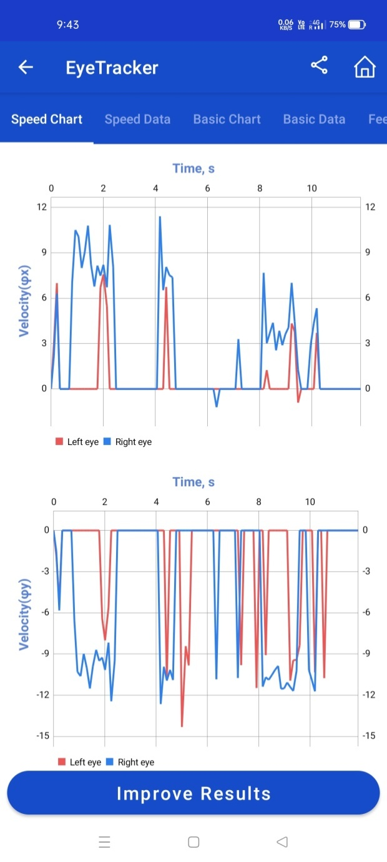

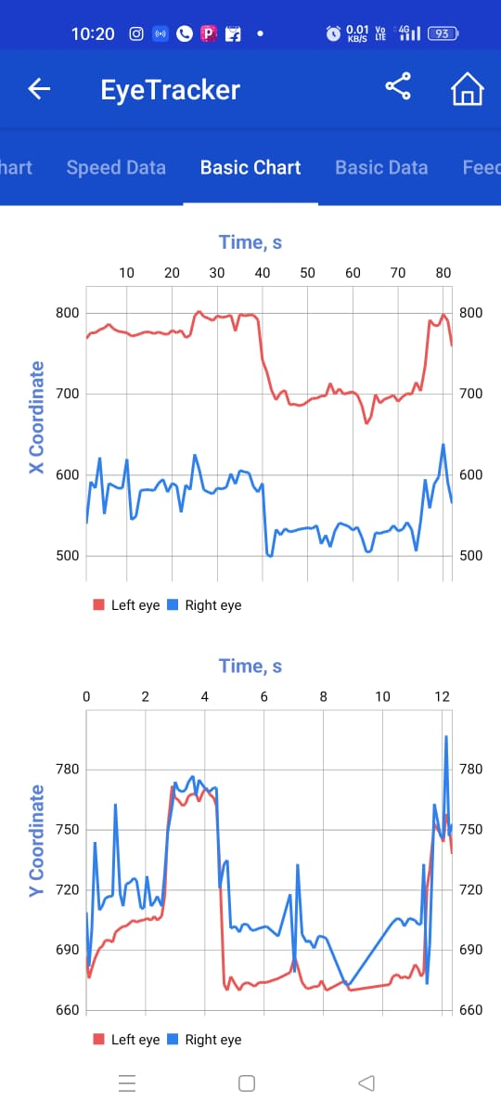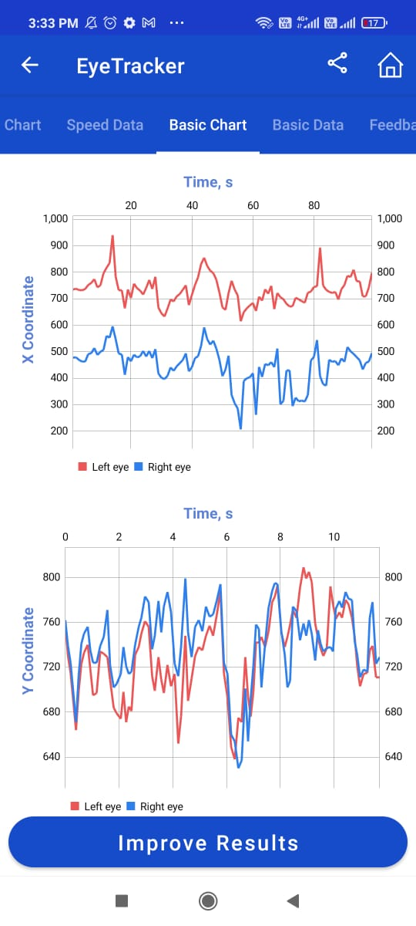

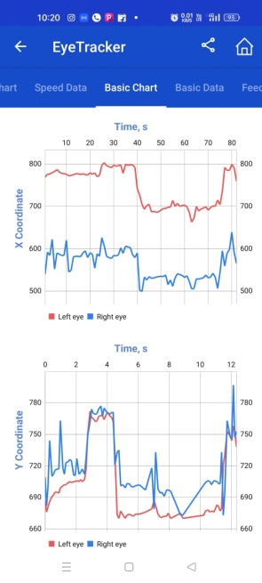

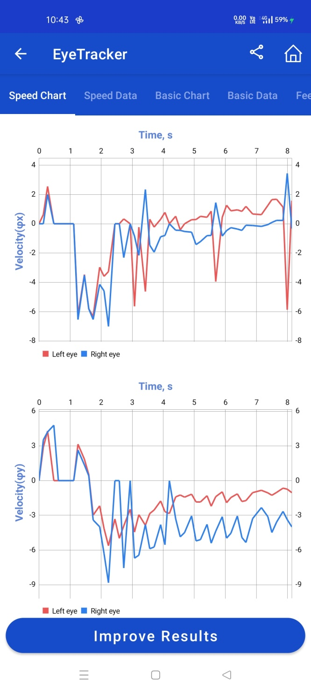

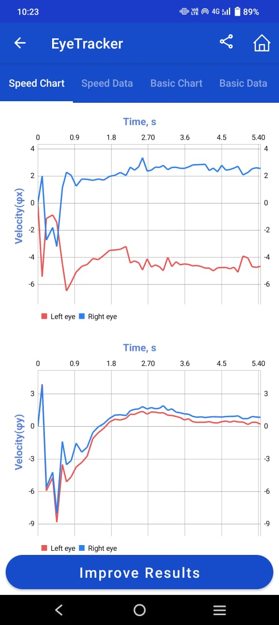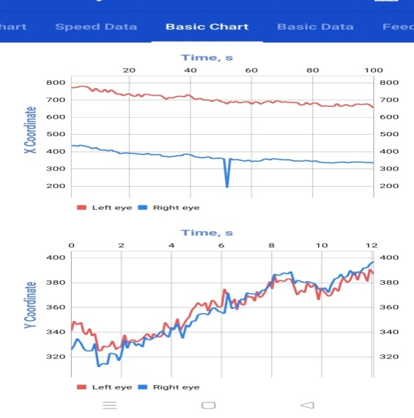

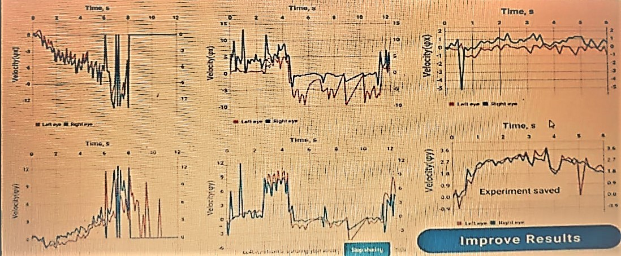

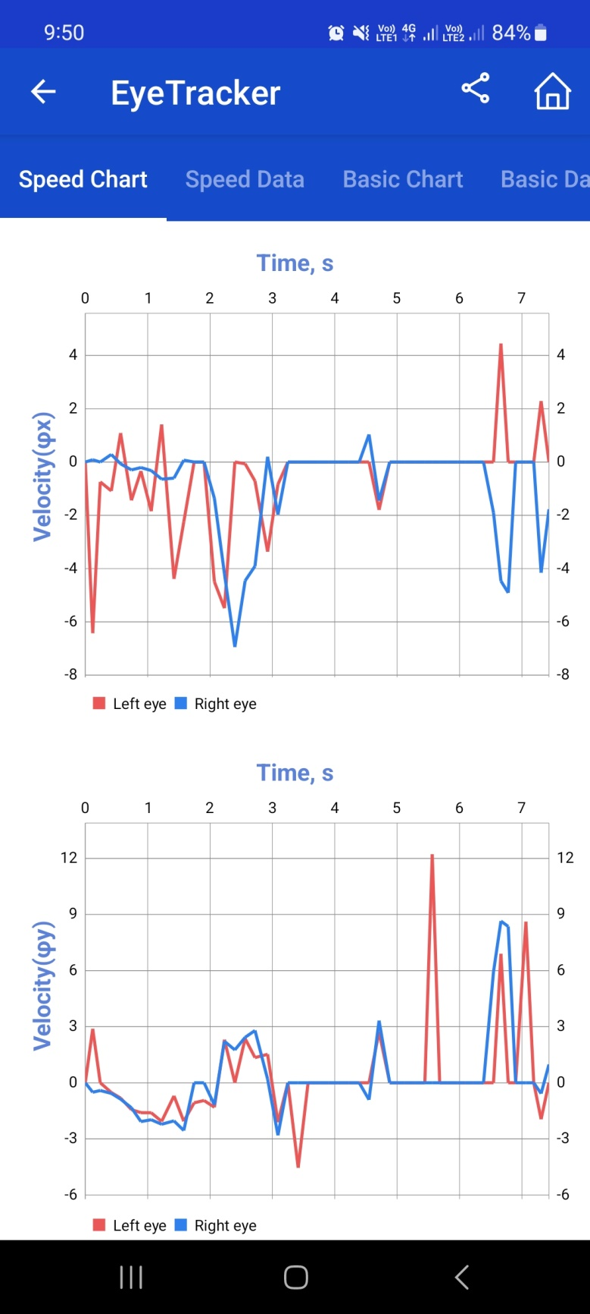

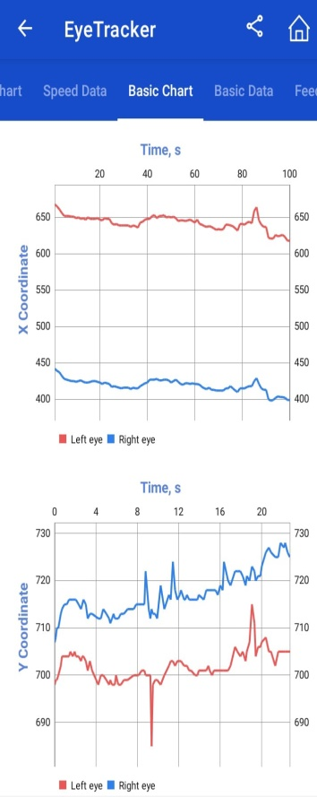

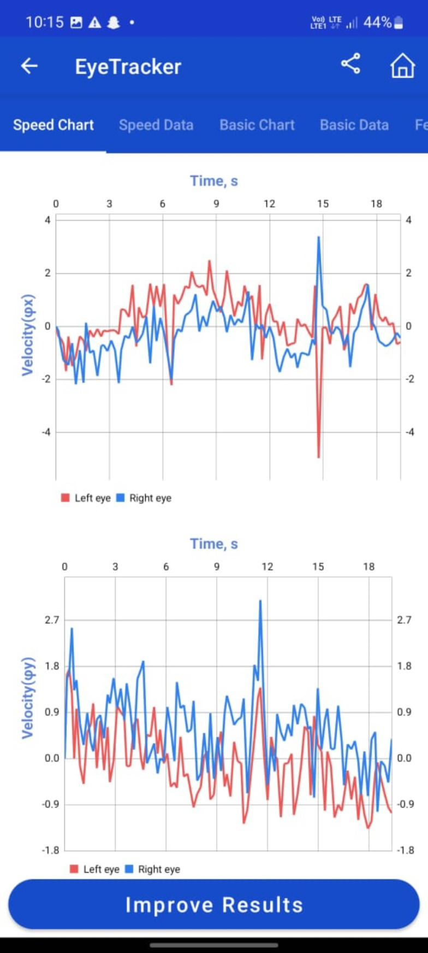

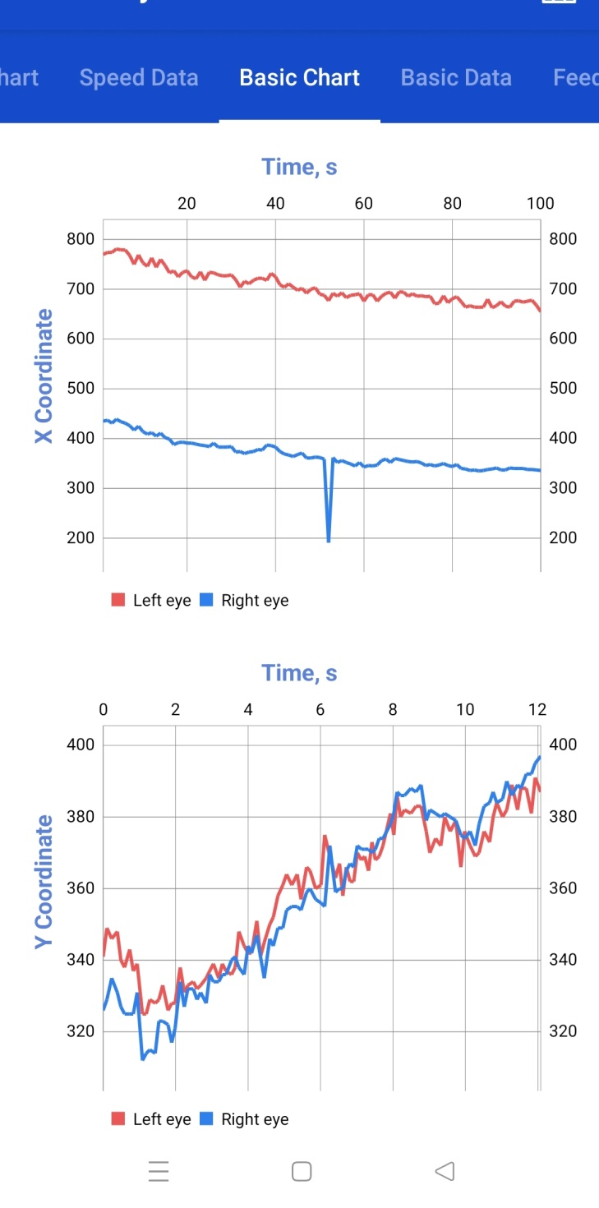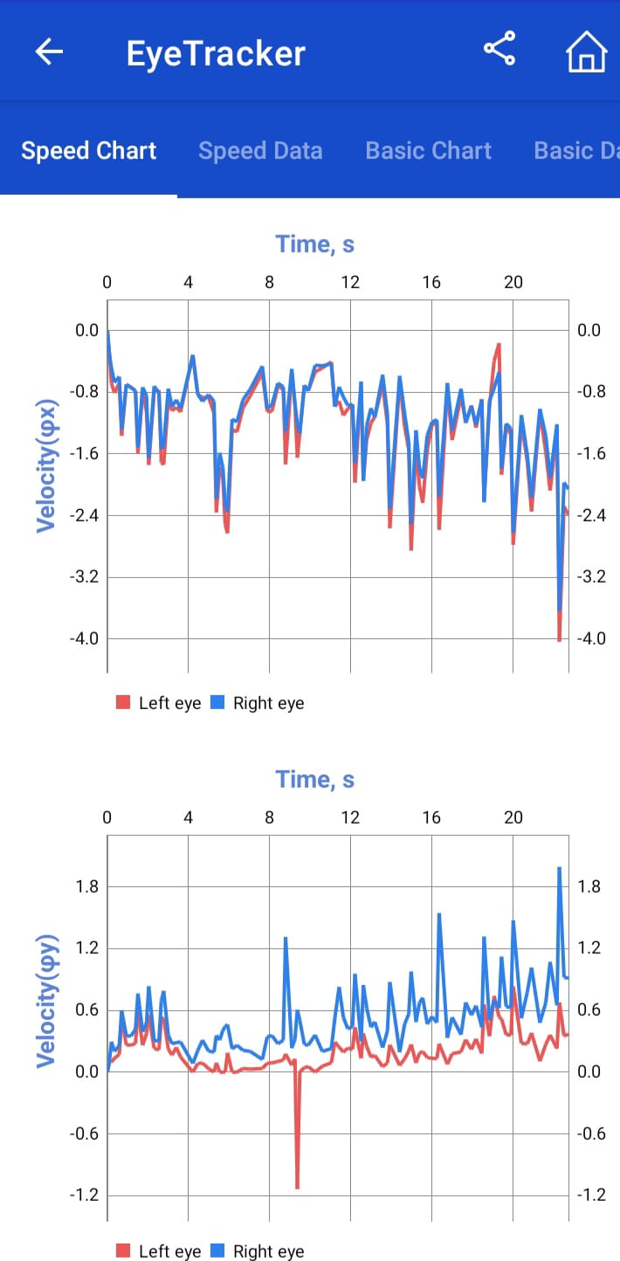

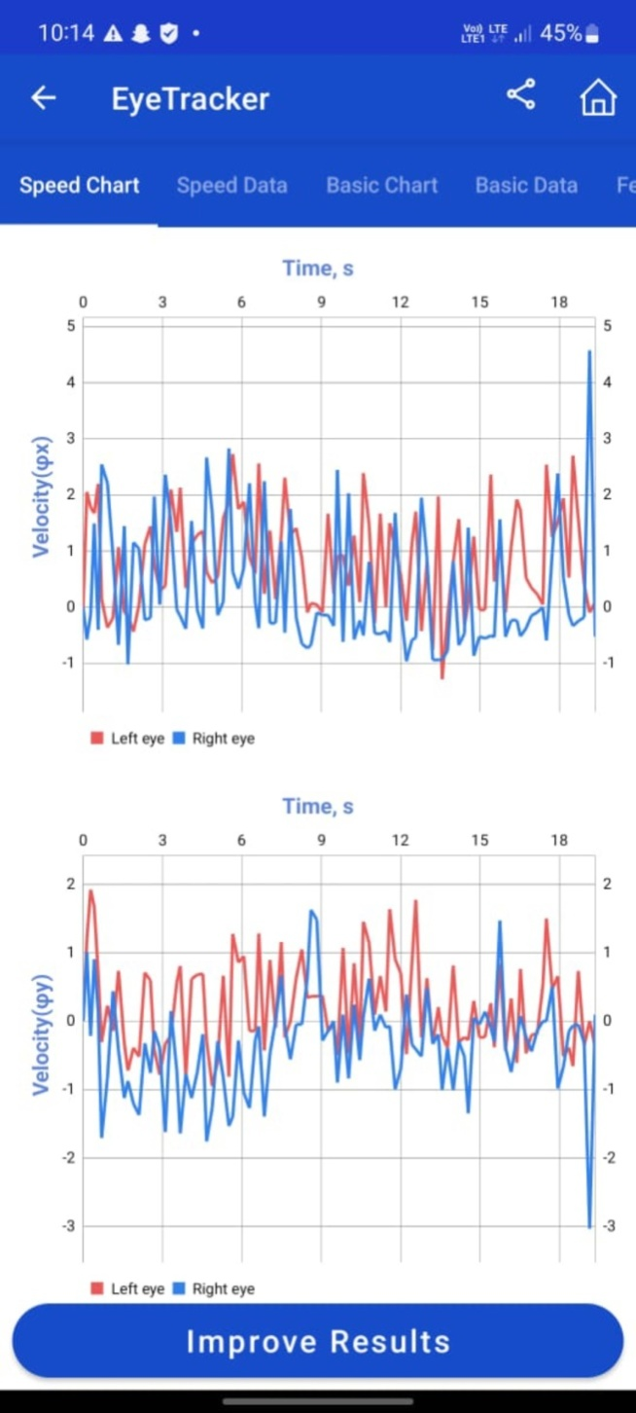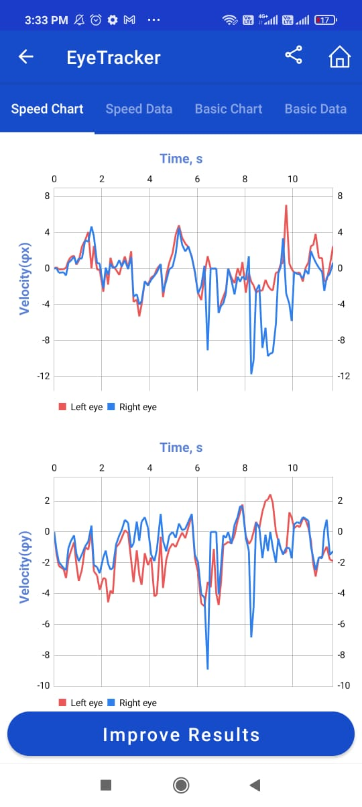



**References**

* *Aaker, David A. (1970), ‘A New Method For Evaluating Stochastic Models Of Brand Choice,’ Journal Of Marketing Research, 7 (August), 300-6.*
* *Adelman L, Miller SL, Henderson D, Schoelles M (2003). Using Brunswikian Theory And A Longitudinal Design To Study How Hierarchical Teams Adapt To Increasing Levels Of Time Pressure. Acta Physiol (Oxf). 112(2).:181–206*
* *Adelman L, Miller SL, Yeo C (2004). Testing The Effectiveness Of Icons For Supporting Distributed Team Decision Making Under Time Pressure. IEEE Trans Syst Man Cybern A Syst Hum 34(2).:179–189*
* *Aitkin, C.D, Santos, E. And Kowler, E. (2013). Anticipatory Smooth Eye Movements In Autism Spectrum Disorder.  Plos One. 8(12).:E83230, 1-11.*
* *Alpert, Mark I. (1971), ‘Identification Of Determinant Attributes: A Comparison Of Methods,’ Journal Of Marketing Research, 9 (May), 184-91. Also in Marx, M. H. (Ed.). (1936). Theories in Contemporary Psychology. New York:*
* *Anderson, N. H. (1969), Comment On ‘An Analysis-Of-Variance Model For The Assessment Of Configural Cue Utilization In Clinical Judgment, ‘ Psychological Bulletin, 72, 63-65.*
* *Araujo, C, Kowler, E. And Pavel, M. (2001). Eye Movements During Visual Search:  The Costs Of Choosing The Optimal Path.  Vision Research, 41, 3613-3625.*
* *Armelius, B.-A, And Armelius, K. (1974). The Use Of Redundancy In Multiple-Cue Judgments: Data From A Suppressor-Variable Task. American Journal Of Psychology, 87(3), 385-392.*
* *Armelius, B.-A, And Armelius, K. (1975). Note On Detection Of Cue Intercorrelation In Multiple-Cue Probability. Scandinavian Journal Of Psychology, 16, 37-41.*
* *Armelius, K, And Armelius, B. A. (1976). The Effects Of Cue-Criterion Correlations, Cue Intercorrelations And The Sign Of The Cue Intercorrelation On Performance In Suppressor Variable Tasks. Organizational Behavior And Human Performance, 17, 241-250.*
* *Aronson, E, And Carlsmith, J. (1968). Experimentation In Social Psychology. In G. Lindzey And E. Aronson (Eds.), The Handbook Of Social Psychology (2nd Ed, Vol. 3). Reading, MA: Addison-Wesley Publishing Co.*
* *Aronson, E, Willerman, B, And Floyd, J. (1966). The Effect of a Pratfall on Increasing Personal Attractiveness. Psychonomic Science, 4, 227-228.*
* *Bahcall, D.O. And Kowler, E. (1999). Illusory Shifts In Perceived Visual Direction Accompany Adaptation Of Saccadic Eye Movements.  Nature, 400, 864-866.*
* *Bahcall, D.O. And Kowler, E. (2000). The Control Of Saccadic Adaptation:  Implications For The Scanning Of Natural Visual Scenes.  Vision Research, 40, 2779-2796.*
* *Bahcall, D.O. And Kowler, E.  (1999). Attentional Interference At Small Spatial Separations. Vision Research, 39, 71-86.*
* *Bakan, D. (1954). A Generalization Of Sidmans Results On Group And Individual Functions, And A Criterion. Psychological Bulletin, 51, 63-64.*
* *Bandura, A. (1978). On Paradigms And Recycled Ideologies. Cognitive Therapy And Research, 2, 79-103.*
* *Banks, A, & Dhami, M. K. (2014). Normative And Descriptive Models Of Military Decisions To Deploy Precision Strike Capabilities. Military Psychology, 26, 33-43.*
* *Bard J (2016). Principles Of Evolution: Systems, Species, And The History Of Life. Garland Science, New York*
* *Barlow HB (1972). Single Units And Sensation: A Neuron Doctrine For Perceptual Psychology? Perception 1(4).:371–394*
* *Baron J (2004). Normative Models Of Judgment And Decision Making. In: Koehler DJ, Harvey N (Eds). Blackwell Handbook Of Judgment And Decision Making. Blackwell, Malden*
* *Bass, Frank H. (1974), ‘The Theory Of Stochastic Preference And Brand Switching,’ Journal Of Marketing Research, 11 (February), 1-20.*
* *Belton, K, & Dhami, M. K. (2021). Cognitive Biases And Debiasing Relevant To Intelligence Analysis. In R. Viale (Ed.), Handbook On Bounded Rationality. Chapter 37. Routledge.*
* *Bennett, Peter D. And Mandell, Robert M. (1969), ‘Prepurchase Information Seeking Behavior Of New Car Purchases - The Learning Hypothesis,’ Journal Of Marketing Research, 7 (November), 430-433.*
* *Berlin B, Kay P (1969). Basic Color Terms: Their Universality And Evolution. University Of California Press, Berkeley*
* *Berman, J. S, And Kenny, D. A. (1976). Correlational Bias In Observer Ratings. Journal Of Personality And Social Psychology, 34(2), 263-273.*
* *Berry MJ II, Brivanlou IH, Jordan TA, Meister M (1999). Anticipation Of Moving Stimuli By The Retina. Nature 398(6725).:334*
* *Block, J. (1977). Correlational Bias In Observer Ratings: Another Perspective On The Berman And Kenny Study. Journal Of Personality And Social Psychology, 35(12), 873-880.*
* *Böhringer C, Jochem PEP (2007). Measuring The Immeasurable—A Survey Of Sustainability Indices. Ecol Econ 63(1).:1–8*
* *Bose U (2015). Design And Evaluation Of A Group Support System Supported Process To Resolve Cognitive Conflicts. Comput Hum Behav 49:303–312*
* *Brehmer B (1976). Social Judgment Theory And The Analysis Of Interpersonal Conflict. Psychol Bull 83(6).:985–1003*
* *Brehmer B (1988). The Development Of Social Judgment Theory. Adv Psychol 54:13–40*
* *Brehmer B, Hagafors R (1986). Use Of Experts In Complex Decision Making: A Paradigm For The Study Of Staff Work. Organ Behav Hum Decis Process 38(2).:181–195*
* *Brehmer, B, And Hammond, K. R. (1977). Cognitive Factors In Interpersonal Conflict. In D. Druckman (Ed.), Negotiations: Social-Psychological Perspectives (Pp. 79-103). Beverly Hills: Sage.*
* *Brehmer, B. (1974). The Effect Of Cue Intercorrelation On Interpersonal Learning Of Probabilistic Inference Tasks. Organizational Behavior And Human Performance, 12, 397-412.*
* *Brehmer, B. (1975). Policy Conflict And Policy Change As A Function Of Task Characteristics. IV. The Effect Of Cue Intercorrelations. Scandinavian Journal Of Psychology, 16, 85-96.*
* *Brehmer, B. (1976). Social Judgment Theory And The Analysis Of Interpersonal Conflict. Psychological Bulletin, 83(6), 985-1003.*
* *Brehmer, Berndt (1974), ‘Hypotheses About Relations Between Scaled Variables In The Learning Of Probabilistic Inference Tasks,’ Organizational Behavior And Human Performance, 11, 1-27.*
* *Brehmer, Berndt (1976), ‘Learning Complex Rules In Probabilistic Inference Task,’ Scandinavian Journal Of Psychology, 17, 309-312.*
* *Bronfenbrenner, U. (1977). Toward An Experimental Ecology Of Human Development. American Psychologist, 32(7), 513-531.*
* *Bruce CJ, Friedman HR (2002). Eye Movements. In: Ramachandran VS (Ed). Encyclopedia Of The Human Brain. Elsevier, Dordrecht, Pp 269–297*
* *Bruner, J. S, Goodnow, J. J, And Austin, G. A. (1956). A Study Of Thinking. New York: Wiley.*
* *Brunswik E (1936). Psychologie Vom Gegenstand Her [Psychology In Terms Of The Object]. In: Congress Board Of The International Congress Of Philosophy (Ed). Congrès International De Philosophie À Prague, 2–7 Septembre 1934 [Documents Of The Eighth International Congress Of Philosophy At Prague, 2–7 September 1934]. Orbis, Prag, Pp 840–845*
* *Brunswik E (1937). Psychology As A Science Of Objective Relations. Philos Sci 4(2).:227–260*
* *Brunswik E (1939). Probability As Determiner Of Rat Behavior. J Exp Psychol 25:175–197*
* *Brunswik E (1940). Thing Constancy As Measured By Correlation Coefficients. Psychol Rev 47:69–78*
* *Brunswik E (1943). Organismic Achievement And Environmental Probability. Psychol Rev 50(3).:255–272*
* *Brunswik E (1946). Points Of View: Components Of Psychological Theorizing. In: Harriman PL (Ed). Encyclopedia Of Psychology. Carol Publishing Group: Philosophical Library, New York, Pp 532–537*
* *Brunswik E (1952). The Conceptual Framework Of Psychology. University Of Chicago Press, Chicago*
* *Brunswik E (1955). Representative Design And Probabilistic Theory In A Functional Psychology. Psychol Rev 62(3).:193–217*
* *Brunswik E (1956). Perception And The Representatve Design. Design Of Psychological Experiments. University Of California Press, Berkeley*
* *Brunswik E (1957). Scope And Aspects Of The Cognitive Problem. In: Gruber H, Hammond KR, Jessor R (Eds). Contemporary Approaches To Cognition. Harvard University Press, Cambridge, Pp 41–69*
* *Brunswik, E. (1927). Strukturmonismus und Physik. Unpublished Dissertation, Philosophische Fakultät der Universität, Wien. Structure-monism and physics. Faculty of Philosophy. University of Vienna.*
* *Brunswik, E. (1928). Zur Entwicklung der Albedowahrnehmung. Zeitschrift für Psychologie,* ***109****, 40-115.*
* *Brunswik, E. (1929). Prinzipienfragen der Gestalttheorie. In E. Brunswik, C. Bühler, H. Hetzer, L. Kardos, E. Köhler, J. Krug, & A. Willwoll (Eds.), Beiträge zur Problemgeschichte der Psychologie: Festschrift zu Karl Bühlers 50. Geburtstag (pp. 78-149).*
* *Brunswik, E. (1930). Über Farben-, Größen- und Gestaltkonstanz in der Jugend. In H. Volkelt (Ed.), Bericht über den 11. Kongreß für experimentelle Psychologie in Wien 1929 (pp. 52-56). Jena: G. Fisher.*
* *Brunswik, E. (1932). Experimente über Kritik. Ein Beitrag zur Entwicklungspsychologie des Denkens. In G. Kafka (Ed.), Bericht über den 12. Kongreß der Deutschen Gesellschaft für Psychologie in Hamburg 1931 (pp. 300-305). Jena: G. Fischer.*
* *Brunswik, E. (1933). Die Zugänglichkeit von Gegenständen für die Wahrnehmung und deren quantitative Bestimmung. Archiv für die gesamte Psychologie,* ***88****, 377-418.*
* *Brunswik, E. (1934). Flächeninhalt und Volumen als Gegenstände der Wahrnehmung. In O. Klemm (Ed.), Bericht über den 13. Kongreß der Deutschen Gesellschaft für Psychologie in Leipzig (pp. 120-123). Jena: G. Fischer.*
* *Brunswik, E. (1934). Wahrnehmung und Gegenstandswelt: Grundlegung einer Psychologie vom Gegenstand her. Leipzig und Wien: F. Deuticke (Habilitationsschrift).*
* *Brunswik, E. (1935). Experimentelle Psychologie in Demonstrationen. Wien: J. Springer.*
* *Brunswik, E. (1935). Prüfung und Übung höherer Wahrnehmungsleistungen (Dingkonstanz), Bericht über den 8. Internationalen Kongreß für Psychotechnik in Prag 1934 (pp. 684-689). Prag.*
* *Brunswik, E. (1935). Psychologie als objektive Beziehungswissenschaft. Actualitiés Scientifiques et Industrielles,* ***389****, 7.*
* *Brunswik, E. (1936). Psychologie als objektive Beziehungswissenschaft, Actes du Congres International de Philosophie Scientifique a Paris 1935. Tome II: Unite de la Science (pp. 15-21). Paris: Hermann.*
* *Brunswik, E. (1936). Psychologie vom Gegenstand her, Actes du Huitieme Congres International de Philosophie a Prague 1934 (pp. 840-845). Prag: Orbis.*
* *Brunswik, E. (1936). Psychology in terms of objects. In H. W. Hill (Ed.), Proceedings of the 25th Anniversary Celebration of the Inauguration of Graduate Studies (pp. 122-126). University of Southern California.*
* *Brunswik, E. (1937). Psychology as a science of objective relations. Philosophy of Science,* ***4****, 227-260.*
* *Brunswik, E. (1938). Das Induktionsprinzip in der Wahrnehmung. In H. Pieron & J. Meyerson (Eds.), 11ieme Congres International de Psychologie a Paris 1937. Rapports et Comptes Rendus (pp. 346-347). Paris: Alcan.*
* *Brunswik, E. (1939). Perceptual characteristics of schematized human figures. Psychological Bulletin,* ***36****, 553.*
* *Brunswik, E. (1939). Probability as a determiner of rat behavior. Journal of Experimental Psychology,* ***25****, 175-197.*
* *Brunswik, E. (1939). The conceptual focus of some psychological systems. Journal of Unified Science (Erkenntnis),* ***8****, 36-49.*
* *Brunswik, E. (1940). A random sample of estimated sizes and their relation to corresponding size measurements. Psychological Bulletin,* ***37****, 585-586.*
* *Brunswik, E. (1940). Thing constancy as measured by correlation coefficients. Psychological Review,* ***47****, 69-78.*
* *Brunswik, E. (1941). Perceptual size-constancy in life situations. Psychological Bulletin,* ***38****, 611-612.*
* *Brunswik, E. (1943). Organismic achievement and environmental probability. Psychological Review,* ***50****, 255-272.*
* *Brunswik, E. (1943). Organismic Achievement And Environmental Probability. Psychological Review, 50, 255-272.*
* *Brunswik, E. (1944). Distal focussing of perception: Size constancy in a representative sample of situations. Psychological Monographs,* ***56****(254), 1-49.*
* *Brunswik, E. (1945). Social perception of traits from photographs. Psychological Bulletin,* ***42****, 535-536.*
* *Brunswik, E. (1946). Four types of experiment. American Psychologist,* ***1****, 457.*
* *Brunswik, E. (1946). Points of view: Components of psychological theorizing. In P. L. Harriman (Ed.), Encyclopedia of Psychology (pp. 523-537): Philosophical Library.*
* *Brunswik, E. (1947). Systematic and representative design of psychological experiments. With results in physical and social perception. Berkeley: University of California Press.*
* *Brunswik, E. (1948). Statistical separation of perception, thinking, and attitudes. American Psychologist,* ***3****, 342.*
* *Brunswik, E. (1949). Discussion: Remarks on functionalism in perception. Journal of Personality,* ***18****, 56-65.*
* *Brunswik, E. (1951). Note on Hammond's analogy between ‘relativity and representativeness’. Philosophy of Science,* ***18****, 212-217.*
* *Brunswik, E. (1952). The Conceptual Framework of Psychology, International Encyclopedia of Unified Science (Vol. 1, No. 10, pp. IV + 102). Chicago: University of Chicago Press.*
* *Brunswik, E. (1952). The Conceptual Framework Of Psychology. In International Encyclopedia Of Unified Science (Vol. 1, No. 10, Pp. 4-102). Chicago: University Of Chicago Press.*
* *Brunswik, E. (1955). ‘Ratiomorphic’ models of perception and thinking. Acta Psychologica,* ***11****, 108-109.*
* *Brunswik, E. (1955). In defense of probabilistic functionalism: A reply. Psychological Review,* ***62****, 236-242.*
* *Brunswik, E. (1955). Representative design and probabilistic theory in a functional psychology. Psychological Review,* ***62****(3), 193-217.*
* *Brunswik, E. (1956). Historical and thematic relations of psychology to other sciences. Scientific Monthly,* ***83****, 151-161.*
* *Brunswik, E. (1956). Historical And Thematic Relations Of Psychology To Other Sciences. Scientific Monthly, 83, 151-161.*
* *Brunswik, E. (1956). Perception and the representative design of psychological experiments. Berkeley: University of California Press.*
* *Brunswik, E. (1956). Perception and The Representative Design Of Psychological Experiments. (2nd Ed.). Berkeley: University Of California Press.*
* *Brunswik, E. (1957). Scope and aspects of the cognitive problem. In H. Gruber, K. R. Hammond, & R. Jessor (Eds.), Contemporary approaches to cognition (pp. 5-31). Cambridge: Harvard University Press.*
* *Brunswik, E. (1957). Scope And Aspects Of The Cognitive Problem. In H. Gruber, K. R. Hammond, And R. Jessor (Eds.), Contemporary Approaches To Cognition (Pp. 5-31). Cambridge: Harvard University Press.*
* *Brunswik, E. (1959). Ontogenetic and other developmental parallels to the history of science. In H. M. Evans (Ed.), Men and Moments in the History of Science (pp. 3-21). Seattle: University of Washington Press.*
* *Brunswik, E. (1966). Reasoning as a universal behavior model and a functional differentiation between ‘perception’ and ‘thinking’. In K. R. Hammond (Ed.), The Psychology of Egon Brunswik (pp. 487-494). New York: Holt, Rinehart and Winston.*
* *Brunswik, E., & Cruikshank, R. M. (1937). Perceptual size-constancy in early infancy. Psychological Bulletin,* ***34****, 713-714.*
* *Brunswik, E., & Herma, H. (1951). Probability learning of perceptual cues in the establishment of a weight illusion. Journal of Experimental Psychology,* ***41****, 281-290.*
* *Brunswik, E., & Kamiya, J. (1953). Ecological cue-validity of ‘proximity’ and of other Gestalt factors. American Journal of Psychology,* ***66****, 20-32.*
* *Brunswik, E., & Kardos, L. (1929). Das Duplizitätsprinzip in der Theorie der Farbenwahrnehmung. Zeitschrift für Psychologie,* ***111****, 307-320.*
* *Brunswik, E., & Kindermann, H. (1929). Eidetik bei taubstummen Jugendlichen. Zeitschrift für angewandte Psychologie,* ***34****, 244-274.*
* *Brunswik, E., & Reiter, L. (1937). Eindruckscharaktere schematisierter Gesichter. Zeitschrift für Psychologie,* ***142****, 67-134.*
* *Brunswik, E., Goldscheider, L., & Pilek, E. (1932). Untersuchungen zur Entwicklung des Gedächtnisses bei Knaben und Madchen vom 6-18 Jahren. Zeitschrift für angewandte Psychologie,* ***Beiheft 64****, VIII+158.*
* *Brunswik, Egon (1944), ‘Distal Focusing Of Perception: Size Constancy In A Representative Sample Of Situations,’ Psychological Monographs, 56, 1-49.*
* *Bryson JM (2004). What To Do When Stakeholders Matter. Stakeholder Identification And Analysis Techniques. Public Manag Rev 6(1).:21–53*
* *Burr, D, Kowler, E, Reeves, A. And Verghese, P. (2004). Visual Attention.  Special Issue Of Vision Research, Volume 44 (June).*
* *Busch P, Heinonen T, Lahti P (2007). Heisenberg’s Uncertainty Principle. Phys Rep Rev Sect Phys Lett 452(6).:155–176. Doi:*[*10.1016/J.Physrep.2007.05.006*](https://doi.org/10.1016/j.physrep.2007.05.006)
* *Camerer C (1981). General Conditions For The Success Of Bootstrapping Models. Organ Behav Hum Perform 27(3).:411–422. Doi:*[*10.1016/0030-5073(81).90031-3*](https://doi.org/10.1016/0030-5073(81)90031-3)
* *Campbell, D. (1966), ‘Pattern Matching As An Essential In Distal Knowing,’ In K. R. Hammond (Ed.), The Psychology Of Egon Brunswik, New York: Holt, Rinehart & Winston, 81-107.*
* *Castellan, N. John (1973), ‘Comments On The 'Lens Model' Equation And The Analysis Of Multiple-Cue Judgment Tasks,’ Psychometrika, (March), 87-100.*
* *Castellan, N. John (1977), ‘Decision Making With Multiple Probabilistic Cues,’ In N. J. Castellan, Jr, D. B. Pisoni And G. R. Potts (Eds.), Cognitive Theory, Volume 2, Hillsdale. NJ: L. Erlbaum Associates.*
* *Chapman, L. J, And Chapman, J. P. (1967). Genesis Of Popular But Erroneous Psychodiagnostic Observations. Journal Of Abnormal Psychology, 72(3), 193-204.*
* *Chapman, L. J, And Chapman, J. P. (1969). Illusory Correlation As An Obstacle To The Use Of Valid Psychodiagnostic Signs. Journal Of Abnormal Psychology, 74(3), 271-280.*
* *Chapman, L. J. (1967). Illusory Correlation In Observational Report. Journal Of Verbal Learning And Verbal Behavior, 6, 151-155.*
* *Christensen, L. B. (1977). Experimental Methodology. Boston, MA: Allyn And Bacon.*
* *Clark, H. H. (1973). The Language-As-Fixed-Effect Fallacy: A Critique Of Language Statistics In Psychological Research. Journal Of Verbal Learning And Verbal Behavior, 12, 335-359.*
* *Cohen IR (2000a). Discrimination And Dialogue In The Immune System. Semin Immunol 12(3).:215–219*
* *Cohen IR (2000b). Tending Adam’s Garden: Evolving The Cognitive Immune Self. Academic Press, London*
* *Cohen, E.H, Schnitzer, B.S, Gersch, T.M, Singh, M, And Kowler, E. (2007). The Relationship Between Spatial Pooling And Attention In Saccadic And Perceptual Tasks.  Vision Research, 47, 1907-1923. PMC2736607*
* *Cohen, Joel B, Fishbein, Martin, And Ahtola, Olli (1972), ‘The Nature And Uses Of Expectancy-Value Models In Consumer Attitude Research,’ Journal Of Marketing Research, 9 (November). 456-60.*
* *Collewijn, H, Steinman, R.M, Erkelens, C.J, Pizlo, Z, Kowler, E, And Van Der Steen, J. (1992). Binocular Gaze Control Under Free-Head Conditions.  In H. Shimazu And Y. Shinoda.  Vestibular And Brain Stem Control Of Eye, Head And Body Movements. Basel:  Karger.*
* *Collewijn, H. And Kowler, E.  (2008). The Significance Of Microsaccades For Vision And Oculomotor Control.  Journal Of Vision, 8(14).:20, 1-21. (*[*Http://Journalofvision.Org/8/14/20/*](http://journalofvision.org/8/14/20/)*, Doi:10.1167/8.14.20).*
* *Corbetta M, Shulman GL (2002). Control Of Goal-Directed And Stimulus-Driven Attention In The Brain. Nat Rev Neurosci 3(3).:201–215. Doi:*[*10.1038/Nrn755*](https://doi.org/10.1038/nrn755)
* *Cosmides L, Tooby J (1996). Are Humans Good Intuitive Statisticians After All? Rethinking Some Conclusions From The Literature On Judgment Under Uncertainty. Cognition 58(1).:1–73. Doi:*[*10.1016/0010-0277(95).00664-8*](https://doi.org/10.1016/0010-0277(95)00664-8)
* *Cosmides, L, And Tooby, J. (1996). Are Humans Good Intuitive Statisticians After All? Rethinking Some Conclusions From The Literature On Judgment Under Uncertainty. Cognition: International Journal Of Cognitive Science, 58, 1-73.*
* *Cronbach, L. J. (1975). Beyond The Two Disciplines Of Scientific Psychology. American Psychologist, 30, 116-127.*
* *Crow, W. (1957). The Need For Representative Design In Studies Of Interpersonal Perception. Journal Of Consulting Psychology, 21, 321-325.*
* *Curcio CA, Sloan KR, Kalina RE, Hendrickson AE (1990). Human Photoreceptor Topography. J Comp Neurol 292(4).:497–523*
* *De França Doria M, Boyd E, Tompkins WL, Adger WN (2009). Using Expert Elicitation To Define Successful Adaptation To Climate Change. Environ Sci Policy 12(7).:810–819*
* *Deane, D. H, Hammond, K. R, And Summers, D. A. (1972), ‘Acquisition And Application Of Knowledge In Complex Inference Tasks,’ Journal Of Experimental Psychology, 92, 20-26.*
* *Denisova, K, Singh, M, And Kowler, E. (2006). The Role Of Part Structure In The Perceptual Localization Of Shape.  Perception, 35, 1073-1087.*
* *Derbyshire, J, Belton, I, Dhami, M. K, & Onkal, D. (2022). The Value Of Experiments In Futures And Foresight Science As Illustrated By The E Of Scenario Planning. Futures & Foresight Science.*[*Https://Doi.Org/10.1002/Ffo2.146*](https://doi.org/10.1002/ffo2.146)
* *Derbyshire, J, Belton, I, Dhami, M. K, & Onkal, D. (2023). The Value Of Experiments In Futures And Foresight Science: A Reply To Commentary On Derbyshire Et Al. (2023). Futures & Foresight Science. E156.*[*Https://Doi.Org/10.1002/Ffo2.156*](https://doi.org/10.1002/ffo2.156)
* *Dhami MK, Hertwig R, Hoffrage U (2004). The Role Of Representative Design In An Ecological Approach To Cognition. Psychol Bull 130(6).:959–988. Doi:*[*10.1037/0033-2909.130.6.959*](https://doi.org/10.1037/0033-2909.130.6.959)
* *Dhami MK, Olsson H (2008). Evolution Of The Interpersonal Conflict Paradigm. Judgm Decis Mak J 3(7).:547–569*
* *Dhami, M. K, & Belton, I. (2016). Statistical Analyses Of Court Decisions: An Example Of Multilevel Models Of Sentencing. Law And Method. DOI: 10.5553/REM/.000019.*
* *Dhami, M. K, & Careless, K. E. (2015). Intelligence Analysis: Does Collaborative Analysis Outperform The Individual Analyst? The Journal Of Intelligence And Analysis, 22(3), 43-58.*
* *Dhami, M. K, & Careless, K. E. (2015). Ordinal Structure Of The Generic Analytic Workflow: A Survey Of Intelligence Analysts. 2015 European Intelligence And Security Informatics Conference, 141-144. DOI: 10.1109/EISIC.2015.37*
* *Dhami, M. K, & Garcia-Retamero, R. (2012). Spanish Young Adults’ Perceptions Of The Costs And Benefits Of Risky Driving. The Spanish Journal Of Psychology, 15, 638-647.*
* *Dhami, M. K, & Harries, C. (2010). Information Search In Heuristic Decision Making. Applied Cognitive Psychology, 24, 571-586.*
* *Dhami, M. K, & Mandel, D. R. (2012). Crime As Risk Taking. Psychology, Crime And Law, 18, 389-403.*
* *Dhami, M. K, & Mandel, D. R. (2021). Words Or Numbers? Communicating Probability In Intelligence Analysis. American Psychologist, 76(3), 549-560.*[*Https://Doi.Org/10.1002/Acp.3550*](https://doi.org/10.1002/acp.3550)
* *Dhami, M. K, & Mumpower, J. (2018). Kenneth R. Hammond’s Contributions To The Study Of Human Judgment And Decision Making. Judgment And Decision Making, 13, 1-22.*
* *Dhami, M. K, & Olsson, H. (2008). Evolution Of The Interpersonal Conflict Paradigm. Judgment And Decision Making, 3, 547-569.*
* *Dhami, M. K, & Souza, K. A. (2009). Sentencing And Its Outcomes Project: Part One Pilot Study Report. Ministry Of Justice Research Series 2/09, London, UK.*
* *Dhami, M. K, & Thomson, M. (2012). On The Relevance Of Cognitive Continuum Theory For Understanding Management Judgment And Decision Making. European Management Journal, 30, 316-326.*
* *Dhami, M. K, Belton, I, & Careless, K. (2016). Critical Review Of Analytic Techniques. 2016 European Intelligence And Security Informatics Conference, 152-155. DOI: 10.1109/EISIC.2016.33*
* *Dhami, M. K, Hastie, R, Koehler, J. J, & Wiener, R. L. (2007). Introduction To The Special Issue: Decision Making And The Law. Journal Of Behavioral Decision Making, 20, 453-454.*
* *Dhami, M. K, Hertwig, R, & Hoffrage, U. (2004). The Role Of Representative Design In An Ecological Approach To Cognition. Psychological Bulletin, 130, 959-988.*
* *Dhami, M. K, Mandel, D. R, & Belton, I. (2019). The ‘Analysis Of Competing Hypotheses’ In Intelligence Analysis. Applied Cognitive Psychology, 33, 1080-1090. DOI: 10.1002/Acp.3550*
* *Dhami, M. K, Mandel, D. R, & Garcia-Retamero, R. (2011). Canadian And Spanish Youths’ Risk Perceptions Of Drinking And Driving And Riding With A Drunk Driver. International Journal Of Psychology, 46, 81-90.*
* *Dhami, M. K, Mandel, D. R, Loewenstein, G, & Ayton, P. (2006). Prisoners’ Positive Illusions Of Their Post-Release Success. Law And Human Behavior, 30, 631-647.*
* *Dhami, M. K, Mandel, D. R, Mellers, B, & Tetlock, P. (2015). Improving Intelligence Analysis With Decision Science. Perspectives On Psychological Science, 10, 753-757.*
* *Dhami, M. K, Schlottmann, A, & Waldmann, M. (2011). (Eds.). Judgment And Decision Making As A Skill: Learning, Development, And Evolution. Cambridge: Cambridge University Press.*
* *Dhami, M. K, Wicke, L, & Onkal, D. A (2022). Scenario Generation And Scenario Quality Using The Cone Of Plausibility. Futures, 142.*[*Https://Doi.Org/10.1016/J.Futures.2022.102995*](https://doi.org/10.1016/j.futures.2022.102995)
* *Dhami, M. K. & Belton, I. K. (2017). On Getting Inside The Judge’s Mind. Translational Issues In Psychological Science, 3, 214-226. Https://Doi.Org/10.1037/Tps0000115*
* *Dhami, M. K. & Careless, K. (2019). A Survey Of Intelligence Analysts’ Strategies For Solving Analytic Tasks. Military Psychology, 31, 117-127.*
* *Dhami, M. K. & Careless, K. E. (2021). Development And Validation Of The ‘Analysis Support Guide.’ International Journal Of Intelligence And Counterintelligence. 10.1080/08850607.2021.1966589*
* *Dhami, M. K. & Harries, C. (2001). Fast and Frugal Versus Regression Models Of Human Judgment. Thinking & Reasoning, 7, 5-27.*
* *Dhami, M. K. & Wallsten, T. S. (2005). Interpersonal Comparison Of Subjective Probabilities. Memory & Cognition, 33, 1057-1068.*
* *Dhami, M. K. (2003). Psychological Models Of Professional Decision-Making. Psychological Science, 14, 175-180.*
* *Dhami, M. K. (2005). From Discretion To Disagreement: Explaining Disparities In Judges’ Pre-Trial Decisions. Behavioral Sciences & The Law, 23, 367-386.*
* *Dhami, M. K. (2006). Legal Decision Making: Psychological Reality Meets Legal Idealism. In B. Brooks, & M. Freeman (Eds.), Law And Psychology (Pp. 49-76). Oxford: Oxford University Press.*
* *Dhami, M. K. (2008). Bail Setting Decisions. In B. Cutler (Ed.), Encyclopaedia Of Psychology And Law (Pp. 37-39). Thousand Oaks, CA: Sage.*
* *Dhami, M. K. (2008). On Measuring Quantitative Interpretations Of Reasonable Doubt. Journal Of Experimental Psychology: Applied, 14, 353-363.*
* *Dhami, M. K. (2012). Representative Design: Brunswik’s Challenge For Scientific Psychology. In K. O. Moore, & N. P. Gonzalez (Eds.), Handbook On Psychology Of Decision-Making (Pp. 249-261). Nova Science Publishers, Inc.*[*Http://Www.Novapublishers.Org/Catalog/Product_Info.Php?Products_Id=22923*](http://www.novapublishers.org/catalog/product_info.php?products_id=22923)
* *Dhami, M. K. (2013). A ‘Decision Science’ Perspective On The Old And New Sentencing Guidelines In England And Wales. In A. Ashworth & J. V. Roberts (Eds.), Structured Sentencing In England And Wales: From Guidance To Guidelines (Pp. 165-181). Oxford: Oxford University Press.*
* *Dhami, M. K. (2013). Sentencing Guidelines In England And Wales: Missed Opportunities? Law And Contemporary Problems, 76, 287-305. Https://Scholarship.Law.Duke.Edu/Cgi/Viewcontent.Cgi?=4355&Context=Lcp*
* *Dhami, M. K. (2018). Towards An Evidence-Based Approach To Communicating Uncertainty In Intelligence Analysis. Intelligence And National Security, 33, 257-272.*
* *Dhami, M. K, & Mandel, D. R. (2012). Foreted Risk Taking In Youth: Evidence For A Bounded-Rationality Perspective. Synthese, 189, 161-171. DOI: 10.1007/S11229-012-0110-2*
* *Dhami, M. K, & Mandel, D. R. (2013). How Do Defendants Choose Their Trial Court? Evidence For A Heuristic Processing Account. Judgment And Decision Making, 8, 552-560.*
* *Dhami, M. K, & Mandel, D. R. (2022). Communicating Uncertainty Using Words And Numbers. Trends In Cognitive Sciences.*[*Https://Doi.Org/10.1016/J.Tics.2022.03.002*](https://doi.org/10.1016/j.tics.2022.03.002)
* *Dhami, M. K, & Murray, J. (2016). Male Youth Perceptions Of Violent Extremism: Towards A Test Of Rational Choice Theory. The Spanish Journal Of Psychology, 19, E51, 1-10. DOI: 10.1017/Sjp.2016.49*
* *Dhami, M. K, Belton, I, & Goodman-Delahunty, J. (2015). Quasi-Rational Models Of Sentencing. Journal Of Applied Research On Memory And Cognition, 4, 239-247.*
* *Doherty ME, Kurz ME (1996). Social Judgement Theory. Think Reason 2(2).:109–140*
* *Doherty ME, Tweney RD (2004). Reasoning And Task. In: Manktelow K, Chung MC (Eds). Psychology Of Reasoning: Theoretical And Historical Perspectives. Taylor And Francis, Hove, Pp 11–41*
* *Dörner D, Schaub H (1994). Errors In Planning And Decision-Making And The Nature Of Human Information Processing. Appl Psychol 43(4).:433–453*
* *Dowling, J. F, And Graham, J. R. (1976). Illusory Correlation And The MMPI. Journal Of Personality Assessment, 40(5), 531-538.*
* *Dunwoody PT (2009). Theories Of Truth As Assessment Criteria In Judgment And Decision Making. Judgm Decis Mak 4(2).:116–125*
* *Eaton, W. O, And Clore, G. L. (1975). Interracial Imitation At A Summer Camp. Journal Of Personality And Social Psychology, 32, 1099-1105.*
* *Einhorn, H. J. (1970), ‘The Use Of Nonlinear Noncompensatory Models In Decision Making,’ Psychological Bulletin, 73, 221-230.*
* *Einhorn, H. J. (1972). Expert Measurement And Mechanical Combination. Organizational Behavior And Human Performance, 7, 86-106.*
* *Eliashberg, Jehoshua (1980), ‘Consumer Preference Judgments: An Exposition With Empirical Applications,’ Management Science, 26 (January, #1), 60-77.*
* *Elms, A. C. (1975). The Crisis Of Confidence In Social Psychology. American Psychologist, 30, 967-976.*
* *Epelboim, J, Kowler, E, Steinman, R.M, Collewijn, H, Erkelens, C.J, And Pizlo, Z. (1995). When Push Comes To Shove:  Compensation For Passive Perturbations Of The Head During Natural Gaze Shifts.  Journal Of Vestibular Research, 5, 421-442.*
* *Epelboim, J, Steinman, R.M, Kowler, E, Edwards, M, Pizlo, Z, Erkelens, C.J. And Collewijn, H. (1995). The Function Of Visual Search And Memory In Sequential Looking Tasks.  Vision Research, 35, 3401-3422.*
* *Epelboim, J, Steinman, R.M, Kowler, E, Pizlo, Z, Erkelens, C.J, And Collewijn, H. (1997). Gaze Shift Dynamics In Two Kinds Of Sequential Looking Tasks.  Vision Research, 37, 2597-2607.*
* *Epelboim, J. And Kowler, E. (1993).  Slow Control With Eccentric Targets: Evidence Against A Position-Corrective Model.  Vision Research, 33, 361-380.*
* *Errata: Philosophy of Science, (1938), 5, 110.*
* *Fischer KR, Stadler F (Eds). (1997). ‘Wahrnehmung Und Gegenstandswelt’: Zum Lebenswerk Von Egon Brunswik (1903–1955). [Perception And World Of Objects: On The Lifework Of Egon Brunswik (1903–1955).]. Springer, Vienna*
* *Fischhoff, B. (1976). Attribution Theory And Judgment Under Uncertainty. In J. H. Harvey, W. J. Ickes, And R. F. Kidd (Eds.), New Directions In Attribution Research (Pp. 421-452). Hillsdale, NJ: Erlbaum.*
* *Fisher, R. A. (1947). The Design Of Experiments (4th Ed.). New York: Hafner.*
* *Fodor JA (1981). The Mind-Body Problem. Sci Am 244(1).:124–132*
* *Foley E (2014). Sustainability Planning Guidebook For Teams. Retrieved From Pennsylvania*
* *Fox E, Griggs L, Mouchlianitis E (2007). The Detection Of Fear-Relevant Stimuli: Are Guns Noticed As Quickly As Snakes? Emotion 7(4).:691–696. Doi:*[*10.1037/1528-3542.7.4.691*](https://doi.org/10.1037/1528-3542.7.4.691)
* *Frank, Ronald E. And Massy, William F. (1970), ‘Shelf Position And Space Effects,’ Journal Of Marketing Research, 7, 59-66.*
* *Friedrich E, Pillay S, Buckley C (2007). The Use Of LCA In The Water Industry And The E For An Environmental Performance Indicator. Water Sa 33(4).:443–452*
* *Friend J, Hickling J (2005). Planning Under Pressure. The Strategic Choice Approach. Elsevier, Amsterdam*
* *Frodi, A. (1974). On The Elicitation And Control Of Aggressive Behavior. Göteborg Psychological Reports, 4, 16.*
* *G. Gigerenzer, R, Hertwig, & T. Pachur (Eds.), (2011). Heuristics: The Foundations Of Adaptive Behaviour (Pp. 602-609). New York: Oxford University Press.]*
* *G. Gigerenzer, R, Hertwig, & T. Pachur (Eds.), (2011). Heuristics: The Foundations Of Adaptive Behavior (Pp. 579-588). New York: Oxford University Press.]*
* *Gankar, S. S. And Satpathy, J. (2020). 21st Century ‘Tabula Rasa’ Personnel Manager, National Institute Of Personnel Management, ‘Personnel Today’ And International Institute Of Management Science, Pune, Research Compendium ‘YASHOMANTHAN’ (Special Issue), ISSN (Print).: 2347-8039, Vol 7 / Issue 2 / Sept 2020, Pp: 14 - 17, India (National).*
* *Garcia-Retamero, R, & Dhami, M. K. (2009). Differences Between Experts And Novices In Cue Estimation In Crime. Psicothema, 21, 376-381.*
* *Garcia-Retamero, R, & Dhami, M. K. (2009). Policías, Ladrones Y Genete Corriente: Diferencias Entre Expertos Y Noveles En El Uso De Estrategias Para La Toma De Decisiones. Ciencia Cognitiva: Revista Electónrica De Divulgación, 3, 42-45.*
* *Garcia-Retamero, R, & Dhami, M. K. (2009). Take-The-Best In Expert-Novice Decision Strategies For Residential Burglary. Psychonomic Bulletin & Review, 16, 163-169.*
* *Garcia-Retamero, R, & Dhami, M. K. (2011). Pictures Speak Louder Than Numbers: On Communicating Medical Risks To Immigrants With Non-Native Language Proficiency. Health Expectations, 14, (Suppl. 1.), 46-57.*
* *Garcia-Retamero, R, Galesic, M, & Dhami, M. K. (2013). Reducing Denominator Neglect. In Garcia-Retamero, R, & M. Galesic (Eds.), Transparent Communication Of Risks About Health: Overcoming Cultural Differences (Pp. 145-164). New York: Springer.*
* *Garcia-Retamero, R,& Dhami, M. K. (2013). On Avoiding Framing Effects In Experienced Decision Makers. Quarterly Journal Of Experimental Psychology, 66, 829-842.*
* *Gergen, K. J. (1973). Social Psychology As History. Journal Of Personality And Social Psychology, 26, 309-320.*
* *Gergen, K. J. (1976). Social Psychology, Science And History. Personality And Social Psychology Bulletin, 2, 373-383.*
* *Gersch, T.M, Kowler, E, Schnitzer, B.S, And Dosher, B. (2009). Attention During Sequences Of Saccades Along Marked And Memorized Paths.  Vision Research, 49, 1256-1266. PMC3516297*
* *Gersch, T.M, Kowler, E, Schnitzer, B.S, And Dosher, B.  (2008). Visual Memory During Pauses Between Successive Saccades.  Journal Of Vision, 8(16).:16, 1-18.  (*[*Http://Journalofvision.Org/8/16/15/*](http://journalofvision.org/8/16/15/)*, Doi:10.1167/8.16.15).*
* *Gersch, T.M, Kowler, E. And Dosher, B. (2004). Dynamic Allocation Of Attention During Sequences Of Saccades. Vision Research, 44, 1469-1483.*
* *Gibbons M, Nowotny H (2001). The Potential Of Transdisciplinarity. In: Thompson Klein J, Grossenbacher-Mansuy W, Häberli R, Bill A, Scholz RW, Welti M (Eds). Transdisciplinarity: Joint Problem Solving Among Science, Technology, And Society. An Effective Way For Managing Complexity. Birkhäuser, Basel, Pp 67–80*
* *Gibson, J. J. (1957). Survival In A World Of Probable Objects [Review Of Perception And The Representative Design Of Psychological Experiments]. Contemporary Psychology, 2(2), 33-35.*
* *Gifford R (1994). A Lens-Mapping Framework For Understanding The Encoding And Decoding Of Interpersonal Dispositions In Nonverbal Behavior. J Pers Soc Psychol 66(2).:398–412. Doi:*[*10.1037/0022-3514.66.2.398*](https://doi.org/10.1037/0022-3514.66.2.398)
* *Gigerenzer G (1997). Ecological Intelligence: An Adaption For Frequencies. Psychologische Beiträge 39:107–125*
* *Gigerenzer G, Kurz EM (2001). Vicarious Functioning Reconsidered: A Fast And Frugal Lens Model. In: Hammond KR, Stewart TR (Eds). The Essential Brunswik. Beginnings, Explications, Applications. Oxford University Press, New York, Pp 342–347*
* *Gigerenzer G, Murray DJ (1987). Cognition As Intuitive Statistics. Erlbaum, Hillsdale*
* *Gillis, J, And Schneider, C. (1966). The Historical Preconditions Of Representative Design. In K. Hammond (Ed.), The Psychology Of Egon Brunswik (Pp. 204-236). New York: Holt, Rinehart, And Winston.*
* *Gillis, J. S. (1975). The Effects Of Selected Anti-Psychotic Drugs On Objective Task Learning, And Interpersonal Learning With Acute Schizophrenics. In K. R. Hammond And C. R. B. Joyce (Eds.), Psychoactive Drugs And Social Judgment: Theory And Research. New York: Wiley.*
* *Girod B, De Haan P, Scholz RW (2011). Consumption-As-Usual Instead Of Ceteris Paribus Assumption For Demand—Integration Of Potential Rebound Effects Into LCA. Int J Life Cycle Assess 16(1).:3–11*
* *Glöckner A, Betsch T (2012). Decisions Beyond Boundaries: When More Information Is Processed Faster Than Less. Acta Physiol (Oxf). 139(3).:532–542*
* *Goldberg, L. R. (1968), ‘Simple Models Or Simple Processes? Some Research On Clinical Judgments,’ American Psychologist, 23, 483-496.*
* *Goldberg, L. R. (1970). Man Versus Model Of Man: A Rationale, Plus Some Evidence, For A Method Of Improving On Clinical Inferences. Psychological Bulletin, 73(6), 422-432.*
* *Golding, S. L, And Rorer, L. G. (1972). Illusory Correlation And Subjective Judgment. Journal Of Abnormal Psychology, 80(3), 249-260.*
* *Goldstein WM & Hogarth RM (1997). Judgment And Decision Research: Some Historical Context. In: Goldstein WM, Hogarth RM (Eds). Reserach And Judgement And Decision Making: Currents, Connections, And Controversies. Cambridge University Press, Cambridge, Pp 3–68*
* *Goldstein WM (2006). Introduction To Brunswikian Theory And Method. In: Kirlik A (Ed). Adaptive Perspectives On Human–Technology Interaction. Methods And Models For Cognitive Engineering And Human–Computer Interaction. Oxford University Press, Oxford, Pp 10–24*
* *Gollisch T, Meister M (2008). Rapid Neural Coding In The Retina With Relative Spike Latencies. Science 319(5866).:1108–1111*
* *Goodman-Delahunty, J, Saunders, P, Tinsley, Y, & Dhami, M. K. (2012). Strengthening Forensic Science In Korea. Korean Institute Of Criminology, Seoul, Korea.*
* *Grady D (1993). The Vision Thing: Mainly In The Brain. Discover (June 01).*
* *Graham, K. R. (1977). Psychological Research: Controlled Interpersonal Interaction. New York: Brooks Cole.*
* *Green DM, Swets JA (1966). Signal Detection Theory And Psychophysics. Wiley, New York*
* *Greenwald, A. G. (1976). Within-Subjects Designs: To Use Or Not To Use? Psychological Bulletin, 83(2), 314-320.*
* *Gregory R, Failing L, Harstone M, Mcdaniels T, Ohlson D (2012). Structured Decision Making. A Practical Guide To Environmental Management Choices. Wiley, Chichester*
* *Gross CG (2002). Genealogy Of The ‘Grandmother Cell’. Neuroscientist 8(5).:512–518*
* *Grossman, I, Rotella, A, Hutcherson, C. A, Sharpinskyi, K, Varnum, M. E. W, Achter, S, & Dhami, M. K, Et Al. (2023). Insights Into The Accuracy Of Social Scientists' Forets Of Societal Change. Nature Human Behavior.*[*Https://Doi.Org/10.1038/S41562-022-01517-1*](https://doi.org/10.1038/s41562-022-01517-1)
* *Hamilton, D. L, And Gifford, R. K. (1976). Illusory Correlation In Interpersonal Perception: A Cognitive Basis Of Stereotypic Judgments. Journal Of Experimental Social Psychology, 12, 392-407.*
* *Hamm RM, Yang HQ (2017). Alternative Lens Model Equations For Dichotomous Judgments About Dichotomous Criteria. J Behav Decis Mak 30(2).:527–532. Doi:*[*10.1002/Bdm.1969*](https://doi.org/10.1002/bdm.1969)
* *Hammond KR (1954). Representative Vs. Systematic Design In Clinical Psychology. Psychol Bull 51:150–159*
* *Hammond KR (2000). Human Judgment And Social Policy: Irreducible Uncertainty, Inevitable Error, Unavoidable Injustice. Oxford University Press, Oxford*
* *Hammond KR (2001). Scope And Aspects Of The Cognitive Problem [1957]. Comment. Last Words. In: Hammond KR, Stewart TR (Eds). The Essential Brunswik. Beginning. Explications, Applications. Oxford University Press, Oxford, Pp 298–300*
* *Hammond KR (2006). Foreword. In: Kirlik A (Ed). Adaptive Perspectives On Human–Technology Interaction. Methods And Models For Cognitive Engineering And Human–Computer Interaction. Oxford University Press, Oxford, Pp 7–10*
* *Hammond KR, Brehmer B (1973). Quasi-Rationality And Distrust: Implications For International Conflict, Human Judgment And Social Interaction. In: Rappoport L, Summers DA (Eds). Human Judgment And Social Interaction. Holt, Rinehart And Winston, New York*
* *Hammond KR, Mcclelland GH, Mumpower J (1980). Human Judgment And Decision Making: Theories, Methods, And Procedures. Praeger Publishers, New York*
* *Hammond KR, Stewart TR (Eds). (2001). The Essential Brunswik. Beginning, Explications, Applications. Oxford University Press, Oxford*
* *Hammond KR, Stewart TR, Brehmer B, Steinmann DO (1975). Social Judgment Theory. In: Kaplan MF, Schwartz S (Eds). Human Judgment And Decision Processes. Academic Press, New York, Pp 271–312*
* *Hammond, K. R, Hursch, C. J. And Todd, F. J. (1964), ‘Analyzing The Components Of Clinical Inference,’ Psychological Review, 71, 438-456.*
* *Hammond, K. R, Rohrbaugh, J, Mumpower, J, And Adelman, L. (1977). Social Judgment Theory: Applications In Policy Formation. In M. F. Kaplan And S. Schwartz (Eds.), Human Judgment And Decision Processes In Applied Settings (Pp. 2-27). New York: Academic Press.*
* *Hammond, K. R, Stewart, T. R, Brehmer, B, And Steinmann, D. O. (1975). Social Judgment Theory. In M. F. Kaplan And S. Schwartz (Eds.), Human Judgment And Decision Processes (Pp. 271-312). New York: Academic Press.*
* *Hammond, K. R. (1948). Subject And Object Sampling: A Note. Psychological Bulletin, 45, 530-533.*
* *Hammond, K. R. (1954). Representative Vs. Systematic Design In Clinical Psychology. Psychological Bulletin, 51(2), 150-159.*
* *Hammond, K. R. (1955). Probabilistic Functioning And The Clinical Method. Psychological Review, 62, 255-262.*
* *Hammond, K. R. (1968). Brunswik, Egon. In International Encyclopedia Of The Social Sciences (Pp. 156-158). New York: Macmillan.*
* *Hammond, K. R. (Ed.). (1966). The Psychology Of Egon Brunswik. New York: Holt, Rinehart And Winston.*
* *Harisoorya, A. U, Vidya N, Satpathy J. & D’ Mello, L. (2022). Analysis Of Significant Electrocardiogram (ECG / EKG). Variations In Psychological Stress, International Journal Of Health Sciences And Pharmacy (IJHSP), Srinivas University, Mangalore, Karnataka State, India (International).*
* *Harries, C. & Dhami, M. K. (2000). On The Descriptive Validity And Prescriptive Utility Of Fast And Frugal Models. Behavioral And Brain Sciences, 23, 753-754.*
* *Hartsough, W. R. (1975). Illusory Correlation And Mediated Association: A Finding. Canadian Journal Of Behavioral Science, 7(2), 151-154.*
* *He P. And Kowler, E. (1991).  Saccadic Localization Of Eccentric Forms. Journal Of The Optical Society Of America, A, 8, 440-449.*
* *He, P. And Kowler, E. (1989).  The Role Of Location Probability In The Programming Of Saccades: Implications For ‘Center-Of-Gravity’ Tendencies.  Vision Research, 29, 1165-1181.*
* *He, P. And Kowler, E. (1992).  The Role Of Saccades In The Perception Of Texture Patterns.  Vision Research, 32, 2151-2163.*
* *Healey P (2009). The Pragmatic Tradition In Planning Thought. J Plan Educ Res 28(3).:277–292. Doi:*[*10.1177/0739456x08325175*](https://doi.org/10.1177/0739456x08325175)
* *Heider F (1920). Zur Subjektivität Der Sinnesqualitäten [On The Subjectivity Of Sense Qualities] Unpublished Doctoral Dissertation. University Of Graz, Austria*
* *Heider, F. (1958). The Psychology Of Interpersonal Relations. New York: Wiley.*
* *Heider-Rosch ER (1971). Focal Color Areas And Development Of Color Names. Dev Psychol 4(3).:447–455*
* *Hertwig R, Bond CF (2011). Why Do Lie-Catchers Fail? A Lens Model Meta-Analysis Of Human Lie Judgment. Psychol Bull 137(4).:643–659. Doi:*[*10.1037/A0023589*](https://doi.org/10.1037/a0023589)
* *Hilborn RC (2004). Sea, Gulls, Butterflies, And Grasshoppers: A Brief History Of The Butterfly Effect In Nonlinear Dynamics. Am J Phys 72(4).:425–427. Doi:*[*10.1119/1.1636492*](https://doi.org/10.1119/1.1636492)
* *Hilgard ER (1955). Discussion Of Probabilistic Functionalism. Psychol Rev 62(3).:226–229. Doi:*[*10.1037/H0040825*](https://doi.org/10.1037/h0040825)
* *Ho, E. H, Budescu, D. V, Dhami, M. K, & Mandel, D. R. (2015). Improving The Communication Of Uncertainty In Climate Science And Intelligence Analysis. Behavioral Science & Policy, 1, 43-55.*
* *Hochberg, J. (1956). Perception: Toward The Recovery Of A Definition. Psychological Review, 63, 400-405.*
* *Hochberg, J. (1966). Representative Sampling And The Purposes Of Perceptual Research: Pictures Of The World And The World Of Pictures. In K. R. Hammond (Ed.), The Psychology Of Egon Brunswik. New York: Holt, Rinehart, And Winston.*
* *Hoffman, P. J, Slovic, P And Rorer, L. G. (1¦68), ‘An Analysis-Of-Variance Model For The Assessment Of Configural Cue Utilization In Clinical Judgment,’ Psychological Bulletin, 69, 338-349.*
* *Hoffman, P. J. (1960), ‘The Paramorphic Representation Of Clinical Judgment,’ Psychological Bulletin, 57, 116-131.*
* *Hogarth RM, Makridakis S (1981). Foreting And Planning—An Evaluation. Manag Sci 27(2).:115–138. Doi:*[*10.1287/Mnsc.27.2.115*](https://doi.org/10.1287/mnsc.27.2.115)
* *Holbrook, Morris B. (1981), ‘Integrating Compositional And Decompositional Analyses To Represent The Intervening Role Of Perceptions In Evaluative Judgments,’ Journal Of Marketing Research, 18 (February), 13-28.*
* *Holbrook, Morris B. And Moore, William L. (1981), ‘Feature Interactions In Consumer Judgments Of Verbal Versus Pictorial Presentations,’ Journal Of Consumer Research, 8 (June), 103-113.*
* *Hölldobler B, Wilson EO (2009). The Superorganism: The Beauty, Elegance, And Strangeness Of Insect Societies. WW Norton & Company, New York*
* *Holleman, G, Dhami, M. K, Hooge, I. T. C, & Hessels, R. S. (In Press). Representative Design: A Realistic Alternative To (Systematic). Integrative Design. Commentary. Behavioral And Brain Sciences.*
* *Hollenbeck JR, Ilgen DR, Sego DJ, Hedlund J, Major DA, Phillips JR (1995). Multilevel Theory Of Team Decision Making: Decision Performance In Teams Incorporating Distributed Expertise. J Appl Psychol 80(2).:292*
* *Huber A (2014). Egon Brunswick (Brunswik). Gedenkbuch Für Die Opfer Des Nationalsozialismus An Der Universität Wien 1938. Universität Wien, Wien*
* *Hulburt EM (2002). The Four Principles Of Adaptation. Ecol Model 156(1).:61–84*
* *Hull CL (1934). The Concept Of The Habit-Family Hierarchy And Maze Learning. Psychol Rev 41(3353).:134–142*
* *Hull, C. L. (1943). The Problem Of Intervening Variables In Molar Behavior Theory. Psychological Review, 50, 273-291.*
* *Hursch CJ, Hammond KR, Hursch JL (1964). Some Methodological Considerations In Multiple-Cue Probability Studies. Psychol Rev 71(1).:42–60. Doi:*[*10.1037/H0041729*](https://doi.org/10.1037/h0041729)
* *Hutson SR, Stanton TW (2007). Cultural Logic And Practical Reason: The Structure Of Discard In Ancient Maya Houselots. Camb Archaeol J 17(2).:123–144. Doi:*[*10.1017/S0959774307000212*](https://doi.org/10.1017/s0959774307000212)
* *Islam S, Susskind LE (2012). Water Diplomacy: A Negotiated Approach To Managing Complex Water Networks. Routledge, New York*
* *Jarvik, M. (1966). A Functional View Of Memory. In K. R. Hammond (Ed.), The Psychology Of Egon Brunswik. New York: Holt, Rinehart, And Winston.*
* *Jenkins, J. J. (1974). Remember That Old Theory Of Memory? Well, Forget It! American Psychologist, 29, 785-795.*
* *Jha, V. & Satpathy, J. (2022). Neuro - Jurisprudence In Criminal Judgements, National Seminar On Cyber Crime, Security And Regulation’ (CCSR). - 2022, 03 - 05 March 2022, School Of Law, Sharda University, New Delhi, (National).*
* *Jones, J. Morgan (1970), ‘A Comparison Of Three Models Of Brand Choice,’ Journal Of Marketing Research, 7 (November), 466-73.*
* *Jones, J. Morgan (1971), ‘A Stochastic Model For Adaptive Behavior In A Dynamic Situation,’ Management Science, 17 March #7), 484-497.*
* *Jost J (2004). External And Internal Complexity Of Complex Adaptive Systems. Theory Biosci 123(1).:69–88*
* *Kamleitner, B, Mandel, D. R, & Dhami, M. K. (2011). Risky Discounts: Do People Prefer Per Item Or Per Purchase Discounts? Journal Of Economic Psychology. 32, 951-961.*
* *Kamleitner, B, Dhami, M. K. & Mandel, D. R. (2008), Gambling For A Discount: Preferring Discount Per Item To Discount Per Purchase? In A. L. Mcgill & S. Shavitt (Eds.), Advances In Consumer Research, Vol. 36. Duluth, MN: Association For Consumer Research*
* *Karayiannis N, Venetsanopoulos AN (2013). Artificial Neural Networks: Learning Algorithms, Performance Evaluation, And Applications, Vol 209. Springer, Berlin*
* *Karelaia N, Hogarth RM (2008). Determinants Of Linear Judgment: A Meta-Analysis Of Lens Model Studies. Psychol Bull 134(3).:404–426. Doi:*[*10.1037/0033-2909.134.3.404*](https://doi.org/10.1037/0033-2909.134.3.404)
* *Karelitz, T. M, Dhami, M. K, Budescu, D. V, & Wallsten, T. S. (2002). Toward A Universal Translator Of Verbal Probabilities. Proceedings Of The Fifteenth International Florida Artificial Intelligence Research Society Conference, 498-502.*
* *Karl F (2012). A Free Energy Principle For Biological Systems. Entropy 14(11).:2100–2121*
* *Kaufmann E, Athanasou JA (2009). A Meta-Analysis Of Judgment Achievement As Defined By The Lens Model Equation. Swiss J Psychol 68(2).:99–112. Doi:*[*10.1024/1421-0185.68.2.99*](https://doi.org/10.1024/1421-0185.68.2.99)
* *Kaufmann E, Wittmann WW (2016). The Success Of Linear Bootstrapping Models: Decision Domain-, Expertise-, And Criterion-Specific Meta-Analysis. Plos ONE 11(6).:21. Doi:*[*10.1371/Journal.Pone.0157914*](https://doi.org/10.1371/journal.pone.0157914)
* *Kay P, Regier T (2007). Color Naming Universals: The E Of Berinmo. Cognition 102(2).:289–298. Doi:*[*10.1016/J.Cognition.2005.12.008*](https://doi.org/10.1016/j.cognition.2005.12.008)
* *Keeley, S. M, And Doherty, M. E. (1972). Bayesian And Regression Modeling Of Graduate Admission Policy. Organizational Behavior And Human Performance, 8, 297-323.*
* *Khurana, B. And Kowler, E. (1987).  Shared Attentional Control Of Smooth Eye Movements And Perception. Vision Research, 27, 1603-1618.*
* *Kibbe M.M. And Kowler E. (2011). Visual Search For Category Sets:  Tradeoffs Between Exploration And Memory.  Journal Of Vision, 11(3), 14, 1-21. Doi: 10.1167/11.3.14.*
* *Kirlik A (2006a). Cognitive Engineering: Toward A Workable Concept Of Mind. In: Kirlik A (Ed). Adaptive Perspectives On Human–Technology Interaction: Methods And Models For Cognitive Engineering And Human–Computer Interaction. Oxford University Press, Oxford, P 1*
* *Kirlik A (Ed). (2006b). Adaptive Perspectives On Human–Technology Interaction. Methods And Models For Cognitive Engineering And Human–Computer Interaction. Oxford University Press, Oxford*
* *Kleeb U, Heller M (1997). Blumenwiese Zwischen Wahrnehmung Und Wirklichkeit. Eine Installation In 14 Bildern [Flower Fields Between Perception And Reality. A Setup In 14 Pictures]. Museum Für Gestaltung, Zurich*
* *Knowles, B. A, Hammond, K. R, Stewart, T. R, And Summers, D. A. (1971). Positive And Negative Redundancy In Multiple Cue Probability Tasks. Journal Of Experimental Psychology, 90, 157-159.*
* *Knowles, B. A, Hammond, K. R, Stewart, T. R, And Summers, D. A. (1972). Detection Of Redundancy In Multiple Cue Probability Tasks. Journal Of Experimental Psychology, 93, 425-427.*
* *Koch, S. (Ed.). (1959-1963). Psychology: Å Study Of A Science (Vol. 1-6). New York: Mcgraw-Hill.*
* *Koehler, J. J. (1996). The Base Rate Fallacy Reconsidered: Descriptive, Normative, And Methodological Challenges. The Behavioral And Brain Sciences, 19(1), 1-53.*
* *Komatsu H (2006). The Neural Mechanisms Of Perceptual Filling-In. Nat Rev Neurosci 7(3).:220*
* *Konorski J (1967). Integrative Activity Of The Brain. An Interdisciplinary Approach. University Of Chicago Press, Chicago*
* *Kowler E. (2011). Eye Movements: The Past 25 Years  Vision Research (Special 50th Anniversary Issue; Invited Review), 51, 1457-1483.  PMC3094591.*
* *Kowler E. And  Collewijn H.  (2010). The Eye On The Needle (News And Views). Nature  Neuroscience, 13(12), 1443-1444.*
* *Kowler, E, Aitkin, C.D, Ross, N.M, Santos, E.M. And Zhao, M. (2014).  Davida  Teller Award Lecture: The Importance Of Prediction And Anticipation In The Control Of Smooth Pursuit Eye Movements.  Journal Of Vision, 14(5).:10, 1-16.  Doi 10.1167/14.5.10*
* *Kowler, E, And Zingale, C. (1985).  Smooth Eye Movements As Indicators Of Selective Attention.  In  M.I. Posner, And O.S.M. Marin.  Attention And Performance XI.  Hillsdale, NJ: Erlbaum.*
* *Kowler, E, Anderson, E, Dosher, B. And Blaser, E. (1995). The Role Of Attention In The Programming Of Saccades.  Vision Research, 35, 1897-1916.*
* *Kowler, E, Erkelens, C.J. And Spekreijse, H. (2001). Eye Movements And Vision In The Natural World.  Special Issue Of Vision Research, Volume 41 (Nov-Dec).*
* *Kowler, E, Martins, A. J, And Pavel, M. (1984).  The Effect Of Expectations On Slow Oculomotor Control--IV:  Anticipatory Smooth Eye Movements Depend On Prior Target Motions.  Vision Research, 24, 197-210.*
* *Kowler, E, Murphy, B. J. And Steinman, R. M. (1978).  Velocity Matching During Smooth Pursuit Of Different Targets On Different Backgrounds. Vision Research, 18, 603-605.*
* *Kowler, E, Pizlo, Z, Zhu, G.L, Erkelens, C, Steinman, R.M, And Collewijn, H. (1991).  Coordination Of Head And Eyes During The Performance Of Natural (And Unnatural). Visual Tasks.  In  A. Berthoz, W. Graf, And P.P. Vidal.  The Head-Neck Sensory Motor System.  N.Y.:  Oxford University Press.*
* *Kowler, E, Rubinstein, J.F, Santos, E.M, Andamp; Wang, J (2019). Predictive Smooth Pursuit Eye Movements. Annual Review Of Vision Science, 5, 223-246.*
* *Kowler, E, Van Der Steen, J, Tamminga, E. P, And Collewijn, H. (1984). Voluntary Selection Of The Target For Smooth Eye Movements In The Presence Of Superimposed, Full-Field Stationary And Moving Stimuli, Vision Research, 24, 1789-1798.*
* *Kowler, E. (1989).  Cognitive Expectations, Not Habits, Control Anticipatory Smooth Oculomotor Pursuit. Vision Research, 29, 1049-1057.*
* *Kowler, E. (1990).  (Ed.). Eye Movements And Their Role In Visual And Cognitive Process.  Volume 4 In Reviews Of Oculomotor Research, Elsevier Science Publishers, Amsterdam.*
* *Kowler, E. (1990).  The Role Of Visual And Cognitive Processes In The Control Of Eye Movement. In E. Kowler.  Eye Movements And Their Role In Visual And Cognitive Processes. Amsterdam: Elsevier.*
* *Kowler, E. (1991).  The Stability Of Gaze And Its Implications For Vision.  In  R.H.S. Carpenter.   Eye Movements (Volume  9 Of Vision And Visual Dysfunction).  London: Macmillan Press*
* *Kowler, E. (1995). Cogito Ergo Moveo:  Cognitive Control Of Eye Movement.  In M. Landy, L. Maloney And M. Pavel.   Exploratory Vision: The Active Eye.  N.Y.:  Springer-Verlag.  Pp. 51-77.*
* *Kowler, E. (1995). Eye Movement.  In S. Kosslyn.    Invitation To Cognitive Science, Vol. 2. .  Cambridge:  MIT Press.*
* *Kowler, E. (1999).   Eye Movements And Visual Attention.  In:  MIT Encyclopedia Of Cognitive Science.  Cambridge: MIT Press.*
* *Kowler, E. (2006).  The Basis Of A Saccadic Decision:  What We Can Learn From Visual Search And Visual Attention.  In Seeing Spatial Form. (Editors M.R.M. Jenkins And L.R. Harris).  NY: Oxford University Press.  (Pp. 169-186).*
* *Kowler, E. (2008). Attention And Eye Movements.  In: New Encyclopedia Of Neuroscience.  (Editor, L. Squire; Volume Editor, R. Krauzlis).  Amsterdam: Elsevier.  Pp. 605-616. ( ISBN-13: 978-0-08-045046-9; See:*[*Http://Www.Sciencedirect.Com/Science/Referenceworks/9780080450469*](http://www.sciencedirect.com/science/referenceworks/9780080450469)*).*
* *Kowler, E. And Anton, S. (1987).  Reading Twisted Text:  Implications For The Role Of Saccades. Vision Research, 27, 45-60.*
* *Kowler, E. And Blaser, E. (1995). The Accuracy And Precision Of Saccades To Small And Large Targets.  Vision Research, 35, 1741-1754.*
* *Kowler, E. And Collewijn, H. (2010). Eye Movements:  Behavior.  In Sage Encyclopedia Of Perception.*
* *Kowler, E. And Martins, A. J. (1982).  Eye Movements Of Preschool Children. Science, 215, 997-999.*
* *Kowler, E. And Martins, A. J. (1983).  Eye Movements Of Preschool Children (Technical Comment). Science, 222, 75-77.*
* *Kowler, E. And Mckee, S. M. (1987).  Sensitivity Smooth Eye Movements To Small Differences In Target Velocity.  Vision Research, 27, 993-1015.*
* *Kowler, E. And Pavel, M. (2013). Strategies Of Saccadic Planning.  In:  Human Information Processing:  Vision, Memory And Attention.  (Editors C. Chubb, B.A. Dosher, Z-L. Lu And R.M. Shiffrin).  Washington DC: APA Press.  Pp 133-147.*
* *Kowler, E. And Sperling, G. (1980).  Transient Stimulation Does Not Aid Visual Search:  Implications For The Role Of Saccades.  Perception And Psychophysics, 27, 1-10.*
* *Kowler, E. And Sperling, G. (1983).  Abrupt Onsets Do Not Aid Visual Search. Perception And Psychophysics, 34, 307-313.*
* *Kowler, E. And Steinman, R. M. (1977).  The Role Of Small Saccades In Counting. Vision Research, 17, 141-146.*
* *Kowler, E. And Steinman, R. M. (1979).  Miniature Saccades:  Eye Movements That Do Not Count.  Vision Research, 19, 105-108.*
* *Kowler, E. And Steinman, R. M. (1979).  The Effect Of Expectations On Slow Oculomotor Control--I: Periodic Target Steps.  Vision Research, 19, 619-632.*
* *Kowler, E. And Steinman, R. M. (1979).  The Effect Of Expectations On Slow Oculomotor Control--II: Single Target Displacements.  Vision Research, 9, 633-646.*
* *Kowler, E. And Steinman, R. M. (1980).  Small Saccades Serve No Useful Purpose.  Vision Research, 20, 273-276.*
* *Kowler, E. And Steinman, R. M. (1981).  The Effect Of Expectations On Slow Oculomotor Control-III:  Guessing Unpredictable Target Displacements. Vision Research, 21, 191-203.*
* *Kozma R, Freeman WJ, Wong D, Erdi P (2004). Learning Environmental Clues In The KIV Model Of The Cortico-Hippocampal Formation. Neurocomputing 58:721–728. Doi:*[*10.1016/J.Neucom.2004.01.119*](https://doi.org/10.1016/j.neucom.2004.01.119)
* *Kraut, R. (1978). Verbal And Nonverbal Cues In The Perception Of Lying. Journal Of Personality And Social Psychology, 36, 380-391.*
* *Kuehn, Alfred A. (1962), ‘Consumer Brand Choice As A Learning Process,’ Journal Of Advertising Research, 2 (December), 10-17.*
* *Kuhn, T. (1962). The Structure Of Scientific Revolutions. Chicago: University Of Chicago Press.*
* *Kuylenstierna, Jan And Brehmer, Berndt (1981), ‘Memory Aids In The Learning Of Probabilistic Inference Tasks,’ Organizational Behavior And Human Performance, 28, 415-424.*
* *Laws D, Scholz RW, Shiroyama H, Susskind L, Suzuki T, Weber O (2004). Expert Views On Sustainability And Technology Implementation. Int J Sustain Dev World Ecol 11(3).:247–261*
* *Laza, S, Cuevas, M. & Satpathy, J. (2022). Retrospective View On Reason, Emotion & Economic Theory, IUJ Journal Of Management, ICFAI University Jharkhand, June, Vol. 10, No.1, June 2022, ISSN: 2347 - 5080, EOI: EOI: Eoi.Citefactor.Org/10.11224/IUJ.10.01.14, Ranchi, Jharkhand. India (National).*
* *Laza,S, Satpathy, J, K, Sahoo, K, & Sindhi, S, (2021), Epistemology In Neuro - Management, International Journal Of Advances In Engineering And Management (IJAEM), ISSN: 2395 - 5252, Volume No: 03, Issue No: 10, October, Pp: 1273 - 1302, DOI: 10.35629/5252-031012731303, India (International).*
* *Leeper, R. W. (1966). A Critical Consideration Of Egon Brunswik�S Probabilistic Functionalism. In K. R. Hammond (Ed.), The Psychology Of Egon Brunswik. New York: Holt, Rinehart, And Winston.*
* *Lettvin JY, Maturana HR, Mcculloch WS, Pitts WH (1959). What The Frog’s Eye Tells The Frog’s Brain. Proc IRE 47(11).:1940–1951*
* *Levin J (2013). Functionalism. In: Zalta EN (Ed). The Stanford Encyclopedia Of Philosophy. The Metaphysics Research Lab, Center For The Study Of Language And Information (CSLI), Stanford University, Stanford*
* *Lewin, K. (1943). Defining The ‘Field At A Given Time.’ Psychological Review, 50, 292-310.*
* *Lewin, K. (1943). Defining The 'Field At A Given Time'. Psychological Review, 50(3), 292-310.*
* *Lindell, M. K, And Stewart, T. R. (1974). The Effects Of Redundancy In Multiple-Cue Probability Learning. American Journal Of Psychology, 87, 393-398.*
* *Lindell, M. K. (1976). Cognitive And Outcome Feedback In Multiple-Cue Probability Learning Tasks. Journal Of Experimental Psychology, 2, 739-745.*
* *Linkov I, Cormier S, Gold J, Satterstrom FK, Bridges T (2012). Using Our Brains To Develop Better Policy. Risk Anal 32(3).:374–380*
* *Liu J, Dietz T, Carpenter SR, Alberti M, Folke C, Moran E Et Al (2007a). Complexity Of Coupled Human And Natural Systems. Science 317(5844).:1513*
* *Liu JG, Dietz T, Carpenter SR, Folke C, Alberti M, Redman CL Et Al (2007b). Coupled Human And Natural Systems. Ambio 36(8).:639–649*
* *Loevinger, J. (1966). Psychological Tests In The Conceptual Framework Of Psychology. In K. R. Hammond (Ed.), The Psychology Of Egon Brunswik. New York: Holt, Rinehart, And Winston.*
* *Loukopoulos P, Scholz RW (2004). Sustainable Future Urban Mobility: Using ‘Area Development Negotiations’ For Scenario Assessment And Participatory Strategic Planning. Environ Plan A 36(12).:2203–2226*
* *Lovelock JE (1995). Gaia. Oxford University Press, Oxford*
* *Lundrigan, S, Dhami, M. K, & Agudelo, K. (2019). Factors Predicting Jury Convictions In Stranger Rape Es. Frontiers In Psychology, Section Forensic And Legal Psychology, 10, 526, 1-12. DOI: 10.3389/Fpsyg.2019.00526*
* *Lundrigan, S, Dhami, M. K, & Agudelo, K. (2020). Factors Predicting Conviction In Child Stranger Rape. Child Abuse & Neglect, 101, 104-242. DOI:*[*10.1016/J.Chiabu.2019.104242*](https://doi.org/10.1016/j.chiabu.2019.104242)
* *Lundrigan, S, Dhami, M. K, & Mueller-Johnson, K. (2016). Predicting Verdicts Using Pre-Trial Attitudes And Standard Of Proof. Legal And Criminological Psychology, 21, 95-110.*
* *Mallik, B, Satpathy, J, Gankar S. S, Rodriguez C. M, Hejmadi, A, Laza, S. & Okeyo, W. (2021). Neuro - Calibrations In Business Judgments, Journal Of Shodh Sanchar Bulletin, UGC - CARE, Vol. 10, Issue. 40, ISSN: 2348 - 2397, Pp: 49 - 57, UGC - CARE, Dec, 2020, India (International).*
* *Mallik, B. & Satpathy, J. (2022). Green Marketing: An Environmental Protection, Proceedings Of International Conference On Green Technology, Agriculture IT Business Management & Social Sciences, 16 - 17 July, Centurion University Of Technology And Management (CUTM), Bhabanipatna, India (National).*
* *Mandel, D. R, Karvetski, C. W, & Dhami, M. K. (2018). Boosting Intelligence Analysts’ Judgment Accuracy: What Works, What Fails? Judgment And Decision Making, 607-621.*
* *Mandel, D. R, Dhami, M. K, Budescu, D. V. (2022). Meta-Informational Cue Inconsistency And Judgment Of Information Accuracy: Spotlight On Intelligence Analysis. Journal Of Behavioral Decision Making.*[*Https://Doi.Org/10.1002/Bdm.2307*](https://doi.org/10.1002/bdm.2307)
* *Mandel, D. R, Dhami, M. K, Tran, S, & Irwin, D. (2021). Arithmetic Computation With Probability Words And Numbers. Journal Of Behavioral Decision Making, 34(4), 593-608.*[*Https://Doi.Org/10.1002/Bdm.2232*](https://doi.org/10.1002/bdm.2232)
* *Martin L (1986). Eskimo Words For Snow—A E-Study In The Genesis And Decay Of An Anthropological Example. Am Anthropol 88(2).:418–423. Doi:*[*10.1525/Aa.1986.88.2.02a00080*](https://doi.org/10.1525/aa.1986.88.2.02a00080)
* *Martinez-Conde, S, Krauzlis, R, Miller, J, Morrone, C.M, Williams, D. And Kowler, E. (2008). Eye Movements And The Perception Of A Clear And Stable World.  Special Issue Of Journal Of Vision (Volume 8, Number 14).*[*Http://Journalofvision.Org/8/14/I/*](http://journalofvision.org/8/14/i/)*, Doi:10.1167/8.14.I.*
* *Martins, A. J, Kowler, E. And Palmer, C. (1985).  Smooth Pursuit Of Small Amplitude Sinusoidal Motion.  Journal Of The Optical Society Of America, A, 2, 234-242.*
* *Masland RH (2001). The Fundamental Plan Of The Retina. Nat Neurosci 4(9).:877–886*
* *Mayr E (1998). Prologue: Some Thoughts On The History. In: Mayr E (Ed). The Evolutionary Synthesis: Perspectives On The Unification Of Biology, 2nd Edn. Cambridge, Pp 1*
* *Mcbride MF, Garnett ST, Szabo JK, Burbidge AH, Butchart SH, Christidis L Et Al (2012). Structured Elicitation Of Expert Judgments For Threatened Species Assessment: A E Study On A Continental Scale Using Email. Methods Ecol Evol 3(5).:906–920*
* *Mcdaniels T, Wilmot S, Healey M, Hinch S (2010). Vulnerability Of Fraser River Sockeye Salmon To Climate Change: A Life Cycle Perspective Using Expert Judgments. J Environ Manag 91(12).:2771–2780*
* *Mcgowan, J, Kowler, E, Sharma, A. And Chubb, C.  (1998). Saccadic Localization Of Random Dot Targets.  Vision Research, 38, 895-909.*
* *Mcguire, W. J. (1973). The Yin And Yang Of Progress In Social Psychology: Seven Koan. Journal Of Personality And Social Psychology, 26(3), 446-456.*
* *Mcmahon DBT, Jones AP, Bondar IV, Leopold DA (2014). Face-Selective Neurons Maintain Consistent Visual Responses Across Months. Proc Natl Acad Sci 111(22).:8251–8256*
* *Meehl P (1954). Clinical Versus Statistical Prediction: A Theoretical Analysis And A Review Of The Evidence. University Of Minnesota Press, Minneapolis*
* *Melcher, D. And Kowler, E. (1999).  Shape, Surfaces And Saccades. Vision Research, 39, 2929-2946.*
* *Melcher, D. And Kowler, E. (2001). Visual Scene Memory And The Guidance Of Saccadic Eye Movements.  Vision Research, 41, 3597-3611.*
* *Merrall, E. L. C, Dhami, M. K, & Bird, S. M. (2010). Exploring Methods To Investigate Sentencing Decisions. Evaluation Review. 34, 185-219.*
* *Merriam Webster (Ed). (2017). Webster’s Third New International Dictionary, Unabridged. Merriam Webster, Springfield*
* *Meyer, Robert J. (1981), ‘A Model Of Multiattribute Judgments Under Attribute Uncertainty And Informational Constraint,’ Journal Of Marketing Research, 18 (November), 428-441.*
* *Minsky M (1963). Steps Toward Artificial Intelligence. In: Feigenbaum AE, Feldman J (Eds). Computers And Thought. Mcgraw-Hill, New York, Pp 102–154*
* *Misra, L, And Satpathy, J. (2023). Experiments In Neuro - Economic Decisions, The IUJ Journal Of Management (IUJ-JOM), The ICFAI University Journal, Ranchi, India (National).*
* *Misra, L, And Satpathy, J. (2023). Experiments In Neuro - Economic Decisions, Proceedings Of International Conference On Digital Transformation For Sustainable Business Performance, Mar 16 - 17 2023, ICFAI University, Jharkhand, Ranchi, India, (International).*
* *Mohanty, V, Sahoo, K. And Satpathy, J, Okeyo, W. And Mello, L. (2021). Contentment Quotient In Work - Family Fortification, Proceedings Of National Level Virtual - Conference, Mental Health In An Unequal World Challenges In Social Sciences, Management, Information Science, Education, 20 Nov 2021, Srinivas University, Mangaluru, India (International).*
* *Mohanty, V, Satpathy, J. & Zunjur A. (2022). Covid-19 Pandemic Preparedness Of Organizations And Its Impact On Digital Maturity, Proceedings Of The International Conference On Management Research On Chaos, Complexity, And Resilience: Business And Society In Pandemic Context, KIIT School Of Management, 26 - 27 Feb, KIIT University, India (International).*
* *Mohanty, V, Satpathy, J. And Shinde, D. (2021). Perceptive Cross Currents In Vocational Training, Online International Conference On Innovations In Management Science (ICI2MS), 05 - 06 Mar, 2021, School Of Management, International Institute Of Management Science (IIMS), Pune, Journal Of Shodh Sanchar, Vol.11, Issue, 41, Jan - Mar 2021 India (International).*
* *Mohanty, V. And Satpathy, J. (2020). Neuro - Reflections In Work - Family Enrichment, Online Multidisciplinary International Conference On Transformation And Survival Post Pandemic, 14 - 15 Oct, 2020, School Of Management, Ajeenkya DY Patil University, Pune, India (National). Published In SHODH SARITA (International). Journal, Vol.7, Issue.28, Oct - Dec 2020, Pune, India*
* *Monroe, Kent B. (1971), ‘The Information Content Of Price: A Preliminary Model For Estimating Buyer Response,’ Management Science, 17 (April 88), B519-532.*
* *Mori K, Christodoulou A (2012). Review Of Sustainability Indices And Indicators: Towards A New City Sustainability Index (CSI). Environ Impact Assess Rev 32(1).:94–106*
* *Morse S (2015). Developing Sustainability Indicators And Indices. Sustain Dev 23(2).:84–95*
* *Mossman K (2014). The Complexity Paradox: The More Answers We Find, The More Questions We Have. Oxford University Press, Oxford*
* *Moutoussis K, Zeki S (2002). The Relationship Between Cortical Activation And Perception Investigated With Invisible Stimuli. Proc Natl Acad Sci 99(14).:9527–9532*
* *Muchinsky, P And Dudycha, A. (1974), ‘The Influence Of A Suppressor Variable And Labeled Stimuli OD Multiple Cue Probability Learning,’ Organizational Behavior And Human Performance, 12, 429-444.*
* *Mueller-Johnson, K, Dhami, M. K, & Lundrigan, S. (2018). Effects Of Judicial Instructions And Juror Characteristics On Interpretations Of Beyond Reasonable Doubt. Psychology, Crime And Law, 24, 117-133. DOI: 10.1080/1068316X.2017.1394461*
* *Mukhitdinova, F.A, Satpathy, J. & Satpathy, M. (2022). Neuro-Technologies In Crafting Women's Political Activism, International Journal Of Research Publication And Reviews, ISSN 2582-7421, Vol 03, No 02, Pp: 515-520, February 2022, India (International).*
* *Mumpower JL (2001). Brunswikian Research Ond Social Perception, Interpersonal Learning, And Conflict, And Negotiation. In: Hammond KR, Stewart TR (Eds). The Essential Brunswik: Beginnings, Explication, Applications. Oxford University Press, Oxford, Pp 388–393*
* *Mumpower, J. L, And Hammond, K. R. (1974). Entangled Task Dimensions: An Impediment To Interpersonal Learning. Organizational Behavior And Human Performance, 11, 377-389.*
* *Murphy, B. J, Kowler, E. And Steinman, R. M. (1975).  Slow Oculomotor Control In The Presence Of Moving Backgrounds.  Vision Research, 15, 1263-1268.*
* *Murrell, G. (1977). Combination Of Evidence In Perceptual Judgment. In M. F. Kaplan And S. Schwartz (Eds.), Human Judgment And Decision Processes In Applied Settings. New York: Academic Press.*
* *National Research Council (2015). Developing A Framework For Measuring Community Resilience: Summary Of A Workshop. National Academies Press, Washington, DC*
* *Naylor, J. C, And Schenck, E. A. (1968). The Influence Of Cue Redundancy Upon The Human Inference Process For Tasks Of Varying Degrees Of Predictability. Organizational Behavior And Human Performance, 3, 47-61.*
* *Neisser, U. (1976). Cognition And Reality. San Francisco: W. H. Freeman And Co.*
* *Nisbett, R. E, And Wilson, T. D. (1977). The Halo Effect: Evidence For Unconscious Alternation Of Judgments. Journal Of Personality And Social Psychology, 35, 250-256.*
* *Orne, M. T. (1970). Hypnosis, Motivation, And Ecological Validity. In W. Arnold And M. Page (Eds.), Nebraska Symposium On Motivation. Lincoln, NE: University Of Nebraska Press.*
* *Osgood, C. (1957). Discussion. In H. Gruber, R. Jessor, And K. Hammond (Eds.), Contemporary Approaches To Cognition: A Symposium Held At The University Of Colorado. Cambridge, MA: Harvard University Press.*
* *Papathomas, T, Chubb, C, Gorea, A. And Kowler, E. (1995). (Eds.). Early Vision And Beyond.  MIT Press, Cambridge, MA.*
* *Parke, R. P. (1976). Social Cues, Social Control And Ecological Validity. Merrill Palmer Quarterly, 22, 111-123.*
* *Piperides, C, Allen, R. J, Dhami, M. K, Flessner, A, Hastie, R, Koehler, J. J, Lempert, R, Schulz, J, & Wagner, G. (2006). Group Report: What Is The Role Of Heuristics In Litigation? In C. Engel & G. Gigerenzer (Eds.), Heuristics And The Law. Dahlem Workshop Report 94 (Pp. 343-377). Cambridge, MA: MIT Press.*
* *Postman, L, And Tolman, E. C. (1959). Brunswik�S Probabilistic Functionalism. In S. Koch (Ed.), Psychology: A Study Of Science (Vol. 1). New York: Mcgraw-Hill.*
* *Pras, Bernard And Summers, John (1975), ‘A Comparison Of Linear And Nonlinear Evaluation Process Models,’ Journal Of Marketing Research, 12 (August), 276-81.*
* *Radler J (2015). Bringing The Environment In: Early Central European Contributions To An Ecologically Oriented Psychology Of Perception. Hist Psychol 18(4).:401–413. Doi:*[*10.1037/A0039059*](https://doi.org/10.1037/a0039059)
* *Rajpurohit, J, S. And Satpathy, J. (2021). Techno - HR Functions For Organizational Efficacy In National Cadet Corps, Proceedings Of The 02nd Research Compendium Of Personnel Today, National Institute Of Personnel Management, Pune Chapter, Maharashtra, India. (National).*
* *Rappoport, L. H, And Summers, D. A. (1973). Human Judgment And Social Interaction. New York: Holt, Rinehart And Winston.*
* *Redla, S.S, Mallik, B, Satpathy, J. And Mangalampalli, V. K. (2021). Empirical Review On Face Recognition Models, International Journal Of Research In Engineering And Technology (IMPACT: IJREAT), ISSN (P).: 2347 - 4599; ISSN (E).: 2321- 8843, Vol. 09, Issue 7, Jul 2021, Pp: 01-12, India (National).*
* *Reed MS, Graves A, Dandy N, Posthumus H, Hubacek K, Morris J Et Al (2009). Who’s In And Why? A Typology Of Stakeholder Analysis Methods For Natural Resource Management. J Environ Manag 90(5).:1933–1949. Doi:*[*10.1016/J.Jenvman.2009.01.001*](https://doi.org/10.1016/j.jenvman.2009.01.001)

***References***

* *Rohrbaugh J (1979). Improving The Quality Of Group Judgment: Social Judgment Analysis And The Delphi Technique. Organ Behav Hum Perform 24(1).:73–92*
* *Rosen, G. J. (1975). On The Persistence Of Illusory Correlation Associated With The Rorschach. Journal Of Abnormal Psychology, 84, 571-573.*
* *Rosenblatt F (1958). The Perceptron—A Probabilistic Model For Information-Storage And Organization In The Brain. Psychol Rev 65(6).:386–408. Doi:*[*10.1037/H0042519*](https://doi.org/10.1037/h0042519)
* *Rosenblatt F (1961). Principles Of Neurodynamics. Perceptrons And The Theory Of Brain Mechanisms. Retrieved From Buffalo*
* *Ross, L. (1977). The Intuitive Psychologist And His Shortcomings: Distortions In The Attribution Process. Advances In Experimental Social Psychology, 10, 173-220.*
* *Ross, N.M. And Kowler, E. (2013). Eye Movements While Viewing Narrated, Captioned And Silent Videos.  Journal Of Vision, 13(4).: 1, 1-19. Doi: 10.1167/13.4.1.*
* *Roth G, Dicke U (2005). Evolution Of The Brain And Intelligence. Trends Cognit Sci 9(5).:250–257*
* *Rotter, J. (1973). The Future Of Clinical Psychology. Journal Of Clinical And Consulting Psychology, 40, 313-321.*
* *Rubinstein, J.F. And Kowler, E. (2018). The Role Of Implicit Perceptual-Motor Costs In The Integration Of Information Across Graph And Text. Journal Of Vision, 18(13).:16. 1-18, Doi:10.1167/18.13.16*
* *Rumenik, D, Capasso, D, And Hendrick, C. (1977). Experimenter Sex Effects In Behavioral Research. Psychological Bulletin, 84, 852-877.*
* *Saaty TL (1990). The Analytic Hierarchy Process, 2nd Edn. RWS Publications, Pittsburgh*
* *Sahoo, K, Satpathy, J, Raj, K. And Aithal, P.S. (2021). Neuro - Experimentations In Emotive Continuum, Proceedings Of International Conference On Academic Research And Innovation In Management, IT, Social Science And Education). ICARI), 24 - 25 Nov 2021, Srinivas University, Mangaluru, India In Collaboration With European International University, Paris, France (International).*
* *Sahoo, K. & Satpathy, J. (2022). Leveraging Management Of Entrepreneur Talent, Proceedings Of The 5th Research Compendium Of Personnel Today, National Institute Of Personnel Management, Pune Chapter, Maharashtra, India. (National).*
* *Sahoo, K. And Satpathy, J. (2021). Alarms In Entrepreneurial Quasi-Rational Decisions, Proceedings Of 07 Th International Conference On Global Business Environment, IMI - EGADE Spain, December 10-11, 2021, Paper Id: 56 IMI Bhubaneswar, India (International).*
* *Sahoo, K. And Satpathy, J. And Laza, S. (2021). Philosophical Undercurrents In Neuro - Organizational Economic Behaviour, IJAEM, Volume 3, Issue. 11, Pp: 381 - 409, Nov. 2021, DOI: 10.35629/5252-0311381409, Impact Factor Value: 7.429, India (International).*
* *Sahoo, K. And Satpathy, J. Mohanty, V, Subramanium, K. & Raj, K. (2021). Cognito - Tectonics In Stress Induced Emotional Behaviour, Journal Of YMER, / ISSN: 0044-0477, Volume 20: Issue 11, DOI Number: 10.37896 / YMER, 20.11 / 31, (Nov). 2021, Pp: 340 - 368, India (International). Scopus*
* *Santos, E.M, Gnang, E.K. And Kowler, E. (2012). Anticipatory Smooth Eye Movements With Random Dot Kinematograms.  Journal Of Vision, 12 (11).: 1, 1-20.  Doi: 10.1167/12.11.1.*
* *Santos, E.M. And Kowler, E. (2017).  Anticipatory Smooth Eye Movements Evoked By Probabilistic Cues. Journal Of Vision, 17(13), 1-16. Doi:10.1167/17.13.13*
* *Satpathy, B, Patri, P, Misra, L. And Satpathy, J. (2023). Neuro-Perspectives In Farmers Decision Architecture, Roots International Journal Of Multi-Disciplinary Researches, ISSN: 2349-8684, Volume. 09, Issue.04, May 2023, Pp: 06 - 31, Madurai, India (International).*
* *Satpathy, B, Patri, P. Misra, L. And Satpathy, J. (2023). Neuro - Perspectives In Farmers Decision Architecture, Proceedings Of The International Conference On The Journey Of Development In India: Reflections On Economic & Communication Scenario In 75th Year Of Independence, March 28 - 29, School Of Economics & School Of Journalism & Mass Communication, The Central University Of Odisha, Koraput, India (International).*
* *Satpathy, J, (2023). Neuro-Substantiations In Complex Economic Choices, Proceedings Of The International Conference On Contemporary Trends In Commerce And Management, St. Francis College, Bengaluru University, 30 June 2023, Bengaluru, India (International).*
* *Satpathy, J, Aithal, P.S, Okeyo, W, Misra, L, Lidija, W, Subramanian, K, Singh, A, Roza, J, Chowdhury, D. And Weir, D. (2023). Neuro - Probabilistic Heterodoxian Functionalism In Decision Endoscopy, Bulletin For Technology & History Journal, ISSN No: 0391-6715, Vol. 23, Issue. 06, Pp: 01 - 46, DOI: 10.37326 / Bthnlv22.1 /1263, Manuscript ID: BTH / 1734, India (International). Scopus*
* *Satpathy, J, Aithal, P.S, Singh, A, Lockhart, J, Rolle, J.A,, & Dima, J. (2023). Neuro - Probabilistic Functionalism Endoscopy In Brunswick’s Lens Decisions, Proceedings Of International Conference On Innovations & Advances In Management And IT, Initiatives, Catalysts And Impacts, Aug 25 - 26, 2023, International School Of Informatics & Management, Jaipur, India, (International).*
* *Satpathy, J, Aithal, P.S, Torben, L, Roza, J, Chin, P. N, Lockhart, J, Chowdhury, D, & Misra, L. (2023). Fluid Intelligence In Unpredictability Behaviour, Bulletin For Technology & History Journal, ISSN No: 0391-6715, Vol. 23, Issue. 05, Pp: 368 - 383, DOI: 10.37326 / Bthnlv22.1 /1263, Manuscript ID: BTH / 1724, India (International). Scopus*
* *Satpathy, J, And Mohanty, V. (2021). Post - Pandemic Metamorphosis In HR Curvatures (Extended Abstract), Proceedings Of The International Conference On Re - Inventing The Future Of Work And Business: Challenges, Opportunities And The Path Ahead, Feb 27 - 28, Pp: 77, Code: HR-76, KIIT School Of Management, KIIT University, Bhubaneswar, Odisha, India (International).*
* *Satpathy, J, And Thomas, T. (2023). Emerging Trends In Optometric Design Approximations, International Seminar On Digital Innovations In Business And Finance, ICSSR, New Delhi, 26 - 27 April 2023, Bharat Mata College, Kerala, India, Colombo University, Colombo, Sri Lanka, Sankara College, Coimbatore, And Mahatma Gandhi University, India (International).*
* *Satpathy, J, Das, A, Deo, M. And Pati, P. (2020). Rebooting: Big Push Or Big Pull (Extended Abstract), National Zoominar On ‘Life After COVID - 19 Pandemic And Rebooting Economy’, S. B. Patil Institute Of Management Conference And Pune Business School, 13 June, Pune, India (National).*
* *Satpathy, J, Das, A, Laza, S. And Hejmadi, A. (2020). Experiment In Neuroentrepreneurial ‘Preference’, Journal Of Juni Khyat, UGC - CARE Group I Journal, ISSN: 2278 - 4632, Volume 10, Issue 05 (06), Pp: 86 - 99, India (National).*
* *Satpathy, J, Das, A, Okeyo, W. And Maddali, S. S. (2021). Disruptive Neuro - Heretical In Heterodox Decision Management, Proceedings Of International Conference On International Conference On ‘Managing Inflection Point In Changing Landscape: Through Technological Innovations (ICMIC21), Institute Of Management Studies, Ghaziabad, 24 Apr 2021, Ghaziabad, India (International).*
* *Satpathy, J, Das, A. & Okeyo, W. (2021). Conscience Based Hemato - Cerebral Decision Values, Proceedings Of National Seminar On ‘Value Based Management, 23 - 24 March 2021, Acharya Nagarjuna University, Ongole, Andhra Pradesh, India (National).*
* *Satpathy, J, Das, A. And Panda, M. And Gankar, S. (2020). Neuro - Cursors In Entrepreneurial ‘Choice Mosaic’, Journal Of Juni Khyat, UGC - CARE Group I Journal, ISSN: 2278 - 4632, Volume 10, Issue 05 (14), Pp: 383 - 391, India (National).*
* *Satpathy, J, Fariba, A, Okeyo, W, P. S, Torben, L, Lockhart, J, Misra, L, Mageswari, R, Torben, L, Ana, H.A.R, Mohd, Salmai, I, Kavitha, S, Sabri, O. And Warrier, U. (2023). Neuro-Drivers In Entrepreneurial Decision Anxiety, Proceedings Of The 5th International Spring Conferences, 26 May 2023, İstanbul Commerce University, Istanbul, Turkey (International).*
* *Satpathy, J, Gankar, S, S, And Okeyo, W. (2021). Anthological Commentary On Cerebral Guesstimates, Journal Of STEAM, Vol. 01, Issue.02, August, Pp: 29 - 55, D Y Patil University, Ambi, Pune, Maharashtra (India). (National).*
* *Satpathy, J, Gankar, S, S, Malik, B, Okeyo, W. And Chhaniwal P. (2021). Hematological Signatures In Technopreneurial Decision Corridors, Proceedings Of The NIRMA International Conference On Management (NICOM - 2021), 07 - 09 Jan 201, Ahmedabad, Gujarat (India). (International).*
* *Satpathy, J, Gankar, S. And Patnaik, J. (2020). Neuro - Couplings In Managerial Choice Preference, IUJ Journal Of Management (IUJJOM), ISSN: 2347 - 5080, EOI: 10.11224 / IUJ, Volume 08, Issue. 01, Pp: 79 - 91, June, ICFAI University Jharkhand, India (National).*
* *Satpathy, J, Gankar, S.S, Hejmadi, A. And Malik, B. (2021). Hematological Signatures In Technopreneurial Rational Decision Corridors, The IUP Journal Of Organizational Behavior, Vol.20, No. 2 (Quarterly), April, Pp: 25 - 65, IUP Publications, ICFAI University, Hyderabad, Telangana, India (National).*
* *Satpathy, J, Hejmadi, A, Laza, S. & Mishra, S. (2020). Neuro - Smidgeons In Deciding To Decide, Proceedings Of National Conference On Decision Science And Operation Management: Recent Trends And Development, Birla Global University (BGU), Bhubaneswar, 07 March 2020, Odisha, India (National).*
* *Satpathy, J, Hejmadi, A, Pal, S. G. & Feiner, T. (2022). Neuro Soundings In Data -Driven Entrepreneurial Decisions, Paper Presented At The International Conference On Economic Equity In A Post - Pandemic World, 15 Oct 2022, Birla School Of Management, India, School Of Business, Medgar Evers College, And School Of Labor And Urban Studies, City University Of New York, USA (International).*
* *Satpathy, J, Hejmadi, A, Singh, A. And Laza, S. (2020). Neuro - Genetic Underpinnings In Managerial Decision, Paper Presented At The International Conference On Transforming HR In The Digital ERA: Prospects And Implicit Issues (INCTHR 2020), Institute Of Management Studies, Ghaziabad, 11 Jan 2020, Ghaziabad, India (International).*
* *Satpathy, J, Hejmadi, A, Singh, A. And Laza, S. (2020). Neuro - Genetic Underpinnings In Managerial Decision, Journal Of Mukt Shabd, UGC - CARE Group - I Journal, ISSN: 2347 - 3150, Vol. IX, Issue IV (Special Issue - 2020 - 1), April, Pp: 158 - 168, Hyderabad, India (National).*
* *Satpathy, J, Hejmadi, A, Weis, L. & Mishra, S. (2022). Meta - Cognitive Soundings In Preference Making (Abstract), Proceedings Of International Conference On Managerial Business Practices And Theories Post COVID, 20 -21 Oct 2022, School Of Management & Commerce, K. R. Mangalam University, Gurugram, India (International).*
* *Satpathy, J, Hejmadi, A, Weis, L. And Mishra, S. (2022). Ophthalmologic Soundings In Business Decisions (Abstract), Proceedings Of International Conference On Managerial Business Practices & Theories Post COVID, 20 -21 Oct 2022, School Of Management & Commerce, K. R. Mangalam University, Gurugram, India (International).*
* *Satpathy, J, Hejmadi, A. & Gankar, S. (2020). Ophthalmological Catalysts In Managerial Decision (Poster), Proceedings Of Neuropsychoeconomics Conference, Serial: Pp: 09, 11 - 12, June 2020, Neuropsychoeconomics Conference (Zoom), (International).*
* *Satpathy, J, Hejmadi, A. & Weis, L. (2022). Evidence Based Hematological Soundings In Entrepreneurial Decisions, Paper Presented At The National Conference On Human Resource Management & International Business Transformation In The Digital Era, 21 Sep 2022, Dept. Of Management Studies, Jamia Millia Islamia (Central). University, New Delhi, India (National).*
* *Satpathy, J, Hejmadi, A. & Weis, L. (2022). Ophthalmologic Soundings In Neuro Feedback, Paper Presented At The National Bioengineering Conference (NBC 2022), 22-23 Dec 2022, Department Of Biotechnology And Medical Engineering, National Institute Of Technology (NIT), Rourkela (National).*
* *Satpathy, J, Hejmadi, A. & Weis, L. (2022). Ophthalmologic Soundings In Neuro - Feedback, Paper Presented At 2nd International Conference On Applied Sciences, 24 - 25 Nov 2022, SCMS School Of Engineering And Technology (SSET), Vidya Nagar, Palissery, Karukutty, Ernakulam, Kerala, India (International).*
* *Satpathy, J, Hejmadi, A. And Weis, L. (2022). Evidence Based Ophthalmologic Soundings In Entrepreneurial Decisions, Paper Presented At The National Conference On Human Resource Management & International Business Transformation In The Digital Era, 21 Sep 2022, Dept. Of Management Studies, Jamia Millia Islamia (Central). University, New Delhi, India (National).*
* *Satpathy, J, Isai, M, Majumdar, A, Weir, D, Lockhart, J, Satpathy, M, Bonnstetter, R.J. & Gera, S. (2022). Neuro-Entrepreneurial Biology Protocols In Executive Decisions, Proceedings Of International Conference On Research Trends, Strategies & Technical Advancements In Biological And Biomedical Sciences For Sustainability [(RTSTA'22).], 14 - 15 Dec, 2022, Department Of Zoology, Seethalakshmi Ramaswami College, Bharatidasan University, Tiruchirappalli, India (International).*
* *Satpathy, J, K, Sahoo, K, Saufi, R. B. A, Aithal, P. S, & Jijja, A, (2021), Neuro - Leadership: Exchange Of Ideas With Dr Neuropsychonomist, International Journal Of Advances In Engineering And Management (IJAEM), ISSN: 2395-5252, Volume No: 03, Issue No: 10, Pp: 1143-1166, October, DOI: 10.35629/5252-031011431166, India (International).*
* *Satpathy, J, Larsen, T, Lockhart, J. And Misra, L. (2023). Scalable - Vector Based Soundings In Neuro - Economic Decisions, International Journal Of Management Sciences & Business Research, Feb 2023, ISSN (2226-8235). Vol 12, Issue 02, Impact Factor 4.136, Doi, 10.5281 / Zenodo. 7716328, Manchester, England (International). Reprinted In Roots International Journal Of Multidisciplinary Researches As Scalable - Vector Based Soundings In Neuro - Decisions, Vol. 09, Number. 03, Pp: 137 - 165, Feb 2023, ISSN: 2349-8684, With Authors; Aithal, P.S, Baikal, E, Warrier, U, Subramaniam, K, & Ozer, O, Madurai, India (International).*
* *Satpathy, J, Larsen, T, Lockhart, J. And Misra, L. (2023). VUCA And BANI Matrices In Neuro - Farming Decisions, Proceedings Of National Conference On Agriculture, Natural Resources & Rural Development, 24 - 25 May 2023, Dept. Of Economics, Sidho Kanho Birsha University, Purulia, West Bengal, India (National).*
* *Satpathy, J, Laza, S, Choudhary, D. And Mishra, S. (2021). Hemato - Psychological Designs In Decision Architecture, International Journal Of Management Sciences And Business Research, ISSN: 2226 - 8235, Vol. 10, Issue. 05, Pp: 52 - 86, London, United Kingdom (International).*
* *Satpathy, J, Laza, S. And Choudhary, D. (2021). Brain, Mind And Neuroeconomics, IUJ Journal Of Management, Vol 09, No.01, June (2021), Pp: 111 - 133, ICFAI University, Jharkhand, Chhattisgarh, India (National). Reprinted In Odisha Journal Of Social Science, Vol.8, Issue-2, July, Pp: 72 - 90, 2021 India (National).*
* *Satpathy, J, Lockhart, J. & Weis, L. (2023). Explorations In Digital Knowledge Management, Proceedings Of The 5th Eastern European Conference Of Management And Economics: Future Challenges Of Management, 25 May 2023, Page: 05, Ljublana School Of Business, Slovenia (International).*
* *Satpathy, J, Majumdar, A, Mallik, B.M, Mahapatra, D.R, Warrier, U, Khatun, T. & Okeyo, W. (2023). Neuro Soundings In Data - Driven Entrepreneurial Decisions, Submission No. 9953, Proceedings Of 3rd International Conference On Management Research On ‘Business, Technology, Innovation & Sustainability, ICMR 2023, Feb 23 - 24 2023, KIIT University, Bhubaneswar, India, (International).*
* *Satpathy, J, Majumdar, A. & Khatun, T. (2022). Random Thoughts In Conceptual Decision Geometry, The IUJ Journal Of Management (IUJ-JOM), Issue: Vol. 10, Issue No. 2 (2022), ISSN: 2347-5080, The ICFAI University Journal, Ranchi, India (National).*
* *Satpathy, J, Mallik, B. And Garg, S, Hejmadi, A. And Gankar, S. (2020). Skin Conductance In ‘Smart’ Managerial Judgement, Journal Of Test Engineering And Management, ISSN: 0193 - 4120, Volume 83, Pp: 17581 - 17588, Mar - Apr 2020, The Mattingley Publishing Co, Inc, California, (USA). (International). Scopus*
* *Satpathy, J, Mishra, I, Laza, S, Padhi, S. & Das, D.P. (2020). Perceptive Entrepreneurial Decision Comportment, Journal Of The Social Sciences, Academic Publication Council (APC), July 2020, Vol 48 (Issue 03), Pp: 1156 - 1165, E-ISSN: 0975-8935 P-ISSN: 0253-1097, Impact Factor: 6.120, Prinses Beatrixlaan, Kempston, Kuwait (International). Scopus*
* *Satpathy, J, Mishra, I, Padhi. S And Das, D. P, (2020), Insightful Entrepreneurial Behaviour Deportment, Palarch’s Journal Of Archaeology Of Egypt / Egyptology, Vol. 17(6), 1705 - 1720, ISSN 1567-214 X, Egypt, (International). Scopus*
* *Satpathy, J, Mishra, I. & Das, D. P. (2021). Neuro - Hematological Strategy In Entrepreneurial Decision (Extended Abstract), Proceedings Of The International Conference On Re - Inventing The Future Of Work And Business: Challenges, Opportunities And The Path Ahead, Feb 27 - 28, Pp: 252, Code: STG-9, KIIT School Of Management, KIIT University, Bhubaneswar, Odisha, India (International).*
* *Satpathy, J, Misra, L, Singh, A. And Torben, L. (2023). Business - Economic Decisions In ‘Zwicky’ Morphological Frame, Proceedings Of II International Conference On Engineering, Social Sciences & Management, 22 June 2023, Department Of Applied Sciences & Department Of Master Of Computer Application, Sri Balaji College Of Engineering & Technology, Rajasthan Technical University, Jaipur, India (International). Accepted &*
* *Satpathy, J, Misra, L, Singh, A. And Torben, L. (2023). Mathematical Doodling In Tracking Resilient Choice Neuro - Pathways, II International Conference On Engineering, Social Sciences & Management, June 22nd, 2023, Department Of Applied Sciences & Department Of Master Of Computer Application, Sri Balaji College Of Engineering & Technology, Rajasthan Technical University, Jaipur, India (International).*
* *Satpathy, J, Misra, L. & Subramaniam, K. (2023). The Great Debate In Neuro-Management, Proceedings Of International Conference On Ancient Indian Knowledge System And Modern Business Management, April 14-15, 2023, Vivekananda Global University, Jaipur, India (International).*
* *Satpathy, J, Misra, L. And P.S, Roza J. (2023). Ocular - Peep Into Entrepreneurial Decisions, International Conference On Connecting Social, Financial And Human Sciences For Sustainable Development, Technical Session No. 4, KIIT University, Bhubaneswar, India , 05 May 2023, Bhubaneswar, India (International).*
* *Satpathy, J, Misra, L. And Warrier, U. (2023). Geometric Paths In Fluid Intellect, Poster, 17th Annual Neuropsychoeconomic Conference, 08 - 09 June 2023, University Of Granada, Granada, Spain (International).*
* *Satpathy, J, Misra, L. Larsen, T, Lockhart, J. And Ozer, O. (2023). Experiments In Managerial Decision Behaviour, Paper Number: 00085, Proceedings Of The International Conference On Management Practices For Sustainable Future, April 07 - 08, 2023, School Of Management Studies, Sangam University, Bhilwara, Rajasthan, India (International).*
* *Satpathy, J, Mohammad Shahidul I, Sebastian, Z. And Zupok & Fariba, A. (2022). Tourists Travelling Patterns In Tourism Management, Journal Of Tourism Research And Hospitality (Scitechnol Journal), Vol.11, Issue. 09, 06 Sept, 2022, DOI: 10.4172/2324-8807.10001003, 10001003 (MRPFT), UK (International).*
* *Satpathy, J, Molly, J. And Sivaraman, S. (2023). Fluid Intelligence In Managerial Decisions, National Conference On Intelligence: Animals, Humans & Machines, Dept. Of Psychology, Kristu Jayanti College, Bangalore & National Institute Of Advanced Studies, Bangalore, , 18 - 19 April 2023, Bangalore, India (National).*
* *Satpathy, J, Monika, M, K, Sahoo, K, Saufi, R. B. A, Moreira, A. M. P, Fathuma H. A. F. And Sindhi, S, (2021), Opthalmic - Curvatures In Entrepreneurial Decisions, Pramana Research Journal (PRJ), ISSN 2249 - 2976, Paper Code: PRJ/P1837, DOI: 16.10089.PRJ. 2021.V11I10.20.9505, Volume 11, Issue 10 (October 2021), Pp: 29 - 41, Pune, India (International).*
* *Satpathy, J, Moreira, A. M. P, Mallik, B, Weiss, L. And Saufi, R. B. A. (2021). Behavioral Transmitters In Sustainable Entrepreneurial Decision, (Abstract), International Conference On Financial Inclusivity And Corporate Social Responsibility And Sustainable Development, School Of Commerce And Economics, KIIT Deemed To Be University, September 5, 2021 Bhubaneswar, India (International).*
* *Satpathy, J, Okeyo, W, Aithal, P.S, Roza J. And Misra, L. (2023). Configurations In Entrepreneurial Decision Making, International Conference On Connecting Social, Financial And Human Sciences For Sustainable Development, Technical Session No. 4, KIIT University, Bhubaneswar, India , 05 May 2023, Bhubaneswar, India (International).*
* *Satpathy, J, Okeyo, W, Ana, R.H, A, Salmi, I, Aithal, P. S, Sindhi, S. (2023). Fluid Intelligence In Unpredictability Quadrant Behaviour, Proceedings Of International Conference On Dynamic Quadrants In The World Of Commerce, Feb 16 - 17 2023, Bishop Heber College, Tiruchirapalli, India, (International).*
* *Satpathy, J, Okeyo, W, Salmi Mohd I, Lockhart, J, Larsen, T, Rolle, J, Subramaniam, K. & Aithal, P.S. (2023). Neuro - Signatures In C-3 Economic Decisions, Proceedings Of The National Conference On Changing Dynamics Of Economic And Financial Sector: Issues & Challenges For Sustainable Development’, March 04-05, 2023, Birla Global University, Bhubaneswar, India (National).*
* *Satpathy, J, Okeyo, W, Torben, L. Lockhart, J. Misra, L. And Aithal, P. (2023). Neuro – Protocols In Economic Decisions, International Conference On Emerging Trends In Social, Business And Management Science Research (ICSBMR), Vellore Institute Of Technology, Vellore, India , 04 May 2023, Vellore, India (International).*
* *Satpathy, J, Pati, P, Rozarina, J.A, Ahmad, S, Mishra, I, Dash, D. P, Padhi, S, Laza, S, Wadhwa, C. & Neena, P. C. (2020), Noetic Alleyways: Choosing To Choose Or Deciding To Decide, Journal Of Strad Research, Web Of Science Group, UGC - CARE Group II Journal, Impact Factor 6.1, ISSN 0039 - 2049, Vol (7), Issue (7), Pp: 500 - 513, India (National). Web Of Science Group*
* *Satpathy, J, Routray & Misra, L. (2023). Anatomical Peep Into Resilient Decision Pathways, National Conference Building & Sustaining High Performance Through Organizational Resilience & Innovation, 21 - 22 2023, Department Of Business Management, Fakir Mohan University, Balasore, India In Collaboration With Association Of Indian Management Schools (AIMS), Hyderabad, India (National).*
* *Satpathy, J, Routray And Misra, L. (2023). Debate In Neuroentrepreneurial Modus Operandi, National Conference Building & Sustaining High Performance Through Organizational Resilience & Innovation, 21 - 22 2023, Department Of Business Management, Fakir Mohan University, Balasore, India In Collaboration With Association Of Indian Management Schools (AIMS), Hyderabad, India (National).*
* *Satpathy, J, Roza, J. Chowdhury, D. And Misra, L. (2023). Complexities In Opthalmic - Based Business Decisions, Roots International Journal Of Multi-Disciplinary Researches, ISSN: 2349-8684, Volume. 09, Issue.04, Pp: 91 - 106, May 2023, Madurai, India (International).*
* *Satpathy, J, Sahoo, K. & Gankar, S. (2021). Avant-Garde Stratagems In Future Neuroleadership (Extended Abstract), Proceedings Of The International Conference On Re - Inventing The Future Of Work And Business: Challenges, Opportunities And The Path Ahead, Feb 27 - 28, Pp: 30, Code: HR-29, KIIT School Of Management, KIIT University, Bhubaneswar, Odisha, India (International).*
* *Satpathy, J, Sahoo, K. & Raj, K. (2022). Communication And Personality Amongst Management Students, Proceedings Of International Conference On Business Research And Innovation, ICBRI - 2022, January 28-29, 2022, Management Development Institute Murshidabad, West Bengal, India (International).*
* *Satpathy, J, Satpathy, M, & Sahoo, K. (2022). Cognito Fluctuations In Decision Making, Poster, Poster No. C -18, 9th Mind-Brain-Body Symposium 2022, 16 - 18 March 2022, Max Planck Institute For Human Cognitive And Brain Sciences, Leipzig, Germany (International).*
* *Satpathy, J, Satpathy, M. & Sahoo, K. (2022). Anthropocentricity On Resilient Business Neuro - Leadership, Annual Conference Of Global Institute Of Flexible Systems Management, April 21-23 2022, Indian Institute Of Management Shillong, Shillong, India (International).*
* *Satpathy, J, Wadhwa, C, Rodriguez, C. M, Hejmadi, A. & Laza, S. (2020). Neuro - Curvatures In Business Decisions (Poster), Proceedings Of Neuropsychoeconomics Conference, Serial: Pp: 10, 11 - 12, June 2020, Neuropsychoeconomics Conference (Zoom), (International).*
* *Satpathy, J. & Gankar, S, S (2021). Construal On Satpathy - Gankar ‘Hemachoicovation’ Model, Proceedings Of The International Conference On Management And Business Practices, ICMBP - 21, 08 - 09 Feb 2021, Aliah University, Kolkata, West Bengal (India). (National).*
* *Satpathy, J. & Mund, S. (2022). Decision Making Actors In Circular Economic Leadership, Proceedings Of National Conference On Sustainable Finance For Circular Economy In Pre & Post Pandemic Era, 13th & 14 May 2022, S. B. Patil Institute Of Management (SBPIM), In Association With Indian Council Of Social Science Research, Pune India (National).*
* *Satpathy, J. & Sahoo, K. (2021). Behavioral Humanomics In Anthropoid Brain, International Research Journal Of Modernization In Engineering Technology And Science, E-ISSN: 2582-5208, Volume:03/Issue:11/November - 2021, Pp: 264 - 282, India (International).*
* *Satpathy, J. & Sahoo, K. (2021). Neuro - Scans On Economic Decision Interregnums, The British Journal Of Biological Studies, Vol. 1, No. 1 (2021), DOI: 10.32996/Bjbs.2021.1.1.2, Pp: 11 - 41, Hanwell, London, UK (International).*
* *Satpathy, J. & Sahoo, K. (2022). Brain - Eye Co - Adjuvancy In Military Decision Dynamics, Proceedings Of 57th National And 26th International Conference Of Indian Academy Of Applied Psychology (2022), Department Of Clinical Psychology And Department Of Psychology, 27-29 January 2022, Mizoram University, Aizawl, Mizoram, India (International).*
* *Satpathy, J. & Satpathy, M. (2022). Cognito - Tectonics In Stress Induced Emotional Behaviour, Poster, Poster No. C - 17, 9th Mind-Brain-Body Symposium 2022, 16 - 18 March 2022, Max Planck Institute For Human Cognitive And Brain Sciences, Leipzig, Germany (International).*
* *Satpathy, J. & Saufi, R. B. A. (2021). Noise Sensitivity In VUCA Decision Scenario, International Conference On Sustainable Excellence In Business And Entrepreneurship, Techno India School Of Management, 25 - 26 Nov 2021, Kolkatta, India (International).*
* *Satpathy, J. & Singh, A. (2022). Neuro - Based Jurisprudence In Cyber Verdicts, National Seminar On Cyber Crime, Security And Regulation’ (CCSR). - 2022, 03 - 05 March 2022, School Of Law, Sharda University, New Delhi, (National).*
* *Satpathy, J. & Weiss, L. (2022). Paradigm Tectonics In Global Knowledge Business Processes, 4th Eastern European Conference Of Management And Economics (EECME - 2022), Ljubljana School Of Business, Slovenia, May 26, 2022, Slovenia (International).*
* *Satpathy, J. (2020). Neuro - Milieus In Technopreneurial Choices, National Seminar On ‘Entrepreneurship And Technology: Future Trends’, Army Institute Of Law, 27 Nov, Mohali, India (National).*
* *Satpathy, J. (2020). Neuro - Perspectives In Managerial Decisions: An Anthology, Odisha Journal Of Social Science, OJSS, Vol.07, Issue - 01, Pp: 60 - 66 Jan, 2020, Bhubaneswar, Odisha, India (National).*
* *Satpathy, J. (2020). Neuro - Trajectories In Decision Making, Proceedings Of 5th International Conference (INCONSYM 2020). On Business Transformation In Global Digital Era: Re-Innovator - Strategize And Re - Model, 21- 22 Feb 2020, Symbiosis Centre For Management Studies, Symbiosis University, NOIDA, Delhi, India (International).*
* *Satpathy, J. (2020). Neuro - Trajectories In Technology - Driven Managerial Decisions, Proceedings Of International Conference On Research, Innovation, Knowledge Management And Technology Application For Business Sustainability, 19 - 21 Feb 2020, INBUSH ERA World Summit, Amity University, NOIDA, India (International).*
* *Satpathy, J. (2021). Heretical Gradients In Entrepreneurial Choice, Proceedings Of 07th International Conference On Global Business Environment, IMI - EGADE Spain, December 10 - 11, 2021, Paper Id: 56 IMI Bhubaneswar, India (International).*
* *Satpathy, J. (2022). Neuro - Traces In Marketing Choice Strategy, Paper Presented At The 5th Global Conference On Business And Technology, 04 - 05 Nov 2022, Canterbury Christ Church University, Canterbury, Kent, England Great Britain (International).*
* *Satpathy, J. (2023). Neuro - Ophthalmology In Agricultural Decisions, Proceedings Of International Conference On Contemporary Economy In Post - Covid Era [CEPCE], Feb 17 - 18 2023, BJB Autonomous College, Bhubaneswar, India, (International).*
* *Satpathy, J. (2023). Neuro-Psychological Signatures In C4 Decisions, Proceedings Of International Conference On Strategic Business Decisions For Sustainable Development, 01 - 02 Mar 2023, E-ISBN: 978-81-946660-4-2, Department Of Commerce, B.S. Abdur Rahman Crescent Institute Of Science And Technology, Vandalur, Chennai, India , 05 May 2023, Bhubaneswar, India (International). Published By Alborear (OPC). Publishers, Aravali, Sanghvi Hills, Ghodbander Road Thane - 400607, Maharashtra, India (National).*
* *Satpathy, J. (2023). Pluralist Behavioral Economics (Repositioning In VUCA - BANI Seismicity), International Conference On Thriving In Turbulent Times: Sustainable Growth Through Innovative Practices, 9th & 10th August 2023, Departments Of Commerce & Innovation Council, Women's Christian College, Chennai, India (International).*
* *Satpathy, J. (2023). Treatment Of Heterodox Economics For Complex Digital Transformation Protocols In Economic Choice, Proceedings Of International Scientific Conference On ‘Digital Transformation And Artificial Intelligence’, 03.07.2023, Business And Technology University, Tbilisi, Georgia (International).*
* *Satpathy, J. And Gankar, S. (2020). Behavioral Neuromangement In Coronomics (Extended Abstract), National Zoominar On ‘Life After COVID - 19 Pandemic And Rebooting Economy’, S. B. Patil Institute Of Management Conference And Pune Business School, 13 June, Pune, India (National).*
* *Satpathy, J. And Gera, S. (2020). Random Reflections On Neurodecisions Dynamics, Odisha Journal Of Social Science, OJSS, Vol.07, Issue - 01, Pp: 67 - 74, Jan, 2020, Bhubaneswar, Odisha, India (National).*
* *Satpathy, J. And Hejmadi, A. & Weis, L. (2022). Neuro Soundings In Data - Driven Entrepreneurial Decisions, Paper Presented At The International Virtual Conference On Cognitive Approach, Social Ethics And Sustainability, 23 - 24 Nov 2022, Woxsen University, Hyderabad, Telengana, India (International).*
* *Satpathy, J. And Hejmadi, A. (2020). Neuro - Smidgeons In Choosing To Decide (Poster), Proceedings Of Neuropsychoeconomics Conference, Serial: Pp: 08, 11 - 12 June 2020, Neuropsychoeconomics Conference (Zoom), (International).*
* *Satpathy, J. And Juster, G. N, (2022). Revised Estimates In Choice Guestimates, 9th International Conference On Redefining Organizational Leadership & Management Towards Post Covid - 19 Pandemic, 15 - 16 Sep 2022, The Management University Of Africa, Nairobi, Kenya (International).*
* *Satpathy, J. And Mallik, B. (2020). Computational ‘Neuro - Trajectories’ In Decision Making, National Seminar On Mathematical Analysis And Computing (ACOMS 2020). And Proceedings Of 47th Conference Of Odisha Mathematical Society, Dept. Of Mathematics, National Institute Of Science And Technology (Autonomous), Berhampur, 15 - 16 Feb 2020, Odisha, India (National).*
* *Satpathy, J. And Mishra, D. P. (2020). Cognitive Reconnaissance In Lending Comportment, Journal Of Mukt Shabd, UGC - CARE Group - I Journal, ISSN: 2347 - 3150, Vol. IX, Issue IV (Special Issue - 2020 - 1), April, Pp: 56 - 73, Hyderabad, India (National).*
* *Satpathy, J. And Mishra, D. P. (2020). Neuro - Heterodoxies In Loan Decision Topography, Journal Of Information And Computational Science, ISSN 1548 - 771, UGC - CARE Group II Journal, Volume 10, Issue 03, Pp: 963 - 975, India (International).*
* *Satpathy, J. And Neena, P. C. (2020). Neuro - Trajectories In Managerial Decisions, Proceedings Of The National Conference On Application Of Analytics In Business Reengineering, 07 March 2020, Christ University, Lavasa, Pune, Maharashtra. India (National). Printed As A Conference Proceeding In Journal Of Xi'an University Of Architecture And Technology, ISSN No: 1006-7930, Volume XI, Issue XII, 2019, Pp: 1140 - 1147, Xi'an University Of Architecture And Technology, Xian, Shaanxi Province, Peoples Republic Of China (International). Scopus*
* *Satpathy, J. And Okeyo, W. (2022). Paradigm Shifts In Contemporary Economic Leadership, 9th International Conference On Redefining Organizational Leadership & Management Towards Post Covid - 19 Pandemic, 15 - 16 Sep 2022, The Management University Of Africa, Nairobi, Kenya (International).*
* *Satpathy, J. Et. Al. (202). E Study: Disruptive Blood Guestimates In Preference Circuits, Pramana Research Journal, ISSN No. 2249 – 2976, Volume 11, Issue 07, 2021, Pp: 45 - 74, India (National).*
* *Satpathy, J. Et.Al. (2022). Managerial Neuro - Heterodox Attitude In Disordered Scenario, Journal Of YMER, / ISSN: 0044-0477, Volume 21: Issue 01, DOI Number: 10.37896 / YMER, 20.11 / 31, (Jan). 2022, Pp: 577 - 604, India (International). Scopus*
* *Satpathy, J. Laza, S. & Mund, S. (2022). Retrospective View On Reason And Emotion, Proceedings Of CMC And Emotion Workshop, June 06 - 07, Department Of Psychology And Institute For Learning And Brain Sciences, University Of Washington, Seattle, USA (International).*
* *Satpathy, M, & Satpathy, J. (2022). Some Controversies On Creativity Versus Intelligence, Poster, 7th Meeting Of Society For Neuroscience Of Creativity (Sfnc), 12 - 13 May 2022, Washington, DC 20057 (International).*
* *Satpathy, M, Satpathy, J. & Laza, S. (2022). Game Theoretic Economics In Neurodecisions, Journal Of IJBMSR, Feb-2022 ISSN (2226-8235). Vol-11, Pp: 01 - 13, Issue 2, Manchester, UK, (International).*
* *Satpathy, M. & Satpathy, J. (2022). Neuro Farming Decisions, National Seminar On Creating A Sustainable Road Map For Fpos In India’, 25th & 26th February 2022, The ICFAI Universities, Jharkhand, India (National).*
* *Satpathy, M. & Satpathy, J. (2022). Stimulus In Choosing At Higher Studies Institutes, Pramana Research Journal, ISSN NO: 2249-2976, DOI: 16.10089.PRJ. 2022. V12I2.20.10002 Volume 12, Issue 02, 2022, Pp: 32 - 43, India (National).*
* *Satpathy, M. And Satpathy, J. (2022). Knowledge Transmission From Neuropsychonomics To Management In Crafting Decisions, (Competitive Paper), Track: Organizational Behaviour, 18th Neuropsychoeconomics Conference, June 09 - 10, 2022, Lille, France. (International).*
* *Schiller PH, Logothetis NK, Charles ER (1990). Functions Of The Colour-Opponent And Broad-Band Channels Of The Visual System. Nature 343(6253).:68*
* *Schnitzer, B.S. And Kowler, E. (2006). Eye Movements During Multiple Readings Of The Same Text.  Vision Research, 46, 1611-1632.*
* *Scholz RW (1987). Cognitive Strategies In Stochastic Thinking. Reidel, Dordrecht*
* *Scholz RW (2011). Environmental Literacy In Science And Society: From Knowledge To Decisions. Cambridge University Press, Cambridge*
* *Scholz RW (2017a). Digital Threat And Vulnerability Management: The SVIDT Method. Sustainability 9(4).:554*
* *Scholz RW, Blumer YB, Brand FS (2012). Risk, Vulnerability, Robustness, And Resilience From A Decision-Theoretic Perspective. J Risk Res 15(3).:313–330. Doi:*[*10.1080/13669877.2011.634522*](https://doi.org/10.1080/13669877.2011.634522)
* *Scholz RW, Bösch S, Koller T, Mieg HA, Stünzi J (Eds). (1996). Industrieareal Sulzer-Escher Wyss: Umwelt Und Bauen—Wertschöpfung Durch Umnutzung (ETH-UNS Fallstudie 1995). [Industrial Area Sulzer-Escher Wyss: Environment And Construction—Value Added Through Re-Use (ETH-UNS E Study 1995).]. Vdf, Zurich*
* *Scholz RW, Lang DJ, Wiek A, Walter AI, Stauffacher M (2006). Transdisciplinary E Studies As A Means Of Sustainability Learning: Historical Framework And Theory. Int J Sustain High Educ 7(3).:226–251*
* *Scholz RW, Roy AH, Brand FS, Hellums DT, Ulrich AE (Eds). (2014). Sustainable Phosphorus Management: A Global Transdisciplinary Roadmap. Springer, Berlin*
* *Scholz RW, Stauffacher M (2007). Managing Transition In Clusters: Area Development Negotiations As A Tool For Sustaining Traditional Industries In A Swiss Prealpine Region. Environ Plan A 39(10).:2518–2539*
* *Scholz RW, Stauffacher M (2010). The Transdisciplinarity Laboratory At The ETH Zurich: Fostering Reflection-In-Action In Higher Education. Plan Theory Pract 11(2).:606–609*
* *Scholz RW, Stauffacher M, Bösch S, Krütli P, Wiek A (Eds). (2007). Entscheidungsprozesse Wellenberg—Lagerung Radioaktiver Abfälle In Der Schweiz (ETH-UNS Fallstudie 2006). [Decision Processess Wellenberg—Repository Of Radioactive Waste In Switzerland (ETH-UNS E Study 2006).]. Rüegger, Zurich*
* *Scholz RW, Steiner G (2015a). The Real Type And The Ideal Type Of Transdisciplinary Processes. Part I—Theoretical Foundations. Sustain Sci 10(4).:527–544. Doi:*[*10.1007/S11625-015-0326-4*](https://doi.org/10.1007/s11625-015-0326-4)
* *Scholz RW, Steiner G (2015b). The Real Type And The Ideal Type Of Transdisciplinary Processes. Part II—What Constraints And Obstacles Do We Meet In Practice? Sustain Sci 10(4).:653–671. Doi:*[*10.1007/S11625-015-0327-3*](https://doi.org/10.1007/s11625-015-0327-3)
* *Scholz RW, Tietje O (1996). Methoden Der Fallstudie. In: Scholz RW, Bösch S, Koller T, Mieg HA, Stünzi J (Eds). Industrieareal Sulzer-Escher Wyss: Umwelt Und Bauen—Wertschöpfung Durch Umnutzung (ETH-UNS Fallstudie 1995). Vdf, Zürich, Pp 31–70*
* *Scholz RW, Tietje O (2002). Embedded E Study Methods: Integrating Quantitative And Qualitative Knowledge. Sage, Thousand Oaks*
* *Scholz RW, Tietje O, Stünzi J, Heitzer A (1997). Methods Of Environmental Problem Solving And Of Knowledge Integration In E Studies. In: Vezjak M, Stuhler EA, Muley M (Eds). Environmental Problem Solving: From Es And Experiments To Concepts, Knowledge, Tools And Motivation. Hampp, München, Pp 211–216*
* *Schori S, Krütli M, Stauffacher M, Flüeler T, Scholz RW (2009). Siting Of Nuclear Waste Repositories In Switzerland And Sweden. Stakeholder Preferences For The Interplay Between Technical Expertise And Social Input. ETH-NSSI E Study 2008. Retrieved From Zurich*
* *Seidl R, Brand F, Stauffacher M, Krütli P, Le QB, Spörri A Et Al (2013). Science With Society In The Anthropocene. Ambio 42(1).:5–12*
* *Selby, J. W, Calhoun, L. G, And Brock, T. A. (1977). Sex Differences In The Perception Of Rape Victims. Personality And Social Psychology Bulletin, 3, 412-415.*
* *Sidman, M. (1952). A Note On Functional Relations Obtained From Group Data. Psychological Bulletin, 49(3), 263-267.*
* *Silverstein, C. H, And Strang, D. G. (1976). Seating Position And Interaction In Triads: A Field Study. Sociometry, 39, 166-170.*
* *Simon, Herbert A. (1950), ‘Theories Of Decision-Making In Economics And Behavioral Science,’ The American Economic Review, 49 (June 13), 253-281.*
* *Singh, A, Singh, L. B, & Satpathy, J. (2022). Work Values As Moderator In Personality Dimensions And Engagement Of Gen Z, Journal Of YMER, / ISSN: 0044-0477, Volume 21: Issue 02, DOI Number: 10.37896/YMER21.02/46, (Feb). 2022, Pp: 454 - 473, India (International). Scopus*
* *Slovic P, Fischhoff B, Lichtenstein S (1977). Behavioral Decision Theory. Annu Rev Psychol 28(1).:1–39*
* *Slovic, P, And Lichtenstein, S. (1971). Comparison Of Bayesian And Regression Approaches To The Study Of Information Processing In Judgment. Organizational Behavior And Human Performance, 6, 649-744.*
* *Slovic, P, Rorer, L. G, And Hoffman, P. J. (1971), ‘Analyzing Use Of Diagnostic Signs,’ Investigative Radiology, 6, 18-26.*
* *Smedslund, J. (1955). Multiple Probability Learning. Oslow: Akademisk Forlag.*
* *Smith, M. B. (1976). Social Psychology, Science, And History: So What? Personality And Social Psychology Bulletin, 2, 438-444.*
* *Sniezek, J. A. And Naylor, 3. F. (1978), ‘Cue Measurement Scale And Functional Hypothesis Testing In Cue Probability Learning,’ Organizational Behavior And Human Performance, 22, 336-374.*
* *Snowden R, Snowden RJ, Thompson P, Troscianko T (2012). Basic Vision: An Introduction To Visual Perception. Oxford University Press, Oxford*
* *Sperling G (1963). A Model For Visual Memory Tasks. Hum Factors 5(1).:19–31*
* *Starr, B. J, And Katkin, E. S. (1969). The Clinician As An Aberrant Actuary: Illusory Correlation And The Incomplete Sentences Blank. Journal Of Abnormal Psychology, 74(6), 670-675.*
* *Stauffacher M, Scholz RW (2013). HES-Based Transdisciplinary E Studies: The Example Of Sustainable Transformation Of Leisure Traffic In The City Of Basel. In: Mieg HA, Töpfer K (Eds). Institutional And Social Innovation For Sustainable Urban Development. Routledge, London, Pp 25–43*
* *Steinman, R.M, Kowler, E. And Collewijn, H. (1990).  New Directions For Oculomotor Research. Vision Research, 30, 1845-1864.*
* *Steinmann, D. O, And Doherty, M. E. (1972). A Lens Model Analysis Of A Bookbag And Poker Chip Experiment: A Methodological Note. Organizational Behavior And Human Performance, 8, 450-455.*
* *Stewart, T. R. (1976). Components Of Correlation And Extensions Of The Lens Model Equation. Psychometrika, 41(1), 101-120.*
* *Street P (1997). Scenario Workshops: A Participatory Approach To Sustainable Urban Living? Futures 29(2).:139–158*
* *Susskind LE, Mckearnan S, Thomas-Larmer J (2000). The Consensus Building Handbook. Sage, Thousand Oaks*
* *Swenk J (1999). Planning Failures: Decision Cultural Clashes. Rev High Educ 23(1).:1–21*
* *Tajfel, H. (1968). Social And Cultural Factors In Perception. In G. Lindzey And E. Aronson (Eds.)._, The Handbook Of Social Psychology (2nd Ed, Vol. 3). Reading, MA: Addison-Wesley Publishing Co.*
* *The Brunswikian Society (2015). Complete Bibliography Of The Publications Of Egon Brunswik. Retrieved From*[*Http://Www.Brunswik.Org/Resources/Brunswikrefs.Html*](http://www.brunswik.org/resources/brunswikrefs.html)
* *Thorndike, E. L. (1920). A Constant Error In Psychological Ratings. Journal Of Applied Psychology, 4, 25-29.*
* *Tietje O (2005). Identification Of A Small Reliable And Efficient Set Of Consistent Scenarios. Eur J Oper Res 162(2).:418–432*
* *Todd, F. J. And Hammond, S. R. (1965), ‘Differential Feedback In Two Multiple-Cue Probability Learning Tasks,’ Behavioral Science, 10, 429-435.*
* *Tolman CW, Postman BFR, Ritchie BF (1958). University Of California: In Memoriam. Egon Brunswik, Psychology: Berkeley, 1903–1955. The Regents Of The University Of California, Academic Senate, Berkeley, Pp 18–21*
* *Tolman EC (1933). Purposive Behavior In Animals And Men. Century, New York*
* *Tolman EC (1956). Brunswik, Egon—1903–1955. Am J Psychol 69(2).:315–324*
* *Tolman EC, Brunswik E (1935). The Organism And The Causal Texture Of The Environment. Psychol Rev 42(1).:43–77*
* *Tolman, E. C. (1956). Eulogy: Egon Brunswik: 1903-1955. American Journal Of Psychology, 69, 315-342.*
* *Tolman, E. C., & Brunswik, E. (1935). The organism and the causal texture of the environment. Psychological Review,* ***42****, 43-77.*
* *Tolman, Edward C. And Brunswik, Egon (1935), ‘The Organism And The Causal Texture Of The Environment,’ Psychological Review, 42, 43-77.*
* *Torben, L. & Satpathy, J. (2022). Socio-Economics For The 21st Century, International Journal Of Management Sciences And Business Research, Dec-2022, ISSN (2226-8235), Vol. - 11, Issue 12, Pp: 01 - 15, London, UK (International).*
* *Tourki Y, Keisler J, Linkov I (2013). Scenario Analysis: A Review Of Methods And Applications For Engineering And Environmental Systems. Environ Syst Decis 33(1).:3–20. Doi:*[*10.1007/S10669-013-9437-6*](https://doi.org/10.1007/s10669-013-9437-6)
* *Tversky A, Kahneman D (1974). Judgment Under Uncertainty: Heuristics And Biases. Science 185:1124–1131*
* *Tversky, A, And Kahneman, D. (1973). Availability: A Heuristic For Judging Frequency And Probability. Cognitive Psychology, 5, 207-232.*
* *Tversky, A. (1972). Elimination By Aspects: A Theory Of Choice. Psychological Review, 79(4), 281-299.*
* *Uebel T (2011). Vienna Circle. In: Lab TMR (Ed). Stanford Encyclopedia Of Philosophy*
* *UN (2016). Sustainable Development Goals. Guidelines For The Use Of The SDG Logo, Including The Colour Wheel, And 17 Icons. In U. Nations (Ed). United Nations Department Of Public Information*
* *Van Breda J (2014). Personal Communication (See For The E: Enkanini Informal Settlement).*
* *Vishwanath, D, Kowler, E. And Feldman, J. (2000). Saccadic Localization Of Occluded Targets.  Vision Research, 40, 2797-2811.*
* *Vishwanath, D. And Kowler, E. (2003). Localization Of Shapes:  Eye Movements And Perception Compared.  Vision Research, 43, 1637-1653.*
* *Vishwanath, D. And Kowler, E. (2004). Saccadic Localization Of Shapes In The Presence Of Cues To 3- Dimensional Shape .  Journal Of Vision, 4, 445-458 (*[*Http://Journalofvision.Org/4/6/4*](http://journalofvision.org/4/6/4)*).*
* *Von Uexküll T (1987). The Sign Theory Of Jakob Von Uexküll. In: Krampen M, Oehler K, Posner R, Sebeok TA, Von Uexküll T (Eds). Classics Of Semiotics. Plenum Press, New York, Pp 147–179*
* *Wadhwa, C. And Satpathy, J. (2020). Negotiating Work - Life Equilibrium With Mindfulness, Proceedings Of International Conference On Business Interventions For Effective Management Of Technology And Innovation, Indian Institute Of Management, Simraur, 06 - 07 March 2020, Himachal Pradesh, India (International).*
* *Wadhwa, C. And Satpathy, J. (2020). Traversing Work - Life Equilibrium With Mindfulness, Special Issue (INCTHR 2020), International Journal Of Technology And Globalisation, Inderscience Publishers, Vol. 8, Issue No. 3 - 4, Pp: 211-225, CH-1215 Geneva, Switzerland (International).*
* *Wadhwa, C. And Satpathy, J. (2020). Traversing Work - Life Equilibrium With Mindfulness, Proceedings Of International Conference On Transforming HR In The Digital ERA: Prospects And Implicit Issues (INCTHR 2020), Institute Of Management Studies, Ghaziabad, 11 Jan 2020, Ghaziabad, (Adjudged As Best Research Paper), India (International).*
* *Wallace, H. A. (1923). What Is In The Corn Judge's Mind? Journal Of The American Society Of Agronomy, 15, 300-304.*
* *Wang, J. And Kowler, E. (2021). Micropursuit And The Control Of Attention And Eye Movements In Dynamic Environments. Journal Of Vision (2021). 21(8).:6, 1–27*
* *Ward, E, & Dhami, M. K. (2016). Editorial: The Aging Decision-Maker: Advances In Understanding The Impact Of Cognitive Change On Decision-Making. Frontiers In Psychology, Section Cognition, 7, 1622. DOI: 10.3389/Fpsyg.2016.01622*
* *Whorf B (1956). Language, Thought And Reality. University Of California Press, Berkeley*
* *Wike, E. L, And Church, J. D. (1976). Comments On Clark's ‘The Language-As-Fixed-Effect Fallacy.’ Journal Of Verbal Learning And Verbal Behavior, 15, 249-255.*
* *Wilder, J.D, Kowler, E, Schnitzer, B.S, Gersch, T.M, And Dosher, B.A. (2009).  Attention During Active Visual Tasks:  Counting, Pointing And Simply Looking.  Vision Research, 49, 1017-1031. PMC2744585*
* *Wilson DS, Sober E (1989). Reviving The Superorganism. J Theor Biol 136(3).:337–356*
* *Wilson DS, Sober E (1994). Reintroducing Group Selection To The Human Behavioral-Sciences. Behav Brain Sci 17(4).:585–608*
* *Wilson DS, Sober E (1996). More On Group Selection And Human Behavior. Behav Brain Sci 19(4).:782–787*
* *Wilson DS, Sober E (1998). Multilevel Selection And The Return Of Group-Level Functionalism—Response. Behav Brain Sci 21(2).:305–306. Doi:*[*10.1017/S0140525x98221194*](https://doi.org/10.1017/s0140525x98221194)
* *Wilson DS, Wilson EO (2007). Rethinking The Theoretical Foundation Of Sociobiology. Q Rev Biol 82(4).:327–348*
* *Wilson EO, Nowak MA (2014). Natural Selection Drives The Evolution Of Ant Life Cycles. Proc Natl Acad Sci 111(35).:12585–12590*
* *Witt, J. K, & Dhami, M. K. (2022). Visual Organization Of Icon Arrays Affects Bayesian Reasoning And Risk Judgments. Journal Of Applied Research On Memory And Cognition.*[*Https://Doi.Org/10.1037/Mac0000044*](https://psycnet.apa.org/doi/10.1037/mac0000044)
* *Wolf B (1995). Brunswik Und Ökologische Perspektiven In Der Psychologie. Deutscher Studien Verlag, Weinheim*
* *Wright, D. B. (1996). Issues For Applied Cognitive Psychology. Theory And Psychology, 6, 287-291.*
* *Wu, C-C And Kowler, E. (2013). Timing Of Saccadic Eye Movements During Visual Search For Multiple Targets.  Journal Of Vision. 13(11). Doi:Pii: 11. 10.1167/13.11.11.*
* *Wu, C-C, Kwon, O-S, And Kowler, E. (2010). Fitts’s Law and Speed/Accuracy Trade-Offs during Sequences of Saccades:  Implications for Strategies of Saccadic Planning.  Vision Research, 50, 2142-2157. PMC2949070.*
* *Wyer, R. S, Jr. (1975). The Role Of Probabilistic And Syllogistic Reasoning In Cognitive Organization And Social Inference. In M. F. Kaplan And S. Schwartz (Eds.), Human Judgment And Decision Processes (Pp. 229-289). New York: Academic Press.*
* *Yuodelis C, Hendrickson A (1986). A Qualitative And Quantitative Analysis Of The Human Fovea During Development. Vis Res 26:847–856*
* *Zhao, M, Gersch, T.M, Schnitzer, B.S, Dosher, B.A, And Kowler, E. (2012). Eye Movements And Attention:  The Role Of Pre-Saccadic Shifts Of Attention In Perception, Memory And The Control Of Saccades.  Vision Research, 74, 40-60.*
* *Zimbardo PG, Johnson RL, Weber AL (2005). Psychology: Core Concepts, 5th Edn. Pearson, Boston*
* *Zingale, C. And Kowler, E. (1987).  Planning Sequences Of Saccades.  Vision Research, 27, 1327-1341.*