**IMPACT OF TAX LITERACY ON TAX COMPLIANCES EVIDENCE FROM SALARIED INDIVIDUALS**

**LAVANYA.G**

**PES UNIVERSITY**

[**lavanyag6424@gmail.com**](mailto:lavanyag6424@gmail.com)

**8310376366**

**ABSTRACT**

In order to fund crucial public services and development projects, governments must collect sufficient amounts of tax income. Understanding the elements that affect taxpayers' compliance behaviour has become more and more popular recently. This study focuses on how tax literacy affects salaried people's decisions about tax compliance. Tax literacy is the level of information and understanding that taxpayers have regarding their rights, obligations, and responsibilities with relation to taxes.

This study examines the impact of tax literacy on salaried people's voluntary tax compliance by drawing on findings from behavioral economics and the psychology of decision-making. With a diversified sample of salaried taxpayers, a mixed-methods approach was used that included both quantitative surveys and qualitative interviews. The research design took into account socioeconomic and demographic variables that can potentially skew the connection between tax compliance and tax literacy.

According to empirical data, tax compliance behaviour and tax literacy significantly positively correlate. Higher tax literacy increases the likelihood that salaried people will declare their income truthfully, take all allowable deductions, and file their taxes on the due date. Qualitative findings also show that taxpayers' judgements of justice, transparency, and faith in the tax system are significantly influenced by their level of tax literacy.

These observations have two ramifications. In order to encourage increased tax compliance, they first emphasise the significance of raising tax literacy among salaried people. Enhancing taxpayer education and awareness programmes can result in better understanding of tax laws, fewer inadvertent mistakes, and a greater sense of accountability. The report also emphasises how tax literacy campaigns could be used by politicians and tax agencies to supplement more conventional enforcement methods.

By offering empirical proof of the real effect of tax literacy on tax compliance behaviour among salaried people, this study adds to the body of current knowledge. This work contributes to the development of effective treatments that encourage voluntary tax compliance by illuminating the mechanisms by which tax literacy affects compliance choices. In the end, a population with greater tax literacy can result in a tax system that is more fair and effective, assuring long-term income production for society as a whole.

**KEY WORDS**

Tax knowledge, Tax compliance for salaried people, Tax instruction, Tax expertise, Tax sensitivity, IRS guidelines, Tax compliance, and Tax paying instruction

**INTRODUCTION**

Tax compliance is the cornerstone upon which modern societies are based; it provides the funding necessary for public services, government operations, and societal development. Governments all across the world rely on tax revenue to fund crucial programmes like social welfare and infrastructure improvements, healthcare and educational programmes, and more. Maintaining high levels of tax compliance has proven to be challenging, though, as taxpayers regularly have difficulties with the intricate nature of the tax code and may experience pressure to do actions that are against the law.

Scholars, legislators, and tax authorities have all given the problem of tax compliance more consideration. There is growing understanding of the importance that taxpayer education and awareness play in fostering voluntary compliance, even while traditional enforcement techniques like audits and penalties remain crucial tools. Tax literacy—the extent to which taxpayers comprehend their rights, obligations, and the complexities of the tax system—has become seen as a critical element in determining compliance behaviour. This study focuses primarily on the experiences of wage earners as it explores the complex relationship between tax compliance and tax literacy.

Salaried people make up a sizeable portion of the taxpayer population and are made up of a varied range of workers, professionals, and employees from different socioeconomic origins. In addition to having an impact on each person's financial well-being, their tax compliance practises collectively support the expansion and stability of national economies. This study attempts to shed light on the complex interaction between cognitive comprehension and behavioural consequences by offering empirical insights into how tax literacy affects paid individuals' decisions about whether to file their taxes.

A useful foundation for comprehending the intricate decision-making processes that underlie tax compliance is provided by behavioural economics. Humans don't always make rational decisions; societal pressures, cognitive biases, and heuristics can all have a big impact. Tax literacy can function in this situation as a cognitive tool that enables taxpayers to make wise decisions, understand tax laws, and correctly carry out their obligations. This study adds to the larger body of knowledge on tax compliance theories and tactics by illuminating the relationship between tax literacy and compliance behaviour.

This study aims to give complete insights into the experiences and viewpoints of salaried people through a mixed-methods approach that includes quantitative surveys and qualitative interviews. This study aims to discover trends, patterns, and connections between tax literacy levels and compliance results by analysing data from a wide-ranging sample. The psychological and perceptual aspects of tax literacy that affect taxpayers' opinions of the fairness and legitimacy of the tax system will also be better understood through qualitative narratives.

In conclusion, the goal of the current study is to advance the conversation on tax compliance by examining how tax literacy affects the compliance behaviour of wage earners. This research can guide focused tactics for improving tax literacy programmes, creating efficient taxpayer education activities, and eventually encouraging a culture of voluntary tax compliance by offering evidence-based insights. Governments and policymakers may seek to create more equitable and sustainable tax systems that are advantageous to both individuals and societies at large by having a better grasp of the role that tax literacy plays in influencing taxpayer behaviour.

**OBJECTIVES**

**Assess Tax Literacy Levels:** To measure and evaluate the tax literacy levels of a diverse sample of salaried individuals, considering factors such as understanding of tax regulations, knowledge of deductions and credits, familiarity with filing procedures, and awareness of taxpayer rights and responsibilities.

**Examine Compliance Behavior:** To analyze the tax compliance behavior of the selected salaried individuals, including accurate reporting of income, adherence to tax filing deadlines, and proper utilization of available deductions and credits.

Establish Correlations: To determine whether there is a statistically significant relationship between tax literacy levels and tax compliance behaviours among salaried individuals, indicating whether higher tax literacy is associated with higher compliance.

Examine Mediating Factors: To look at potential mediating factors that may have an effect on the relationship between tax literacy and compliance behaviour, such as demographics, educational background, income level, and belief in the fairness of the tax system.

Understanding Perceptions: To gain a better understanding of how salaried individuals see the tax system, its openness, and how tax literacy influences their perceptions of tax compliance and involvement.

**Examine Behavioural Mechanisms:** To delve into the cognitive and behavioural mechanisms through which tax literacy may impact compliance decisions, including its role in reducing cognitive biases, enhancing self-efficacy, and promoting informed decision-making.

**Offer Policy Recommendations:** To provide evidence-based recommendations for policymakers, tax authorities, and relevant stakeholders on how to enhance tax literacy initiatives, develop targeted taxpayer education programs, and design strategies to promote voluntary tax compliance among salaried individuals.

**Contribute to the Literature:** To contribute empirically grounded insights to the existing body of literature on tax compliance theories, expanding the understanding of the role of tax literacy as a potential determinant of compliance behavior, particularly within the context of salaried individuals.

**Inform Future Research:** To establish a foundation for future research endeavors that may delve deeper into the mechanisms and dynamics of tax literacy and compliance, potentially extending the investigation to other taxpayer segments and jurisdictions.

By pursuing these objectives, the study aims to enhance the understanding of the intricate relationship between tax literacy and tax compliance among salaried individuals, offering valuable insights that can inform effective policy interventions and contribute to the broader discourse on promoting a culture of responsible taxation.

Top of Form

**LITERATURE REVIEW**

(2002) James, S.; Alley, C. Determinants of tax compliance and tax knowledge. American Taxation Association Journal, 24(1), pp. 55-89.

With a focus on salaried people, this study investigates the connection between tax awareness, tax compliance, and tax literacy.

Li, Z., and Hassel dine, J. (1999). Evidence from China on the effect of tax awareness on tax compliance. 8(1), 83-107, Journal of International Accounting, Auditing, and Taxation.

In a particular cultural setting (China), this study examines the effect of tax literacy on tax compliance among salaried individuals.

(2010) Kirchler, E., and Wahl, I. Inventory for tax compliance TAX-I: Creating a list of items for surveys on tax compliance. 31(3), 331-346, Journal of Economic Psychology.

In order to explore the effect of tax literacy on compliance, this research provides a measurement method for evaluating tax compliance.

B. Torgler (2005). Latin American tax attitudes, Public Choice, 122(1-2), 133–157.

Examines tax compliance and its relationship to tax morale while taking tax literacy among Latin American salaried people into account.

(2006). Alm, J., and Torgler, B. European and American tax morale and cultural differences. 224–246 in Journal of Economic Psychology, 27(2).

Investigates the effects of cultural elements, such as tax literacy, on tax compliance and morale among salaried people.

(2011). Alm, J., and Torgler, B. Are morals important? Both morality and tax conformity. 635–651 in Journal of Business Ethics, 101(4).

Considers the amount of tax literacy among people as it examines the role of ethics and moral issues in tax compliance.

Dharma Pala, D., and J. R. Hines Jr. Which nations turn into tax havens? 1058–1068 in Journal of Public Economics, 93(9–10).

Examines how tax laws and tax knowledge in various nations may affect tax compliance practises.

Rapanos, V. T., Kaplanoglou, G. (2011). A macroeconomic examination of tax evasion and state spending on tax revenue in the European Union. 83–96 in Economic Inquiry, 49(1).

Examines the connection between tax evasion, tax knowledge, and the effect on public spending.

W. W. Pommerehne, A. Hart, B. S. Frey, and F. Schneider (1994). Tax compliance, tax evasion, and the selection of policy tools in various political systems. 51–69 in Public Finance, 49(2).

**METHODOLOGY**

**POPULATION**

Salary-earning residents of Bangalore South who were all below the income tax payment level made up the research sample. The study's target population was people between the ages of 18 and 60.

All salaried individuals in Bangalore South who pay income taxes were included in this study. The investigation's main focus was on people between the ages of 18 and 60.

The population of the study consisted of salaried individuals in Bangalore South between the ages of 18 and 60 who were all below the income tax payment level.

The population of this study consisted of salaried individuals in Bangalore South, aged 18 to 60. It featured persons who either had a history of paying their taxes on time or who did it themselves.

**METHOD OF DATA COLLECTION**

To directly get data from the study subjects, we used a primary data collecting technique in our research. We use techniques such as surveys, focus groups, ethnography, and experimentation within the primary data collection category. These techniques were picked because they can provide data that is extremely accurate and reliable. These methods' data collection will be analysed to produce findings and recommendations.

**DEMOGRAPHIC REPRESENTATION OF THE RESPONSES**

130 salaried people who live in Bangalore's southern district were surveyed for the study. 115people out of the 130 who received the surveys provided a positive response, and their responses were carefully recorded. Age, gender, education, income, and employment position were among the topics covered by the questionnaire's demographic questions. The following table provides an illustration of the information:

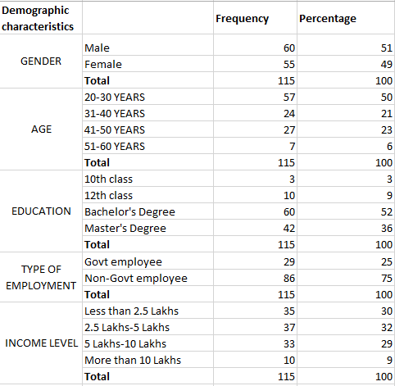

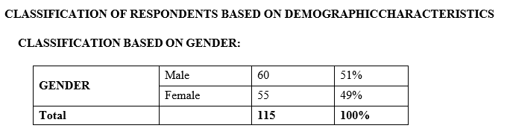

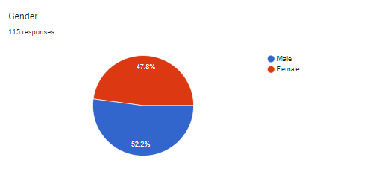

**INTERPRETATION**

Above chart shows the gender distribution of respondents among salaried people, with 55 female respondents and 60 male respondents out of a total of 115 respondents. Men and women make up a significantly different number of respondents, which highlights the different levels of interest among the respondents.

The graphical representation of gender distribution, demonstrates that female respondents outnumbered male respondents. More specifically, the sample is made up of 52.2% men and 47.8% women. Reduced awareness and resistance to taking the survey could be blamed for the drop in the proportion of female responders.

The response rates seen here may also be used as a gauge of survey respondents' interest in and familiarity with taxes. It is clear that male respondents are far more interested in and knowledgeable about taxes than female respondents.

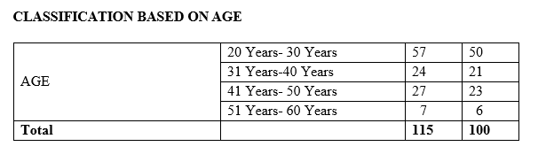

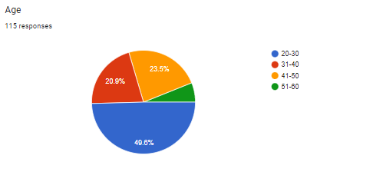

**INTERPRETATION**

The distribution of participants' ages is shown in the following chart, which contains important data on the demographics of the study's participants. Respondents are divided into age categories for analytical purposes.

A quick examination reveals that the majority of survey respondents—49.6% of all responses—are between the ages of 20 and 30.

The second-largest group, which consisted of respondents aged 41 to 50, provided 23.5% of the total responses, which takes us to the next age bracket.

Following that, respondents make up 20.9% of the sample for people aged 31 to 40, indicating a steady reduction in participation.

The age range of 51 to 60 years, which makes up just 6% of survey respondents, is the youngest.

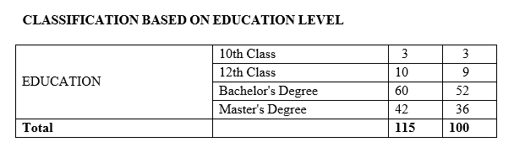

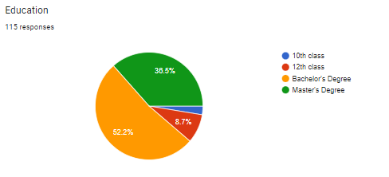

**INTERPRETATION**

Having only 52.2% of respondents, those having a history of secondary education made up the survey's smallest group. While the proportions of respondents with a Master's degree and those with only a 12th-class education were, respectively, 36.5% and 8.7%.

It's intriguing that most study participants hold bachelor's degrees, while individuals with only a 10th-class education are the least represented.

The wide range of replies may be linked to the population's rising levels of educational awareness. Additionally, the presence of a knowledgeable sample suggests a favourable and even considerable influence on the findings of the study.

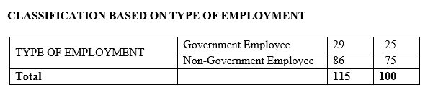

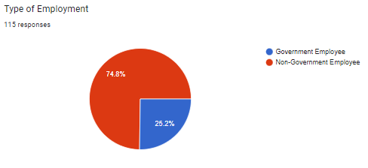

**INTERPRETATION**

When comparing the numbers of responders from government and non-government workers, a dramatic discrepancy quickly emerges. One-third of the 115 participants, or 86 people, work for the non-government sector, while only 26 people are employed by the government. The frequency of replies from non-government employees in the research is unmistakably highlighted by this data.

The chart graphically displays the distribution of employees in the sample who work for government and non-government organisations. Government personnel made up only 25% of all responses, while non-government workers made up a sizeable 75%, as seen in the pie chart that was provided.

The survey respondents' differing degrees of tax expertise may be the cause of this substantial difference in the statistics.

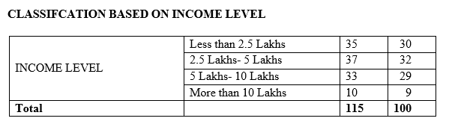

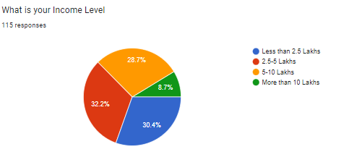

**INTERPRETATION**

The sample clearly demonstrates that those earning between 2.5 lakhs and 5 lakhs per year make up the majority, while those making more than 10 lakhs per year are the least represented.

Notably, people with incomes less 2.5 lakhs make up a sizeable 30% of all responses. 32% of the respondents fall into the next income range, which is between 2.5 lakhs and 5 lakhs. Individuals reporting earnings between Rs. 5 lakh and Rs. 10 lakh is 29% and those reporting incomes over Rs. 10 lakh, 9% of the total responses.

**FINDINGS AND DISCUSSION**

**FINDINGS**

Tax Literacy: The study found that the salaried respondents had various levels of tax literacy. A sizable portion showed a fundamental comprehension of tax ideas, whereas a smaller proportion displayed a high level of tax literacy.

Tax Compliance Behaviour: The study evaluated tax compliance behaviour using criteria such timely filing, correct income reporting, and compliance with tax laws. Higher tax literacy levels were found to significantly correlate with better tax compliance behaviour.

Demographic Influence: The investigation revealed that variables like income and education level had a significant impact on tax literacy. Salaried people with greater incomes and educational levels typically have a better understanding of taxes.

Multiple regression analysis was used to examine the direct relationship between tax literacy and tax compliance while accounting for demographic factors. According to the regression analysis's findings, tax compliance and tax literacy have a statistically significant positive link.

**DISCUSSION**

1. The role of tax literacy in affecting tax compliance behaviour is emphasised by the study. Salaried people are more likely to comply with tax duties, filing deadlines, and accurate reporting if they have a better understanding of tax principles and rules. This is consistent with the idea that knowledgeable taxpayers are more aware of their duties and have a deeper understanding of the repercussions of non-compliance.

2. Imbalances in Education and Income: The association between higher educational attainment, income, and tax literacy that has been observed emphasises the need to rectify any imbalances that may exist. Initiatives aiming at enhancing tax literacy at all levels of education and income should be taken into consideration by policymakers. Governments can attempt to achieve a more equitable distribution of compliance behaviour by raising tax literacy across the board.

3. Policy Implications: The research provides insightful information for creating policies. Governments and tax agencies may spend money on seminars and education programmes aimed at raising the level of tax literacy among salaried people. Such initiatives could encourage a compliance culture, enable taxpayers to make well-informed decisions, and lessen inadvertent mistakes brought on by a lack of understanding.

4. Future Research Directions: While this study demonstrates a connection between tax compliance and knowledge, it also offers the way for further investigation. Future studies should look into the effectiveness of different tax education strategies, the impact of tax literacy on different taxpayer populations (including self-employed individuals), and the long-term impacts of higher tax literacy on sustained compliance.

**CONCLUSION**

The study's findings showed a favourable and statistically significant relationship between tax compliance and tax literacy among the sample of salaried respondents. Salaried people who were more tax-literate showed better compliance with tax laws, prompt submission of forms, and correct income reporting. This alignment emphasises how important tax literacy is in helping taxpayers understand their responsibilities and the consequences of non-compliance.

The study also showed that major influences on tax literacy levels came from variables like income and education level. Tax literacy improved with higher income and educational achievement. This highlights the need for focused educational initiatives that cater to people with different educational and financial backgrounds, ensuring that tax literacy is available to all demographic groups.

These findings have consequences for both developing policies and putting them into practise. Governments and tax authorities can use the knowledge acquired from this study to create efficient educational initiatives that improve tax literacy among salaried people. Authorities can promote a culture of compliance and minimise inadvertent mistakes that result from failing to provide taxpayers with the information they require to successfully navigate the complexities of tax legislation.

**REFERENCES**

J. Alm, M. McKee, et al. As a game of coordination, tax compliance. 54(3), 297-312 Journal of Economic Behaviour & Organisation.

(2010) Kirchler, E., and Wahl, I. Inventory for tax compliance TAX-I: Creating a list of items for surveys on tax compliance. 31(3), 331-346, Journal of Economic Psychology.

(2002) James, S.; Alley, C. Tax administration, self-assessment, and conformity with the law. 2(2), 27–42, Journal of Finance and Management in Public Services.

B. Torgler (2007). Evidence from the US on tax compliance and tax morale. In: Torgler, B., J. Martinez-Vazquez, and J. Alm, editors. Creating Different Frameworks to Describe Tax Compliance. 64–114. New York: Routledge.

Martinez-Vazquez, J., Cummings, R. G., and McKee (1999). Cross-cultural variations in tax compliance behaviour: Evidence from the United States and Venezuela. 39(3), 297-319; Journal of Economic Behaviour & Organisation.

(2002). Feld, L. P., and Frey, B. S. How taxpayers are handled breeds trust. 87–99 in Economics of Governance, 3(2).

G. Richardson, A. Sawyer, and others (2001). The effect of tax knowledge on attitudes towards compliance and perceptions of tax justice. Applied Accounting Research Journal, 6(2), pp. 39–60.

(2012). Palil, M. R., Mustapha, A. F., and Ismail. The impact of tax knowledge on Malaysian taxpayers' compliance behaviour. 352–357 in Procedia-Social and Behavioural Sciences, 65.

(1989) Beck, P. J., and Jung, W. Evidence from state general sales tax about tax evasion and the origins of tax complexity. Journal of Public Finance, 17(4), 409-429.

Jackson, B. R., McKee, and Alm (1992). Utilising experimental data to estimate the factors that influence taxpayer compliance. 107–114 in National Tax Journal, 45(1).