**RESEARCH PAPER- TERM PAPER**

**TITLE: Impact of gender prejudice on recruiting and selecting employees**

**DATE: September 26th, 2023**

**TUESDAY,**

**Submitted to: vishruth sir (professor)**

**PES UNIVERSITY, BANGALORE**

**Keerthana k**

**PES1202202832**

**PES1PG22MB11**

ABSTRACT

Orientation predisposition in the working environment is an unavoidable and complex issue that keeps frustrating advancement toward orientation equity. This theoretical article gives a thorough outline of the complex idea of orientation predisposition, its fundamental causes, its extensive ramifications for people and associations, and expected systems to moderate its effect. Orientation predisposition in the working environment alludes to the out-of-line treatment, mentalities, and assumptions coordinated towards people in light of their orientation, with ladies frequently confronting fundamental drawbacks. This theory investigates the assorted appearances of orientation predisposition, dives into its underlying drivers, inspects its significant repercussions, and presents likely answers to address this squeezing concern. The task of assigning foreordained jobs, ways of behaving, or characteristics to people given their orientation, propagating destructive stereotypes Gender pay gaps continue around the world, reflecting aberrations in profit among people and frequently coming about because of fundamental segregation. Ladies are much of the time underrepresented in positions of authority and experience slower vocational movement compared with their male partners. Provocation and Occasions of lewd behavior and unfair practices establish unfriendly workplaces and impede ladies' professional success. Orientation predisposition can add to troubles in adjusting work and family obligations, putting an unbalanced weight on ladies A few elements add to the propagation of orientation. Firmly established cultural assumptions and generalizations about orientation jobs shape discernments and ways of behaving in the working environment. Oblivious predispositions held by people can impact independent direction, prompting accidental segregation. Hierarchical designs and strategies may coincidentally support orientation inclinations, like unbendable work hours or an absence of family-accommodating strategies. The lack of portrayal of ladies in administrative roles can propagate predisposition, as good examples and tutors are urgent for professional success. Orientation inclination claims a high cost for people and Orientation predisposition adversely influences the confidence, psychological wellness, and occupation fulfillment of impacted representatives. Associations pass up the different viewpoints and abilities of ladies, which can block development and seriousness. Organizations might confront legal and reputational ramifications for neglecting to address orientation predisposition satisfactorily. To battle orientation inclination, associations can carry out different systems. Effectively advance variety and incorporation through arrangements, preparation, and initiative responsibility. Guarantee fair pay structures and routinely review pay to recognize and correct orientation-based pay inconsistencies. Offer adaptable work game plans to help balance fun and serious activities for all representatives. Lead inclination mindfulness projects to help representatives perceive and address their predispositions. Lay out encouraging groups of people and partiality gatherings to cultivate a feeling of having a place and mentorship, which are valuable open doors for underrepresented gatherings.

Keywords: discrimination, workplace, harassment, family accommodation, stereotypes.

MBA, (3RD) TRISEM, PES UNIVERSITY

INTRODUCTION:

Gender prejudice in the selection and recruitment process is an unwelcome issue in most companies that can crucially collide with the working environment and continue inequality in the workplace. Gender bias refers to intolerance or unfair practices against a single discrete based on their gender during the recruitment process. This procedure of bias can affect both men and women in their workplace, although it creates an inordinate between women in many cases. Across the globe, many countries/ societies have deeply existed for generations regarding gender bias selection and stereotypes, determining how recruiters notice the capability and the suitability of individuals for specific job roles. These prejudices can unwittingly influence hiring managers, recruiters, and HR professionals as they evaluate job candidates. One of the easiest or unseasonable stages where gender prejudice appears is in job advertisements. This might create an unintentional bias between the individuals due to the language that is posted in jobs. for example, “strong leader” or “competitive” could hinder women from applying to certain jobs that they see these terms as more manly. As the recruitment process advances, gender prejudice can be undergone during resume screening. An unconscious prejudice can lead to the treatment of comparing resumes from one gender over another even though the qualifications and experiences are alike. This prejudice can cause underrepresentation of gender who are shortlisted. Additionally continuing the gender gap. The purpose of conducting a recruitment and selection process is to identify one’s capability and ability to acquire a job that depends on their qualification and talent. Gender prejudice occurs when individuals are evaluated knowingly or unknowingly by their gender rather than by their qualifications. This kind of behavior can influence many people in many ways and ruins the fulfillment of a genuinely different and comprehensive labor force. Gender prejudice often influences job descriptions and requirements. Some professions relate to specific gender prejudice. Women think that they do not fit in the mold as the role of leadership is only suitable for masculine. Tending to recruitment and selection isn't simply an issue of social societies, it is likewise a question of monetary significance. Research has reliably shown that different groups are more inventive, innovative, and useful, which at last advantages the primary concern of associations. By disregarding gifted competitors because of orientation inclination, organizations pass up important commitments that could drive development and seriousness. In recent years, gender prejudice has created awareness about the recruitment and selection process as many organizations have inculcated a transparent and unbiased recruiting process which includes blind resume screening, structured interviews, and diversity training. Regardless of these efforts, the recruitment and selection process remains a constant challenge. This issue requests progressing watchfulness, instruction, and a promise to change at each level of an association. organizations can make a critical stride toward building more comprehensive, different, and fair work environments. Gender prejudice in the process of recruitment and selection process is a squeezing worry in India. This predisposition presents imposing difficulties to accomplishing orientation fairness and evenhanded work valuable open doors for ladies, as well as people of other minimized orientation characters. This article investigates the multi-layered components of orientation predisposition in India's enlistment and choice cycles and proposes likely solutions for addressing this profoundly imbued issue as India's work market has for quite some time been affected by conventional orientation jobs and generalizations.

Women's experience in some organizations is very crucial as they face consequences like harassment, gender bias, color discrimination, personality discrimination, and many other aspects. Women make up 53.5% of the workforce in law,68.4% in higher education, and 77% In health care. However, women are the backbone of industries still they are still facing gender prejudice. One model is obliged correspondence, in which ladies must be careful while communicating authority and minimizing their achievements. They revealed the absence of affirmation for their commitments and being interfered with by men while talking. Furthermore, in any event, when ladies were very much addressed, their work environment frequently still had a young men's club mindset where choices were made for the most part by men. The members were on occasion on a glass bluff, being considered liable for issues unchangeable as far as they might be concerned. They frequently needed coaches and patrons. What's more, ultimately, a few ladies viewed it as no other decision except to restrict their goals because of individual commitments. As such, their working environment was not strong in consolidating work with family. Past these boundaries, our outcomes showed outstanding contrasts in different parts of orientation predisposition between the businesses. To build a trustworthy relationship between the employees the organization should make sure to conduct a fair interview without discriminating, by this it makes them make better decisions and communication. it creates a better value for the employees in the organization. Gender prejudice occurs because, by the expected set of responsibilities, there will be things and pronouns of people for going after jobs in the position. In numerous nations remote positions assumed a crucial part during the pandemic, Not simply have delegate soul and harmony among fun and serious exercises improved with less break and about and extra open doors for exceptional objectives and family responsibilities. A few associations, such as Salesforce and Field Drugs, have moved to full-time remote work. In different businesses like advanced education, a half-breed labor force might be ideal.

The employment gap between men and women in India is higher than in any other country by 98%. Even in the company when the employees get a reward or promotion it is based on a different personal perspective but coming to the women even though they get the same promotion their pay will be lesser than men who achieved the same promotion.

PROBLEM STATEMENT:

the problems faced by the recruitment and selection process in any organization have many issues that affect the candidate's true talent and ability to get the job, Here are some of the issues that have been faced by the candidates in interviews.

* Some company restricts a woman from doing certain jobs by discriminating according to their gender prejudice This limits their career opportunity, independent living, and professional growth.
* There is also a problem with the wages that are given to the candidates as women always tend to opt for lower salaries than men.
* It is believed that gender prejudice can create issues of leadership as it can only be managed by men and not by women where it is difficult to adopt the leadership qualities by women easily.
* At the point when the association searches for just exceptionally qualified individuals rather than the abilities of its competitors, it could lose the capacity to get the right applicant into the organization.
* Affiliations that disregard to address direction tendencies could miss business opportunities associated with assortment and thought, for instance, by zeroing in on various client sections effectively.

LITERATURE REVIEW:

Kunda Gideon 1992. Engineering Culture: Control and Commitment in a High-Tech Corporation. Philadelphia, PA: Temple University Press.

Leidner Robin 1993. Fast Food, Fast Talk: Service Work and the Routinization of Everyday Life. Berkeley, CA: University of California Press.

Chambliss Elizabeth, Uggen Christopher 2000. “Men and Women of Elite Law Firms: Reevaluating Kanter's Legacy.” Law and Social Inquiry 25: 41–68.

Nelson Robert L. 1988. Partners with Power: The Social Transformation of the Large Law Firm. Berkeley, CA: University of California Press.

Eliasoph Nina, Lichterman Paul 2003. “Culture in Interaction.” American Journal of Sociology 108: 735–94.

Goldhaber Michael D. 2000. “In Macho Territory.” The National Law Journal February 7: A1.

Heilman Madeline E. 1983. “Sex Bias in Work Settings: The Lack of Fit Model.” Pp. 269–98 in Research in Organizational Behavior, vol. 5, edited by Staw Barry M., Cumming Larry L. Greenwich, CT: JAI Press.

Jacobs Jerry 1989. Revolving Doors: Sex Segregation and Women's Careers. Stanford, CA: Stanford University Press.

Johnston Hank 1995. “A Methodology for Frame Analysis: From Discourse to Cognitive Schemata.” Pp. 217–46 in Social Movements and Culture, edited by Johnston H., Klandermans B. Minneapolis, MN: University of Minnesota Press

OBJECTIVES:

* EQUAL OPPORTUNITIES:

All genders are equal hence, every candidate should be treated with an equal opportunity without any discrimination, This results in balanced criteria for men, women, and individuals of other genders

* TRANSPARENT SELECTION:   
  every company must be aware to evaluate the candidates according to their qualifications, skills, and interests rather than gender prejudice. the aim is to reduce as much as unconscious prejudice of the gender of one candidate over another candidate.
* LEGAL LAWS:  
  many countries have already adopted the scheme of eliminating gender prejudice and discrimination by having certain laws and regulations One goal ought to be to agree with these legitimate necessities to stay away from lawful outcomes and maintain moral principles.
* DEVELOP ORGANIZATIONAL CULTURE:  
  by keeping in mind the issue of gender prejudices the organization can develop a decent equal transparency culture for each candidate. This can prompt higher working confidence and develop employee maintenance.
* LESS TURNOVER:  
  Coming to gender bias it faces lower turnover rates as the candidates or employees tend to stay only if there is value to their identity and respect and get equal opportunities.

PROS AND CONS OF GENDER PREJUDICE:

Gender prejudice has both advantages and disadvantages respectively, gender prejudice has been deeply ingrained in our society. It is situated in the workplace between men and women by discriminating between color, gender, personality, and favoritism. Here are some of the pros and cons of gender prejudice,

* ABILITY TO MAKE DECISIONS:  
  it's good to make better and quicker decisions in the organization to reduce the issue of facing the consequences. For example, I, being the HR/interviewer, has to make quick decision while selecting the candidate for the role that is vacant and need to be filled soon. The judgment that is based on gender stereotypes may not be true or a good evaluation sometimes but It will help to make better decisions.
* ARROGANT VIEWPOINTS:  
  only men can bring out an aggressive debate that is strong and specific. When group discussion is conducted in the organization men have stronger leadership qualities, as they know how to argue with the point by creating a professional environment rather than carrying by emotions.
* SEEKING EMPATHY:  
  society frequently encourages a misinterpretation of female perspectives that they are more sympathetic than their male partners.

women who are in higher positions can utilize this generalization for their potential benefit by being more congenial. They can consequently make their workers more joyful and more useful and make decent compatibility with youngsters who will quite often find true success.

* HANDLING WORK EFFICIENTLY:  
  men have a strong ability to handle some field work or other physical work that may or may not be handled by women so here women can depend on men to uplift their physical field work which is difficult to do. An opportunity can be grabbed by gender stereotypes.
* BUILD COMMUNICATION SKILLS:

Women tend to chat too much in the organization's “chatterbox” which might create a good or bad reputation among the organization and people. Women who are good at speaking too much can build better public speaking.

DISADVANTAGE OF GENDER PREJUDICE:

* Envy among collaborators:  
  every organization will have envious employees, getting jealous of everything, every person in the organization. Jealousy is not good behavior as it leads to complications or disruption among the employees. It might cause hatred between the group of people and the organization's growth decreases.
* DISAGREEMENT BETWEEN EMPLOYEES:

Every employee has a decision to be made and it should be respected. Every employee should have equal rights and authority without gender prejudice. If an employee is assigned some important tasks it might lead to discord as other employees also have to take part in it or it will lead to a quarrel.

* FEWER PROMOTION:  
  Due to gender prejudice, there might be complications regarding the promotion. Even though every employee is rewarded with promotion it also depends on the gender, perspective, and language of the employee. This might occur because of the discernment that specific jobs are more qualified for men. Such inclination can cause a ton of indigestion and disdain among individuals who merit advancement and severely affect the workplace climate.
* DISCORD BETWEEN HIRING AND FIRING:  
  Orientation-based generalizations assume a significant role in recruiting and terminating representatives, even inside huge associations. Inside Fortune 500 organizations, women make up just 15% of corporate official positions and not exactly 2% of president-level positions. Hence, the possibility of ladies getting top administration-level positions is very low.
* LESS RECOGNITION:  
  every person/employee has equal rights to succeed and achieve their goals, it is the women who are targeted every time they achieve their goals. even though women achieve their tasks, they have been judged by their capabilities and are not recognized much in the organization.

TYPE OF GENDER PREJUDICE:

* **AFFINITY PREJUDICE:**

Affinity prejudice refers to the favoritism of the candidate who is presented in the interview, who shares a similar topic or the same character of their perspective. Being alike with the topic or with the person plays a vital role in this affinity prejudice but this leads to an unconscious prejudice knowingly or unknowingly.

* **CONFIRMATION BIAS:**confirmation bias is the issue where the interviewer might know some of the past existing information about the candidate and believe that it is true and reject the candidate according to their perspective of belief they got from their past. This lacks fair evaluation to bring the right candidate to the organization.
* **HALO EFFECT:**a single positive impression can build the entire impression of a candidate without concerning the proper information about the candidate. This might lead to an unfair evaluation of selection, and it changes the perspective of the person who might not be a good fit for the job but has a positive impact on him.
* **HORN EFFECT:**the horn effect is the right opposite of the halo effect where one negative information can impact the candidate's impression overall perspective and unfair evaluation might take place.

SOLUTION FOR GENDER PREJUDICE:

RAISE AWARENESS:  
it is important to create awareness about gender prejudice among the people of the organization and make them create an optimistic behavior toward gender equality and treat everyone equally.

IMPLEMENTING THE BLIND RESUME SCREENING:  
blind resume refers to the evaluation of people’s resumes according to their skills, qualifications, and talent. Blind resume screening does not include name, address, and other personal information that might affect the candidate’s performance.

USING STRUCTURED INTERVIEW:  
by developing a structured interview system, that includes standardized questions that are the same for all the candidates, This results in fair interviews and no discrimination taking place. It also ensures consistency.

CONDUCT FAIR EVELAUTAION:  
in the organization giving equal rights to everyone is important and it builds a good relationship between the candidate and the interviewer. In an interview, it is good to make better decisions and evaluate fairly to determine the candidates according to their skills, intelligence, and qualifications.

METHODOLOGY:

This study is conducted by using Google Forms to get reviews from employees working in the organization students, HR, etc. All these roles are very important to get the relevant answers for all the problems people face from gender prejudice in their respective organizations. It is very important to know about the discrimination that is happening and to make it fair enough to get rid of the gender prejudice.

SCOPE :

The scope in the recruitment and selection process of gender bias is huge by encountering discriminated resumes, prejudiced job descriptions, inequitable interview evaluations, unfair hiring processes, income gaps, and dismissive impact on the workplace. This study is mainly focused on gender prejudice, how to overcome this in organizations, how to implement equal opportunity standards, and how to make fair decisions

SAMPLINGS:   
here, I have gathered the information from students, employees, HR, managers, and other self-employed people. who has attempted to clear all the doubts about gender prejudice and discrimination and share their perspective side of gender bias.

POPULATION: I gathered information from a group of people who are working in organizations and facing the same issue of gender prejudice even now and some companies are yet to implement the solution for this issue.

DATA COLLECTION:



To examine gender prejudice in the recruitment and selection process the primary data is used by providing Google forms to the people who are working in their companies and gather all the information regarding gender bias, discrimination, and other issues happening in the organization, and how the organization is trying to resolve this issue and giving the equal opportunity and a transparent selection in hiring the candidates.

Every piece of data is collected to encompass the issue and to resolve it. It is an individual review that I gathered according to their perspective.

PRIMARY DATA

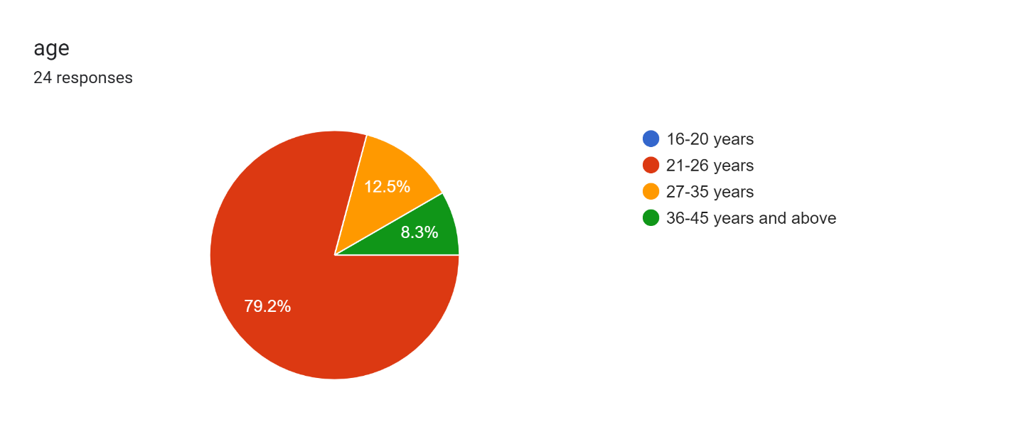



here, the responses I got for age range from 21 years to 45 years, these include student, employee, self-employed, manager, and HR. according to their response, I have gathered information on gender prejudice.

the different age group has different opinion regarding gender prejudice and all the consequence they have faced or they have come across.



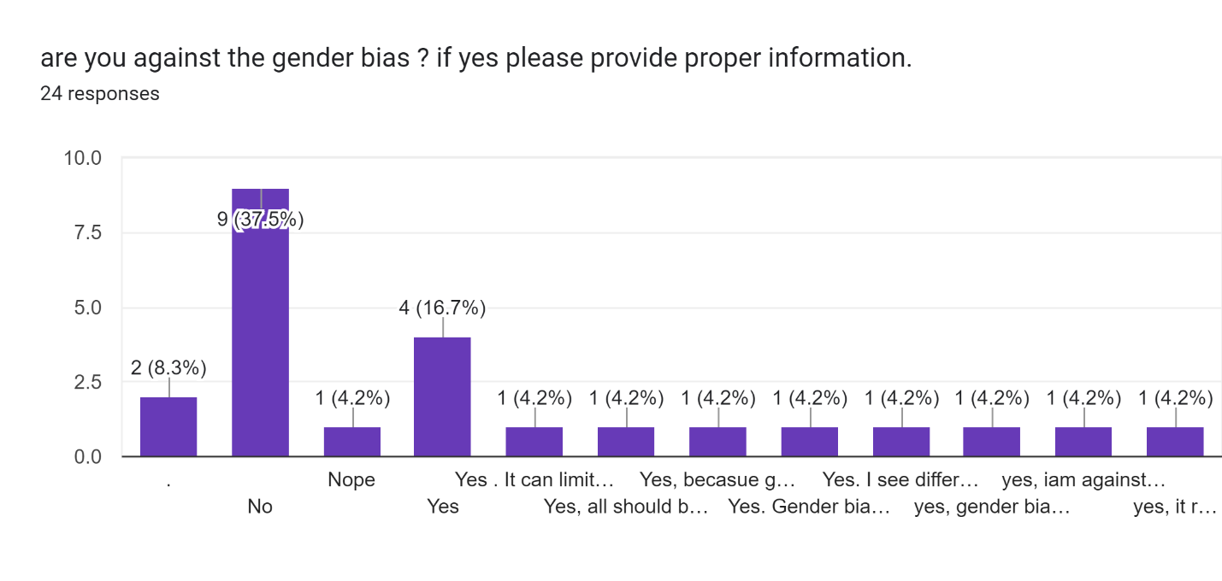  
the question asked here is against gender bias, and according to the response, says that people are against gender prejudice and says it should not be considered in the organization as it might lead to a bad relationship between the candidate and the interviewer. It creates a wall of discrimination among themselves and might lose their opportunity.



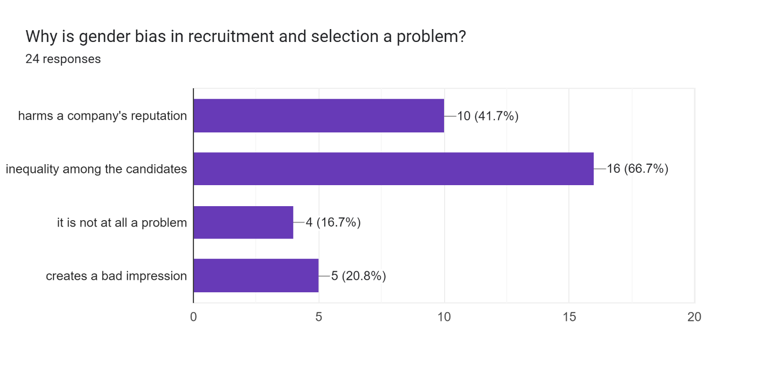



Gender prejudice has created a problem in recruiting and selecting the candidates that are right for the role and qualification, companies are failing to adopt a fair evaluation in an interview as this can lead to a lack of trust and create a bad impression on the organization., 66.7% people have said it’s the inequality among the candidates and 41.7% says it might harm the company reputation due to gender prejudice.

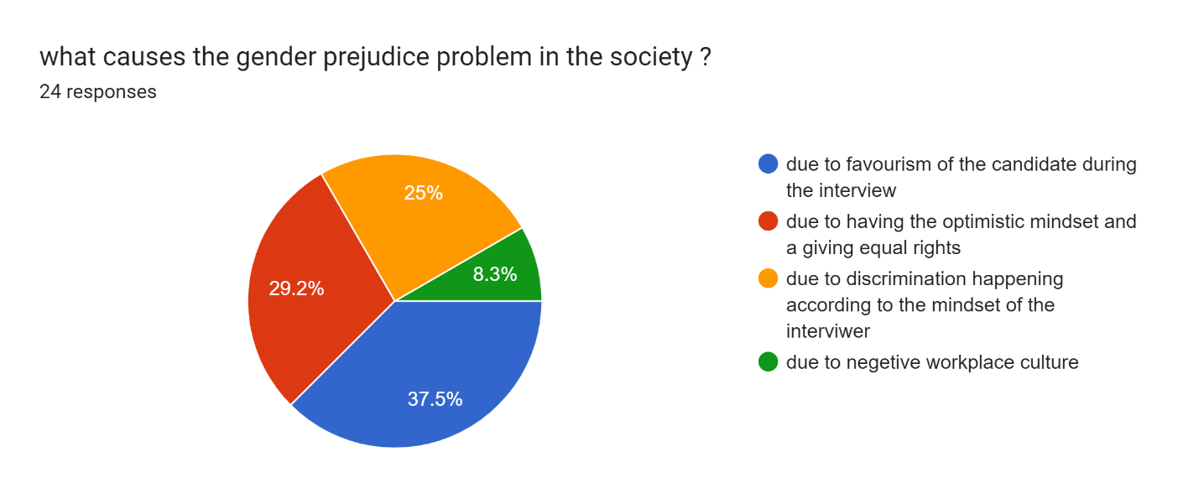  
due to discrimination, favoritism, negligence, and gender prejudice creating a bad impression.



This causes the candidates to lose their jobs even though they are eligible for the role that is present.

Forms response chart. Question title: How can gender bias manifest in job postings?
. Number of responses: 24 responses.



Forms response chart. Question title: How can organizations address gender bias in recruitment?
. Number of responses: 24 responses.



The organization can address gender prejudice by raising awareness about it, implementing fair evaluation of blind screening, establishing diverse and standardized interviews for the candidates, and treating them with equal opportunity.

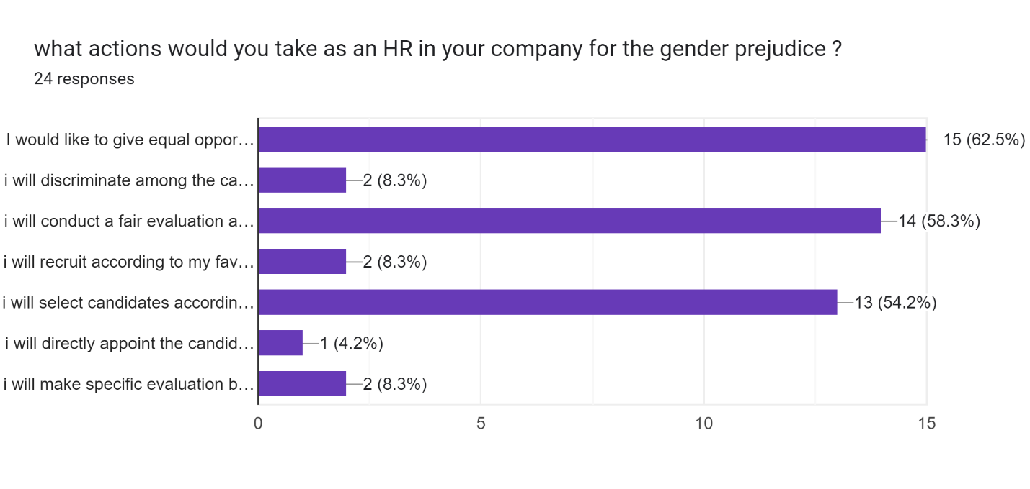



As an HR what actions would you take? So the response I got here is,

* Giving equal opportunity
* Conducting fair evaluation based on skills and qualifications.
* Selecting candidates based on blind screening interviews without discrimination.

RESULTS AND DISCUSSIONS

Orientation predisposition in the enrollment cycle stays a steady test in the present labor force. Despite critical advancement in advancing orientation balance, numerous associations keep on wrestling with oblivious predispositions that influence recruiting choices. To fabricate more assorted and comprehensive work environments, significant to carry out procedures effectively to relieve orientation inclination all through the enrollment cycle. Implementing blind application surveys can be a successful method for decreasing orientation predisposition. This approach includes eliminating all recognizable data from resumes and applications before they arrive at the recruiting administrator. Along these lines, choices depend exclusively on capabilities and abilities, as opposed to orientation or other segment factors. Guarantee that the employing boards themselves are different. Having a blend of people from various foundations and sexes engaged with the recruiting system can assist with balancing predisposition by offering different points of view and lessening oblivious obedience. Utilize organized interviews with normalized questions and assessment measures. This guarantees that all applicants are surveyed reliably, making it harder for orientation predisposition to crawl into the assessment cycle. Required oblivious predisposition preparation for all representatives engaged with the recruiting system can be helpful. It helps bring issues to light about intrinsic predispositions and outfits staff with the apparatuses to perceive and check them. Foster clear and objective rules for sets of responsibilities and capabilities. Try not to utilize gendered language that might deter underrepresented bunches from applying. This guarantees that work postings draw in a different pool of up-and-comers. Consistently track and distribute a variety of measurements connected with enlistment. By considering associations responsible for their employing rehearses, straightforwardness urges them to move toward diminishing inclination. Make mentorship and sponsorship projects to help the vocational development of underrepresented people inside your association. This helps span orientation holes and gives potential open doors to ladies to progress into influential positions. Offer adaptable work game plans and family-accommodating arrangements to draw in and hold female ability. Such arrangements can assist with addressing the orientation pay hole and urge ladies to stay in the labor force. Consistently survey and change remuneration designs to guarantee pay value inside the association. Straightforward compensation scales can assist with wiping out orientation-based pay aberrations. Support open correspondence with up-and-comers and workers about their encounters with the enrollment cycle. Follow up on criticism to constantly improve and refine your procedures for decreasing orientation predisposition. Guarantee consistency against separation regulations and guidelines. Remain informed about developing regulations connected with orientation inclination and adjust your practices likewise. Decreasing orientation predisposition in the enlistment cycle isn't just about gathering a variety of portions; it's tied in with making a fair and comprehensive work environment where all people have equivalent chances to flourish. By carrying out these methodologies, associations can cultivate a culture of balance, draw in top ability from different foundations, and eventually benefit from the imagination and development that accompanies an assorted labor force. In the journey for orientation fairness, each step taken in the enlistment cycle carries us more like a more impartial future for all.

References

“Abdullah, T. and Zeidenstein, S. A. (1982) Village Women of Bangladesh: Prospects for

Change. Oxford: Pergamon Press.

Abecasis, D. (1990) Identity, Islam and Human Development in Rural Bangladesh. Dhaka: The

University Press.

Abu-Lughud, L. (1986) Veiled Sentiments: Honor and Poetry in a Beduin Society. Berkeley, CA:

University of California Press.

Ackerly, B. (1997) What's in a Design? The Effects of NGO Programme Delivery Choices on

Womens Empowerment in Bangladesh. In A. M. Goetz (ed.), Getting the Institutions Right for

Women in Development. New York: Zed Books, pp. 140160.

Adams, D. and Vogel, R. (1986) Rural Financial Markets in Low-income Countries: Recent

Controversies and Lessons. World Development 14: 477488.

Adams, D. W. , Graham D. H. and von Pischke, J. D. (1984). Undermining Rural Development

with Cheap Credit. Boulder, CO: Westview Press.

Afsar, H. (ed.) (1998) Women and Empowerment: Illustration from the Third World.

Basingstoke: Macmillan.

Agarwal, B. (1994) A Field of One's Own: Gender and Land Rights in South Asia. Cambridge:

Cambridge University Press.

Agarwal, B. (1997) Bargaining and Gender Relations: Within and Beyond the Household.

Feminist Economics 3(1): 151.

Ahmad, M. M. (2002) Who Cares? The Personal and Professional Problems of the NGO Field

Workers in Bangladesh. Development in Practice 12(2):177191.

Ahmad, M. M. (2003) Distant Voices: The Views of the Field Workers of NGOs in Bangladesh

on Microcredit. The Geographical Journal 169(1): 6574.

Ahmad, Q. K. (ed.) (2007) Socio-Economic and Indebtedness: Related Impact of Micro-credit in

Bangladesh. Dhaka: The University Press.

Ahmed, M. (1985) Status, Perception, Awareness and Marital Adjustment of Rural Women: The

Role of Grameen Bank. Grameen Bank Paper No. 31, Dhaka: Grameen Bank.

Ahmed, S. M. (2005) Intimate Partner Violence against Women: Experiences from a Women”