**CONTROL AND ANALYSIS OF ADULTERANT FACTOR OF FOUR STROKE IGNITION CYCLE**

***Parveen1, Mr. Vishant Kumar2 Dr. Hari Parshad3***

1Student, Department of Mechanical Engineering, School Of Engineering & Technology, A Unit Of Ganga Technical Campus, Soldha, Bahadurgarh

2Assistant Professor, Department of Mechanical Engineering, School Of Engineering & Technology, A Unit Of Ganga Technical Campus, Soldha, Bahadurgarh 3 Assistant Professor, Department of Mechanical Engineering, School Of Engineering & Technology, A Unit Of Ganga Technical Campus, Soldha, Bahadurgarh

**ABSTRACT**

The name of the engine reveals that it has a cycle with six strokes, of which two are the powerful ones. This reciprocating engine also has a two-stage charge progression and is capable of using both internal and external ignition. Because of its thermodynamic cycle, it completely differs from 2 and 4 stroke engines. This kind of engine has a "modified cylinder head" and "two supplementary chambers," one of which is a combustion chamber and the other is a chamber for heating air, both of which are completely independent of the cylinder. Due to the separation of the cylinder and combustion chamber, the design analysis of this type of engine is quite simple. Compared to a four-stroke engine, this sort of engine has two more valves, and both of those valves are driven by a piston arrangement. Because the volume change in the power stroke is greater than that in the compression stroke and intake stroke, this engine has a higher thermodynamic efficiency. This engine's main benefit is "the reduction in fuel consumption by 40%." There are two power strokes in each of the engine's six-stroke cycles, and it also produces less pollution than other types of engines. The vehicle industry's decision to use six-stroke engines would have a significant impact on the planet and the global economy.

Key words: Stroke, Engine, Efficiency, Fuel, Heat.

# INTRODUCTION

The burning that occurs in the chamber following each compression cycle in an internal ignition engine has one constant component and results in gas development that is limited to 180° of the crankshaft point and shows up directly on the cylinder (the work). The six-stroke engine[1] with internal and external ignition and two streams is similar to a real internal responsive ignition engine, as shown by its mechanical design. In any event, due to its thermodynamic cycle and an adjustable chamber head with two beneficial chambers, it completely distinguishes itself: Although it doesn't occur inside the chamber, combustion does not act fast on the cylinder in the favorable burning chamber, and it is free from the 180° crank shaft revolution that occurs during the growth of the burning gases (work).

The air-warming room entirely encloses the burning chamber. Air pressure in the warming chamber rises due to heat exchange through the shining ignition chamber partitions, which in turn creates control for a useful work stroke. This leads to a few advantageous circumstances, the increase of warm efficacy being one of the most significant. The crucial cooling of the ignition chamber dividers results in large calorific losses in the modern internal ignition engine. Burning occurs in the main chamber with each turn, just like in a two-stroke engine, and with oil, just like in a four-stroke engine.Fuel injection can occur in the cylinder charger[2], in the gas move divert or in the ignition chamber. It is likewise conceivable to charge two working

# LITERATURE REVIEW

### Six Stroke Engine

This segment clarifies the valuable angles in a six stroke motor which doesn't exist in a 4 stroke engine. The significant contrasts between 4 are 6 stroke engine are the additional 2 strokes of which the fifth stroke is the power stroke. It is of 2 kinds recorded underneath:

### Air Induction System

The six-stroke engine, as previously discussed, is primarily used for high output and efficiency[3]. The air from the air channel is subsequently passed to the mass stream sensor by a noticeable all-around acceptance mechanism. Although there is also an admission temperature sensor that aids in determining temperature, the mass wind stream sensor in the system displays the wind stream. It goes without saying that the system will have a high compression ratio due to the high power and efficiency. This causes the system to activate the explosive impact or pre-start. These days, a suppressor is used to eliminate the noises that this hit causes. Due to the turbochargers and superchargers in the engine, which heat the inlet air , the air acceptance system requires high temperature entrance air. The intercoolers, which assist in lowering the temperature of the hot packed air and so reducing its weight, can also aid to dissipate this heat. This broadens the show by removing heat from the environment. Flying machines use this method because it provides more power and is useful in high burden limit motors.

### 

### Water Injection

The specific heat estimate for water, as it is known for its solid qualities, is around 4.18 J/g°C. Water or any other fluid's vaporization is determined by a parameter known as "the idle heat of vaporization"[4], which determines how water changes from a fluid to a vaporous state. The four-stroke motor has one force stroke in addition to the additional power stroke seen in the six-stroke engine. Water is infused into the system after the admission, compression, start, and exhaust strokes. It is done to prepare for a systemic explosion. The air is subsequently introduced into the fifth stroke, which causes a system weight that is unusually high and allows ascent to higher pressures.

These weights and temperatures cause an unstable air consumption pattern, which turns out to be harmful to the engine. Once the temperature has reached or exceeded 40°C, the water infusion mechanism is activated. It provides the framework with higher pressure ratios, which giv es the framework antiknock qualities that assist protect it against explosion and provide a powerful power stroke. Initially, the Boeing B-52 used water infusion for takeoffs since such systems are necessary for vehicles with larger burden carrying limits. Since water has a larger heat injection limit than air and when air assimilates the warmth and expands in the fifth stroke, it produces high weights in the engine head that lead to high weight on chamber, the water infusion method is argued to be superior to the air recruitment strategy.

### Hybrid Technology

A hybrid between a gas-powered car and an electric vehicle, the gas electric crossover vehicle is exactly what it sounds like[5]. A fuel tank is a feature of a gas-powered vehicle that supplies gas to the engine. At that point, the engine rotates the transmission, which moves the wheels. The hybrid is a compromise. In order to overcome the drawbacks of an electric vehicle, it aims to radically increase the mileage and reduce emissions of a gas-powered vehicle. A vehicle must satisfy a few fundamental requirements in order to be useful to you or me. Ideally, travel at least 300 miles (482 km) before reviving. be successfully and quickly refueled. Follow the flow of the other on-street traffic.

These requirements are met by a gas vehicle, although it pollutes somewhat heavily and typically gets bad gas mileage. Even so, an electric car can only travel 50 to 100 miles (80 to 161 km) between charges while producing no pollution. Additionally, the difficulty in recharging the electric car has been a problem. These two systems, which combine gas and electric power, are combined into one in a fuel electric car. Vehicles that are fuel electric hybrids include the auxiliary components. Gasoline engine: The crossover vehicle has a gas engine that is similar to those found in the majority of cars. However, the engine on a hybrid is smaller and makes use of cutting-edge technologies to reduce outflows and increase efficiency. Fuel tank: The energy storage device for the gas engine in a hybrid is the fuel tank. Compared to batteries, gas has a far larger energy thickness. For instance, 1,000 pounds of batteries are required to store the same amount of energy as one gallon (7 pounds) of gas.

Modern electric engine: A hybrid car has an electric engine. It is capable of functioning as both an engine and a generator thanks to propelled devices. For instance, it can use energy from the batteries to accelerate the car if necessary. However, by acting as a generator, it may switch the car off and restore power to the batteries.

Generator: A generator is similar to an electric engine, however it just produces electricity. The majority of the time, it is used on arranging crossbreeds. Batteries: The energy storage mechanism for the electric engine in a hybrid car is the battery[7]. The electric engine on a hybrid car can both charge the batteries and draw power from them, in contrast to the gas in the fuel tank, which can only power the gas motor. Transmission: The primary role of the transmission in a hybrid car is the same as that of a regular car. A few half and half vehicles use conventional transmissions, much like the Honda Insight. Others have vastly different ones, such the Toyota Prius. In this way, the combination of six strokes and a hybrid car would result in an unheard-of motor vehicle that would not only improve the current eco-friendliness, efficient[8] framework with respect to its individual fuel efficiencies but would also completely re-establish the framework with regard to its mileage, power, control yield, and in particular its interest.

# PRINCIPLE

In order to capture the waste heat from the four-stroke Otto cycle and use it to manage an additional power and exhaust stroke of the cylinder, a six-stroke engine uses a variety of unique strategies in the interior ignition engine. Steam or air are used by structures as the working fluid for the additional power stroke. The extra stroke cools the engine and eliminates the need for a cooling system, making the engine lighter and providing 40% more productivity than the Otto Cycle. This is similar to reducing power. For each injection of fuel, the cylinders in a six-stroke engine rotate repeatedly in various directions.

The six-stroke engine has two power strokes[9], one of which can be either steam or air or fuel. The "Bajulaz engine," "Crower's" six-stroke engine, and the "six-stroke engine" are among the currently popular six-stroke engine designs. "The Beare Head engine[10]" is also a six-stroke but differs from the others. It uses a second opposed cylinder in each chamber that rotates at a significant percentage of the principal cylinder's regular speed, resulting in six cylinder developments for each cycle. There is no additional working liquid used. Instead of an air/fuel mixture (like in a petroleum engine), outside air is drawn into the chamber from the air channel after the first stroke and is ejected during the sixth stroke. The valve covers have been removed, and using air infusion, the additional two strokes have been better rummaged. The fuel consumption of the engine has decreased by 40%, and emotional pollution has decreased. It doesn't have as much explicit power as a four-stroke oil engine. The engine can be powered by a variety of fuels, including gasoline, diesel, and LPG. Comparing a modified engine to the four-stroke engine from which it was derived, the latter displays a 65% reduction in CO pollution.

# WORKING

The workings of six stroke engine are as follows below-

First stroke (“suction stroke”) - During the principal stroke, the inlet valve opens and fuel- air blend from carburetor is drawn into the chamber through the inlet chamber.

Second stroke (“compression stroke”) - During the subsequent stroke, cylinder moves from BDC to TDC, both the inlet compressed. valve and fumes valves are shut and air-fuel blend is

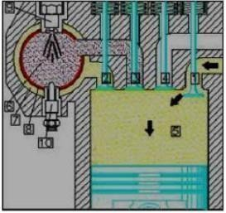

Figure 1 Suction Stroke of Six Stroke Engine

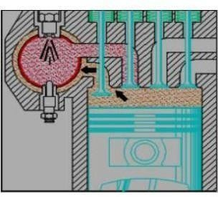

Figure 2 Compression Stroke of Six Stroke Engine

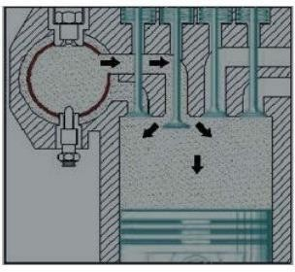

Figure 3 Compression Stroke of Six Stroke Engine

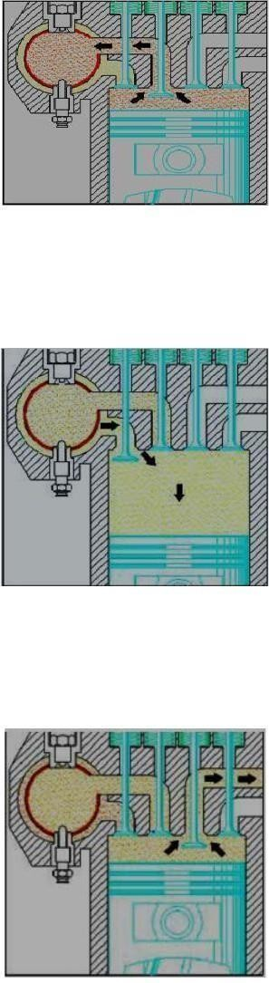Figure 4 Compression Stroke of Six Stroke Engine

Third stroke (“fuel power stroke”) - During the third stroke, control is gotten from the engine by lighting the air-fuel mixture utilizing a flash attachment. The two valves stay shut. Cylinder moves from Top Dead Center to Base Dead Center.

Figure 5 Fuel Power Stroke of Six Stroke Engine

Fourth stroke (“recompression stroke”) - During the third stroke, cylinder moves from Bottom Dead Focus to Top Dead Center. Both the inlet and the fumes valves are shut. Whencylinder arrives at Top Perfectly focused, water injector infuses water which is then changed over to steam.

Figure 6 Recompression Stroke of Six Stroke Engine

Fifth stroke (“steam power stroke”) - During the fifth stroke, the steam starts the subsequent power stroke. The two valves stay shut. Cylinder moves from Top Dead Center to Bottom Dead Center.

Sixth stroke (“Exhaust stroke”) - During the 6th stroke, cylinder moves from Bottom Dead Center to Top Right on target. The inlet valve stays shut. The fumes valve opens and the fumes gases are discharged.

# CONCLUSION

From the above information the idea and working of the six-stroke engine can be comprehended. Six stroke engine with all the ideal characteristics[11] as better from four stroke engine will hit the market soon. Diminishing fuel utilization and contamination with no impact on execution will reassessed

the idea of car. Just enhancements of innovation can assist it with advancing inside sensible time and budgetary breaking points. The six-stroke engine fits consummately into this view. Its reception by the car business would have a decent sway on the earth and world economy.

## REFERENCES

* 1. A.. Holkar and V. S. Jagadale, “Six Stroke Engine,” Int. J. Innov. Eng. Res. Technol., 2015.
  2. B. H. Qi, B. Chen, and D. Zhang, “Combustion and exhaust emissions characteristics of a dual-fuel compression ignition engine operated with diesel fuel and liquefied petroleum gas,”J. Energy Eng., vol. 142, no. 4, 2016.
  3. B. Doǧan, “The influence of n-butanol/diesel fuel blends utilization on a small diesel engine performance and emissions,” Fuel, vol. 90, no. 7, pp. 2467–2472, 2011.
  4. C. Huh and M. Hwan, “Flow Boiling in an Asymmetrically Heated Single Rectangular Microchannel,” in Evaporation, Condensation and Heat transfer, 2011.
  5. D. Liu, “Hybrid Electric Vehicle System Modeling,” in Hybrid Electric Vehicle System Modeling and Control, 2017, pp. 38–96.
  6. F. C. Bansal, “Electric vehicles,” in Handbook of Automotive Power Electronics and Motor Drives, 2017.
  7. J. Jaguemont, L. Boulon, and Y. Dubé, “A comprehensive review of lithium-ion batteries used in hybrid and electric vehicles at cold temperatures,” Applied Energy. 2016.
  8. H. N. Toosi, A. H. Kakaee, and H. Ebne-Abbasi, “Exhaust gas heat recovery through secondary expansion cylinder and water injection in an internal combustion engine,” Therm. Sci., 2017.
  9. H. Arabaci and Y. İçingür, “Thermodynamic investigation of experimental performance parameters of a water injection with exhaust heat recovery six-stroke engine,” J. Energy Inst., vol. 89, no. 4, pp. 569–577, 2016.
  10. “A REVIEW ON SIX STROKE INTERNAL COMBUSTION ENGINE,” Int. J. Adv. Eng. Res. Dev., 2016.
  11. H. Chen et al., “A new six stroke single cylinder diesel engine referring Rankine cycle,” Energy, 2015.