DRUG PROGNOSIS

Priyadharshini B^{1,a)} , Mahalakshmi S^{2,b)} , Mahmood Farshana S^{3,c)} and Shenbagaraman A M.E.,^{4,d)}

Author Affiliations

¹4th Year Student, Department Of Computer Science Engineering , National Engineering College , Kovilpatti .

²4th Year Student, Department Of Computer Science Engineering ,National Engineering College , Kovilpatti.

³4th Year Student, Department Of Computer Science Engineering ,National Engineering College , Kovilpatti.

⁴ Assistant Professor, Department Of Computer science Engineering National Engineering College, Kovilpatti.

Author Emails

^{a)}2012001@nec.edu.in

^{b)}2012026@nec.edu.in

^{c)}2012097@nec.edu.in
^{d)}sraman@nec.edu.in

Abstract

In the ever-evolving landscape of pharmaceutical research and drug development, the need for innovative approaches to predict drug outcomes has become paramount. This study introduces a pioneering method that harnesses the power of sentiment analysis in conjunction with Long Short-Term Memory (LSTM) algorithms to predict drug outcomes effectively. By analyzing sentiment data from diverse sources, including social media platforms and medical forums, the aim is to unveil a comprehensive understanding of the relationships between drug effectiveness, adverse reactions, and the attributes of protein components.The research demonstrates that sentiments expressed by individuals in these sources can be highly informative in predicting drug outcomes. Positive sentiment often correlates with perceived drug effectiveness, indicating the potential for a successful treatment, while negative sentiment can serve as an early warning sign for potential adverse reactions, allowing for timely intervention.To achieve these insights, By employing LSTM, a deep learning model known for its ability to capture sequential patterns in data. LSTM's inherent capacity to process and remember long-range dependencies in textual information allows us to extract nuanced sentiment signals and uncover subtle connections between sentiment and drug attributes.
1.INTRODUCTION

Protein structure prediction (PSP) stands as a central challenge in the fields of bioinformatics, structural biology, and drug discovery. The intricate and three-dimensional architectures of proteins hold the key to understanding their functions, interactions, and potential applications in the development of therapeutics. At the heart of this quest for unraveling protein structures lies the critical endeavor of protein secondary structure (SS) prediction, as these secondary structures constitute the fundamental building blocks of a protein's three-dimensional conformation. This introduction serves as a precursor to the exploration of the profound impact of deep learning on the accuracy and reliability of protein SS prediction. In the subsequent sections, we delve into the principles of deep learning, the methodologies employed, and the key achievements and challenges in the realm of protein secondary structure prediction. Through this exploration, we illuminate how deep learning is reshaping our ability to decode the intricate language of proteins, enabling breakthroughs in structural biology and drug discovery with far-reaching implications for the biomedical sciences.

2.LITERATURE SURVEY

[1]Kwong-Sak Leung and Pengfei Liu (2018) - Accelerating Drug Discovery Using Convolution Neural Network Based Active Learning-Drug discovery is an expensive and time consuming process, especially in the era of new technology, such as personalized medicine where tremendous experiments and analysis are needed before bringing new drugs to the market. While In vivo and In vitro experiments are expensive, In silico methods become important and they can reduce the cost in drug discovery by prioritizing the experiments in more efficient ways. In this paper, we propose a new convolution neural network based active learning model which helps to reduce the number of experiments needed in drug discovery. Using the drugs performance on other cell lines as assisting information, our model can precisely select the most promising drug from those candidates for a new cell line. Our model uses a deep neural network structure where there are two CNN channels for drugs and cell lines respectively, which are followed by a fully connected network. The experimental results show that our model can achieve significantly better performance than the existing methods.

[2]Qing Ye and Xiaolong Zhang(2020)-Drug-target Interaction Prediction via Multiple Output Deep Learning -Computational prediction of drug-target interaction (DTI) is very important for the new drug discovery. However, by connecting drugs and targets to form drug target pairs, the number of interactions is limited, most interactions focus on only a few targets or a few drugs, and the number of drug target pairs is far more than the number of interactions, which causes them to be over-fitting. To overcome the above problem, in this paper, a multiple output deep neural network (MODNN) based DTI prediction is designed. MODNN enhances its learning ability with a kind of auxiliary classifier layer. The parameters used in the training process are elaborated from the auxiliary and main classifier layers, which can increase the gradient signal that gets propagated back, utilize multi-level features to train the model, and use the features produced by the higher, middle or lower layers in a unified framework. The conducted experiments validate the effectiveness of our MODNN.

[3]Chun Yen Lee and Yi-Ping Phoebe Chen (2021)-New Insights Into Drug Repurposing for COVID-19 Using Deep Learning - The coronavirus disease 2019 (COVID-19) has continued to spread worldwide since late 2019. To expedite the process of providing treatment to those who have contracted the disease and to ensure the accessibility of effective drugs, numerous strategies have been implemented to find potential anti-COVID-19 drugs in a short span of time. By optimizing hyperparameter settings, deploying suitable activation functions, and designing optimization algorithms, the improved DL approach will be able to perform feature extraction from quality big data, turning the traditional DL approach, referred to as a “black box,” which generalizes and learns the transmitted data, into a “glass box” that will have the interpretability of its rationale while maintaining a high level of prediction accuracy. When adopted for drug repurposing for COVID-19, this improved approach will create a new generation of DL approaches that can establish a cause and effect relationship as to why the repurposed drugs are suitable for treating COVID-19.

[4]Shichao Liu and Yang Zhang(2021) - Enhancing Drug-Drug Interaction Prediction Using Deep Attention Neural Networks-Drug-drug interactions are one of the main concerns in drug discovery. Accurate prediction of drug-drug interactions plays a key role in increasing the efficiency of drug research and safety when multiple drugs are co-prescribed. With various data sources that describe the relationships and properties between drugs, the comprehensive approach that integrates multiple data sources would be considerably effective in making high-accuracy prediction. In this paper, we propose a Deep Attention Neural Network based Drug-Drug Interaction prediction framework, abbreviated as DANN-DDI, to predict unobserved drug-drug interactions. First, we construct multiple drug feature networks and learn drug representations from these networks using the graph embedding method; then, we concatenate the learned drug embeddings and design an attention neural network to learn representations of drug-drug pairs; finally, we adopt a deep neural network to accurately predict drug-drug interactions. The experimental results demonstrate that our model DANN-DDI has improved prediction performance compared with state-of-the-art methods. Moreover, the proposed model can predict novel drug-drug interactions and drug-drug interaction-associated events.

[5]Nelson R. C. Monteiro (2022) - Drug-Target Interaction Prediction: End-to-End Deep Learning Approach-The discovery of potential Drug-Target Interactions (DTIs) is a determining step in the drug discovery and repositioning process, as the effectiveness of the currently available antibiotic treatment is declining. Therefore, establishing effective computational methods is decisive to find new leads in a reasonable amount of time. Successful approaches have been presented to solve this problem but seldom protein sequences and structured data are used together. In this paper, we present a deep learning architecture model, which exploits the particular ability of Convolutional Neural Networks (CNNs) to obtain 1D representations from protein sequences (amino acid sequence) and compounds SMILES (Simplified Molecular Input Line Entry System) strings. The results achieved demonstrate that using CNNs to obtain representations of the data, instead of the traditional descriptors, lead to improved performance. The proposed end-to-end deep learning method outperformed traditional machine learning approaches in the correct classification of both positive and negative interactions.

[6]Mohammad A. Rezaei and Yanjun Li(2021) - Deep Learning in Drug Design: Protein-Ligand Binding Affinity Prediction-Protein-ligand prediction plays a key role in drug discovery. Nevertheless, many algorithms are over reliant on 3D structure representations of proteins and ligands which are often rare. Techniques that can leverage the sequence-level representations of proteins, ligands and pockets are thus required to predict binding affinity and facilitate the drug discovery process. We have proposed a deep learning model with an attention mechanism to predict protein-ligand binding affinity. Our model is able to make comparable achievements with state-of-the-art deep learning models used for protein-ligand binding affinity prediction.

[7]Yuqian Pu; Jiawei Li; Jijun Tang(2022) DeepFusionDTA: Drug-Target Binding Affinity Prediction With Information Fusion and Hybrid Deep-Learning Ensemble Model - DeepFusionDTA, which delivers 1.5 percent CI increase on KIBA dataset and 1.0 percent increase on Davis dataset, by comparing with existing prediction tools,DeepDTA. Furthermore, the ideas we have offered can be applied to in-silico screening of the interaction space, to provide novel DTIs which can be experimentally pursued.

[8]Ganesh Ravindra Padalkar and Shivani Dinkar Patil(2020)- Drug Discovery using Generative Adversarial Network with Reinforcement Learning-A large amount of medical data is available to many of us and along with well-established deep learning algorithms, so the design of automated drug development pipelines has increased. The pipeline speeds up the drug discovery process and helps us better understand the disease. They help in planning pre-clinical lab experiments. This reduces the low productivity rate that the pharmaceutical companies are facing currently. Accurate predictions and insights are obtained by using deep learning techniques. So, this increases the need for deep learning approaches that have the potential to speed up the process, decision making, and reduce failure rates in drug discovery and development. With the fast development of computing power and enormous medical data, the project involving drug discovery has benefited from artificial intelligence. The deep learning model known as Generative Adversarial Network (GAN) with reinforcement learning is used to solve the problem.

[9]Boshu Ru; Dingcheng Li and Yueqi Hu (2019) -A Machine-Learning Application for Mining Serendipitous Drug Usage From Social Media - Serendipitous drug usage refers to the unexpected relief of comorbid diseases or symptoms when taking medication for a different known indication. Historically, serendipity has contributed significantly to identifying many new drug indications. If patient-reported serendipitous drug usage in social media could be computationally identified, it could help generate and validate drug-repositioning hypotheses. They investigated deep neural network models for mining serendipitous drug usage from social media.They used the word2vec algorithm to construct word-embedding features from drug reviews posted in a WebMD patient forum. They adapted and redesigned the convolutional neural network, long short-term memory network, and convolutional long short-term memory network by adding contextual information extracted from drug-review posts, information-filtering tools, medical ontology, and medical knowledge. Finally, They implemented natural-language processing and machine-learning methods in a web-based application to help scientists and software developers mine social media for serendipitous drug usage.

[10]L Jegan Antony Marceline and I Rexiline Sheeba(2022) - Identification of Drug Discovery for Patients Using Machine Learning, 2022 - Deep learning plays a very important role in the identification. In this paper an Identification of drug for medicine preparing machines has been proposed. In general, a medicine name contains large characters in the medicine box, the drug identification can be converted into the largest character identification in the image in this proposed system. Firstly, Support Vector Machine (SVM) is used with Connected Components to recognize the text region which in turn finds the largest region to identify the drug name. Later Fragment Link is used for text division purposes, that is it helps to divide the drug name into two elements. Those elements are Fragment and Link which join the full word according to the rules. For identification Convolutional neural network software is used. After identification the final output is played in the audio player.

3.PROBLEM STATEMENT

In the realm of protein secondary structure prediction, a critical challenge lies in unraveling the intricate structural characteristics of proteins. This multifaceted problem is addressed through a systematic workflow. Initially, the foundation is laid with the installation of essential tools, notably the Keras package, which serves as a powerful deep learning library, and the LSTM (Long Short-Term Memory) algorithm, renowned for its sequential data processing capabilities. These tools are harnessed within a meticulously crafted Python code, which drives two pivotal phases: model training and testing.

During the training phase, the model is immersed in a carefully curated dataset, sourced from Kaggle, comprising protein sequences and their corresponding secondary structure labels. Through iterative learning, the model discerns intricate patterns and relationships within these sequences, laying the groundwork for accurate predictions.

Subsequently, the model undergoes rigorous testing, wherein it is challenged with unseen protein data. It showcases its prowess by providing predictions regarding secondary structure elements, including alpha helices, beta sheets, and coil regions. These predictions are presented in a graphical format, often taking the form of a bar graph or pie chart. This visual representation offers researchers a concise view of the composition of each secondary structure component within the analyzed protein sequences.

In essence, the problem at hand revolves around unraveling the complex world of protein secondary structure, and the solution lies in the integration of cutting-edge tools and techniques, culminating in a graphical depiction that sheds light on the structural composition of proteins. This process not only aids in understanding protein behavior but also serves as a stepping stone for further studies in fields such as bioinformatics, drug design, and molecular biology.

4.PROPOSED SYSTEM
Harnessing the power of sentiment analysis, this study explores a novel approach to predict drug outcomes. By analyzing sentiment from various sources, such as social media and medical forums, we correlate the attributes of protein components. Our research demonstrates that positive sentiment often aligns with perceived drug effectiveness, while negative sentiment signals potential adverse reactions. Combining sentiment scores with domain-specific features, we present a predictive model offering valuable insights for pharmaceutical decision-making, ultimately revolutionizing drug prediction and accelerating the drug discovery process.In the realm of protein structure analysis, the prediction of secondary structure elements plays a pivotal role in deciphering the behavior and function of proteins. To tackle this challenge, machine learning methodologies play an important role. One common approach involves employing the Keras package in Python, a powerful deep learning library, in combination with the LSTM (Long Short-Term Memory) algorithm. This combination allows for the creation of predictive models that can learn from large datasets and discern the secondary structure characteristics of proteins. Researchers often obtain training and testing datasets from sources like Kaggle, which provide extensive protein structure data. After training the LSTM-based model on these datasets, it becomes capable of making predictions regarding the secondary structure components of proteins, such as alpha helices, beta sheets, and coil regions. The output of the model is typically presented graphically, with a visual representation showing the proportion of each secondary structure element within the protein sequence. This graphical result aids researchers in gaining insights into the structural composition of proteins, aiding in further studies of their function and behavior."
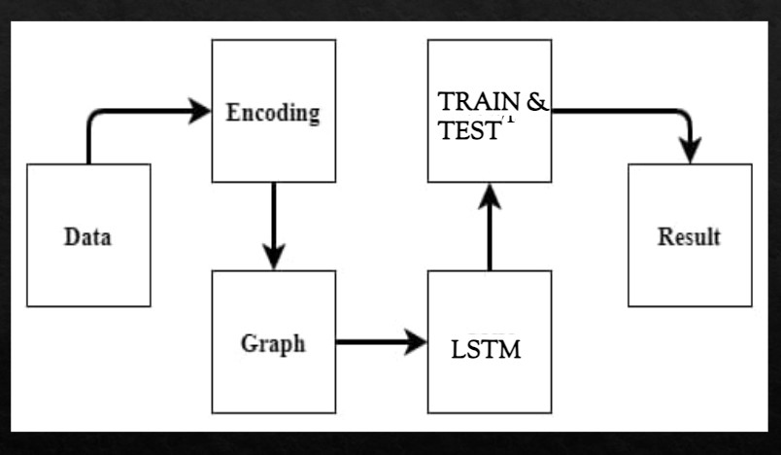
Figure 1 – BLOCK DIAGRAM

5.HARDWARE COMPONENTS

  - RAM

DESCRIPTION OF HARDWARE COMPONENTS

A. RAM



Random Access Memory (RAM) is a crucial component of a computer system, serving as its primary temporary data storage. RAM is characterized by its speed and ability to provide rapid access to data, making it essential for the smooth operation of modern computing devices. It enables the quick retrieval and manipulation of data by the central processing unit (CPU) during active tasks.

RAM comes in various capacities, typically measured in gigabytes (GB), and is installed on the motherboard of a computer. It plays a pivotal role in multitasking, allowing users to run multiple applications simultaneously without significant slowdowns. When an application is launched, relevant data is loaded into RAM for fast access, ensuring efficient performance.

One of the key characteristics of RAM is its volatility, meaning it loses all data when the computer is powered off. This is in contrast to non-volatile storage like hard drives or SSDs, which retain data even when the computer is turned off.

SOFTWARE COMPONENTS

- Python Idle
- Keras Package

DESCRIPTION OF SOFTWARE COMPONENTS
1) PYTHON IDLE:
IDLE, which stands for "Integrated Development and Learning Environment," is a user-friendly integrated development environment (IDE) that comes bundled with the Python programming language. It is designed to provide a simple and accessible environment for writing, running, and experimenting with Python code, making it particularly well-suited for beginners and those who are learning Python.One of the notable features of IDLE is its interactive Python shell, where you can enter Python commands and see their immediate results. This interactive shell is useful for quickly testing code snippets, performing calculations, or exploring Python's capabilities.In addition to the interactive shell, IDLE also includes a basic text editor for creating and editing Python scripts. Users can write and save their Python code in script files with the ".py" extension. These script files can then be executed within IDLE, and the output is displayed in the interactive shell.IDLE offers a straightforward and minimalistic interface, making it easy for newcomers to Python to get started without the distractions of more complex IDEs. It also provides basic debugging functionality, such as setting breakpoints and stepping through code, to help users identify and resolve issues in their programs.While IDLE is a useful tool for learning Python and performing simple scripting tasks, it may lack some of the advanced features and extensions found in more specialized Python IDEs and code editors. For more extensive Python development projects, developers often turn to other IDEs like PyCharm, Visual Studio Code, or Jupyter Notebook, which offer a broader range of features and customization options. Nonetheless, IDLE remains a valuable tool for many Python enthusiasts, especially those who prefer a straightforward and lightweight development environment.

2)KERAS PACKAGE:
Keras, a popular open-source deep learning framework for Python, is known for its user-friendly, high-level interface. Originally a standalone framework, it seamlessly integrated with TensorFlow starting from TensorFlow 2.0, becoming its official high-level API. This fusion combines Keras' ease of use with TensorFlow's power, making it a versatile tool for creating, training, and experimenting with artificial neural networks.Keras excels at abstracting the complex details of neural network implementation, offering a clear and intuitive syntax that eliminates the need for intricate TensorFlow or PyTorch code. Its modularity and flexibility enable developers to construct intricate models by stacking various layers like convolutional, recurrent, and dropout layers.
Keras, when used with TensorFlow, is GPU-compatible, leveraging GPU acceleration for faster training, especially crucial for large-scale deep learning tasks. Supported by a thriving community, Keras benefits from abundant online resources, tutorials, and pre-trained models, creating a supportive ecosystem for both beginners and experienced deep learning practitioners.
While TensorFlow is the primary backend for Keras, it also offers compatibility with other deep learning frameworks. In summary, Keras is a versatile and accessible tool for machine learning and deep learning, democratizing the development and experimentation of neural networks for all.

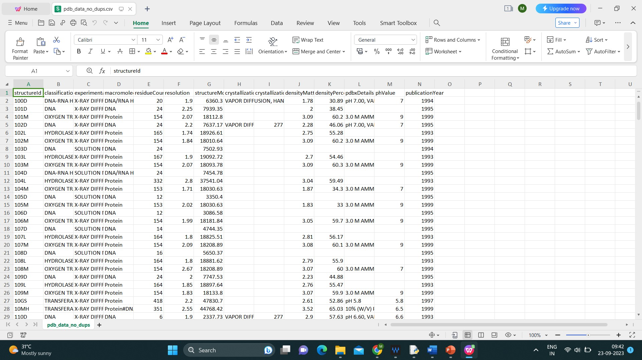
Figure 10 -Dataset collection
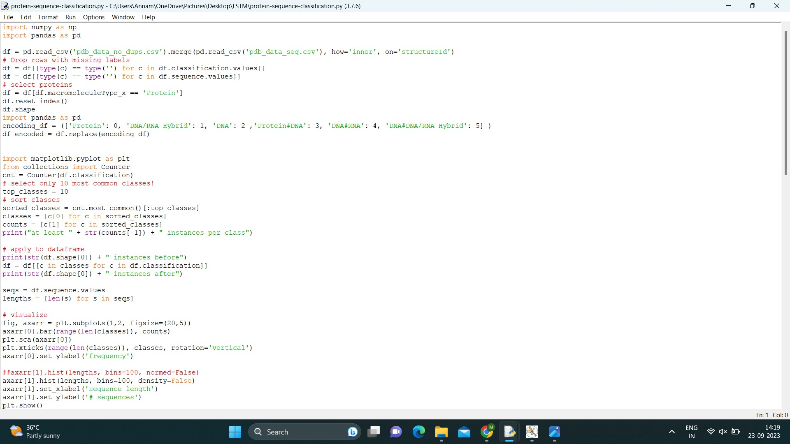
Fig Python Code

TRAINING AND TESTING
In the drug prognosis project utilizing Keras and LSTM, training and testing play distinct yet interconnected roles. During training, Keras guides the LSTM model to recognize patterns in protein sequences through exposure to a carefully curated dataset. The model fine-tunes its parameters to minimize errors, improving its accuracy in categorizing secondary structures like alpha helices, beta sheets, and coils.
After rigorous training, the project transitions to testing, using a separate, unseen dataset. This test assesses the model's ability to predict secondary structures accurately for new protein sequences. Performance metrics evaluate alignment between predictions and actual labels, and visualizations offer insights into protein structure and function. Together, these phases form the project's core framework, enabling the development and evaluation of a robust protein secondary structure prediction model.
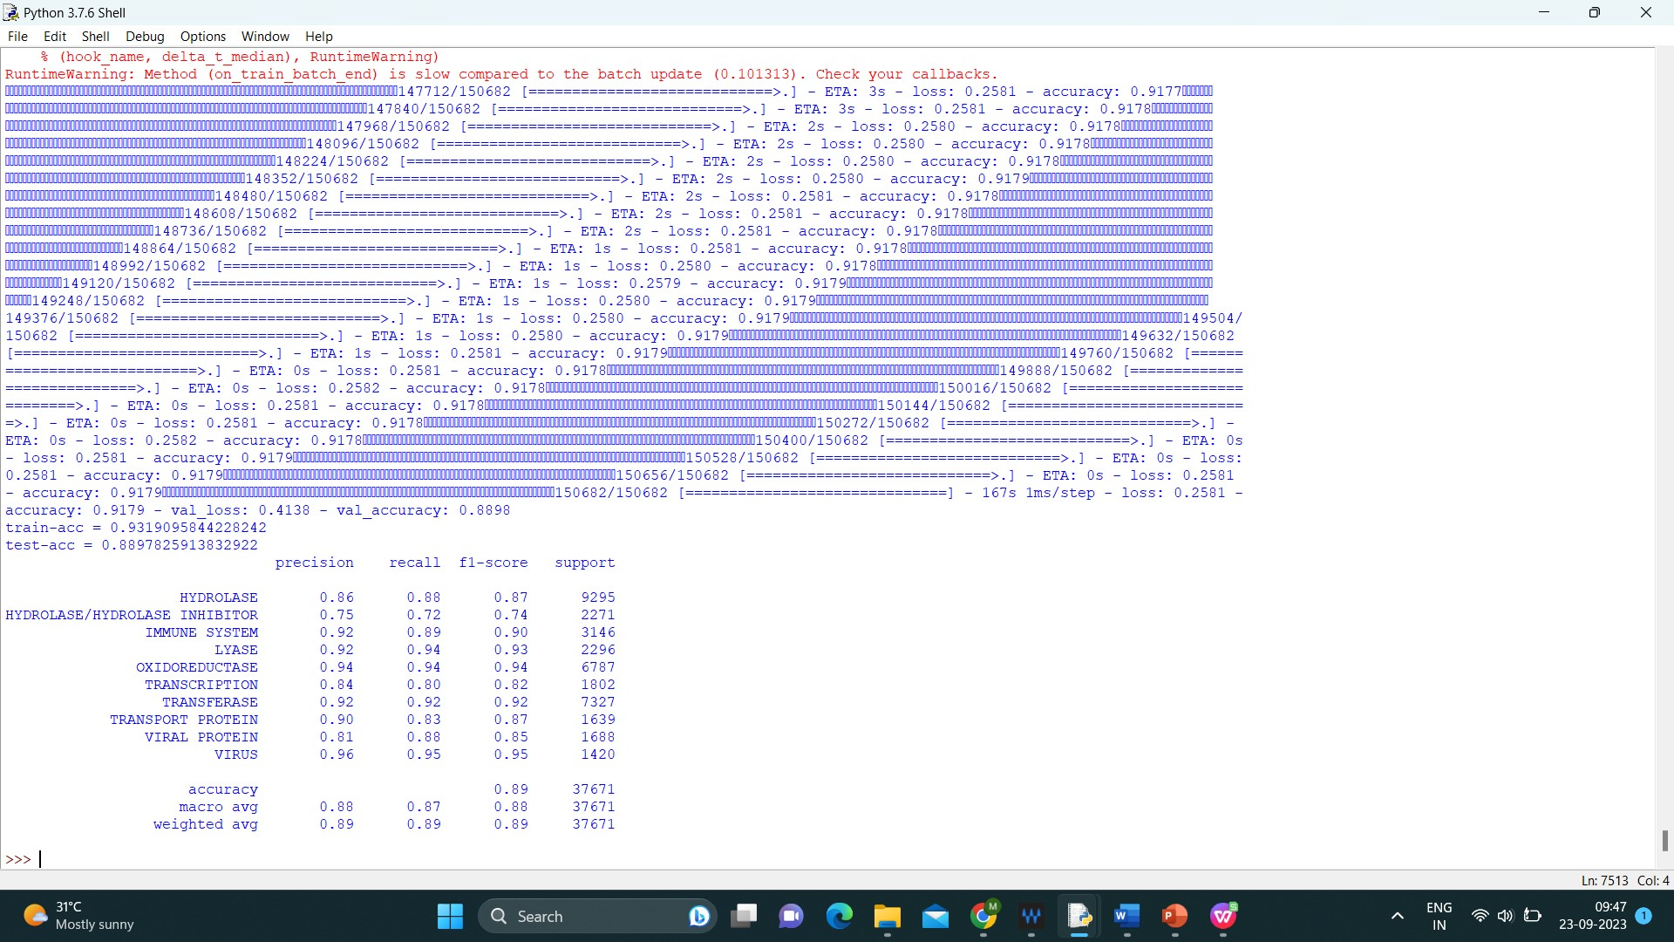
Fig Testing and Training
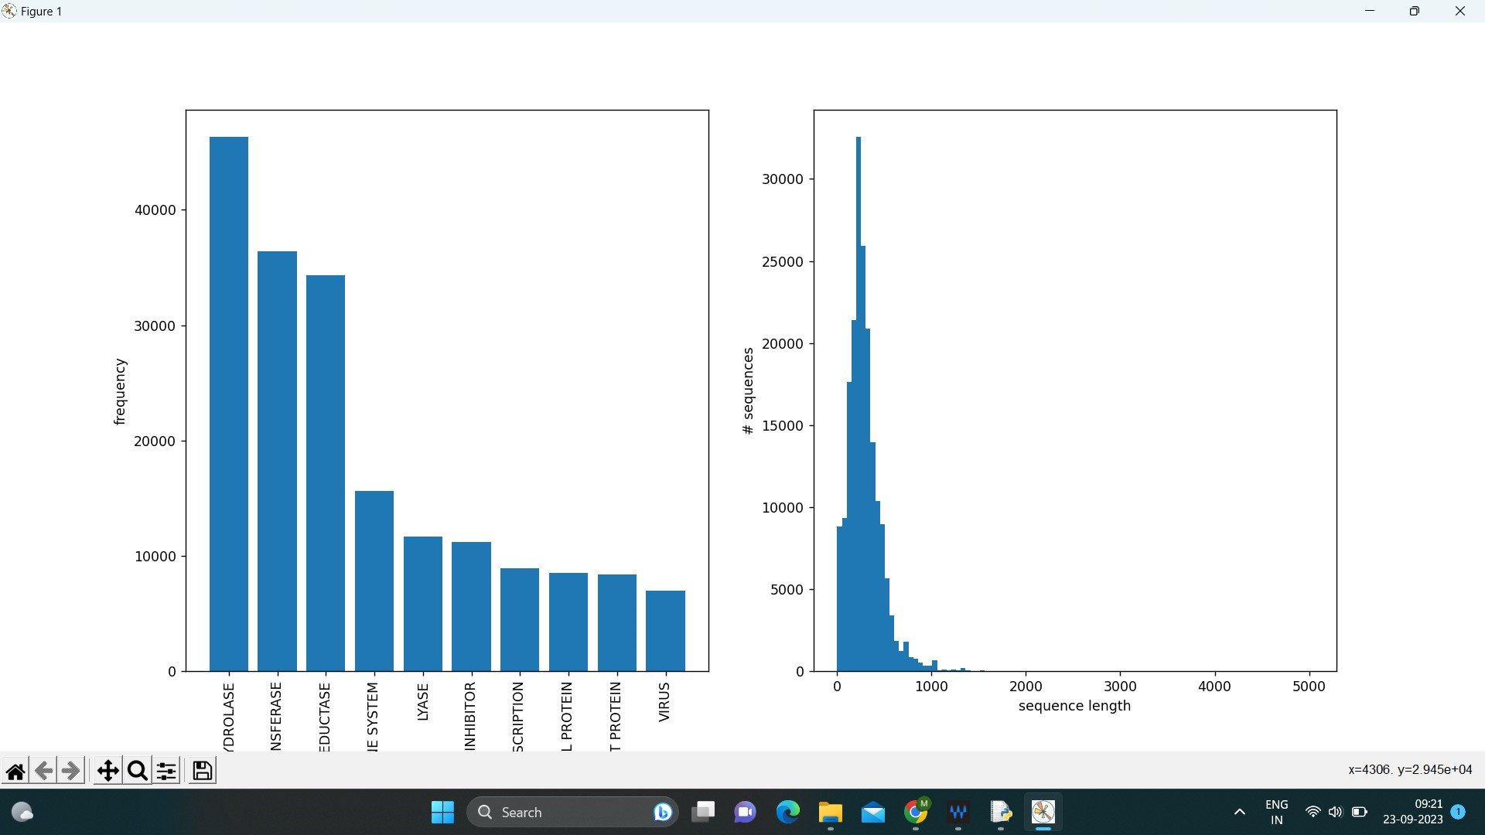
FIG trained graph

EXPERIMENTAL RESULTS:
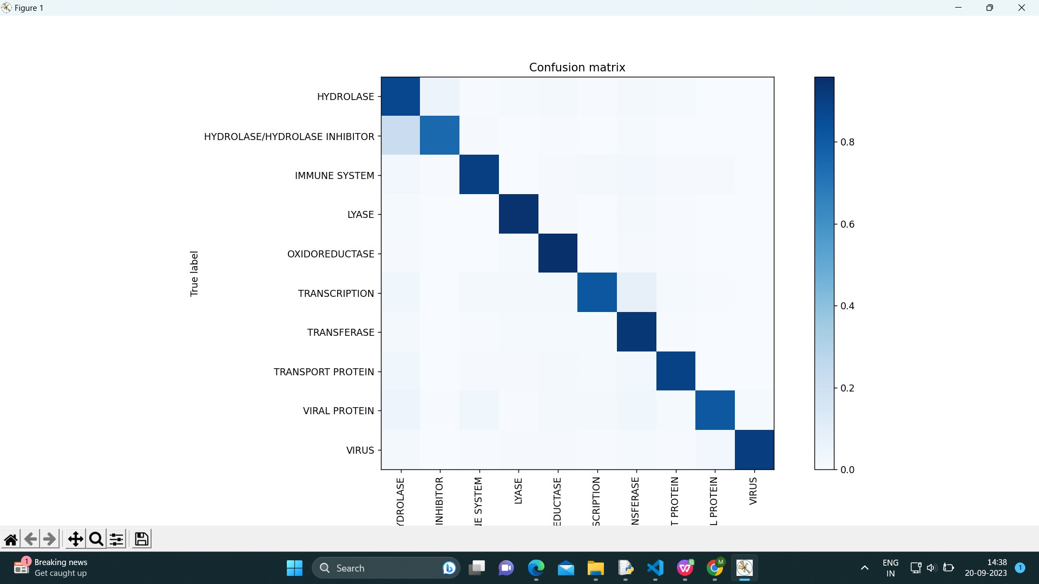
Fig output

Fig accuracy output

11. CONCLUSION
In the realm of protein secondary structure prediction, the journey begins with the installation of essential tools - the Keras package and the LSTM (Long Short-Term Memory) algorithm. These components form the backbone of a robust predictive model. Through diligent Python coding, this model is then meticulously trained and rigorously tested, honing its ability to recognize intricate patterns within protein sequences. The training dataset, sourced from Kaggle, furnishes the model with the knowledge required to make accurate predictions about secondary structure elements.

Upon successful training, the model transitions to the testing phase, where it encounters previously unseen protein data. Here, it demonstrates its proficiency by providing predictions regarding the secondary structure of these new sequences. The culmination of this process is a visual representation of the findings in the form of a graph. This graphical output serves as an invaluable tool for researchers, revealing the proportion of each secondary structure component within the analyzed protein sequences.

In conclusion, the journey from installation to model training and testing, culminating in graphical result generation, exemplifies the intricate and data-driven process of protein secondary structure prediction. This methodology empowers researchers to gain deep insights into the composition of protein structures, facilitating further exploration of their functions and behaviors within biological systems.

12.ACKNOWLEDGEMENT
I extend my sincere gratitude to Dr. V. Gomathi, M.Tech., Ph.D., Professor and Head of the Department of Computer Science and Engineering at National Engineering College, K.R Nagar, Kovilpatti, for providing me with the opportunity to undertake this project.
I would like to express my heartfelt thanks to Dr. Rajakumari, Assistant Professor/(SG) in the Department of Computer Science and Engineering at National Engineering College, K.R Nagar, Kovilpatti, for granting me the opportunity to publish a journal.
A special acknowledgement goes to Dr. Syed Rabiya, Assistant Professor in the Department of Computer Science and Engineering at National Engineering College, K.R Nagar, Kovilpatti, for enhancing the creativity of my paper through valuable reviews.
I am deeply grateful to my project guide,A.Shenbagamraman, Assistant Professor in the Department of Computer Science and Engineering at National Engineering College, K.R Nagar, Kovilpatti. His invaluable guidance and support have been the backbone of my project.

REFERENCES

[1] A. Mullard, “New drugs cost us [dollar] 2.6 billion to develop,” Nature Reviews Drug Discovery, vol. 13, no. 12, pp. 877–877, 2014.
[2] L. Fricker, “Drug discovery over the past thirty years: Why arent there more new drugs?” Einstein Journal of Biology and Medicine, vol. 29, no. 1, pp. 61–65, 2016.
[3] N. R. Coordinators, “Database resources of the national center for biotechnology information,” Nucleic acids research, vol. 44, no. Database issue, p. D7, 2016.
[4] S. Kim, P. A. Thiessen, E. E. Bolton, J. Chen, G. Fu, A. Hindu Lyte, L. Han, J. He, S. He, B. A. Shoemaker et al., “Pubchem substance and compound databases,” Nucleic acids research, vol. 44, no. D1, pp. D1202–D1213, 2015.
[5] R. A. Hodos, B. A. Kidd, K. Shameer, B. P. Redhead, and J. T. Dudley, “In silico methods for drug repurposing and pharmacology,” Wiley Interdisciplinary Reviews: Systems Biology and Medicine, vol. 8, no. 3, pp. 186–210, 2016.
[6] Y. LeCun, Y. Bengio, and G. Hinton, “Deep learning,” nature, vol. 521, no. 7553, p. 436, 2015.
[7] N. Rubens, M. Elahi, M. Sugiyama, and D. Kaplan, “Active learning in recommender systems,” in Recommender systems handbook. Springer, 2015, pp. 809–846.
[8] M. Elahi, F. Ricci, and N. Rubens, “A survey of active learning in collaborative filtering recommender systems,” Computer Science Review, vol. 20, pp. 29–50, 2016. [9] Y. Sverchkov and M. Craven, “A review of active learning approaches to experimental design for uncovering biological networks,” PLoS computational biology, vol. 13, no. 6, p. e1005466, 2017.
[10] R. F. Murphy, “An active role for machine learning in drug development,” Nature chemical biology, vol. 7, no. 6, p. 327, 2011.

