Smart Cycle Parking System-Scps

Mugesh Krishna PV, Haarish Kumar SM, Sanjay jayan J, R.Vazhan Arul Santhiya, K.Mirra

**Abstract:** Most of the students and employees are working or studying on a campus that is too vast to cover by foot. So they use alternative methods like traveling in motorcycle or cars. So our project provides a simple and efficient solution for this problem by providing a smart parking system for their bicycle which will encourage eco friendly mode of transport to use inside their campus. Our project will be able to overcome this problem by identifying the spots were most of the activities takes place we call this. By identifying this hotspots We can create a stand there and then another one in an other hotspot by using we can cover most of the spots were the activities takes place. So now when an customer want to use our parking system. He just need to provide unique rfid tag for everyone(Staffs, Students, Employees).They just need to put their rfid tag on the rfid a random cycle will be unlocked. After reaching their destination He can leave the bicycle in the nearest stand.

**Keywords:** Rfid, Motor, Uno board

**I.INTRODUCTION**

The Smart Cycle Parking Stand Project is an innovative and efficient solution that leverages Internet of Things (IoT) technology to enhance the convenience and security of bicycle parking. Traditional cycle parking stands often lack features that cater to modern needs, such as real-time monitoring, security, and efficient space management. By integrating IoT capabilities, this project aims to create an intelligent and interconnected cycle parking system that addresses these limitations.

The primary objective of the Smart Cycle Parking Stand Project is to create a technologically advanced and user-friendly system that promotes cycling as a sustainable mode of transportation. The project aims to provide cyclists with a hassle-free parking experience while ensuring their bicycles are safe and secure during storage. Additionally, it aims to optimize space utilization and provide valuable data insights to city planners and urban developers.

Key Features:

Real-time Monitoring: Each cycle parking stand will be equipped with IoT sensors that collect real-time data on parking spot availability. This data will be made available through a user-friendly mobile application, allowing cyclists to locate vacant parking spaces conveniently.

Automated Reservation: Cyclists can reserve parking spots in advance through the mobile app, ensuring a guaranteed parking space upon arrival. This feature prevents overcrowding and saves time for the cyclists.

Security and Anti-Theft Measures: The smart parking stands will have integrated locking mechanisms controlled via the mobile app. Cyclists can lock and unlock their bicycles securely, reducing the risk of theft and enhancing overall security.

Environmental Monitoring: The IoT sensors can also measure air quality, temperature, and humidity in the vicinity of the parking stands. This data can be used to promote eco-friendly initiatives and improve the overall cycling experience.

**II.LITERATURE SURVEY**

The literature survey for the Smart Cycle Parking Stand Project using IoT highlights the research and advancements in the field of IoT-based bicycle parking systems. The survey reveals several studies and projects that have explored the integration of IoT technology to enhance the efficiency, security, and user experience of cycle parking stands.

Researchers have emphasized the importance of real-time monitoring and reservation systems in smart cycle parking stands. IoT sensors embedded in the stands allow users to check the availability of parking spots in real-time using mobile applications, reducing the time spent searching for vacant spaces. Additionally, reservation systems enable cyclists to secure parking spots in advance, ensuring a seamless parking experience.

Security is another critical aspect of smart cycle parking stands, and the literature survey highlights various anti-theft measures. These include smart locking mechanisms that can be remotely controlled through mobile apps, GPS tracking, and alarm systems to prevent bicycle theft and enhance security.

Furthermore, the survey reveals the significance of data analytics and user insights. IoT-enabled cycle parking stands collect data on usage patterns, peak hours, and popular parking locations. City planners and policymakers can utilize this data to optimize infrastructure planning, improve traffic flow, and promote cycling as a sustainable mode of transportation.

Several studies have explored the environmental impact of cycling and have suggested integrating environmental sensors into IoT-based parking stands to measure air quality,temperature, and humidity. This data can aid in understanding the ecological benefits of cycling and promote eco-friendly initiatives.

Overall, the literature survey emphasizes the potential of IoT technology to revolutionize cycle parking systems, making them more user-friendly, secure, and environmentally conscious. The studies and projects reviewed in the survey provide valuable insights for the successful implementation and optimization of the Smart Cycle Parking Stand Project using IoT.

**III.PROPOSED SYSTEM**

Students can use their RFID tags that are provided to them which will be unique so that we can keep track of who in particular has accessed the bicycles.

Once they put their RFID tag in front of the RFID scanner, if it got verified the lock of a single Bicycle will be unlocked which will be random.

Once they reach there they can park it in their nearest stand and once they park it in their allocated parking the PIR sensor will detect the motion and will lock the bicycle.

The informations will be stored in a database can be monitored even through by a mobile

**Figure.1 Proposed System Class Diagram**

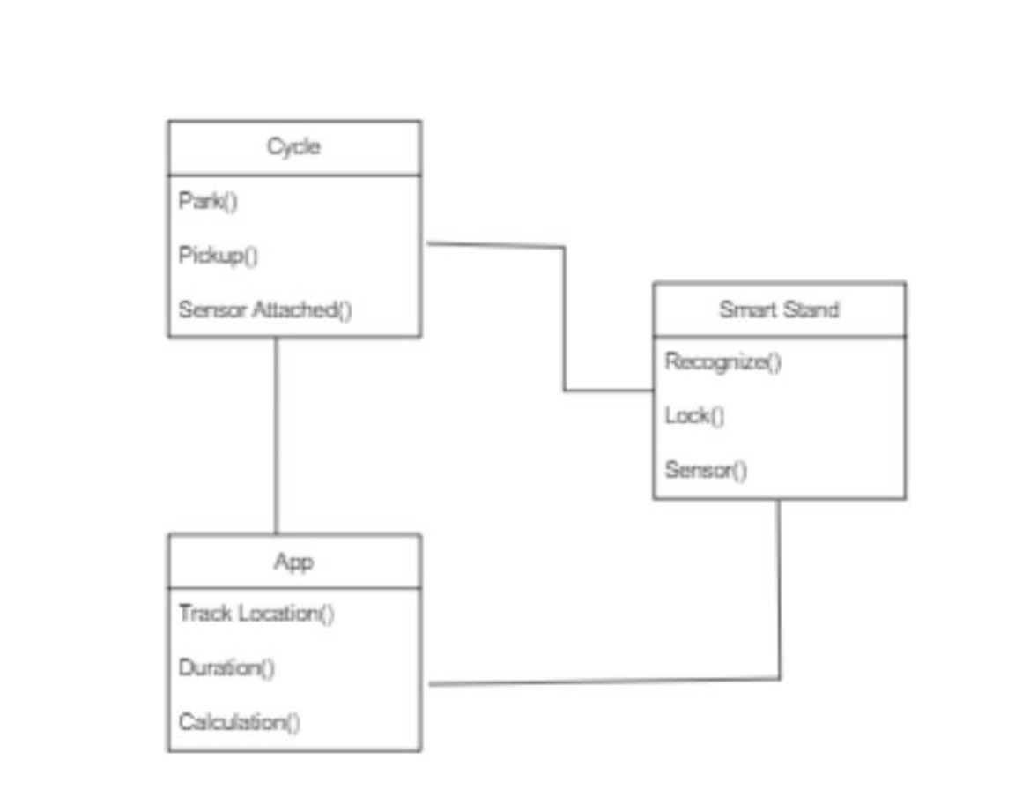

**Figure.2 Block Diagram of proposed system**

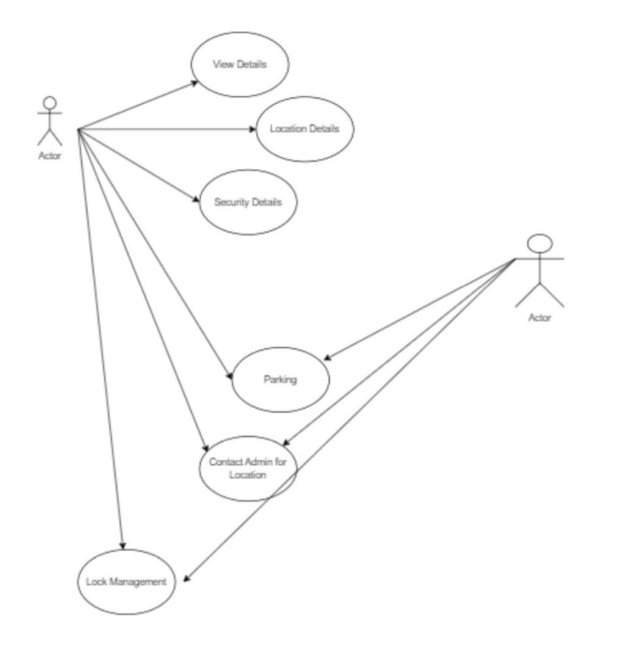

**Figure.**2 A block diagram for the Smart Cycle Parking Stand Project using IoT can be divided into several functional blocks, each representing a specific component or subsystem of the overall system. Here's an explanation of each block:

Cycle Parking Stand with RFID Reader and Locking Mechanism:

This block represents the physical cycle parking stand equipped with an RFID reader and a smart locking mechanism. The RFID reader is used to read RFID tags or smart cards attached to bicycles. When a cyclist approaches the parking stand, the RFID reader scans the RFID tag to identify the user and the bicycle. The smart locking mechanism allows the cyclist to securely lock their bicycle to the stand.

**IoT Gateway:**

The IoT Gateway serves as the central hub that connects the cycle parking stand and its components to the cloud or a central server. It is responsible for transmitting data collected from the RFID reader and locking mechanism to the cloud platform securely. The IoT Gateway may utilize various communication protocols such as Wi-Fi, Bluetooth, or cellular networks to establish connectivity.

**Cloud Platform:**

The Cloud Platform is where all the data from multiple cycle parking stands is stored and processed. It hosts the server-side application responsible for data management, user authentication, reservation processing, and analytics. The cloud platform allows users to access the system through a mobile application or web interface.

**Mobile Application / Web Interface:**

The Mobile Application or Web Interface is the user-facing component of the system. Cyclists can use the mobile app or web interface to locate nearby smart cycle parking stands, check real-time parking availability, and make reservations. The app also enables users to unlock the smart locking mechanism using their smartphones or smart cards.

**Reservation and User Management:**

This block represents the backend processes related to reservation and user management. The system handles reservation requests, checks for availability, and sends confirmation to the user. It also manages user accounts, allowing cyclists to register, login, and manage their profile information.

**Data Analytics and Insights:**

The Data Analytics block processes the data collected from all cycle parking stands. It generates valuable insights and reports on usage patterns, peak hours, popular parking locations, and occupancy rates. These insights help city planners and urban developers optimize infrastructure planning and make informed decisions for improving cycling infrastructure.

**Environmental Sensors (Optional):**

In some implementations, additional environmental sensors can be integrated into the cycle parking stand. These sensors measure air quality, temperature, humidity, etc., in the vicinity of the parking stand. The data collected from these sensors can be used for environmental monitoring and supporting eco-friendly initiatives.

The Smart Cycle Parking Stand Project using IoT leverages the integration of these blocks to create a comprehensive and intelligent system that enhances the convenience, security, and overall user experience of cyclists while promoting sustainable transportation options.

**Figure.3 Flow Diagram of the system**

A flow diagram for the Smart Cycle Parking Stand Project using IoT illustrates the step-by-step process involved in the operation of the system. Here's an explanation of each step in the flow diagram:

**Cyclist Arrival:**

The flow begins when a cyclist arrives at the smart cycle parking stand with their bicycle, intending to park it securely.

**RFID Tag Identification:**

The cyclist presents their RFID tag or smart card attached to the bicycle to the RFID reader integrated into the parking stand. The RFID reader scans the tag, identifying the user and their bicycle uniquely.

**Authentication and User Verification:**

The system checks the authenticity of the RFID tag and verifies the user's identity. If the tag is valid, the system proceeds to the next step. Otherwise, an error message is displayed.

**Parking Spot Availability Check:**

The system checks for the availability of parking spots at the specific parking stand. It gathers real-time data from the stand to determine if there is an empty slot for the user's bicycle.

**Occupancy Status Display:**

Based on the availability check, the system displays the occupancy status of the parking stand. It shows the number of vacant and occupied slots to the cyclist.

**Reservation (Optional):**

If the cyclist wants to reserve a parking spot in advance, they can initiate the reservation process through the mobile app or web interface. The system confirms the reservation and allocates a spot for the specified time.

Smart Locking Mechanism:

After the cyclist decides to park their bicycle, the smart locking mechanism is activated. The cyclist can use their smartphone or RFID tag to securely lock the bicycle to the parking stand.

**Data Transmission to IoT Gateway:**

The RFID reader and locking mechanism relay the data (e.g., user ID, bicycle ID, occupancy status, locking status) to the IoT Gateway, which acts as the intermediary for data transmission.

**IoT Gateway Communication:**

The IoT Gateway establishes communication with the cloud platform using Wi-Fi, Bluetooth, or cellular networks, ensuring secure data transfer to the cloud.

**Cloud Platform Management:**

The cloud platform receives the data from multiple smart cycle parking stands and manages the information. It processes the data, stores it in databases, and updates the system's real-time status.

**Mobile App Interaction:**

Cyclists can interact with the system through the mobile application or web interface. They can access real-time parking availability, reserve spots, or receive alerts about their parking status.

**IV IMPLEMENTATION AND RESULTS**

The following diagram shown in the figure represents the model of the product [Smart Cycle Parking Stand] which includes Aurdino, RFID Scanner and reader etc..,

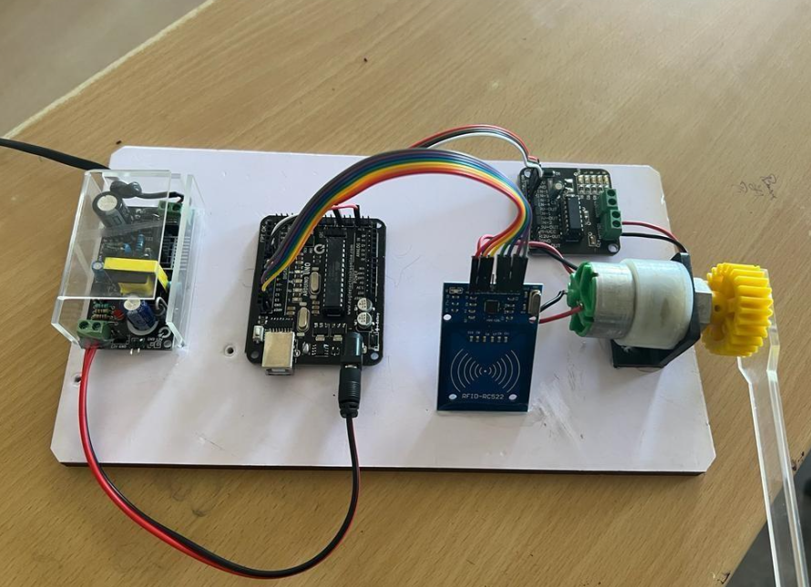

**Figure.4 Model of the product**

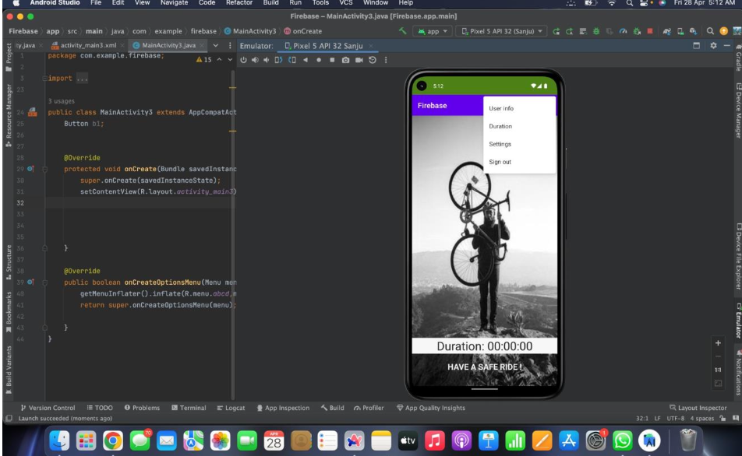

**V.CONCLUSION**

Based on this study and literature reviews, using Smart cycle parking systems in colleges and IT Tech parks could effectively help for many students. Use of Arduino can have a particularly supportive role for this project. So we can also do many future enhancements for this product as itwill surely reach many customers as the main customers are the students and the employees working in the IT Tech parks.

It is also very eco friendly , cost effective and it also saves valuable time forthe students and the employees. Cycling will also make our fitness good. Itis one of the best exercises to keep our body healthy.

So this is the project Smart Cycle Parking System.

**REFERENCES**

1. Wang, Xiang Yu and Rui Chen. "An Experimental Study on Collaborative Effectiveness of Embedded Systems in Urban Design." Codesign 5, no. 4 (2009): 229-244.

2. Kroc, N. (2017, September 20). IOT Comes to the Workplace. Society for Human Resource Management. https://www.shrm.org/hr-today/news/hr- magazine/1017/pages/iot-comes-to-the-workplace.aspx

3. https://developer.android.com/

4. https://wokwi.com/

5. https://firebase.google.com/docs