Single Power Conversion Battery Charger For Light Electric Vehicle

Thavaloshini A

UG Scholar, Dept of EEE St. Joseph’s College of Engineering

Chennai, India [thavaloshinianbalagan@](mailto:kirthikamani01@gmail.com)gmail. com

Sunitha k

UG Scholar, Dept of EEE St. Joseph’s College of Engineering

Chennai, India [sunithadina97@gmail.com](mailto:sunithadina97@gmail.com)

Dr.M.Anitha M.E.,

(Ph.D).,

Assistant Professor, Dept of EEE

St. Joseph’s College of Engineering Chennai, India

[anitham@stjosephs.ac.in](mailto:anitham@stjosephs.ac.in)

*Abstract* — **This paper presents modified bridgeless single- stage converter to charge light Electric vehicle (EV) battery. The main aim is to improve the efficiency a n d a t t a i n t h e U n i t y P o w e r F a c t o r ( U P F ) o f t h e bridgeless converter for battery charger. The converter has a single stage power conversion with tapped inductor boost converter. The converter is having a bridgeless configuration that minimizes the conduction losses of the input diodes. In this configuration the voltage is boosted using the converter and easily charge the EV battery. In tw o - s t a g e co n v e r t e r th e l o s s e s a r e mo r e , an d th e configuration is bulky. In the proposed charger the conduction losses can be reduced, attain voltage gain, PF and efficiency can be improved. Hence the single stage bridgeless converter with boost converter based on tapped inductor is used to improve the above-mentioned parameters. The existing and modified system is verified using MAT LAB Si mul ink so f tw a re and the res ult s p r o v e s t h e e f f e c t i v e n e s s o f t h e c h a r g e r .**

***Keywords: Bridgeless configuration, Single-stage power conversion, Tapped inductor.***

1. INTRODUCTION

In the upcoming year, there will be an increase in the number of EVs, PHEVs and HEVs. Since the vehicles are the major source of environment pollution, the country is concerned about the huge effects. Hence in future the EVs will replace the traditional vehicles. But the challenge faced by EVs are the cost of Li ion battery and the speed of battery charging. The EV batteries are mainly charged from grid using on-board chargers. There are two types of chargers On-board and off- board. Since on- board is placed inside i t should be small, lightweight and have long lifetime. Hence the chargers are the main part of EVs. The charger should be highly efficient and charge within few hours. Mainly the EV battery charger consists of AC-DC converter and PFC stage. Earlier two-stage converters which has one PFC stage and DC-DC power conversion stage were used. However, this two-stage converter even though it provides regulated output power, it has many disadvantages. This two-stage converter has two

power processing stages which can reduce the efficiency and make circuit complex. Also, it has a bulky capacitor that filter power variations. Hence, go for single-stage converters where the PFC stage and DC-DC conversion stages are merged together. This is obtained by sharing of the switches. High switching and conduction losses are due to high voltage rating switches. Changes in the grid voltage or load condition affects the power factor [4]. Single-stage resonance converters with PFC achieves high PF without PFC stage [1]. Also, using the PFC-control techniques almost unity power factor can be achieved. Moreover, these single-stage converters consist of several components and diode that causes both high conduction losses and heat losses. To mitigate this disadvantages, single-stage bridgeless topologies have been introduced [2]. Hence, these converters are suitable mainly for low-power applications that produces high switching stresses.

1. LITERATURE REVIEW

According to the demand for high efficiency and low harmonic pollution, active power factor correction (PFC) circuits are commonly employed in ac–dc converters and switched-mode power supplies. Generally, these kinds of converters include a full-bridge diode rectifier on an input current path so that conduction losses on the full-bridge diode occur and it will be worse, especially at the low line. To overcome this problem, bridgeless converters have recently been introduced to reduce or eliminate the full- bridge rectifier, and hence their conduction losses. [1]. The single-phase boost power factor correction (PFC) circuits improved power factor and reduced input current ripple, while maintaining a simple and compact circuit topology [2- 4]. The single-phase AC-DC converters help to improve power quality and reduce the impact of harmonics on the power systems [5]. The single-stage DC-DC converter provides high step-up voltage conversion ratio with reduced voltage stress on the switching devices [6-7]. The bridgeless topology eliminates the need for a bridge rectifier and the converter exhibits a high power factor and low total harmonic distortion with stable and efficient operation under different load conditions [8]. The ZVZCS operation is achieved by using a resonant inductor in series with the

primary switch, which helps to achieve soft switching and reduces switching losses [9]. The variable on-time control strategy PFC converters provides improved power factor and reduced output voltage ripple [10]. The battery charge controller is an essential component in the charging system of mobile phones, and it must be efficient and reliable. The design of the battery charge controller and the DPSR algorithm, which uses a digital signal processor (DSP) to control the switching of the converter is discussed in the paper [11]. The DC-DC boost converter is used for stepping up the voltage of a DC power source and the PI controller is used to control the output voltage of the converter. The paper also discusses about the cascade control loop which achieves a fast transient response and a low output voltage ripple [12]. The single power control circuit is synchronizes the switching of the two input stages of two-channel two- stage paralleled buck DC-DC converter, which reduces the input current ripple and improves the power factor [13]. The sub-module integrated DC-DC converters improves the efficiency and reliability of PV systems. The paper also discusses about the issues related to power loss, electromagnetic interference, and control stability involved in designing and controlling sub-module integrated DC-DC converters [14]. The interleaved high step-up converter topology achieve a high voltage gain with low voltage stress on the components, which is suitable for PV applications where a high DC voltage is required to feed into the grid [15]. The low-loss auxiliary zero-voltage-transition (ZVT) circuit reduces switching losses and operates at a high switching frequency with low harmonic distortion [16]. The sliding-mode control approach allows for fast and accurate response to changes in the load or input voltage and suitable for applications that require high power factor correction [17-18]. The hybrid resonant PWM technique used in the bridgeless AC-DC power factor correction converter enables high efficiency and low electromagnetic interference (EMI) through soft switching [19-20].

1. ISOLATED AC-DC CONVERTED CHARGER

This paper proposes tapped inductor based bridgeless battery charger for light EV. The Fig 1. Shows the proposed converter. The paper proposes a converter for charging EV battery with high efficiency, light weight and UPF. In this a tapped inductor-based boost converter with high efficiency single-stage power conversion are used mainly as EVs battery charger.The converter consists of AC-DC step up converter with bridgeless circuit having single-stage power conversion. In this configuration the bridge circuit and the forward converter is combined to reduce the switch and diodes. In effect this can reduce the switching losses and conduction losses. Also, there is a combined boost topology to add on the voltage gain. Afterwards the primary voltage is transmitted to secondary side. Secondary consists of tapped inductor and bridge configuration to charge the EV battery. Tapped inductors can improve the efficiency with a voltage gain. In addition, the stress on active semiconductor is reduced.

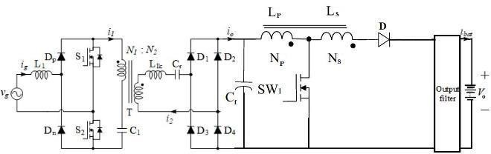

Fig.1 Circuit Of Isolated AC-DC Converter fed EV battery charger.

1. *Operation Of Isolated AC-DC Converter*

Und e r s t e a d y s t a t e co nd i t i on th e pro po s e d charger has certain assumptions: Except the diode’s switches S1, S2 and S3 are ideal. Grid Voltage Vg is considered as constant Since the battery has large capacitance value, the battery voltage Vbat is constant. Transformer T is an ideal transformer with leakage inductance Llk. The circuit has 3 modes of operation. Both the half cycles are symmetrical in operation. The switching period Ts is divided into 3 modes according to the switching state and the output diodes.

* 1. *Mode-I:*

In th i s mo d e sw i t ch S 1 i s dr iv en at hig h frequency and S2 is always on. Diode Dp, D2, D3 are conducting. During this mode the inductor L 1 is charged and the resonance effect created by LC circuit h e l p s t o c h a r g e b a t t e r y f r o m p r i m a r y s i d e t o secondary. At the end the secondary goes to zero.

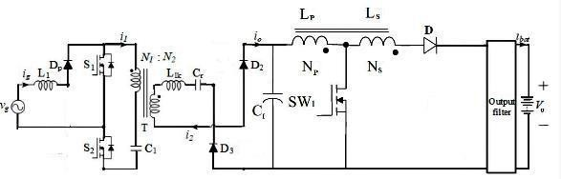

Fig 2a. Mode-I operation of Isolated AC-DC Converter

* 1. *Mode-II:*

In this mode The inductor L1 is charged in this mode also since S1 is on state. But no power flows to secondary as the current is zero. At end diodes D2 and D3 turned off. This reduces reverse recovery losses in output diodes using zero current switching (ZCS). It shows the modes of operation of the converter during both positive and negative half cycles.

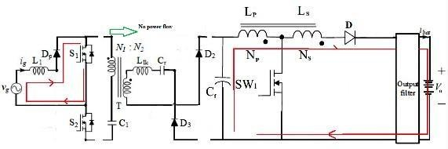Fig 2b. Mode – II operation of Isolated AC-DC Converter

* 1. *Mode-III:*

I n t h i s s w i t c h S 1 i s o f f a n d t h e s w i t c h S2 is on. Here diodes D1 and D4 are conducting. The charge in the inductor is released and the power is transferred from primary to secondary. These 3 modes are for positive half cycles.

The tapped inductor-based boost converter is on secondary side and this boost the voltage gain. According to i t s w i t c h i n g t h e b a t t e r y i s c h a r g e d w i t h a high voltage gain. When the switch S is on the inductor Lo charge and diode Do not conduct. When S is off then Do conducts and battery is charged.

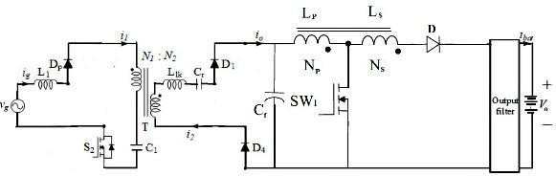

Fig 2c. Mode – III operation of Isolated AC-DC Converter

TABLE I. DESIGN SPECIFICTIONS OF THE PROPOSED SYSTEM

|  |  |  |
| --- | --- | --- |
| **S.NO** | **PARAMETER** | **VALUES** |
| 1 | Supply Voltage | 12V |
| 2 | Supply Frequency | 50 Hz |
| 3 | Switching Frequency | 20kHz |
| 4 | Converter Capacitor | 0.001F |
| 5 | Input Side Inductor | 0.001H |
| 6 | Input Side Capacitor | 0.002F |
| 7 | Load | 100 ohms |

1. CONTROL OF ISOLATED AC-DC CONVERTER WITH PFC CORRECTION

The control block for the proposed converter is Sh o w n . Us i n g th i s co n t r o l , th e po w e r fa c t o r i s corrected. In this the duty ratio is adjusted to correct the PF. The voltage and current controllers are selected as PI controller.

The output voltage Vo is compared with the reference value Vref. The error value is given as input to PI controller. To get the duty ratio variation ΔD, grid current Ig and reference current Ig pk is compared and given to PI controller.

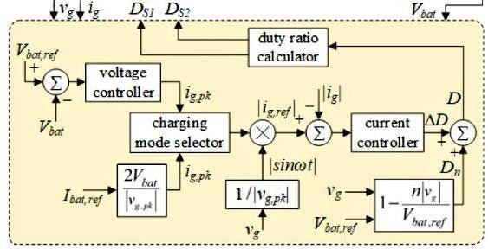

Fig 3. Control System For Proposed Converter

1. CHARGER’S SYSTEM CONFIGURATION

The system configuration of an EV battery charger using an Isolated AC-DC converter with power factor correction (PFC) typically consists of the following components:

* 1. *Rectifier:*

The rectifier converts the AC input voltage from the power grid into a DC voltage that is suitable for the DC-DC converter stage.

* 1. *Isolated AC-DC Converter:*

The Isolated AC-DC converter converts the high-voltage DC input from the PFC stage to a lower-voltage DC output suitable for charging the EV battery. The Isolated AC-DC converter consists of two channels, with each channel consisting of an inductor, a diode, and a capacitor. The channels are phase-shifted to reduce input current ripple and improve efficiency.

* 1. *Control System:*

The control system regulates the output voltage and maintains a high power factor. The control system uses PI which is implemented using a digital signal processor (DSP).

* 1. *EV Battery:*

The EV battery is the energy storage device that is being charged. The battery can be a lithium-ion battery, lead-acid battery, or any other type of battery that is suitable for EV applications.

1. CONVERTER TOPOLOGY

The Isolated AC-DC converter is a power electronics topology that can be used for EV battery charging with power factor correction (PFC). The converter topology consists of two channels, where each channel consists of an inductor, a diode, and a capacitor.The input voltage is applied to the input of the first channel, and the output voltage of each channel is added together to obtain the

overall output voltage of the converter. The phase shift between the channels helps to reduce the input current ripple and improve the power factor of the system.

To implement PFC, an additional boost converter can be added to the input side of the converter. The boost converter shapes the input current waveform to reduce the reactive power demand and improve the power factor. The output of the boost converter is connected in series with the input of the Isolated AC-DC converter.

1. DCM OPERATION IN ISOLATED AC-DC CONVERTER

In this type of converter ,the DC-DC conversion stage can operate in discontinuous conduction mode (DCM) under certain conditions. DCM occurs when the inductor current drops to zero during each switching cycle.

During DCM operation, the inductor current reaches zero before the end of the switching cycle, and the output diode conducts to discharge the energy stored in the output inductor. The duration of the discharge time depends on the output current, the inductor value, and the duty cycle of the switches.

Here, DCM can occur when the duty cycle is low or when the output current is low. The duty cycle is the ratio of the time the switch is on to the total switching period. When the duty cycle is low, the switch is on for a shorter time, and the inductor current has less time to charge.

As a result, the inductor current drops to zero before the end of the switching cycle, causing DCM operation.

Similarly, when the output current is low, the inductor current drops to zero faster, causing DCM operation.

1. BENEFITS OF ISOLATED AC-DC CONVERTER TECHNIQUE

* Increased safety: Isolation of the output from the input AC mains provides an extra layer of protection against electrical shock. If there is a fault in the output circuit, it does not pose a direct risk to the user or the equipment connected to the input.
* Improved reliability: Isolated AC to DC converters are more reliable because they have fewer components, resulting in fewer failure points. Additionally, the transformer-based design provides a galvanic isolation barrier that helps to prevent damage to the converter due to electrical noise or surges.
* Enhanced performance: Isolated AC to DC converters typically have a higher efficiency than non-isolated converters. The transformer-based design also enables them to deliver a smooth, regulated DC output voltage, which is free from ripple and noise.
* Versatility: Isolated AC to DC converters can be used in a wide range of applications, including power supplies for electronic devices, battery chargers, and motor drives. The galvanic isolation feature of these converters makes them suitable for use in applications where there are stringent safety requirements.

1. SIMULATED RESULTS
2. *Simulation of Isolated AC-DC Converter*

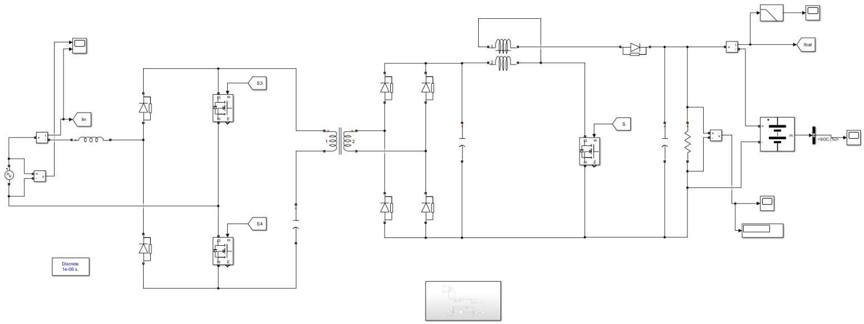

1. *Input Voltage Waveforms*

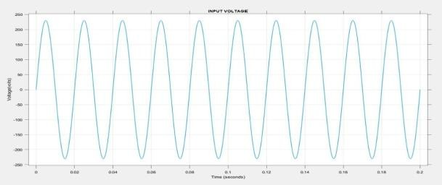

1. *Input Current Waveforms*

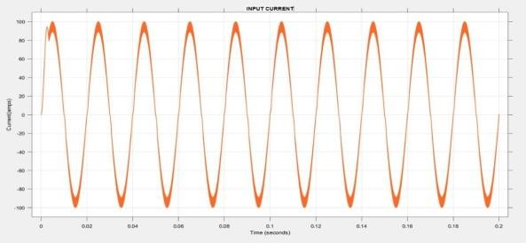

1. *Output Voltage Waveforms*

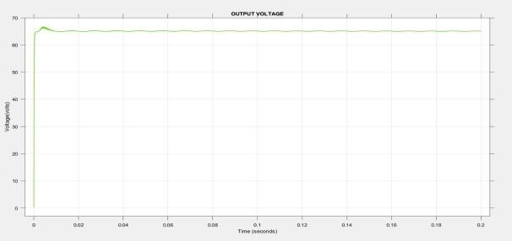

1. *Output Current Waveforms*

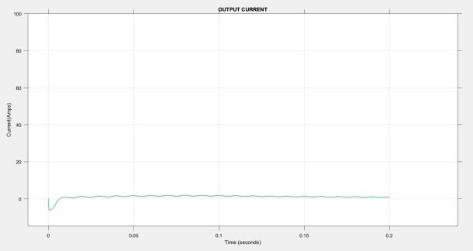

1. *SOC Of Proposed System*

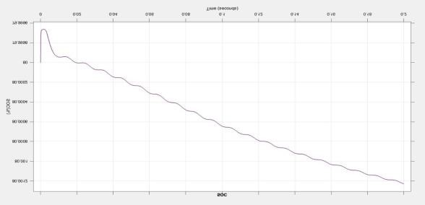

1. HARDWARE IMPLEMENTATION AND RESULTS

The hardware implementation of the Isolated AC- DC Converter involves, the selection of appropriate components, such as power semiconductors, inductors, capacitors, and control circuits. These components have been selected to meet the converter's requirements for voltage and current ratings, switching speed, and power dissipation.

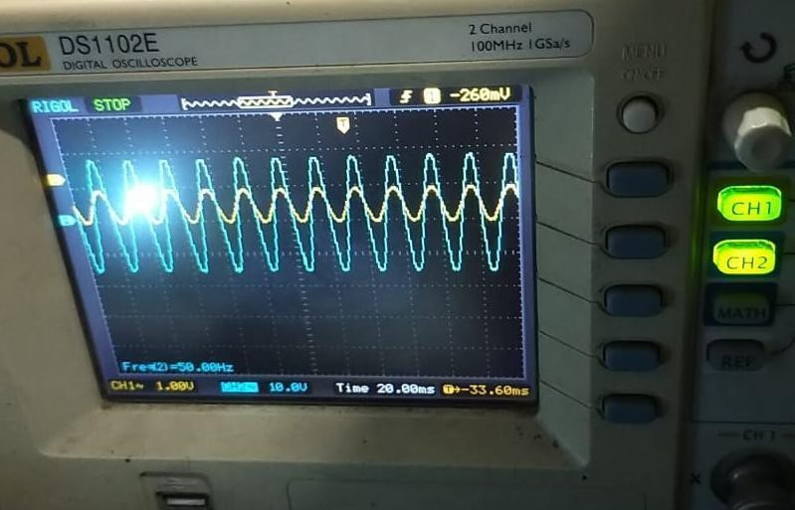

Fig 4. PFC operation using Interleaved Landsman Converter

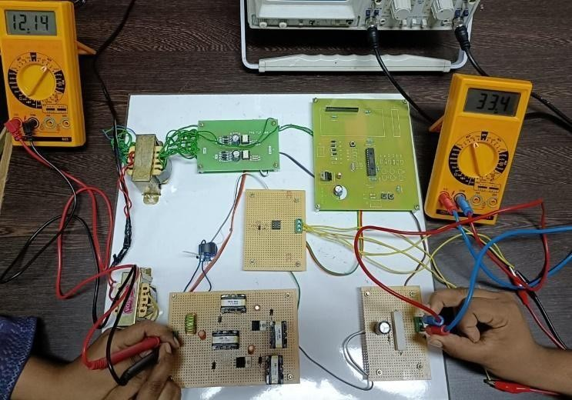

Fig 5. Hardware implementatiom of the proposed system

REFERENCES

1. Woo-Young choi, “Bridgeless Boost Rectifier with Low Conduction Losses and Reduced Diode Reverse-Recovery Problems” IEEE Transactions on Industrial Electronics, vol. 54, no.2, pp.769-780, April 2007.
2. lsmail EH. “Bridgeless SEPIC Rectifier with Unity Power Factor and Reduced Conduction Losses”, IEEE Transactions on Industrial Electronics; vol 56, no.4, pp.1147-1157, April 2009.
3. M Mahdavi and H. Farzanehfard, “Bridgeless SEPIC PFC rectifier with reduced components and conduction losses,” IEEE Transaction on Industrial Electronics, vol. 58, no. 9, pp. 4153– 4160, Sep. 2011.
4. Esam H. Ismail, “Bridgeless SEPIC Rectifier with Unity Power Factor and Reduced Conduction Losses”, IEEE Transactions on Industrial Electronics, vol. 56, no. 4, April 2009.
5. MohdRodhi Sahid, Abdul Halim Mohd Yatim, “Modeling and simulation of a new Bridgeless SEPIC power factor correction circuit”, IEEE Conference on Industrial Electronics, vol. 57, no. 6, pp 599-611, April 2011.
6. B. Singh and R. Kumar, "Solar photovoltaic array fed water pump driven by brushless DC motor using Landsman converter", IET Renewable Power Generation, vol. 10, no. 4, pp. 474-484, 2018.
7. K. Ando et al., "Power factor correction using modified landsman converter", in Proc. 26th Annu. Int. Telecommun. Energy Conf, pp. 117-124, Sept. 19–23, 2020.
8. X. Deng and Y. Wang and D. Xu, "Single-Stage Bridgeless LED Driver Based on CLCL Resonant Converter", IEEE Transactions Industry Applications, vol. 54, no. 2, pp. 1832- 1841, April 2018.
9. M. Pahlevaninezhad, P. Das, J. Drobnik, P. K. Jain and A. Bakhshai, "A novel ZVZCS full-bridge DC/DC converter used for electric vehicles", IEEE Trans. Power Electron, vol. 27, no. 6, pp. 2752-2769, Jun. 2020.
10. C. Zhao, J. Zhang and X. Wu, "An improved variable on-time control strategy for a CRM flyback pfc converter", IEEE Transactions Power Electronics, vol. 32, no. 2, pp. 915-919, Feb. 2017.
11. P. C.-P. Chao, W. D. Chen and R. H. Wu, "A battery charge controller realized by a flyback converter with digital primary side regulation for mobile phones", Microsystem Technologies, vol. 20, no. 8-9, pp. 1689-1703, 2021.
12. O. Rabiaa, B. H. Mouna, S. Lassaad, F. Aymen and A. Aicha, "Cascade Control Loop of DC-DC Boost Converter Using PI Controller," 2018 International Symposium on Advanced Electrical and Communication Technologies (ISAECT), Rabat, Morocco, 2018, pp. 1-5.
13. Yang, Xi-Jun;Qu, Hao;Yao, Chen;Zhang, Ning-Yun;Tang, Hou- Jun;Chen, Quan;Blaabjerg, Frede.Research on two-channel interleaved two-stage paralleled Buck DC-DC Converter for plasma cutting power supply[J].Proceedings - 2014 International

Power Electronics and Application Conference and Exposition, IEEE PEAC 2014.2014：914-919.

1. Olalla C, Clement D, Rodriguez M, and Maksimovic D 2013 “Architectures and control of sub module integrated DC–DC converters for photovoltaic applications,” IEEE Trans. Ind.

Appl., vol. 28, no. 6, pp. 2980–2997

1. Wuhua L and Wenfeng C et al 2011 "Interleaved high step-up converter with built-in transformer and voltage doubler for PV grid-connected generation systems", Europ. Conf. on Power Elect. and App. (EPE 2011) (Birmingham: United Kingdom/IEEE) pp.1-10
2. Siddharth Kulasekaran and Raja Ayyanar, “A 500-kHz, 3.3-kW power factor correction circuit with low-loss auxiliary ZVT circuit,” IEEE Transactions Power Electronics, vol. 33, no. 6, pp. 4783-4795, June 2018.
3. Adria Marcos-Pastor, Enric Vidal-Idiarte, Angel Cid-Pastor and

L. Martinez-Salamero, “Interleaved digital power factor correction based on the sliding-mode approach,” IEEE Transactions Power Electronics, vol. 31, no. 6, pp. 4641-4653, June 2016.

1. Bhim Singh and Vashist Bist, "A BL-CSC Converter-Fed BLDC Motor Drive With Power Factor Correction," IEEE Transactions Industrial Electronics, vol. 62, no. 1, pp. 172-183, Jan. 2015.
2. Muntasir Alam, Wilson Eberle, Deepak S. Gautam, Chris Botting, Nicholas Dohmeier and Fariborz Musavi, “A hybrid resonant pulse-width modulation bridgeless AC–DC power factor correction converter,” IEEE Transactions Industry Applications, vol. 53, no. 2, pp. 1406-1415, March-April 2017.
3. Hong-Tzer Yang, Hsin-Wei Chiang and Chung-Yu Chen, “Implementation of bridgeless cuk power factor corrector with positive output voltage,” IEEE Transactions Industry Applications, vol. 51, no. 4, pp. 3325-3333, July-Aug 2015.