**Environment Laws in India: Problems and Prospects**

Mr. Swapnil P. Dhatrak

Research Scholar, Ph.D.

P.G. Department of Geography,

Loknete Vyankatrao Hiray Arts, Science and Commerce College Panchavati, Nashik-03

Email: [swapnildhatrak45@gmail.com](mailto:swapnildhatrak45@gmail.com)

**Abstract:**

In India, there are many laws pertaining to environmental protection, but their implementation has not been up to par. There is a need for the Constitutional mandate and other environmental laws to be enforced effectively and efficiently. The judiciary has played an important and praiseworthy creative role. Numerous Public Interest Litigations against numerous industries for failing to provide adequate pollution control, as well as against Pollution Control Boards to order them to take appropriate measures to ensure pollution control, have been filed in the Supreme Court of India in accordance with the constitutional provisions found in Articles 48A and 51A (h) of the Indian Constitution. Caring for regulating and protecting the environment is essentially a desire to see that national development should proceed along the rational sustainable laws.

**Keywords**: Environmental Protection, Sustainable Development, Litigation, Judiciary

**Introduction**:

Environmental laws are an important part of any governance body. It comprises a set of laws and regulations concerning air quality, water quality, and other aspects of the environment. The environmental laws in India are guided by environmental legal principles and focus on the management of specific natural resources, such as forests, minerals, or fisheries. The environmental laws in India are a direct reflection of what was envisaged in the constitution. The detailed and developed framework for environmental protection came after the [UN conference on Human Environment](https://www.un.org/en/conferences/environment/stockholm1972)in Stockholm, in 1972.This led to the formation of the National Council for Environmental Policy and Planning in 1972 within the science and technology department. This was set up to establish a regulatory body for the overview of the environmental-related issues and concerns. India ranks 155th out of 178 countries in its efforts to address environmental challenges, according to the 2014 Environmental Performance Index (EPI). India performs the worst among other emerging economies including, China, which ranks 118th, Brazil, at 77th, Russia, at 73rd, and South Africa at 72nd. A bottom performer on nearly every policy issue included in the 2014 EPI, with the exception of forests, fisheries, and water resources, India’s performance lags most notably in the protection of human health from environmental harm. In particular, India’s air quality is among the worst in the world, tying China in terms of the proportion of the population exposed to average air pollution levels exceeding World Health Organization.

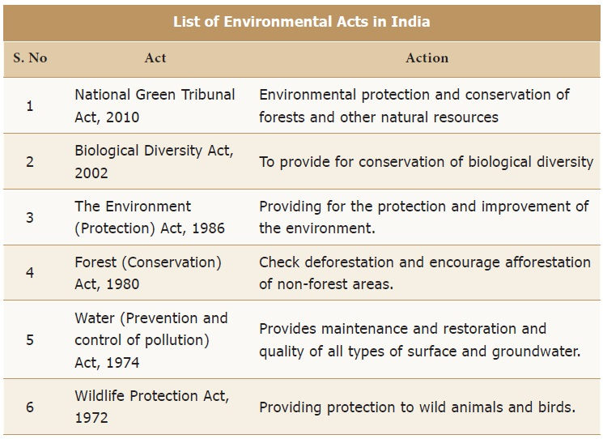

**List of Environmental acts in India**

|  |  |  |
| --- | --- | --- |
| **Sr.No.** | **Name of the Environmental Act** | **Action** |
| 1 | National Green Tribunal Act,2010 |  |
| 2 | Biological Diversity Act, 2002 |  |
| 3 | The Environment Protection Act,1986 |  |
| 4 | Forest Conservation Act,1980 |  |
| 5 | Water Prevention and Control of Pollution act, 1974 |  |
| 6 | Wildlife Protection Act, 1972 |  |

**Resource:** [**https://www.brainkart.com/article/Environmental-Policies-in-India_35746/**](https://www.brainkart.com/article/Environmental-Policies-in-India_35746/)

**1) The Wildlife (Protection) Act, 1972**

The Act provides for the protection of wild animals, birds, and plants; and for matters connected therewith or ancillary or incidental thereto. It extends to the whole of India.

It has six schedules that give varying degrees of protection:

**Schedule I and part II of Schedule provide** **absolute protection**, offences under these are prescribed the highest penalties.

Species listed in **Schedule III and Schedule IV** are also protected, but the **penalties are much lower**.

Animals under **Schedule V**, e.g. common crows, fruit bats, rats, and mice, are legally considered **vermin** and may be hunted freely.

The specified **endemic plants in Schedule VI are prohibited from cultivation and planting.**

**Statutory bodies** under WPA:National Board for Wildlife and state wildlife advisory boards Central Zoo Authority.

Wildlife Crime Control Bureau

**(2) The Air (prevention and control of pollution) act, 1981**

The act targets to control and prevent air pollution in India and its main objectives are

To provide for prevention, control, and abatement of air pollution.

To provide for the establishment of the boards at the central and state levels to implement the act**.**

CPCB and SPCB were given the responsibility. It states that the sources of air pollution such as internal combustion engines, industry, vehicles, power plants, etc., are not permitted to release particulate matter, lead, carbon monoxide, sulphur dioxide, nitrogen oxide, volatile organic compounds (VOCs), or other toxic substances beyond the predetermined limit. It empowers the state government to designate air pollution areas.**(4) The Environment (Protection) Act, 1986** This act was passed under **article 253 (legislation for giving effect to international agreements)**This was passed in the wake of the **Bhopal gas tragedy**in December 1984.It was enacted to achieve the UN conference on the human environment, 1972- Stockholm declaration**.** Eco-sensitive zones or ecologically fragile areas are notified by MoEFCC under EPA, 1986 – 10 km buffer zones around protected areas. Statutory bodies under the EPA, 1986: **Genetic Engineering Appraisal Committee, National Coastal Zone Management Authority** (later converted to **National Ganga Council** under Ministry of Jal Sakthi)

**The ozone-depleting substances (regulation and control) rules, 2000.**

It set deadlines for phasing out of various [Ozone](https://www.clearias.com/oxygen-cycle/) Depleting Substances (ODSs) and regulating production, trade import, and export of the product containing ODS.These rules prohibit the use of CFCs, halons, ODSs such as carbon tetrachloride and methyl chloroform, and SFC except in metered-dose inhalers and for other medical purposes. **Coastal Regulation zone notification 2018,**It was notified based on the recommendations of the **Shailesh Nayak Committee.** To promote sustainable development while taking into account the natural hazards such as increasing sea levels due to global warming. To conserve and protect biodiversity besides livelihood security to local communities including the fishermen.

CRZs have been classified into 4 zones for regulation:

**CRZ I**– **ecologically sensitive areas such** as mangroves, coral reefs, salt marshes, turtle nesting ground, and the inter-tidal zone.

**CRZ II**– **areas close to the shoreline**, and which have been developed.

**CRZ III- Coastal areas that are not substantially built up**, including rural coastal areas.

**CRZ IV- water area from Low Tide Line (LTL) to the limit of territorial waters of India.**

**(5) The energy conservation act, 2001**

It was enacted as a step towards improving energy efficiency and reducing wastage. It specifies the energy consumption standards for equipment and appliances. It prescribes energy consumptions norms and standards for consumers. It prescribes energy conservation building codes for commercial buildings. **Bureau of energy efficiency (BEE)** is a statutory body established under the act.

**(6) Biological diversity act 2002**

It was implemented to give effect to **CBD, Nagoya Protocol**.

To check bio piracy, protect biological diversity, and local growers through a three-tier structure of central and state boards and local committees.

To set up National Biodiversity Authority (NBA), State Biodiversity Boards (SBBS), and Biodiversity Management Committees (BMCS).

**7) Scheduled Tribes and Other Traditional Forest Dwellers (Recognition of Forest Rights) Act, 2006 (FRA)**

The act recognizes and vests the forest rights and occupation in forest land in **Forest Dwelling Scheduled Tribes (FDST)** and Other **Traditional Forest Dwellers (OTFD)**who have been residing in such forests for generations. This act comes under the aegis of the Ministry of Tribal Affairs. The act also establishes the responsibilities and authority for sustainable use, conservation of biodiversity, and maintenance of the ecological balance of FDST and OTFD .It strengthens the conservation regime of the forests while ensuring the livelihood and food security of the FDST and OTFD .It seeks to rectify colonial injustice to the FDST and OTFD who are integral to the very survival and sustainability of the forest ecosystem.

The act identifies four types of rights:

**1. Title rights** It gives FDST and OTFD the right to ownership of land farmed by tribal or forest dwellers subject to a maximum of 4 hectares. Ownership is only for land that is being cultivated by the concerned family and no new lands will be granted.

**2. Use rights** the rights of the dwellers extend to extracting Minor Forest Produce, grazing areas, pastoralist routes, etc.

**3. Relief and development rights** to rehabilitation in case of illegal eviction or forced displacement and basic amenities, subject to restrictions for forest protection.

**4. Forest management rights** It includes the right to protect, regenerate or conserve or manage any community forest resource which they have been traditionally protecting and conserving for sustainable use.

**(5) The National Green Tribunal Act, 2010**

It was established in concurrence to **Rio Summit 1992** to provide judicial and administrative remedies for the victims of the pollutants and other environmental damage. It also agrees with **article 21, the Right to a healthy environment to its citizens of the constitution.** The NGT has to dispose of the cases presented to it within 6 months of their appeals.NGT has original jurisdiction on matters related to substantial questions of the environment.

NGT deals with the civil cases under the 7 acts related to the environment:

1. Water (Prevention And Control Of Pollution) Act, 1974
2. Water (Prevention And Control Of Pollution) Cess Act, 1974
3. Air (Prevention And Control Of Pollution) Act, 1977
4. Forest Conservation Act, 1980
5. Environmental Protection Act, 1986
6. Public Liability Insurance Act 1991
7. Biological Diversity Act, 2002

2 acts have been kept out of the jurisdiction of NGT:Wildlife Protection Act, 1972Scheduled Tribes and Other Traditional Forest Dwellers (Recognition of Forest Rights) Act, 2006 (FRA).

The decisions of the NGT can be challenged in High Courts and the Supreme Court.**(9) Compensatory Afforestation Fund Act, 2016**The CAF Act was enacted to manage the funds collected for compensatory afforestation which till then was managed by **ad hoc Compensatory Afforestation Fund Management and Planning Authority (CAMPA).Compensatory afforestation**means that every time forest land is diverted for non-forest purposes such as mining or industry, the user agency pays for planting forests over an equal area of non-forest land, or when such land is not available, twice the area of degraded forest land. As per the rules, **90% of the CAF money is to be given to the states while 10% is to be retained by the Centre.**The funds can be used for the treatment of catchment areas, assisted natural generation, forest management, wildlife protection and management, relocation of villages from protected areas, managing human-wildlife conflicts, training and awareness generation, supply of wood saving devices, and allied activities.

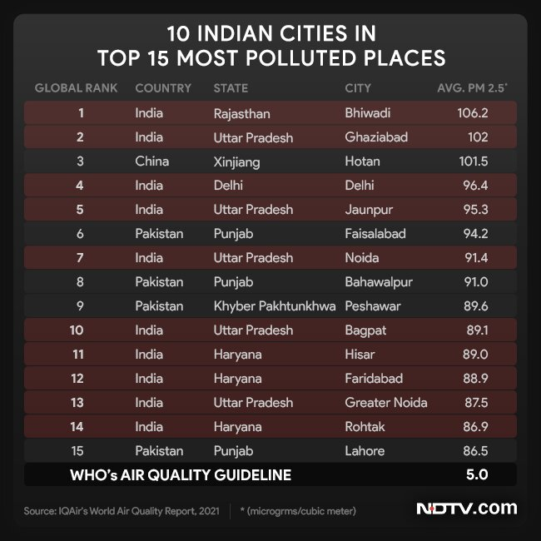

**Principles of Environmental Law**

**Precautionary principle:**

The precautionary approach enables decision-makers to adopt precautionary measures when scientific evidence about an environmental or human health hazard is uncertain and the stakes are high. It first emerged during the 1970s and has since been enshrined in a number of international treaties on the environment.

**Prevention principle:**

This principle allows action to be taken to protect the environment at an early stage .It's not only about repairing damages after they have occurred, but to prevent those damages occurring at all. It means it is better to prevent than repair.

**Polluter's pay principle**:

Since the early 1970s the "polluter pays" principle has been a dominant concept in environmental law. It simply means that those who produce pollution should bear the costs of managing it to prevent damage to human health or the environment.

**Objectives of study**

1 To find out loopholes of Environment laws in India

2 To find out positive impact of Environment laws in India

**Methodology** This paper has adopted a secondary research methodology like literature reviews, which include textbook reviews, Wikipedia, and journal articles reviews and Newspapers Articles.

**Problems of Environment Laws in India:**

**Lack of Stringent Enforcement:** While India has comprehensive environmental laws and regulations, enforcement can often be lax. This leads to violations going unchecked and undermines the effectiveness of these laws.

**Inadequate Resources:** Environmental agencies and regulatory bodies often face a lack of resources, both in terms of personnel and funding. This hampers their ability to effectively monitor and regulate environmental compliance.

**Complexity and Overlapping Laws:** The regulatory landscape can be complex and sometimes there is overlap between different laws and regulations. This can lead to confusion among industries and enforcement agencies, and can also provide loopholes for non-compliance.

**Delay in Legal Proceedings:** Legal proceedings related to environmental violations can be time-consuming and lengthy in India's judicial system. This delay can result in a lack of timely justice and deter effective enforcement.

**Lack of Public Participation:** Meaningful public participation is often lacking in the formulation and implementation of environmental policies and projects. This can result in projects being approved without adequate consideration of local environmental and social concerns.

**Weak Environmental Impact Assessment (EIA) Process:** The EIA process is designed to assess the potential environmental impacts of projects, but there have been instances of inadequate assessments and even manipulation of the process.

**Corruption:** Corruption within regulatory bodies can lead to improper approvals, lenient enforcement, and misuse of resources meant for environmental protection.

**Inadequate Penalties:** Penalties for environmental violations may not always be stringent enough to deter non-compliance effectively. This can make it more profitable for industries to pay fines rather than invest in sustainable practices.

**Lack of Data and Monitoring:** Accurate and up-to-date data on environmental indicators is crucial for effective decision-making. However, there can be gaps in data collection and monitoring systems.

**Inconsistent Implementation:** Environmental regulations might be implemented inconsistently across different states and regions due to varying capacities and priorities of state governments.

**Lack of Public Awareness:** Many citizens might not be fully aware of their rights and responsibilities regarding environmental protection. This lack of awareness can hinder active public participation.

**Urbanization and Industrialization Pressure:** Rapid urbanization and industrial growth can put immense pressure on the environment. Balancing economic development with environmental protection is a constant challenge.

**Environment laws in India have had several positive impacts on the country's environmental protection and sustainable development efforts. Some of the key positive impacts include:**

1. **Biodiversity Conservation**: India's environment laws have contributed to the conservation of its rich biodiversity. Laws like the Wildlife Protection Act and the Forest Conservation Act have helped in the preservation of endangered species and their habitats.

2. **Air and Water Quality Improvement**: The Air (Prevention and Control of Pollution) Act and the Water (Prevention and Control of Pollution) Act have led to improved air and water quality in many areas. These laws have established regulatory bodies that monitor and control pollution sources, leading to a reduction in harmful emissions and pollutants in the environment.

3. **Waste Management:** The implementation of laws like the Solid Waste Management Rules and the Hazardous Waste Management Rules has promoted better waste management practices across the country. This has helped in reducing the adverse impacts of improper waste disposal on human health and the environment.

4. **Renewable Energy Promotion**: India has enacted policies and regulations to promote renewable energy sources such as solar, wind, and hydroelectric power. These initiatives have led to increased investment in renewable energy projects, contributing to reduced greenhouse gas emissions and a more sustainable energy mix.

5. **Conservation of Natural Resources**: Laws such as the Forest (Conservation) Act have played a significant role in conserving India's natural resources by regulating the diversion of forest land for non-forest purposes and promoting afforestation.

6. **Protection of Coastal Areas:** The Coastal Regulation Zone (CRZ) notification aims to protect the fragile coastal ecosystem from unregulated development. It helps in maintaining the ecological balance of coastal areas and preventing the degradation of coastal resources.

7. **Public Awareness and Participation**: Environment laws in India often emphasize public participation in environmental decision-making processes. This has led to increased awareness and engagement of local communities in environmental issues, fostering a sense of ownership and responsibility.

8. **Legal Framework for Environmental Justice**: Environmental laws provide a legal framework for addressing environmental injustices and holding polluters accountable. This empowers affected communities to seek remedies for environmental harm through legal channels.

9. **International Commitments**: India’s environment laws have helped the country meet its international commitments related to environmental protection and sustainable development. These laws support India's efforts to achieve the Sustainable Development Goals (SDGs) and fulfil its obligations under international environmental agreements.

10. **Green Technologies and Innovation**: The legal framework for environmental protection has encouraged the development and adoption of green technologies and innovations. This has created new business opportunities and industries focused on sustainability. Overall, India's environment laws have played a crucial role in mitigating environmental degradation, promoting sustainable development, and safeguarding the well-being of both present and future generations.

**Conclusion** India has established a comprehensive legal framework to address environmental challenges and promote sustainable development. The country's environmental laws reflect its commitment to safeguarding its diverse ecosystems, conserving natural resources, and ensuring a healthier and cleaner environment for its citizens. These laws encompass various aspects of environmental protection, including air and water quality, forest and wildlife conservation, waste management, and the preservation of biodiversity. While India's environmental laws provide a solid foundation, their successful implementation requires the active involvement of government bodies, industries, communities, and individuals. Effective enforcement, awareness campaigns, and cooperation among stakeholders are crucial to achieving the intended goals of these laws. Additionally, continuous updates and adaptations to the legal framework are essential to address emerging environmental challenges in a rapidly changing world. The Environment Protection Laws have failed to bring about the desired results. Consequently, for the purpose of efficient and effective enforcement of these laws, it is Necessary to set up the Environment Courts; with one Judge and two technical experts from the field of Environmental Science and Ecology. These Courts should be allowed to adopt summary proceedings for speedy disposal of the cases. To begin with we may have such Courts at the State and National levels that may later be extended to district level on need-based principle. In order to discourage prolonged litigation, the provisions should be confined to single appeal.

**References**

1. Agarwal, V. K. (2005). Environmental laws in India: challenges for enforcement. *Bulletin of the National Institute of Ecology*, *15*, 227-238.
2. Desai, B. (1994). Environmental laws of India: basic documents.
3. Divan, S., & Rosencranz, A. (2022). *Environmental Law and Policy in India: Cases and Materials*. Oxford University Press.
4. Singh, R. B., & Misra, S. (1996). *Environmental law in India: issues and responses*. Concept Publishing Company.
5. Sankar, U. (1998). Laws and institutions relating to environmental protection in India. *The role of law and legal institutions in Asian economic development. Rotterdam: Erasmus University*.
6. Singh, R. B., & Misra, S. (1996). *Environmental law in India: issues and responses*. Concept Publishing Company.
7. Abraham, C. M., & Abraham, S. (1991). The Bhopal case and the development of environmental law in India. *International & Comparative Law Quarterly*, *40*(2), 334-365.
8. Tiwari, A. K. (2006). *Enviromental Laws in India*. Deep and Deep Publications.
9. [**https://www.clearias.com/environmental-laws-india/**](https://www.clearias.com/environmental-laws-india/)
10. [**https://www.un.org/esa/dsd/agenda21/res_agenda21_36.shtml**](https://www.un.org/esa/dsd/agenda21/res_agenda21_36.shtml)
11. [**https://manalaexcellence.com/29th-may-2022-environment-vs-development-definition-of-environment-environmentalism-environmental-protection-policy-environmental-policy-instruments/**](https://manalaexcellence.com/29th-may-2022-environment-vs-development-definition-of-environment-environmentalism-environmental-protection-policy-environmental-policy-instruments/)
12. [**https://www.pmfias.com/wild-life-protection-biodiversity-forest-conservation-rights/**](https://www.pmfias.com/wild-life-protection-biodiversity-forest-conservation-rights/)
13. [**https://www.drishtiias.com/to-the-points/Paper2/forest-rights-act-2006**](https://www.drishtiias.com/to-the-points/Paper2/forest-rights-act-2006)
14. [**https://www.academia.edu/16288090/Environmental_pollution_and_waste_management**](https://www.academia.edu/16288090/Environmental_pollution_and_waste_management)
15. Basu, R. (2000). India's Environmental Policy: Major Problems of Policy Implementation in a Developing Country. *PUBLIC ADMINISTRATION AND PUBLIC POLICY*, *83*, 221-242.
16. Divan S. and Rosencranz A., Environmental law and policy in India, cases, materials and status, 2nd edition, New York, Oxford University Press (2001)
17. [**https://learnfinite.com/ca/community-forest-rights**](https://learnfinite.com/ca/community-forest-rights)
18. [**https://ilearncana.com/details/Community-Forest-Resource-CFR-rights/3277**](https://ilearncana.com/details/Community-Forest-Resource-CFR-rights/3277)
19. [**http://ecoursesonline.iasri.res.in/mod/page/view.php?id=26234**](http://ecoursesonline.iasri.res.in/mod/page/view.php?id=26234)
20. [**https://iasbaba.com/2022/07/forest-rights-act-2006/**](https://iasbaba.com/2022/07/forest-rights-act-2006/)
21. [**http://www.indiaenvironmentportal.org.in/content/386993/2014-environmental-performance-index/**](http://www.indiaenvironmentportal.org.in/content/386993/2014-environmental-performance-index/)
22. Environmental Issues, Law and Technology - An Indian Perspective. Ramesha Chandrappa and Ravi D.R., Research India Publication, Delhi, ISBN 978-81-904362- 5-0 (2009)
23. Gupta, S., 1996. ‘Environmental Policy and Federalism in India’, National Institute of Public Finance and Policy, New Delhi.