

Design of Circularly Polarized Microstrip Antenna for Wearable Applications

**Selva Murugan P1, Surya R2, Vigneshwara Perumal M3,** Asha Beaula C4

1,2,3 Student, Department of Electronics and Communication Engineering, National Engineering College, Kovilpatti, Tamil Nadu, India

4 Assistant Professor, Department of Electronics and Communication Engineering, National Engineering College, Kovilpatti, Tamil Nadu, India.

Email: [11911101@nec.edu.in](mailto:11911101@nec.edu.in)[,21911117@nec.edu.in](mailto:21911117@nec.edu.in)

**\*Corresponding Author:** Selva Murugan P, Surya R

Student, Department of Electronics and Communication Engineering, National Engineering College, Kovilpatti, Tamil Nadu, India.

**DOI:** 10.47750/pnr.2022.13.S10.192

The FR4 epoxy resin was used to create the antenna. Its small size, broad capabilities, and superior performance in the loading situation of the human body, this antenna is a good choice for small wearable biomedical equipment. A circularly polarised antenna with a multiple-input multiple-output (MIMO) architecture will be offered by our design. The main growing technology, wearable antenna, supports numerous uses in the fields of entertainment, navigation, health care, and the military. A number of physiological characteristics of the human body can be remotely sensed and monitored with the help of WBAN technology, particularly wearable antennas. While weighing the benefits of WBAN and wearable antennas, it's important to be mindful of how they may affect a person's physiology. The selection of an acceptable RF technology for wearable designs should be made by antenna designers, with the least possible impact on efficiency and gain owing to electromagnetic immersion in human tissue.

Keywords—Wearable Antenna, MIMO, EM Waves, epoxy material, circularly polarized antenna

1. INTRODUCTION

Any antenna that is specifically created to operate while being worn is referred to as a wearable antenna. It is intended to be a component of clothing worn for communication reasons, such as public safety, mobile computing, tracking, and navigation. A transducer that transforms electric signals into electromagnetic waves is an antenna. An antenna can be used as a receiving or a transmitting antenna. A transmitting antenna is one that radiates electromagnetic waves created from electrical signals. A receiving antenna is one that transforms electrical signals from electromagnetic waves in the received beam. Antennas are implemented based on the wearable device's size, application, electrical performance, polarisation effects, and bandwidth needs. Circularly polarised microstrip antennas can be used in wireless systems to achieve higher data rates when the frequency bands are broad enough. An electromagnetic wave is said to be in circular polarisation when its electromagnetic field has a constant amplitude at each location and rotates at a constant speed in a plane perpendicular to the wave's direction. To lessen the signal loss brought on by multi-path propagation, circularly polarised antennas are needed. The cavity approach, as opposed to the Transmission Line method, may precisely represent the circular patch. Circularly polarised radiation can be produced by changing the patch's physical parameters or by employing single, double, or multiple feeds. Circularly polarised antennas are made specifically to broadcast or receive electromagnetic radiation for relatively brief periods of time. They are quick and secure.

An antenna's fundamental parameter is gain. It relates to the antenna's capacity to either efficiently receive incoming power from a certain direction or to efficiently direct the antenna's radiated power in that direction. The ratio of the maximum radiation intensity to the average radiation intensity of a perfect isotropic antenna is known as the directivity of the antenna. The High Frequency Structure Simulator Tool 2020 is used to simulate the proposed antenna.

Journal of Pharmaceutical Negative Results ¦ Volume 13 ¦ Special Issue 10 ¦ 2022

1675

1. LITERATURE SURVEY
2. Millimeter-wave

This research proposes a substrate integrated waveguide (SIW) network-fed millimeter-wave circularly polarised microstrip array. The parasitic radiation and insertion loss of the SIW feeding network are significantly reduced, and the circularly polarised microstrip antenna results in good radiation performance of the array. Sum and difference beams between 36.0 and 37.0GHz can be realised by the suggested array, and two ports' reflection coefficients are less than -15dB while their isolation is better than 30dB. At the centre frequency, the difference beam's null depth is 30.3 dB, the axial ratio in half-power beam width is less than 1.6 dB, and the gain of the sum beam is 23.3 dBi with a sidelobe level below - 23.8 dB.

1. Array Antenna

It is suggested to use a broadband array of circularly polarised microstrip antennas. Four circular micro-strip antenna coupled to a patch antenna with a circular polarisation make up the series fed array. Two orthogonal L- probes with a 90° phase offset between them feed the centre patch. In addition, the centre patch is connected to four successively rotated parasitic patches that resonate at a higher frequency band. The parasitic patch raises the antenna's axial ratio and gain in the higher frequency range. The antenna's impedance bandwidth ranges from 3.77 to 6.30 GHz (50.2%). The antenna's axial ratio is 3 dB, and its operating frequency range is 3.77 to 5.85 GHz (43.2%). The series-fed CP antenna array's maximum gain is 12.1 db.

1. X-band Satellite Communication Systems

A microstrip patch antenna with dual circular polarisation that is broad-band for use with satellite communications. The antenna is made up of two layers of square patches and a 3-dB coupler, which naturally sends signals to the orthogonal microstrips of the square patches with equal amplitude and a 90° phase difference. A dual circularly polarised antenna is subsequently built. Then it is suggested to use two well-designed four-way Wilkinson power dividers to power a 22 antenna array. According to the simulation results, the antenna array's fractional impedance bandwidth for |S11| -10 dB is 16%. The antenna has an Axis Ratio (AR) of less than 3 dB and a constant gain more than 15 dB in its operational frequency band.

1. ANTENNA DESIGN



W1

W4

r

L2

W3

W2

L1

Fig. 1. Geometry of the proposed ***circularly polarized Microstrip antenna for wearable applications (L1=70mm, L2=29.9mm, W1=70mm, W2=33.5mm, W3=33.5mm, W4=3mm, r=16.87mm)***

`

CONSTRUCTION OF DESIGN:

Fig. 1 shows the entire shape and specific design characteristics of the circularly polarized microstrip antenna that is presented as a wearable antenna. It is constructed on a 3.6 mm-thick FR4 substrate with a dielectric constant of r = 4.4 and a loss tangent tan of 0.02. This antenna uses a circular slot patch with a vertical coupling strip and is fed by a 50 microstrip line with a width and radius of 16.87 mm. Additionally, the antenna's overall dimensions were just 70 (L) x 70 (W) mm, and a ground plane with such dimensions was chosen. At 2.45 GHz, the antenna's longest resonance length was planned to be around a fourth of a guided wavelength.

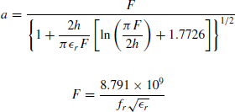Step 1: Determine - The actual radius *a* of the patch

Step 2: Determine - The actual radius *ae* of the patch



Fig. 2 Ground plane Fig. 3 Substrate

Fig. 4. Microstrip patch Fig. 5 Circular patch

Fig. 2. In circular microstrip antennas **an area of copper foil on the opposite side of a printed circuit board** serves as a ground plane

Fig. 3. The proposed antenna has been designed using FR4substrate of dielectric constant, ε r = 4.4 sandwiched between copper patch and ground plane.

Fig. 4. The dielectric material is mounted on a ground plane, where the ground plane supports the whole structure. Fig. 5. United the inner circle with rectangular patch by reducing the circular dimensions.

An electromagnetic software package, HFSS, has been utilized to simulate and analyse the electrical features and radiation performance of the proposed antenna.

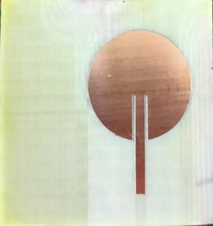

## (A)



(B)

Fig. 6. Photograph of the proposed Circularly polarized microstrip wearable antenna. a) top side of the fabricated antenna, b) bottom side of the fabricated antenna.

1. RESULTS AND DISCUSSIONS

The ANSYS High Frequency Structure Simulator (HFSS) is used to simulate the antenna's performance metrics like the reflection coefficient (S11), voltage standing wave ratio (VSWR), gain, directivity, and radiation pattern. These factors play a crucial role in an antenna's design, analysis, and testing, as well as in determining its general efficacy and performance in relation to the relevant applications.

* 1. Reflection Coefficient

This is a measurement of the energy that the antenna reflects back from it as a result of the transmission line's and antenna's mismatched impedance. The power loss will be lower if the reflection coefficient is low. Circularly polarised microstrip antenna results for the reflection coefficient are shown via simulation. With a reflection coefficient of less than -10 dB, it is seen that the antenna resonates at 2.4 GHz. Our approach successfully achieves a return loss of -30.4 dB.

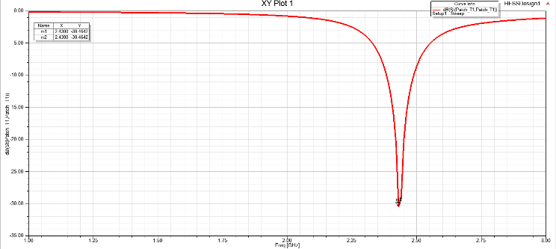\

Fig. 7.1 Reflection coefficient of circularly polarized microstrip antenna.

* 1. Voltage standing wave ratio

The proportion of voltage standing waves that are reflected and transmitted in an RF electrical transmission system. It is described as the ratio of the standing wave's maximum amplitude to its smallest amplitude along the transmission line. It gauges how well RF power is sent from the power source, along the transmission line, and into the load.



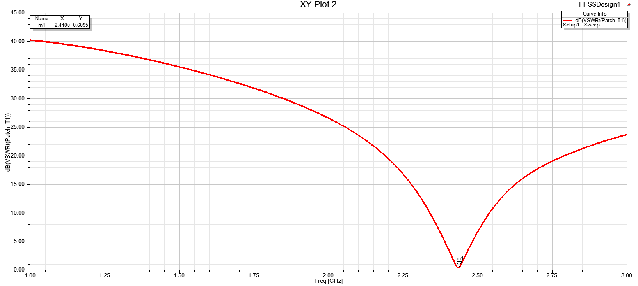

Fig. 7.2 shows the VSWR of circularly polarized microstrip antenna.

* 1. Radiation pattern

It typically consists of a certain number of lobes, and if it is detected far from the antenna, distance is irrelevant. It controls the strength and direction of the electromagnetic field that it emits. Figure 4.4 depicts the proposed antenna's radiation pattern in the E-Plane and H-Plane. The H-plane has seen nearly perfect omnidirectional patterns, and the E-plane has seen nearly perfect bidirectional patterns.

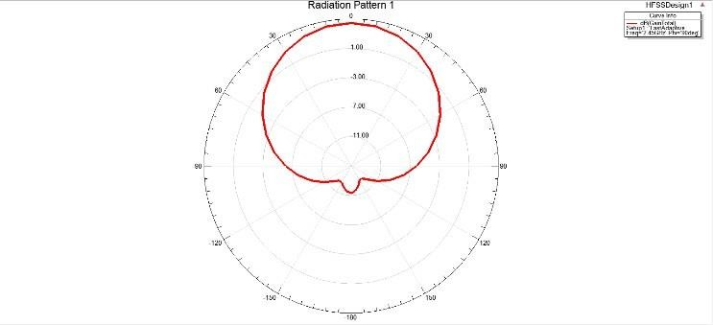

Fig. 7.3 Radiation pattern of circularly polarized microstrip antenna.

4.2 Directivity

This is a measurement of the amount of energy that is concentrated in one direction relative to the total amount of energy that is emitted. The antenna's power density divided by its average power density in the direction of greatest radiation in three dimensions. The gain in directivity D. Beamwidth and TheDirectivity have an inverse relationship.

G = 4 Pi/Ω (4.3)

where (Omega) denotes the antenna's radiation angle.

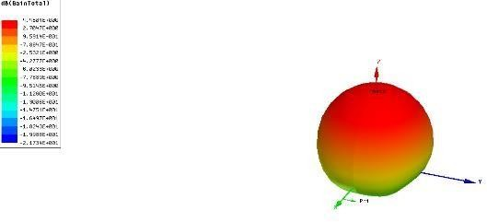

Fig 7.4 Directivity of circularly polarized microstrip antenna.

* 1. Gain

This is a comparison of an antenna's energy output in a given direction to that of an ideal, isotropic radiator. The antenna will emit equally in all directions at its maximum radiation intensity when compared to either the reference antenna or any hypothetical antenna.

G = Directivity (dBi) * Antenna Efficiency

The gain of the suggested antenna, which has a gain of around 4.5 GHz across the whole working band, is shown below.

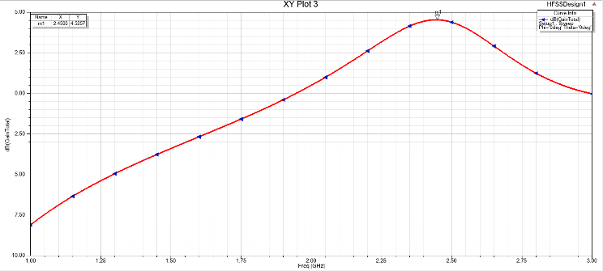

Fig. 7.5 Gain of circularly polarized microstrip antenna.

* 1. Surface current distribution

In order to see how the electromagnetic field distribution surrounding the antenna is distributed, field overlays are used in antenna analysis and design. They help us comprehend how electromagnetic forces move through space and

engage with their surroundings. Here is a surface distribution in the E and H planes.

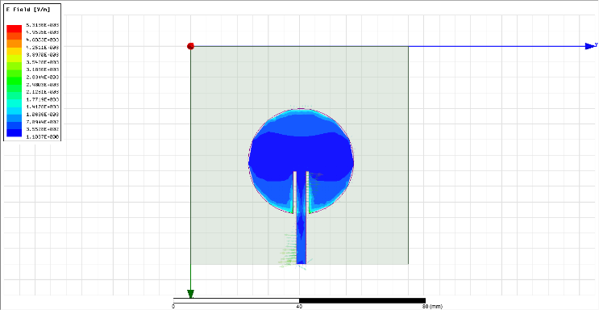

Fig. 7.6 Show the simulated result of surface current distribution in E-plane.

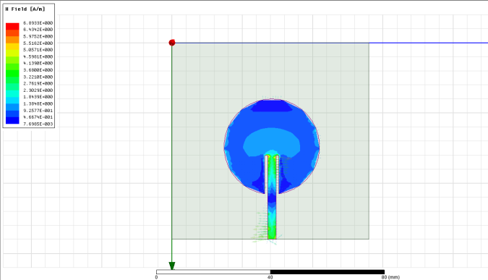

Fig. 7.7 Shows the simulated surface current distribution in H-plane.

# Impedance

This is a gauge for the antenna's electromagnetic energy flow resistance. Reflection and transmission losses are caused by an improper fit between the antenna and the transmission line or source. Usually, it is described in terms of the transmission line's characteristic impedance or input impedance. We use a 50 microstrip line impedance to feed our antenna.

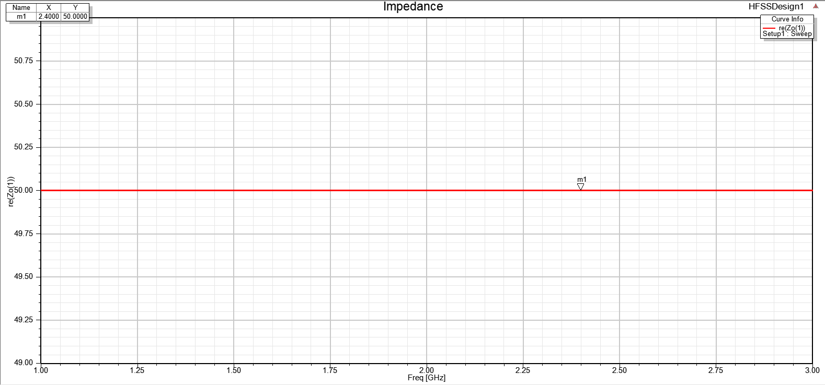

# Efficiency

Fig. 7.8 Shows the impedance match of circularly polarized antenna

This gauges the antenna's capacity to transform electrical energy into electromagnetic energy that is radiated. The radiation efficiency of the circular patch antenna we constructed is 59.1%. Antenna performance can be increased overall, resulting in greater signal transmission and reception, by raising antenna efficiency.

1. CONCLUSION

For wearable applications, a Circularly Polarised Microstrip antenna has been developed. In contrast to previous designs, the suggested antenna can readily and adaptably change its stopband feature, leading to improved radiation performance. The suggested circular antenna is also well suited for incorporation into clothing because to its outstanding pulse handling capability, stable transmission characteristics, and good omni-directional coverage. Due to their distinctive polarisation characteristics, circularly polarised antennas have many uses in a variety of fields. The following are some typical uses for circularly polarised antennas: using satellite technology Since they operate better in environments with significant polarisation distortion, circularly polarised antennas are frequently utilised in satellite communication systems. Wireless transmission: In wireless communication systems like cellular networks, Wi-Fi, Bluetooth, and RFID, circularly polarised antennas are utilised because they lessen the impacts of multipath fading and polarisation mismatch. Satellite-based global positioning systems (GNSS) In GNSS systems like GPS, GLONASS, and Galileo, circularly polarised antennas are employed to reduce the effects of polarisation distortion brought on by atmospheric and environmental conditions. remote monitoring Because they offer greater sensitivity to objects with various polarisation properties, circularly polarised antennas are employed in remote sensing applications including weather radar and synthetic aperture radar (SAR). Medicinal purposes Circularly polarised antennas are used to transmit and receive circularly polarised electromagnetic waves in medical applications like magnetic resonance imaging (MRI).

In general, circularly polarised antennas are utilised in a variety of applications where polarisation mismatch and distortion might impair system performance

REFERENCES

* 1. P. S. Hall and Y. Hao, Antennas and propagation forbody-centric wireless communications. Boston, Mass: Artech House,2012.
  2. S. Adami, P. Proynov, G. S. Hilton, G. Yang, C. Zhang,

S. P. Beeby, I. J. Craddock, and B. H. Stark, “A flexible 2.45-GHz power harvesting wristband with net system output from

–24.3 dBm of RF power,” IEEE Transactions on MicrowaveTheory and Techniques, vol. 66, no. 1, pp. 380–395, 2018.

* 1. G. A. Conway and W. G. Scanlon, “Antennas for over- body-surface communication at 2.45 GHz,” IEEE Transactions on Antennas and Propagation, vol. 57, no. 4, pp. 844–855, 2009.
  2. H. Lee, J. Tak, and J. Choi, “Wearable antenna integratedinto military berets for indoor/outdoor positioning system,” IEEE Antennas and Wireless Propagation Letters, vol. 16, pp. 1919–1922, 2017.
  3. S. J. Chen, D. C. Ranasinghe, and C. Fumeaux, “A robustsnap-on button solution for reconfigurable wearable textile antennas,” IEEE Transactions on Antennas and Propagation,vol. 66, no. 9, pp. 4541– 4551, 2018.
  4. C. Hertleer, H. Rogier, L. Vallozzi, and L. V. Langenhove,“A textile antenna for off-body communication integrated into protective clothing for firefighters,” IEEE Transactions on Antennas and Propagation, vol. 57, no. 4, pp. 919–925, 2009.
  5. S. Agneessens and H. Rogier, “Compact half diamond dual-band textile HMSIW on-body antenna,” IEEETransactions on Antennas and Propagation, vol. 62, no. 5, pp. 2374–2381, 2014.
  6. Y. Hong, J. Tak, and J. Choi, “An all-textile SIW cavity-

backed circular ring-slot antenna for WBAN applications,” IEEE Antennas and Wireless Propagation Letters, vol. 15, pp. 1995–1999, 2016.

* 1. P. B. Samal, P. J. Soh, and G. A. E. Vandenbosch, “UWBall-textile antenna with full ground plane for off-body WBAN communications,” IEEE Transactions on Antennas and Propagation, vol. 62, no. 1, pp. 102–108, 2014.
  2. L. Zhang, Z. Wang, and J. L. Volakis, “Textile antennasand sensors for body-worn applications,” IEEE Antennas andWireless Propagation Letters, vol. 11, pp. 1690–1693, 2012.
  3. M. Mantash, A. C. Tarot, S. Collardey, and K. Mahdjoubi, “Wearable monopole zip antenna,” Electronics Letters, vol. 47, no. 23, pp. 1266– 1267, 2011.
  4. S. J. Chen, T. Kaufmann, D. C. Ranasinghe, and C. Fumeaux, “A modular textile antenna design using snap- on buttons for wearable applications,” IEEE Transactions on Antennas and Propagation, vol. 64, no. 3, pp. 894–903, 2016.
  5. B. Sanz-Izquierdo, J. C. Batchelor, and M. Sobhy, “UWB wearable button antenna,” in 2006 First European Conference on Antennas and Propagation, 2006, Conference Proceedings, pp. 1–4.
  6. B. Sanz-Izquierdo, F. Huang, and J. C. Batchelor, “Covert dual-band wearable button antenna,” Electronics Letters, vol. 42, no. 12, pp. 668– 670, 2006.
  7. B. Sanz-Izquierdo, J. C. Batchelor, and M. I. Sobhy, “Button antenna on textiles for wireless local area network onbody applications,” IET Microwaves, Antennas and Propagation, vol. 4, no. 11, pp. 1980–1987, 2010.
  8. B. Sanz-Izquierdo, J. A. Miller, J. C. Batchelor, and M. I.Sobhy, “Dual- band wearable metallic button antennas and transmission in body area networks,” IET Microwaves, Antennas and Propagation, vol. 4, no. 2, pp. 182–190, 2010.
  9. X. Y. Zhang, H. Wong, T. Mo, and Y. F. Cao, “Dual- band dual- mode button antenna for on-body and off- body communications,” IEEE Transactions on Biomedical Circuitsand Systems, vol. 11, no. 4, pp. 933–941, 2017.
  10. X. Hu, S. Yan, and G. A. E. Vandenbosch, “Compact circularly polarized wearable button antenna with broadside pattern for U-NII worldwide band applications,” IEEE Transactions on Antennas and Propagation, vol. 67, no. 2, pp. 1341–1345, 2019.
  11. H. Xiaomu, S. Yan, and G. A. E. Vandenbosch, “Wearable button an- tenna for dual-band WLAN applications with combined on and off-body radiation patterns,” IEEE Transactions on Antennas and Propagation, vol. 65, no. 3, pp. 1384–1387, 2017.
  12. S. Yan and G. A. E. Vandenbosch, “Design of widebandbutton antenna based on characteristic mode theory,” IEEE Transactions on Biomedical Circuits and Systems, vol. 12, no. 6,pp. 1383–1391, 2018.
  13. J. Zhang, S. Yan, X. Hu, and G. A. E. Vandenbosch, “Dual-band dual-polarized wearable button array with miniaturized radiator,” IEEE Transactions on BiomedicalCircuits and Systems,pp. 1–1, 2019.
  14. X.-Q. Zhu, Y.-X. Guo, and W. Wu, “Miniaturized dual- band and dual-polarized antenna for MBAN applications,” IEEE Transactions on Antennas and Propagation, vol. 64, no.7, pp. 2805–2814, 2016.