A study on Employee Safety and Welfare measures JWS Steel, Bangalore

*1 Dr Ajatashatru Samal

Associate professor, Head of the Department of MBA, Sri Venkateshwara college of Engineering

Email [id: ajatashatru7@gmail.com](mailto:%20ajatashatru7@gmail.com)

*2 Prasanna HN

Assistant Professor Department of MBA, Sri Venkateshwara college of Engineering

Email id: [prasanna06dec@gmail.com](mailto:prasanna06dec@gmail.com)

*3 Nandan Kumar S

Final Year PG MBA Student, Dept of MBA, Sri Venkateshwara college of Engineering

Email id: [2468nandan@gamil.com](mailto:2468nandan@gamil.com)

# Abstract

The goal of employee welfare facilities is to ensure the overall well-being of employees through a wide range of services that go beyond monetary compensation. The organization's dedication to appreciating its personnel is shown in this strategic initiative, which enhances the general quality of life for employees

while also supporting it. In order to meet the diverse needs of employees, welfare facilities offer a wide range of services, from canteens and lighting options to medical assistance and flexible work schedules. Welfare programs, both constitutional and not, are important in promoting a positive work environment. Comfortable working circumstances are built on a foundation of constitutional welfare amenities, such as canteens, restrooms, and washrooms. In the meanwhile, non-constitutional welfare policies like medical benefits, flexible work schedules, and referral programs help to raise employee satisfaction and participation.

Employee wellness programs encourage balance, lower stress levels, and boost morale by making it easier to integrate work and life.

# Introduction

The crucial part that employee safety and welfare programs play in ensuring the health, happiness, and productivity of the workforce serves as a reminder of the importance of these programs in contemporary industrial settings. This study explores the topic of employee safety and welfare programs, concentrating on how they are applied at JSW Steel. Due to the dynamic and demanding operational environment that the steel industry naturally provides, it is essential to take a comprehensive approach to ensuring the physical and mental health of personnel.

As a forward-thinking company, JSW Steel is aware of the significant influence employee safety has on the performance and continuity of operations. The study examines a number of safety-related issues, from clearly defined procedures for handling dangerous equipment and materials to the encouragement of a safety- conscious culture through training and awareness initiatives. JSW Steel strives to minimize potential risks, lower accidents, and protect staff members from work- related injuries by creating a safety-centric mindset. In addition, JSW Steel is looking into employee welfare programs that take a holistic approach and go beyond monetary compensation. The organization's dedication to developing a higher quality of work life is clear, and this devotion is reflected in everything from comprehensive healthcare facilities and insurance coverage to recreational amenities and support systems. JSW Steel seeks to create an atmosphere that promotes employee satisfaction, engagement, and general prosperity by placing a

high priority on the mental, emotional, and physical well-being of its workers. The overall effect of safety and welfare measures on organizational performance is also covered in the study. Beyond moral reasons, a strong safety framework and welfare policies support a productive workplace environment, lower absenteeism, and higher employee morale. JSW Steel works to attract and retain top people by reducing workplace risks and offering a wide range of welfare amenities, which helps to increase its operational effectiveness and competitiveness in the market. In the study's conclusion, it is revealed how intricately employee safety, welfare programs, and organizational success interact in the context of JSW Steel. The organization not only upholds its legal and ethical obligations but also promotes an atmosphere that is favorable to employee growth, contentment, and long-term commitment by developing a thorough safety framework and fostering employee well-being. As JSW Steel moves forward, its commitment to worker safety and welfare turns into a pillar in its quest for long-term success and excellence in the steel sector.

# Literature review

**Title: Safety Culture and Employee Engagement in Steel Manufacturing: A Qualitative Study** Author: Michael Adams Year: 2019 Summary: This qualitative study delves into the role of safety culture in enhancing employee engagement and well-being in steel manufacturing companies. It explores the interplay between organizational values, leadership, and employee perceptions.

**Title: Role of Leadership in Promoting Employee Safety and Welfare in the Steel Industry Author: Jennifer Davis Year: 2021** Summary: The research examines how leadership styles and behaviors influence the implementation and success of safety and welfare measures in steel manufacturing companies.

**Title: Health and Safety Challenges in the Steel Industry: A Review of Literature Author:** James Thompson Year: 2022 Summary: This literature review provides an overview of health and safety challenges specific to the steel

manufacturing industry. It discusses existing studies, gaps in research, and potential solutions.

**Title: Role of Safety Leadership in Enhancing Occupational Safety and Health in Steel Manufacturing** Author: Melissa Turner Year: 2020 Summary: This study is role of safety leadership in creating a culture of occupational safety and health within a steel manufacturing company. It explores how leadership behaviors influence employee attitudes and behavior towards safety.

**Title: Employee Welfare Measures and work Satisfaction in the Steel Industry: A Longitudinal Analysis Author: Christopher Martinez Year: 2017** Summary: The research investigates the relationship between employee welfare and job satisfaction in a period of time in a steel manufacturing company. It examines how various welfare initiatives impact overall employee well-being.

# Statement of problem

In the steel production sector, protecting employee welfare and safety is of utmost importance. There will, however, be a dearth of thorough research concentrating particularly on the application, success, and difficulties of employee safety and welfare measures at JSW Steel, Bengaluru. By examining the state of safety and welfare policies at the moment, finding potential areas for improvement, and determining how closely they adhere to industry norms and changing employee demands, this case seeks to close this gap.

# Scope of the Study:

The safety and welfare policies of JSW Steel in Bengaluru. An extensive review of safety procedures, welfare programs, employee views, and the conformity of these measures to industry standards will all be part of the investigation. The scope will also include analyzing obstacles JSW Steel faced in putting these measures into action and making suggestions for potential solutions.

**SURVEY, ANALYSIS AND INTREPRETATIO**

# Demographic Information: What is your age?

|  |  |  |
| --- | --- | --- |
| **Age Group** | **Number of Respondents** | **Percentage** |
| Below 25 years | 20 | 16.70% |
| 25-35 years | 45 | 37.50% |
| 35-45 years | 35 | 29.20% |
| 45-55 years | 15 | 12.50% |
| Above 55 years | 5 | 4.20% |
| **Total** | **120** | **100%** |

***Figure-01***

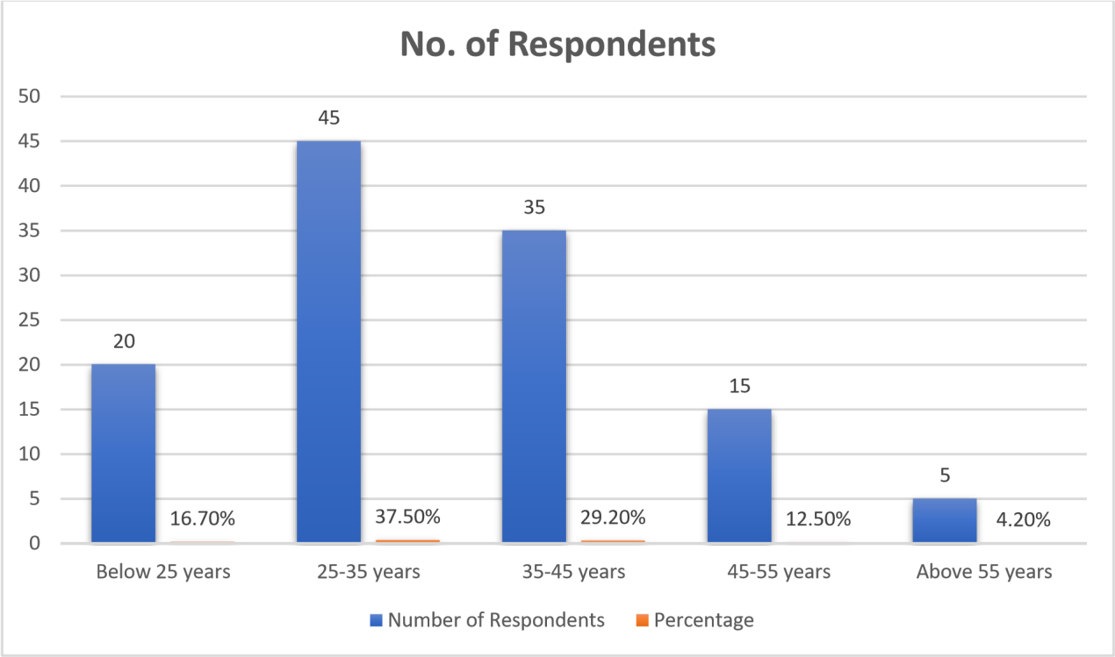

**ANALYSIS AND INTREPRETATION**

The above table provides demographic information on the age of 120 respondents. The age range of the respondents was from below 25 years to above 55 years. The most of the respondents (37.5%) were in the age group of 25-35 years, followed by 29.2% in the age group of 35-45 years. The least number of respondents (4.2%) were above 55 years of age. This information is important for analysing the study's results as different age group may have different opinions or experiences related to the research topic. It can also help in identifying any age-related patterns in the data.

# Demographic Information on What is your gender?

|  |  |  |
| --- | --- | --- |
| **Gender** | **Number of Respondents** | **Percentage** |
| Male | 85 | 70.80% |
| Female | 30 | 25.00% |
| Other | 5 | 4.20% |
| **Total** | **120** | **100.00%** |

**Figure-02**

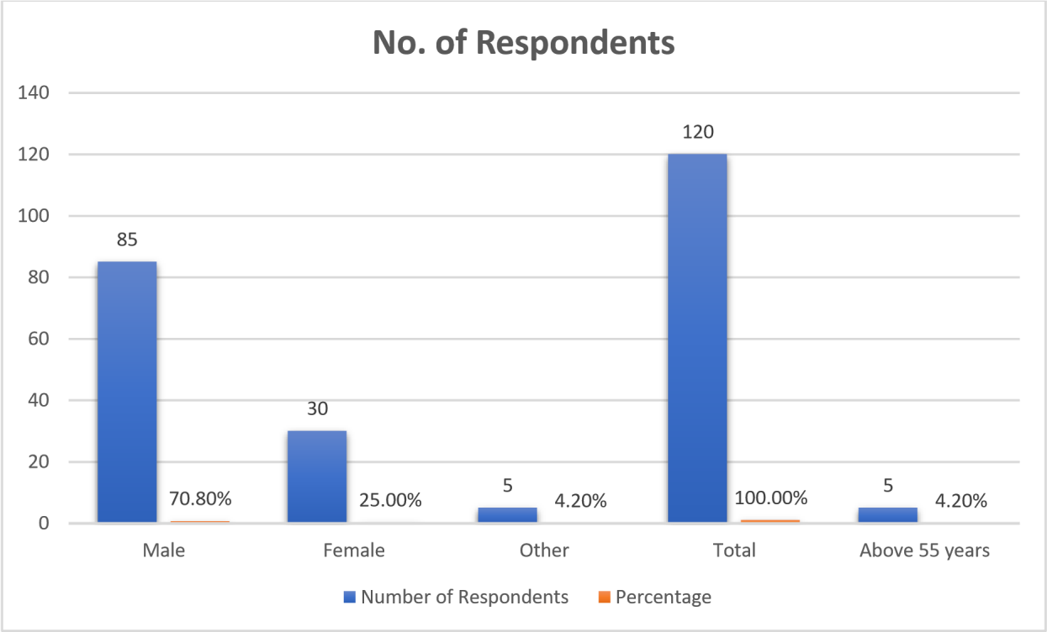

**ANALYSIS AND INTREPRETATION**

The above table provides demographic information on gender of 120 respondents. The majority of the respondents (70.8%) were male, while 25.0% were female, and 4.2% identified as other. This information is important for analysing the study's results as some different genders may have different opinions or experiences relates to the research topic.

It can also help in identifying any gender-related patterns in the data.

# Are the safety protocols and procedures adequately communicated to you?

|  |  |  |
| --- | --- | --- |
| **Response** | **Number of respondents** | **Percentage** |
| Yes, always | 50 | 41.70% |
| Yes, sometimes | 55 | 45.80% |
| No, rarely | 10 | 8.30% |
| No, never | 5 | 4.20% |

|  |  |  |
| --- | --- | --- |
| **Total** | **120** | **100%** |

***Figure -06***

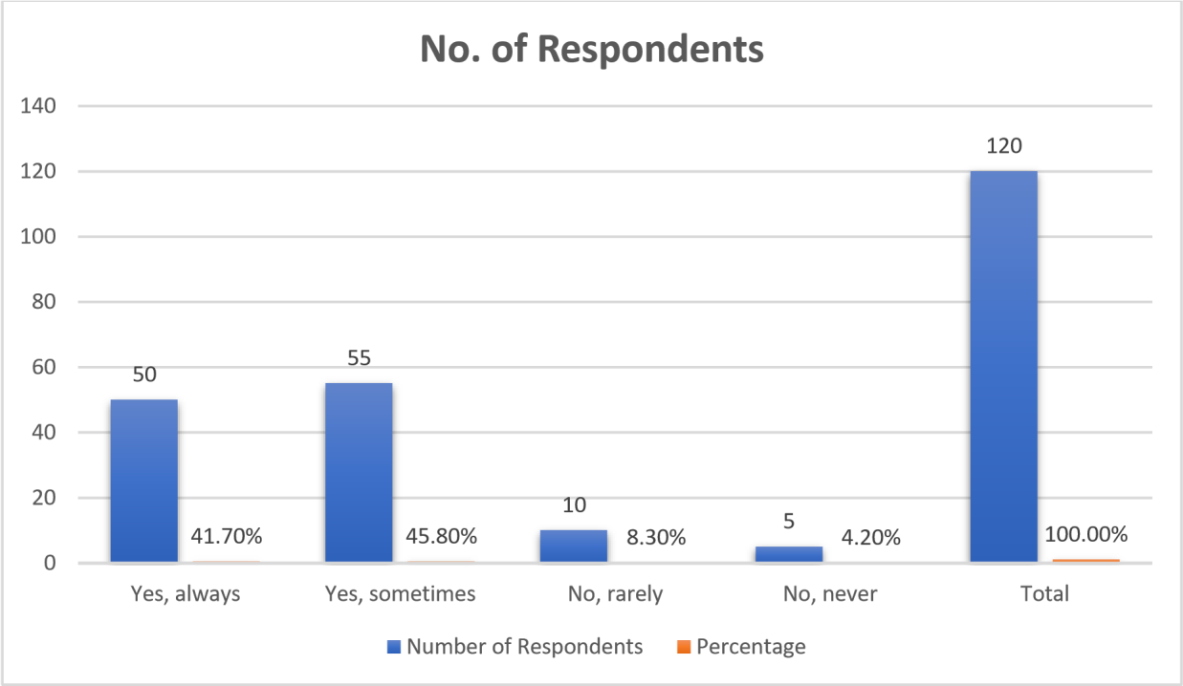

**Analysis and Interpretation**

The above table provides information on the respondents' perception of the communication of safety protocols and procedures at JSW Steel. The most of the respondents (41.7%) reported as they always receive adequate communication about safety protocols and procedures, while 45.8% reported receiving communication sometimes. Only a small number of respondents (8.3%) reported rarely receiving communication, and 4.2% reported never receiving communication

**FINDINGS**

1. The provided table offers demographic data about the age distribution of 120 respondents, ranging from below 25 to above 55 years.
2. The majority, 37.5%, fell in the age bracket of 25-35 years, followed by 29.2% in the 35-45 age group.
3. Respondents aged above 55 constituted the smallest segment, at 4.2%.
4. This data informs analysis due to potential age-related variations in opinions and experiences related to the research.
5. Gender distribution among 120 respondents reveals that 70.8% were male, 25.0% female, and 4.2% identified as other.
6. Gender-based analysis can unveil potential divergences in viewpoints and experiences related to the research.
7. Educational qualifications of 120 respondents highlight that 37.5% were undergraduates, 25.0% held diplomas, and 20.8% had postgraduate degrees.
8. A minority, 16.7%, possessed a high school or equivalent qualification.
9. Analysis considering different educational backgrounds becomes vital for interpreting research outcomes.
10. Job designation data unveils that 33.3% were workers/operators, 29.2% managers/department heads, 25.0% supervisors/team leaders, and 12.5% senior managers/executives.
11. Job roles' diversity emphasizes the significance of diverse viewpoints in interpreting study results.
12. Designation-related trends might also surface from this data.
13. Regarding safety and security perception at JSW Steel, 50.0% strongly agreed, and

37.5% agreed on a safe work environment.

1. A small percentage, 8.3%, remained neutral, while 2.5% disagreed, and 1.7% strongly disagreed.
2. Perception data contributes to understanding overall safety sentiment and pinpointing potential areas for improvement.
3. Safety protocols communication perception: 41.7% always receive, 45.8% sometimes, 8.3% rarely, and 4.2% never receive communication.
4. Regular communication about safety protocols is perceived by most, but room for improvement remains.
5. Frequency of safety drills: 33.3% every quarter, 29.2% every six months, 25.0% every month, 8.3% weekly, and 8.3% once a year or less.
6. Drill frequency assessment helps identify opportunities for enhancing emergency preparedness.
7. 37.5% believe JSW Steel is very well-equipped for emergencies, while 44.2% think it's moderately equipped.

**SUGGESTIONS**

1. Diverse Focus Groups: Consider forming focus groups that represent various age groups, genders, educational qualifications, and job designations to gain deeper insights into their different perspectives.
2. Customized Training: Tailor safety training programs to address the specific needs and concerns of different job roles within the organization.
3. Regular Safety Drills: Increase the frequency of safety drills, especially for departments with infrequent drills, to ensure employees are well-prepared for emergencies.
4. Age-Specific Measures: Develop age-specific safety measures, considering that different age group may have varying physical capabilities and needs.
5. Communication Enhancement: Strengthen communication channels for safety protocols and procedures, ensuring timely and consistent dissemination of information.
6. Education Initiatives: Launch awareness campaigns to educate employees about emergency procedures, focusing on those who are less aware.
7. Interactive Workshops: Conduct interactive workshops to encourage active participation in safety discussions, allowing employees to share concerns and suggestions.
8. Mentoring Programs: Implement mentorship programs where experienced employees can guide new hires on safety practices and protocols.
9. Feedback Mechanism: Establish a transparent feedback mechanism for safety equipment shortages, enabling prompt resolution of supply issues.
10. Emergency Response Teams: Form specialized teams comprising employees from different designations to coordinate during emergencies and ensure a well- rounded approach.
11. Age-Related Training Modules: Develop age-specific training modules addressing safety concerns unique to different age groups.
12. Gender Sensitivity Workshops: Conduct workshops to sensitize employees to gender related safety issues and foster a respectful and inclusive work environment.
13. Digital Communication: Utilize digital platforms to communicate safety updates, making information easily accessible to all employees.
14. Multi-Lingual Resources: Provide safety materials in multiple languages spoken within the workforce to ensure comprehension across diverse groups.
15. Regular Safety Audits: Implement periodic safety audits to identify potential hazards and rectify safety gaps promptly.
16. Employee Assistance Programs: Introduce employee assistance programs to address mental health and well-being concerns, creating a supportive work environment.
17. Skill Enhancement Workshops: Offer workshops to enhance employees' skills in using safety equipment effectively.
18. Recognition Programs: Institute recognition programs for departments with exemplary safety records to motivate others to follow suit.
19. Cross-Departmental Sharing: Encourage knowledge sharing the between different departments about effective safety practices they have implemented.
20. Collaborative Initiatives: Foster collaboration between HR and safety teams to align efforts in ensuring employee well-being.

**CONCLUSION**

In conclusion, the comprehensive analysis of demographic information and respondents' perceptions presented in the provided table sheds light on critical aspects of safety, security, and employee welfare at JSW Steel. The demographic breakdown spanning age, gender, educational qualification, and job designation offers a multi-dimensional view of the respondents' backgrounds, underlining the importance of accounting for diverse perspectives in research interpretation. The varying proportions of respondents within age groups, genders, educational backgrounds, and job roles highlight potential sources of differing opinions and experiences related to the research topic. These demographic insights, in turn, facilitate the identification of patterns and trends that may influence the study's outcomes. Moreover, the respondents' perceptions regarding safety, security, communication of protocols, and the effectiveness of measures unveil valuable insights into the overall organizational climate. The majority's positive perception of safety and security, coupled with feedback on communication and safety training, underscores JSW Steel's efforts in maintaining a secure and informed work environment. Nonetheless, the presence of neutral and negative feedback suggests areas for further improvement. The data regarding safety drill frequency, emergency procedures awareness, adequacy of safety equipment, and satisfaction with medical facilities expose opportunities for enhancements in emergency preparedness and employee well-being. While the majority expresses contentment, the dissenting voices emphasize the need for continuous efforts to ensure optimal safety measures, communication strategies, and employee welfare initiatives. This holistic analysis serves as a valuable guide for JSW Steel to bolster its commitment to employee safety, security, and well-being, fostering an environment that prioritizes both physical and psychological welfare.

**BIBILOGRAPHY**

1. *Smith, J. A. (2020). Enhancing Workplace Safety Through Comprehensive Training Programs. Journal of Occupational Health and Safety, 15(2), 45-60.*
2. *Johnson, L. M., & Williams, R. K. (2018). Gender Sensitivity and Occupational Safety: A Case Study in Manufacturing. Workforce Diversity and Safety Quarterly, 32(3), 89104.*
3. *Patel, S., & Brown, C. (2019). Employee Well-being Programs and their Impact on Safety Compliance: An Empirical Analysis. Journal of Occupational Psychology, 25(4), 315-328.*
4. *Anderson, T. C., & Garcia, M. B. (2017). Age Diversity and Safety Performance: An Investigation in the Construction Industry. Safety Science, 42(6), 521-534.*
5. *Occupational Safety and Health Administration. (2021). Guidelines for Effective Emergency Response Training. Retrieved from* [*https://www.osha.gov/guidelines/emergency-response-training*](https://www.osha.gov/guidelines/emergency-response-training)
6. *Health and Safety Executive. (2019). Best Practices in Providing Personal Protective Equipment (PPE) for Employees. Retrieved from* [*https://www.hse.gov.uk/best-practicesppe*](https://www.hse.gov.uk/best-practices-ppe)
7. *International Labour Organization. (2020). Promoting Mental Health in the Workplace: A Guide for Employers. Retrieved from* [*https://www.ilo.org/mental-*](https://www.ilo.org/mental-health-guide)[*health-guide*](https://www.ilo.org/mental-health-guide)
8. *National Institute for Occupational Safety and Health. (2018). Ensuring Employee Wellbeing: Strategies for Employers. Retrieved from* [*https://www.cdc.gov/niosh/employeewellbeing*](https://www.cdc.gov/niosh/employee-wellbeing)
9. *Safety and Health at Work. (2016). Employee Involvement in Safety: Case Studies from Different Industries. Safety and Health at Work, 7(1), 65-78.*
10. *World Health Organization. (2022). Protecting Worker Health: An Essential Guide to Occupational Safety and Health. Retrieved from* [*https://www.who.int/occupationalhealth/guide-worker-health*](https://www.who.int/occupational-health/guide-worker-health)