**COMPACT SLOT BASED MICROSTRIP PATCH ANTENNA FOR WEARABLE APPLICATIONS**

SHUNMUGASUNDARAM M1, KARTHICK G2, SHENBAGARUBAN M3, NAVIN PRASATH M4, BALAMURUGAN C4

1,2,3 Student Department of Electronics and Communication Engineering, National Engineering College, Kovilpatti, Tamilnadu, India

4 Assistant Professor, Department of Electronics and Communication Engineering, National Engineering College, Kovilpatti, Tamilnadu, India

Email: [1911014@nec.edu.in](mailto:1911014@nec.edu.in), [1911040@nec.edu.in](mailto:1911040@nec.edu.in), [1911102@nec.edu.in](mailto:1911102@nec.edu.in), 1911010@nec.edu.in,

***Abstract*—** **In this study, a slot-based micro strip antenna for wearable applications is designed, simulated, and manufactured on a FR4 substrate. The antenna has a rectangular patch with a slot in the middle to achieve impedance matching and radiation efficiency. It is made to function in the 5 GHz ISM band. Standard PCB manufacturing procedures are employed to create the antenna, and the FR4 substrate material was selected for its affordability and availability.** **This work conducts in-depth literature research to design patch antennas for wearable applications. Using the ANSYS HFSS Package, a slot-based microstrip patch antenna for use at 5 GHz is built based on the findings from the data acquired in the survey.** **To obtain the desired radiation properties, the Patch has many U-slots. On a FR4 EPOXY substrate with a 4.4 dielectric constant, the suggested antenna is constructed. For the suggested antenna, a number of antenna properties, including return loss, radiation pattern, bandwidth, directivity, antenna gain, radiation efficiency, etc., are studied. The suggested antenna has a reflection coefficient of less than -30 dB at 5 GHz. At resonance, the antenna generates a gain of 2.08 db.**

***Keywords: On-body Applications, Wireless Communications, Wearable Application, High Gain, Wearable Antenna, U Slot Microstrip Patch.***

1. INTRODUCTION

The antenna is the component of a wireless infrastructure that is physically most visible. Every form of communication, including radio, LAN, and other forms, requires an antenna. Sending and receiving crystal-clear signals between various wireless locations is the antenna's primary function. An functional and efficient wireless network cannot run without antennas, it can be said with confidence. For indoor, outdoor, and wireless networks at work or home, a decent antenna offers a professional alternative for wireless connectivity. There are a vast variety of antenna types with different specifications.

Therefore, in order to select an antenna that is best suited to your wireless needs, it is crucial to understand the three key characteristics of an antenna: frequency, beam width, and gain.

The development of so-called "smart clothes" has increased interest in wearable wireless technologies in recent years. In the future, the garment will make it easier for people and objects to communicate. Making the electronics undetectable to the user is the main difficulty in constructing wearable antenna. Another important factor is how well the antenna performs under mechanical solicitation, in working conditions, and during operations like washing and ironing. The wearable antenna also operates near or in direct contact with the human body, which has a substantial impact on the performance of the antenna.

The capability of wearable technology to deliver wireless communications from or to the body via conformal and wearable antennas is one of its most crucial features. These antennas' design strategy may be quite different from that of ordinary antennas because they must be installed on the body. As a result, the antenna's fabric was strong, flexible, and wearable, making it suitable for use in clothing. For body-centric communications, wearable antennas are frequently employed in body area networks (BAN) and personal area networks (PAN). Many specialized occupational groups, including the military, paramedics, and firefighters, use body-centric communication systems.

The antenna is a viable option for wearable applications due to its small size, low price, and excellent performance. The antenna is simple to incorporate into a wearable device and can provide a reliable 5 GHz ISM band connection. This study provides a substantial addition to the design of wearable antennas by demonstrating the potential of slot-based micro strip antennas on FR4 substrates for a variety of wearable applications.

Due to their low profile, simplicity of integration, and excellent radiation efficiency, microstrip patch antennas have gained popularity for wearable applications. Microstrip patch antennas can be used in a variety of wearable technology applications, including medical sensors, smart watches, fitness trackers, and other wearable health monitoring devices. The antenna, which provides a dependable 2.4 GHz ISM band connection, can be fitted into the design of the device. Sports: Microstrip patch antennas can be used to offer dependable communication between the device and the user's smartphone or other devices in wearable sports gadgets such smart helmets, chest straps, and armbands. For connection and data, wearables like smart glasses and virtual reality headsets can make use of microstrip patch antennas.

1. U SLOT ANTENNA DESIGN

The following specifications are intended for a wearable application of a microstrip patch antenna with U-slots employing FR4 EPOXY. To get the desired results, the patch concept is employed as a trial-and-error technique. The National Electrical Manufacturers Association (NEMA) established the FR4 standard for an epoxy resin laminate with glass fibre reinforcement. A substance is said to be "flame retardant" (FR) if it meets with the UL94V-0 standard for plastic materials' flammability.

Equation (1) is used to calculate the radiating rectangular patch antenna's parameter width. Equation (2) is used to calculate the rectangular patch antenna's effective dielectric constant.



The effective length is specified at the resonance frequency is determined from equation (3):



Equation (4) is used to calculate the rectangular patch antenna's extension length.

Equation (5) is used to get the rectangular patch antenna's length "L":



Fig-1. Microstrip patch antenna in top view with U-slot



Fig-2 Microstrip patch antenna side view with inset feed

TABLE 1. THE PROPOSED ANTENNA'S PARAMETERS

|  |  |  |  |
| --- | --- | --- | --- |
| **Parameter** | **Value** | **Parameter** | **Value** |
| **Wp** | 18mm | **Wg** | 23.5mm |
| **Lp** | 22mm | **Lg** | 24mm |
| **Ts** | 1mm | **Lf** | 2.6mm |
| **Ws** | 23.5mm | **Wf** | 0.5mm |
| **Ls** | 24mm | **DC** | 4.4 |

Table 1. Depicts the precise measurements of the intended U-slot antenna. The overall size of the suggested antenna, including the ground plane, which is 23.5 mm x 24 mm, is only 18 mm x 22 mm x 1 mm.

1. RESULTSANALYSIS

A. RETURN LOSS: Fig. 3 shows the predicted return loss of the proposed wearable antenna. The proposed wearable multiband antenna's resonance frequencies are at 5 GHz (return loss: 13.5406), 8.8 GHz (return loss: 22.3103), and 12.5 GHz (return loss: 25.6577). The ability of the planned antenna to match impedance is evaluated using its reflection coefficient. The antenna's 5 GHz reflection coefficient is estimated to be -30 dB.

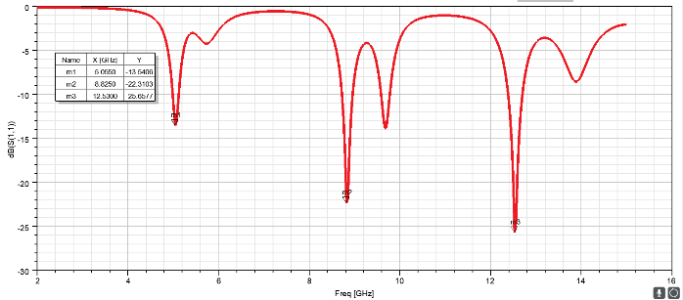

Fig 3- Return loss for the intended antenna

B. GAIN: Figure 4 shows the suggested antenna's 3-D design, which shows an extraordinarily directional radiation pattern with a total gain of 2.08 dB.

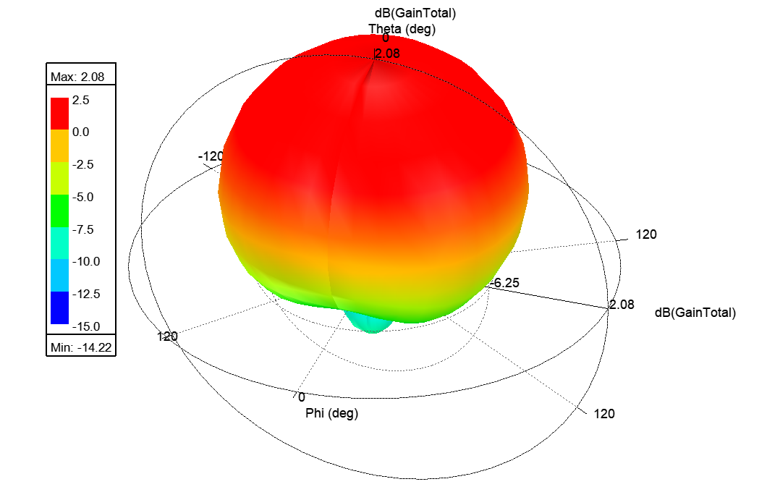 Fig. 4. The proposed antenna's simulated 3-D pattern used to calculate gain.

C. VSWR: It is anticipated that the voltage standing wave ratio will be 1. Figure 5 below displays the VSWR for three different frequencies: 3.7 at 5 GHz, 1.4 at 8.8 GHz, and 1.05 at 12.5 GHz. It appears to improve as the frequency rises.

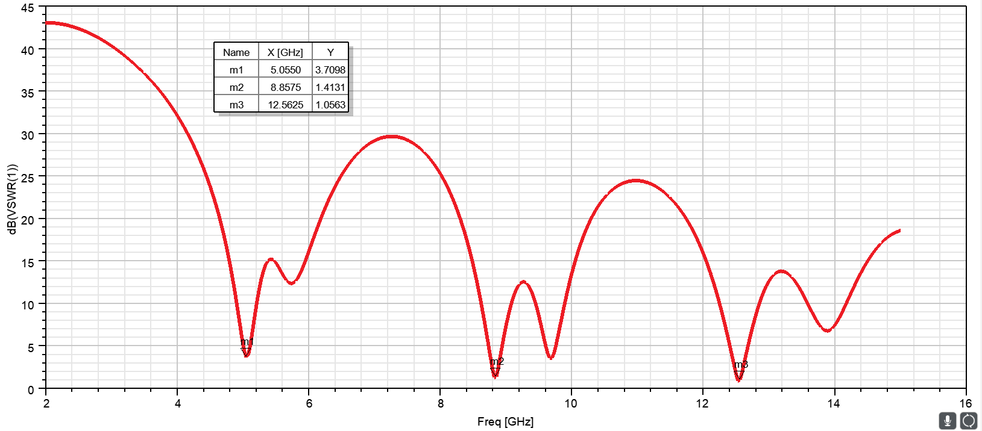

Fig 5- The proposed antenna's VSWR

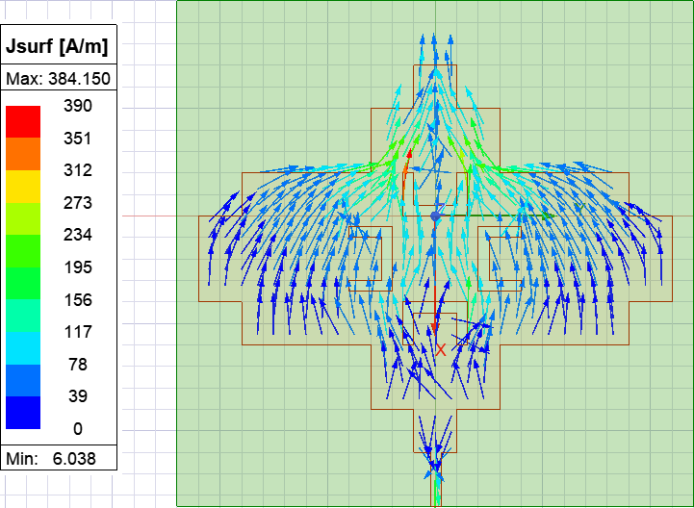

(a)

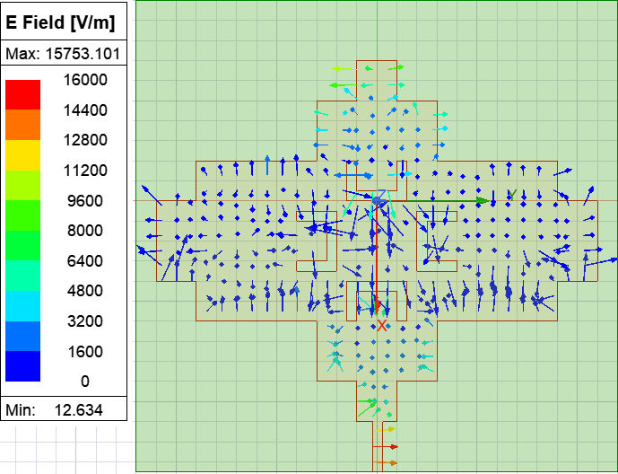

(b)

Fig 6. The simulated current and electric field distributions for the proposed antenna

IV **C**ONCLUSION

ANSYS planned and simulated the requested work using HFSS to solve electromagnetic structures. A trade-off between bandwidth and gain must be made because wearable antenna gain is often low due to human body losses. U slotting is used to boost the antenna's gain while decreasing its size because smaller antennas are required at higher frequencies. This makes the antenna lightweight and small enough to be worn on the body for wireless body area network applications. With a return loss of -30 dB and a VSWR of 1.2, the gain for this suggested antenna is 6 dB. Due to its small aperture area, the wearable antenna experiences higher losses, making it challenging to increase its gain in a particular desired direction without enlarging the antenna aperture.

REFERENCES

1. Huda A. Majid, Mohamad K. A. Rahim, Mohamad Rand Muhammad F. Ismail,2013 “Frequency Reconfigurable Microstrip Patch-Slot Antenna with Directional Radiation Pattern”, Progress. In Electromagnetics Research, Vol. 144,
2. Colebeck E, Kiourti A, Topsakal E, Volakis JL (2014)Pulmonary monitoring sensor with integrated body-a network for remote medical sensing. IEEE Trans Antenna Propag 62:2787–2794
3. Sankaralingam S., Gupta B., 2011, Design development of flexible fabric antenna for body-worn Applications and its Performance Study.
4. Salonen P., Samii Y.R., Kivikoski M. 2004,”wearable antenna in vicinity of human body” s IEEE AP-S International Symposium Digest, pp.467-47
5. Salonen, P. and Y. Rahmat-Samii, “Textile antennas: Effects of antenna bending on input matching and impedance bandwidth,” IEEE Aerospace and Electronic Systems Magazine, Vol. 22, No. 3, 10–14, 2007.
6. J. Gemio, and J. Soler on (2010) "Human body effects on implantable antennas for ism bands applications: models comparison and propagation losses study," Progress In Electromagnetics Research, Vol. 110, 437-452
7. P. Soontornpipit, C. M. Furse, and Y. C. Chung, (2004) “Design of implantable microstrip antenna for communication with medical implants,” IEEE Transactions on Microwave Theory and Techniques, vol. 52, no. 8, pp. 1944–1951.
8. Pankaj Kumar Singh, Subodh Kumar Tripathi, Rahul Sharma, Ashok Kumar, November 2013 ‘Design and Simulation of Microstrip Antenna for Cancer Diagnosis’, International Journal of Scientific and Engineering Research, Volume 4, Issue 11, 1821 ISSN 2229-5518.
9. Irishina N, Moscoso N, and Dorn N,april 2019 "Microwave imaging for early breast cancer detection using a shapebased strategy," IEEE Trans. Biomed. Eng., vol. 56, no. 4, pp. 1 143- 1153
10. Akalya C G and Nandalal V 2015 On-body adhesive microstrip antenna for wearable application in Proc. of the 14th Int. Conf. on Circuits, Systems, Electronics, Control and Signal Processing
11. T. Dimri, S. Sharma and A. Singh, "Wearable Antenna for Wireless Applications at 5.3 GHz Frequency," 2018 2nd International Conference on Micro-Electronics and Telecommunication Engineering, pp. 215-218,2018
12. G. Gao, C. Yang, B. Hu, R. Zhang and S.

Wang, "A Wearable PIFA With an All-Textile Metasurface for 5 GHz WBAN Applications," in IEEE Antennas and Wireless Propagation Letters, vol. 18, no. 2, pp. 288-292, Feb. 2019.

1. J. Cui, S. Yan, and A. Zhang, "A Wearable Filtering Antenna Based on Multilayer Structure," 2019 International Symposium on Antennas and Propagation (ISAP), pp. 1-3,2019.
2. J. Zhang, S. Yan, X. Hu, and G. A. E. Vandenbosch, "Dual-Band Dual-Polarized Wearable Button Array with Miniaturized Radiator," in IEEE Transactions on Biomedical Circuits and Systems, vol. 13, no. 6, pp. 1583-1592, Dec. 2019.
3. L. Xu and Z. Duan, "Differential wide band metal-frame antenna for wristband applications," 2016 IEEE MTT-S International Microwave Workshop Series on Advanced Materials and Processes for RF and THz Applications, pp. 1-3, 2016