**COMPACT PRESSURE AND SINTER STRENGTH RELATION FOR BRASS POWDER SAMPLE PRODUCED BY OBSOLETE MACHINING PROCESS**

Orji Ugochukwu Richards1, Ifeyinwa Faith Ogbodo2, Onyenanu Chukwunonso Nnanyelum3, Ogbodo Emmanuel Utochukwu4,

Department of Industrial & Production Engineering1,2

Department of Chemical Engineering3,

Department of Electronics & Computer Engineering4

Nnamdi Azikiwe University, Awka.

Email: ur.orji@unizik.edu.ng, [if.ogbodo@unizik.edu.ng](mailto:if.ogbodo@unizik.edu.ng), [cn.onyenanu@unizik.edu.ng](mailto:cn.onyenanu@unizik.edu.ng), emma.ogbodo@unizik.edu.ng.

**ABSTRACT**

The paucity of metal powder for PM products manufacturer prompted an alternative sourcing. Brass chips/powder sourced from artisan workshops was characterized for standard PM process; a particle length of 140micron was obtained the resultant brass sinter was investigated considering some selected physical and mechanical properties of the 1.44cm diameter sinter.

At a press load value of 45, 50, 55, 60, 65, 70 and 75 KN, a compact pressure of 245, 280, 310, 340, 370, 395 and 424 MPa resulted respectively.

Congruently, tensile strength of each of the seven samples investigated reflected the following sinter strengths: 349, 360, 381, 408, 423 and 445 MPa respectively. However, there was a relative fall in sinter height with respect to increasing compact pressure from 2.12, 2.07, 2.01, 1.97, 1.92, 1.88 to 1.85cm. The total keeping time and sintering temperature of 30 minutes and 800 degrees Celsius were uniformly applied.

The least square method of linear regression was subsequently applied; an expression for compact pressure (P) and Tensile strength (T): P=1.78T – 364 was developed at a coefficient of association of 0.995.

**Key Words: Sinter, Green Part, Keeping Time, Sinter Part, Bulk Density**

**INTRODUCTION**

Traditional method of manufacturing engineering components includes, melting, casting, rolling, forging, extrusion drawing among others. However, a radical innovation in manufacturing process may by-pass these processes in product or components manufacture.

Powder metallurgy is a process of manufacturing components from metal powder (Dagamo, 2012) a more rounded definition may consequently refer to powder metallurgy as the process of making metal powder among other products guided by the PM process algorithm.

Items of diverse application are manufactured using this technological process. Application of PM has a spatial listing including automobile, aircraft, electrical, foundry and machine tools.

Like captured in the definition, production of metal powder is one of the basis of this technology .The common approach to metal powder production are; atomization, shotting, crushing, milling, reduction, electronic deposition condensation and a host of all others. (Sheasby, 1979). The rate of PM products .. use in the U.K. and USA can account for 4.0% and 10% of general metallic wares or components .Item and applications produced with this technology include, bearings, gears, barker, gas turbine blades, light alloys (Al,Mg, Ti*)* stainlesssteel, Nii and CO based super alloys. soft magnetic core (Fe-Ni, Fe-Si) , high speed steels and other important products range.

A host of mechanical, electrical and physical effectiveness that gives the PM products a dominating presence in the scale of metallic component applications.

Powder metallurgy products would come out, bright, precise, clean and ready to use. Therefore, further machining and processing operation are almost non-existent. Wastage is also minimal with some important physical properties say, density weight, conductivity and porosity regulated in line with design information (Khan, 1980).

However, high cost of metal powder; size of products;need for large scale press machine, Powder explosion during storage; difficulty in sintering low melting powder ;density and elastic properties are till date major challenges in the industry.

**EXPERIMENTS AND METHODS**

Experimental samples were obtained from artisan machine shops operational at Igun, Benin City and mile XII market, Lagos, both in Nigeria. The brass powder was chips produced during machining of brass for production of various articles in the workshop.

Generally, filling and grinding were the common milling operations in use.

**Mould Design**

The mould is of a mild steel material of strength 600MPa. The depth of its cavity is 65mm; the external and internal diameters of the cylindrical cavity are 29.6mm and 15mm respectively. The length of punch and clearance are 56mm and 0.1mm.

The cylindrical single action punch is 14.6mm in diameter; the mould steel material constituting the base of the assembly is 5cm x 5cm x 5cm in dimension . the crossectional areaof the mould cavity is 1.77x10-4

**Particle Characterization**

The chips material collected from the said locations is brass powder of varying particle lengths. Using appropriate characterization technique, a sieve screen of mesh count Mc and diameter, M*d* was used to sieve the powder of bulk density 2200kg/m3.

Applying (Renard, 1859) equation for particle size :

. The proximate particle length obtained was 0.14micron ; on conversion, the estimated particle size was 140 micron.

**Blending and Sintering of Green Part**

Graphite used as binder and was mixed with SAE-10 oil that served the lubricating effect during ejection of green part. They were both mixed in equal proportion before blending ; the resultant characterized brass powder mixture was introduced into the mould cavity and compacted with a load press of magnitude 45, 50, 55, 60, 65, 70andand 70 and 75KN in turn. The preheat and full sintering temperature measured, 500oC and 800oC. The sintering temperature was in the range of 70% - 90% of the crystalline temperature of brass material (German, 1994).

The preheat and keeping time was a 7 minutes and 30 minutes for presetting and full sintering respectively (Angerer, 2005). The final height of the cylindrical sintered part were 2.12, 2.05, 2.01, 1.97, 1.92, 1.88 and 1.85cm in order of increasing press load. The final crossetional area of the sintered green part was 1.72 squared centimeter with a final mass of 16.2g after cooling to roomtemperature.

**Investigated Parametals**

They include, compact pressure and material strength of the sinter .The test of material strength with respect to varying compact pressure was done applyingBrinell hardness test from the equation :

,where d and D are deformation by indenter and diameter of indenter respectively. The value of HB for the numbers of test were 101.4, 105.0, 108.8 113.1, 116.0, 121.0 and 124.3 across respective samples.

The size of sinter was relatively small and therefore accommodated on them in a universal testing machine. The ratio of force to area of the green part provided the compact pressure in each case.

**Results and Modeling**

The compact pressure,  and tensile strength  are both independent and dependent parameters respectively.

The experiment’s result is also displayed on the table below

|  |  |  |  |  |  |
| --- | --- | --- | --- | --- | --- |
| S/N | Press load (KN) | Compact pressure P(MPa) | Sinter height (cm) | Sinters hardness (HB) | Tensile strengtT(MPa) |
| 1 | 75 | 424 | 2.12 | 134.3 | 445 |
| 2 | 70 | 395 | 2.07 | 121.0 | 423 |
| 3 | 65 | 370 | 2.01 | 116.0 | 408 |
| 4 | 60 | 340 | 1.97 | 131.1 | 394 |
| 5 | 55 | 310 | 1.92 | 108.8 | 381 |
| 6 | 50 | 280 | 1.88 | 105.0 | 360 |
| 7 | 45 | 245 | 1.85 | 101.4 | 349 |

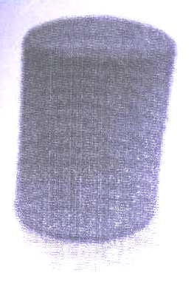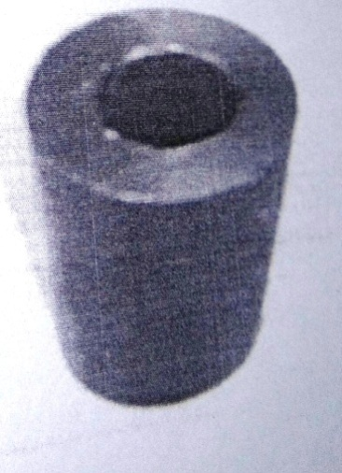

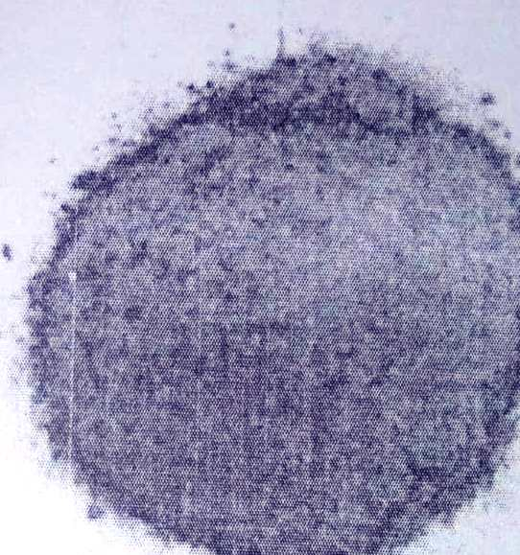

Brass Sinter

Brass Powder/Chips

Mould

Linear regression was used to develop the model in the form  translated to P, T , a andb are compact pressure tensile strength ofsinter samples intercept on P-axis, gradient of the fitting line respectively.

The coefficient of correlation was calculated from the relation: 

From, 

,

a and b were substituted into the regression equation above and results to the developed model equation:

Compact pressure, P= -364+1.78T. The values of a, b and coefficient of correlation, r are, +396.5, 1.86 and 0.995 respectively.

Sintering information: Sintering was carried out in vacuum atmosphere in a single phase non-liquidus (solid) state at about 850o C.

**RESULTS AND DISCUSION**

Compressive load and compact pressure increase inversely as sinter height and directly in proportion as tensile strength; sample hardness was measured with Brinell hardness device and tensile strength, mini universal tester. Decreasing height of sinter samples as magnitudes of press loads suggests that increased compact loading effected a relatively small space for packing of green metallic powder which may be interpreted also as increase in mass per unit volume of particles (density).

Illustrating from the molecular point of fluid (surface tension), deformation on matter is most at a low mass per unit volume.

At a coefficient of association of r=0.995, the developed model; P=-364+1.78T for compact pressure, P and tensile strength, T has more than an upper quartile performance in predicting both P and T as the case may be.

**REFERENCES**

Angener P., L.G. Khor, K.A. Korb, Zalite I. (2005) Spark plama sintering (SPS) of nano structured carbonitride powder”. J. European ceramic society, vol. 25, p.1919.

Degamo, E.P. (2008) “materials and processes in manufacturing” 10th ed. Willey. ISBN 978047005120

EPMA figures 2015, European Powder Metallurgy Association.

German R.M., Suri P, Park S.J. (2009). “Review: Liquid phase sintering” Journal of material science. 44(1): 1-39, doi 1007

Gupta, A Peck, G.E. Miller, R.W.Meris K.R. (2004) “Non-destructive measurement of compact strength and particle size distribution after milling of roller compacted powder by near intra-red spectroscopy.

Jain R.K. (2009) “Production Technology” 7th edition, Khana publishers 2B, Nath market, Nai Sarah, Delhi pg. 252-256.

Khan M.K. (1980), The importance of powder particle size and the flow behavior in the production of P/M parts for soft magnetic applications” Intern. J. powder metallurgy and powder tech. 16(2) 123-130

Sharma (1998) “ Production Technology” 1st edition, Dampat Rat Ltd, Kapur, Ansari Road, New Delhi, 110002, pg 14:12 and 14:5

Sharma, P.K. (2014) “Production Technology”, 3rd edition, Noirja publishers and printers, put ltd, Ram Nargar, New Delhi. 110 055 pg 604.

Zak Z., Fang, Pei sun, (2012) “pathways to optimize performance/cost ratio of powder metallurgy titanium a perspective” key engineering materials 520, 15-13.

Zoxas P.E, German R.M., Hwang K.S., Li C.J. (1983) “Activated and liquid phase sintering – progress and problems” Journal of metals 35(1): 28 – 33. Doi 10-1007