**STUDYING AND UNDERSTANDING THE ALGORITHM USED FOR FAKE REVIEW DETECTION**

**1Kartekay Kaushik, 2Rupesh Kumar Dewang**

1Researcher

2Motilal Nehru National Institute of Technology Allahabad, Prayagraj

**Abstract:**

Enormous piece of the clients can give survey in the wake of purchasing from which at any point shop they need. Whether you buy from a retail store or online. When a customer buys a product online, they read customer reviews, which are very important for making a decision in today's e-commerce products. As composing counterfeit surveys accompanies cash gain, there has been an immense expansion in misdirecting assessment on specific item surveys on their sites. Deluding survey is a risky survey. Giving positive surveys to focus on the clients that draw in clients and gain expansion in deals. There as regrettable survey of an item could cause lesser interest of that item which might diminish its deals. These deceptive surveys are hazardous to an item notoriety. Prior to making a buy, ~80% of clients read internet based surveys or remarks on items and administrations. Be that as it may, a portion of these surveys can be false as advancing specific items or devaluing them and, therefore, mislead purchasers. For sure, Google reported that in 2020, they identified 40 billion spam surveys day to day. This article makes sense of how phony surveys are made, techniques used to distinguish misleading audits, and genuine applications for recognizing them. Here by utilizing AI Calculation. Examples include the Supervised Learning algorithm SVM. We anticipated the review, i.e. a survey is phony or not. Our goal is to conclude whether a survey is phony or veritable one.

**Keywords :** Fake reviews, Machine Learning, Support Vector Machines, Supervised Learning.

**Introduction**

Surveys are unit of estimations which are actually quite much significant for progress or disappointment in deals of an item. Surveys are being controlled or made deceiving for positive or adverse consequences. As today would like to think has turned into a hazardous issue to clients and Online business monsters. It is really important and difficult to find these fake reviews. These phony commentators are paid to compose these surveys. It is a tough spot for a typical client to distinguish the deceptive surveys from certified ones, simply by perusing each audit .Since they are written so that they look real. The clients are truly reliant upon this surveys to pursuing their choices to purchase an items from this internet based vender or not.

**Fake review detection methods**

**Manual detection**

It is the most fundamental approach to recognizing counterfeit surveys, and annotators physically conclude whether a survey is phony. Despite the fact that it very well may be a promising methodology, research shows that people have 57% precision in a phony survey discovery task. Furthermore, as there is a dramatic expansion in web-based surveys, it requires an extraordinary labor force and time.

**Algorithm-based detection**

The number of online reviews on TripAdvisor has[increased](https://www.statista.com/statistics/684862/tripadvisor-number-of-reviews/) from 200 million to 1 billion from 2014 to 2021. As customers’ reviews increase exponentially, so do fake reviews. Machine learning techniques provide a solution to detect online spam. ML algorithms analyze the texts based on

* Textual (e.g., nouns, phrases, punctuation, linguistic style) features
* Behavioral (e.g., number of reviews, review dates, user profile) features

Then, algorithms make classifications based on these features. Recent research applying the -means algorithm, an ML method, achieves 96% accuracy in detecting fake reviews.

Algorithms can be trained to detect fake reviews through textual features such as

* Excessive punctuation use
* Poor grammar
* An overly negative or positive tone

Analysts use opinion examination methods to distinguish counterfeit audits in view of text based highlights. Opinion examination distinguishes sentiments or sentiments in messages as containing positive, negative, or impartial tones. For more inside and out information on opinion investigation, download our thorough whitepaper:

You can likewise check our information driven rundown of opinion investigation administrations.

Calculations can likewise screen the personal conduct standard of analysts, for example, the client's all out number of surveys, audit dates, and client profile subtleties. These measurements permit ML models to characterize dubious audits and assist with deciding phony survey qualities.

**Sponsored**

Clickworker gives feeling investigation administrations in 70 business sectors, including online business, retail, and medical services, and they offer great and human-created preparing information for ML calculations. Clickworker gives arrangements in excess of 158 nations overall by means of their 4+ million publicly supported laborers.

## How are fake reviews generated?

## Fake Google reviews boosting UK businesses - Which? News

**Figure 1. Examples of fake reviews on the Internet**

Fake reviews are mainly written in two ways: human-generated and machine-generated.

**Human-generated fake reviews**

Content creators get paid to create fake online reviews, and they promote or depreciate certain products in their reviews. In general, there exist two patterns:

* The owner of the products can pay content creators to write feedback to obtain higher ratings or impress potential customers
* Or, competitors may hire spammers to demonize the products of other brands and try to direct customers to alternatives, in that case, their products.

### Machine-generated fake reviews

Making surveys physically is tedious, work escalated, and expensive. In this manner, computerized calculations (e.g., Regular Language Handling (NLP) and AI (ML) techniques) are applied to make counterfeit audits. In opposition to human-created surveys, machine-produced surveys are delivered through text age, which can produce audits for a huge scope.

### Case studies for the detection of fake reviews

### Sentiment analysis of Amazon reviews

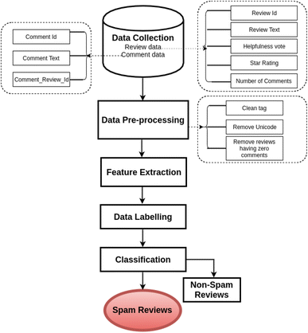

Source:[CSI Transactions on ICT](https://link.springer.com/article/10.1007/s40012-018-0193-0)

**Figure 2. Flow diagram of the study on detecting fake reviews through sentiment analysis**

Analysts gathered ~40,000 audits through web scrubbers from the Amazon site and led feeling investigation, arranging messages in view of their opinion score as good, pessimistic, or impartial. Then, using the scores they got, they used Random Forest classification and determined a sentiment threshold to find reviews that looked suspicious. Their outcomes showed 91% exactness in recognizing counterfeit audits.

### Using machine learning (ML) techniques and two datasets, researchers perform feature engineering on Yelp restaurant and hotel reviews. Cry Café and Lodging on the web surveys. They thought about different ML models on these datasets and found that strategic relapse performs better compared to different calculations, giving 88% exactness in identifying counterfeit surveys.

### Order of phony surveys on the Application Store

### Scientists utilized the Apple Application Store dataset containing 22+ million surveys from 1.4 million applications to recognize counterfeit audits. Results show that ~66 million (35% of all surveys) were fake.7 Among those, 60,000 were composed by a solitary spammer.

### Here we additionally give some genuine utilizations of how organizations battle against counterfeit audits:

### Yelp fake reviews consumer alert

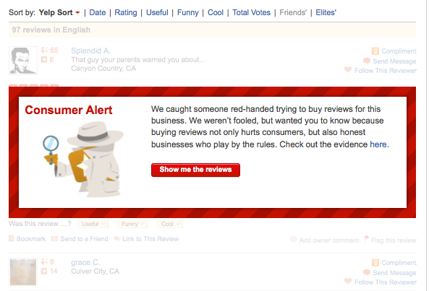

Source:[Yelp Blog](https://blog.yelp.com/news/how-yelp-protects-consumers-from-fake-reviews/)

Yelp identifies that a few merchants purchase counterfeit surveys. Yelp alerts potential customers to the fraudulent actions of those who have purchased reviews that are not genuine. They intend to disgrace merchants that purchase online spammers to compose positive surveys for their brands.

In 2022, Amazon discovered 10,000 Facebook groups that were created to buy fake reviews in exchange for money or free products. The company announced that it had taken proactive legal action to remove the groups and identify the bad actors. Amazon has more than 12,000 employees who work on fraud or abuse.

**Machine Learning technique used for training classifier**



**Figure 3 : Working of Machine Learning Model**

Here the three periods of AI Model for acquiring expectation are portrayed beneath.

Information Pre-handling: In this Part different activities are carried on information A portion of the activities are like smoothing of information, Commotion sifting. Eliminating the invalid qualities from the information and so forth.

Classifier by SVM: SVM is characterized as Help Vector Machine Classifier. SVM is a regulated Learning calculation which can be utilized for order of the information. Support Vector Machine is quick and solid calculation which upgrades the interaction for location of phony surveys.

Forecast Of Result: By applying the SVM we anticipate the aftereffects of given information which is been ordered for expectation.

Test Assortment: Sample collection is the process of collecting data for the purpose of training the algorithm.

Regulated Learning Calculation:

Administered Learning is done on marked dataset.

Labeled Data: The input and output parameters that the classifier needs to train itself are contained in labeled data.

Subsequent to acquiring the Marked information we can prepare our classifier and afterward when can utilize our classifier on unlabelled information to get the appropriate examination report confirming the facts: In machine learning, the term "validation of data" can be a bit hazy, but it can be defined as "obtaining an output within a specific range." Or on the other hand we can approve our outcome with specific measure of boundaries. These parameters can demonstrate whether or not our predicted outcome is accurate. In Managed Learning we require both preparation of information and approving the information.

Set of training data: With the assistance of marked information we gave preparing to our SVM Classifier. by indicating to the classifier whether this kind of review is genuine or fake. With the assistance of this preparing the classifier can separate effectively and between huge datasets of audits. The accuracy of classification is greatly improved after learning more from labeled data.

**Figure 4 : Supervised Learning Model**

**SVM ALGORITHM TECHNIQUE**

The supervised machine learning formula known as SVM Support Vector Machine is utilized for both classification and regression. It's essentially utilized for order related issues. While in this equation, we regularly attempt to plot each information on object as a degree in n-layered region. . Here n is the scope of choices we have with respect to each component which is a chosen coordinate. After this we perform arrangement by finding the hyper plane that separates between the two classes.

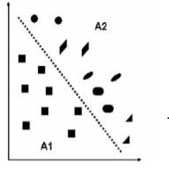

**Figure 5 :Hyper plane used for categorization**

The principal saying for utilizing the Help vector machines is that it is simple maker of hyper plane what isolates the dataset into different classes. which enables us to begin with a sample disadvantage. Let's say we have to distinguish blue circles from red triangles for a particular dataset. We really want objective structure a line that orders the data into two classes, having an effect between red triangles and blue circles. though one will get us a straightforward line that isolates the two classifications, there are a few lines which might attempt this work.

There's not so much as one line that will settle on which could play out this errand. The target of SVM thoroughly relies upon straight partition in an exceptionally high aspect.

Include region where information square measure are planned to contemplate a definitive non-linearity of the matter. to get a little degree of speculation capacity. Maximum distance exists between the hyperplane and the knowledge. The preparation of Help Vector Machine is conveyed with the matching scores of the vector. A hyper-plane is a plane that divides the n-dimensional knowledge points in half in a linear fashion.

Whenever expected for the subsequent stage, hyper plane is line, for good measure of 3D it's plane. The n-dimensional line is the combination of them.

**Figure 6 : Design of our proposed system**

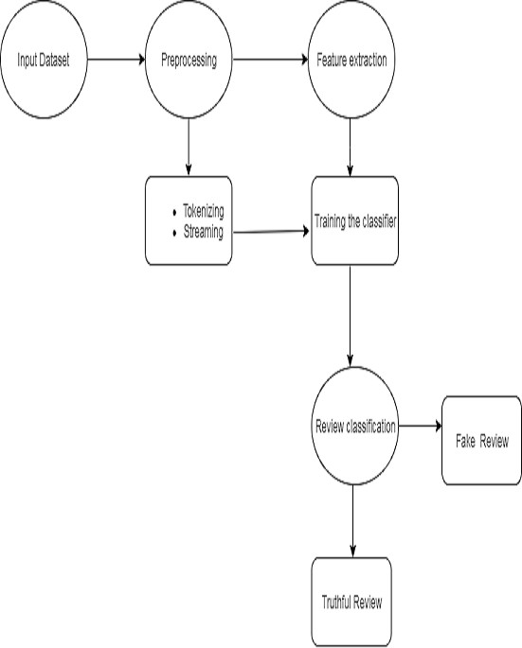

Future work in AI Application as for Counterfeit Survey Discovery

a. Currently we are thinking about just the static information and the open-data sets which are accessible. This project's future feature is real-time review detection.

b. We have as of now utilized just Help Vector Machine classifier, in future perspective various calculations can be executed to really look at audits.

c. While utilizing different AI calculations we can upgrade the precision of identification of phony audits.

d. Training a solitary classifier at a time. Is absolutely tedious, in future perspective we can prepare numerous classifiers at the same time. So different classifiers can be prepared and utilized of legitimate audit location.

e. When we are able to load multiple datasets and carry out review analysis on each of them, this would be considered a future aspect.

**Conclusion**

In this paper, we have made a model for counterfeit survey recognition utilizing AI calculations like SVM (Backing Vector Machines). The model which we have made accomplishes its most raised rightness. Counterfeit Survey discovery is a creating research field .With restricted measure of open datasets. With this undertaking we are attempting to get high precision and furthermore lessen the time expected to recognize the Phony Surveys. Likewise we can utilize this undertaking to distinguish the various phony Surveys.

**References:**

1. Kearns, JK. (April 29, 2021). “Five ways we’re making Google the safer way to search.” *Google*. Retrieved January 17, 2023.
2. Plotkina, D., Munzel, A., & Pallud, J. (2020). “[Illusions of truth—Experimental insights into human and algorithmic detections of fake online reviews](https://www.sciencedirect.com/science/article/pii/S0148296318306192).” *Journal of Business Research*, 109, 511-523. Retrieved January 17, 2023.
3. “[Total number of user reviews and opinions on Tripadvisor worldwide from 2014 to 2021](https://www.statista.com/statistics/684862/tripadvisor-number-of-reviews/)“. *Statista*. February 21, 2022. Retrieved January 17, 2023.
4. Li, J., Lv, P., Xiao, W., Yang, L., & Zhang, P. (2021). “[Exploring groups of opinion spam using sentiment analysis guided by nominated topics](https://www.sciencedirect.com/science/article/pii/S0957417421000269?casa_token=74vpTo3cGKUAAAAA:tvYSBSssfFN0JUVm4Xmph9RymGr4QjMA9Md14KpsOfg83wiL1JuAM-dMKs0TrZuMF32T2fYQOTY).” *Expert Systems with Applications*, *171*, 114585. Retrieved January 17, 2023.
5. Saumya, S., & Singh, J. P. (2018). “[Detection of spam reviews: a sentiment analysis approach.](https://link.springer.com/article/10.1007/s40012-018-0193-0)” *CSI Transactions on ICT*, *6*(2), 137-148. Retrieved January 17, 2023.
6. Jain, P. K., Pamula, R., & Ansari, S. (2021). “[A supervised machine learning approach for the credibility assessment of user-generated content.](https://link.springer.com/article/10.1007/s11277-021-08136-5)” *Wireless Personal Communications*, *118*(4), 2469-2485. Retrieved January 17, 2023.
7. Martens, D., & Maalej, W. (2019). “[Towards understanding and detecting fake reviews in app stores.](https://link.springer.com/article/10.1007/s10664-019-09706-9)” *Empirical Software Engineering*, *24*(6), 3316-3355. Retrieved January 17, 2023.
8. “[Amazon targets fake review fraudsters on social media](https://www.aboutamazon.com/news/policy-news-views/amazon-targets-fake-review-fraudsters-on-social-media).” *Amazon*. July 19, 2022. Retrieved January 17, 2023.
9. Chengai Sun, Qiaolin Du and Gang Tian, “Exploiting Product Related Review Features for Fake Review Detection,” Mathematical Problems in Engineering, 2016.
10. Heydari, M. A. Tavakoli, N. Salim, and Z. Heydari, ”Detection of review spam: a survey”, Expert Systems with Applications, vol. 42, no.7, pp. 3634–3642, 2015.
11. M. Ott, Y. Choi, C. Cardie, and J. T. Hancock, “Finding deceptive opinion spam by any stretch of the imagination,” in Proceedings of the 49th Annual Meeting of the Association for Computational Linguistics: Human Language Technologies (ACL-HLT), vol. 1, pp. 309–319, Association for Computational Linguistics, Portland, Ore, USA, June 2011.
12. Prof Vaishali Babanne , Mr Girish Navale " Load Balancer Plug-in Filter"
13. S. Feng, R. Banerjee, and Y. Choi, “Syntactic stylometry for deception detection,” in Proceedings of the 50th Annual Meeting of the Association for Computational Linguistics: Short Papers, Vol. 2, 2012.
14. Yuejun Li, Xiao Feng, Shuwu Zhang, Yuejun Li." Detecting Fake Reviews Utilizing Semantic and Emotion Model"
15. E. P. Lim, V.-A. Nguyen, N. Jindal, B. Liu, and H. W. Lauw, “Detecting product review spammers using rating behaviors,” in Proceedings of the 19th ACM International Conference on Information and Knowledge Management (CIKM), 2010.
16. J. K. Rout, A. Dalmia, and K.-K. R. Choo, “Revisiting semi-supervised learning for online deceptive review detection,” IEEE Access, Vol. 5,pp. 1319–1327, 2017
17. Rakibul Hassan, Md. Rabiul Islam. " Detection of fake online reviews using semi-supervised and supervised learning."